**INDIAN SPORTS ASSOCIATION :**

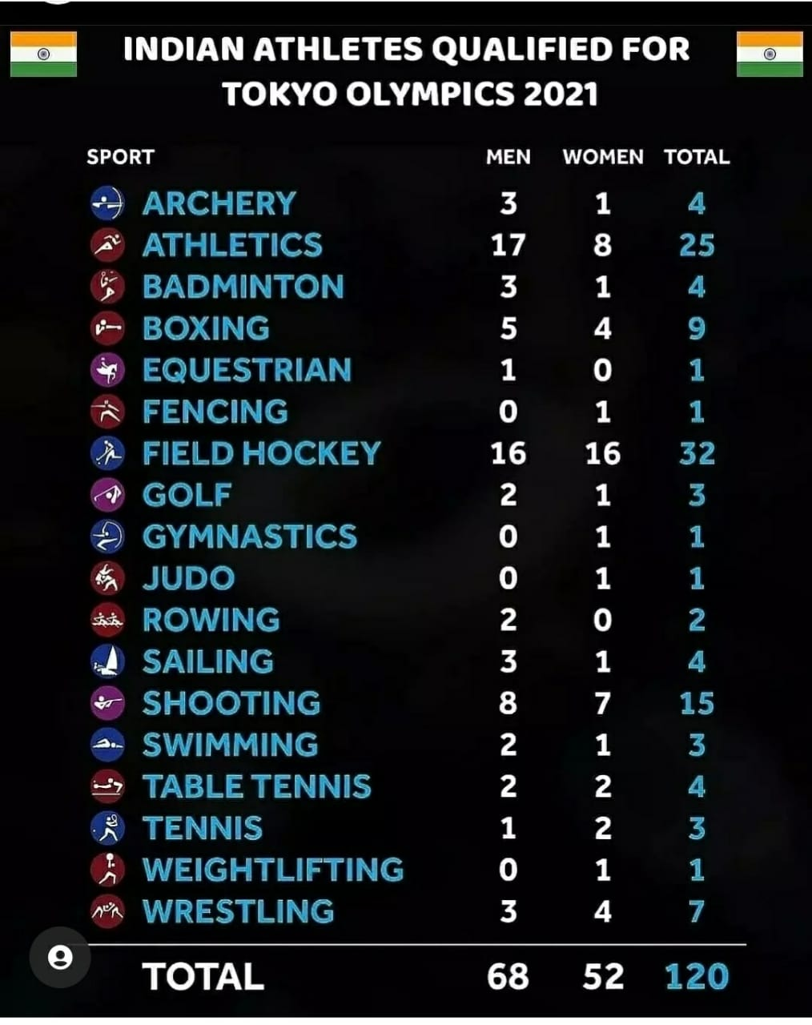

INDIA AT OLYMPICS ,ONLY 120 PARTICIPANTS FROM POPULATION OF 120 CRORES i.e Only 0.001 percentage of population this is because of less knowledge of sports and less importance of many sports in INDIA .Sports like CRICKET,FOOTBALL,HOCKEY everyone knows that in INDIA but sports like EQUESTRIAN,FENCING,RUBDY,TAEKWONDO, ARTISTIC GYMNASTICS,BASEBALL,CANOE SLALOM and many more.So Basically our website will not contain information about well known sports it will contain information of Sports which are lesser or not played in india.

**Website will have Features of:-**

1)Details about the coaching centre

2)about the sport admin side to check the needs and donatons otherside to provide the pyment and donations

3) awards received till date

4) Nearby grounds ,places to play that sports

5) Future in that particular sport

6) trainers

INDIA AND CHINA HAVE ALMOST SAME POPULATION THEN TOO AT THE MEDALS LIST THEY DIFFER BY 50/60 POSITIONS. Even countries like Australia,Japan which has almost 70% less population has more participation of athlethes and Medals than INDIA.

