IBM HR teaching data · fictional, simulated employees · executive summary
Overtime workers leave most in IBM’s fictional HR data, lower-paid junior ones most of all
EXECUTIVE SUMMARY
In IBM’s fictional teaching dataset of 1,470 simulated employees, 16% left. Overtime workers are 28% of staff but 54% of everyone who left, and within that group lower-paid, mostly junior staff leave most: about 55% of them left, close to 30% of all leavers. Newer staff also leave more often, with or without overtime; we flag that as one career-stage picture to watch, not a cleared finding. As an illustration, not a forecast, if overtime workers left at the company average, attrition would fall from about 16% to about 12%, roughly 60 fewer leavers. The first step is to find out where overtime is concentrated and why, then pilot changes in teams where overtime is heavy and not chosen; these are simulated people, and the data show who left, not why.
What the Data Shows: overtime workers leave most, lower-paid junior ones most of all
In this fictional dataset, 416 people, 28% of staff, worked overtime. 31% of them left, about 1.9 times the company rate of 16% and about 3 times the rate of staff without overtime (10%). Together they account for 54% of everyone who left.
Within overtime, lower-paid, mostly junior staff leave most. Overtime workers earning under roughly $3,000 to $3,500 a month (about 115 to 130 people, 8% to 9% of staff) left at about 55%, about 2.7 to 2.9 times the rate of the other overtime workers (about 20%). They account for close to 30% of everyone who left. They are part of the overtime finding, not a separate pattern.
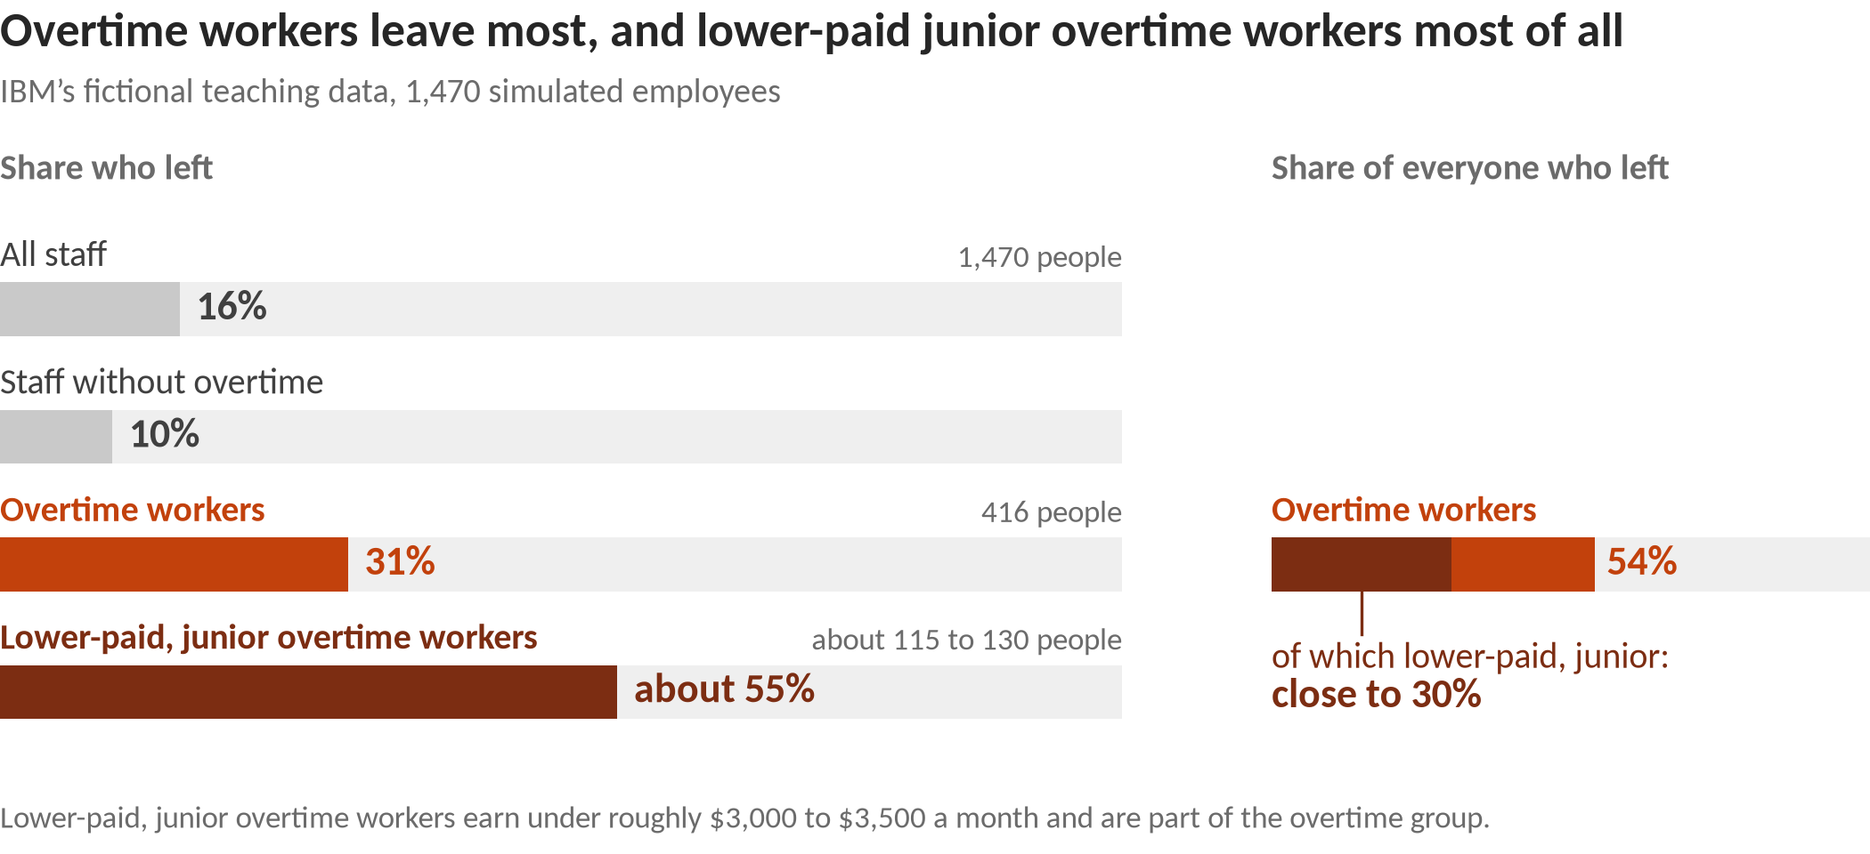
Context: one career-stage picture. Pay, job level, tenure and total experience move together, and the data cannot say which of them matters. Almost all of these lower-paid overtime workers (97%) are in the most junior job level, so pay and job level cannot be separated: overtime workers in the most junior job level (156 people) left at 53%, against 17% for the 260 overtime workers at higher job levels, close to the company average of 16%.
Worth watching, not a cleared finding: newer staff
Staff with 1 year or less at the company (215 people, 15% of staff) left at 35%, about 40 people above the company rate; about a third of them (32%) work overtime. The group is large, but the exact group isn’t stable across repeated analyses, because new hires, short tenure, junior level and low pay overlap. Treat them as one career-stage picture to watch, not a proven cause; it is not added to the overtime figures. Among staff without overtime, newer staff also leave more often: a real difference inside that group, but modest against the company rate.
Research finds that longer time with a company goes with less leaving (Rubenstein et al., 2018); people newer to a company have had less chance to build the ties, fit and stake that go with staying (Mitchell et al., 2001). Research on newcomers finds that how people are brought in matters: structured orientation, finding the information they need, a clear role and feeling accepted by colleagues relate to how well new hires settle, and settling relates to outcomes that include intending to stay and actually staying (Bauer et al., 2007).
Look into (watch item, not a cleared finding)
1. Review onboarding for the first year across roles and teams. Check whether new hires get a clear role, the information they need and a chance to meet colleagues (Bauer et al., 2007).
2. Hold a 90-day and a 6-month check-in for all new hires. The same offer to everyone who joins (Mitchell et al., 2001; Bauer et al., 2007).
3. Track first-year leaving by team. Report it next to overtime levels, so leaders can see whether it is a company-wide pattern or sits in a few teams (Rubenstein et al., 2018).

Why It Matters and What to Do: overtime is the clearest place to start
In this fictional data, the overtime group is large enough to move the overall number. If overtime workers left at the company average, overall attrition would fall from about 16% to about 12%, roughly 60 fewer leavers. On the same illustration, the lower-paid, mostly junior overtime workers would take it from about 16% to about 13%, roughly 45 to 50 fewer leavers. They are already inside the overtime group, so the two illustrations overlap and are not added. Both are illustrations of scale, not forecasts of what any change would achieve.
These are ideas to test, not proven fixes. Each applies to teams and groups as a whole, never to individuals and never selected by age, gender or marital status.
Overtime workers (cleared finding)
Long hours can drain time and energy from family life (Greenhaus & Beutell, 1985), and that kind of conflict is linked to leaving (Rubenstein et al., 2018). But research measures workload, not overtime, and finds it only weakly related to leaving, if anything slightly protective (Rubenstein et al., 2018). Research on workload would not lead us to expect a gap this large, so treat this fictional result as a pointer to where to look, not proof of cause or evidence about any real employer.
1. Review workload and staffing where overtime is concentrated. Map overtime by team and role, and ask whether it is a predictable crunch or a chronic pattern, and whether it is chosen or required. (Podsakoff et al., 2007)
2. Offer manager check-ins (“stay conversations”) to everyone in the overtime group. Ask what keeps people and what might make them leave, then act on what is in the team’s control. (Mitchell et al., 2001; Hausknecht et al., 2009)
3. Pick one measure and pilot before rolling out. Track the leaving rate of overtime workers by team, try changes in a few teams, and compare with similar teams that did not change. (Griffeth et al., 2000; Rubenstein et al., 2018)
Within overtime: lower-paid, mostly junior workers (part of the overtime finding; overlaps it, not added)
Classic theory holds that people stay while what they get outweighs what they give (March & Simon, 1958), and that feeling under-rewarded can prompt people to leave (Adams, 1965); this data does not record how people felt about their pay or their overtime. Research finds that lower pay goes with more leaving, and so does being newer to a company, though both links are modest (Rubenstein et al., 2018). This is consistent with the pattern, as an illustration only.
Aimed at junior-level overtime workers as a job-level group, never by pay cut, age, gender or marital status.
1. Check overtime pay, recognition and scheduling at the junior job level. Ask whether overtime is paid or recognized, whether notice is given, and whether extra hours are shared fairly across the team. (March & Simon, 1958; Adams, 1965)
2. Hold a defined next-step conversation for junior roles. Make clear what the next level involves and how people get there, offered to everyone at that level. (Mitchell et al., 2001)
3. Pilot in a few junior-level overtime teams, with measurement. Track their leaving rate against similar teams that did not change before rolling out. (Rubenstein et al., 2018)
What Not to Conclude: limits of a fictional sample
It is a fictional sample. IBM created these 1,470 employees for teaching. They describe no real workforce or employer.
It shows who left, not why. Overtime may simply mark busy or understaffed roles, and pay moves with job level and experience.
Pay and career stage overlap. Lower pay, junior job level, short tenure and little experience go together, and the data can’t say which matters.
It is not for decisions about individuals. The patterns describe groups. Age, gender and marital status are descriptive only and never grounds for targeting anyone.
Small groups are left out. Groups under 100 people were set aside as too small to act on.
Sources: Adams (1965); Bauer, Bodner, Erdogan, Truxillo & Tucker (2007); Greenhaus & Beutell (1985); Griffeth, Hom & Gaertner (2000); Hausknecht, Rodda & Howard (2009); March & Simon (1958); Mitchell, Holtom, Lee, Sablynski & Erez (2001); Podsakoff, LePine & LePine (2007); Rubenstein, Eberly, Lee & Mitchell (2018). Numbers: analysis/exec2/exec_findings_v2_draft.md (QA-cleared Oct 9, 2026). Technical detail: analysis/exec2/technical_appendix.md in the project repo.

