IBM HR teaching data · fictional, simulated employees · executive summary
Overtime workers leave most: what IBM’s fictional HR data suggests
EXECUTIVE SUMMARY
In IBM’s fictional teaching dataset of 1,470 simulated employees, 16% left, and overtime workers stand out: they are 28% of staff but 54% of everyone who left. If they left at the company average, overall attrition would fall from about 16% to about 12%, roughly 60 fewer leavers, as an illustration rather than a forecast. The first step is to find out where overtime is concentrated and why, then test lighter workloads in the busiest teams. The key caution: these are simulated people, and the data show who left, not why.
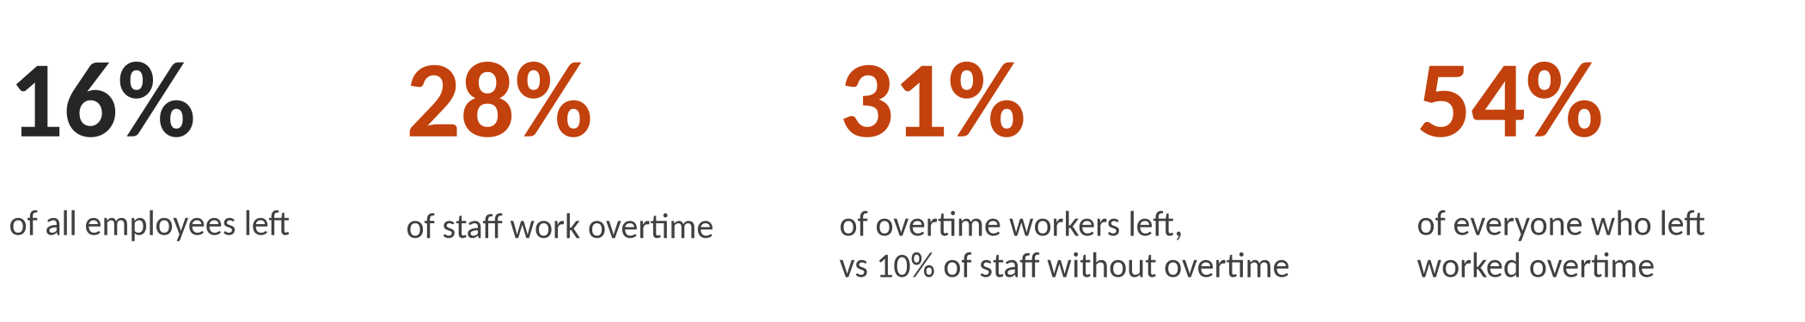
What the Data Shows: overtime workers leave at about three times the rate of other staff
In this fictional dataset, 416 people, 28% of staff, worked overtime. 31% of them left, about three times the rate of staff without overtime (10%). Together they account for 54% of everyone who left. It is the one large group that held up under every check the team ran.
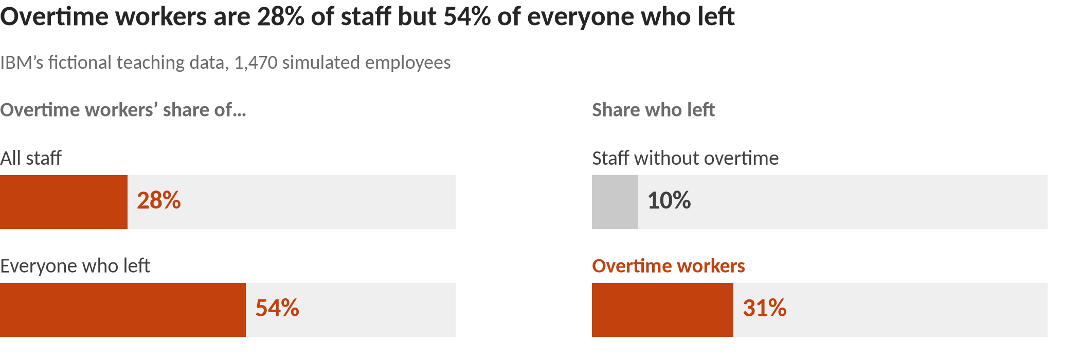
Context, not a separate finding: pay and career stage. Lower-paid staff (roughly the bottom third, under about $3,000–$4,000 a month) left at about 27%, against 11% for everyone else. But 95% of them are in the most junior job level, so pay and career stage can’t be separated here. Most of their extra leaving is among those who also work overtime: without overtime, lower-paid staff leave at about the company average (16%), against 8% for better-paid staff without overtime.
Why It Matters and What to Do: overtime is the clearest place to start
In this fictional data, the overtime group is large enough to move the overall number. If overtime workers left at the company average, overall attrition would fall from about 16% to about 12%, roughly 60 fewer leavers. That is an illustration of scale, not a forecast of what any change would achieve.
Research on real organizations gives reason to take overtime seriously, and reason for care. Long hours can take time and energy from family and other roles, and that kind of conflict is linked to leaving (Greenhaus & Beutell, 1985; Rubenstein et al., 2018). People who feel they give more than they get back are also more likely to go (Adams, 1965). But on its own, overtime is usually only a weak predictor of who leaves (Rubenstein et al., 2018), and demanding work that people experience as a stretch is often linked to staying (Podsakoff et al., 2007). So this fictional data should not be read as confirming the research. In a real company, what matters is whether overtime is chosen or required, and how long it lasts.
Three suggestions to test, not proven fixes. Each is aimed at teams and at overtime workers as a group, never at individuals.
1. Find where overtime sits, and why. Map overtime by team and role, and ask whether it is chosen or required and how long it has been going on.
2. Rebalance workload in the busiest teams. Where overtime is heavy and sustained, try added staffing, redistributed work or schedule changes in a few teams first.
3. Track overtime and leaving together. Report both side by side for each team, so leaders can see whether the changes actually reduce leaving before rolling them out more widely.
What Not to Conclude: limits of a fictional sample
It is a fictional sample. IBM created these 1,470 employees for teaching. They describe no real workforce or employer.
It shows who left, not why. Overtime may simply mark busy or understaffed roles, so cutting overtime alone may not reduce leaving.
Pay and career stage overlap. Lower pay and junior roles go together, and the data can’t say which matters.
It is not for decisions about individuals. The patterns describe groups. Age, gender and marital status are descriptive only and must not be used for decisions about anyone.
Small groups are left out. Groups of under 100 people were set aside as too small to act on.
Sources: Adams (1965); Greenhaus & Beutell (1985); Podsakoff, LePine & LePine (2007); Rubenstein, Eberly, Lee & Mitchell (2018). Numbers: analysis/exec/exec_findings_draft.md (QA-cleared Oct 9, 2026). Technical detail: analysis/exec/technical_appendix.md in the project repo.

