TABLE CREATED AND TABLE SCHEMA:

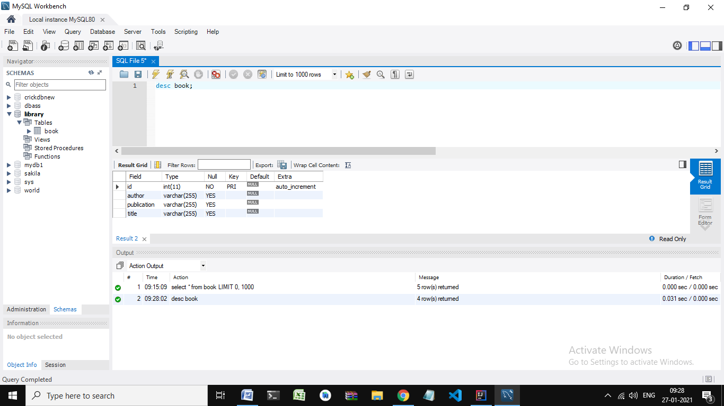

INSERTED 5 BOOKS:

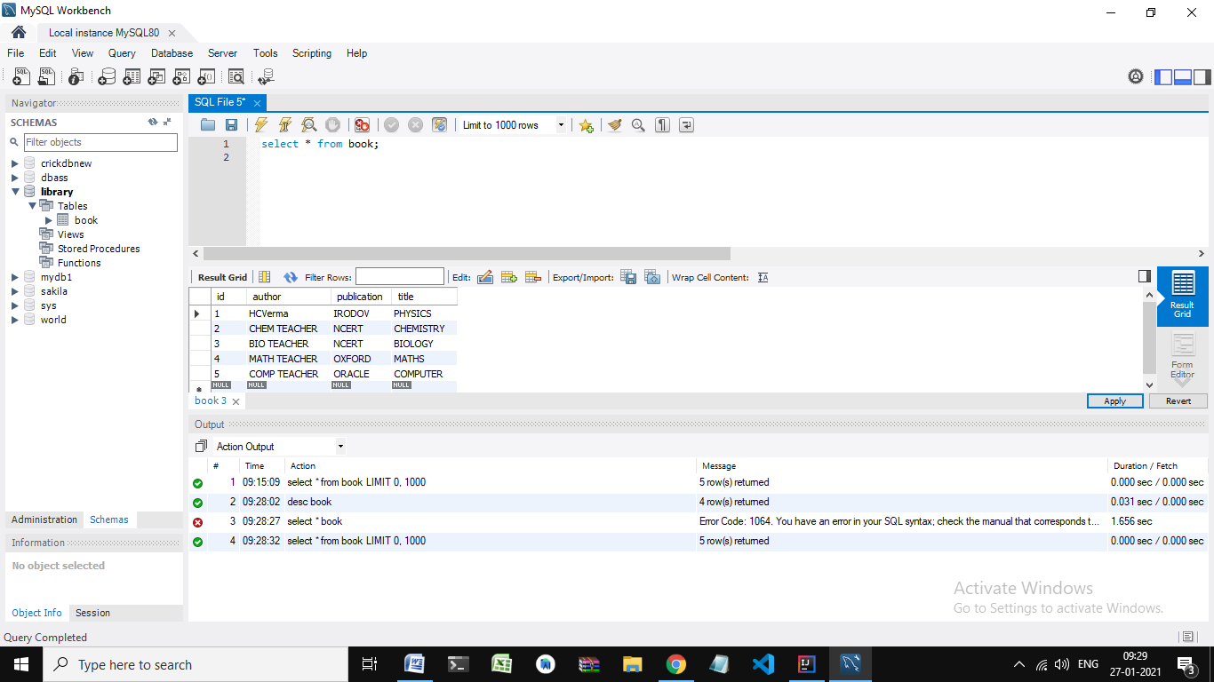

GET ALL BOOKS:

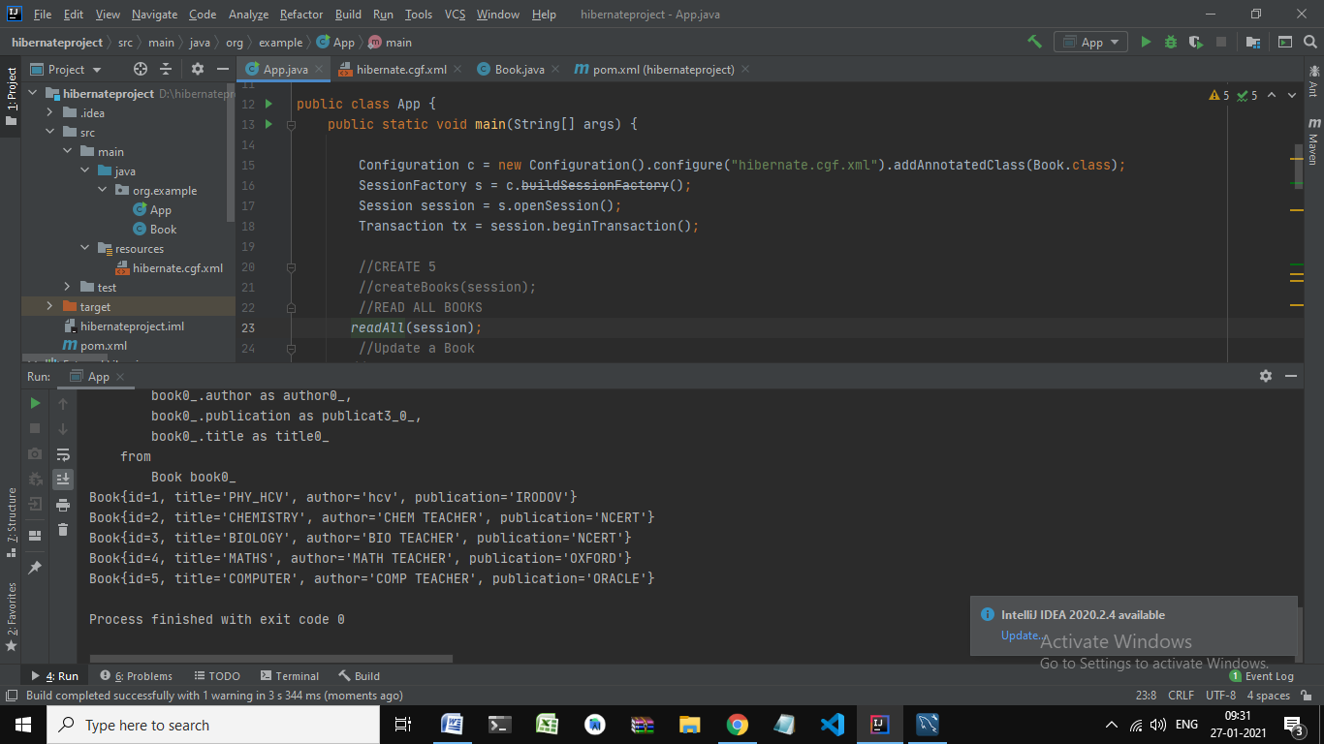

UPDATED A BOOK of ID 1:

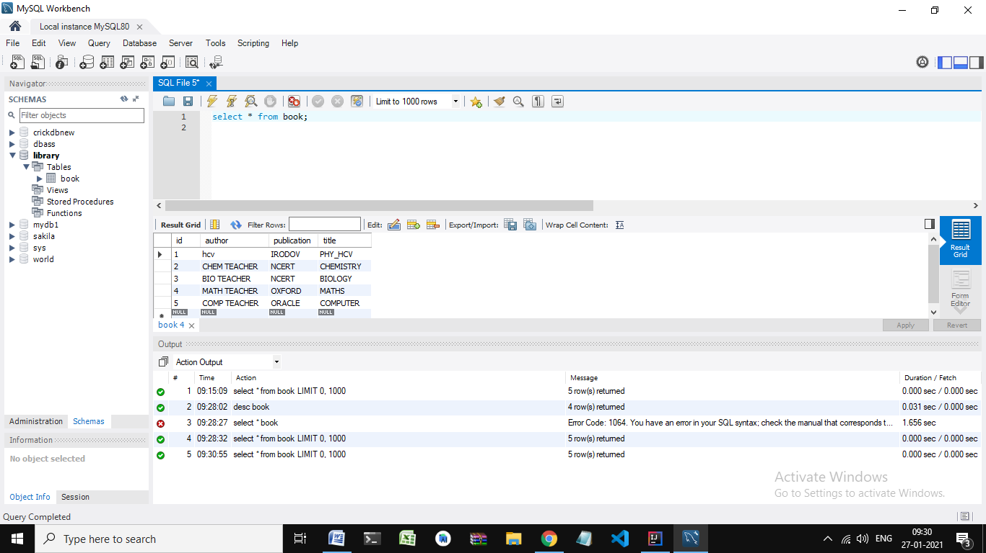

DELETED A BOOK OF ID 3

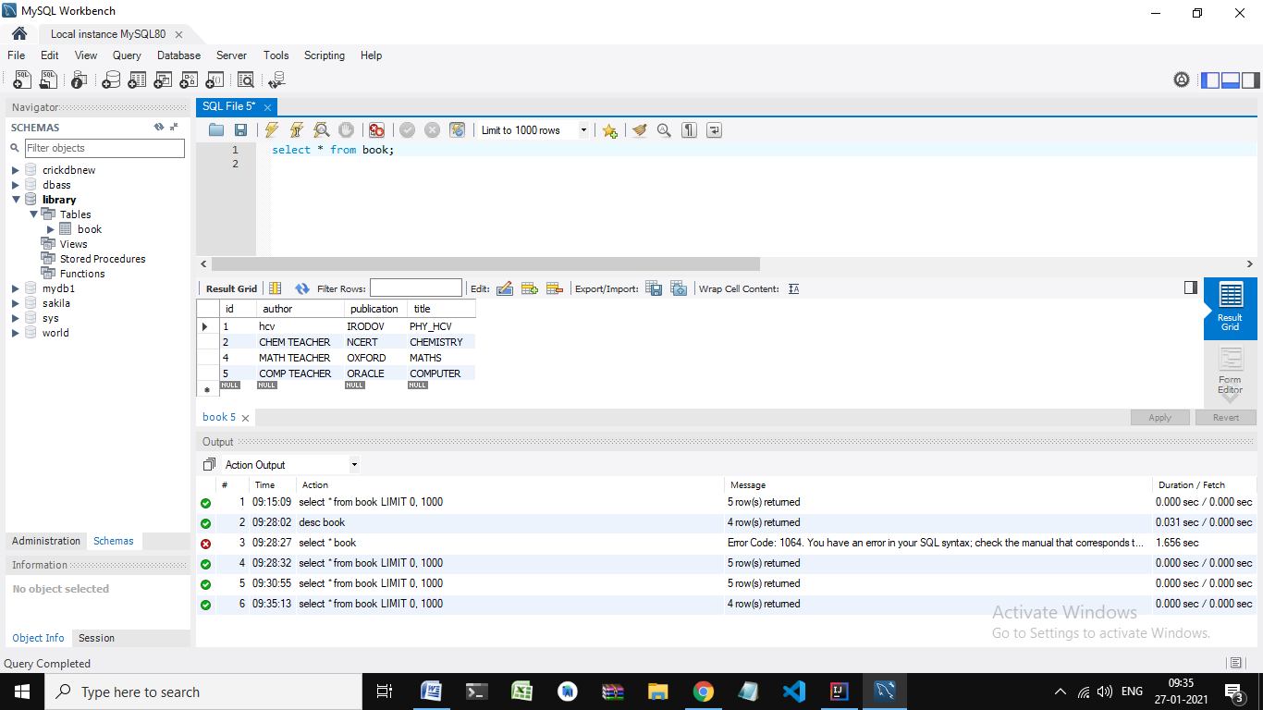

GET COUNT OF BOOKS:

