**DFS_List Code:**

# -*- coding: utf-8 -*-

"""

Created on Mon Sep 19 12:21:25 2016

@author: jaysh

"""

# -*- coding: utf-8 -*-

"""

Created on Mon Sep 19 11:27:08 2016

@author: jaysh

"""

# This is a Depth First Search

# The problem of the program is stored in a List

# The program is always complete if the goal is present

# Variable path represents the path of the Depth First Search

# Variable s represent the current state of the Depth First Search

# This Program is implemented by a stack where the last node from the

#frontier is taken out and the new node is appended in the last of frontier

#intialise_frontier = This function initialises the frontier node to the start node i.e in this case Arad

#choose_node = This function chooses the last state from the frontier its like implementing the half of the stack the last node choosen becomes the current state

#update_frontier = This fucntion updates frontier by inserting those nodes in the frontier which are present in g but they are not explored Basically froniter is the union of the list g and explored

#test_goal = his function compares the current node with the goal node if the current node is the goal node than it sends True else it sends False

#expand_node = #This fucntion Expands the current state It shows all the possibility that can be explored from the current state and it also shows the cost of that possibility

#calculate_path_cost = #This function back tracks and calculates the total path cost friom arad to bucharest

def graph_search(start,goal,problem):

explored = [] #Represents the states which has been already explored

g = [] #Represents the nodes and one of the nodes will be explored

path = [] #Represents the path of the graph

current_state='' #Represents the current state

parent = []

frontier=intialise_frontier(start)

print ('\n Initialisation value of frontier = '+", ".join(frontier))

while frontier:

path.append(choose_node(frontier))

print ('\n The value of current state = '+path[-1])

length_of_path = len(path)

if(length_of_path > 1):

print ("\nThe parent node of current state "+path[-1]+" is "+path[-2])

print ("\n path value= "+", ".join(path))

current_state= path[-1]

print ('\n frontier bfore updation = '+", ".join(frontier))

explored.append(current_state)

print ('\n explored node = '+", ".join(explored))

if(test_goal(current_state,goal) == False):

print ("\n The curent state is NOT the goal state ")

g = expand_node(g,problem,current_state,parent)

update_frontier(g,explored,frontier)

print ('\n frontier after updation = '+", ".join(frontier))

else:

print ("\n The curent state is the goal state ")

break

g=[]

actual_path,cost = backtracking(start,goal,parent)

actual_path = actual_path[::-1]

final_path = ', '.join(actual_path)

final_explored = ', '.join(explored)

print('\n FINAL OUTPUT --------------------------------------------------------')

print("\n The Final Explored states are :\n "+final_explored)

print ("\n The Path from Arad to Bucharest using Depth first Search : \n "+final_path)

print ("\n Final Path Cost from Arad To Bucharest = "+str(cost))

print('\n FINAL OUTPUT --------------------------------------------------------')

#This function back tracks and calculates the

#total path cost from arad to bucharest

def backtracking(start,goal,parent):

reverse_path = [goal]

child = goal

cost = 0

while start not in reverse_path:

for elements in parent:

if elements[1]==child:

reverse_path.append(elements[0])

cost = cost + elements[2]

child=elements[0]

break

return reverse_path,cost

#This function initialises the frontier node to the start node i.e in this case Arad

def intialise_frontier(start):

frontier = [start]

return frontier

#This function chooses the first state from the frontier its like

#implementing the half of the queue

#The first node choosen becomes the current state

def choose_node(frontier):

path = frontier.pop()

return path

#This fucntion updates frontier by

#inserting those nodes in the frontier

#which are present in g but they are not explored

#Basically froniter is the union of the list g and explored

def update_frontier(g, explored, frontier):

for element in g:

if element not in explored:

frontier.append(element)

return frontier

#This function compares the current node with the goal node

#if the current node is the goal node than it sends True else it sends False

def test_goal(s,goal):

if (s==goal):

return True

return False

#This function Expands the current state

# It shows all the possibility that can be explored from the current state

# and it also shows the cost of that possibility

def expand_node(g,problem,s,parent):

for place_distance_list in problem :

if place_distance_list[0] == s :

print ("\n The distance to be explored is :"+place_distance_list[0]+" to "+place_distance_list[1])

print ("The cost of the above distance to be explored is :"+str(place_distance_list[2]))

g.append(place_distance_list[1])

parent.append(place_distance_list)

return g

problem = [ ['Arad','Zerind',75], ['Arad','Timisoara',118], ['Arad','Sibiu',140], ['Zerind','Oradea',71],

['Oradea','Sibiu',151], ['Timisoara','Lugoj',111], ['Lugoj','Mehadia',70], ['Mehadia','Drobeta',75],

['Drobeta','Craiova',120], ['Craiova','Rimnicu-Vilcea',146], ['Craiova','Pitesti',138],

['Sibiu','Fagaras',99], ['Sibiu','Rimnicu-Vilcea',80], ['Rimnicu-Vilcea','Pitesti',97],

['Fagaras','Bucharest',211], ['Pitesti','Bucharest',101],['Bucharest','Urziceni',85],

['Bucharest Giurgiu',90], ['Urziceni Vaslui',142], ['Vaslui Iasi',92], ['Iasi Neamt',87],

['Urziceni Hirsova',98], ['Hirsova Eforie',86] ]

start = "Arad"

goal = "Bucharest"

graph_search(start,goal,problem)

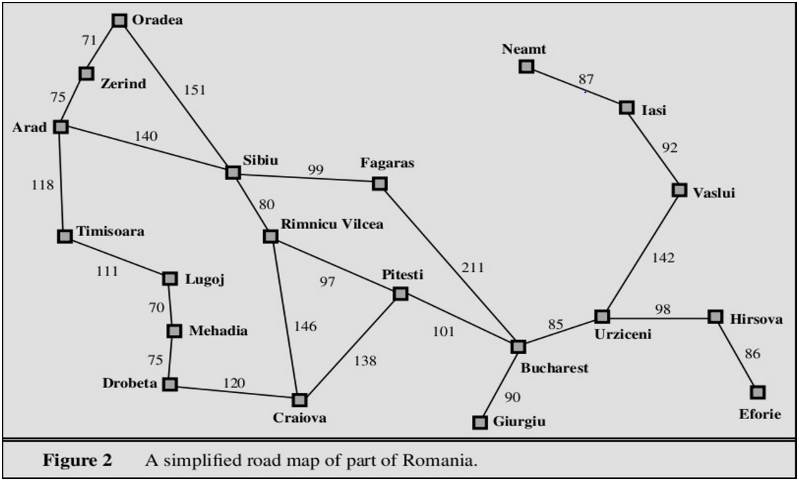

**OUTPUT :**

Initialisation value of frontier = Arad

The value of current state = Arad

path value= Arad

frontier bfore updation =

explored node = Arad

The curent state is NOT the goal state

The distance to be explored is :Arad to Zerind

The cost of the above distance to be explored is :75

The distance to be explored is :Arad to Timisoara

The cost of the above distance to be explored is :118

The distance to be explored is :Arad to Sibiu

The cost of the above distance to be explored is :140

frontier after updation = Zerind, Timisoara, Sibiu

The value of current state = Sibiu

The parent node of current state Sibiu is Arad

path value= Arad, Sibiu

frontier bfore updation = Zerind, Timisoara

explored node = Arad, Sibiu

The curent state is NOT the goal state

The distance to be explored is :Sibiu to Fagaras

The cost of the above distance to be explored is :99

The distance to be explored is :Sibiu to Rimnicu-Vilcea

The cost of the above distance to be explored is :80

frontier after updation = Zerind, Timisoara, Fagaras, Rimnicu-Vilcea

The value of current state = Rimnicu-Vilcea

The parent node of current state Rimnicu-Vilcea is Sibiu

path value= Arad, Sibiu, Rimnicu-Vilcea

frontier bfore updation = Zerind, Timisoara, Fagaras

explored node = Arad, Sibiu, Rimnicu-Vilcea

The curent state is NOT the goal state

The distance to be explored is :Rimnicu-Vilcea to Pitesti

The cost of the above distance to be explored is :97

frontier after updation = Zerind, Timisoara, Fagaras, Pitesti

The value of current state = Pitesti

The parent node of current state Pitesti is Rimnicu-Vilcea

path value= Arad, Sibiu, Rimnicu-Vilcea, Pitesti

frontier bfore updation = Zerind, Timisoara, Fagaras

explored node = Arad, Sibiu, Rimnicu-Vilcea, Pitesti

The curent state is NOT the goal state

The distance to be explored is :Pitesti to Bucharest

The cost of the above distance to be explored is :101

frontier after updation = Zerind, Timisoara, Fagaras, Bucharest

The value of current state = Bucharest

The parent node of current state Bucharest is Pitesti

path value= Arad, Sibiu, Rimnicu-Vilcea, Pitesti, Bucharest

frontier bfore updation = Zerind, Timisoara, Fagaras

explored node = Arad, Sibiu, Rimnicu-Vilcea, Pitesti, Bucharest

The curent state is the goal state

FINAL OUTPUT --------------------------------------------------------

The Final Explored states are :

Arad, Sibiu, Rimnicu-Vilcea, Pitesti, Bucharest

The Path from Arad to Bucharest using Depth first Search :

Arad, Sibiu, Rimnicu-Vilcea, Pitesti, Bucharest

Final Path Cost from Arad To Bucharest = 418

FINAL OUTPUT --------------------------------------------------------