Reconnaissance

1. Low Tech: Best Buy
2. Annual report

Best buy has published the annual report in 2019. As per the annual report, best buy net promoter score has increased more than 1500 basis points since 2012. They also have doubled their online sales to 6.5 billion and 17% revenue. In 2019, they have expanded more than 500 advisors, who made 175000 visits to customer’s home, where they have addressed customers need in a more human and effective fashion, unlocking latent, incremental demand.

1. Internal phonebook lists

|  |  |  |
| --- | --- | --- |
|  | Phone number | Email address |
| [Hubert Joly](http://quotes.wsj.com/BBY/company-people/executive-profile/56681743), 59 Executive Chairman | 612-291-1000 | hubert.joly@bestbuy.com |
| [Corie Sue Barry](http://quotes.wsj.com/BBY/company-people/executive-profile/142413750), 43 Chief Executive Officer & Director | 281-931-6609 | [Corie.barry@bestbuy.com](mailto:Corie.barry@bestbuy.com) |
| [Cindy Kent](http://quotes.wsj.com/BBY/company-people/executive-profile/174214650), 50 Director |  | Cindy.kent@bestbuy.com |
| [Eugene A. Woods](http://quotes.wsj.com/BBY/company-people/executive-profile/176767305), 53 Director |  | Eugene.woods@bestbuy.com |
| [Richelle P. Parham](http://quotes.wsj.com/BBY/company-people/executive-profile/86285607), 50 Independent Director |  | Richelle.parham@bestbuy.com |
|  |  |  |

1. Geographic info

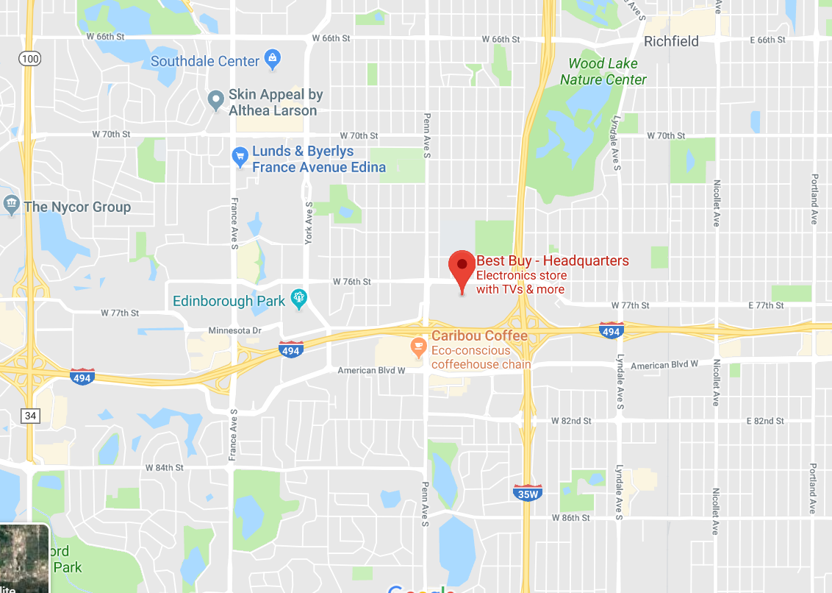

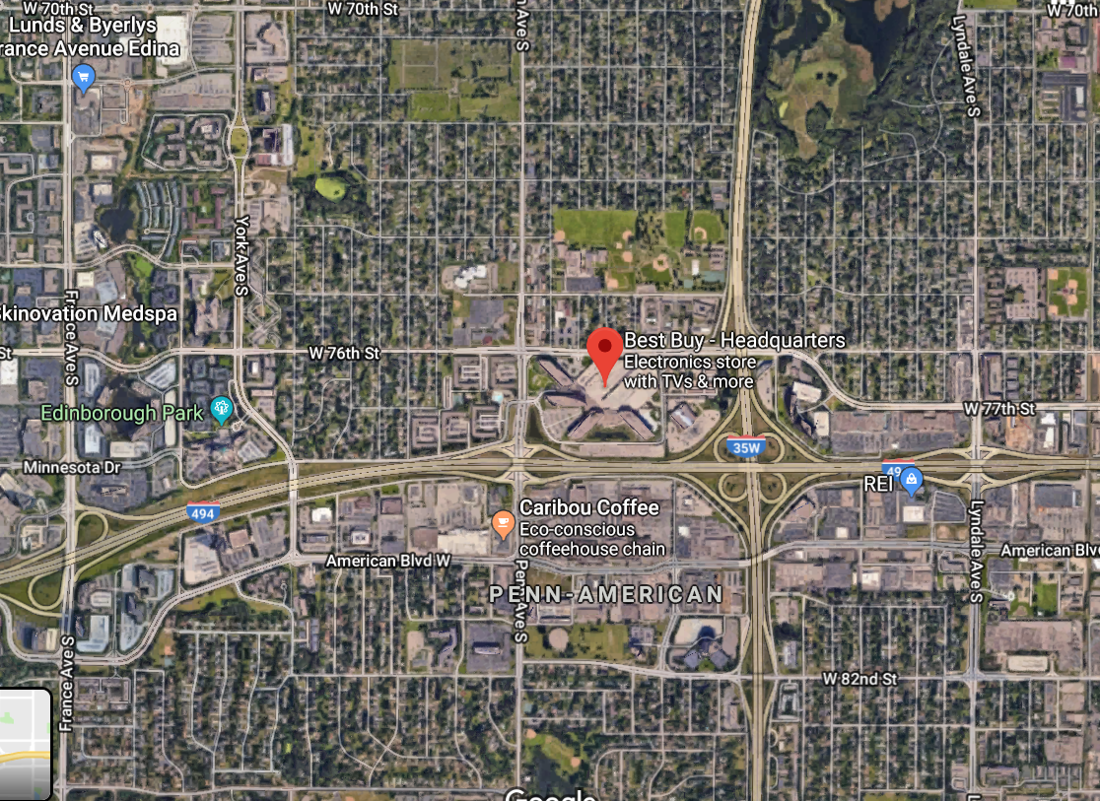

A)

I was looking for annual report of best buy and it was available on its site for free download. There store numbers are available on google. Also, I found CEO’s phone number and email address online on google. Then I was interested in their employer emails. I tried to find it online, but I couldn’t find it easily. When I started looking for common keyword in all best buy employer email, I found one thing. All the emails are [firstname.lastname@bestbuy.com](mailto:firstname.lastname@bestbuy.com), even the CEO email follows this format. I was looking for how best buy creates their employee’s credentials. I couldn’t find it easily online, but I noticed that their employee portal has no privacy. Basically, it means employer’s details is available for best buy use. Portal sites are not secure as it seems because I recently visited one of nearest best buy and when they login in computer I was able to see his credentials. Basically, their credentials are like first, middle, last initials and 3digit number. Example, if person name is john. D. Rivas then it’s jds and last three digits could be from their birthdate digit or ssn last 4 digit. Which is easy to pull out, once you know the name of employee you can easily look for his Facebook profile and figure out 3 digits and using combination of figured digits you can try to get access. Best buy site also provides about how many stores they have and where it’s located.

B)

If hacker wants to hack and get customers information, he can use Best Buy annual reports, which states , “During fiscal 2019, we expanded to more than 500 advisors, and they made, collectively, more than 175,000 visits to customers’ homes, where they are able to address customer needs in a more human and effective fashion, unlocking latent, incremental demand.” The answer to the question how hacker can use this information is, he can physically go to a family as in a best buy specialist, or he can do research about when and where best buy specialist went to a customer house for advice. Once he gets this information, he can send that customer an email or mail saying that in order provide your feedback or to get special service create an account on this site. Once the customer creates account on hacker site, he can easily crack in customers best buy account. By running multiple hack like this, he can order stuffs using customer account and multiple false order inquiry will hurt best buy business. He can use employee email and once he figures out the credentials. Since best buy has access to employee portal and private information, hacker can run reverse check to figure best buy important information.

1. Medium Tech –

When I tried to use my name to look for myself, I got around 130,000,000 results but after using different technics when I finally enter my username I found very few results.

1. How many hits did you get?

* Result 1to 10 of about 39,400,000 (0.56) for “jay shah” – google.com
* Result 1 to 10 of about 56 for “jay shah” – dogpile.com

1. How many of the results were a surprise to you?

🡪 Three of the results surprised me. Because it was showing me my email address details and details about my 2 friends. It also found my pic.

1. How many of them were about someone other than you?

* Three of them wasn’t about me.

1. High tech: Organization - Best buy
2. Hubert Joly is the executive chairman of the best buy. Corie Sue Barry is the chief executive officer and director.
3. In order to get information about company and employees most of the information was available on Wall Street Journal and other were available at best buy site or at forumsbby site. Like email, phone number, fax number, external ink, partners information was available at wall street journal and dns and whois information, I obtained from dnsstuff.com and mxtoolbox.com.
4. First information I gathered using whois and another tool,

physical address: 7601 Penn Avenue South, B6 - Legal Dept, Richfield, MN, 55423.

Phone number - +1.6122911000.

Name servers - asia3.akam.net  
eur1.akam.net  
eur2.akam.net  
ns1-118.akam.net  
ns1-119.akam.net  
usc2.akam.net  
use1.akam.net  
usw2.akam.net

IP address – 104.117.65.199

2.16.66.252

104.70.185.18

23.55.213.104

HTML comments - <https://forums.bestbuy.com/t5/BestBuy-com/Online-chat-with-expert/td-p/1047494>

On this webpage they are providing link where customers can chat, and sites doesn’t seem to be secured. if hacker wants to steal customers info, he can make a similar pagelike this and his personal link.

1. My conclusion to this research is, best buy is a retailer and it has value in market. If a hacker can steal information using their site, it’s very bad for company and customers. If hacker can get access to one of best buy main server and plants his virus there, whenever best buy employee connects a computer to their network for installation purpose this virus can spread out to all those computers. If we see in bigger picture, Best Buy is one of the popular tech retailer and security in tech related companies are necessary.
2. The information I have gathered is very valuable for a hacker. Like name servers, hacker can spy on name servers and, he can get access to customers information. Customer keeps their credit card information in their account, once hacker has their email, he can get an access to their account and can steal that information. If he gets access to one of the employee portal account, it becomes easy for him to hack in and get company’s private information. He can also plant a virus to their network system and as soon as other computers connects to the network it can spread out in computers.

DNS lookup

Domain name – Bestbuy.com

IP address - 104.117.65.199

MX Lookup

|  |  |  |
| --- | --- | --- |
| Host name | Ip address | TTL |
| Mxa-002a6b01.gslb.pphosted.com | 67.231.144.196 | 5 min |
| Mxa-002a6b01.gslb.pphosted.com | 67.231.153.219 | 5 min |

Blacklist:

Which resolves to 2.23.135.40 against 103 known blacklists

Listed 0 times with 0 timeouts

|  |  |  |
| --- | --- | --- |
| Type | Value | Prefix Desc |
| Version | Spf1 |  |
| Ip4 | 198.22.123.0/24 | Pass |
| Ip4 | 168.94.230.0/24 | Pass |
| Include | _spf.q4press.com | pass |

Whois:

|  |  |
| --- | --- |
| Name | Value |
| Registrar | MarkMonitor Inc. |
| Name server | ASIA3.AKAM.NET |
| Name server | EUR1.AKAM.NET |
| Name server | EUR2.AKAM.NET |
| Name server | NS1-118.AKAM.NET |
| Name server | NS1-119.AKAM.NET |
| Name server | USC2.AKAM.NET |
| Name server | USE1.AKAM.NET |
| Name server | USW2.AKAM.NET |
| Domain Name | BESTBUY.COM |
| Registry Domain ID | 2646566_DOMAIN_COM-VRSN |
| Registrar WHOIS Server | whois.markmonitor.com |
| Registrar URL | http://www.markmonitor.com |