614 Project

JAY SHAH

December 6, 2017

library(readxl)  
Project_data <- read_excel("Project_data.xlsx",   
 col_names = FALSE)  
#View(Project_data)  
#PCA  
pca=prcomp(Project_data,scale = T)  
pca$sdev

## [1] 1.2706247 1.1241929 1.1163074 1.0911532 1.0809568 1.0676043 1.0581909  
## [8] 1.0496262 1.0250884 1.0098225 1.0043088 1.0004415 0.9959623 0.9859729  
## [15] 0.9721307 0.9629673 0.9529222 0.9398268 0.9289453 0.9262012 0.9147261  
## [22] 0.8854170 0.8790350 0.8690745 0.7602094

biplot(pca, scale=0)

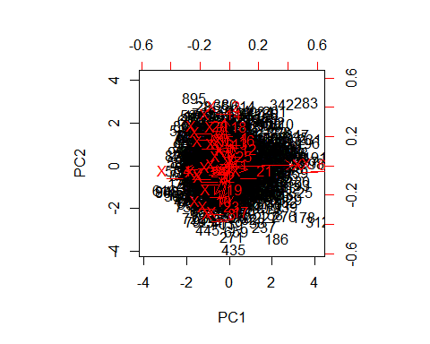

pr.var=pca$sdev^2  
pr.var

## [1] 1.6144871 1.2638097 1.2461421 1.1906154 1.1684676 1.1397789 1.1197679  
## [8] 1.1017152 1.0508063 1.0197415 1.0086361 1.0008831 0.9919409 0.9721425  
## [15] 0.9450380 0.9273059 0.9080608 0.8832745 0.8629393 0.8578487 0.8367238  
## [22] 0.7839633 0.7727026 0.7552906 0.5779184

pve=pr.var/sum(pr.var)  
pve

## [1] 0.06457948 0.05055239 0.04984568 0.04762461 0.04673870 0.04559116  
## [7] 0.04479072 0.04406861 0.04203225 0.04078966 0.04034544 0.04003532  
## [13] 0.03967763 0.03888570 0.03780152 0.03709224 0.03632243 0.03533098  
## [19] 0.03451757 0.03431395 0.03346895 0.03135853 0.03090810 0.03021162  
## [25] 0.02311673

plot(pca$sdev, xlab="Principal Component", ylab="Proportion of Variance Explained", ylim=c(0,2),type='b')

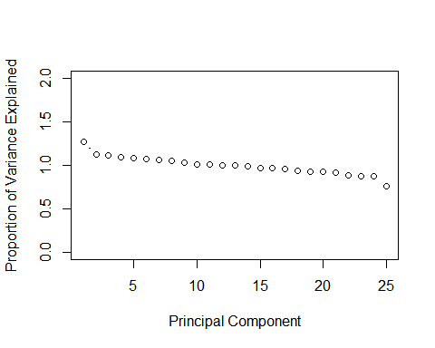

plot(cumsum(pve), xlab="Principal Component", ylab="Cumulative Proportion of Variance Explained", ylim=c(0,1),type='b')

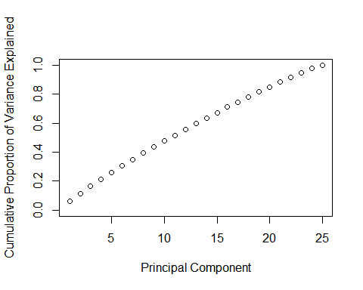

#T2 Chart  
library(qcc)

## Package 'qcc' version 2.7

## Type 'citation("qcc")' for citing this R package in publications.

indices=c(1:1000)  
  
data=cbind(indices,Project_data)  
  
lim=limits.T2(ngroups=1000,size=1,nvars=25,conf=0.9973)

## Warning in qf(conf, p, m * n - m - p + 1): NaNs produced  
  
## Warning in qf(conf, p, m * n - m - p + 1): NaNs produced

CHART=mqcc(data[,-1], type = c("T2"),  
 pred.limits = FALSE,confidence.level = .9973,  
 limits=TRUE, rules = shewhart.rules,  
 plot = TRUE)

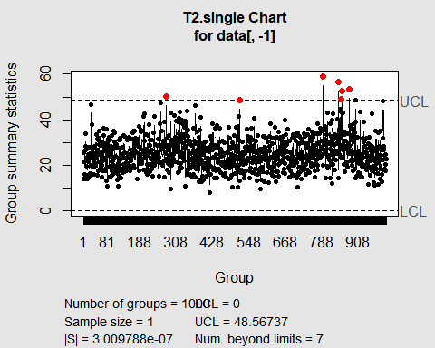

violation=CHART$violations$beyond.limits  
new=data[-violation,]  
CHART1=mqcc(new[,-1], type = c("T2"), center=NULL, cov=NULL,  
 limits = TRUE, pred.limits = FALSE,  
 confidence.level = .9973, rules = shewhart.rules,  
 plot = TRUE)

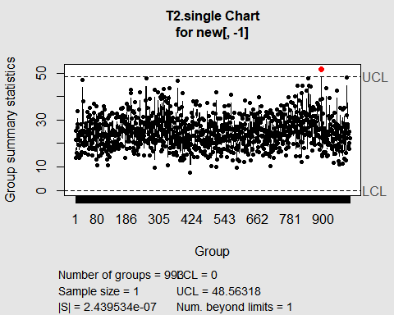

violation1=CHART1$violations$beyond.limits  
new1=new[-violation1,]  
CHART2=mqcc(new1[,-1], type = c("T2"), center=NULL, cov=NULL,  
 limits = TRUE, pred.limits = FALSE,  
 confidence.level = .9973, rules = shewhart.rules,  
 plot = TRUE)

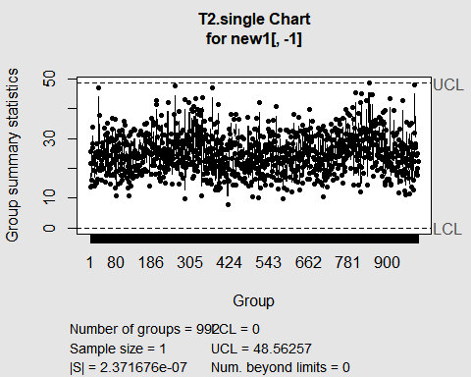

CHART2$center

## X__1 X__2 X__3 X__4 X__5   
## -0.006295196 0.018433697 -0.041747459 -0.096047712 -0.039822558   
## X__6 X__7 X__8 X__9 X__10   
## 0.202684805 0.394032719 0.009722109 -0.018130408 0.012051320   
## X__11 X__12 X__13 X__14 X__15   
## -0.043382042 -0.015808032 -0.011056646 0.013070983 0.023711541   
## X__16 X__17 X__18 X__19 X__20   
## -0.018168694 -0.008417846 -0.013173940 0.025662505 0.007566129   
## X__21 X__22 X__23 X__24 X__25   
## -0.398066317 0.066318856 0.002529854 -0.016192226 -0.008873372

#Mcusum CHart  
library(MSQC)  
cus=mult.chart(type = "mcusum", x=new1[,-1], alpha = 0.0027, k = 2, h = 19.97, phase = 1, method = "sw")

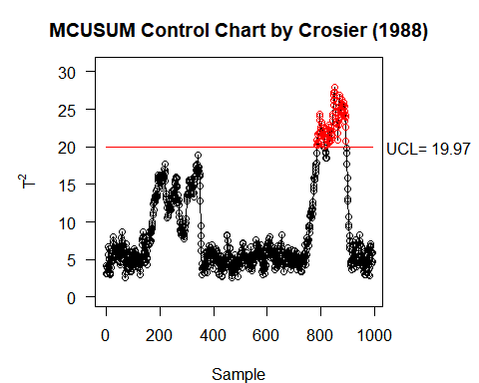

summary(cus)

## Length Class Mode   
## 1 -none- character  
## ucl 1 -none- numeric   
## t2 992 -none- numeric   
## Xmv 25 -none- numeric   
## covariance 625 -none- numeric

#cus$t2  
  
itr_points1=c(785:815,821:894)  
  
new2=new1[-itr_points1,]  
  
cus2=mult.chart(type = "mcusum", x=new2[,-1], alpha = 0.0027, k = 2, h = 19.97, phase = 1, method = "sw")

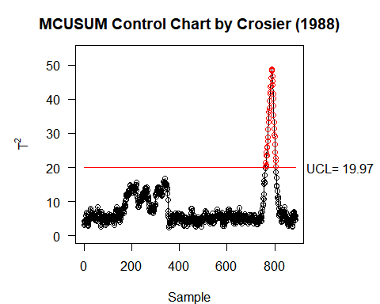

#cus2$t2  
  
itr_points2=c(761:805)  
new3=new2[-itr_points2,]  
  
cus3=mult.chart(type = "mcusum", x=new3[,-1], alpha = 0.0027, k = 2, h = 19.97, phase = 1, method = "sw")

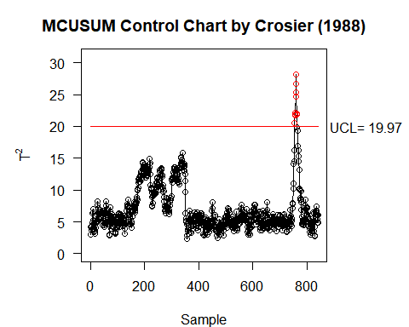

#cus3$t2  
  
  
itr_points3=c(755:764)  
new4=new3[-itr_points3,]  
  
cus4=mult.chart(type = "mcusum", x=new4[,-1], alpha = 0.0027, k = 2, h = 19.97, phase = 1, method = "sw")

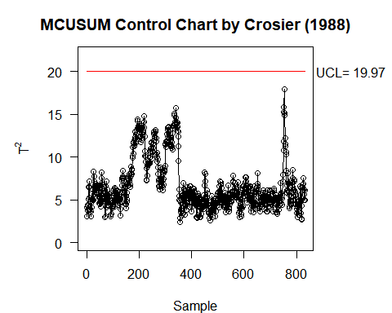

#cus4$t2  
  
  
  
  
#checking in t2 chart  
  
Chart3=mqcc(new4[,-1], type = c("T2"), center=NULL, cov=NULL,  
 limits = TRUE, pred.limits = FALSE,  
 confidence.level = .9973, rules = shewhart.rules,  
 plot = TRUE)

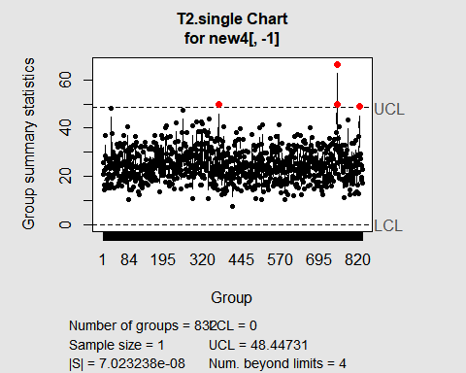

violation2=Chart3$violations$beyond.limits  
new5=new4[-violation2,]  
  
Chart4=mqcc(new5[,-1], type = c("T2"), center=NULL, cov=NULL,  
 limits = TRUE, pred.limits = FALSE,  
 confidence.level = .9973, rules = shewhart.rules,  
 plot = TRUE)

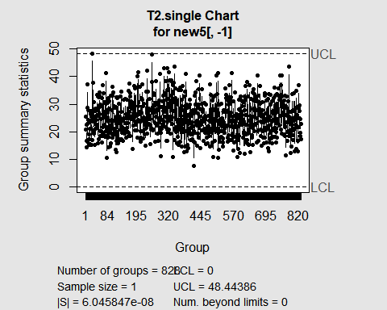

#checking in cusum chart  
cus5=mult.chart(type = "mcusum", x=new5[,-1], alpha = 0.0027, k = 2, h = 19.97, phase = 1, method = "sw")

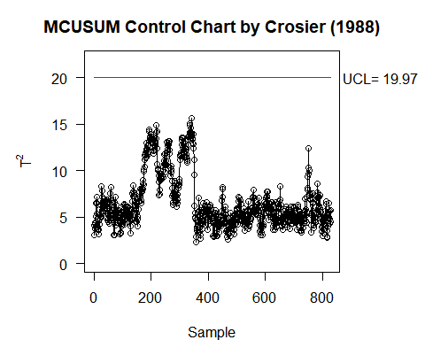

#cus5$t2  
  
  
  
#write.csv(new5[,-1],"new5.csv")  
  
  
  
  
  
  
  
#checking individual xbar chart  
  
x1=qcc(data=new5[,2],type='xbar.one',sizes = 1,std.dev = "MR")

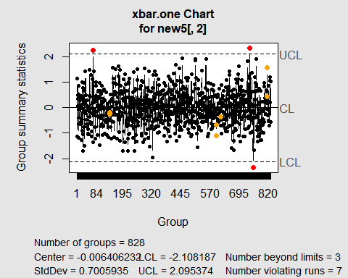

xbar_violation1=x1$violations$beyond.limits  
  
  
x2=qcc(data=new5[,3],type='xbar.one',sizes = 1,std.dev = "MR")

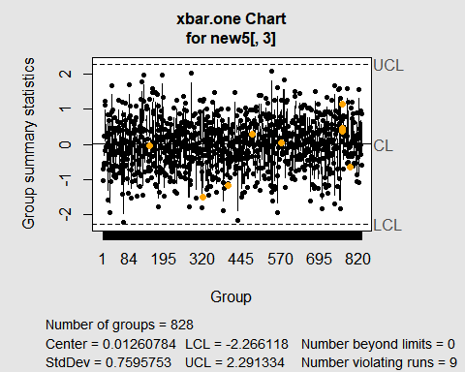

xbar_violation2=x2$violations$beyond.limits  
  
x3=qcc(data=new5[,4],type='xbar.one',sizes = 1,std.dev = "MR")

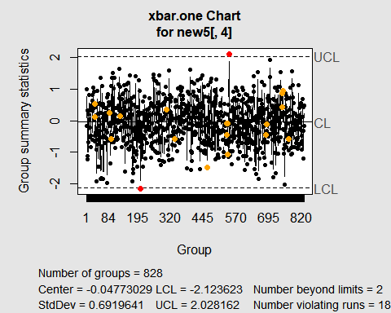

xbar_violation3=x3$violations$beyond.limits  
  
  
x4=qcc(data=new5[,5],type='xbar.one',sizes = 1,std.dev = "MR")

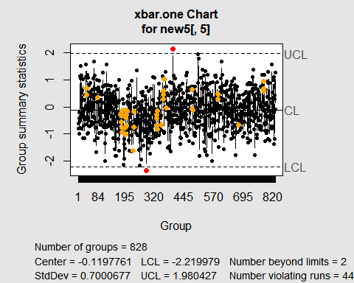

xbar_violation4=x4$violations$beyond.limits  
  
  
x5=qcc(data=new5[,6],type='xbar.one',sizes = 1,std.dev = "MR")

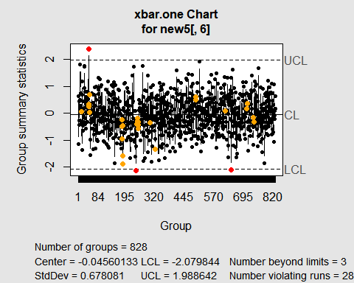

xbar_violation5=x5$violations$beyond.limits  
  
  
x6=qcc(data=new5[,7],type='xbar.one',sizes = 1,std.dev = "MR")

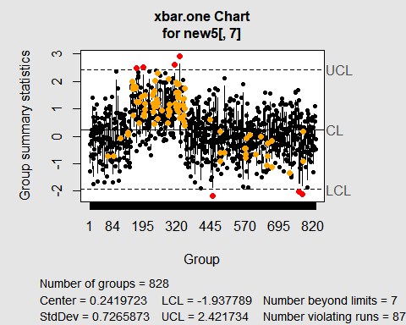

xbar_violation6=x6$violations$beyond.limits  
  
  
x7=qcc(data=new5[,8],type='xbar.one',sizes = 1,std.dev = "MR")

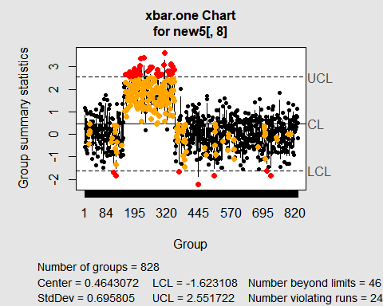

xbar_violation7=x7$violations$beyond.limits  
  
x8=qcc(data=new5[,9],type='xbar.one',sizes = 1,std.dev = "MR")

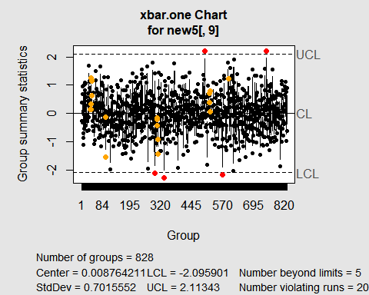

xbar_violation8=x8$violations$beyond.limits  
  
x9=qcc(data=new5[,10],type='xbar.one',sizes = 1,std.dev = "MR")

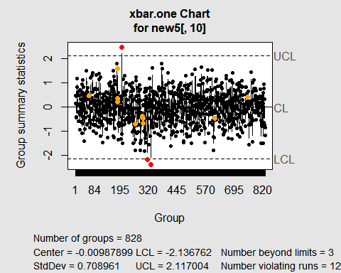

xbar_violation9=x9$violations$beyond.limits  
  
x10=qcc(data=new5[,11],type='xbar.one',sizes = 1,std.dev = "MR")

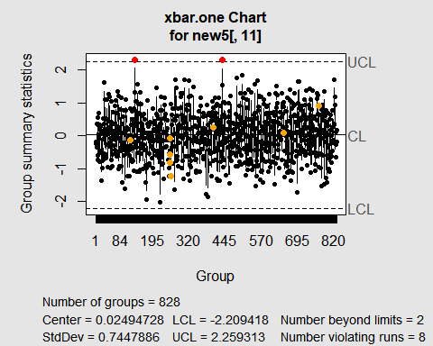

xbar_violation10=x10$violations$beyond.limits  
  
x11=qcc(data=new5[,12],type='xbar.one',sizes = 1,std.dev = "MR")

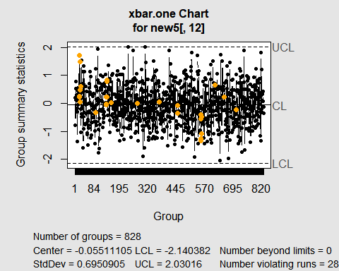

xbar_violation11=x11$violations$beyond.limits  
  
x12=qcc(data=new5[,13],type='xbar.one',sizes = 1,std.dev = "MR")

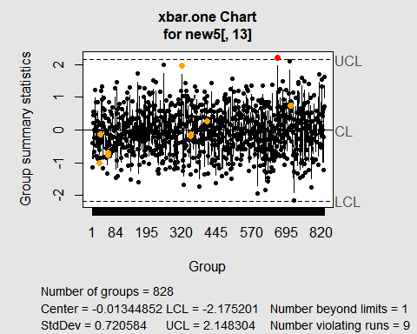

xbar_violation12=x12$violations$beyond.limits  
  
x13=qcc(data=new5[,14],type='xbar.one',sizes = 1,std.dev = "MR")

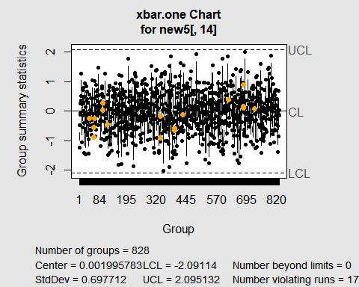

xbar_violation13=x13$violations$beyond.limits  
  
x14=qcc(data=new5[,15],type='xbar.one',sizes = 1,std.dev = "MR")

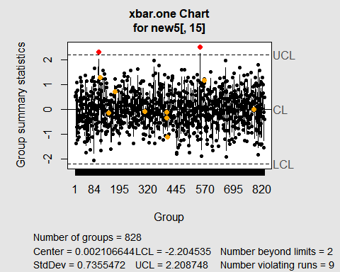

xbar_violation14=x14$violations$beyond.limits  
  
x15=qcc(data=new5[,16],type='xbar.one',sizes = 1,std.dev = "MR")

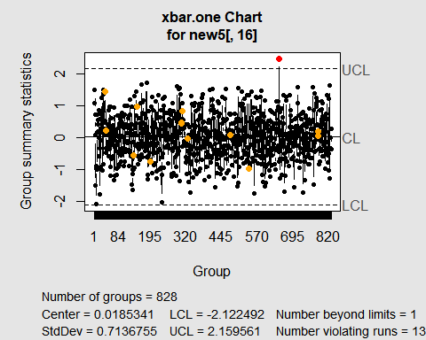

xbar_violation15=x15$violations$beyond.limits  
  
x16=qcc(data=new5[,17],type='xbar.one',sizes = 1,std.dev = "MR")

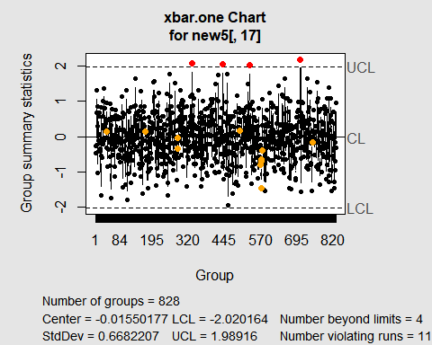

xbar_violation16=x16$violations$beyond.limits  
  
x17=qcc(data=new5[,18],type='xbar.one',sizes = 1,std.dev = "MR")

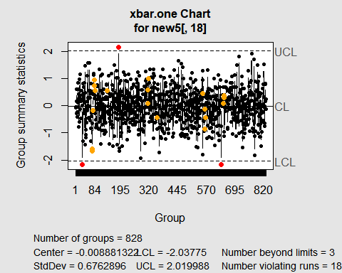

xbar_violation17=x17$violations$beyond.limits  
  
x18=qcc(data=new5[,19],type='xbar.one',sizes = 1,std.dev = "MR")

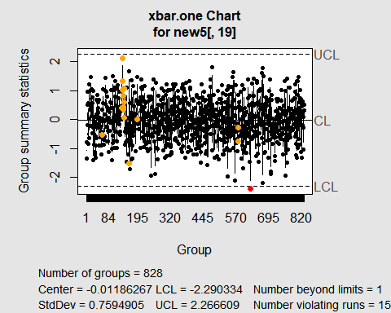

xbar_violation18=x18$violations$beyond.limits  
  
x19=qcc(data=new5[,20],type='xbar.one',sizes = 1,std.dev = "MR")

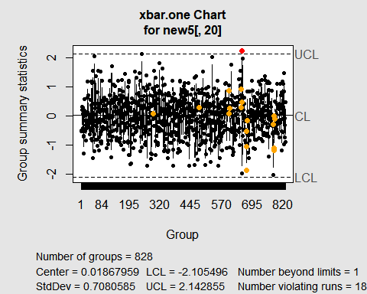

xbar_violation19=x19$violations$beyond.limits  
  
x20=qcc(data=new5[,21],type='xbar.one',sizes = 1,std.dev = "MR")

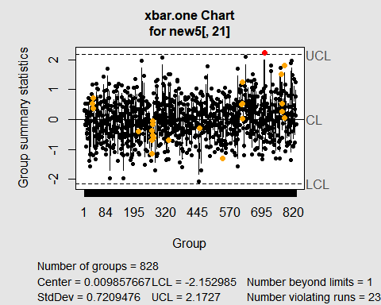

xbar_violation20=x20$violations$beyond.limits  
  
x21=qcc(data=new5[,22],type='xbar.one',sizes = 1,std.dev = "MR")

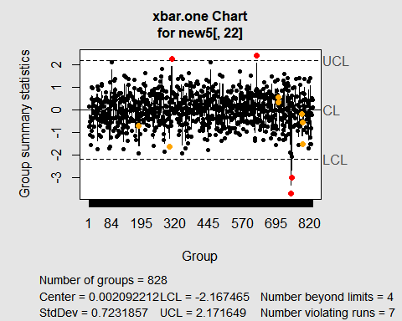

xbar_violation21=x21$violations$beyond.limits  
  
x22=qcc(data=new5[,23],type='xbar.one',sizes = 1,std.dev = "MR")

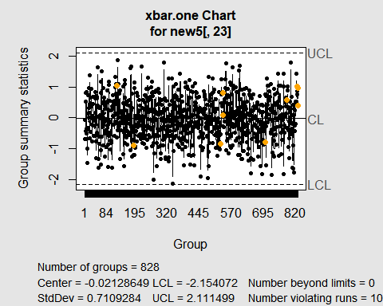

xbar_violation22=x22$violations$beyond.limits  
  
x23=qcc(data=new5[,24],type='xbar.one',sizes = 1,std.dev = "MR")

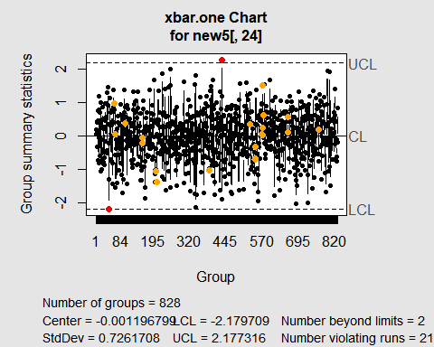

xbar_violation23=x23$violations$beyond.limits  
  
x24=qcc(data=new5[,25],type='xbar.one',sizes = 1,std.dev = "MR")

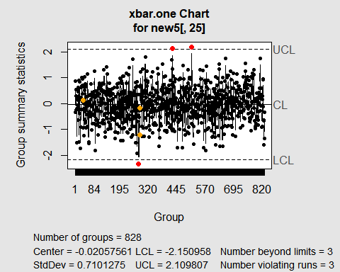

xbar_violation24=x24$violations$beyond.limits  
  
x25=qcc(data=new5[,26],type='xbar.one',sizes = 1,std.dev = "MR")

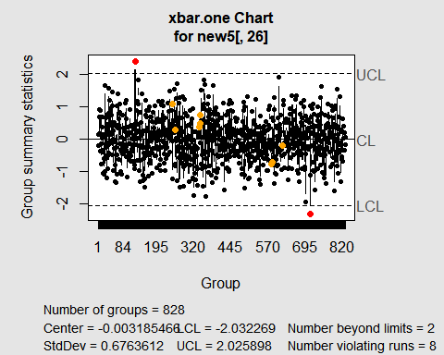

xbar_violation25=x25$violations$beyond.limits  
  
  
  
#ooc  
xbarv=c(68, 739, 753,  
 542, 206,  
 397, 287,  
 43, 242, 642,  
 170, 196, 311, 328, 451, 768, 779,   
 160, 167, 170, 174, 175, 179, 183, 188, 191, 193 ,200, 203, 208, 210, 214, 216, 219, 231, 246, 251, 256, 260, 281, 282 ,285,  
 287, 295, 297, 307, 311, 324, 329, 330, 332, 334, 335, 339, 341, 347, 112, 122, 367, 440 ,502, 707, 724,  
 497, 746, 294, 333, 567,  
 202, 315, 328,   
 134, 434,  
 660,  
 102 ,545,  
 646,  
 331, 439, 530, 706,  
 186, 28, 633,  
 623,  
 652,  
 703,  
 306, 622, 748, 751,  
 433, 44,  
 426, 510, 278,  
 123, 711)  
  
  
  
  
new6=new5[-xbarv,]  
  
  
  
  
  
  
  
  
x1=qcc(data=new6[,2],type='xbar.one',sizes = 1,std.dev = "MR")

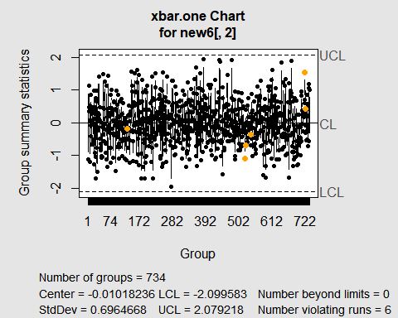

xbar_violation1=x1$violations$beyond.limits  
  
  
x2=qcc(data=new6[,3],type='xbar.one',sizes = 1,std.dev = "MR")

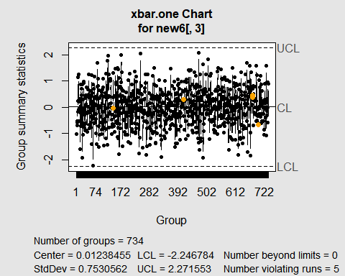

xbar_violation2=x2$violations$beyond.limits  
  
x3=qcc(data=new6[,4],type='xbar.one',sizes = 1,std.dev = "MR")

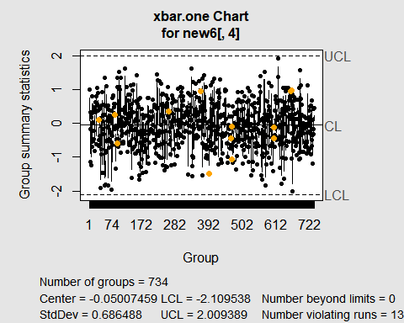

xbar_violation3=x3$violations$beyond.limits  
  
  
x4=qcc(data=new6[,5],type='xbar.one',sizes = 1,std.dev = "MR")

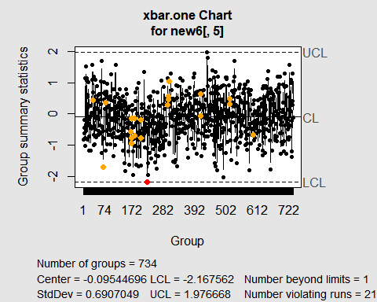

xbar_violation4=x4$violations$beyond.limits  
  
  
x5=qcc(data=new6[,6],type='xbar.one',sizes = 1,std.dev = "MR")

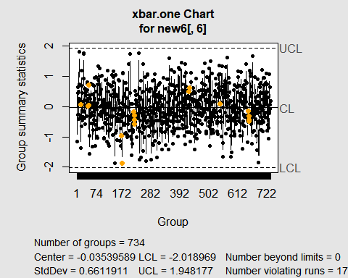

xbar_violation5=x5$violations$beyond.limits  
  
  
x6=qcc(data=new6[,7],type='xbar.one',sizes = 1,std.dev = "MR")

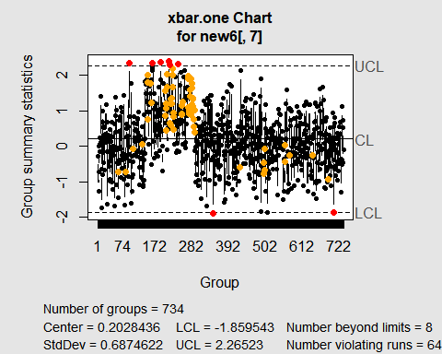

xbar_violation6=x6$violations$beyond.limits  
  
  
x7=qcc(data=new6[,8],type='xbar.one',sizes = 1,std.dev = "MR")

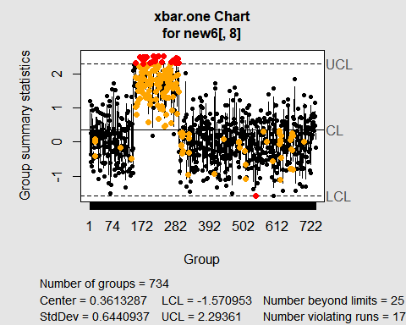

xbar_violation7=x7$violations$beyond.limits  
  
x8=qcc(data=new6[,9],type='xbar.one',sizes = 1,std.dev = "MR")

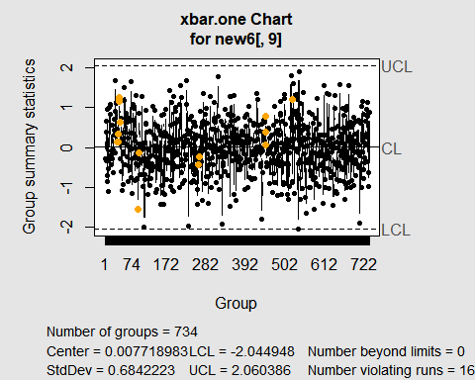

xbar_violation8=x8$violations$beyond.limits  
  
x9=qcc(data=new6[,10],type='xbar.one',sizes = 1,std.dev = "MR")

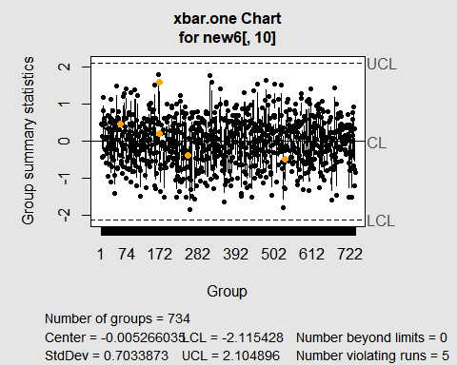

xbar_violation9=x9$violations$beyond.limits  
  
x10=qcc(data=new6[,11],type='xbar.one',sizes = 1,std.dev = "MR")

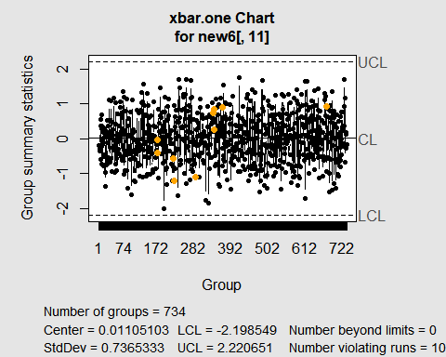

xbar_violation10=x10$violations$beyond.limits  
  
x11=qcc(data=new6[,12],type='xbar.one',sizes = 1,std.dev = "MR")

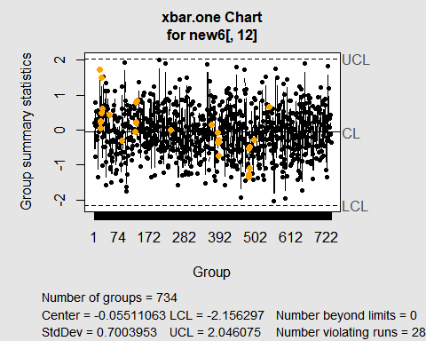

xbar_violation11=x11$violations$beyond.limits  
  
x12=qcc(data=new6[,13],type='xbar.one',sizes = 1,std.dev = "MR")

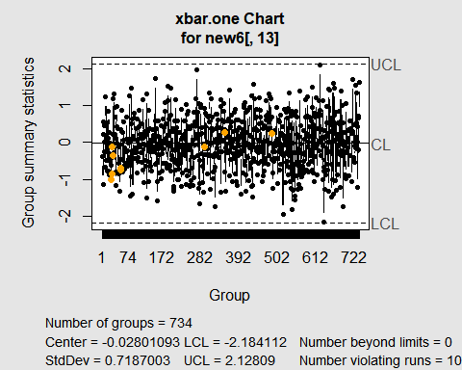

xbar_violation12=x12$violations$beyond.limits  
  
x13=qcc(data=new6[,14],type='xbar.one',sizes = 1,std.dev = "MR")

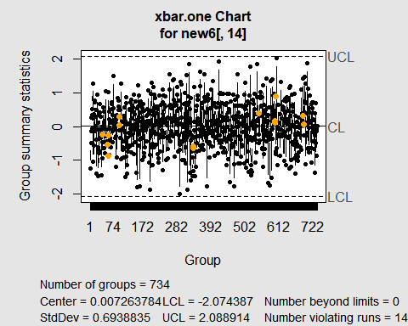

xbar_violation13=x13$violations$beyond.limits  
  
x14=qcc(data=new6[,15],type='xbar.one',sizes = 1,std.dev = "MR")

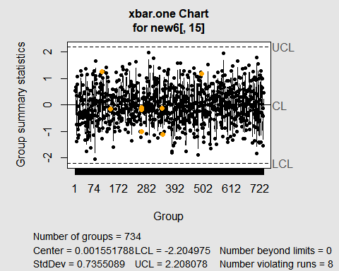

xbar_violation14=x14$violations$beyond.limits  
  
x15=qcc(data=new6[,16],type='xbar.one',sizes = 1,std.dev = "MR")

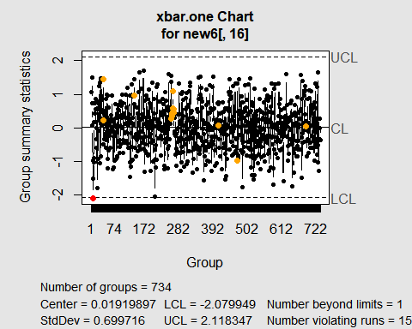

xbar_violation15=x15$violations$beyond.limits  
  
x16=qcc(data=new6[,17],type='xbar.one',sizes = 1,std.dev = "MR")

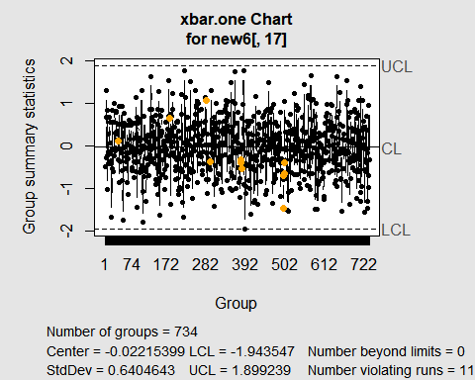

xbar_violation16=x16$violations$beyond.limits  
  
x17=qcc(data=new6[,18],type='xbar.one',sizes = 1,std.dev = "MR")

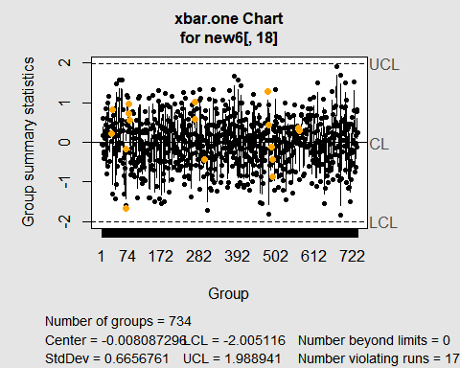

xbar_violation17=x17$violations$beyond.limits  
  
x18=qcc(data=new6[,19],type='xbar.one',sizes = 1,std.dev = "MR")

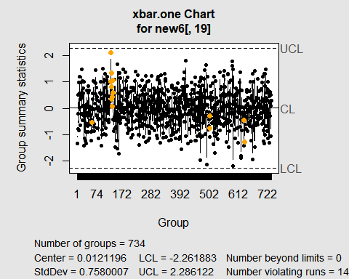

xbar_violation18=x18$violations$beyond.limits  
  
x19=qcc(data=new6[,20],type='xbar.one',sizes = 1,std.dev = "MR")

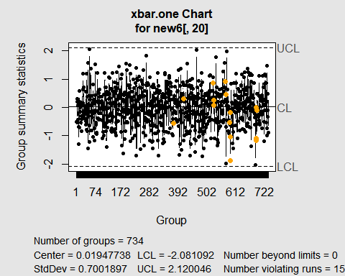

xbar_violation19=x19$violations$beyond.limits  
  
x20=qcc(data=new6[,21],type='xbar.one',sizes = 1,std.dev = "MR")

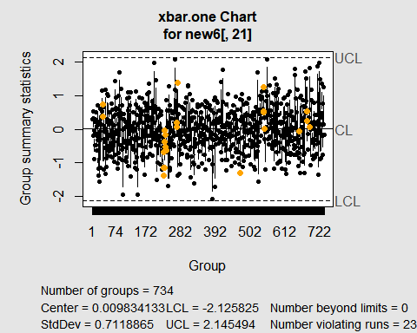

xbar_violation20=x20$violations$beyond.limits  
  
x21=qcc(data=new6[,22],type='xbar.one',sizes = 1,std.dev = "MR")

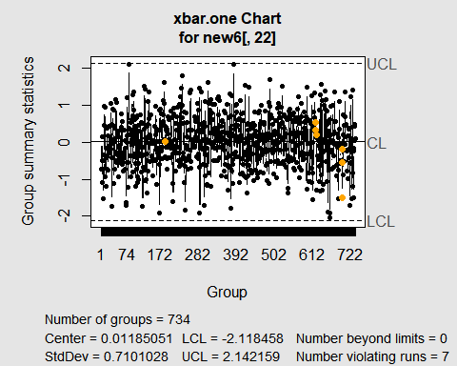

xbar_violation21=x21$violations$beyond.limits  
  
x22=qcc(data=new6[,23],type='xbar.one',sizes = 1,std.dev = "MR")

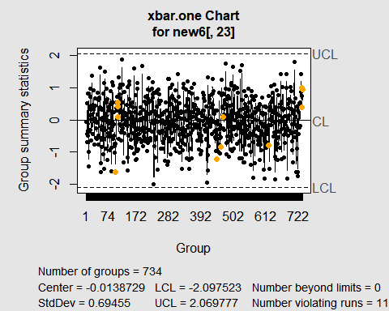

xbar_violation22=x22$violations$beyond.limits  
  
x23=qcc(data=new6[,24],type='xbar.one',sizes = 1,std.dev = "MR")

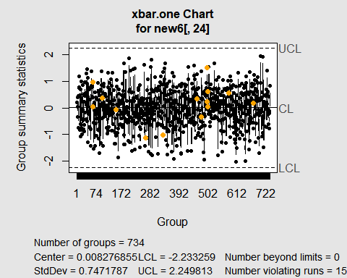

xbar_violation23=x23$violations$beyond.limits  
  
x24=qcc(data=new6[,25],type='xbar.one',sizes = 1,std.dev = "MR")

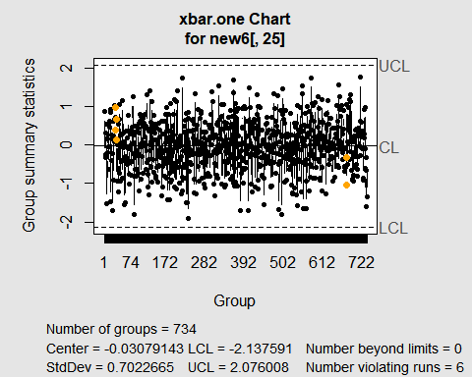

xbar_violation24=x24$violations$beyond.limits  
  
x25=qcc(data=new6[,26],type='xbar.one',sizes = 1,std.dev = "MR")

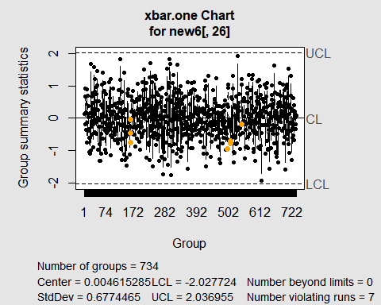

xbar_violation25=x25$violations$beyond.limits  
  
  
  
  
xbarv2=c( 223,  
 93, 164, 188, 211, 215, 239, 345, 703,  
 149, 164, 169, 171, 173, 174, 179, 181, 184, 196, 202, 208, 211, 217, 223, 233, 239, 265, 271, 279, 281, 284, 287, 289, 538,  
 7)  
  
new7=new6[-xbarv2,]  
  
  
x1=qcc(data=new7[,2],type='xbar.one',sizes = 1,std.dev = "MR")

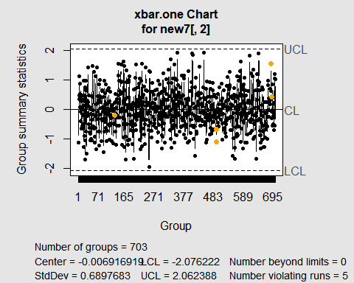

xbar_violation1=x1$violations$beyond.limits  
  
  
x2=qcc(data=new7[,3],type='xbar.one',sizes = 1,std.dev = "MR")

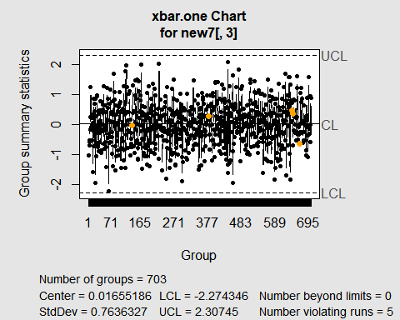

xbar_violation2=x2$violations$beyond.limits  
  
x3=qcc(data=new7[,4],type='xbar.one',sizes = 1,std.dev = "MR")

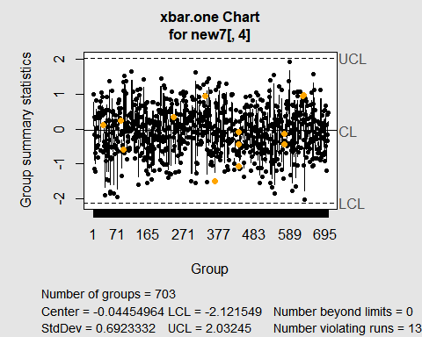

xbar_violation3=x3$violations$beyond.limits  
  
  
x4=qcc(data=new7[,5],type='xbar.one',sizes = 1,std.dev = "MR")

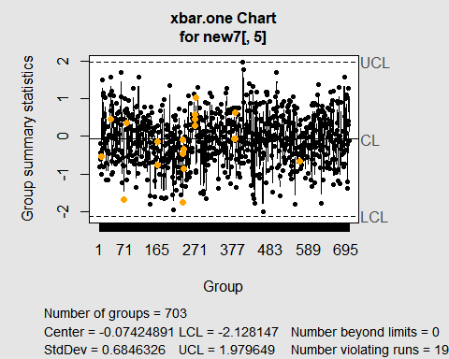

xbar_violation4=x4$violations$beyond.limits  
  
  
x5=qcc(data=new7[,6],type='xbar.one',sizes = 1,std.dev = "MR")

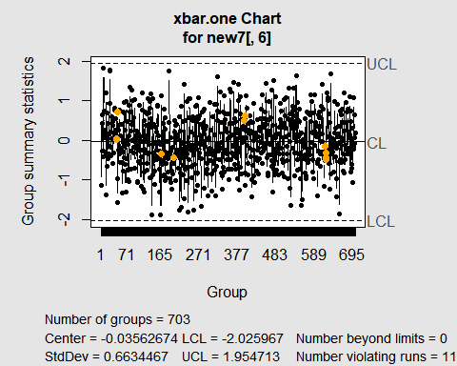

xbar_violation5=x5$violations$beyond.limits  
  
  
x6=qcc(data=new7[,7],type='xbar.one',sizes = 1,std.dev = "MR")

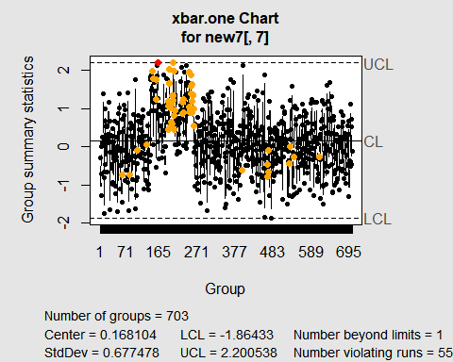

xbar_violation6=x6$violations$beyond.limits  
  
  
x7=qcc(data=new7[,8],type='xbar.one',sizes = 1,std.dev = "MR")

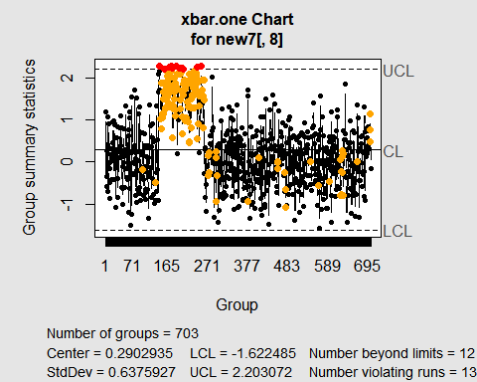

xbar_violation7=x7$violations$beyond.limits  
  
x8=qcc(data=new7[,9],type='xbar.one',sizes = 1,std.dev = "MR")

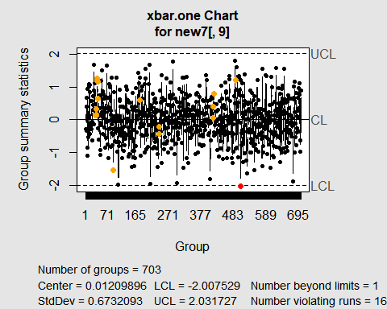

xbar_violation8=x8$violations$beyond.limits  
  
x9=qcc(data=new7[,10],type='xbar.one',sizes = 1,std.dev = "MR")

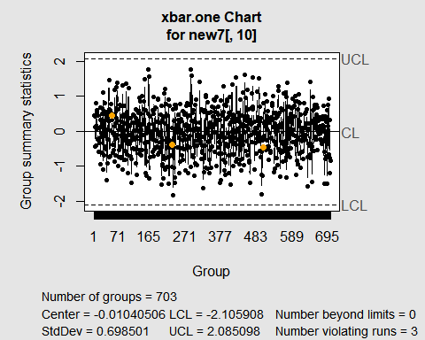

xbar_violation9=x9$violations$beyond.limits  
  
x10=qcc(data=new7[,11],type='xbar.one',sizes = 1,std.dev = "MR")

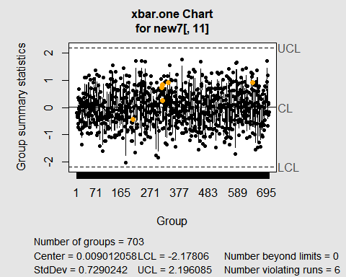

xbar_violation10=x10$violations$beyond.limits  
  
x11=qcc(data=new7[,12],type='xbar.one',sizes = 1,std.dev = "MR")

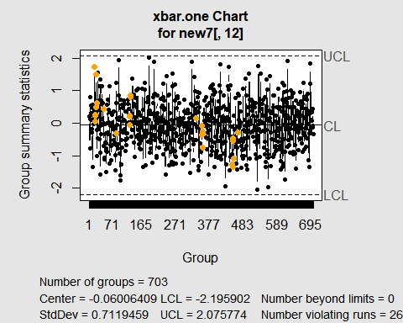

xbar_violation11=x11$violations$beyond.limits  
  
x12=qcc(data=new7[,13],type='xbar.one',sizes = 1,std.dev = "MR")

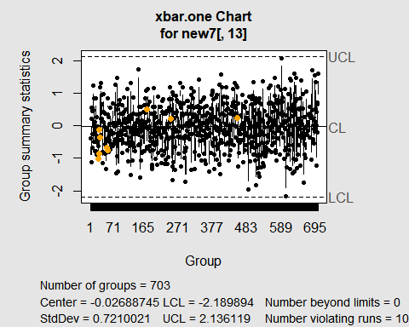

xbar_violation12=x12$violations$beyond.limits  
  
x13=qcc(data=new7[,14],type='xbar.one',sizes = 1,std.dev = "MR")

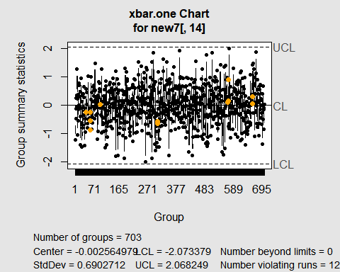

xbar_violation13=x13$violations$beyond.limits  
  
x14=qcc(data=new7[,15],type='xbar.one',sizes = 1,std.dev = "MR")

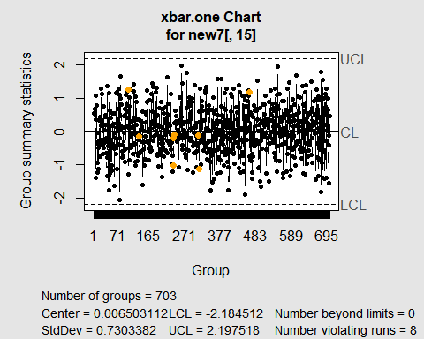

xbar_violation14=x14$violations$beyond.limits  
  
x15=qcc(data=new7[,16],type='xbar.one',sizes = 1,std.dev = "MR")

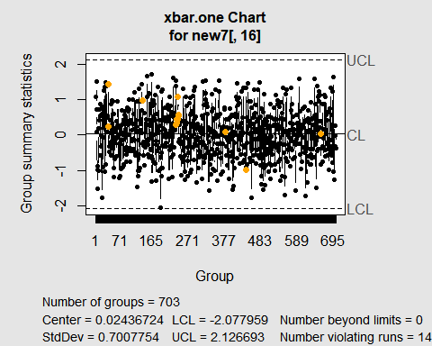

xbar_violation15=x15$violations$beyond.limits  
  
x16=qcc(data=new7[,17],type='xbar.one',sizes = 1,std.dev = "MR")

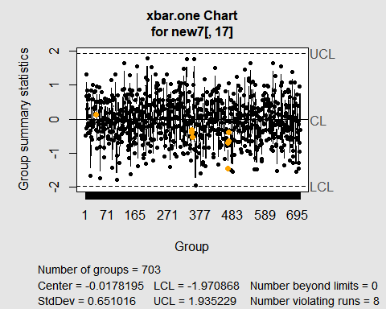

xbar_violation16=x16$violations$beyond.limits  
  
x17=qcc(data=new7[,18],type='xbar.one',sizes = 1,std.dev = "MR")

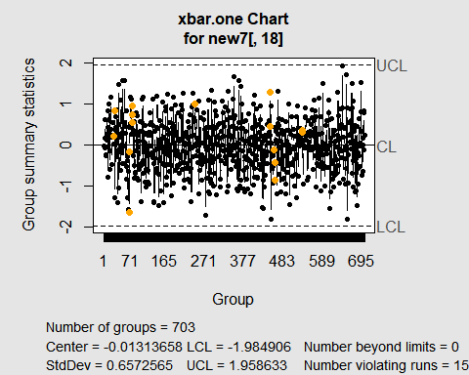

xbar_violation17=x17$violations$beyond.limits  
  
x18=qcc(data=new7[,19],type='xbar.one',sizes = 1,std.dev = "MR")

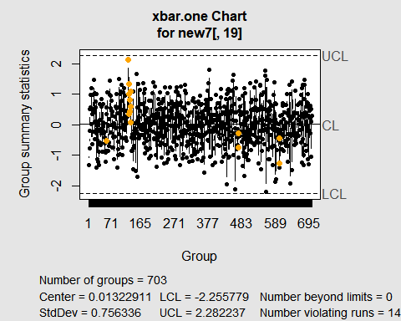

xbar_violation18=x18$violations$beyond.limits  
  
x19=qcc(data=new7[,20],type='xbar.one',sizes = 1,std.dev = "MR")

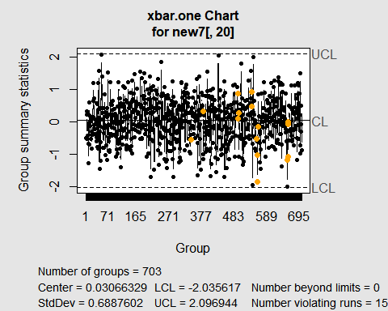

xbar_violation19=x19$violations$beyond.limits  
  
x20=qcc(data=new7[,21],type='xbar.one',sizes = 1,std.dev = "MR")

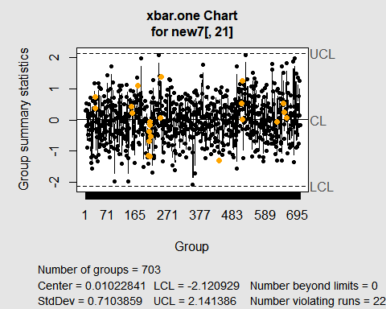

xbar_violation20=x20$violations$beyond.limits  
  
x21=qcc(data=new7[,22],type='xbar.one',sizes = 1,std.dev = "MR")

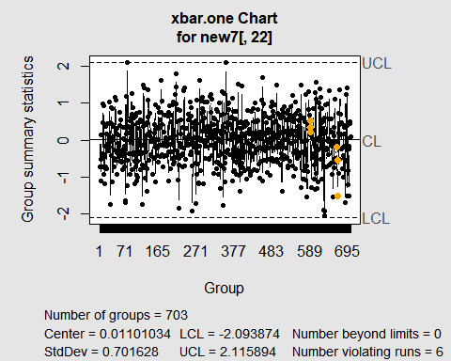

xbar_violation21=x21$violations$beyond.limits  
  
x22=qcc(data=new7[,23],type='xbar.one',sizes = 1,std.dev = "MR")

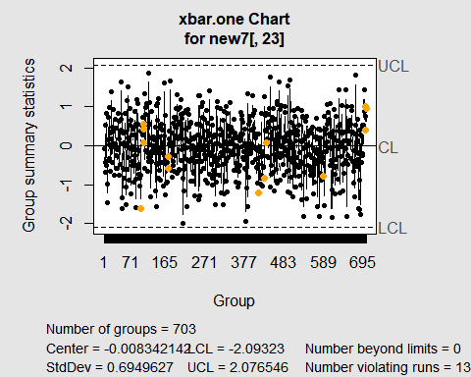

xbar_violation22=x22$violations$beyond.limits  
  
x23=qcc(data=new7[,24],type='xbar.one',sizes = 1,std.dev = "MR")

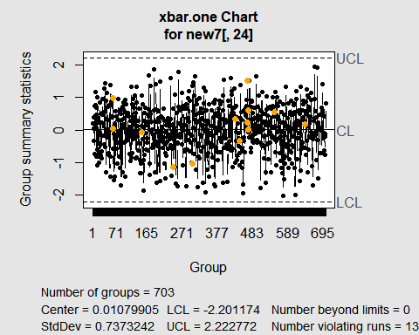

xbar_violation23=x23$violations$beyond.limits  
  
x24=qcc(data=new7[,25],type='xbar.one',sizes = 1,std.dev = "MR")

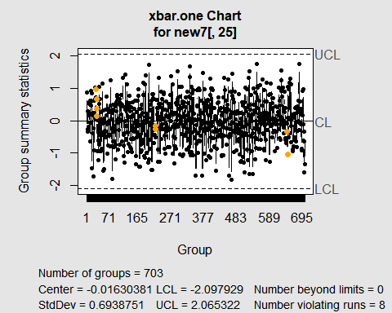

xbar_violation24=x24$violations$beyond.limits  
  
x25=qcc(data=new7[,26],type='xbar.one',sizes = 1,std.dev = "MR")

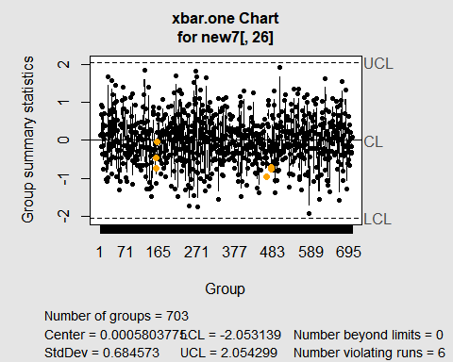

xbar_violation25=x25$violations$beyond.limits  
  
  
xbarv3=c( 142, 157, 168, 175, 177, 188, 195, 196, 202, 205, 242, 254,  
 7,   
 507,  
 160)  
  
new8=new7[-xbarv3,]  
  
  
  
x1=qcc(data=new8[,2],type='xbar.one',sizes = 1,std.dev = "MR")

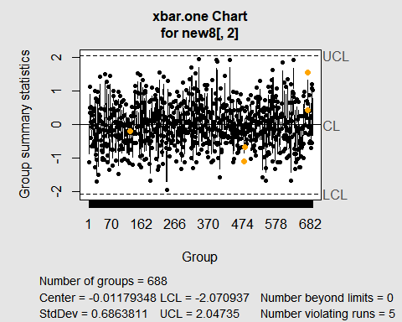

xbar_violation1=x1$violations$beyond.limits  
  
  
x2=qcc(data=new8[,3],type='xbar.one',sizes = 1,std.dev = "MR")

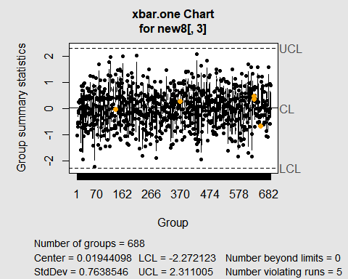

xbar_violation2=x2$violations$beyond.limits  
  
x3=qcc(data=new8[,4],type='xbar.one',sizes = 1,std.dev = "MR")

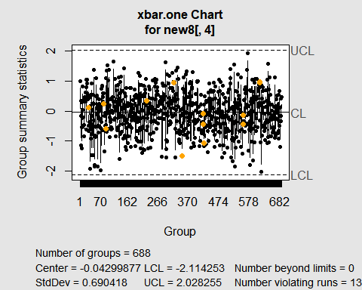

xbar_violation3=x3$violations$beyond.limits  
  
  
x4=qcc(data=new8[,5],type='xbar.one',sizes = 1,std.dev = "MR")

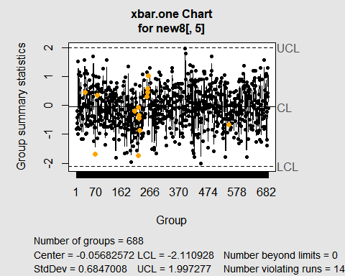

xbar_violation4=x4$violations$beyond.limits  
  
  
x5=qcc(data=new8[,6],type='xbar.one',sizes = 1,std.dev = "MR")

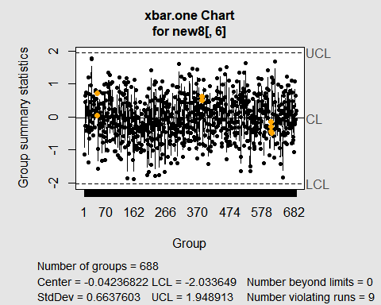

xbar_violation5=x5$violations$beyond.limits  
  
  
x6=qcc(data=new8[,7],type='xbar.one',sizes = 1,std.dev = "MR")

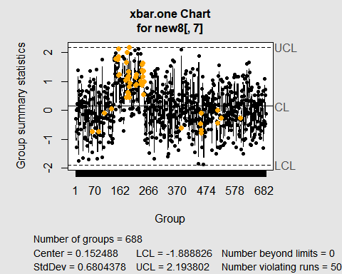

xbar_violation6=x6$violations$beyond.limits  
  
  
x7=qcc(data=new8[,8],type='xbar.one',sizes = 1,std.dev = "MR")

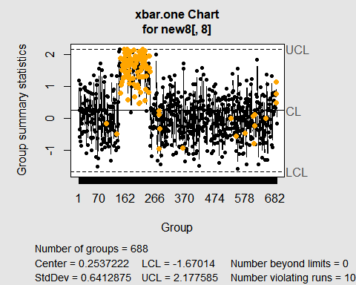

xbar_violation7=x7$violations$beyond.limits  
  
x8=qcc(data=new8[,9],type='xbar.one',sizes = 1,std.dev = "MR")

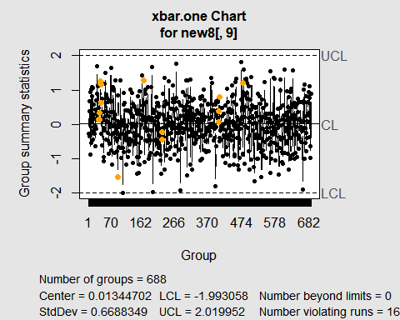

xbar_violation8=x8$violations$beyond.limits  
  
x9=qcc(data=new8[,10],type='xbar.one',sizes = 1,std.dev = "MR")

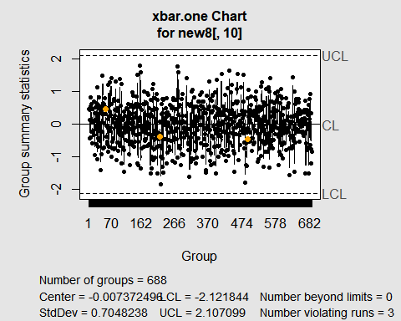

xbar_violation9=x9$violations$beyond.limits  
  
x10=qcc(data=new8[,11],type='xbar.one',sizes = 1,std.dev = "MR")

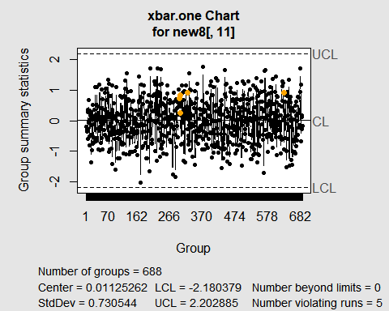

xbar_violation10=x10$violations$beyond.limits  
  
x11=qcc(data=new8[,12],type='xbar.one',sizes = 1,std.dev = "MR")

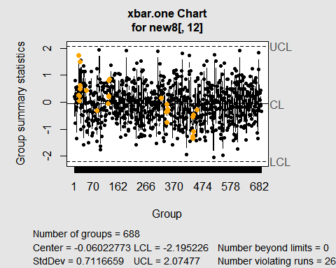

xbar_violation11=x11$violations$beyond.limits  
  
x12=qcc(data=new8[,13],type='xbar.one',sizes = 1,std.dev = "MR")

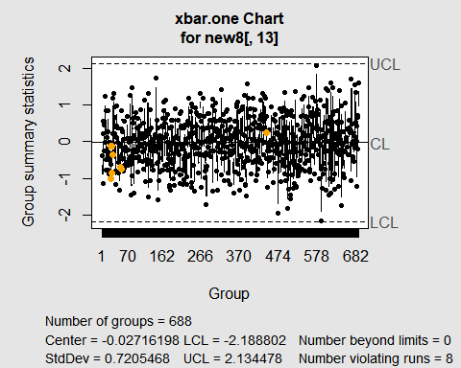

xbar_violation12=x12$violations$beyond.limits  
  
x13=qcc(data=new8[,14],type='xbar.one',sizes = 1,std.dev = "MR")

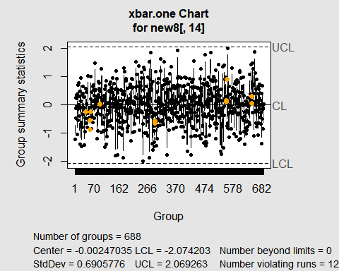

xbar_violation13=x13$violations$beyond.limits  
  
x14=qcc(data=new8[,15],type='xbar.one',sizes = 1,std.dev = "MR")

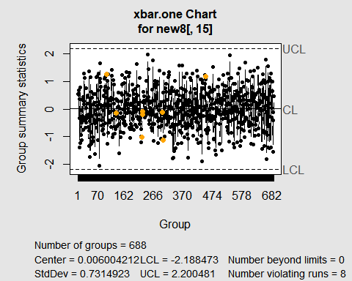

xbar_violation14=x14$violations$beyond.limits  
  
x15=qcc(data=new8[,16],type='xbar.one',sizes = 1,std.dev = "MR")

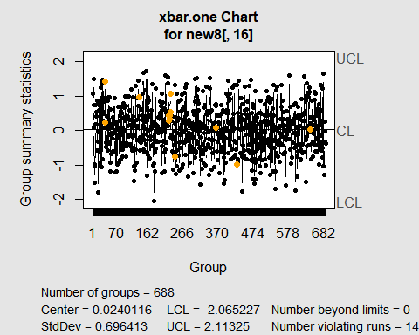

xbar_violation15=x15$violations$beyond.limits  
  
x16=qcc(data=new8[,17],type='xbar.one',sizes = 1,std.dev = "MR")

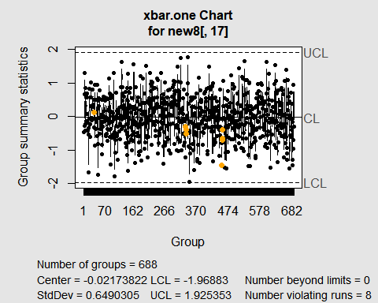

xbar_violation16=x16$violations$beyond.limits  
  
x17=qcc(data=new8[,18],type='xbar.one',sizes = 1,std.dev = "MR")

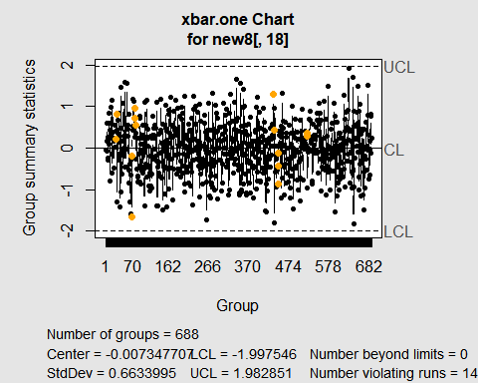

xbar_violation17=x17$violations$beyond.limits  
  
x18=qcc(data=new8[,19],type='xbar.one',sizes = 1,std.dev = "MR")

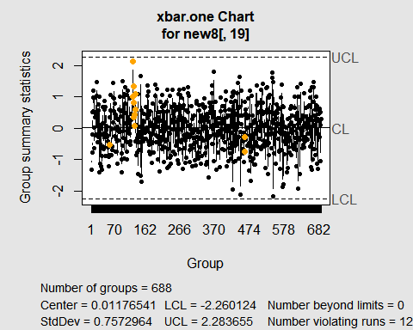

xbar_violation18=x18$violations$beyond.limits  
  
x19=qcc(data=new8[,20],type='xbar.one',sizes = 1,std.dev = "MR")

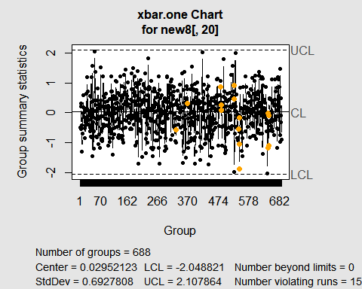

xbar_violation19=x19$violations$beyond.limits  
  
x20=qcc(data=new8[,21],type='xbar.one',sizes = 1,std.dev = "MR")

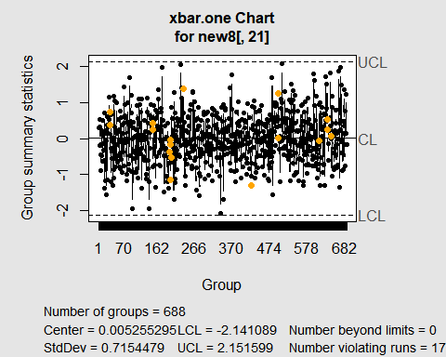

xbar_violation20=x20$violations$beyond.limits  
  
x21=qcc(data=new8[,22],type='xbar.one',sizes = 1,std.dev = "MR")

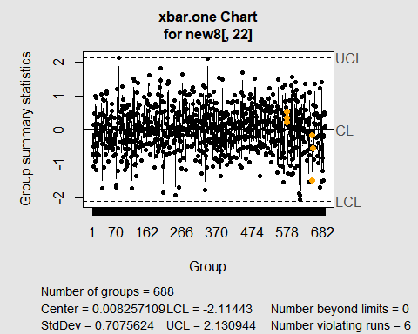

xbar_violation21=x21$violations$beyond.limits  
  
x22=qcc(data=new8[,23],type='xbar.one',sizes = 1,std.dev = "MR")

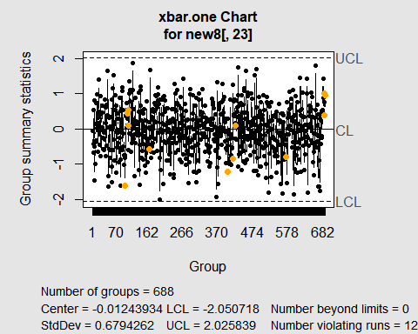

xbar_violation22=x22$violations$beyond.limits  
  
x23=qcc(data=new8[,24],type='xbar.one',sizes = 1,std.dev = "MR")

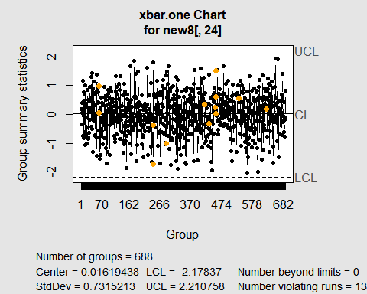

xbar_violation23=x23$violations$beyond.limits  
  
x24=qcc(data=new8[,25],type='xbar.one',sizes = 1,std.dev = "MR")

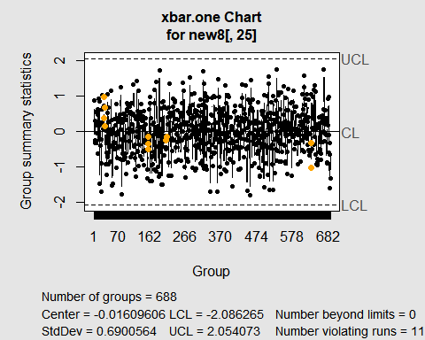

xbar_violation24=x24$violations$beyond.limits  
  
x25=qcc(data=new8[,26],type='xbar.one',sizes = 1,std.dev = "MR")

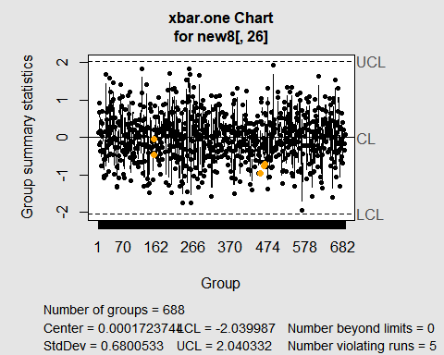

xbar_violation25=x25$violations$beyond.limits  
  
inc=new8[,1]  
  
doc=c(1:1000)  
ooc=doc[-c(inc)]  
#Out of Control Points  
ooc

## [1] 7 8 28 43 44 68 97 102 112 122 123 134 153 158 160 167 170  
## [18] 172 174 175 177 178 179 183 185 186 188 189 191 192 193 194 196 197  
## [35] 200 201 202 203 205 206 208 210 211 213 214 216 217 218 219 226 231  
## [52] 232 233 239 241 242 243 244 246 248 250 251 254 256 258 259 260 269  
## [69] 274 276 279 282 283 286 288 295 296 298 307 308 310 312 313 316 320  
## [86] 325 327 329 330 331 332 333 334 335 336 337 339 340 342 344 347 348  
## [103] 350 368 371 399 409 428 435 436 441 442 453 499 504 512 516 533 545  
## [120] 548 570 614 616 625 626 636 645 649 655 663 706 709 710 714 727 742  
## [137] 749 751 752 754 756 757 758 759 760 761 762 763 764 765 766 767 768  
## [154] 769 770 771 772 773 774 775 776 777 778 779 780 781 782 783 784 785  
## [171] 786 787 788 789 790 791 792 793 794 795 796 797 798 799 800 801 802  
## [188] 803 804 805 806 807 808 809 810 811 812 813 814 815 816 817 818 819  
## [205] 820 821 822 823 824 825 826 827 828 829 830 831 832 833 834 835 836  
## [222] 837 838 839 840 841 842 843 844 845 846 847 848 849 850 851 852 853  
## [239] 854 855 856 857 858 859 860 861 862 863 864 865 866 867 868 869 870  
## [256] 871 872 873 874 875 876 877 878 879 880 881 882 883 884 885 886 887  
## [273] 888 889 890 891 892 893 894 895 896 897 898 899 900 901 902 903 904  
## [290] 905 906 907 908 909 910 911 912 913 914 915 916 917 918 919 920 921  
## [307] 922 924 939 950 968 990