final_clust

JAY SHAH

March 16, 2018

### Setting working Directory to Data lOcation

library(data.table)  
library(factoextra)

## Loading required package: ggplot2

## Welcome! Related Books: `Practical Guide To Cluster Analysis in R` at https://goo.gl/13EFCZ

train = fread("E:/USA/Projects/Research/R_code/w6/train_clust.csv",data.table = T)  
train = train[,-1]  
test = fread("E:/USA/Projects/Research/R_code/w6/test_clust.csv",data.table = T)  
test = test[,-1]

Here I have built Custom Function to create Features

features = function(data){  
 newdata = NULL  
 mean_speed = as.data.frame( rep(0,dim(data)[1]))  
 mean_acc_lot =as.data.frame( rep(0,dim(data)[1]))  
 mean_acc_lan = as.data.frame(rep(0,dim(data)[1]))  
 sd_speed = as.data.frame(rep(0,dim(data)[1]))  
 sd_acc_lot = as.data.frame(rep(0,dim(data)[1]))  
 sd_acc_lat = as.data.frame(rep(0,dim(data)[1]))  
 max_speed = as.data.frame(rep(0,dim(data)[1]))  
 max_acc_lot = as.data.frame(rep(0,dim(data)[1]))  
 max_acc_lat = as.data.frame(rep(0,dim(data)[1]))  
 min_speed = as.data.frame(rep(0,dim(data)[1]))  
 min_acc_lot = as.data.frame(rep(0,dim(data)[1]))  
 min_acc_lat = as.data.frame(rep(0,dim(data)[1]))  
 for (i in c(1:dim(data)[1])) {  
 mean_speed[i,] = mean(unlist(data[i,4:64]))  
 mean_acc_lot[i,] = mean(unlist(data[i , 65:125]))  
 mean_acc_lan[i,] = mean(unlist(data[i, 126:186]))  
 sd_speed[i,] = sd((unlist(data[ i,4:64])))  
 sd_acc_lot[i,] = sd((unlist(data[i , 65:125])))  
 sd_acc_lat[i,] = sd((unlist(data[i , 126:186])))  
 max_speed[i,] = max((unlist(data[ i,4:64])))  
 max_acc_lot[i,] = max((unlist(data[i , 65:125])))  
 max_acc_lat[i,] = max((unlist(data[i , 126:186])))  
 min_speed[i,] = min((unlist(data[ i,4:64])))  
 min_acc_lot[i,] = min((unlist(data[i , 65:125])))  
 min_acc_lat[i,] = min((unlist(data[i , 126:186])))  
 }  
 newdata =as.data.table(cbind(mean_speed,mean_acc_lot,mean_acc_lan, sd_speed,sd_acc_lot,sd_acc_lat,  
 max_speed,max_acc_lot,max_acc_lat,min_speed,mean_acc_lot,mean_acc_lan))  
 colnames(newdata) = c("mean_speed","mean_acc_lot","mean_acc_lan", "sd_speed","sd_acc_lot","sd_acc_lat","max_speed",  
 "max_acc_lot","max_acc_lat","min_speed", "mean_acc_lot","mean_acc_lan")  
 return(newdata)  
}

### Creating Data

train_feat = features(train)  
test_feat = features(test)

hc_ward=hclust(dist(train_feat), method="ward.D")

### Questions related to type of Dissimilarity measure to use?

plot(hc_ward,main="ward.D", xlab="", sub="", cex=.9)

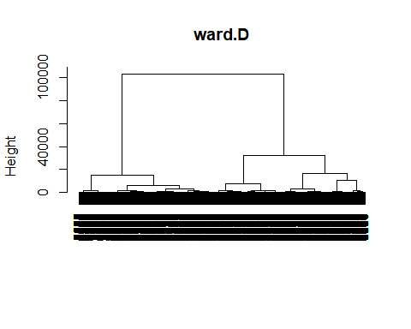 Here we can see only 2 clusters.

fviz_nbclust(train_feat, hcut, method = "wss",hc_method = "ward.D", main = "Ward.D") +  
 geom_vline(xintercept = 2, linetype = 2)

