R Notebook

### Setting working Directory to Data lOcation

library(data.table)  
library(factoextra)

## Loading required package: ggplot2

## Welcome! Related Books: `Practical Guide To Cluster Analysis in R` at https://goo.gl/13EFCZ

library(dplyr)

##   
## Attaching package: 'dplyr'

## The following objects are masked from 'package:data.table':  
##   
## between, first, last

## The following objects are masked from 'package:stats':  
##   
## filter, lag

## The following objects are masked from 'package:base':  
##   
## intersect, setdiff, setequal, union

library(tidyverse)

## -- Attaching packages ----------------------------------------------------- tidyverse 1.2.1 --

## v tibble 1.4.1 v purrr 0.2.4  
## v tidyr 0.7.2 v stringr 1.2.0  
## v readr 1.1.1 v forcats 0.2.0

## -- Conflicts -------------------------------------------------------- tidyverse_conflicts() --  
## x dplyr::between() masks data.table::between()  
## x dplyr::filter() masks stats::filter()  
## x dplyr::first() masks data.table::first()  
## x dplyr::lag() masks stats::lag()  
## x dplyr::last() masks data.table::last()  
## x purrr::transpose() masks data.table::transpose()

train = fread("E:/USA/Projects/Research/R_code/w6/train_clust.csv",data.table = T)  
train = train[,-1]  
test = fread("E:/USA/Projects/Research/R_code/w6/test_clust.csv",data.table = T)  
test = test[,-1]

Here I have built Custom Function to create Features

features = function(data){  
 newdata = NULL  
 mean_speed = as.data.frame( rep(0,dim(data)[1]))  
 mean_acc_lot =as.data.frame( rep(0,dim(data)[1]))  
 mean_acc_lan = as.data.frame(rep(0,dim(data)[1]))  
 sd_speed = as.data.frame(rep(0,dim(data)[1]))  
 sd_acc_lot = as.data.frame(rep(0,dim(data)[1]))  
 sd_acc_lat = as.data.frame(rep(0,dim(data)[1]))  
 max_speed = as.data.frame(rep(0,dim(data)[1]))  
 max_acc_lot = as.data.frame(rep(0,dim(data)[1]))  
 max_acc_lat = as.data.frame(rep(0,dim(data)[1]))  
 min_speed = as.data.frame(rep(0,dim(data)[1]))  
 min_acc_lot = as.data.frame(rep(0,dim(data)[1]))  
 min_acc_lat = as.data.frame(rep(0,dim(data)[1]))  
 for (i in c(1:dim(data)[1])) {  
 mean_speed[i,] = mean(unlist(data[i,4:64]))  
 mean_acc_lot[i,] = mean(unlist(data[i , 65:125]))  
 mean_acc_lan[i,] = mean(unlist(data[i, 126:186]))  
 sd_speed[i,] = sd((unlist(data[ i,4:64])))  
 sd_acc_lot[i,] = sd((unlist(data[i , 65:125])))  
 sd_acc_lat[i,] = sd((unlist(data[i , 126:186])))  
 max_speed[i,] = max((unlist(data[ i,4:64])))  
 max_acc_lot[i,] = max((unlist(data[i , 65:125])))  
 max_acc_lat[i,] = max((unlist(data[i , 126:186])))  
 min_speed[i,] = min((unlist(data[ i,4:64])))  
 min_acc_lot[i,] = min((unlist(data[i , 65:125])))  
 min_acc_lat[i,] = min((unlist(data[i , 126:186])))  
 }  
 newdata =as.data.table(cbind(mean_speed,mean_acc_lot,mean_acc_lan, sd_speed,sd_acc_lot,sd_acc_lat,  
 max_speed,max_acc_lot,max_acc_lat,min_speed,mean_acc_lot,mean_acc_lan))  
 colnames(newdata) = c("mean_speed","mean_acc_lot","mean_acc_lan", "sd_speed","sd_acc_lot","sd_acc_lat","max_speed",  
 "max_acc_lot","max_acc_lat","min_speed", "mean_acc_lot","mean_acc_lan")  
 return(newdata)  
}

### Creating Data

train_feat = features(train)  
test_feat = features(test)

hc_ward=hclust(dist(train_feat), method="ward.D")

### Questions related to type of Dissimilarity measure to use?

plot(hc_ward,main="ward.D", xlab="", sub="", cex=.9)

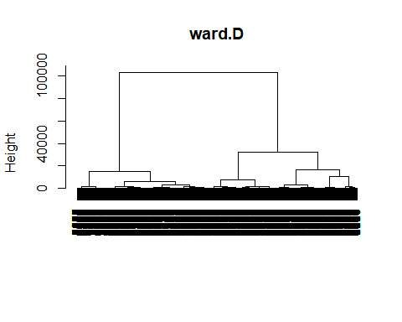 Here we can see only 2 clusters.

fviz_nbclust(train_feat, hcut, method = "wss",hc_method = "ward.D", main = "Ward.D") +  
 geom_vline(xintercept = 2, linetype = 2)

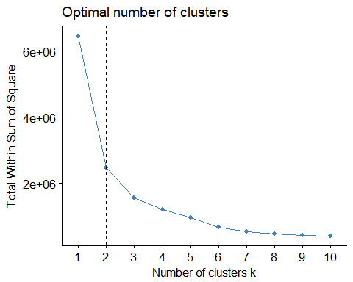

hc_ward_cut = cutree(hc_ward,k=2)  
hc_ward_cut2 = cutree(hc_ward,k=3)

index = fread("E:/USA/Projects/Research/R_code/w6/index_all.csv")  
index$new = paste(index$RunName,index$win60s)  
train$new = paste(train$RunName,train$win60s)  
  
index_train = as.data.table(train$new)  
colnames(index_train)='new'  
index_train = merge(index_train, index[,c('c','new')],by = 'new')  
  
index_train1 = cbind(index_train,as.data.table(hc_ward_cut))

index_train1$c = as.factor(index_train1$c)  
index_train1$hc_ward_cut =as.factor(index_train1$hc_ward_cut)

ind = group_by(index_train1[,2:3], c) %>% summarize(size = length(hc_ward_cut), frq1 = summary(hc_ward_cut)[1],frq2 = summary(hc_ward_cut)[2])  
  
barplot(height = t(ind[,c(3,4)]), names.arg = ind$c,col=c("blue","red"),legend.text = c("1","2"),args.legend = list(x = "topleft"),axisnames = T,cex.names = 0.5)

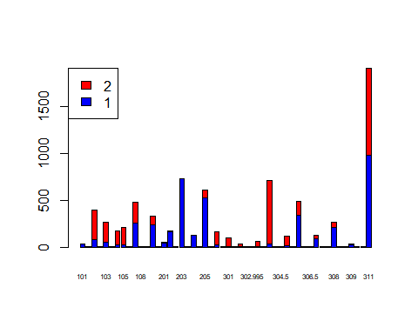

index_train2 = cbind(index_train,as.data.table(hc_ward_cut2))  
index_train2$c = as.factor(index_train2$c)  
index_train2$hc_ward_cut2 =as.factor(index_train2$hc_ward_cut2)

ind1 = group_by(index_train2[,2:3], c) %>% summarize(size = length(hc_ward_cut2), frq1 = summary(hc_ward_cut2)[1],frq2 = summary(hc_ward_cut2)[2],frq3 = summary(hc_ward_cut2)[3])  
  
barplot(height = t(ind1[,c(3,4,5)]), names.arg = ind1$c,col=c("blue","red","green"),legend.text = c("1","2","3"),args.legend = list(x = "topleft"),axisnames = T,cex.names = 0.5)

