

PROJECT REPORT ON

“PRDA-01 – PROFIT ANALYSIS”

Submitted By:
Jay Suthar — jaysuthar7890@gmail.com

Project Type

Profit Analysis using Multiple Linear Regression

DATASET: STARTUP DATASET
Source: CSV
ABSTRACT
Profit prediction is an important application of data analytics and machine learning that can help organizations understand the relationship between business expenditures and profitability. This project focuses on developing a machine learning model to predict company Profit using Research and Development (R&D) Spend, Administration expenditure, and Marketing Spend. The dataset consists of 50 company observations with five variables: R&D Spend, Administration, Marketing Spend, State, and Profit. The dataset was analyzed using Python-based data analysis and visualization techniques.
The project follows a complete machine learning workflow, including data understanding, data quality checking, exploratory data analysis, correlation analysis, feature selection, train-test splitting, model training, and evaluation. Multiple Linear Regression was selected because Profit is a continuous target variable and can be modeled as a linear combination of multiple expenditure factors. State was used only for descriptive analysis and was excluded from the final prediction model. The dataset was divided into 80% training data and 20% testing data.
The analysis found that R&D Spend had the strongest positive correlation with Profit, with a Pearson correlation of 0.9729, followed by Marketing Spend with 0.7478, while Administration showed a weaker positive correlation of 0.2007. The trained Multiple Linear Regression model achieved an R² score of 0.9001, with an MAE of 6,979.15 and an RMSE of 8,995.91 on the test data. The model was also used to predict Profit for new expenditure combinations.
Python libraries including Pandas, NumPy, Scikit-learn, and Matplotlib were used for data processing, analysis, visualization, and model development, while Power BI was used to present analytical insights through visualizations. The project demonstrates how Multiple Linear Regression can be applied to historical business expenditure data to estimate future Profit and support data-driven financial and resource allocation decisions.

CONTENTS

S No | Topics | Page No
1 | Introduction | 4
2 | Problem Statement | 4
3 | Dataset Description | 4
4 | Dataset Source | 5
5 | Tools and Technologies used | 5
6 | Data Preprocessing | 5
7 | Exploratory Data Analysis | 6
8 | Feature Selection | 8
9 | Multi Linear Regression | 8
10 | Train-Test Split | 8
11 | Model Training | 9
12 | Regression Result | 9
13 | Interpretation of regression coefficients | 10
14 | Model Evaluation | 10
15 | Actual vs Predicted Analysis | 11
16 | Profit Prediction | 11
17 | Power BI Visualization | 12
18 | Key Insights | 13
19 | Business Recommendations | 14
20 | Conclusion | 14
21 | Final Summary | 15
22 | Declaration | 15

1. INTRODUCTION
The purpose of this project is to analyze the factors affecting the Profit of startups using Multiple Linear Regression.
The analysis focuses on three major expenditure variables:
1. R&D Spend
2. Administration Spend
3. Marketing Spend
The main objective is to identify how these three variables affect the Profit of a startup and to predict Profit for the given input values.
Multiple Linear Regression is used because the target variable, Profit, is influenced by more than one independent variable.
The project also includes data visualization using Power BI to identify important patterns, relationships, and business insights from the dataset.
2. PROBLEM STATEMENT
The problem is to determine how the money spent on Research & Development, Administration, and Marketing affects the Profit of a startup.
The project also requires predicting the Profit for the following given input combinations:
Input 1:
R&D Spend = 21892.92
Administration = 81910.77
Marketing Spend = 164270.70
Input 2:
R&D Spend = 23940.93
Administration = 96489.63
Marketing Spend = 137001.10
The analysis is performed using Multiple Linear Regression, and the results are supported with Power BI visualizations.

3. DATASET DESCRIPTION
The dataset contains information about 50 startups from New York, California, and Florida.
The dataset contains the following attributes:
R&D Spend:
The amount of money spent by a startup on Research and Development.
Administration:
The amount of money spent by a startup on administration.
Marketing Spend:
The amount of money spent by a startup on marketing strategies.
State:
The state in which the startup belongs.
Profit:
The amount of profit generated by the startup.

4. DATASET SOURCE
Dataset Source: CSV
The startup dataset was provided in CSV format and was used for the analysis.
The dataset was loaded into Python using the Pandas library.

5. TOOLS AND TECHNOLOGIES USED
The following tools and technologies were used for this project:
1. Python
2. Pandas
3. Scikit-learn
4. Matplotlib
5. Power BI
6. CSV Dataset

6. DATA PREPROCESSING
Before applying the regression model, the dataset was inspected to understand its structure and quality.
The following preprocessing steps were performed:
1. Loaded the CSV dataset into Python.
2. Checked the first few records using the head() function.
3. Checked the number of rows and columns.
4. Checked the data types of all columns.
5. Checked for missing values.
6. Checked for duplicate records.
7. Selected the required numerical features for regression.
The independent variables selected for the model were:
- R&D Spend
- Administration
- Marketing Spend
The dependent variable selected was:
- Profit

7. EXPLORATORY DATA ANALYSIS
Exploratory Data Analysis (EDA) was used to understand the distribution of Profit and the relationships between the candidate predictors and Profit before interpreting the regression model.

7.1 RD_Spend vs Profit
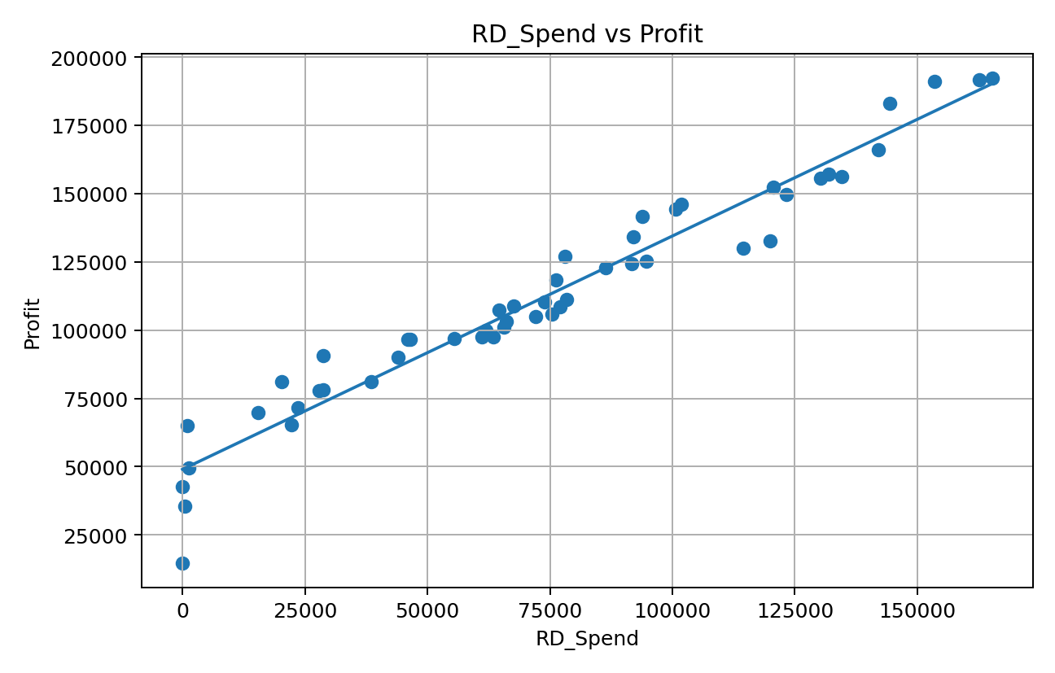

7.1 RD Spend vs Profit

7.2 Administration vs Profit
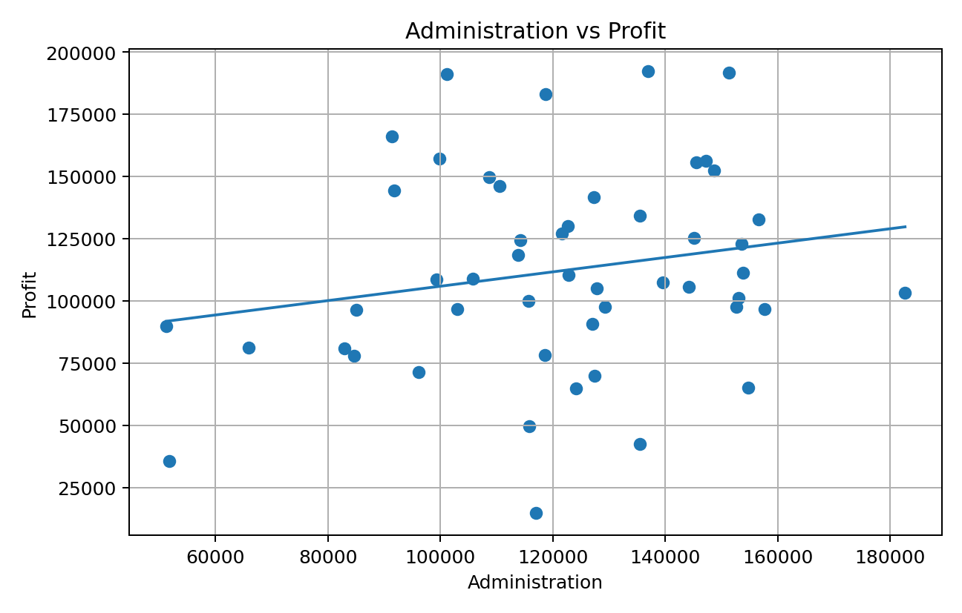

7.2 Administration vs Profit

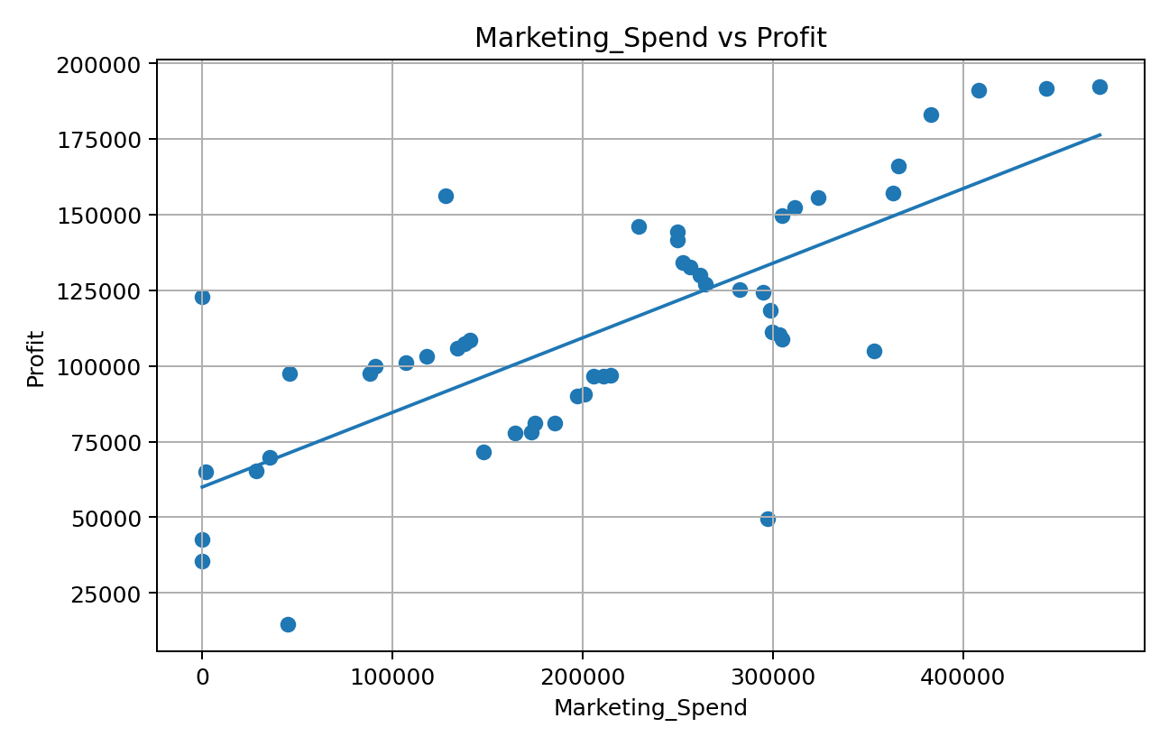
7.3 Marketing_Spend vs Profit
7.3 Marketing spend vs Profit

8. FEATURE SELECTION
For Multiple Linear Regression, the variables were divided into independent variables and a dependent variable.
Independent Variables (X):

1. R&D Spend
2. Administration
3. Marketing Spend
Dependent Variable (y):
Profit
The objective is to predict Profit using the three selected spending variables.

9. MULTIPLE LINEAR REGRESSION
Multiple Linear Regression is a supervised machine learning algorithm used to predict a continuous dependent variable using multiple independent variables.
In this project, the regression model estimates Profit based on R&D Spend, Administration Spend, and Marketing Spend.
The general regression equation is:Profit = β0 + β1(R&D Spend) + β2(Administration) + β3(Marketing Spend)
Where:
β0 = Intercept
β1 = Coefficient of R&D Spend
β2 = Coefficient of Administration Spend
β3 = Coefficient of Marketing Spend

10. TRAIN-TEST SPLIT
The dataset was divided into training and testing data using an 80:20 ratio.
80% of the data was used for training the regression model, while 20% was used for testing the model.
The train-test split was performed using:
test_size = 0.2
A random_state of 42 was used to make the split reproducible.
The training data was used by the model to learn the relationship between the spending variables and Profit.
The testing data was then used to evaluate the performance of the trained model.

11. MODEL TRAINING
The Multiple Linear Regression model was created using the LinearRegression class from Scikit-learn.
The model was trained using the training dataset.
The model learned the relationship between:
R&D Spend Administration Spend Marketing Spend
and:
Profit

12. REGRESSION RESULTS
The following values were obtained from the Python regression model.
Intercept:
54071.87574599087
R&D Spend Coefficient:
0.8037792756297526
Administration Coefficient:
-0.06792917400149993
Marketing Spend Coefficient:
0.031241545897732773
R² Score:
0.9000653083037321
Mean Squared Error (MSE):
80926321.22295156

13. INTERPRETATION OF REGRESSION COEFFICIENTS
The regression coefficients indicate the estimated effect of each independent variable on Profit while keeping the other variables constant.
R&D Spend Coefficient:
The coefficient represents the estimated change in Profit for a one-unit change in R&D Spend, while Administration and Marketing Spend remain constant.
Administration Coefficient:
The coefficient represents the estimated change in Profit for a one-unit change in Administration Spend, while R&D and Marketing Spend remain constant.
Marketing Spend Coefficient:
The coefficient represents the estimated change in Profit for a one-unit change in Marketing Spend, while R&D and Administration Spend remain constant.
The variable having the strongest estimated effect should be identified from the magnitude and direction of the actual regression coefficients.

14. MODEL EVALUATION
Two important evaluation metrics were used:
1. R² Score
2. Mean Squared Error (MSE)
R² Score:
R² Score measures how well the regression model explains the variation in Profit.
A higher R² value generally indicates that the model explains a larger proportion of the variation in the target variable.
R² Score obtained:
0.9000653083037321
Mean Squared Error:
MSE measures the average squared difference between the actual Profit values and the predicted Profit values.
MSE obtained:
80926321.22295156

15. ACTUAL vs PREDICTED ANALYSIS
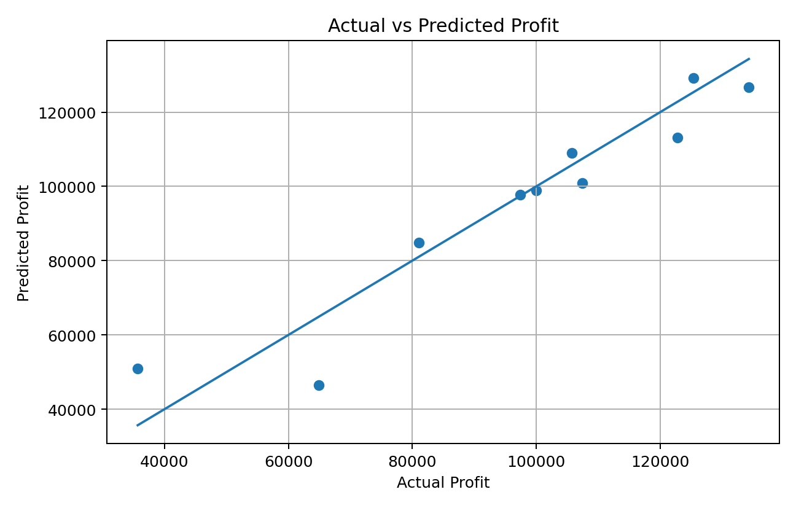
The test-set predictions were compared with the actual Profit values. The table below presents all ten held-out observations used in the evaluation.

15. Actual vs Predicted Profit

16. PROFIT PREDICTION
The trained Multiple Linear Regression model was used to predict Profit for the two input combinations provided in the assignment.
Input 1:
R&D Spend = 21892.92
Administration = 81910.77
Marketing Spend = 164270.70
Predicted Profit = 71236.89079079
Input 2:
R&D Spend = 23940.93
Administration = 96489.63
Marketing Spend = 137001.10
Predicted Profit = 71040.76440737
The predicted values represent the Profit estimated by the trained regression model for the given spending combinations.

17. POWER BI VISUALIZATION
Power BI was used to visualize the dataset and understand the relationship between spending variables and Profit.
The following visualizations were created/recommended:
1. R&D Spend vs Profit
A scatter chart was used to examine the relationship between R&D expenditure and Profit.
2. Marketing Spend vs Profit
A scatter chart was used to examine the relationship between Marketing expenditure and Profit.
3. Administration Spend vs Profit
A scatter chart was used to examine the relationship between Administration expenditure and Profit.
4. State-wise Profit
A bar or column chart was used to compare Profit across different States.
5. KPI Cards
Important measures such as Total Profit, Average Profit, R&D Spend, and Marketing Spend, Admin Spend and R² Score were displayed using KPI cards.
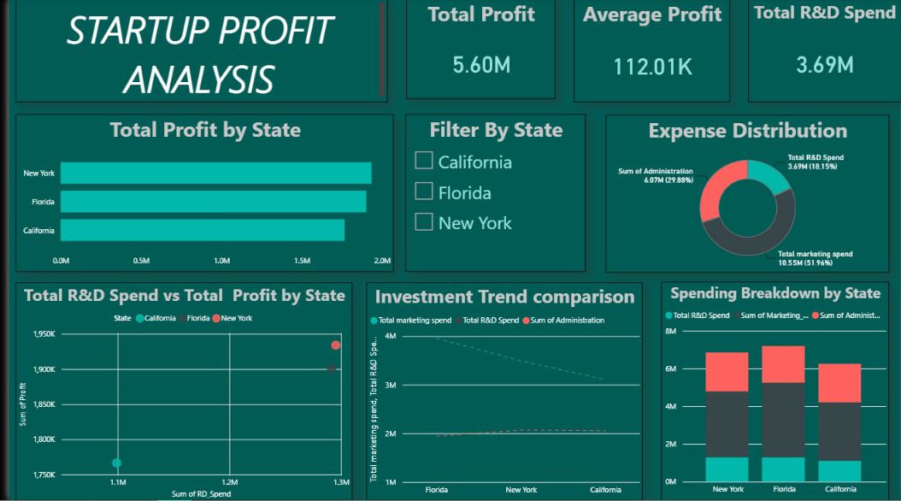
18. KEY INSIGHTS
The following insights should be derived from the actual Python regression results and Power BI dashboard.
1. R&D Spend and Profit:
The relationship between R&D Spend and Profit was analyzed using the scatter chart and regression coefficient.
Finding:
R&D Spend has a positive relationship with Profit. The regression coefficient of 0.8038 indicates that, while keeping Administration and Marketing Spend constant, an increase in R&D Spend is associated with an increase in predicted Profit.
2. Administration Spend and Profit:
The relationship between Administration Spend and Profit was analyzed using the scatter chart and regression coefficient.
Finding:
Administration Spend has a negative relationship with Profit. The regression coefficient of -0.06793 indicates that, while keeping R&D and Marketing Spend constant, an increase in Administration Spend is associated with a decrease in predicted Profit.
3. Marketing Spend and Profit:
The relationship between Marketing Spend and Profit was analyzed using the scatter chart and regression coefficient.
Finding:
Marketing Spend has a positive relationship with Profit. The regression coefficient of 0.03124 indicates that, while keeping R&D and Administration Spend constant, an increase in Marketing Spend is associated with an increase in predicted Profit
4. Most Influential Spending Variable:
Based on the regression coefficients, the spending variable with the strongest estimated effect on Profit was:
Among the three spending variables, R&D Spend has the strongest estimated positive coefficient (0.8038). Therefore, based on the regression coefficients, R&D Spend has the strongest estimated effect on Profit in this model.
5. State-wise Performance:
Based on the Power BI analysis, the State with the highest average Profit was:
Florida

6. Overall Model Performance:
The regression model achieved an R² Score of:
0.9000653083037321
This indicates how well the selected spending variables explain the variation in Profit.

19. BUSINESS RECOMMENDATIONS
Based on the regression analysis and Power BI visualizations, the following recommendations can be considered:
1. The company should focus on the spending category that shows
the strongest positive relationship with Profit.
2. R&D expenditure should be monitored carefully because investment
in Research and Development can be important for the long-term growth and profitability of a startup.
3. Administration expenses should be reviewed regularly to ensure
that unnecessary administrative costs are controlled.
4. Marketing expenditure should be optimized according to its
observed relationship with Profit instead of increasing the budget without measuring its effectiveness.
5. Management should use data-driven analysis to decide how to
allocate resources among R&D, Administration, and Marketing.
6. Power BI dashboards can be used regularly to monitor Profit and
spending patterns and support future business decisions.

20. CONCLUSION
This project analyzed the relationship between R&D Spend, Administration Spend, Marketing Spend, and Profit using Multiple Linear Regression.
The dataset was first inspected and prepared for analysis. The three spending variables were selected as independent variables, while Profit was selected as the dependent variable.
The dataset was divided into training and testing sets using an 80:20 ratio. A Multiple Linear Regression model was then trained using the training data.
The model was evaluated using R² Score and Mean Squared Error. The regression coefficients were analyzed to understand the estimated effect of R&D Spend, Administration Spend, and Marketing Spend on Profit.
The trained model was also used to predict Profit for the two input combinations provided in the assignment.
Power BI visualization was used to present relationships and patterns in an easy-to-understand form. The combination of regression analysis and visualization provides useful information for understanding how startup expenditure is associated with Profit.
Based on the final results, management can use the identified relationships to make more informed decisions regarding the allocation and optimization of business expenditure.

21. FINAL SUMMARY
Project Type:
Profit Analysis using Multiple Linear Regression
Target Variable:
Profit
Independent Variables:
R&D Spend Administration Marketing Spend

Train-Test Ratio:
80:20
Regression Algorithm:
Multiple Linear Regression
Evaluation Metrics:
R² Score Mean Squared Error (MSE)
Visualization Tool:
Power BI
Prediction:
Profit predicted for the two input combinations provided in the assignment.

22. DECLARATION
I hereby confirm that the analysis presented in this report was performed as part of the PRDA-01 Profit Analysis project. The regression analysis was performed using Python, and Power BI was used for data visualization and insight generation.

======================== END OF REPORT ========================

