Code
`import pandas as pd
import numpy as np
import material_fingerprinting as mf

# ==========================================================
# LOAD EXPERIMENTAL DATA
# ==========================================================

file_path = r"C:\Users\jayme\Desktop\Final of eve.xlsx"
df = pd.read_excel(file_path, header=None)

# Column 0 = Stretch Ratio λ
F11 = df.iloc[:, 0].astype(float).to_numpy()

# Column 1 = Nominal Stress MPa
P11 = df.iloc[:, 1].astype(float).to_numpy()

# Remove NaNs
mask = np.isfinite(F11) & np.isfinite(P11)

F11 = F11[mask]
P11 = P11[mask]

print(f"\nLoaded {len(F11)} data points")
print(f"Stretch range: {F11.min():.4f} to {F11.max():.4f}")
print(f"Stress range: {P11.min():.4f} to {P11.max():.4f}")

# ==========================================================
# CREATE MATERIAL FINGERPRINTING MEASUREMENT
# ==========================================================

measurement = mf.Measurement(
"uniaxial tension/compression",
F11,
P11
)

# ==========================================================
# DISCOVER CONSTITUTIVE MODEL
# ==========================================================

print("\nRunning Material Fingerprinting...\n")
import matplotlib.pyplot as plt

plt.close("all")
mf.discover([measurement])

Source
Characterization of the anisotropic mechanical properties of
excised human skin (Fig 4b)

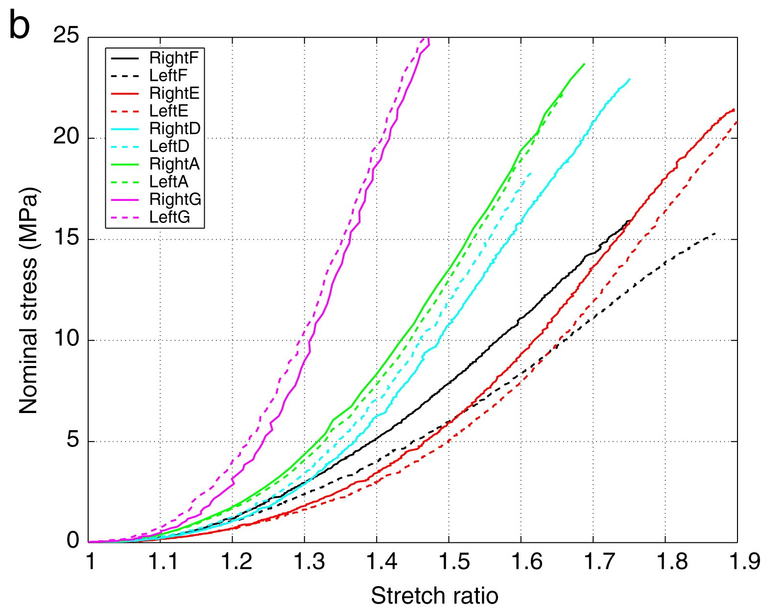

Red
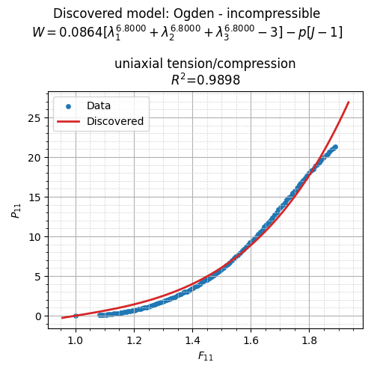

Loaded 117 data points
Stretch range: 1.0834 to 1.8896
Stress range: 0.0621 to 21.3023

Running Material Fingerprinting...

=== Material Fingerprinting ===
Contact moritz.flaschel@fau.de for help and bug reports.

The pickle database is loaded from the package resources.
Database Information:
models in the database:
Blatz-Ko - incompressible
Demiray - incompressible
Gent - incompressible
Holzapfel - incompressible
Mooney-Rivlin - incompressible
Neo-Hooke - incompressible
Ogden - incompressible
number of fingerprints = 2502
uniaxial tension: stretch ranges from 0.1 to 10.0 in the database

Material Fingerprinting Results:
discovered model: Ogden - incompressible
identified parameters: [0.08637377 6.8 ]
formula: $0.0864 [\lambda_1^{6.8000} + \lambda_2^{6.8000} + \lambda_3^{6.8000} - 3] - p [J-1]$
R² values per experiment:
uniaxial tension/compression: 0.9898
R² average over all experiments: 0.9898

Pink
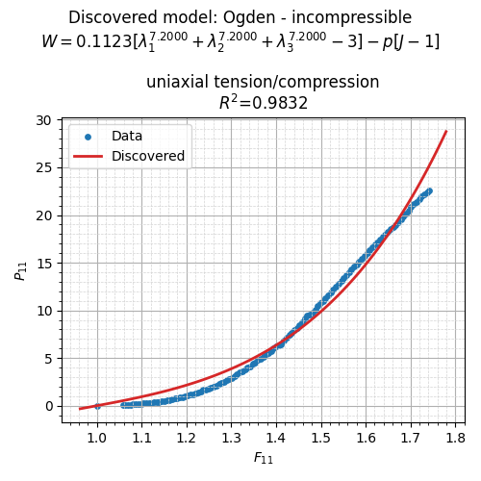

Loaded 119 data points
Stretch range: 1.0580 to 1.7424
Stress range: 0.0309 to 22.5906

Running Material Fingerprinting...

=== Material Fingerprinting ===
Contact moritz.flaschel@fau.de for help and bug reports.

The pickle database is loaded from the package resources.
Database Information:
models in the database:
Blatz-Ko - incompressible
Demiray - incompressible
Gent - incompressible
Holzapfel - incompressible
Mooney-Rivlin - incompressible
Neo-Hooke - incompressible
Ogden - incompressible
number of fingerprints = 2502
uniaxial tension: stretch ranges from 0.1 to 10.0 in the database

Material Fingerprinting Results:
discovered model: Ogden - incompressible
identified parameters: [0.11228907 7.2 ]
formula: $0.1123 [\lambda_1^{7.2000} + \lambda_2^{7.2000} + \lambda_3^{7.2000} - 3] - p [J-1]$
R² values per experiment:
uniaxial tension/compression: 0.9832
R² average over all experiments: 0.9832

Black
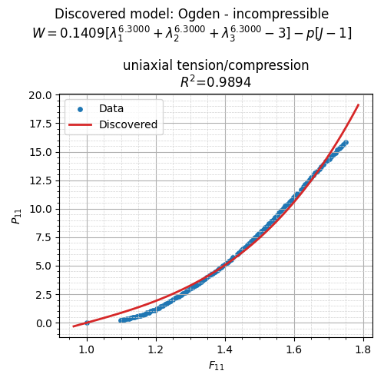

Loaded 111 data points
Stretch range: 1.0986 to 1.7482
Stress range: 0.2316 to 15.8706

Running Material Fingerprinting...

=== Material Fingerprinting ===
Contact moritz.flaschel@fau.de for help and bug reports.

The pickle database is loaded from the package resources.
Database Information:
models in the database:
Blatz-Ko - incompressible
Demiray - incompressible
Gent - incompressible
Holzapfel - incompressible
Mooney-Rivlin - incompressible
Neo-Hooke - incompressible
Ogden - incompressible
number of fingerprints = 2502
uniaxial tension: stretch ranges from 0.1 to 10.0 in the database

Material Fingerprinting Results:
discovered model: Ogden - incompressible
identified parameters: [0.14086302 6.3 ]
formula: $0.1409 [\lambda_1^{6.3000} + \lambda_2^{6.3000} + \lambda_3^{6.3000} - 3] - p [J-1]$
R² values per experiment:
uniaxial tension/compression: 0.9894
R² average over all experiments: 0.9894

Green
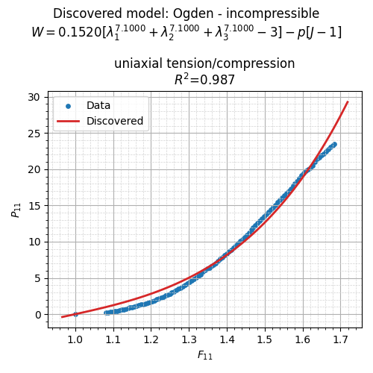

Loaded 105 data points
Stretch range: 1.0812 to 1.6844
Stress range: 0.2136 to 23.5204

Running Material Fingerprinting...

=== Material Fingerprinting ===
Contact moritz.flaschel@fau.de for help and bug reports.

The pickle database is loaded from the package resources.
Database Information:
models in the database:
Blatz-Ko - incompressible
Demiray - incompressible
Gent - incompressible
Holzapfel - incompressible
Mooney-Rivlin - incompressible
Neo-Hooke - incompressible
Ogden - incompressible
number of fingerprints = 2502
uniaxial tension: stretch ranges from 0.1 to 10.0 in the database

Material Fingerprinting Results:
discovered model: Ogden - incompressible
identified parameters: [0.1520324 7.1 ]
formula: $0.1520 [\lambda_1^{7.1000} + \lambda_2^{7.1000} + \lambda_3^{7.1000} - 3] - p [J-1]$
R² values per experiment:
uniaxial tension/compression: 0.9870
R² average over all experiments: 0.9870

Blue
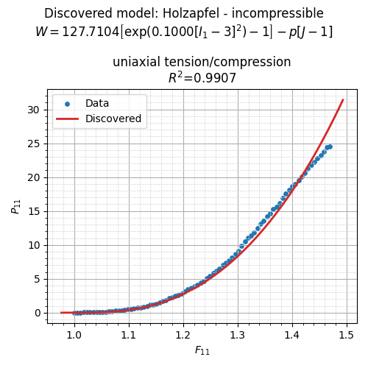

Loaded 81 data points
Stretch range: 1.0058 to 1.4698
Stress range: 0.0181 to 24.5428

Running Material Fingerprinting...

=== Material Fingerprinting ===
Contact moritz.flaschel@fau.de for help and bug reports.

The pickle database is loaded from the package resources.
Database Information:
models in the database:
Blatz-Ko - incompressible
Demiray - incompressible
Gent - incompressible
Holzapfel - incompressible
Mooney-Rivlin - incompressible
Neo-Hooke - incompressible
Ogden - incompressible
number of fingerprints = 2502
uniaxial tension: stretch ranges from 0.1 to 10.0 in the database

Material Fingerprinting Results:
discovered model: Holzapfel - incompressible
identified parameters: [1.27710402e+02 1.00000000e-01]
formula: $127.7104 \left[\exp(0.1000 [I_1 - 3]^2) - 1\right] - p [J-1]$
R² values per experiment:
uniaxial tension/compression: 0.9907
R² average over all experiments: 0.9907

Compiled

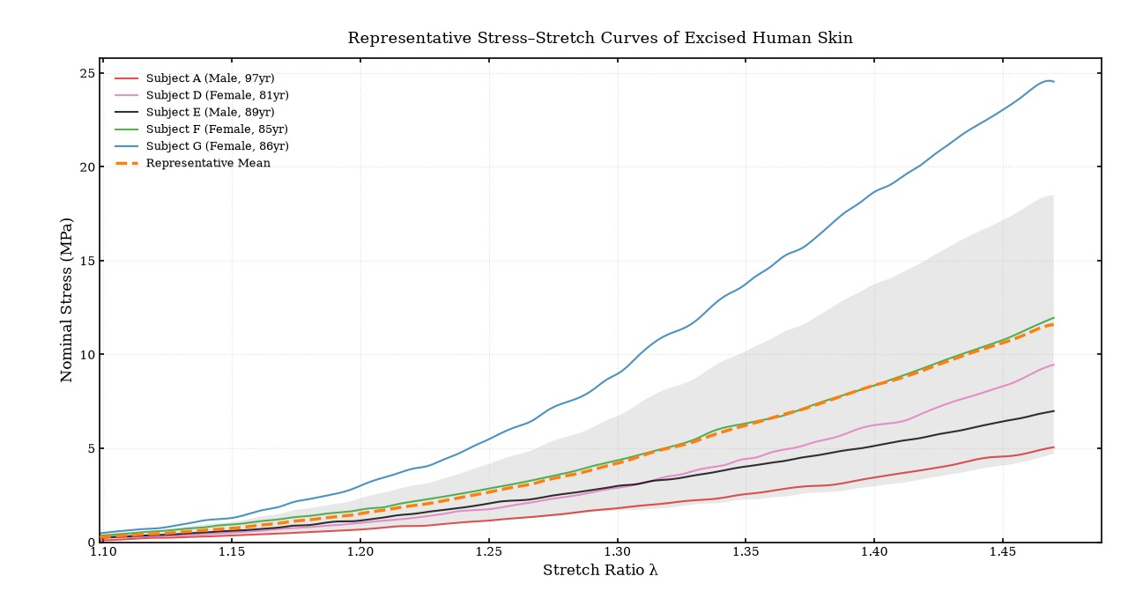

FINAL OUTCOME
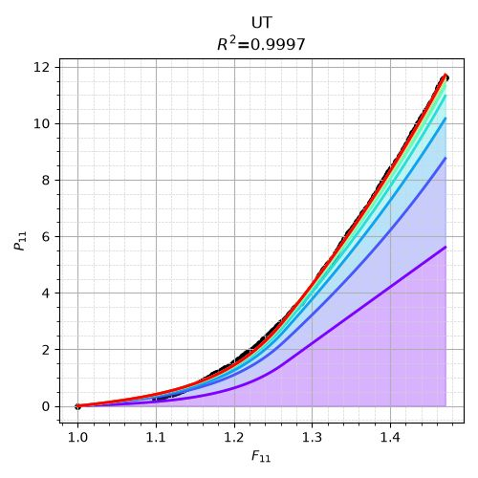

=== Adaptive Material Fingerprinting ===
Contact moritz.flaschel@fau.de for help and bug reports.

The pickle database is loaded from the local path.
Database Information:
models in the database:
f(stretch) - #1 - incompressible
f(area) - #1 - incompressible
f(stretch) - #2 - incompressible
f(area) - #2 - incompressible
f(stretch) - #3 - incompressible
f(area) - #3 - incompressible
number of fingerprints = 2800
uniaxial tension: stretch ranges from 0.1 to 10.0 in the database

Adaptive Material Fingerprinting Results:
------------------------------------------------------------
[01] f(stretch) - #3 - incompressible
formula: $3.1049e-09 \sum_i \left[ \exp\left(13.21 [\lambda_i - 1] + 13.93\right) - \exp(13.93) \right] - p [J-1]$
parameters: [3.1049e-09, 1.3205e+01, 1.3933e+01]

[02] f(stretch) - #1 - incompressible
formula: $0.0093 \sum_i \left[ \lambda_i^{10.1000} - 1 \right] - p [J-1]$
parameters: [9.3365e-03, 1.0100e+01]

[03] f(stretch) - #3 - incompressible
formula: $7.7854e-10 \sum_i \left[ \exp\left(13.21 [\lambda_i - 1] + 13.93\right) - \exp(13.93) \right] - p [J-1]$
parameters: [7.7854e-10, 1.3205e+01, 1.3933e+01]

[04] f(area) - #1 - incompressible
formula: $0.0021 \sum_{j=2}^3 \sum_{k<j} \left[ [\lambda_j \lambda_k]^{-10.4000} - 1 \right] - p [J-1]$
parameters: [2.0572e-03, -1.0400e+01]

[05] f(stretch) - #3 - incompressible
formula: $1.0267e-10 \sum_i \left[ \exp\left(25.00 [\lambda_i - 1] + 11.17\right) - \exp(11.17) \right] - p [J-1]$
parameters: [1.0267e-10, 2.5000e+01, 1.1167e+01]

[06] f(stretch) - #3 - incompressible
formula: $1.3397e-10 \sum_i \left[ \exp\left(11.89 [\lambda_i - 1] + 13.93\right) - \exp(13.93) \right] - p [J-1]$
parameters: [1.3397e-10, 1.1895e+01, 1.3933e+01]

[07] f(stretch) - #3 - incompressible
formula: $2.6775e-11 \sum_i \left[ \exp\left(19.76 [\lambda_i - 1] + 13.93\right) - \exp(13.93) \right] - p [J-1]$
parameters: [2.6775e-11, 1.9758e+01, 1.3933e+01]

[08] f(stretch) - #3 - incompressible
formula: $5.4948e-11 \sum_i \left[ \exp\left(23.69 [\lambda_i - 1] + 8.40\right) - \exp(8.40) \right] - p [J-1]$
parameters: [5.4948e-11, 2.3689e+01, 8.4000e+00]

[09] f(area) - #3 - incompressible
formula: $2.1582e+07 \sum_{j=2}^3 \sum_{k<j} \left[ \exp\left(0.10 [\lambda_j \lambda_k - 1] + -25.00\right) - \exp(-25.00) \right] - p [J-1]$
parameters: [2.1582e+07, 1.0000e-01, -2.5000e+01]

[10] f(area) - #3 - incompressible
formula: $4.3165e+07 \sum_{j=2}^3 \sum_{k<j} \left[ \exp\left(0.10 [\lambda_j \lambda_k - 1] + -25.00\right) - \exp(-25.00) \right] - p [J-1]$
parameters: [4.3165e+07, 1.0000e-01, -2.5000e+01]

------------------------------------------------------------
R² results:
uniaxial tension/compression : 0.9997
--------------------------------------------------
R² average : 0.9997

