1 Script
Script

import numpy as np
import pandas as pd
import material_fingerprinting as mf

# Load experimental data
df = pd.read_csv("fig1-4-Blue.csv")

# Engineering strain
strain = df["Engineering Strain X"].values

# True stress (MPa)
true_stress = df["True Stress(MPa) Y"].values

# Remove any NaN values
mask = ~(np.isnan(strain) | np.isnan(true_stress))
strain = strain[mask]
true_stress = true_stress[mask]

# Deformation gradient
F11 = 1.0 + strain

# Convert True Stress -> First Piola-Kirchhoff Stress
P11 = true_stress / F11

# Create measurement
measurement = mf.Measurement(
"uniaxial tension/compression",
F11,
P11
)

# Discover material model
result = mf.discover([measurement])

print(result)

fig1A-1-Green
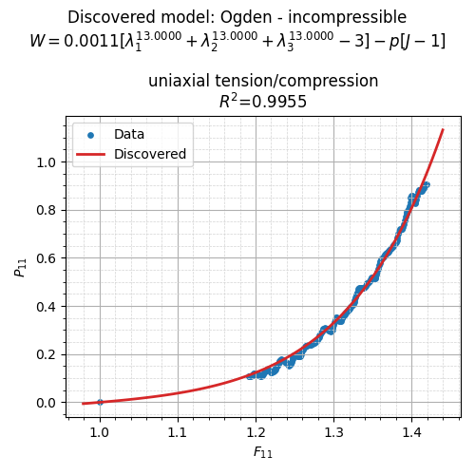

Result

python .\script.py

=== Material Fingerprinting ===
Contact moritz.flaschel@fau.de for help and bug reports.

The pickle database is loaded from the package resources.
Database Information:
models in the database:
Blatz-Ko - incompressible
Demiray - incompressible
Gent - incompressible
Holzapfel - incompressible
Mooney-Rivlin - incompressible
Neo-Hooke - incompressible
Ogden - incompressible
number of fingerprints = 2502
uniaxial tension: stretch ranges from 0.1 to 10.0 in the database

Material Fingerprinting Results:
discovered model: Ogden - incompressible
identified parameters: [1.09629646e-03 1.30000000e+01]
formula: $0.0011 [\lambda_1^{13.0000} + \lambda_2^{13.0000} + \lambda_3^{13.0000} - 3] - p [J-1]$
R² values per experiment:
uniaxial tension/compression: 0.9955
R² average over all experiments: 0.9955
('Ogden - incompressible', array([1.09629646e-03, 1.30000000e+01]), {'R2_per_experiment': {'uniaxial tension/compression': np.float64(0.9955002415702111)}, 'R2_average': np.float64(0.9955002415702111)})
PS C:\Users\abhis\OneDrive\Desktop\New folder>

fig1A-2-Purple
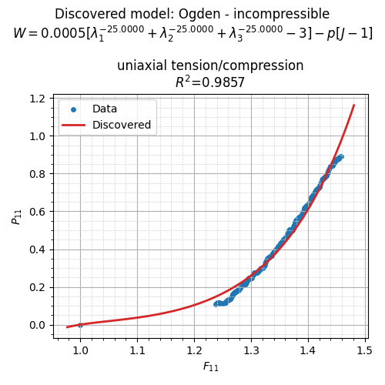
Result

python .\script.py

=== Material Fingerprinting ===
Contact moritz.flaschel@fau.de for help and bug reports.

The pickle database is loaded from the package resources.
Database Information:
models in the database:
Blatz-Ko - incompressible
Demiray - incompressible
Gent - incompressible
Holzapfel - incompressible
Mooney-Rivlin - incompressible
Neo-Hooke - incompressible
Ogden - incompressible
number of fingerprints = 2502
uniaxial tension: stretch ranges from 0.1 to 10.0 in the database

Material Fingerprinting Results:
discovered model: Ogden - incompressible
identified parameters: [ 5.08213717e-04 -2.50000000e+01]
formula: $0.0005 [\lambda_1^{-25.0000} + \lambda_2^{-25.0000} + \lambda_3^{-25.0000} - 3] - p [J-1]$
R² values per experiment:
uniaxial tension/compression: 0.9857
R² average over all experiments: 0.9857
('Ogden - incompressible', array([ 5.08213717e-04, -2.50000000e+01]), {'R2_per_experiment': {'uniaxial tension/compression': np.float64(0.9856635108883962)}, 'R2_average': np.float64(0.9856635108883962)})
PS C:\Users\abhis\OneDrive\Desktop\New folder>

fig1A-3-Red
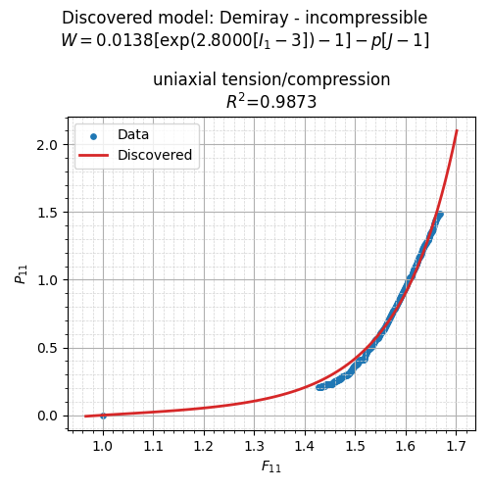

Result
python .script.py

=== Material Fingerprinting ===
Contact moritz.flaschel@fau.de for help and bug reports.

The pickle database is loaded from the package resources.
Database Information
models in the database
Blatz-Ko - incompressible
Demiray - incompressible
Gent - incompressible
Holzapfel - incompressible
Mooney-Rivlin - incompressible
Neo-Hooke - incompressible
Ogden - incompressible
number of fingerprints = 2502
uniaxial tension stretch ranges from 0.1 to 10.0 in the database

Material Fingerprinting Results
discovered model Demiray - incompressible
identified parameters [0.01381233 2.8 ]
formula $0.0138 left[exp(2.8000 [I_1 - 3]) - 1right] - p [J-1]$
R² values per experiment
uniaxial tensioncompression 0.9873
R² average over all experiments 0.9873
('Demiray - incompressible', array([0.01381233, 2.8 ]), {'R2_per_experiment' {'uniaxial tensioncompression' np.float64(0.987301969553367)}, 'R2_average' np.float64(0.987301969553367)})
PS CUsersabhisOneDriveDesktopNew folder

fig1A-4-Blue
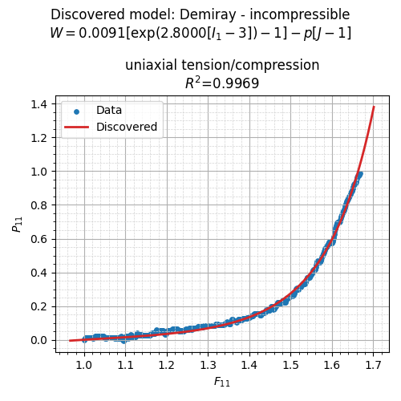
Result
python .\script.py

=== Material Fingerprinting ===
Contact moritz.flaschel@fau.de for help and bug reports.

The pickle database is loaded from the package resources.
Database Information:
models in the database:
Blatz-Ko - incompressible
Demiray - incompressible
Gent - incompressible
Holzapfel - incompressible
Mooney-Rivlin - incompressible
Neo-Hooke - incompressible
Ogden - incompressible
number of fingerprints = 2502
uniaxial tension: stretch ranges from 0.1 to 10.0 in the database

Material Fingerprinting Results:
discovered model: Demiray - incompressible
identified parameters: [0.00908171 2.8 ]
formula: $0.0091 \left[\exp(2.8000 [I_1 - 3]) - 1\right] - p [J-1]$
R² values per experiment:
uniaxial tension/compression: 0.9969
R² average over all experiments: 0.9969
('Demiray - incompressible', array([0.00908171, 2.8 ]), {'R2_per_experiment': {'uniaxial tension/compression': np.float64(0.9969154516301755)}, 'R2_average': np.float64(0.9969154516301755)})
PS C:\Users\abhis\OneDrive\Desktop\New folder>

