1. Introduction 2
1.1. Purpose 2
2. Interfaces 3
2.1. Dashboard 3
2.2. MANAGED MOBILE DEVICES 5
2.3. MANAGEBACKUP 7
2.4. ANTI-THEFT 7
2.5. ASSET MANAGEMENT 9
2.6. Report Templates 10
2.7. Report Scheduler 11
2.8. EVENTS AND DEVICES 12
2.9. SETTINGS 13
2.10. APP STORE 13
2.11. CALL LOGS 14
2.12. CONTENT LIBRARY 14
2.13. DATA USAGE 15
2.14. LOCATION HISTORY 15
2.13. FENCING LOCATION(S) 16

- Introduction (Enterprise Mobility Management)

eScan’s EMM is one of the most powerful security solutions available today to help organizations tide over the challenges of mobile devices (BYOD/COD) in their enterprise network from a Unified Management Console.
Enterprises empower employees by allowing use of mobile devices in the form of Company Owned Devices (COD) or implementing Bring Your Own Device (BYOD) policy for work operations. This enhances employee productivity and allows seamless business operations. eScan’s Enterprise Mobility Management (EMM) solution provides a comprehensive approach in safeguarding critical apps and enterprise data accessed or residing in mobile devices. It ensures that corporate data is secured from data loss, malware or unauthorized access.

1.1 Purpose

Mobile Content Management[MCM]

To allows administrators to deploy and manage content on the mobile devices that includes .pdf, .doc, .xls, .ppt, .jpeg, .png and other popular file formats. Content is deployed through eScan Management Console to managed devices and can be wiped out remotely in case of theft or loss of the device.

Mobile Asset Management[MASM]

To keep the entire hardware configuration and list of software installed on the mobile device thus allowing the administrator to keep track of hardware and software inventory on mobile devices.

Mobile Application Management[MAM]

To deploy, manage and secure authorized applications on mobile devices. Application Control is one of the potent features that restrict installation of malicious & unwanted applications. Administrator can also restrict download and installation of applications from unknown sources.

Mobile Productivity Management[MPM]

Provides application control, advanced web control, call and SMS filter ensuring that the device is used for productive purposes in accordance with the BYOD/COD policy of an enterprise.

Mobile Thread Defense[MTD]

It provides robust anti-malware control and security for the mobile device. All events are captured and the administrator is notified regarding any suspicious change in the mobile device. It is also equipped with advanced features for On Demand / Schedule Scan.

Mobile Identity[MI]

Mobile Identity feature helps in capturing device details through which a device can be correctly identified. This includes username, IMEI Number, mobile number, email id, phone model and other vital information of the device.

INTERFACES

2.1 Dashboard
Dashboard
Purpose | Dashboard is used to show summarized information graphically in the form of pie charts.
Method of use | The Dashboard page is displayed when you click the Dashboard module on the navigation bar. This page contains the following tabs namely Deployment Status, Protection Status and Protection Statistics. It displays all these information graphically in the form of pie charts.
Deployment Status
The exact numerical data of all the managed endpoints can be found here. For example: If eScan has been deployed on 50 machines; it will show the details of all the 50 machines namely the updated, not updated, unknown and the total number of managed endpoints.
Enrollment Status | The Installed status chart shows the total number of Enrolled/Not-Enrolled/Container Not-Enrolled on the device's of EMM Console.
eScan Status | eScan Status show the installed status for the all EMM console devices.
eScan Version | The eScan Version chart shows the total number of eScan versions installed on the device's of EMM Console.
Container Version | The Container Version chart shows the total number of container versions installedon the device's of EMM Console.
Android Version | The Android Version chart shows the total number of android versions installed on the device's of EMM Console.
Device Sync Status | The Device sync status chart shows the all devices last sync status in days /weekly basis.
Device Compliance | The Device Compliance chart shows the device's healthy level status.
Protection Status
The exact numerical data of all the managed endpoints can be found here. For example: If eScan has been deployed on 50 machines; it will show the details of all the 50 machines namely the updated, not updated, unknown and the total number of managed endpoints.
Update Status | The Update status chart shows the total number of Updated/Not-Updated device's of EMM Console.
Scan Status | The Scan status chart shows the total number of Scaned/Not-Scaned device's of EMM Console.
Anti Virus | The Anti Virus chart shows the total Started/Stoped status of antivirus on the device's of EMM Console.
Web Control | The Web Control chart shows the total Started/Stoped status of web control on the device's of EMM Console.
Application control | The Application control chart shows the total Started/Stoped status of App control on the device's of EMM Console.
Call & SMS Filter | The Call & SMS Filter chart shows the total Started/Stoped status of Call & SMS Filter on the device's of EMM Console.
Firewall Status | The Firewall status chart shows the total Enabled/Disabled status of Firewall on the device's of EMM Console.
Protection Statistics
This will display the module activity of all the managed computers. For example: The files that were disinfected, quarantined, deleted, access denied, USB allowed or blocked.
Anti Virus | The Anti Virus chart shows the total Skilled/Deleted action when virus is found on the device's of EMM Console.
Web Control | The Web Control chart shows total number of Allowed/Blocked web action on the device's of EMM Console.
Application control | The Application control chart shows total number of Allowed/Blocked apps on the devices of EMM Console.
Call Statistics | The Call Statistics chart shows total allowed/blocked status of Incoming/Outgoing call on the device's of EMM Console.
SMS Statistics | The SMS Statistics chart shows total sent/received SMS on device's of EMM Console.
Inputs | Name | Type | Description | Validations
 | Configure Dashboard Display |  | Options for deployment and status
Actions | - Configure dashboard  - Click on links to show reports of license, update, scan and protection contains machine name , group name and status.  - By clicking on More link we can see the Additional protection statistics.
 | Name | Type | Description | Validations
Outputs | - It shows the deployment and protection status of every module in graphical structure.  - Show deployment status report, protection status report and protection statistics report.
Error Messages | Type |  | Reason
Log Events
Related SFRs

2.2 Managed Devices
Managed Devices
Purpose | Using Managed devices we can perform all device related action.we can configure the policy for the particular group and also used to perform group action's.
Method of use | Click Managed Devices Module present in the Navigation Panel of Enterprise Mobility Management Console. And perform a require group/client related action or configure policy for specific group.
Inputs | Name | Type | Description |  | Validations
 | Create new sub group |  | Add new group
Group Actions | - New Group.  - Add New Device.  - Add multiple Devices.  - Remove Group.  - Change Server IP.  - Synchronize with Active Directory.  - Properties.
Client Action | - Move to Group.  - Properties.  - Remove from group.  - Resend Enrollment Email.  - Change Username/Email-id.  - Disenroll.
 | Name | Type | Description | Validations
Outputs | - Export to excel/html/pdf report.  - Show the client list and perform the above actions.  - Shows the search output.
Error Messages | Type |  | Reason
 | Please enter a Mobile number. |  | If the Mobile is empty after save info.
 | Length of Username must be between 3 and 25 characters. |  | If the user name is empty or length is not 3 and 20.
 | Please enter valid email id eg. username@company.com. |  | If email id is empty or invalid.
 | Device already present in "Managed Mobile Device" under Managed Devices\test Group. |  | If the device is already with entered mobile no in any group.
 | Please select file to proceed. |  | If file is not selected in case while adding multiple devices.
 | Can not move in the same group! |  | If the selected items are moving into the same group.
 | Can not delete non-empty group. |  | Can not delete group if device is exist to group.
 | Group already existing! |  | If the entered group name is already present.
 | Length of Group name must be between 3 and 20. |  | If the group name is empty or length is not 3 and 20.
Log Events
Related SFRs
Log File | ErrorLogMDM.log

Flow Diagram(Enrollment process)
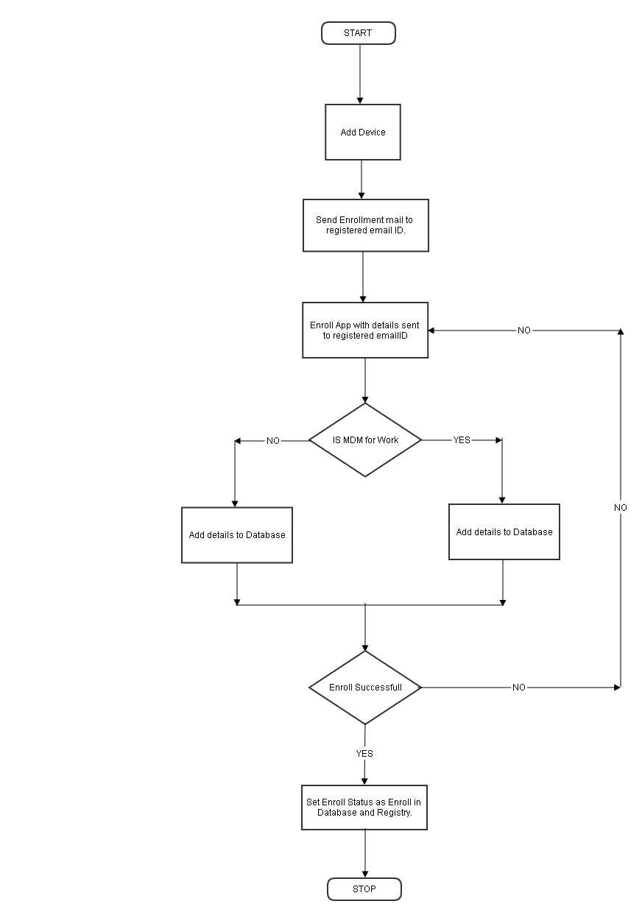

2.3 Manage Backup
Manage Backup
Purpose | Using the Manage Backup module of eScan, you can take backup of SMS and Contact list saved on Managed Device to the server and restore it later on the device whenever required. eScan’s Mobile Device Management allows you to take Backup of SMS and Contacts from the selected Devices/ Groups to the MDM Server.
Method of use | - Select the Devices or Group in Manage Backup module of eScan from where you wish to take backup of SMS to the MDM server.  - Now click Backup Now and select the desired option using respective check box to take backup.  - Click Backup Now option to take the Backup.
Log File | ErrorLogMDM.log

2.4 Anti Theft
Anti-Theft
Purpose | It allows the administrator to block the device remotely thus preventing misuse in case of theft or loss. Administrator can easily unblock the device remotely from the management console when required.
Method of use | Click Anti-theft Module present in the Navigation Panel of Enterprise Mobility Management Console.
Action | Name | Description
1 | Wipe | This will delete container (corporate data and apps), SMS and address book content from the device in case the device is lost or misplaced.
2 | Block | This will block the device as login pin will be changed on command execution remotely through management console.
3 | Scream | Raise an alarm on the device for easily locating the device.
4 | Send Message | Administrator can broadcast a message to managed devices.
5 | Locate | Track the GPS location of the device remotely along with detailed history on a map.
6 | Unblock Device | This will Un-block the block device's remotely through management console.
7 | Remove Work Profile | Remove the work profile from the selected device's and change device status accordingly to management console.
Log File | AntiTheft.log

Flow Diagram(Anti-Theft)
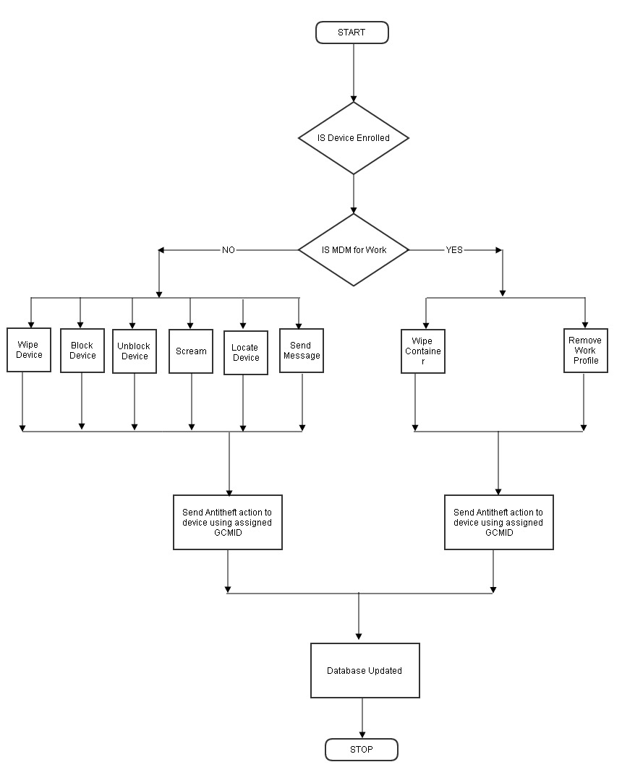

2.5 Asset Management
Asset management
Purpose | This Module displays detailed description of the Hardware and Application installed on the Managed Devices.
Method of use | - Click Asset Management Module present in the Navigation Panel of Mobile Device Management Console.  2. Now select the desired Tab to view related information.
Inputs | Name | Type | Description |  | Validations
 | Filter criteria |  | We can set the filter criteria as per the required field
 | Export Option |  | We can get a exported report file for filtered result.
Actions | - We can set the no. of rows per page.  - By clicking on View Link we can see the Application details like : Application Name ,Application version and application Installed Date.  - In Application information tab by clicking on device count link, we can see the device details like : Phone No,Operating System and Group.
 | Name | Type | Description | Validations
Outputs | - We can Export the report in HTML, PDF and Excel file.  - We can see the device application and Hardware information.
Error Messages | Type |  | Reason
Log Events
Related SFRs

2.6Report Templates
Report Templates
Purpose | The Reports Template page allows you to create and view customized reports based on a given template, for a given period; sorted by date, computer, or action taken; and for a selected condition or target group. It also provides options for configuring or scheduling reports, viewing report properties, and refreshing or deleting existing reports.
Method of use | - Click Reports Template in the navigation bar and select the desired Template.  - Click Create schedule.  - .Now define the Report Name and filter the criteria for generating report by expanding the tree.  - .Select the Conditions and Target Groups for generating Reports.  - Define email and Server settings for sending reports by mail, also select the Format for the report, you can generate report in html, CSV,PDF and Excel formats, as required by you.  - Schedule the report as desired and click OK.  - Report will be created and scheduled instantly.  - To save the settings and to create a report, click Save.
Inputs | Name | Type | Description |  | Validations
 | Create New Template |  | Create new template with report type and date option
 | Create new schedule |  | Create new report with different settings like Template for creating a report, conditions, target groups, report by mail and report format.
Actions | - We can save the properties for selected template  - Delete selected template.  - Allow to create new template  - Allow to create schedule
 | Name | Type | Description | Validations
Outputs | Shows list of templates
Log Events
Related SFRs

2.7 Report Scheduler
Report Scheduler
Purpose | The Report Scheduler page allows you to schedule the creation and sending of reports on based on your requirements.
Method of use | Click Report Schedular Module present in the Navigation Panel of Mobile Device Management Console.And Add/Update the schedule for exiting report template.
Inputs | Name | Type | Description |  | Validations
 | New Schedule |  | Create new report with different settings like Template for creating a report, conditions, target groups, report by mail and report format.
 | View and Create |  | Create New Schedule with Template for creating a report and conditions.
 | Run |  | Generate a specified report and send report to specified email id.
Actions | - Start the selected scheduled tasks  - We can set properties like schedule time, group and settings  - We can delete schedule tasks  - We can create and view new schedule.
 | Name | Type | Description | Validations
Outputs | We can create, delete and set the properties of schedule report.  we can view scheduled report and start the task.
Error Messages | Type |  | Reason
 | Select applied Group/Clients |  | When we perform any action related to Device or group without selecting the a single device or group
 | Email Id already exist |  | If entered email id is already exists
 | Select at least one day of week. |  | If report is scheduled for weekly basis and no week day is selected.
 | Please Select Report Type to Run. |  | You have to select at least one report type.
 | Invalid Recipient Email Id . |  | If no recipient is either empty or invalid.
 | Task already exists with this Name. |  | If the task name is already present.
Log Events
Related SFRs

2.8 Events & Devices
Events & Computers
Purpose | The Events and Devices module enables you to view logs of the events occurred on the client Devices.
Method of use | - Click Events and Devices Module present in the Navigation Panel of Mobile Device Management Console.  2. Now select the desired Node to view related information.
Inputs | Name | Type | Description |  | Validations
 | Events & devices Settings |  | We can set the events & device settings as Event Status, Device selection and Application & hardware changes
Actions | - We can set the number of rows per page
 | Name | Type | Description | Validations
Filter | We can filter events and devices details for MDM ,CONTAINER and Both.
Outputs | - We can see following events status:  - Recent  - Critical  - Information  - Device Selection :  - Devices With “Critical Status”  - Devices with “warning status”  - Database are outdated  - Many Viruses detected  - Not Connected for long time  - Not scanned for long time  - Protection is off  - Application/ Hardware Changes  - Application Changes  - Hardware Changes  - Existing Device Info
Error Messages | Type |  | Reason
 | Host is not active |  | If Client machine is not active

2.9 Settings
Settings
Purpose | Using this module, you can Save Server details for sending Email notifications to the Device user email addresses.
Method of use | 1. Click Settings Module present in the Navigation Panel of Mobile Device Management Console.  2. And configure a server details for sending mail notification.

2.10 App Store
App Store
Purpose | Using the App Store you can Add apps that will be of use to the Mobile Device users accessing your network. After adding the apps to the App Store you can push these apps to the managed devices through policy deployment.
Method of use | - Click Add under the App Store module of eScan’s Mobile Device Management Console.  - Now browse the path where the .apk file for the app is saved and click Continue.  - You will be forwarded to the Edit Application window, write a brief description for the App and click Save.  - App will be added in the store instantly.  5. Click on the Numeric Value present in Installed Column to view the list of devices where the application is installed, initially before policy deployment it will be 0. If the app with the same version number is installed on the devices the count will be shown accordingly.
Action | Name | Type | Description | Validations
 | ADD/EDIT |  | Add/Edit application to console.
 | DELETE |  | Delete Application's form console App store
Outputs | Show a list of all application in tabular form.
Log File | ErrorlogMDM.log

2.11 Call Log
Call Log
Purpose | This feature allows the administrator to maintain call logs of all enrolled devices along with the call duration in hours, minutes and seconds format.  1. Maintain incoming, outgoing and missed call logs of all the enrolled devices.  2. Facilitate call and SMS filtering for enrolled devices.
Method of use | - Click Add under the App Store module of eScan’s Mobile Device Management Console.  - Now browse the path where the .apk file for the app is saved and click Continue.  - You will be forwarded to the Edit Application window, write a brief description for the App and click Save.  - App will be added in the store instantly.  5. Click on the Numeric Value present in Installed Column to view the list of devices where the application is installed, initially before policy deployment it will be 0. If the app with the same version number is installed on the devices the count will be shown accordingly.
It will display the following details:
Sr. No. | Captured Information | Description
1 | Mobile no. | It will display the managed Mobile Device number
2 | Name(As in contact list) | It will display the name of the Contact as in the contact list of
3 | Contact No | The Contact number to which the call was made or the call was received from.
4 | Type of call | It will display whether the call was incoming or outgoing.
5 | Call/Receive Time | It will display the specific time when the call was made or received.
6 | Call Duration | It will display the time duration of each call (incoming and outgoing) of the managed mobile device.
Log File | ErrorlogMDM.log

2.12 Content Library
Content Library
Purpose | This feature will allow the administrator to deploy documents and other important information to the enrolled mobile devices. The documents can be imported from the content library and deployed to the devices through Unified Management Console. The document types that can be deployed are pdf, doc, docx, xls, xlsx, ppt, pptx, txt, jpg, jpeg, png, and bmp.
Method of use | - Click Add under the content Library module of eScan’s Mobile Device Management Console.  - Now browse the path where the file is saved and click Continue.  3. You will be forwarded to the next window, write a brief description for the document and click Save
Log File | ErrorlogMDM.log

2.13 Data Usage
Data Usage
Purpose | This feature will allow the administrator to get the tota
Method of use | - Click Add under the content Library module of eScan’s Mobile Device Management Console.  - Now browse the path where the file is saved and click Continue.  3. You will be forwarded to the next window, write a brief description for the document and click Save
Log File | ErrorlogMDM.log

2.14 Location History
Location History
Purpose | Location history is used to track all a map location of client device's by default it show a current day location on map.
Method of use | Select Location History option in left menu and can select a device group and click on the location count corresponding to device.We can filter a location details with date/time change.
Action | Name | Type | Description | Validations
 | Add Location details to server. |  | Get location data from the locate event a write a location details to server DB.
 | Filter Location |  | Filter location details based on selected date/time.
Outputs | Get some specific map location's to apply specific policy to client device while located to specified fence location.Can see the map/Satellite view.
Log File | LocationHistory.log

2.15 Fencing Location(s)
Fencing Location(s)
Purpose | Fencing Location is used to add some specific google map location to apply a specific policies based on the selected goggle map location.
Method of use | Select Fencing location(s) option in left menu and add/modify location details.
Inputs | Name | Type | Description |  | Validations
 | Add/Edit Location |  | Add option is used to add a new fencing location to server and Edit option used to modify a location details for existing location.
 | View On Map |  | To view a selected location on map.
 | Default Location |  | Default location option is used to set a default location to pointed when we are going add new location in the server.
 | Name | Type | Description | Validations
Outputs | Get some specific map location's to apply specific policy to client device while located to specified fence location.Can see the map/Satellite view.
Log File | LocationHistory.log

