nKindly write any 10 programs.

1. Write a Shell Script to find maximum between two numbers.

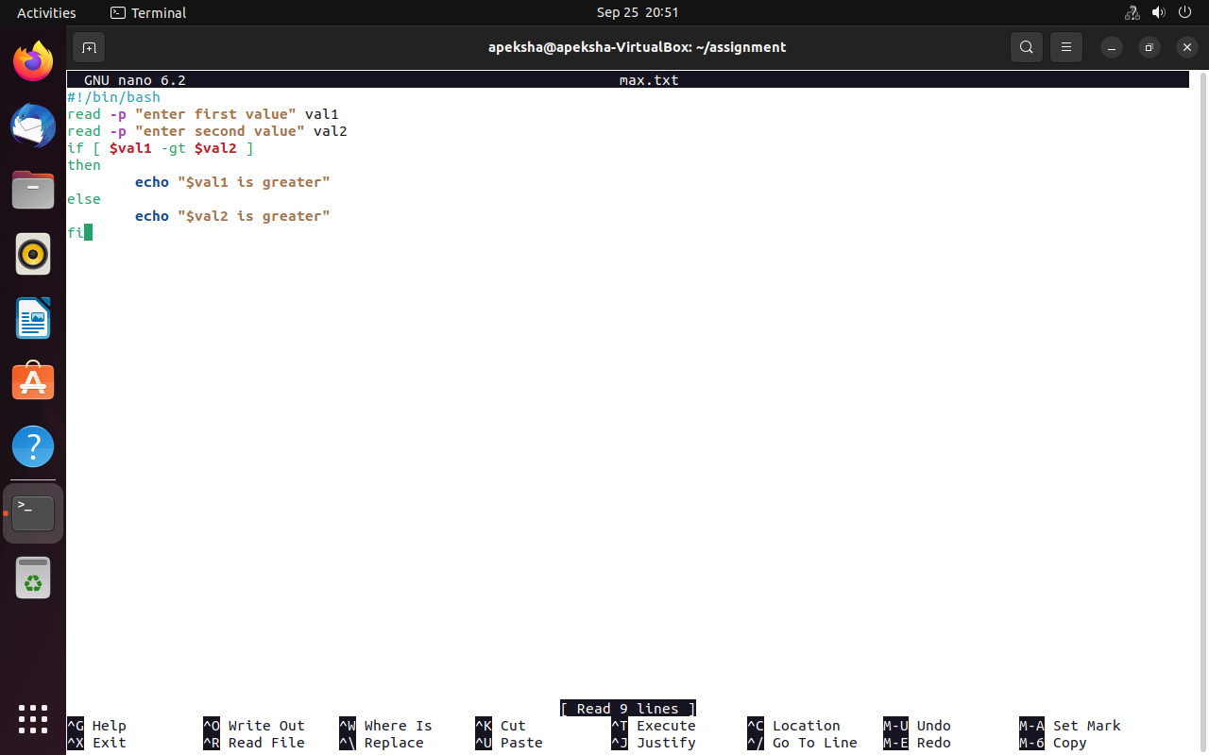

1. Write a Shell Script to find maximum between three numbers.

3. Write a Shell Script to check whether a number is negative, positive or zero.

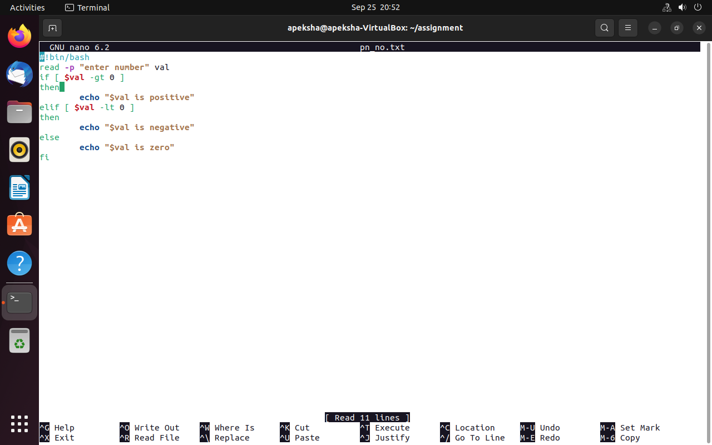

4. Write a Shell Script to check whether a number is divisible by 5 and 11 or not.

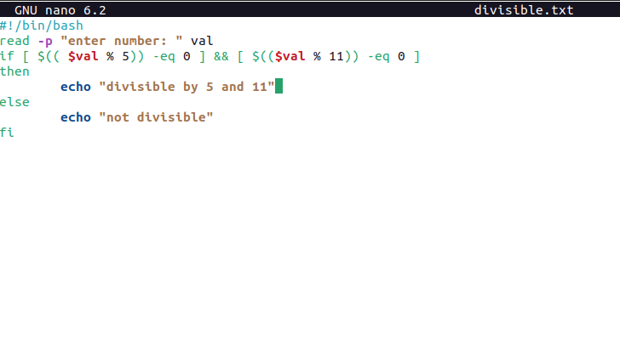

5. Write a Shell Script to check whether a number is even or odd.

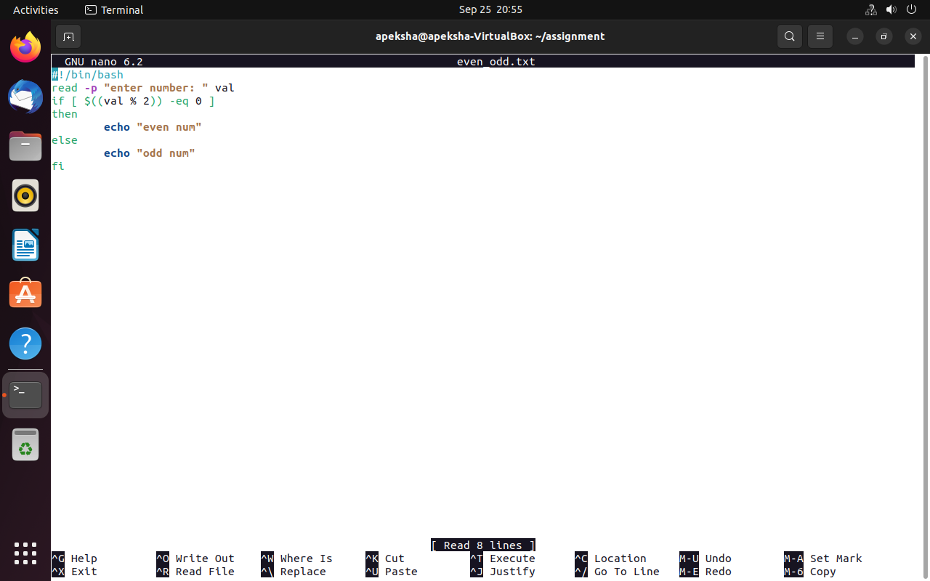

6. Write a Shell Script to check whether a year is leap year or not.

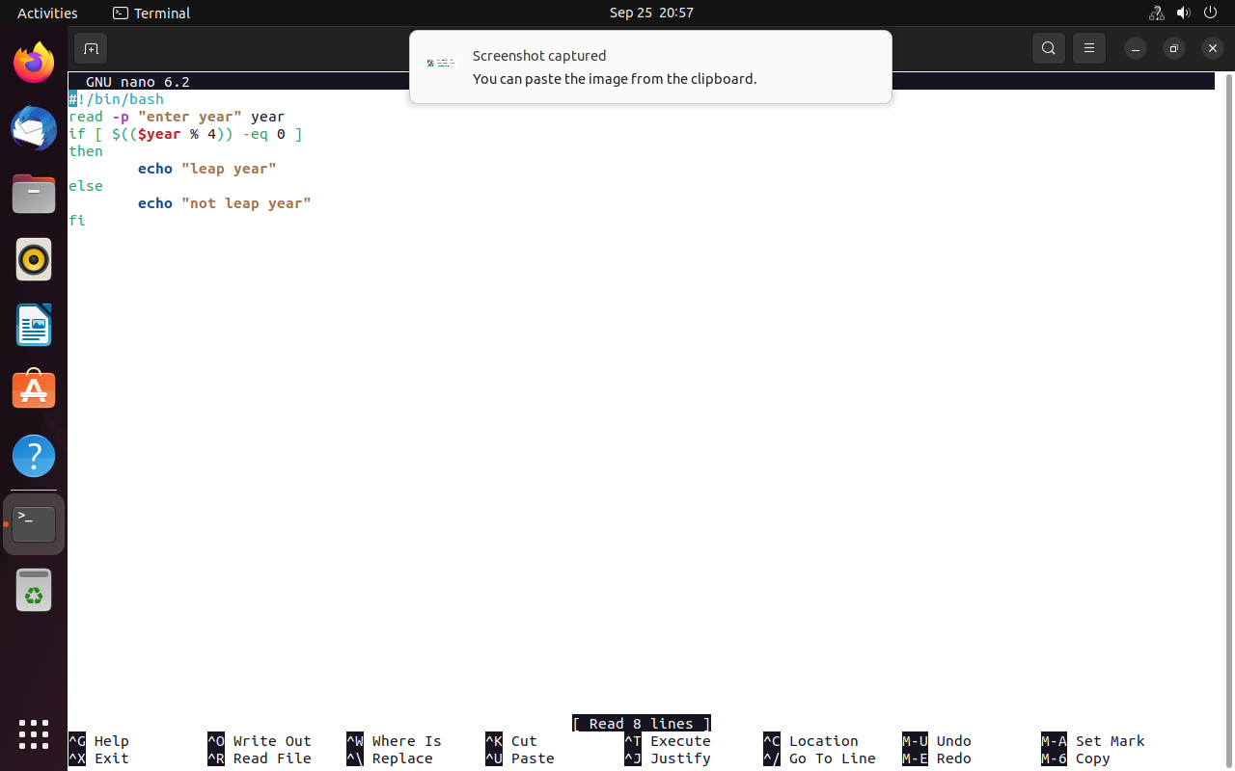

7. Shell Script to print number between 1 to 10 in character format using switch-case.

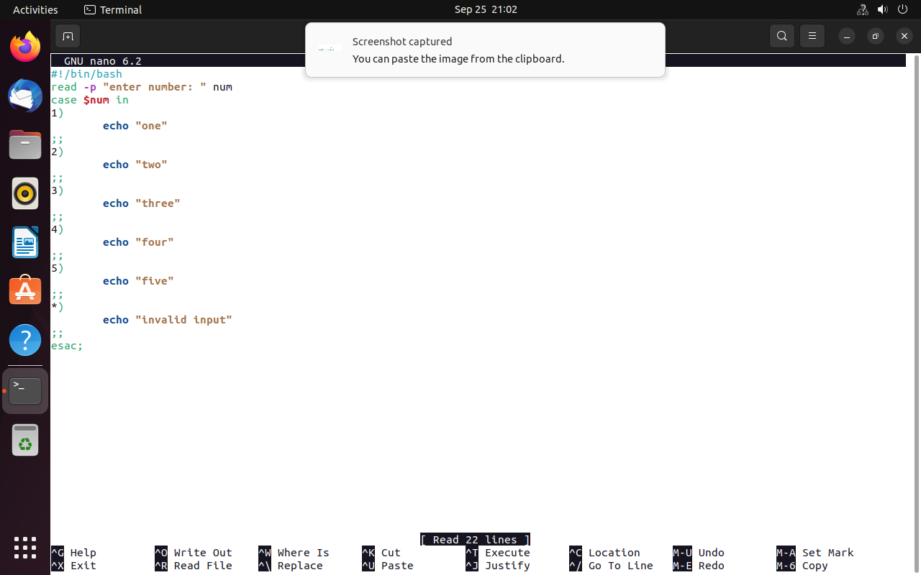

8. Shell Script to accept id from user to confirm department using switch-case.

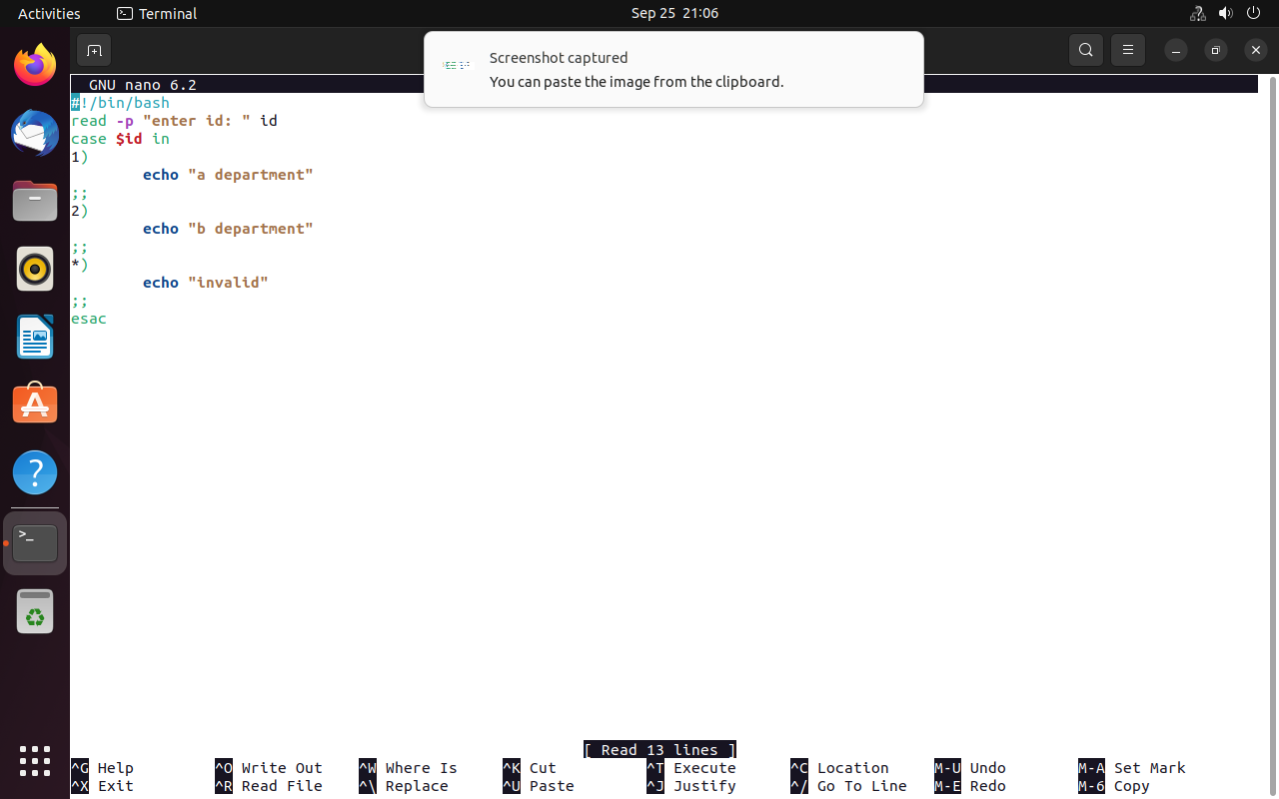

9. Shell Script to check password is correct or incorrect using switch-case.

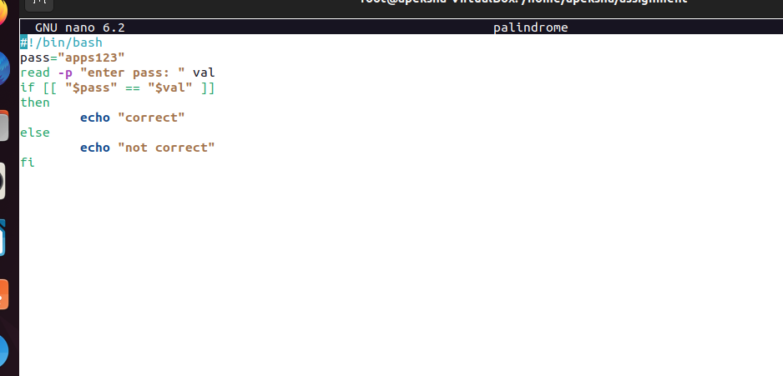

10. Shell Script to print day of week using switch-case.

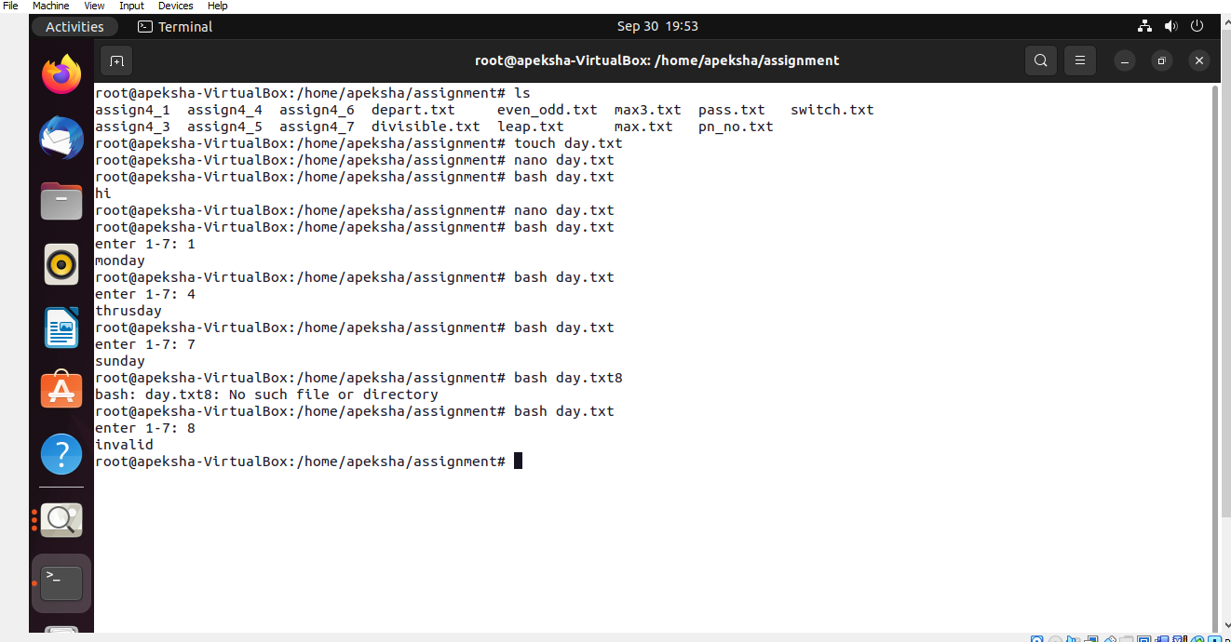

11. Shell Script to create calculator using switch-case.

