1. Shell Script to display the first 10 natural numbers.

Expected Output :

1 2 3 4 5 6 7 8 9 10

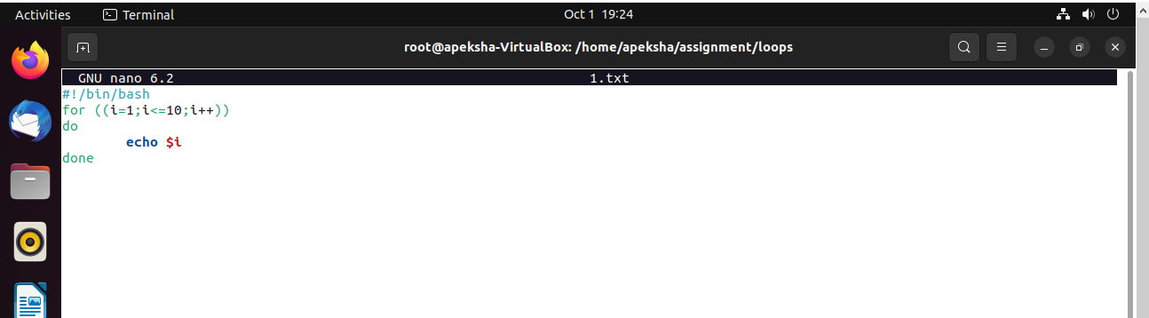

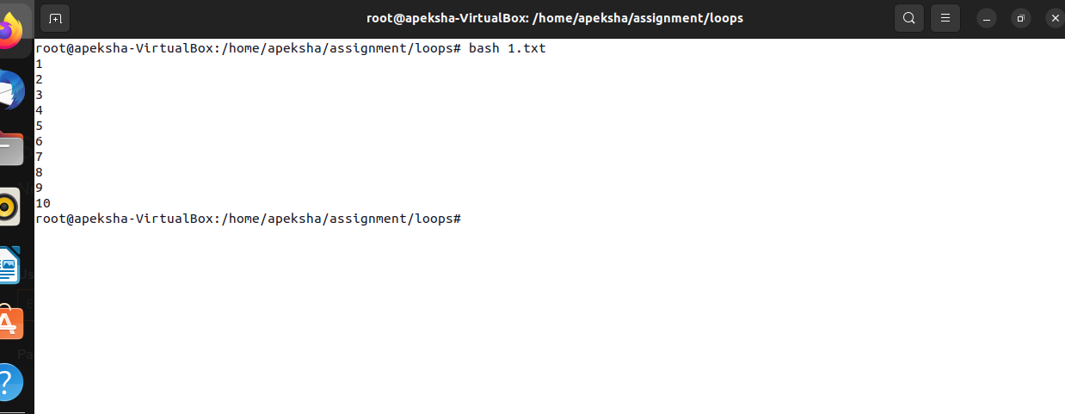

2. Shell Script to compute the sum of the first 10 natural numbers.

Expected Output :

The first 10 natural number is :

1 2 3 4 5 6 7 8 9 10

The Sum is : 55

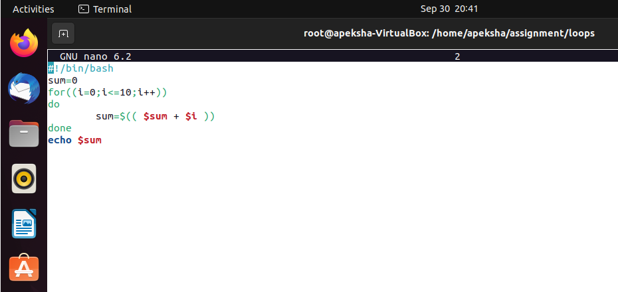



3. Shell Script to display n terms of natural numbers and their sum.

Test Data : 7

Expected Output :

The first 7 natural number is :

1 2 3 4 5 6 7

The Sum of Natural Number upto 7 terms : 28

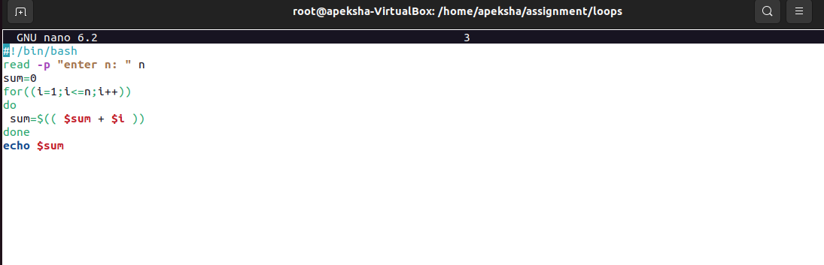

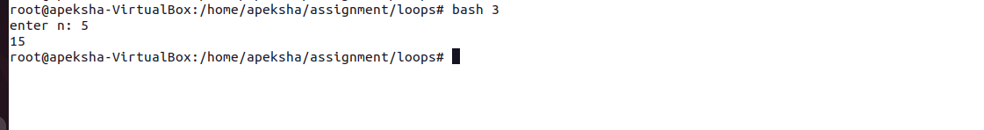

4. Shell Script to read 10 numbers from the keyboard and find their sum and average.

Test Data :

Input the 10 numbers :

Number-1 :2

...

Number-10 :2

Expected Output :

The sum of 10 no is : 55

The Average is : 5.500000

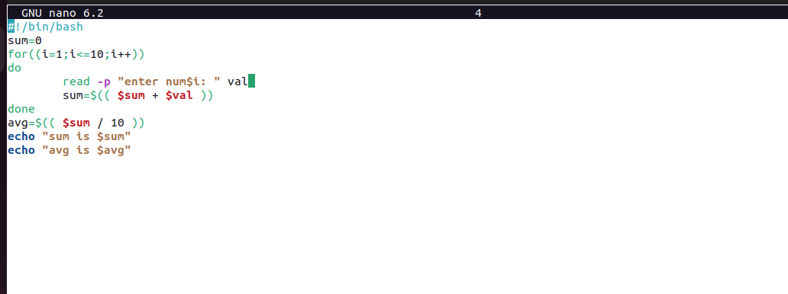

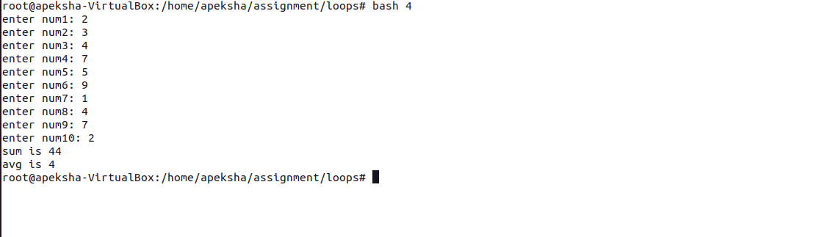

5. Shell Script to display the cube of the number up to an integer.

Test Data :

Input number of terms : 5

Expected Output :

Number is : 1 and cube of the 1 is :1

Number is : 2 and cube of the 2 is :8

Number is : 3 and cube of the 3 is :27

Number is : 4 and cube of the 4 is :64

Number is : 5 and cube of the 5 is :125

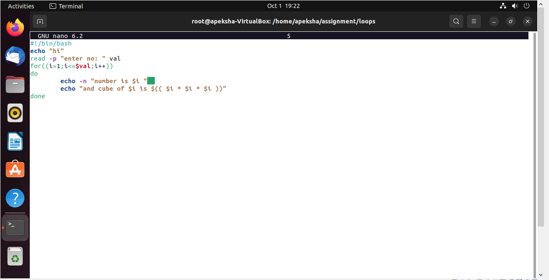

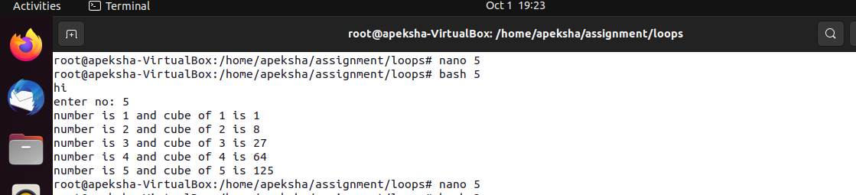

6. Shell Script to display the multiplication table for a given integer.

Test Data :

Input the number (Table to be calculated) : 15

Expected Output :

15 X 1 = 15

...

...

15 X 10 = 150

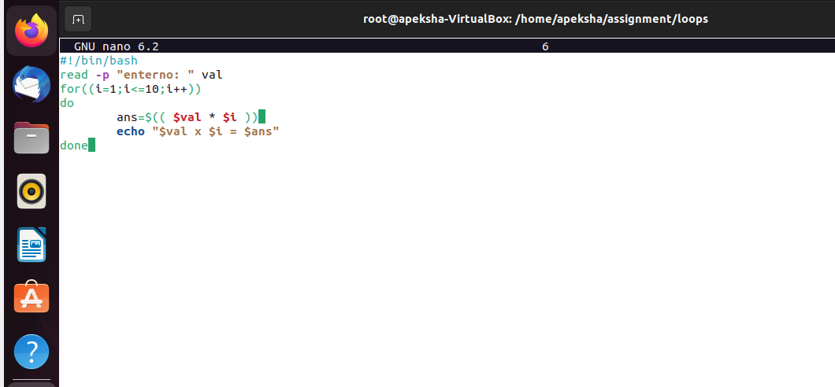

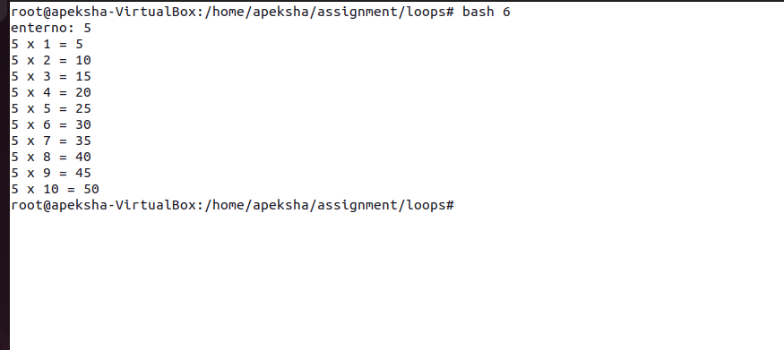

7. Shell Script to display the multiplier table vertically from 1 to n.

Test Data : Input upto the table number starting from 1 : 8

Expected Output : Multiplication table from 1 to 8

1x1 = 1, 2x1 = 2, 3x1 = 3, 4x1 = 4, 5x1 = 5, 6x1 = 6, 7x1 = 7, 8x1 = 8…

1x10 = 10, 2x10 = 20, 3x10 = 30, 4x10 = 40, 5x10 = 50, 6x10 = 60, 7x10 = 70, 8x10 = 80

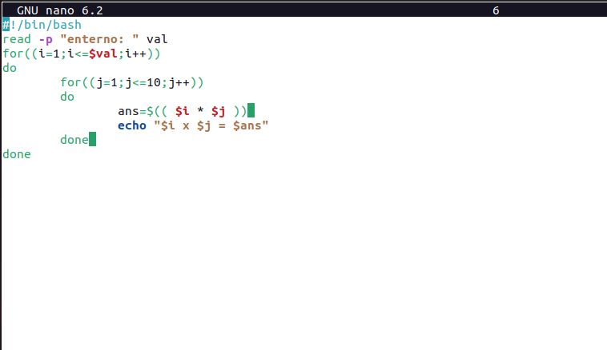

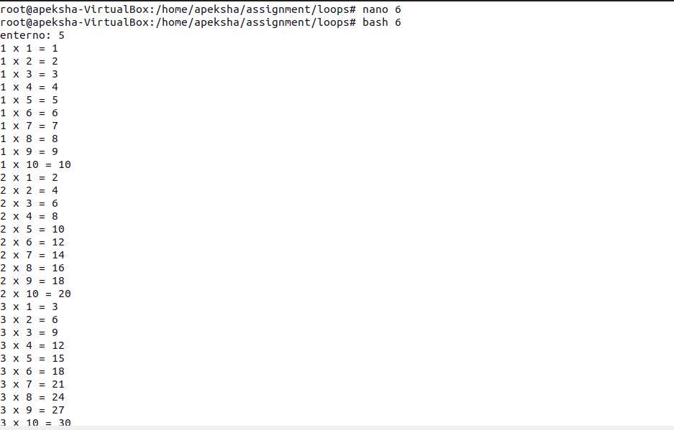

8. Shell Script to display the n terms of odd natural numbers and their sum.

Test Data

Input number of terms : 10

Expected Output :

The odd numbers are :1 3 5 7 9 11 13 15 17 19

The Sum of odd Natural Number upto 10 terms : 100

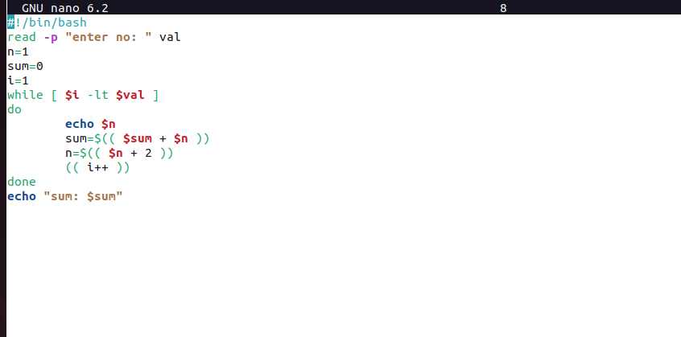

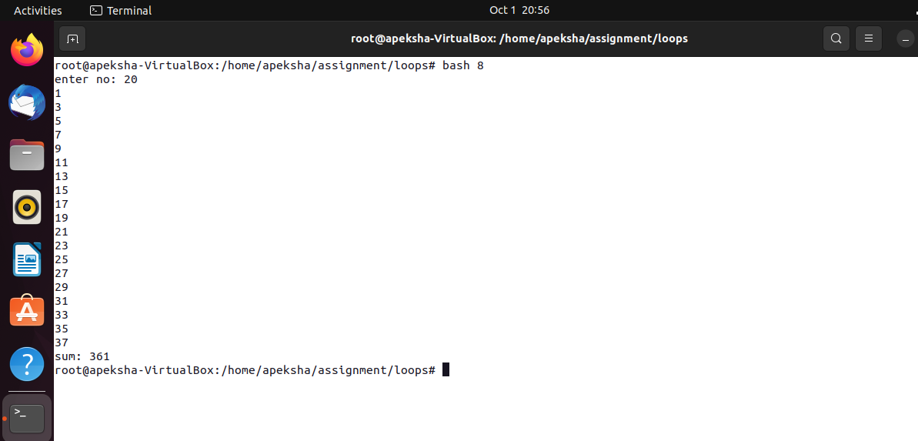

9. Shell Script to display a pattern like a right angle triangle using an asterisk.

The pattern like :

\*

\*\*

\*\*\*

\*\*\*\*

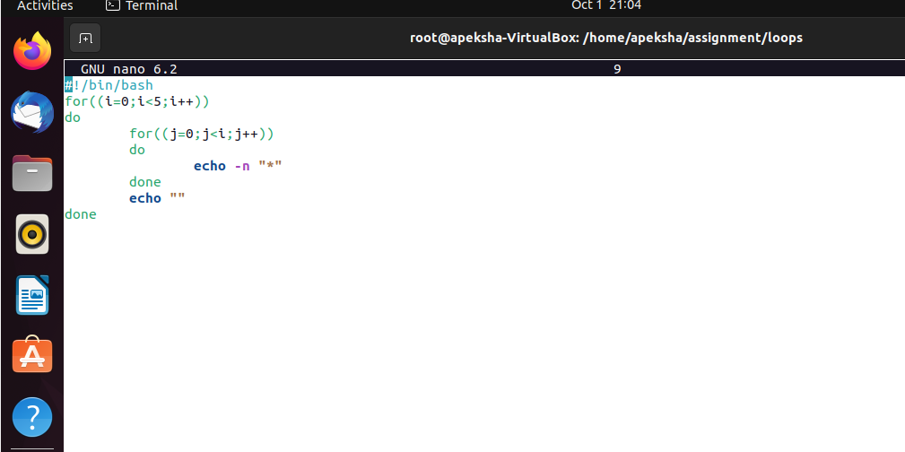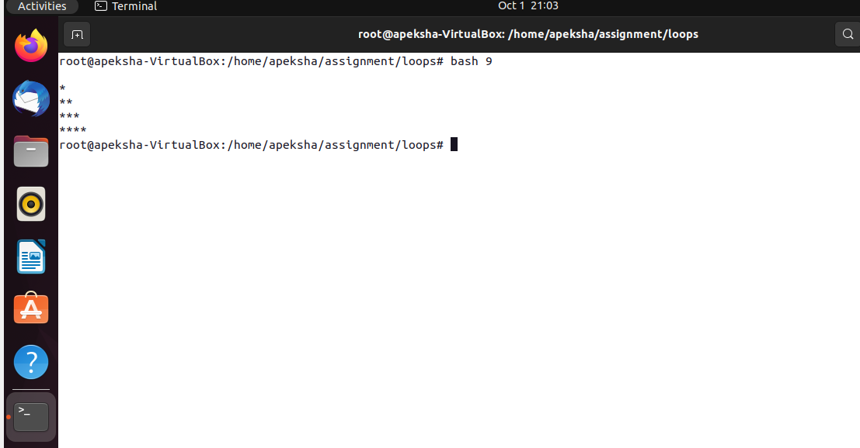

10. Shell Script to display a pattern like a right angle triangle with a number.

The pattern like :

1

12

123

1234

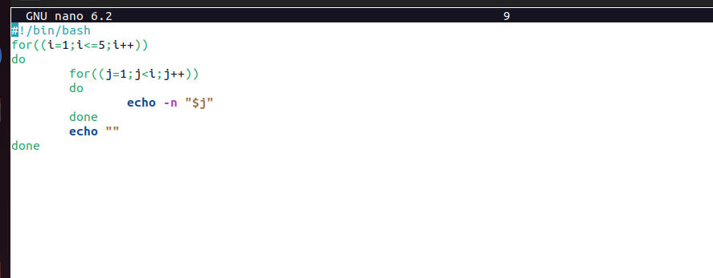

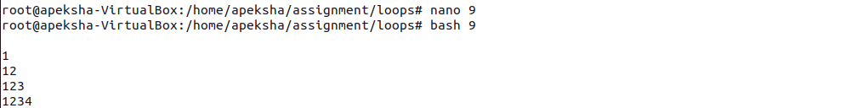

11. Shell Script to make such a pattern like a right angle triangle with a number which will repeat a number in a row.

The pattern like :

1

22

333

4444

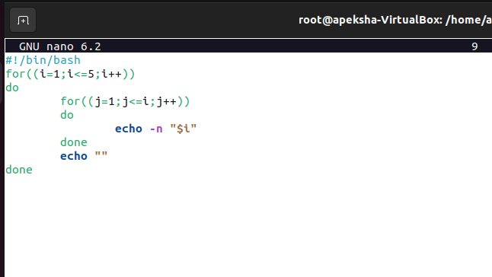

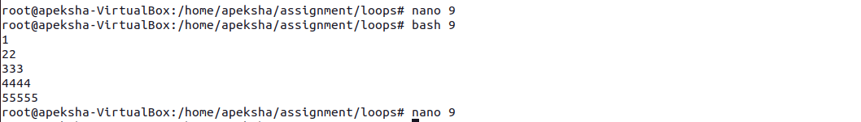

12. Shell Script to make such a pattern like a right angle triangle with the number increased by 1.

The pattern like :

1

2 3

4 5 6

7 8 9 10

