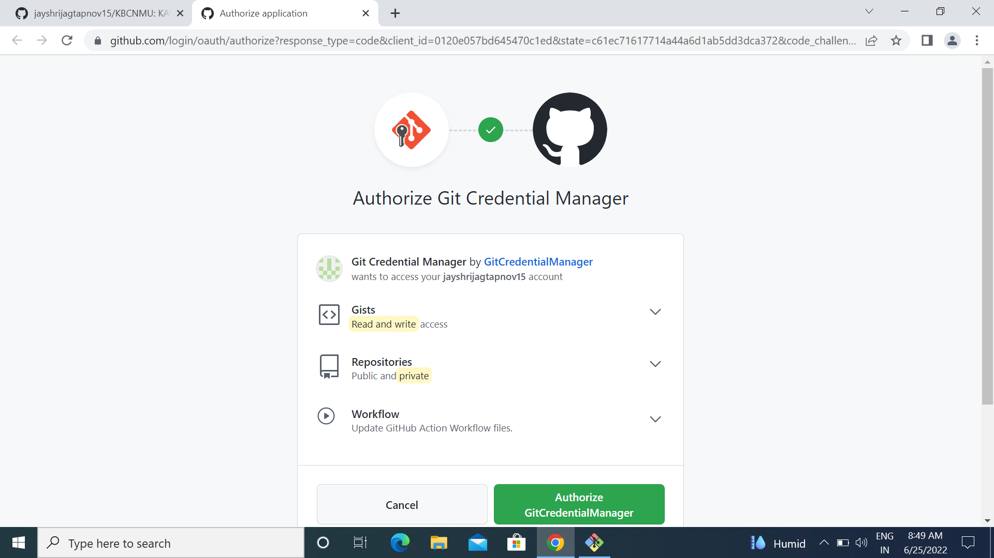

4Cloning into 'JALGOAN'...

remote: Enumerating objects: 3, done.

remote: Counting objects: 100% (3/3), done.

remote: Total 3 (delta 0), reused 0 (delta 0), pack-reused 0

Receiving objects: 100% (3/3), done.

hp@DESKTOP-DGJ0MVU MINGW32 ~

$ cd JALGOAN

hp@DESKTOP-DGJ0MVU MINGW32 ~/JALGOAN (main)

$ git init JALGOAN

Initialized empty Git repository in C:/Users/hp/JALGOAN/JALGOAN/.git/

hp@DESKTOP-DGJ0MVU MINGW32 ~/JALGOAN (main)

$ touch jayshri.txt

hp@DESKTOP-DGJ0MVU MINGW32 ~/JALGOAN (main)

$ git add jayshri.txt

hp@DESKTOP-DGJ0MVU MINGW32 ~/JALGOAN (main)

$ ls

JALGOAN/ README.md jayshri.txt

hp@DESKTOP-DGJ0MVU MINGW32 ~/JALGOAN (main)

$ git commit -m"fourth practicale"

[main f467089] fourth practicale

1 file changed, 0 insertions(+), 0 deletions(-)

create mode 100644 jayshri.txt

hp@DESKTOP-DGJ0MVU MINGW32 ~/JALGOAN (main)

$ git config --global user.name"jayshrijagtapnov15"

hp@DESKTOP-DGJ0MVU MINGW32 ~/JALGOAN (main)

$ git config --global user.email"jagtapjayshri99@gmail.com"

hp@DESKTOP-DGJ0MVU MINGW32 ~/JALGOAN (main)

$ git push -u origin

Enumerating objects: 4, done.

Counting objects: 100% (4/4), done.

Delta compression using up to 4 threads

Compressing objects: 100% (2/2), done.

Writing objects: 100% (3/3), 288 bytes | 144.00 KiB/s, done.

Total 3 (delta 0), reused 0 (delta 0), pack-reused 0

To https://github.com/jayshrijagtapnov15/JALGOAN.git

0d2b931..f467089 main -> main

branch 'main' set up to track 'origin/main'.

hp@DESKTOP-DGJ0MVU MINGW32 ~/JALGOAN (main)

hp@DESKTOP-DGJ0MVU MINGW32 ~

$ git clone https://github.com/jayshrijagtapnov15/KBCNMU.git

fatal: destination path 'KBCNMU' already exists and is not an empty directory.

hp@DESKTOP-DGJ0MVU MINGW32 ~

$ git clone https://github.com/jayshrijagtapnov15/KBCNMU.git

Cloning into 'KBCNMU'...

remote: Enumerating objects: 3, done.

remote: Counting objects: 100% (3/3), done.

remote: Compressing objects: 100% (2/2), done.

remote: Total 3 (delta 0), reused 0 (delta 0), pack-reused 0

Receiving objects: 100% (3/3), done.

hp@DESKTOP-DGJ0MVU MINGW32 ~

$ cd KBCNMU

hp@DESKTOP-DGJ0MVU MINGW32 ~/KBCNMU (main)

$ git init KBCNMU

Initialized empty Git repository in C:/Users/hp/KBCNMU/KBCNMU/.git/

hp@DESKTOP-DGJ0MVU MINGW32 ~/KBCNMU (main)

$ touch jayshri.txt

hp@DESKTOP-DGJ0MVU MINGW32 ~/KBCNMU (main)

$ git add jayshri.txt

hp@DESKTOP-DGJ0MVU MINGW32 ~/KBCNMU (main)

$ ls

KBCNMU/ README.md jayshri.txt

hp@DESKTOP-DGJ0MVU MINGW32 ~/KBCNMU (main)

$ git commit -m"fourth practicle"

[main f614aff] fourth practicle

1 file changed, 0 insertions(+), 0 deletions(-)

create mode 100644 jayshri.txt

hp@DESKTOP-DGJ0MVU MINGW32 ~/KBCNMU (main)

$ git config --global user.name"jayshrijagtapnov15"

hp@DESKTOP-DGJ0MVU MINGW32 ~/KBCNMU (main)

$ git config --global user.email"jagtapjayshri99@gmail.com"

hp@DESKTOP-DGJ0MVU MINGW32 ~/KBCNMU (main)

$ git push -u origin

New

