**Dashboard**

The dashboard component of the project provides the user an interface to communicate with the features of OpenStack. User can launch various mobile instances as well as test server instances on OpenStack. The Hub tab allows the user to communicate their test server with the mobile instances. User can also view the details of their instances like CPU usage, Ram, Storage, number of instances. User can also generate the bill of the instances created. OpenStack horizon code is modified to display details about the instances launched and cost of the resources utilized.

1. Login page authenticates the user by verifying the username and password.

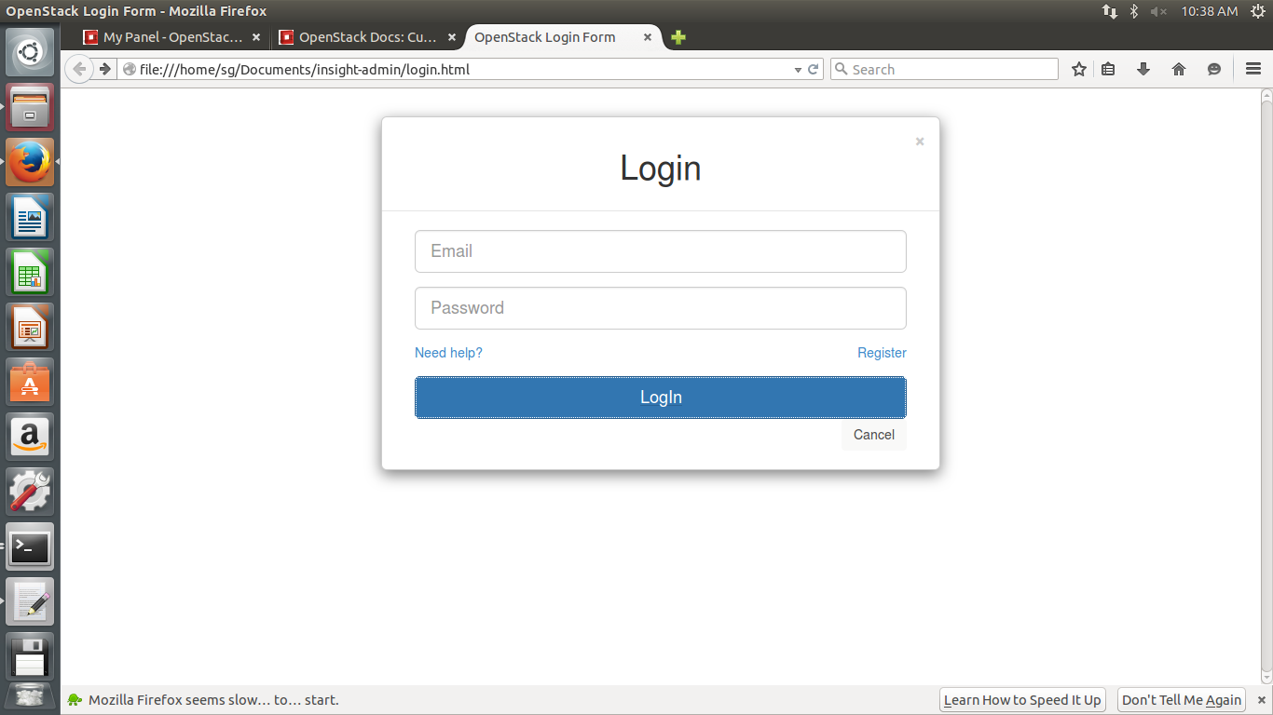

1. Various different tabs define various features of the project.

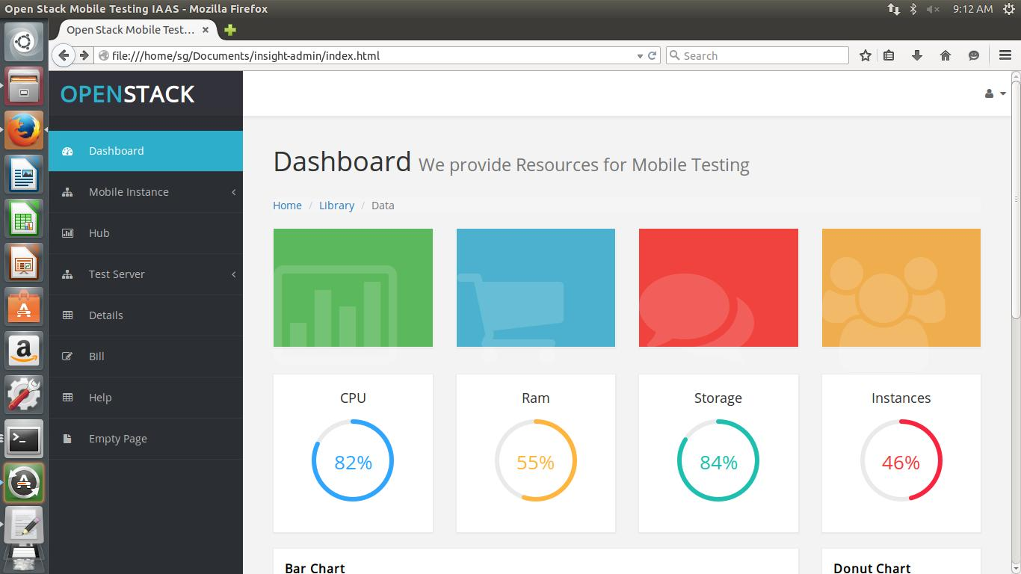

1. User can choose between various different versions of mobile instances of instances.

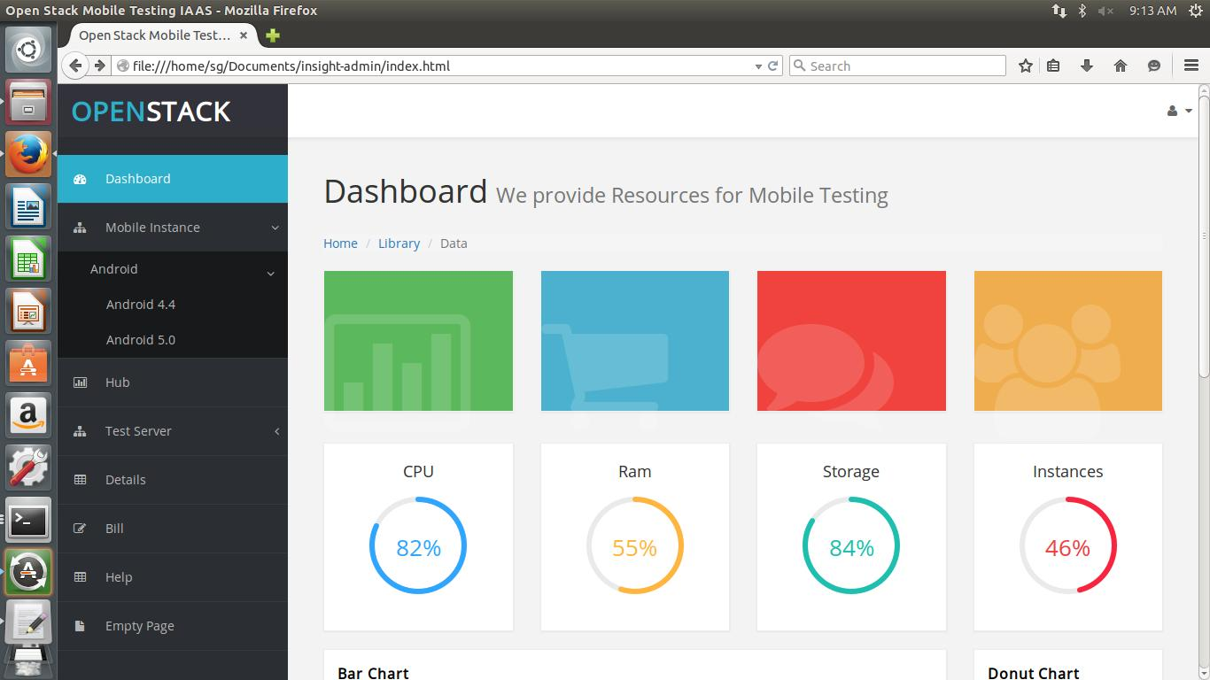

1. To launch test servers user can choose from different operating systems.

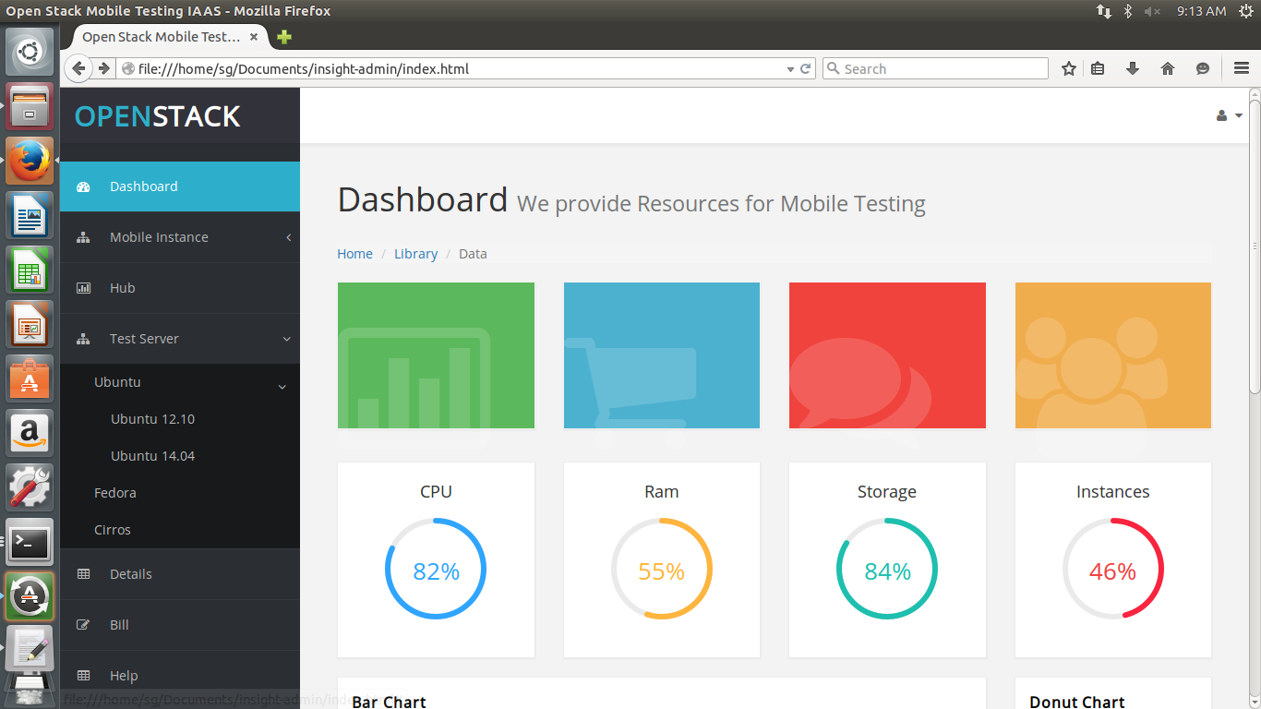

1. Hub allows user to connect mobile instances with the test servers.

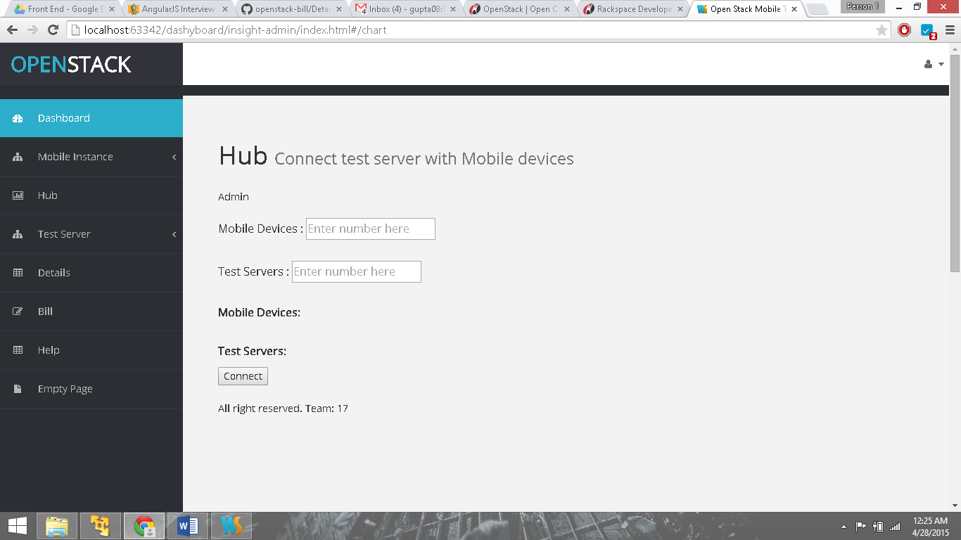

1. When user clicks the detail tab, he is directed to other webpage displaying the specifications of the instances.

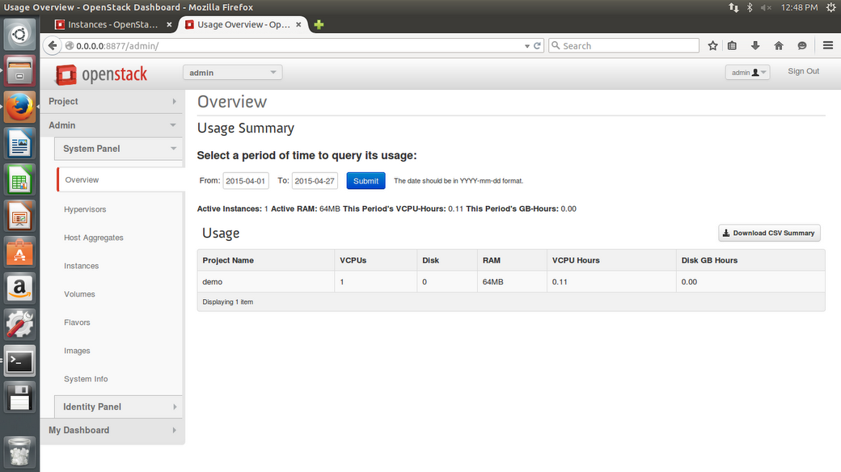

1. Dashboard allows different user to Login and Logout and view their account details.

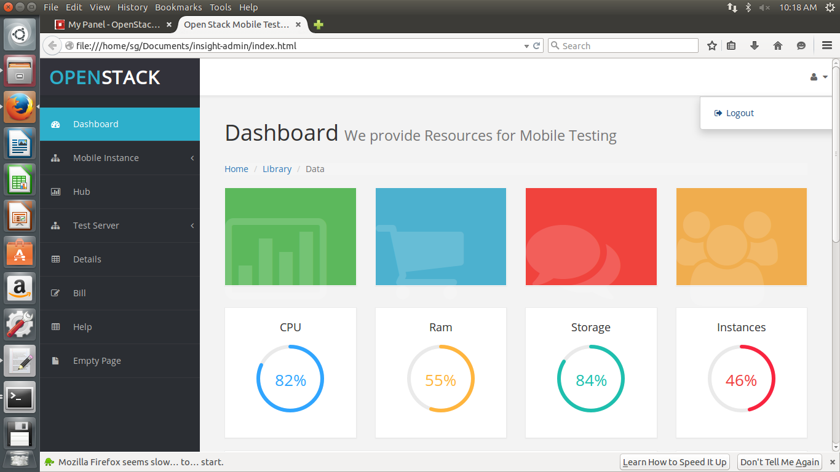

1. This is the index.html file, responsible for displaying different views on the dashboard.

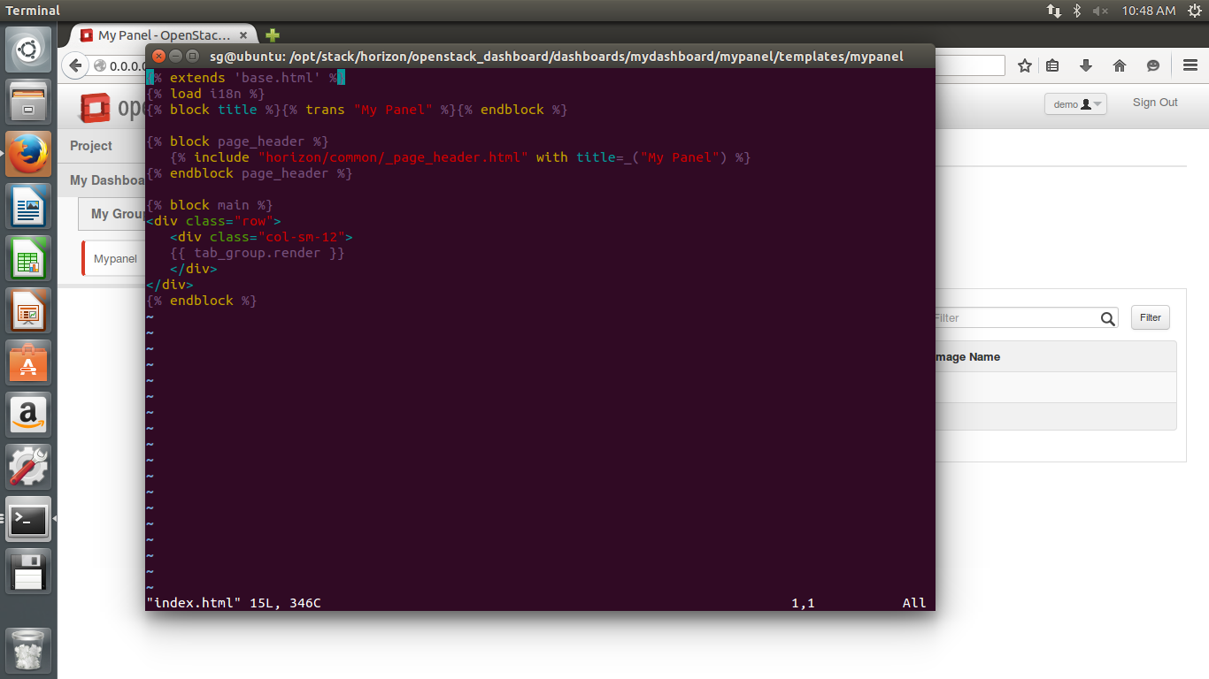

1. The views.py returns the required data in the form of views to the index.html and hence displays the request to the user on the dashboard.

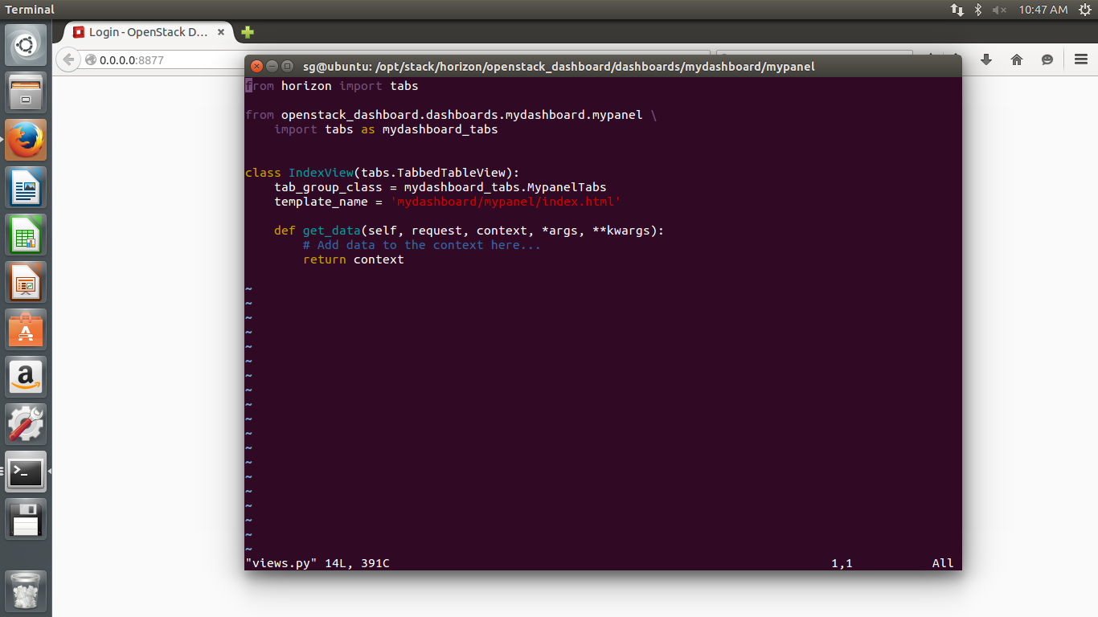

1. Tabs.py file manages the tabs in the navigation bar and communicates with different files, so that when a tab is clicked respective view is displayed on the dashboard.

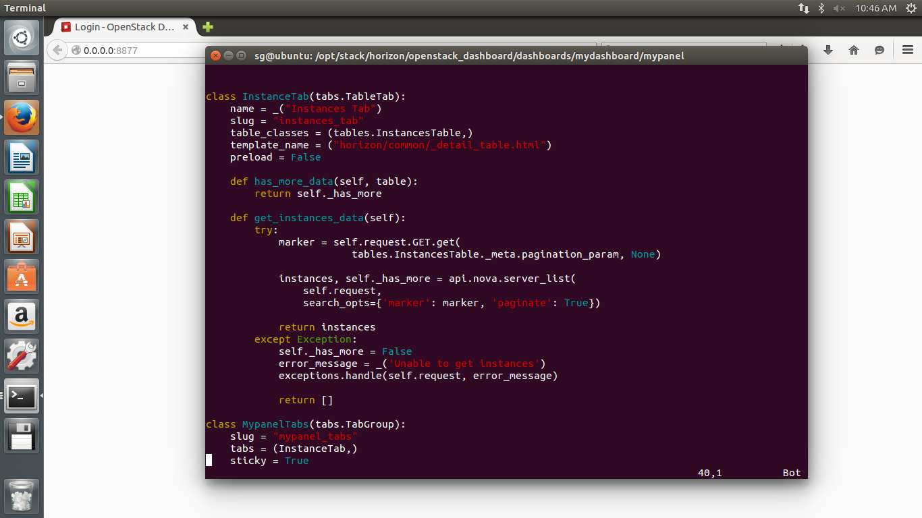

1. This is tables.py file. This file handles the tabular view of the instances. It manages the details of instance and displays them on the dashboard.

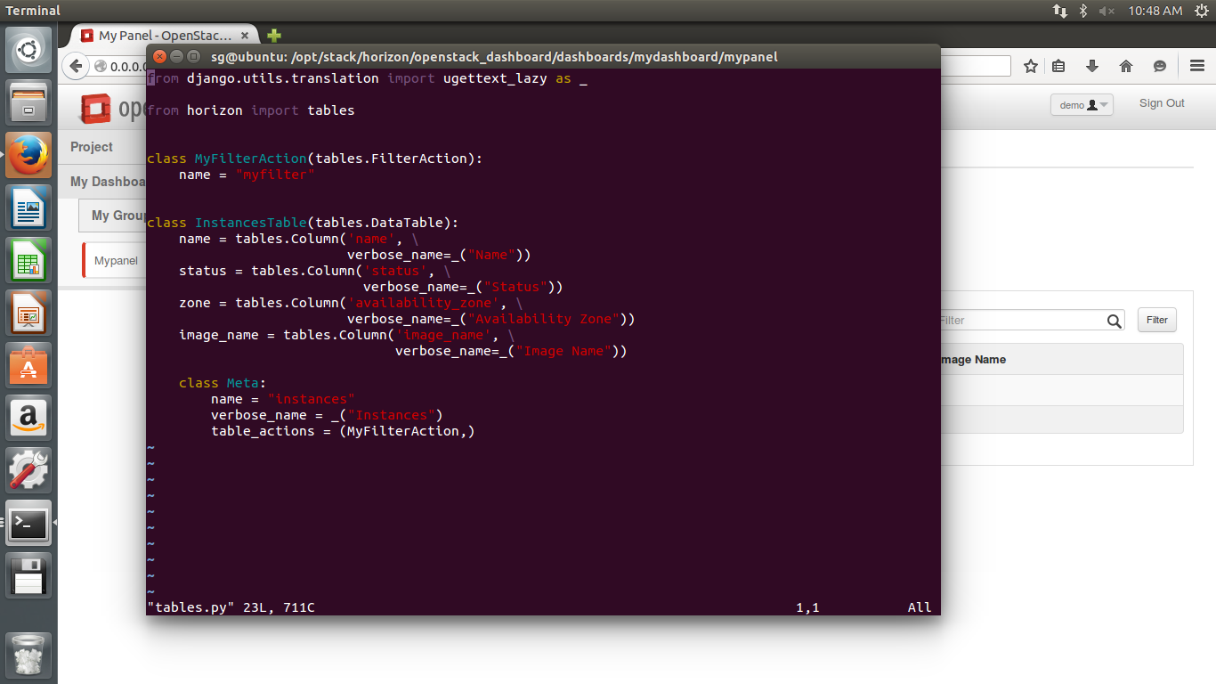

1. This code is written in panel.py file, which adds a new panel to the dashboard and is responsible for the user input to display the instance details.

