**Dashboard**

The dashboard component of the project provides the user an interface to communicate with the features of OpenStack. User can launch various mobile instances as well as test server instances on OpenStack. Hub allows the user to connect test server with mobile instances. User can also view the details of their instances like CPU usage, Ram, Storage, number of instances. User can also generate the bill of the instances created. User also has option to connect real mobile device to the system.

Various functionality of dashboard are:

1. **Login:**

Login page authenticates the user. User has to enter user name and password assigned. The user name and password are verified and if the credentials are valid then user has access to dashboard with various features.

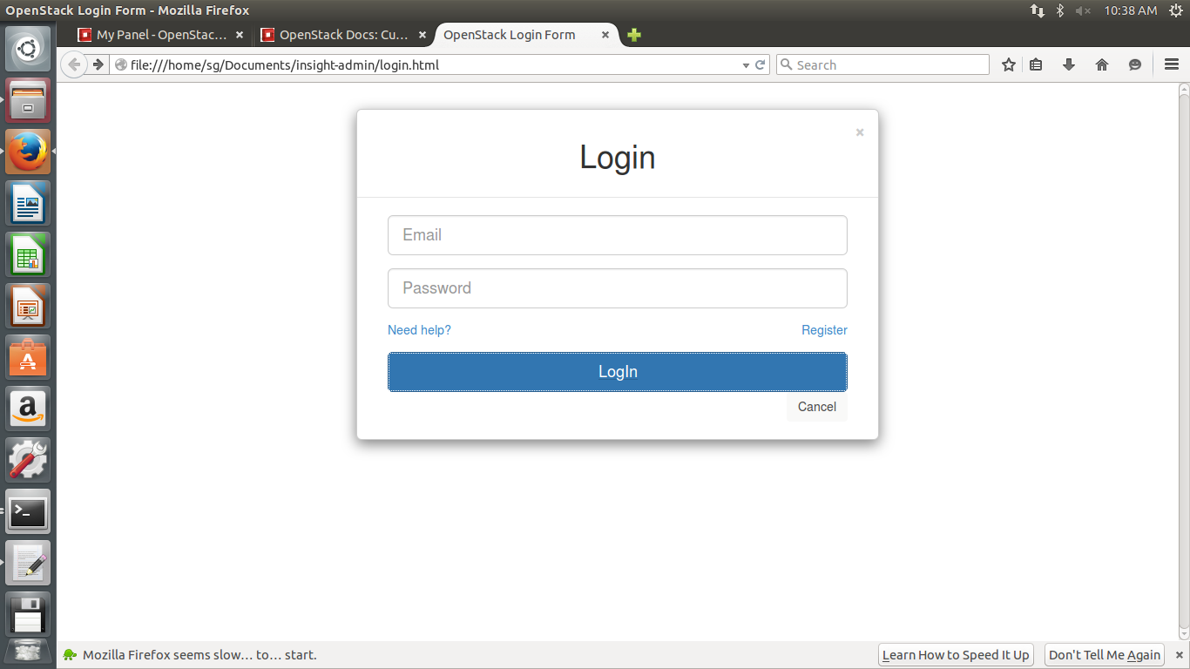

1. **Mobile Instance:**

User has option to choose between various versions of Mobile Instances. User the has to choose from various predefined flavors. Each flavor has predefined specs like, ram, storage, etc. User can click on Launch button anytime to create an instance of defined specification. The details are also displayed once the Launch button is clicked.

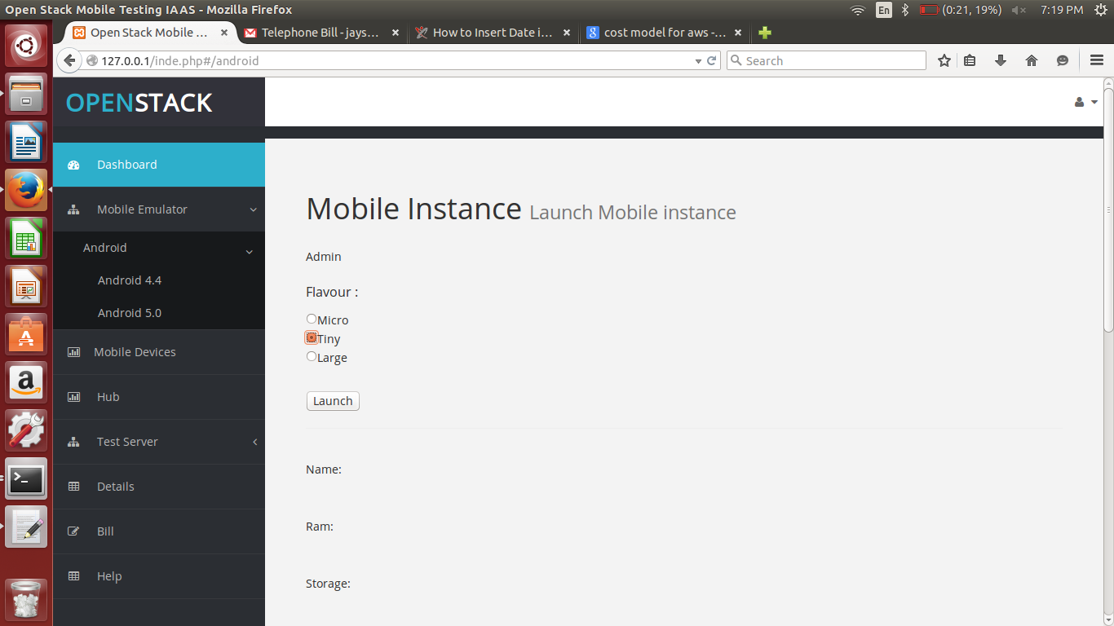

1. **Server Instance:**

User has to choose from a list of servers and then has to choose a flavor and click on Launch button in order to create an instance successfully. The instance is then created in the openstack account of the user and the instance goes in running stage.

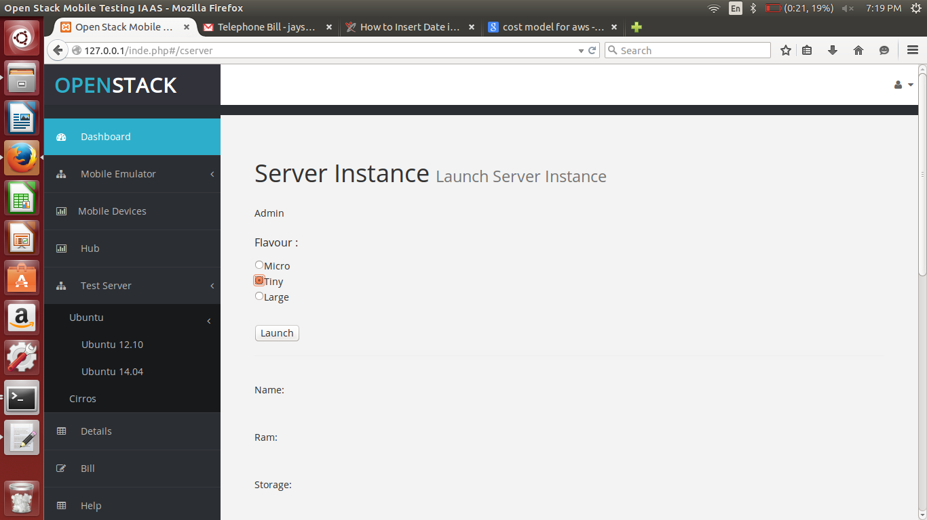

1. **Details:**

User has option to view the details of all the instances created from his account. User can view cloud id, node id, vm id, cpu, ram, storage, active, date (when launched). This basically provides user with the ability to monitor the instances.

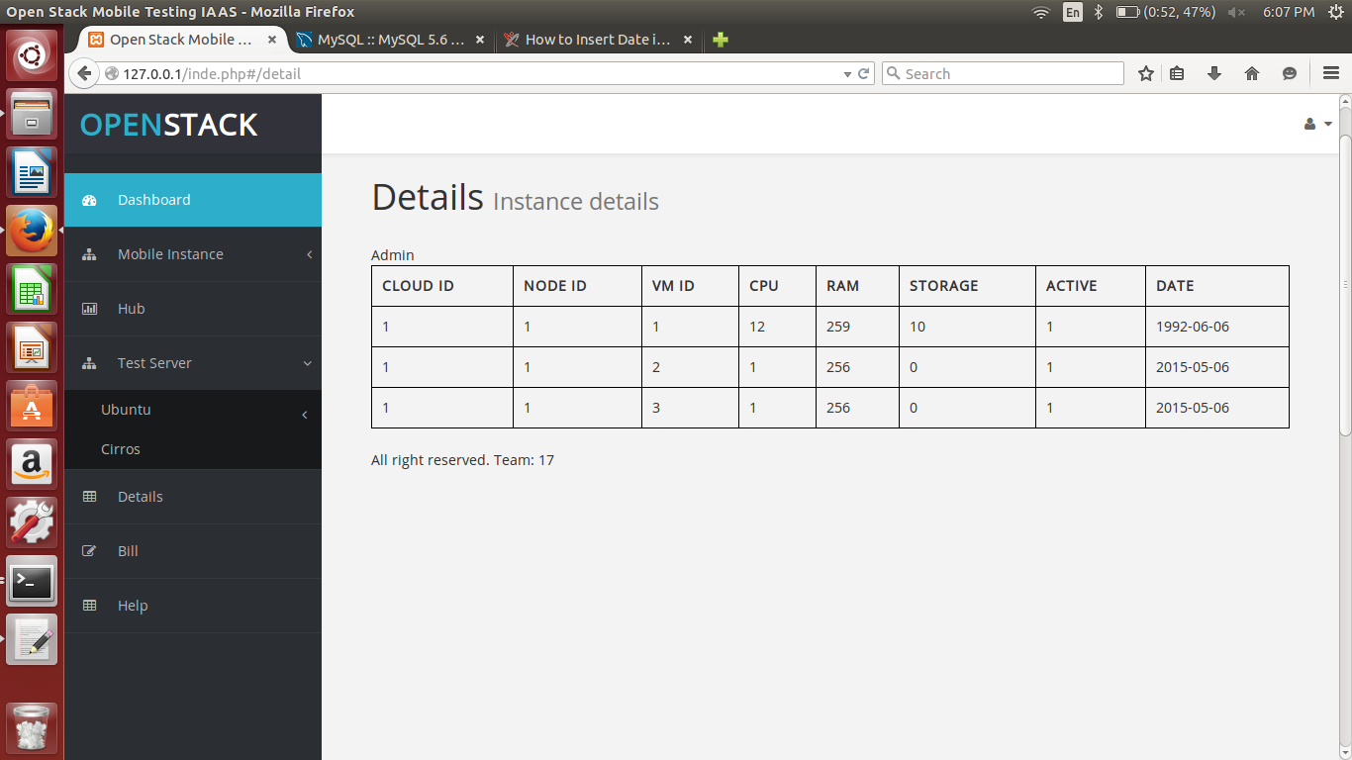

1. **Hub:**

Hub allows user to connect two instances. Communication between the instances is done by using hub as a glue between different instances like, mobile emulator and test server.

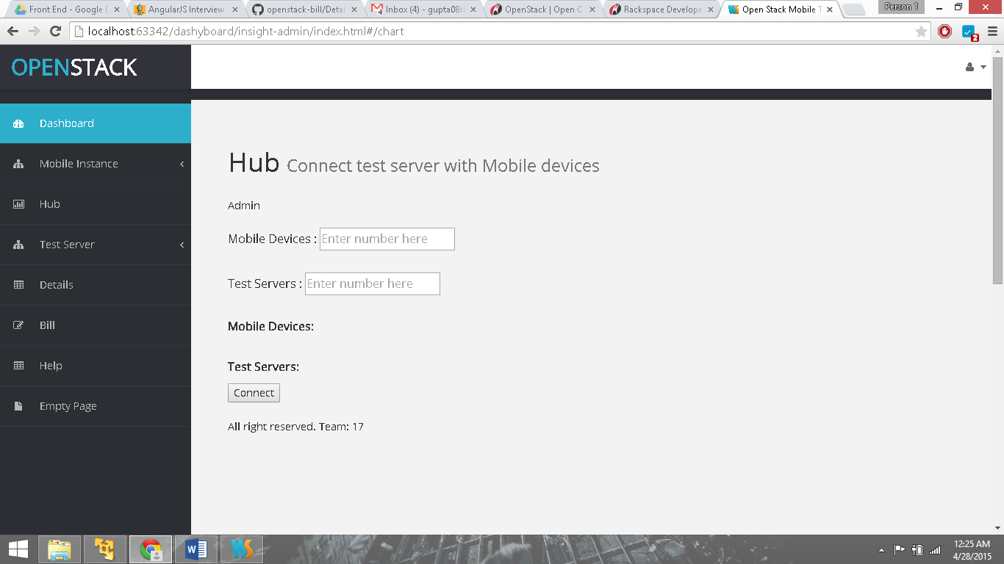

1. **Multiple users:**

Multiple users can access their respective accounts and utilize various features.

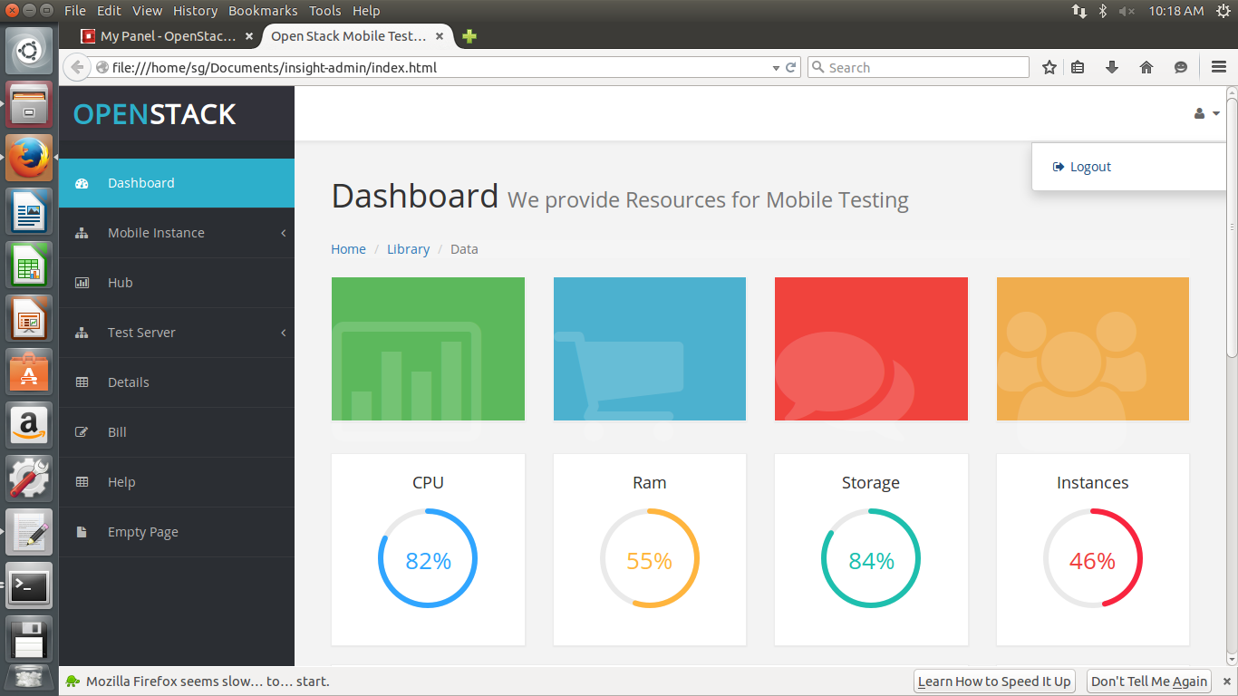

1. **AngularJS file (website.js):**

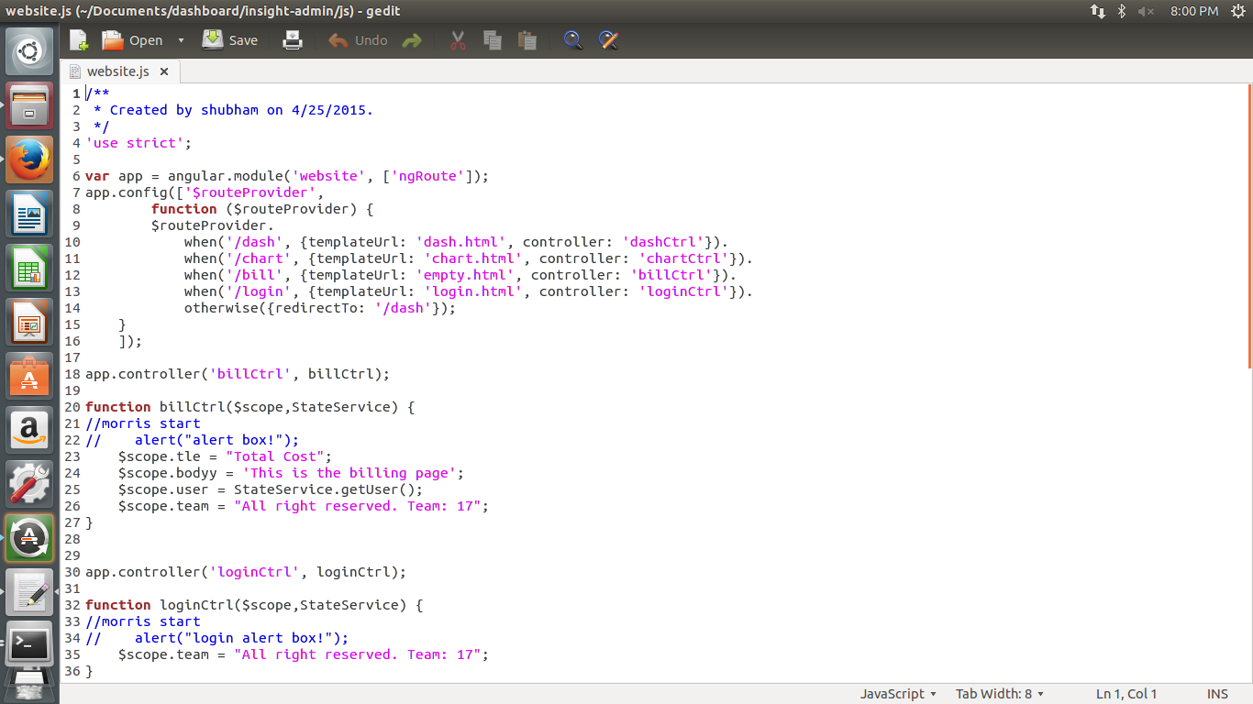

1. **Navigation bar:**

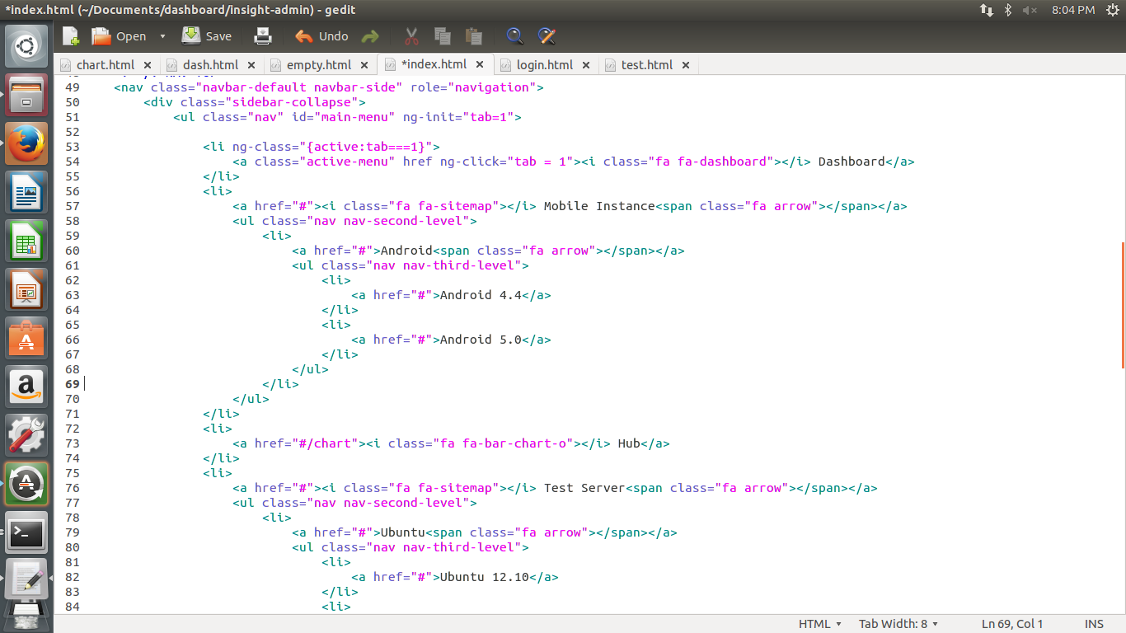

1. **Dashboard:**

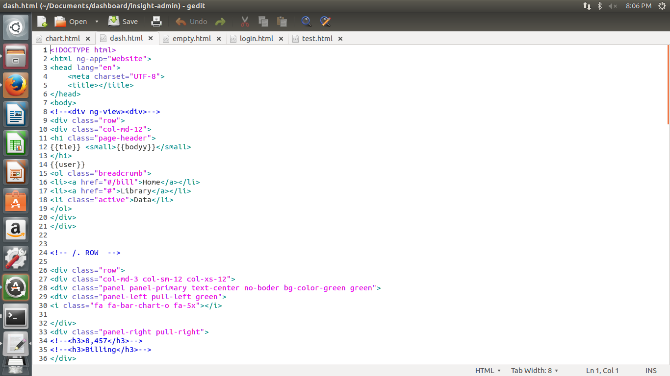

1. **Login page:**

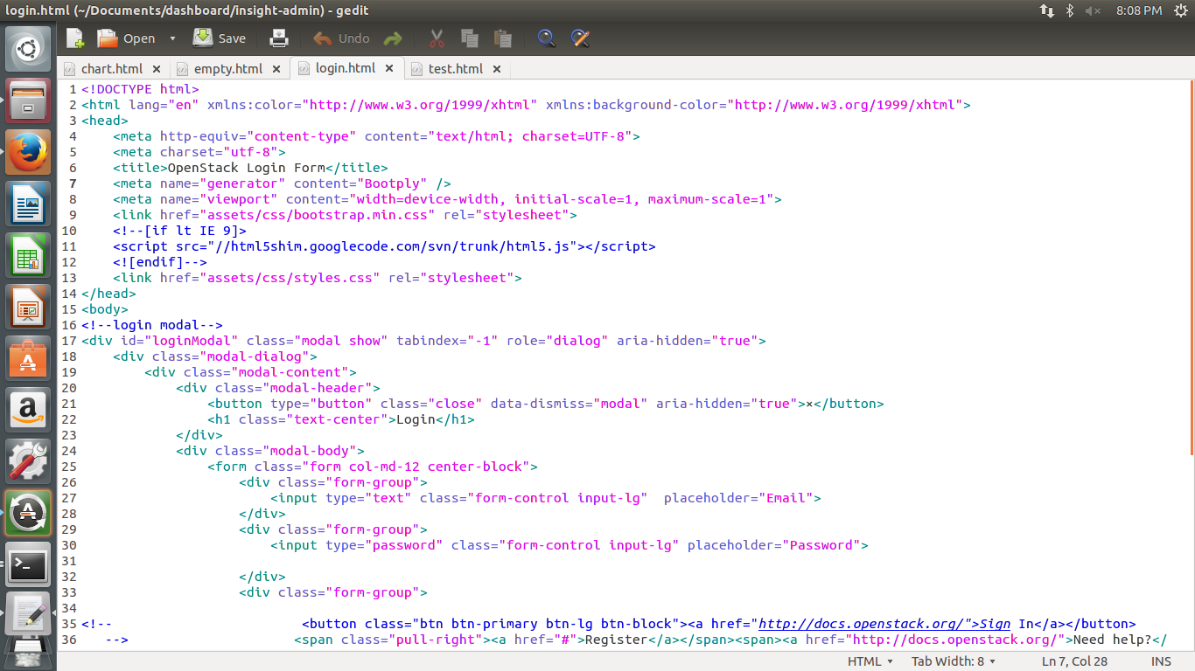

1. **Billing:**

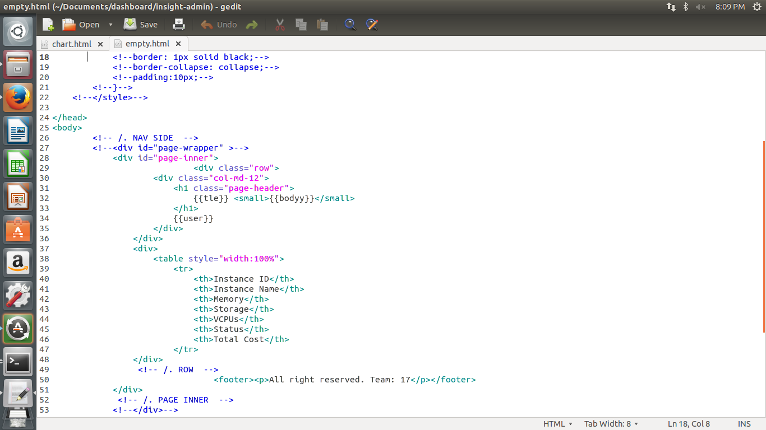

1. **Hub:**

