Max Price:

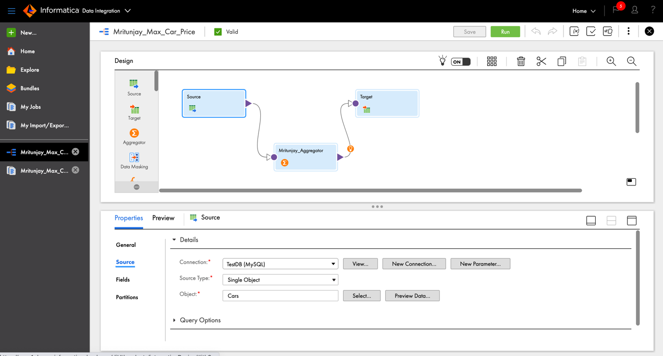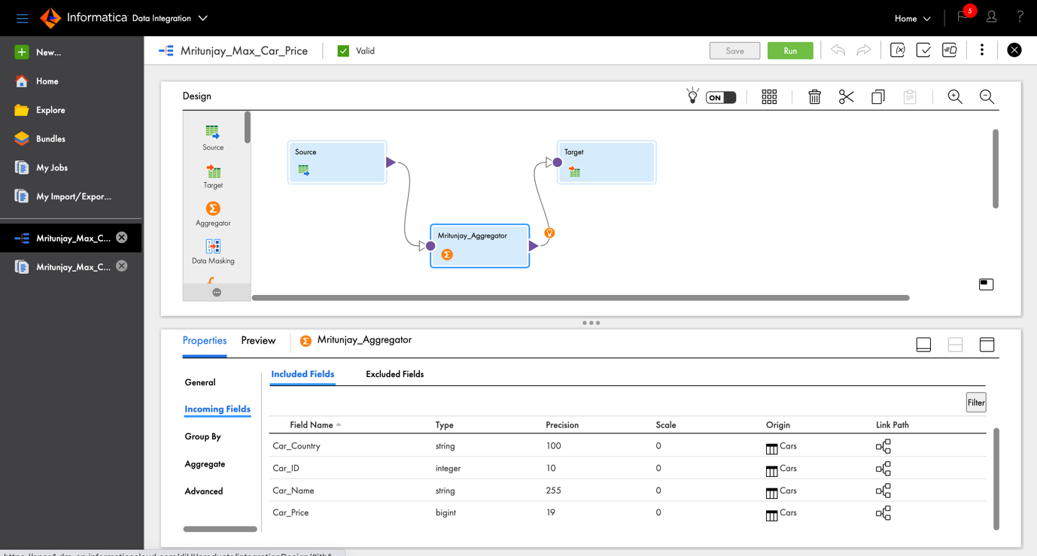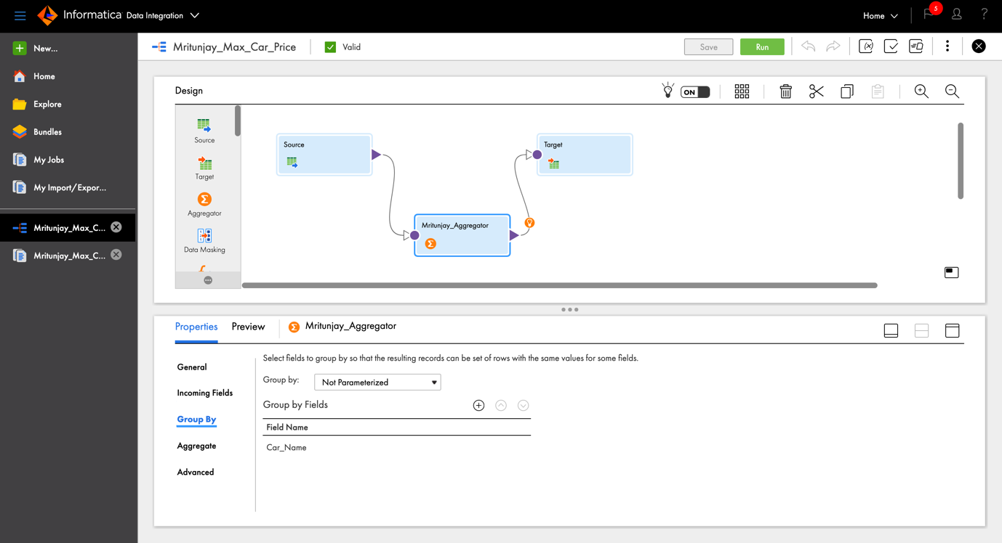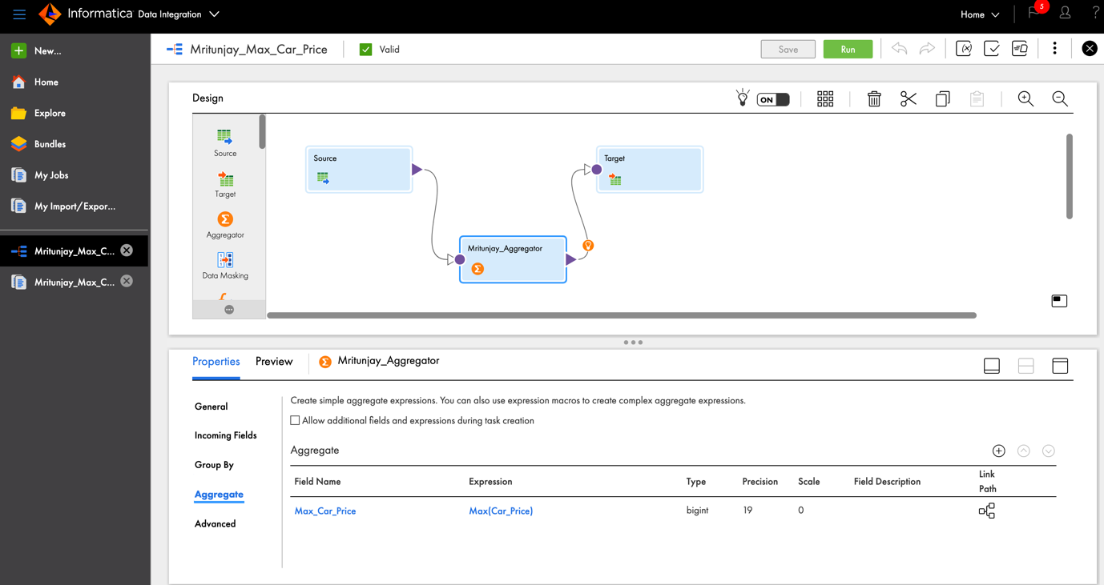

Min Price:

