**Appendix E. Curriculum Vitae**

**JAYSON L. ASCENCION**

San Jose, Talibon, Bohol

jayson.ascencionx@gmail.com

0908 952 7828

Age : 23

Civil Status : Single

Date of Birth : July 13, 1999

Religion : Roman Catholic

**EDUCATION BACKGROUND**

**College Level** Holy Name University (2018 – 2023)

J.A Clarin St., Tagbilaran City, Bohol

Bachelor of Science in Information Technology

**Senior High Level** San Jose National High School (2016 – 2018)

San Jose, Talibon, Bohol

GAS Strand

**Junior High Level** San Jose National High School (2012 – 2016)

San Jose, Talibon, Bohol

**Elementary Level** Talibon II Central Elementary School (2006 – 2012)

San Jose, Talibon, Bohol

**SKILLS AND COMPETENCIES**

* Oriented in Microsoft Office Applications
* Hyper Text Markup Language + JavaScript + CSS
* Programming Language: C, Java, and PHP

**HOBBIES**

* Photography and Editing

**KRIST BERNADETTE F.**

**BERNALES**

Purok Mangga, Pob. 1, Mabini, Bohol

kristdigl@yahoo.com

0991 580 6241

Age : 23

Civil Status : Single

Date of Birth : January 5, 2000

Religion : Roman Catholic

**EDUCATION BACKGROUND**

**College Level** Holy Name University (2018 – 2023)

J.A Clarin St., Tagbilaran City, Bohol

Bachelor of Science in Computer Science

**Senior High Level** Holy Name University (2016 – 2018)

1. A Clarin St., Tagbilaran City, Bohol

STEM Strand

**Junior High Level** Holy Name University (2014 – 2016)

J.A Clarin St., Tagbilaran City, Bohol

**Elementary Level** Mabini Central Elementary School (2009 – 2012)

Poblacion 2, Mabini, Bohol

**SKILLS AND COMPETENCIES**

* Oriented in Microsoft Office Applications
* Hyper Text Markup Language + JavaScript
* Programming Language: C, Java, and PHP
* Good in Oral and Written Communication Skills

**HOBBIES**

* Arts and Music
* Reading and Writing

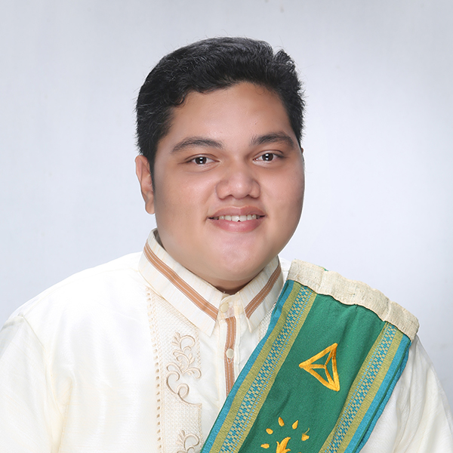**ALLEN JUSTINE B. RAMOS**

Bool District, Tagbilaran City, Bohol

ajr20000501@gmail.com

09687072496

Age : 23

Civil Status : Single

Date of Birth : May 1, 2000

Religion : Saksi ni Jehova

**EDUCATION BACKGROUND**

**College Level** Holy Name University (2018 – 2023)

J.A Clarin St., Tagbilaran City, Bohol

Bachelor of Science in Computer Science

**Senior High Level** Santa Monica Institute (2016 – 2018)

Pob.1, Mabini, Bohol

ICT Strand

**Junior High Level**  Santa Monica Institute (2012 – 2016)

Pob.1, Mabini, Bohol

**Elementary Level** Mabini Central Elementary School (2011 – 2012)

Poblacion 2, Mabini, Bohol

**SKILLS AND COMPETENCIES**

* Oriented in Microsoft Office Applications
* Hyper Text Markup Language + JavaScript
* Programming Language: C, Java, and PHP
* Good in Oral and Written Communication Skills

**HOBBIES**

* Arts and Music
* Literature
* Volunteering