**CHAPTER III**

**METHODOLOGY**

**3.1 Analysis**

This section tackles the interaction between the user and the farm management system, specifically for chickens. The system’s analysis of functionalities is done using the use case diagram and use case narrative. The use case diagram portrays the interactions between the actors (users) and the use cases, which are the components of the system. The system has three identified users: the farm inventory manager, farm employee, and system administrator. The farm inventory manager is assigned to the owner of the farm, while the system administrator falls into its co-owner which is the spouse or the son of the Arlin’s farm owner. On the other hand, the system has five (7) use cases in the use case diagram. It includes manage farm inventory, manage egg production, manage chicken production, manage medicine administration, manage archived record, manage farm user, and generate report. Moreover, a use case narrative is used to discuss the interaction between the actors, which are the identified users, and the components of the system, which are in the use case scenarios such that it would also provide a functional flow of the system’s operation.

**3.1.1 Use Case Diagram**

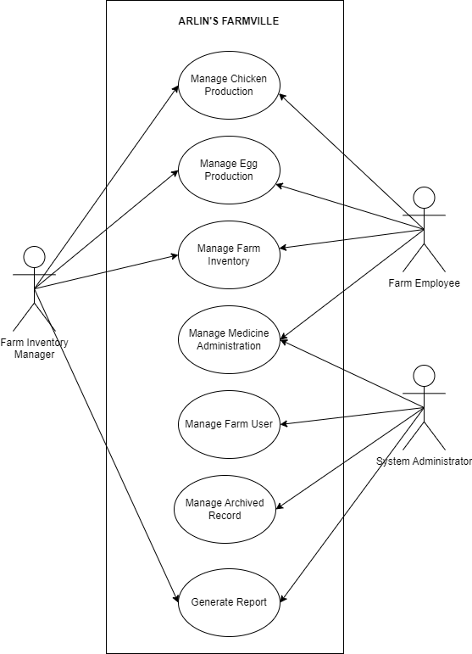

**Use Case Diagram for Arlin’s Farmville**

The Manage Chicken Production process is where the farm chicken production is supervised. The farm inventory manager or a farm employee is responsible for adding new chicken batches and deciding whether they will be used for meat, layers, or breeding. Additionally, the user can add new chicken breeds to the farm as they become available. This process also includes updating the quantity of a specific batch when it is culled, distributed to clients, or reduced due to chicken mortality. These updates allow the inventory manager or farm employee to view detailed information about the batch. Furthermore, the inventory manager or farm employee can edit chicken batch information to correct any data errors and archive chicken batches when necessary. Overall, this process involves the farm inventory manager and the farm employee.

The Manage Egg Production process is where the egg production data is controlled. The process allows the farm inventory manager and farm employee to add the collected eggs daily and categorizes the egg size by selecting small, medium, large, and extra-large. The farm inventory manager or farm employee can update the record reductions and choose if the eggs are distributed to a client, the egg is spoiled, and for personal consumption. This also allows the farm inventory manager or farm employee to update the information to rectify any data errors and remove egg production information when necessary. This process involves the farm inventory manager and farm employee.

The Manage Farm Inventory Process is where the medicines and feeds are being managed. This is where the farm inventory manager and the farm employee can add purchased medicines and feeds. It also allows the user to replenish a medicine or feed batch that is in the inventory. The farm inventory manager and the farm employee can view information about the medicine and feed details that has been recorded. It can also update the information and change the feed or medicine status into an archive mode when necessary. This involves the farm inventory manager and the farm employee.

The Manage Archived Record process is where the archived mode records for chicken production, egg production, medicine inventory, feed inventory and schedule are monitored. The process allows the system administrator to restore and monitor the specific items which are archived from the farm and farm activities schedules that has been archived. This process involves the system administrator.

The Monitor Medicine Administration process involves supervising the details of medicine administration. This process enables the system administrator to add medication administration schedules that can be assigned to the farm employee. The system will also generate and send notifications to the farm employee regarding their assigned medication administration schedules. The scheduling information can be updated or archived by the system administrator as needed. Additionally, this process allows the farm employee to view and update the status of the medicine administration schedule. It is important to note that the scheduling and notification functionalities are included in this process and will be performed by the system. Both the system administrator and the farm employee are involved in this process.

Finally, the Generate Report process is where the reports are generated. The system administrator and farm inventory manager can access reports of chicken production, egg production, and inventory of medicine and feeds. The system will generate detailed reports based on a given time frame specified by the system administrator. This process involves the system administrator and farm inventory manager.

Each user specified above is assigned multiple capabilities in the system depending on their processes.

Firstly, the Farm Inventory Manager is capable of:

* Adding newly acquired batches of chicken.
* Viewing and updating the different records of chicken batches.
* Reducing the quantity of a specific record of the chicken batch.
* Adding a new record of the collected eggs.
* Viewing and updating the records of egg production.
* Reducing the quantity of a specific record of the egg production.
* Adding new farm inventory products specifically the feeds and medicine.
* Viewing and updating the record of the farm inventory product.
* Reducing or replenishing the quantity of a specific record of the farm inventory product.
* Categorizing the acquisition type whether it is for meat, layer, or breeder.
* Viewing the reports for chicken production, egg production and inventory of feeds and medicine.

Next, the Farm Employee/s are capable of:

* Adding newly acquired batches of chicken.
* Viewing and updating the different records of chicken batches.
* Reducing the quantity of a specific record of the chicken batch.
* Adding a new record of the collected eggs.
* Viewing and updating the records of egg production.
* Reducing the quantity of a specific record of the egg production.
* Adding new farm inventory products specifically the feeds and medicine.
* Viewing and updating the record of the farm inventory product.
* Reducing or replenishing the quantity of a specific record of the farm inventory product.
* Categorizing the acquisition type whether it is for meat, layer, or breeder.
* Monitor Medicine Administration per Chicken Batch.
* View the medicine administration list, a specific date for vaccination, and the specified vaccine with the corresponding chicken disease.

Lastly, the System Administrator monitors the farm activities and reports. A quick summary of these capabilities is:

* Adding and assigning medicine administration schedule.
* Viewing and updating the chicken medicine administration list.
* Add, view, update, and archive the vaccine used per Chicken Batch during each scheduled medicine administration and the corresponding disease the vaccine is made for.
* Viewing and selecting specific dates for chicken production, egg production, and inventory reports.
* View and restore records that have been archived from the inventory specifically egg production, medicine inventory, egg production, feeds inventory, and schedules.
* Viewing the reports for chicken production, egg production and inventory of feeds and medicine.

Overall, the functionalities of the system are:

* Recording and managing the records involving the chicken being kept on the farm where the acquisition type is also chosen such as whether it is used for layering, meat, or breeder. The production of chicken, eggs, and farm inventory specifically with the feeds and medicine supply will also be included.
* Monitor the vaccination and medicine intake schedule of each batch corresponding to the type of chicken disease the vaccine is administered for.
* Generate farm production and inventory report which is done daily, weekly, monthly, and yearly.

**3.1.2. Use Case Narrative**

**3.1.2.1 Manage Chicken Production**

|  |  |
| --- | --- |
| **Use Case Name** | Manage Chicken Production |
| **Actor** | Farm Inventory Manager  Farm Employee |
| **Precondition** | Records of the chicken production and chicken reduction must exist in the database. |
| **Description** | This user scenario allows the farm inventory manager manager to store data of chicken production and reduction. The production data includes information on the breed type, batch name, coop number, and number of males and females. On the other hand, the reduction data includes the batch name, reduction type, sex, and quantity. |
| **Typical Course of Action** | |
| **Actor Action** | **System Response** |
| **Step 1**  The farm manager clicks on “Manage Chicken Production” drop-down | **Step 2**  Display the “Chicken Production” and “Chicken Reduction” on the drop-down. |
| **Step 3**  Select an item from the drop-down menu. | **Step 4.1**  If the “Production” button is selected, chicken production data is extracted from the database and will display the record. Display “Add New Coop” and “Chicken Allocation” button and the chicken production record with an option “Edit Record”, “View Record”, “Archive Record”, “Export to Excel”, “Export to PDF”, “View Table”, “Search Bar”, and “Filter” buttons. **Go to Step 5.**  **Step 4.2**  If the “Reduction” button is selected, chicken reduction data is extracted from the database and will display the record. Display “Add Reduction” button and the chicken reduction record with an option “Edit Record”, “View Record”, “Delete Record”, “Export to Excel”, “Export to PDF”, “View Table”, “Search Bar”, and “Filter” buttons. **Go to Step 15.** |
| **Step 5**  Select a button | **Step 6.1**  If the “Add Chicken Batch” button is selected, opens a new page displaying the add chicken batch form with a save and cancel button. **Go to Step 7.**  **Step 6.2**  If the “Edit Record” button is selected, opens a new page displaying the chicken production details extracted from the database in an editable form with an update and cancel button. **Go to Step 9.**  **Step 6.3**  If the “View Record” button is selected, opens a new page displaying the chicken production data extracted from the database with a back button. If the back button is selected, **Go back to Step 5.**  **Step 6.4**  If the “Archive Record” button is selected, opens a new page displaying the chicken production details extracted from the database with a confirmation query, “Are you sure you want to archive this record?” with an archive and cancel button. **Go to Step 11.**  **Step 6.5**  If the “Export to Excel” button is selected, the system downloads the exported excel file. **Go back to Step 5.**  **Step 6.6**  If the “Export to PDF” button is selected, the system downloads the exported pdf file. **Go back to Step 5.**  **Step 6.7**  If the “View Table” button is selected, a new window pops up displaying the printable table. **Go back to Step 5.**  **Step 6.8**  If the “Search Bar” is selected, the search bar accepts a value with a clear button. **Go to Step 13.**  **Step 6.9**  If the “Filter” button is selected, extracts, and display data based on the filter with a reset button. If the reset button is selected, **Go back to Step 5.**  **Step 6.10**  If the “Chicken Allocation” button is selected, opens a new page displaying the chicken allocation form with a save and cancel button. **Go to Step 25.** |
| **Step 7**  Fill up required fields and selects a button. | **Step 8.1**  If the “save” button is selected, validate entries. If all the entries are valid, then the chicken production data is saved to the database. **Go back to Step 5.**  **Step 8.2**  If the “cancel” button is selected, the user is directed back to the chicken production page. **Go back to Step 5.** |
| **Step 9**  Edit fields and select a button | **Step 10.1**  If the “update” button is selected, validate entries. If all the entries are valid, then the edited data is saved to the database. **Go back to Step 5.**  **Step 10.2**  If the “cancel” button is selected, the user is directed back to the chicken production page. **Go back to Step 5.** |
| **Step 11**  Selects a button | **Step 12.1**  If the “archive” button is selected, the data is then archived into the into the database and is hidden in the table.  **Step 12.2**  If the “cancel” button is selected, the user is then redirected back to the chicken production page. **Go back to Step 5.** |
| **Step 13**  Enter a value and selects a button | **Step 14.1**  Searches data in the database based on the value provided by the user. If it matches a data in the database, extract data from the database and displays the record. **Go back to Step 5.**  **Step 14.2**  If the clear button is selected, clears the search bar field and all the record is displayed again. **Go back to Step 5** |
| **Step 15**  Select a button | **Step 16.1**  If the “Add Reduction” button is selected, opens a new page displaying the reduction form with a save and cancel button. **Go to Step 17.**  **Step 16.2**  If the “Edit Record” button is selected, opens a new page displaying the chicken reduction details extracted from the database in an editable form with an update and cancel button. **Go to Step 19.**  **Step 16.3**  If the “View Record” button is selected, opens a new page displaying the chicken reduction data extracted from the database with a back button. If the back button is selected, **Go back to Step 15.**  **Step 16.4**  If the “Delete Record” button is selected, opens a new page displaying the chicken reduction details extracted from the database with a confirmation query, “Are you sure you want to delete this record?” with a delete and cancel button. **Go to Step 21.**  **Step 16.5**  If the “Export to Excel” button is selected, the system downloads the exported excel file. **Go back to Step 15.**  **Step 16.6**  If the “Export to PDF” button is selected, the system downloads the exported pdf file. **Go back to Step 15.**  **Step 16.7**  If the “View Table” button is selected, a new window pops up displaying the printable table. **Go back to Step 15.**  **Step 16.8**  If the “Search Bar” is selected, the search bar accepts a value with a clear button. **Go to Step 23.**  **Step 16.9**  If the “Filter” button is selected, extracts and display data based on the filter with a reset button. If the reset button is selected, **Go back to Step 15.** |
| **Step 17**  Fill up required fields and selects a button. | **Step 18.1**  If the “save” button is selected, validate entries. If all the entries are valid, then the chicken reduction data is saved to the database. **Go back to Step 15.**  **Step 18.2**  If the “cancel” button is selected, the user is directed back to the chicken reduction page. **Go back to Step 15.** |
| **Step 19**  Edit fields and select a button | **Step 20.1**  If the “update” button is selected, validate entries. If all the entries are valid, then the edited data is saved to the database. **Go back to Step 15.**  **Step 20.2**  If the “cancel” button is selected, the user is directed back to the chicken reduction page. **Go back to Step 15.** |
| **Step 21**  Selects a button | **Step 22.1**  If the “delete” button is selected, the data is then archived into the into the database and is hidden in the table.  **Step 22.2**  If the “cancel” button is selected, the user is then redirected back to the chicken reduction page. **Go back to Step 15.** |
| **Step 23**  Enter a value and selects a button | **Step 24.1**  Searches data in the database based on the value provided by the user. If it matches a data in the database, extract data from the database and displays the record. **Go back to Step 15**  **Step 24.2**  If the clear button is selected, clears the search bar field and all the record is displayed again. **Go back to Step 15** |
| **Step 25**  Fill up required fields and selects a button. | **Step 26.1**  If the “save” button is selected, validate entries. If all the entries are valid, then the chicken production data is saved to the database. **Go back to Step 5**  **Step 26.2**  If the “cancel” button is selected, the user is directed back to the chicken production page. **Go back to Step 5** |
| **Alternative Paths**  **Alt path for Step 4.1 and Step 4.2**  • If there is no record in the database, display “No records found”. **Go back to Step 5.**  **Alt path for Step 14.1 and Step 24.1**  • If there is no record in the database, display “No records found”. **Go back to Step 15.**  **Alt path for Step 8.1, Step 10.1, and Step 26.1**  • If entries are invalid, display alert message “This field is required” **Go back to Step 7 or Step 9 or Step 25.**  **Alt path for Step 18.1 and Step 20.1**  • If entries are invalid, display alert message “This field is required” **Go back to Step 15 or Step 19.** | |

**3.1.2.2 Manage Egg Production**

|  |  |
| --- | --- |
| **Use Case Name** | Manage Egg Production |
| **Actor** | Farm Inventory Manager  Farm Employee |
| **Precondition** | Records of the egg production and egg reduction must exist in the database. |
| **Description** | This user scenario allows the farm inventory manager to store data of egg production and reduction. The production data includes information on the egg size, quantity collected, and collection date. On the other hand, the reduction data includes the egg size, quantity reduced, reduction type, and reduction date. |
| **Typical Course of Action** | |
| **Actor Action** | **System Response** |
| **Step 1**  The farm manager clicks on “Manage Egg Production” drop-down | **Step 2**  Display the “Egg Production” and “Egg Reduction” on the drop-down. |
| **Step 3**  Select an item from the drop-down menu. | **Step 4.1**  If the “Production” button is selected, egg production data is extracted from the database and will display the record. Display “Add New Collection” button and the egg production record with an option “Edit Record”, “View Record”, “Archive Record”, “Export to Excel”, “Export to PDF”, “View Table”, “Search Bar”, and “Filter” buttons. **Go to Step 5.**  **Step 4.2**  If the “Reduction” button is selected, egg reduction data is extracted from the database and will display the record. Display “Add Reduction” button and the egg reduction record with an option “Edit Record”, “View Record”, “Delete Record”, “Export to Excel”, “Export to PDF”, “View Table”, “Search Bar”, and “Filter” buttons. **Go to Step 15.** |
| **Step 5**  Select a button | **Step 6.1**  If the “Add New Collection” button is selected, opens a new page displaying the add egg collection form with a save and cancel button. **Go to Step 7.**  **Step 6.2**  If the “Edit Record” button is selected, opens a new page displaying the egg production details extracted from the database in an editable form with an update and cancel button. **Go to Step 9.**  **Step 6.3**  If the “View Record” button is selected, opens a new page displaying the egg production data extracted from the database with a back button. If the back button is selected, **Go back to Step 5.**  **Step 6.4**  If the “Archive Record” button is selected, opens a new page displaying the egg production details extracted from the database with a confirmation query, “Are you sure you want to archive this record?” with an archive and cancel button. **Go to Step 11.**  **Step 6.5**  If the “Export to Excel” button is selected, the system downloads the exported excel file. **Go back to Step 5.**  **Step 6.6**  If the “Export to PDF” button is selected, the system downloads the exported pdf file. **Go back to Step 5.**  **Step 6.7**  If the “View Table” button is selected, a new window pops up displaying the printable table. **Go back to Step 5.**  **Step 6.8**  If the “Search Bar” is selected, the search bar accepts a value with a clear button. **Go to Step 13.**  **Step 6.9**  If the “Filter” button is selected, extracts and display data based on the filter with a reset button. If the reset button is selected, **Go back to Step 5.**  **Step 6.10**  If the “Chicken Allocation” button is selected, opens a new page displaying the chicken allocation form with a save and cancel button. **Go to Step 25.** |
| **Step 7**  Fill up required fields and selects a button. | **Step 8.1**  If the “save” button is selected, validate entries. If all the entries are valid, then the egg production data is saved to the database. **Go back to Step 5.**  **Step 8.2**  If the “cancel” button is selected, the user is directed back to the egg production page. **Go back to Step 5.** |
| **Step 9**  Edit fields and select a button | **Step 10.1**  If the “update” button is selected, validate entries. If all the entries are valid, then the edited data is saved to the database. **Go back to Step 5.**  **Step 10.2**  If the “cancel” button is selected, the user is directed back to the egg production page. **Go back to Step 5.** |
| **Step 11**  Selects a button | **Step 12.1**  If the “delete” button is selected, the data is then archived into the into the database and is hidden in the table.  **Step 12.2**  If the “cancel” button is selected, the user is then redirected back to the egg production page. **Go back to Step 5.** |
| **Step 13**  Enter a value and selects a button | **Step 14.1**  Searches data in the database based on the value provided by the user. If it matches a data in the database, extract data from the database and displays the record. **Go back to Step 5.**  **Step 14.2**  If the clear button is selected, clears the search bar field and all the record is displayed again. **Go back to Step 5.** |
| **Step 15**  Select a button | **Step 16.1**  If the “Add Reduction” button is selected, opens a new page displaying the reduction form with a save and cancel button. **Go to Step 17.**  **Step 16.2**  If the “Edit Record” button is selected, opens a new page displaying the egg reduction details extracted from the database in an editable form with an update and cancel button. **Go to Step 19.**  **Step 16.3**  If the “View Record” button is selected, opens a new page displaying the egg reduction data extracted from the database with a back button. If the back button is selected, **Go back to Step 15.**  **Step 16.4**  If the “Delete Record” button is selected, opens a new page displaying the egg reduction details extracted from the database with a confirmation query, “Are you sure you want to delete this record?” with a delete and cancel button. **Go to Step 21.**  **Step 16.5**  If the “Export to Excel” button is selected, the system downloads the exported excel file. **Go back to Step 15.**  **Step 16.6**  If the “Export to PDF” button is selected, the system downloads the exported pdf file. **Go back to Step 15.**  **Step 16.7**  If the “View Table” button is selected, a new window pops up displaying the printable table. **Go back to Step 15.**  **Step 16.8**  If the “Search Bar” is selected, the search bar accepts a value with a clear button. **Go to Step 23.**  **Step 16.9**  If the “Filter” button is selected, extracts and display data based on the filter with a reset button. If the reset button is selected, **Go back to Step 15.** |
| **Step 17**  Fill up required fields and selects a button. | **Step 18.1**  If the “save” button is selected, validate entries. If all the entries are valid, then the egg reduction data is saved to the database. **Go back to Step 15.**  **Step 18.2**  If the “cancel” button is selected, the user is directed back to the egg reduction page. **Go back to Step 15.** |
| **Step 19**  Edit fields and select a button | **Step 20.1**  If the “update” button is selected, validate entries. If all the entries are valid, then the edited data is saved to the database. **Go back to Step 15.**  **Step 20.2**  If the “cancel” button is selected, the user is directed back to the egg reduction page. **Go back to Step 15.** |
| **Step 21**  Selects a button | **Step 22.1**  If the “delete” button is selected, the data is then archived into the into the database and is hidden in the table.  **Step 22.2**  If the “cancel” button is selected, the user is then redirected back to the egg reduction page. **Go back to Step 15.** |
| **Step 23**  Enter a value and selects a button | **Step 24.1**  Searches data in the database based on the value provided by the user. If it matches a data in the database, extract data from the database and displays the record. **Go back to Step 15.**  **Step 24.2**  If the clear button is selected, clears the search bar field and all the record is displayed again. **Go back to Step 15.** |
| **Step 25**  Fill up required fields and selects a button. | **Step 26.1**  If the “save” button is selected, validate entries. If all the entries are valid, then the chicken production data is saved to the database. **Go back to Step 5.**  **Step 26.2**  If the “cancel” button is selected, the user is directed back to the chicken production page. **Go back to Step 5.** |
| **Alternative Paths**  **Alt path for Step 4.1 and Step 4.2**  • If there is no record in the database, display “No records found”. **Go back to Step 5.**  **Alt path for Step 14.1 and Step 24.1**  • If there is no record in the database, display “No records found”. **Go back to Step 15.**  **Alt path for Step 8.1 and Step 10.1**  • If entries are invalid, display alert message “This field is required” **Go back to Step 5 or Step 9.**  **Alt path for Step 18.1, Step 20.1, and Step 26.1**  • If entries are invalid, display alert message “This field is required” **Go back to Step 15 or Step 19 or Step 25.** | |

**3.1.2.3 Manage Farm Inventory (Medicines)**

|  |  |
| --- | --- |
| **Use Case Name** | Manage Farm Inventory (Medicine) |
| **Actor** | Farm Inventory Manager  Farm Employee |
| **Precondition** | Records medicine and medicine reduction must exist in the database. |
| **Description** | This user scenario is used to store data on the farm’s inventory specifically with its medicine. |
| **Typical Course of Action** | |
| **Actor Action** | **System Response** |
| **Step 1.**  The farm inventory manager clicks “Medicine Inventory.” | **Step 2.**  Display the “Purchased” and “Reduction” drop-downs. |
| **Step 3**  Select a drop-down button. | **Step 4.1**  If the “Purchased” button is selected, medicine data is extracted from the database and will display the record. Display the “Add New Medicine” and “Replenish Medicine” button and the list of medicines recorded with an option “Edit Record” button, “View Record” button, “Archive Record” button, “Export to Excel”, “Export to PDF”, “View Table”, and a search bar. **Go to Step 5.**  **Step 4.2**  If the “Reduction” button is selected, medicine reduction data is extracted from the database and will display the record. Display the “Add Reduction” button and the medicine reduction record with an option “Edit Record” button, “View Record” button, “Delete Record” button, “Export to Excel”, “Export to PDF”, “View Table”, and a search bar. **Go to Step 7.** |
| **Step 5**  Select a button | **Step 6.1**  If the “Add Medicine” button is selected, opens a new page containing a form to add a new batch. The empty fields are labeled Medicine Type, Medicine Name, Medicine Brand, Medicine For, Medicine Type, In Stock, and Expiration Date with a save and cancel button. **Go to Step 9.**  **Step 6.2**  If the “Edit Record” button is selected, opens a new page with a form containing the medicine details with editable fields with a save and cancel button. **Go to Step 11.**  **Step 6.3**  If the “Archive Record” button is selected, opens a new page with a form containing the medicine details with a confirmation query “Are you sure you want to delete this record?” with a delete and cancel button. **Go to Step 5.**  **Step 6.4**  If the “View More” button is selected, medicine data is extracted from the database and shows hidden data, from Date Added to Notes with a close button. If the close button is selected, **Go back to Step 5.**  **Step 6.5**  If the “Export to Excel” button is selected, the system downloads the exported excel file. **Go back to Step 5.**  **Step 6.6**  If the “Export to PDF” button is selected, the system downloads the exported pdf file. **Go back to Step 5.**  **Step 6.7**  If the “View Table” button is selected, a new window pops up displaying the printable table. **Go back to Step 5.**  **Step 6.8**  If the “Search Bar” is selected, the search bar accepts a value with a clear button. **Go to Step 17.**  **Step 6.9**  If the “Filter” button is selected, extracts, and display data based on the filter with a reset button. If the reset button is selected, **Go back to Step 5.**  **Step 6.10**  If the “Replenish Medicine” button is selected, opens a new page displaying the medicine replenishment form with a save and cancel button. **Go to Step 19.** |
| **Step 7**  **Select a button** | **Step 8.1**  If the “Add Reduction” button is selected, opens a new page containing the medicine reduction details such as Medicine ID, Quantity, Reduction Type, and Date Reduced which can be edited, with a save and cancel button. **Go to Step 13.**  **Step 8.2**  If the “Edit Record” button is selected, opens a new page with a form containing the medicine reduction details with editable fields with a save and cancel button. **Go to Step 15.**  **Step 8.3**  If the “Delete Record” button is selected, opens a new page with a form containing the medicine reduction details with a confirmation query “Are you sure you want to delete this record?” with a delete and cancel button. **Go back to Step 7.**  **Step 8.4**  If the “View More” button is selected, medicine reduction data is extracted from the database and shows hidden data, from Date Added to Notes with a close button. If the close button is selected, **Go back to Step 7.**  **Step 8.5**  If the “Export to Excel” button is selected, the system downloads the exported excel file. **Go back to Step 7.**  **Step 8.6**  If the “Export to PDF” button is selected, the system downloads the exported pdf file. **Go back to Step 7.**  **Step 8.7**  If the “View Table” button is selected, a new window pops up displaying the printable table. **Go back to Step 7.**  **Step 8.8**  If the “Search Bar” is selected, the search bar accepts a value with a clear button. **Go to Step 21.** |
| **Step 9**  Fill up the required fields and select a button. | **Step 10.1**  If the “Save” button is selected, validate entries. If all the entries are valid, then the medicine data is saved to the database. **Go back to step 5.**  **Step 10.2**  If the “cancel” button is selected, the form closes. **Go back to Step 5.** |
| **Step 11**  Edit fields and select a button. | **Step 12.1**  If the “save” button is selected. Validate user entries, if all entries are valid the edited data is then saved to the database. **Go back to Step 5.**  **Step 12.2**  If the “cancel” button is selected. The form closes, **Go back to Step 5.** |
| **Step 13**  Fill up the required fields and select a button. | **Step 14.1**  If the “Save” button is selected, validate entries. If all the entries are valid, then the medicine reduction data is saved to the database. **Go back to step 7.**  **Step 14.2**  If the “cancel” button is selected, the form closes. **Go back to Step 7.** |
| **Step 15**  Edit fields and select a button. | **Step 16.1**  If the “save” button is selected. Validate user entries, if all entries are valid the edited data is then saved to the database. **Go back to Step 7.**  **Step 16.2**  If the “cancel” button is selected. The form closes, **Go back to Step 7.** |
| **Step 17**  Enter a value and selects a button | **Step 18.1**  Searches data in the database based on the value provided by the user. If it matches a data in the database, extract data from the database and displays the record. **Go back to Step 17.**  **Step 18.2**  If the clear button is selected, clears the search bar field and all the record is displayed again. **Go back to Step 17.** |
| **Step 19**  Fill up the required fields and select a button. | **Step 20.1**  If the “Save” button is selected, validate entries. If all the entries are valid, then the medicine data is saved to the database. **Go back to step 5.**  **Step 20.2**  If the “cancel” button is selected, the form closes. **Go back to Step 5.** |
| **Step 21**  Enter a value and selects a button | **Step 22.1**  Searches data in the database based on the value provided by the user. If it matches a data in the database, extract data from the database and displays the record. **Go back to Step 21.**  **Step 22.2**  If the clear button is selected, clears the search bar field and all the record is displayed again. **Go back to Step 21.** |
| **Alternative Paths**  **Alt path for Step 4.1 and Step 4.2**  • If there is no record in the database, display “No records found”. **Go back to Step 5.**  **Alt path for Step 10.1, Step 12.1, Step 14.1, Step 16.1, and Step 20.1**  • If entries are invalid, display alert message “This field is required” **Go back to Step 9 or Step 11 or Step 13 or Step 15 or Step 19.**  **Alt path for Step 18.1 and Step 22.1**  • If there is no record in the database, display “No records found”. **Go back to Step 17 or Step 21.** | |

**3.1.2.4 Manage Farm Inventory (Feeds)**

|  |  |
| --- | --- |
| **Use Case Name** | Manage Farm Inventory |
| **Actor** | Farm Inventory Manager  Farm Employee |
| **Precondition** | Records feed and feed reduction must exist in the database. |
| **Description** | This user scenario is used to store data on the farm’s inventory specifically with its feeds. |
| **Typical Course of Action** | |
| **Actor Action** | **System Response** |
| **Step 1.**  The farm inventory manager clicks “Feed Inventory”. | **Step 2.**  Display the “Purchased” and “Reduction” drop-downs. |
| **Step 3**  Select a drop-down button. | **Step 4.1**  If the “Purchased” button is selected, feed data is extracted from the database and will display the record. Display the “Add New Feed” and “Replenish Feed” button and the list of feeds recorded with an option “Edit Record ” button, “View Record” button, “Archive Record” button, “Export to Excel”, “Export to PDF”, “View Table”, and a search bar. **Go to Step 5.**  **Step 4.2**  If the “Reduction” button is selected, feed reduction data is extracted from the database and will display the record. Display the “Add Reduction” button and the feed reduction record with an option “Edit Record ” button, “View Record” button, “Delete Record” button, “Export to Excel”, “Export to PDF”, “View Table”, and a search bar. **Go to Step 7.** |
| **Step 5**  Select a button | **Step 6.1**  If the “Add New Feed” button is selected, opens a new page containing a form to add a new feed. The empty fields are labeled Feed Name, Feed Brand, and In Stock with a save and cancel button. **Go to Step 9.**  **Step 6.2**  If the “Edit Record” button is selected, opens a new page with a form containing the feed details with editable fields with a save and cancel button. **Go to Step 11.**  **Step 6.3**  If the “Archive Record” button is selected, opens a new page with a form containing the feeds details with a confirmation query “Are you sure you want to delete this record?” with a delete and cancel button. **Go to Step 5.**  **Step 6.4**  If the “View More” button is selected, feed data is extracted from the database and shows hidden data, from Date Added to Notes with a close button. If the close button is selected, **Go back to Step 5.**  **Step 6.5**  If the “Export to Excel” button is selected, the system downloads the exported excel file. **Go back to Step 5.**  **Step 6.6**  If the “Export to PDF” button is selected, the system downloads the exported pdf file. **Go back to Step 5.**  **Step 6.7**  If the “View Table” button is selected, a new window pops up displaying the printable table. **Go back to Step 5.**  **Step 6.8**  If the “Search Bar” is selected, the search bar accepts a value with a clear button. **Go to Step 17.**  **Step 6.9**  If the “Filter” button is selected, extracts, and display data based on the filter with a reset button. If the reset button is selected, **Go back to Step 5.**  **Step 6.10**  If the “Replenish Feed” button is selected, opens a new page displaying the medicine replenishment form with a save and cancel button. **Go to Step 19.** |
| **Step 7**  **Select a button** | **Step 8.1**  If the “Add Reduction” button is selected, opens a new page containing the feed reduction form with a save and cancel button. **Go to Step 13.**  **Step 8.2**  If the “Edit Record” button is selected, opens a new page with a form containing the feed reduction details with editable fields with a save and cancel button. **Go to Step 15.**  **Step 8.3**  If the “Delete Record” button is selected, opens a new page with a form containing the feed reduction details with a confirmation query “Are you sure you want to delete this record?” with a delete and cancel button. **Go back to Step 7.**  **Step 8.4**  If the “View More” button is selected, feed reduction data is extracted from the database and shows hidden data. If the close button is selected, **Go back to Step 7.**  **Step 8.5**  If the “Export to Excel” button is selected, the system downloads the exported excel file. **Go back to Step 7.**  **Step 8.6**  If the “Export to PDF” button is selected, the system downloads the exported pdf file. **Go back to Step 7.**  **Step 8.7**  If the “View Table” button is selected, a new window pops up displaying the printable table. **Go back to Step 7.**  **Step 8.8**  If the “Search Bar” is selected, the search bar accepts a value with a clear button. **Go to Step 21.** |
| **Step 9**  Fill up the required fields and select a button. | **Step 10.1**  If the “Save” button is selected, validate entries. If all the entries are valid, then the feed data is saved to the database. **Go back to step 5.**  **Step 10.2**  If the “cancel” button is selected, the form closes. **Go back to Step 5.** |
| **Step 11**  Edit fields and select a button. | **Step 12.1**  If the “save” button is selected. Validate user entries, if all entries are valid the edited data is then saved to the database. **Go back to Step 5.**  **Step 12.2**  If the “cancel” button is selected. The form closes, **Go back to Step 5.** |
| **Step 13**  Fill up the required fields and select a button. | **Step 14.1**  If the “Save” button is selected, validate entries. If all the entries are valid, then the feed reduction data is saved to the database. **Go back to step 7.**  **Step 14.2**  If the “cancel” button is selected, the form closes. **Go back to Step 7.** |
| **Step 15**  Edit fields and select a button. | **Step 16.1**  If the “save” button is selected. Validate user entries, if all entries are valid the edited data is then saved to the database. **Go back to Step 7.**  **Step 16.2**  If the “cancel” button is selected. The form closes, **Go back to Step 7.** |
| **Step 17**  Enter a value and selects a button | **Step 18.1**  Searches data in the database based on the value provided by the user. If it matches a data in the database, extract data from the database and displays the record. **Go back to Step 17.**  **Step 18.2**  If the clear button is selected, clears the search bar field and all the record is displayed again. **Go back to Step 17.** |
| **Step 19**  Fill up the required fields and select a button. | **Step 20.1**  If the “Save” button is selected, validate entries. If all the entries are valid, then the feed data is saved to the database. **Go back to step 5.**  **Step 20.2**  If the “cancel” button is selected, the form closes. **Go back to Step 5.** |
| **Step 21**  Enter a value and selects a button | **Step 22.1**  Searches data in the database based on the value provided by the user. If it matches a data in the database, extract data from the database and displays the record. **Go back to Step 21.**  **Step 22.2**  If the clear button is selected, clears the search bar field and all the record is displayed again. **Go back to Step 21.** |
| **Alternative Paths**  **Alt path for Step 4.1 and Step 4.2**  • If there is no record in the database, display “No records found”. **Go back to Step 5**  **Alt path for Step 10.1, Step 12.1, Step 14.1, Step 16.1, and Step 20.1**  • If entries are invalid, display alert message “This field is required” **Go back to Step 9 or Step 11 or Step 13 or Step 15 or Step 19**  **Alt path for Step 18.1 and Step 22.1**  • If there is no record in the database, display “No records found”. **Go back to Step 17 or Step 21** | |

**3.1.2.5 Manage Medicine Administration (Medication- System Administrator)**

|  |  |
| --- | --- |
| **Use Case Name** | Manage Medicine Administration |
| **Actor** | System Administrator |
| **Precondition** | Records of medicine schedule, chicken production, medicine must exist in the database. |
| **Description** | This scenario allows the system administrator to manage medicine administration for medication. |
| **Typical Course of Action** | |
| **Actor Action** | **System Response** |
| **Step 1**  The system administrator clicks “Medication.” | **Step 2**  Display the “Pending Schedules” and “Completed Schedules” drop-downs. |
| **Step 3**  Select a drop-down button. | **Step 4.1**  If the “Pending Schedules” button is selected, schedule data is extracted from the database and will display the record. Display the “Add Medication Schedule” button and the schedule record with an option “Edit Record” button, “View Record” button, “Delete Record” button, “Export to Excel”, “Export to PDF”, “View Table”,” Search Bar”, and “Filter” buttons. **Go to Step 5.**  **Step 4.2**  If the “Completed Schedules” button is selected, schedule data is extracted from the database and will display the record. Display the completed schedules record with an option “Edit Record” button, “View Record” button, “Delete Record” button, “Export to Excel,” “Export to PDF”, View Table”,” Search Bar”, and “Filter” buttons. **Go to Step 15.** |
| **Step 5**  Select a button | **Step 6.1**  If the “Add Schedule” button is selected, opens a new page displaying the add medication schedule form. The empty fields are labeled Chicken Batch ID, medicine name, method type, dosage, number of heads, administration schedule, administered by, and an additional note with a save and cancel button. **Go to Step 7**  **Step 6.2**  If the “Edit Record” button is selected, opens a new page displaying the pending medication schedule details extracted from the database in an editable form with an update and cancel button. **Go to Step 9**  **Step 6.3**  If the “View Record” button is selected, opens a new page displaying the pending medication schedule data extracted from the database with a back button. If the back button is selected, **Go back to Step 5.**  **Step 6.4**  If the “Delete Record” button is selected, opens a new page displaying the pending medication schedule details extracted from the database with a confirmation query, “Are you sure you want to delete this record?” with a delete and cancel button. **Go to Step 11**  **Step 6.5**  If the “Export to Excel” button is selected, the system downloads the exported excel file. **Go back to Step 5**  **Step 6.6**  If the “Export to PDF” button is selected, the system downloads the exported pdf file. **Go back to Step 5**  **Step 6.7**  If the “View Table” button is selected, a new window pops up displaying the printable table. **Go back to Step 5**  **Step 6.8**  If the “Search Bar” is selected, the search bar accepts a value with a clear button. **Go to Step 13**  **Step 6.9**  If the “Filter” button is selected, extracts, and display data based on the filter with a reset button. If the reset button is selected, **Go back to Step 5** |
| **Step 7**  Fill up required fields and selects a button. | **Step 8.1**  If the “save” button is selected, validate entries. If all the entries are valid, then the pending schedule data is saved to the database. **Go back to Step 5**  **Step 8.2**  If the “cancel” button is selected, the user is directed back to the pending schedule page. **Go back to Step 5** |
| **Step 9**  Edit fields and select a button | **Step 10.1**  If the “update” button is selected, validate entries. If all the entries are valid, then the edited data is saved to the database. **Go back to Step 5**  **Step 10.2**  If the “cancel” button is selected, the user is directed back to the pending schedules page. **Go back to Step 5** |
| **Step 11**  Selects a button | **Step 12.1**  If the “delete” button is selected, the data is then archived into the into the database and is hidden in the table.  **Step 12.2**  If the “cancel” button is selected, the user is then redirected back to the pending schedule page. **Go back to Step 5.** |
| **Step 13**  Enter a value and selects a button | **Step 14.1**  Searches data in the database based on the value provided by the user. If it matches a data in the database, extract data from the database and displays the record. **Go back to Step 5**  **Step 14.2**  If the clear button is selected, clears the search bar field and all the record is displayed again. **Go back to Step 5** |
| **Step 15**  Select a button | **Step 16.1**  If the “Edit Record” button is selected, opens a new page with a form containing the completed schedule details with editable fields with a save and cancel button. **Go to Step 17.**  **Step 16.2**  If the “View Record” button is selected, opens a new page displaying the completed schedule data extracted from the database with a back button. If the back button is selected, **Go back to Step 15.**  **Step 16.3**  If the “Delete Record” button is selected, opens a new page displaying the completed schedule details extracted from the database with a confirmation query, “Are you sure you want to delete this record?” with a delete and cancel button. **Go to Step 19.**  **Step 16.4**  If the “Export to Excel” button is selected, the system downloads the exported excel file. **Go back to Step 15.**  **Step 16.5**  If the “Export to PDF” button is selected, the system downloads the exported pdf file. **Go back to Step 15.**  **Step 16.6**  If the “View Table” button is selected, a new window pops up displaying the printable table. **Go back to Step 15.**  **Step 16.7**  If the “Search Bar” is selected, the search bar accepts a value with a clear button. **Go to Step 21.**  **Step 16.8**  If the “Filter” button is selected, extracts, and display data based on the filter with a reset button. If the reset button is selected, **Go back to Step 15.** |
| **Step 17**  Edit fields and select a button | **Step 18.1**  If the “update” button is selected, validate entries. If all the entries are valid, then the edited data is saved to the database. **Go back to Step 15.**  **Step 18.2**  If the “cancel” button is selected, the user is directed back to the completed schedules page. **Go back to Step 15.** |
| **Step 19**  Selects a button | **Step 20.1**  If the “delete” button is selected, the data is then archived into the into the database and is hidden in the table.  **Step 20.2**  If the “cancel” button is selected, the user is then redirected back to the completed schedules page. **Go back to Step 15.** |
| **Step 21**  Enter a value and selects a button | **Step 22.1**  Searches data in the database based on the value provided by the user. If it matches a data in the database, extract data from the database and displays the record. **Go back to Step 15.**  **Step 22.2**  If the clear button is selected, clears the search bar field and all the record is displayed again. **Go back to Step 15.** |
| **Alternative Paths**  **Alt path for Step 4.1 and Step 4.2**  • If there is no record in the database, display “No records found.” **Go back to Step 5.**  **Alt path for Step 14.1 and Step 22.1**  • If there is no record in the database, display “No records found.” **Go back to Step 15.**  **Alt path for Step 8.1 and Step 10.1**  • If entries are invalid, display alert message “This field is required” **Go back to Step 7 or Step 9.**  **Alt path for Step 18.1**  • If entries are invalid, display alert message “This field is required” **Go back to Step 15 or Step 17.** | |

**3.1.2.6 Manage Medicine Administration (System Administration- Vaccination)**

|  |  |
| --- | --- |
| **Use Case Name** | Manage Medicine Administration |
| **Actor** | System Administrator |
| **Precondition** | Records of medicine schedule, chicken production, medicine must exist in the database. |
| **Description** | This scenario allows the system administrator to add, update, view, and archive medication records for vaccination administration. |
| **Typical Course of Action** | |
| **Actor Action** | **System Response** |
| **Step 1**  The system administrator clicks “Vaccination.” | **Step 2**  Display the “Pending Schedules” and “Completed Schedules” drop-downs. |
| **Step 3**  Select a drop-down button. | **Step 4.1**  If the “Pending Schedules” button is selected, schedule data is extracted from the database and will display the record. Display the “Add Medication Schedule” button and the schedule record with an option “Edit Record” button, “View Record” button, “Delete Record” button, “Export to Excel”, “Export to PDF”, “View Table”,” Search Bar”, and “Filter” buttons. **Go to Step 5.**  **Step 4.2**  If the “Completed Schedules” button is selected, schedule data is extracted from the database and will display the record. Display the completed vaccination schedules record with an option “Edit Record” button, “View Record” button, “Delete Record” button, “Export to Excel,” “Export to PDF”, View Table”,” Search Bar”, and “Filter” buttons. **Go to Step 15.** |
| **Step 5**  Select a button | **Step 6.1**  If the “Add Schedule” button is selected, opens a new page displaying the add medication schedule form. The empty fields are labeled Chicken Batch ID, medicine name, method type, dosage, number of heads, administration schedule, administered by, and an additional note with a save and cancel button. **Go to Step 7.**  **Step 6.2**  If the “Edit Record” button is selected, opens a new page displaying the pending vaccination schedule details extracted from the database in an editable form with an update and cancel button. **Go to Step 9.**  **Step 6.3**  If the “View Record” button is selected, opens a new page displaying the pending vaccination schedule data extracted from the database with a back button. If the back button is selected, **Go back to Step 5.**  **Step 6.4**  If the “Delete Record” button is selected, opens a new page displaying the pending vaccination schedule details extracted from the database with a confirmation query, “Are you sure you want to delete this record?” with a delete and cancel button. **Go to Step 11.**  **Step 6.5**  If the “Export to Excel” button is selected, the system downloads the exported excel file. **Go back to Step 5.**  **Step 6.6**  If the “Export to PDF” button is selected, the system downloads the exported pdf file. **Go back to Step 5.**  **Step 6.7**  If the “View Table” button is selected, a new window pops up displaying the printable table. **Go back to Step 5.**  **Step 6.8**  If the “Search Bar” is selected, the search bar accepts a value with a clear button. **Go to Step 13.**  **Step 6.9**  If the “Filter” button is selected, extracts, and display data based on the filter with a reset button. If the reset button is selected, **Go back to Step 5.** |
| **Step 7**  Fill up required fields and selects a button. | **Step 8.1**  If the “save” button is selected, validate entries. If all the entries are valid, then the vaccination schedule data is saved to the database. **Go back to Step 5.**  **Step 8.2**  If the “cancel” button is selected, the user is directed back to the pending schedule page. **Go back to Step 5.** |
| **Step 9**  Edit fields and select a button | **Step 10.1**  If the “update” button is selected, validate entries. If all the entries are valid, then the edited data is saved to the database. **Go back to Step 5.**  **Step 10.2**  If the “cancel” button is selected, the user is directed back to the chicken production page. **Go back to Step 5.** |
| **Step 11**  Selects a button | **Step 12.1**  If the “delete” button is selected, the data is then archived into the into the database and is hidden in the table.  **Step 12.2**  If the “cancel” button is selected, the user is then redirected back to the pending schedule page. **Go back to Step 5.** |
| **Step 13**  Enter a value and selects a button | **Step 14.1**  Searches data in the database based on the value provided by the user. If it matches a data in the database, extract data from the database and displays the record. **Go back to Step 5.**  **Step 14.2**  If the clear button is selected, clears the search bar field and all the record is displayed again. **Go back to Step 5.** |
| **Step 15**  Select a button | **Step 16.1**  If the “Edit Record” button is selected, opens a new page with a form containing the vaccination completed schedule details with editable fields with a save and cancel button. **Go to Step 17.**  **Step 16.2**  If the “View Record” button is selected, opens a new page displaying the vaccination completed schedule data extracted from the database with a back button. If the back button is selected, **Go back to Step 15.**  **Step 16.3**  If the “Delete Record” button is selected, opens a new page displaying the vaccination completed schedule details extracted from the database with a confirmation query, “Are you sure you want to delete this record?” with a delete and cancel button. **Go to Step 19.**  **Step 16.4**  If the “Export to Excel” button is selected, the system downloads the exported excel file. **Go back to Step 15.**  **Step 16.5**  If the “Export to PDF” button is selected, the system downloads the exported pdf file. **Go back to Step 15.**  **Step 16.6**  If the “View Table” button is selected, a new window pops up displaying the printable table. **Go back to Step 15.**  **Step 16.7**  If the “Search Bar” is selected, the search bar accepts a value with a clear button. **Go to Step 21.**  **Step 16.8**  If the “Filter” button is selected, extracts, and display data based on the filter with a reset button. If the reset button is selected, **Go back to Step 15.** |
| **Step 17**  Edit fields and select a button | **Step 18.1**  If the “update” button is selected, validate entries. If all the entries are valid, then the edited data is saved to the database. **Go back to Step 15.**  **Step 18.2**  If the “cancel” button is selected, the user is directed back to the completed schedules page. **Go back to Step 15.** |
| **Step 19**  Selects a button | **Step 20.1**  If the “delete” button is selected, the data is then archived into the into the database and is hidden in the table.  **Step 20.2**  If the “cancel” button is selected, the user is then redirected back to the completed schedules page. **Go back to Step 15.** |
| **Step 21**  Enter a value and selects a button | **Step 22.1**  Searches data in the database based on the value provided by the user. If it matches a data in the database, extract data from the database and displays the record. **Go back to Step 15.**  **Step 22.2**  If the clear button is selected, clears the search bar field and all the record is displayed again. **Go back to Step 15.** |
| **Alternative Paths**  **Alt path for Step 4.1 and Step 4.2**  • If there is no record in the database, display “No records found.” **Go back to Step 5.**  **Alt path for Step 14.1 and Step 22.1**  • If there is no record in the database, display “No records found.” **Go back to Step 15.**  **Alt path for Step 8.1 and Step 10.1**  • If entries are invalid, display alert message “This field is required” **Go back to Step 7 or Step 9.**  **Alt path for Step 18.1**  • If entries are invalid, display alert message “This field is required” **Go back to Step 15 or Step 17.** | |

**3.1.2.7 Manage Medicine Administration (Farm Employee - Medication)**

|  |  |
| --- | --- |
| **Use Case Name** | Manage Medicine Administration |
| **Actor** | Farm Employee |
| **Precondition** | Records of medicine schedule, chicken production, medicine must exist in the database. |
| **Description** | This scenario allows the farm employee to manage medicine administration for medication. |
| **Typical Course of Action** | |
| **Actor Action** | **System Response** |
| **Step 1.**  The system administrator clicks “Medication.” | **Step 2.**  Display the “Pending Schedules” and “Completed Schedules” drop-downs. |
| **Step 3**  Select a drop-down button. | **Step 4.1**  If the “Pending Schedules” button is selected, schedule data is extracted from the database and will display the record. Display the schedule record with an option “Edit Record” button, “View Record” button, Search Bar,” and “Filter” buttons. **Go to Step 5.**  **Step 4.2**  If the “Completed Schedules” button is selected, schedule data is extracted from the database and will display the record. Display the completed schedules record with an option “Edit Record” button, “View Record” button,” Search Bar”, and “Filter” buttons. **Go to Step 9.** |
| **Step 5**  Select a button | **Step 6.1**  If the “View Record” button is selected, opens a new page displaying the pending medication schedule data extracted from the database with a back button. If the back button is selected, **Go back to Step 5.**  **Step 6.3**  If the “Search Bar” is selected, the search bar accepts a value with a clear button. **Go to Step 7.**  **Step 6.4**  If the “Filter” button is selected, extracts, and display data based on the filter with a reset button. If the reset button is selected, **Go back to Step 5.** |
| **Step 7**  Enter a value and selects a button | **Step 8.1**  Searches data in the database based on the value provided by the user. If it matches a data in the database, extract data from the database and displays the record. **Go back to Step 5.**  **Step 8.2**  If the clear button is selected, clears the search bar field and all the record is displayed again. **Go back to Step 5.** |
| **Step 9**  Select a button | **Step 10.1**  If the “Edit Record” button is selected, opens a new page with a form containing the completed schedule details with editable fields with a save and cancel button. **Go to Step 11.**  **Step 10.2**  If the “View Record” button is selected, opens a new page displaying the completed schedule data extracted from the database with a back button. If the back button is selected, **Go back to Step 9.**  **Step 10.3**  If the “Search Bar” is selected, the search bar accepts a value with a clear button. **Go to Step 15.**  **Step 10.4**  If the “Filter” button is selected, extracts, and display data based on the filter with a reset button. If the reset button is selected, **Go back to Step 9.** |
| **Step 11**  Edit fields and select a button | **Step 12.1**  If the “update” button is selected, validate entries. If all the entries are valid, then the edited data is saved to the database. **Go back to Step 9.**  **Step 12.2**  If the “cancel” button is selected, the user is directed back to the completed schedules page. **Go back to Step 9.** |
| **Step 13**  Selects a button | **Step 14.1**  If the “delete” button is selected, the data is then archived into the into the database and is hidden in the table.  **Step 14.2**  If the “cancel” button is selected, the user is then redirected back to the chicken reduction page. **Go back to Step 9.** |
| **Step 15**  Enter a value and selects a button | **Step 16.1**  Searches data in the database based on the value provided by the user. If it matches a data in the database, extract data from the database and displays the record. **Go back to Step 15.**  **Step 16.2**  If the clear button is selected, clears the search bar field and all the record is displayed again. **Go back to Step 15.** |
| **Alternative Paths**  **Alt path for Step 4.1 and Step 4.2**  • If there is no record in the database, display “No records found.” **Go back to Step 3.**  **Alt path for Step 8.1 and Step 16.1**  • If there is no record in the database, display “No records found.” **Go back to Step 7 and Step 15.** | |

**3.1.2.8 Manage Medicine Administration (Vaccination – Farm Employee)**

|  |  |
| --- | --- |
| **Use Case Name** | Manage Medicine Administration |
| **Actor** | Farm Employee |
| **Precondition** | Records of medicine schedule, chicken production, medicine must exist in the database. |
| **Description** | This scenario allows the farm employee to manage medicine administration for vaccination. |
| **Typical Course of Action** | |
| **Actor Action** | **System Response** |
| **Step 1.**  The system administrator clicks “Vaccination”. | **Step 2.**  Display the “Pending Schedules” and “Completed Schedules” drop-downs. |
| **Step 3**  Select a drop-down button. | **Step 4.1**  If the “Pending Schedules” button is selected, schedule data is extracted from the database and will display the record. Display the schedule record with an option “Edit Record” button, “View Record” button, Search Bar,” and “Filter” buttons. **Go to Step 5.**  **Step 4.2**  If the “Completed Schedules” button is selected, schedule data is extracted from the database and will display the record. Display the completed schedules record with an option “Edit Record” button, “View Record” button,” Search Bar”, and “Filter” buttons. **Go to Step 9.** |
| **Step 5**  Select a button | **Step 6.1**  If the “View Record” button is selected, opens a new page displaying the pending vaccination schedule data extracted from the database with a back button. If the back button is selected, **Go back to Step 5.**  **Step 6.3**  If the “Search Bar” is selected, the search bar accepts a value with a clear button. **Go to Step 7.**  **Step 6.4**  If the “Filter” button is selected, extracts, and display data based on the filter with a reset button. If the reset button is selected, **Go back to Step 5.** |
| **Step 7**  Enter a value and selects a button | **Step 8.1**  Searches data in the database based on the value provided by the user. If it matches a data in the database, extract data from the database and displays the record. **Go back to Step 5.**  **Step 8.2**  If the clear button is selected, clears the search bar field and all the record is displayed again. **Go back to Step 5** |
| **Step 9**  Select a button | **Step 10.1**  If the “Edit Record” button is selected, opens a new page with a form containing the completed schedule details with editable fields with a save and cancel button. **Go to Step 11.**  **Step 10.2**  If the “View Record” button is selected, opens a new page displaying the completed schedule data extracted from the database with a back button. If the back button is selected, **Go back to Step 9.**  **Step 10.3**  If the “Search Bar” is selected, the search bar accepts a value with a clear button. **Go to Step 15.**  **Step 10.4**  If the “Filter” button is selected, extracts, and display data based on the filter with a reset button. If the reset button is selected, **Go back to Step 9.** |
| **Step 11**  Edit fields and select a button | **Step 12.1**  If the “update” button is selected, validate entries. If all the entries are valid, then the edited data is saved to the database. **Go back to Step 9.**  **Step 12.2**  If the “cancel” button is selected, the user is directed back to the completed schedules page. **Go back to Step 9.** |
| **Step 13**  Selects a button | **Step 14.1**  If the “delete” button is selected, the data is then archived into the into the database and is hidden in the table.  **Step 14.2**  If the “cancel” button is selected, the user is then redirected back to the completed schedules page. **Go back to Step 9.** |
| **Step 15**  Enter a value and selects a button | **Step 16.1**  Searches data in the database based on the value provided by the user. If it matches a data in the database, extract data from the database and displays the record. **Go back to Step 15.**  **Step 16.2**  If the clear button is selected, clears the search bar field and all the record is displayed again. **Go back to Step 15.** |
| **Alternative Paths**  **Alt path for Step 4.1 and Step 4.2**  • If there is no record in the database, display “No records found.” **Go back to Step 3.**  **Alt path for Step 8.1 and Step 16.1**  • If there is no record in the database, display “No records found.” **Go back to Step 7 and Step 15.** | |

**3.1.2.9 Manage Farm User**

|  |  |
| --- | --- |
| **Use Case Name** | Manage Farm User |
| **Actor** | System Administrator |
| **Precondition** | User accounts should exist in the database. |
| **Description** | This use case allows the System Administrator to manage the farm users. The System Administrator can add, update, and view user accounts. |
| **Typical Course of Action** | |
| **Actor Action** | **System Response** |
| **Step 1**  The farm manager clicks on “Manage Users” | **Step 2**  User accounts is extracted from the database and will display the record. Display “Add New User” button and the user records with an option “Edit Record”, “View Record”, “Export to Excel”, “Export to PDF”, “View Table”, “Search Bar”, and “Filter” buttons. **Go to Step 3.** |
| **Step 3**  Select a button | **Step 4.1**  If the “Add New User” button is selected, opens a new page displaying the add user form with a save and cancel button. **Go to Step 5.**  **Step 4.2**  If the “Edit Record” button is selected, opens a new page displaying the user account details extracted from the database in an editable form with an update and cancel button. **Go to Step 7.**  **Step 4.3**  If the “View Record” button is selected, opens a new page displaying the user account data extracted from the database with a back button. If the back button is selected, **Go back to Step 3.**  **Step 4.4**  If the “Export to Excel” button is selected, the system downloads the exported excel file. **Go back to Step 3.**  **Step 4.5**  If the “Export to PDF” button is selected, the system downloads the exported pdf file. **Go back to Step 3.**  **Step 4.6**  If the “View Table” button is selected, a new window pops up displaying the printable table. **Go back to Step 3.**  **Step 4.7**  If the “Search Bar” is selected, the search bar accepts a value with a clear button. **Go to Step 9.**  **Step 6.8**  If the “Filter” button is selected, extracts, and display data based on the filter with a reset button. If the reset button is selected, **Go back to Step 3.** |
| **Step 5**  Fill up required fields and selects a button. | **Step 6.1**  If the “save” button is selected, validate entries. If all the entries are valid, then the user account data is saved to the database. **Go back to Step 3.**  **Step 6.2**  If the “cancel” button is selected, the user is directed back to the chicken production page. **Go back to Step 3.** |
| **Step 7**  Edit fields and select a button | **Step 8.1**  If the “update” button is selected, validate entries. If all the entries are valid, then the edited data is saved to the database. **Go back to Step 5.**  **Step 8.2**  If the “cancel” button is selected, the user is directed back to the chicken production page. **Go back to Step 5.** |
| **Step 9**  Enter a value and selects a button | **Step 10.1**  Searches data in the database based on the value provided by the user. If it matches a data in the database, extract data from the database and displays the record. **Go back to Step 5.**  **Step 1402**  If the clear button is selected, clears the search bar field and all the record is displayed again. **Go back to Step 5.** |
| **Alternative Paths**  **Alt path for Step 2**  • If there is no record in the database, display “No records found”. **Go to Step 3.**  **Alt path for Step 6.1 and Step 8.1**  • If entries are invalid, display alert message “This field is required” **Go back to Step 5 or Step 7.**  **Alt path for Step 10.1**  • If there is no record in the database, display “No records found”. **Go back to Step 9.** | |

**3.1.2.10 Manage Archived Record**

|  |  |
| --- | --- |
| **Use Case Name** | Manage Archived Record |
| **Actor** | System Administrator |
| **Precondition** | Records of chicken production, egg production, medicine supply, feed supply, and schedules must exist in the database. |
| **Description** | This use case scenario allows the administrator to restore and permanently delete a record. |
| **Typical Course of Action** | |
| **Actor Action** | **System Response** |
| **Step 1**  The administrator clicks on “Manage Archived Records” | **Step 2**  Display “Chicken Production”, “Egg Production”, “Medicine Inventory”, “Feed Inventory”, and “Schedules” option in the drop-down. |
| **Step 3**  Selects an item from the drop-down | **Step 4.1**  If the “Chicken Production” button is selected, extract and display deleted records of chicken production from the database with a “Filter”, “Restore”, and “Delete” buttons. **Go to Step 5.**  **Step 4.2**  If the “Egg Production” button is selected, extract and display deleted records of egg production from the database with a “Filter”, “Restore”, and “Delete” buttons. **Go to Step 13.**  **Step 4.3**  If the “Medicine Inventory” button is selected, extract and display deleted records of medicines from the database with a “Filter”, “Restore”, and “Delete” buttons. **Go to Step 21.**  **Step 4.4**  If the “Feed Inventory” button is selected, extract and display deleted records of feeds from the database with a “Filter”, “Restore”, and “Delete” buttons. **Go to Step 29.**  **Step 4.5**  If the “Schedules” button is selected, extract and display deleted schedules from the database with a “Filter”, “Restore”, and “Delete” buttons. **Go to Step 37.** |
| **Step 5**  Selects a button | **Step 6.1**  If the “Filter” button is selected, extracts and display data based on the filter with a reset button. If the reset button is selected, **Go back to Step 5.**  **Step 6.2**  If the “restore” button is selected. Opens a new page displaying the extracted data from the database with a confirmation query “Are you sure you want to restore this record?” with a cancel and restore button. **Go to Step 7.**  **Step 6.3**  If the “delete” button is selected. Opens a new page displaying the extracted data from the database with a confirmation query “Are you sure you want to delete this record?” with a cancel and restore button. **Go to Step 9.** |
| **Step 7**  Selects a button | **Step 8.1**  If the “restore” button is selected. Restores the record in the database. **Go back to Step 5.**  **Step 8.2**  If the “cancel” button is selected. The user is redirected back to the deleted chicken production records table. **Go back to Step 5.** |
| **Step 9**  Selects a button | **Step 10.1**  If the “delete” button is selected. A confirmation pops-up with a message “Permanently Delete Record? Once deleted, the record cannot be retrieved or restored” with a cancel and yes button. **Go to Step 11.**    **Step 10.2**  If the “cancel” button is selected. The user redirected back to the deleted chicken production records page. **Go back to Step 5.** |
| **Step 11**  Selects a button | **Step 12.1**  If the “yes” button is selected. Permanently delete the data from the database and redirect the user to the deleted chicken production records page. **Go back to Step 5.**  **Step 12.2**  If the “cancel” button is selected, closed the modal. **Go back to Step 9.** |
| **Step 13**  Selects a button | **Step14.1**  If the “Filter” button is selected, extracts and display data based on the filter with a reset button. If the reset button is selected, **Go back to Step 13.**  **Step 14.2**  If the “restore” button is selected. Opens a new page displaying the extracted data from the database with a confirmation query “Are you sure you want to restore this record?” with a cancel and restore button. **Go to Step 15.**  **Step 14.3**  If the “delete” button is selected. Opens a new page displaying the extracted data from the database with a confirmation query “Are you sure you want to delete this record?” with a cancel and restore button. **Go to Step 17.** |
| **Step 15**  Selects a button | **Step 16.1**  If the “restore” button is selected. Restores the record in the database. **Go back to Step 13.**  **Step 16.2**  If the “cancel” button is selected. The user is redirected back to the deleted egg production records table. **Go back to Step 13.** |
| **Step 17**  Selects a button | **Step 18.1**  If the “delete” button is selected. A confirmation pops-up with a message “Permanently Delete Record? Once deleted, the record cannot be retrieved or restored” with a cancel and yes button. **Go to Step 19.**    **Step 18.2**  If the “cancel” button is selected. The user redirected back to the deleted egg production records page. **Go back to Step 13.** |
| **Step 19**  Selects a button | **Step 20.1**  If the “yes” button is selected. Permanently delete the data from the database and redirect the user to the deleted egg production records page. **Go back to Step 13.**  **Step 20.2**  If the “cancel” button is selected, closed the modal. **Go back to Step 17.** |
| **Step 21**  Selects a button | **Step 22.1**  If the “Filter” button is selected, extracts and display data based on the filter with a reset button. If the reset button is selected, **Go back to Step 21.**  **Step 22.2**  If the “restore” button is selected. Opens a new page displaying the extracted data from the database with a confirmation query “Are you sure you want to restore this record?” with a cancel and restore button. **Go to Step 23.**  **Step 22.3**  If the “delete” button is selected. Opens a new page displaying the extracted data from the database with a confirmation query “Are you sure you want to delete this record?” with a cancel and restore button. **Go to Step 25.** |
| **Step 23**  Selects a button | **Step 24.1**  If the “restore” button is selected. Restores the record in the database. **Go back to Step 21.**  **Step 24.2**  If the “cancel” button is selected. The user is redirected back to the deleted medicine records table. **Go back to Step 21.** |
| **Step 25**  Selects a button | **Step 26.1**  If the “delete” button is selected. A confirmation pops-up with a message “Permanently Delete Record? Once deleted, the record cannot be retrieved or restored” with a cancel and yes button. **Go to Step 27.**    **Step 26.2**  If the “cancel” button is selected. The user redirected back to the deleted medicine records page. **Go back to Step 21.** |
| **Step 27**  Selects a button | **Step 28.1**  If the “yes” button is selected. Permanently delete the data from the database and redirect the user to the deleted medicine records page. **Go back to Step 21.**  **Step 28.2**  If the “cancel” button is selected, closed the modal. **Go back to Step 25.** |
| **Step 29**  Selects a button | **Step 30.1**  If the “Filter” button is selected, extracts and display data based on the filter with a reset button. If the reset button is selected, **Go back to Step 29.**  **Step 30.2**  If the “restore” button is selected. Opens a new page displaying the extracted data from the database with a confirmation query “Are you sure you want to restore this record?” with a cancel and restore button. **Go to Step 31.**  **Step 30.3**  If the “delete” button is selected. Opens a new page displaying the extracted data from the database with a confirmation query “Are you sure you want to delete this record?” with a cancel and restore button. **Go to Step 33.** |
| **Step 31**  Selects a button | **Step 32.1**  If the “restore” button is selected. Restores the record in the database. **Go back to Step 29.**  **Step 32.2**  If the “cancel” button is selected. The user is redirected back to the deleted feed records table. **Go back to Step 29.** |
| **Step 33**  Selects a button | **Step 34.1**  If the “delete” button is selected. A confirmation pops-up with a message “Permanently Delete Record? Once deleted, the record cannot be retrieved or restored” with a cancel and yes button. **Go to Step 35.**    **Step 34.2**  If the “cancel” button is selected. The user redirected back to the deleted feed records page. **Go back to Step 29.** |
| **Step 35**  Selects a button | **Step 36.1**  If the “yes” button is selected. Permanently delete the data from the database and redirect the user to the deleted feed records page. **Go back to Step 29.**  **Step 36.2**  If the “cancel” button is selected, closed the modal. **Go back to Step 33.** |
| **Step 37**  Selects a button | **Step 38.1**  If the “Filter” button is selected, extracts and display data based on the filter with a reset button. If the reset button is selected, **Go back to Step 37.**  **Step 38.2**  If the “restore” button is selected. Opens a new page displaying the extracted data from the database with a confirmation query “Are you sure you want to restore this record?” with a cancel and restore button. **Go to Step 39.**  **Step 38.3**  If the “delete” button is selected. Opens a new page displaying the extracted data from the database with a confirmation query “Are you sure you want to delete this record?” with a cancel and restore button. **Go to Step 41.** |
| **Step 39**  Selects a button | **Step 40.1**  If the “restore” button is selected. Restores the record in the database. **Go back to Step 37.**  **Step 40.2**  If the “cancel” button is selected. The user is redirected back to the deleted schedule records table. **Go back to Step 37.** |
| **Step 41**  Selects a button | **Step 42.1**  If the “delete” button is selected. A confirmation pops-up with a message “Permanently Delete Record? Once deleted, the record cannot be retrieved or restored” with a cancel and yes button. **Go to Step 43.**    **Step 42.2**  If the “cancel” button is selected. The user redirected back to the deleted schedule records page. **Go back to Step 37.** |
| **Step 43**  Selects a button | **Step 44.1**  If the “yes” button is selected. Permanently delete the data from the database and redirect the user to the deleted schedule records page. **Go back to Step 37.**  **Step 44.2**  If the “cancel” button is selected, closed the modal. **Go back to Step 41.** |
| **Alternative Paths** | |

**3.1.2.11 Generate Report**

|  |  |
| --- | --- |
| **Use Case Name** | Generate Production Report |
| **Actor** | Farm Inventory Manager  System Administrator |
| **Precondition** | Records of chicken production, egg production, feed supply, and medicine supply data must exist in the database. |
| **Description** | This scenario is used to allow the manager to generate reports. |
| **Typical Course of Action** | |
| **Actor Action** | **System Response** |
| **Step 1**  The system administrator clicks on “Generate Report” drop-down button. | **Step 2**  Display “Chicken Reports”, “Egg Reports”, and “Inventory Reports” on the drop-down. |
| **Step 3**  Selects a button | **Step 4.1**  If the “Chicken Report” is selected. Extract and display chicken production report for the current date from the database with a “Date Range Picker” and “Export to PDF” button. **Go to Step 5.**  **Step 4.2**  If the “Egg Report” is selected. Extract and display chicken production report from the database with a “Date Range Picker” and “Export to PDF” button. **Go to Step 11.**  **Step 4.3**  If the “Inventory Report” is selected. Extract and display chicken production report from the database with a “Date Range Picker” and “Export to PDF” button. **Go to Step 17.** |
| **Step 5**  Selects a button | **Step 6.1**  If the “Date Range Picker” is selected. Display options “Today”, “Last 7 Days”, “This Month”, “This Year”, and  “Custom Range”. **Go to Step 7.**  **Step 6.2**  If the “Export to PDF” button is selected, downloads the exported pdf file. **Go back to Step 5.** |
| **Step 7**  Selects a date range | **Step 8.1**  If the "Today" date range is selected, retrieve data from the database and generate a report for the current date. **Go back to Step 5.**  **Step 8.2**  If the “Last 7 Days” date range is selected, retrieve data from the database and generate a report for the last 7 days. **Go back to Step 5.**  **Step 8.3**  If the “This Month “date range is selected, retrieve data from the database and generate a report for the current month. **Go back to Step 5.**  **Step 8.4**  If the “This Year” date range is selected, retrieve data from the database and generate a report for the current year. **Go back to Step 5.**  **Step 8.5**  If the “Custom Range” is selected, display calendar with a cancel and apply button. **Go to Step 9.** |
| **Step 9**  Selects a date and selects a button | **Step 10.1**  If the “apply” button is selected, retrieve data from the database and generate a report base on the date applied. **Go back to Step 5.**  **Step 10.2**  If the “cancel” button is selected, the calendar is closed and the date is not applied. **Go back to Step 5.** |
| **Step 11**  Selects a button | **Step 12.1**  If the “Date Range Picker” is selected. Display options “Today”, “Last 7 Days”, “This Month”, “This Year”, and  “Custom Range”. **Go to Step 13.**  **Step 12.2**  If the “Export to PDF” button is selected, downloads the exported pdf file. **Go back to Step 11.** |
| **Step 13**  Selects a date range | **Step 14.1**  If the "Today" date range is selected, retrieve data from the database and generate a report for the current date. **Go back to Step 11.**  **Step 14.2**  If the “Last 7 Days” date range is selected, retrieve data from the database and generate a report for the last 7 days. **Go back to Step 11.**  **Step 14.3**  If the “This Month “date range is selected, retrieve data from the database and generate a report for the current month. **Go back to Step 11**.  **Step 14.4**  If the “This Year” date range is selected, retrieve data from the database and generate a report for the current year. **Go back to Step 11.**  **Step 14.5**  If the “Custom Range” is selected, display calendar with a cancel and apply button. **Go to Step 15.** |
| **Step 15**  Selects a date and selects a button | **Step 16.1**  If the “apply” button is selected, retrieve data from the database and generate a report base on the date applied. **Go back to Step 11.**  **Step 16.2**  If the “cancel” button is selected, the calendar is closed and the date is not applied. **Go back to Step 11.** |
| **Step 17**  Selects a button | **Step 18.1**  If the “Date Range Picker” is selected. Display options “Today”, “Last 7 Days”, “This Month”, “This Year”, and  “Custom Range”. **Go to Step 19.**  **Step 18.2**  If the “Export to PDF” button is selected, downloads the exported pdf file. **Go back to Step 17.** |
| **Step 19**  Selects a date range | **Step 20.1**  If the "Today" date range is selected, retrieve data from the database and generate a report for the current date. **Go back to Step 17.**  **Step 20.2**  If the “Last 7 Days” date range is selected, retrieve data from the database and generate a report for the last 7 days. **Go back to Step 17.**  **Step 20.3**  If the “This Month” date range is selected, retrieve data from the database and generate a report for the current month. **Go back to Step 17.**  **Step 20.4**  If the “This Year” date range is selected, retrieve data from the database and generate a report for the current year. **Go back to Step 17.**  **Step 20.5**  If the “Custom Range” is selected, display calendar with a cancel and apply button. **Go to Step 21.** |
| **Step 21**  Selects a date and selects a button | **Step 22.1**  If the “apply” button is selected, retrieve data from the database and generate a report base on the date applied. **Go back to Step 17.**  **Step 22.2**  If the “cancel” button is selected, the calendar is closed and the date is not applied. **Go back to Step 17.** |
| **Alternative Paths**  **Alt path for Step 4.1, Step 4.2, and Step 4.1**  • If there is no data retrieve based on the time frame, display “No data available” **Go back to Step 3.**  **Alt path for Step 8.1, Step 8.2, Step 8.3, and Step 8.4**  • If there is no data retrieve based on the time frame, display “No data available” **Go back to Step 7.**  **Alt path for Step 10.1**  • If there is no data retrieve based on the time frame, display “No data available” **Go back to Step 9.**  **Alt path for Step 14.1, Step 14.2, Step 14.3, and Step 14.4**  • If there is no data retrieve based on the time frame, display “No data available” **Go back to Step 13.**  **Alt path for Step 16.1**  • If there is no data retrieve based on the time frame, display “No data available” **Go back to Step 15.**  **Alt path for Step 20.1, Step 20.2, Step 20.3, and Step 20.4**  • If there is no data retrieve based on the time frame, display “No data available” **Go back to Step 19.**  **Alt path for Step 22.1**  • If there is no data retrieve based on the time frame, display “No data available” **Go back to Step 21.** | |

**3.2. Design**

**3.2.1 Relational Database**

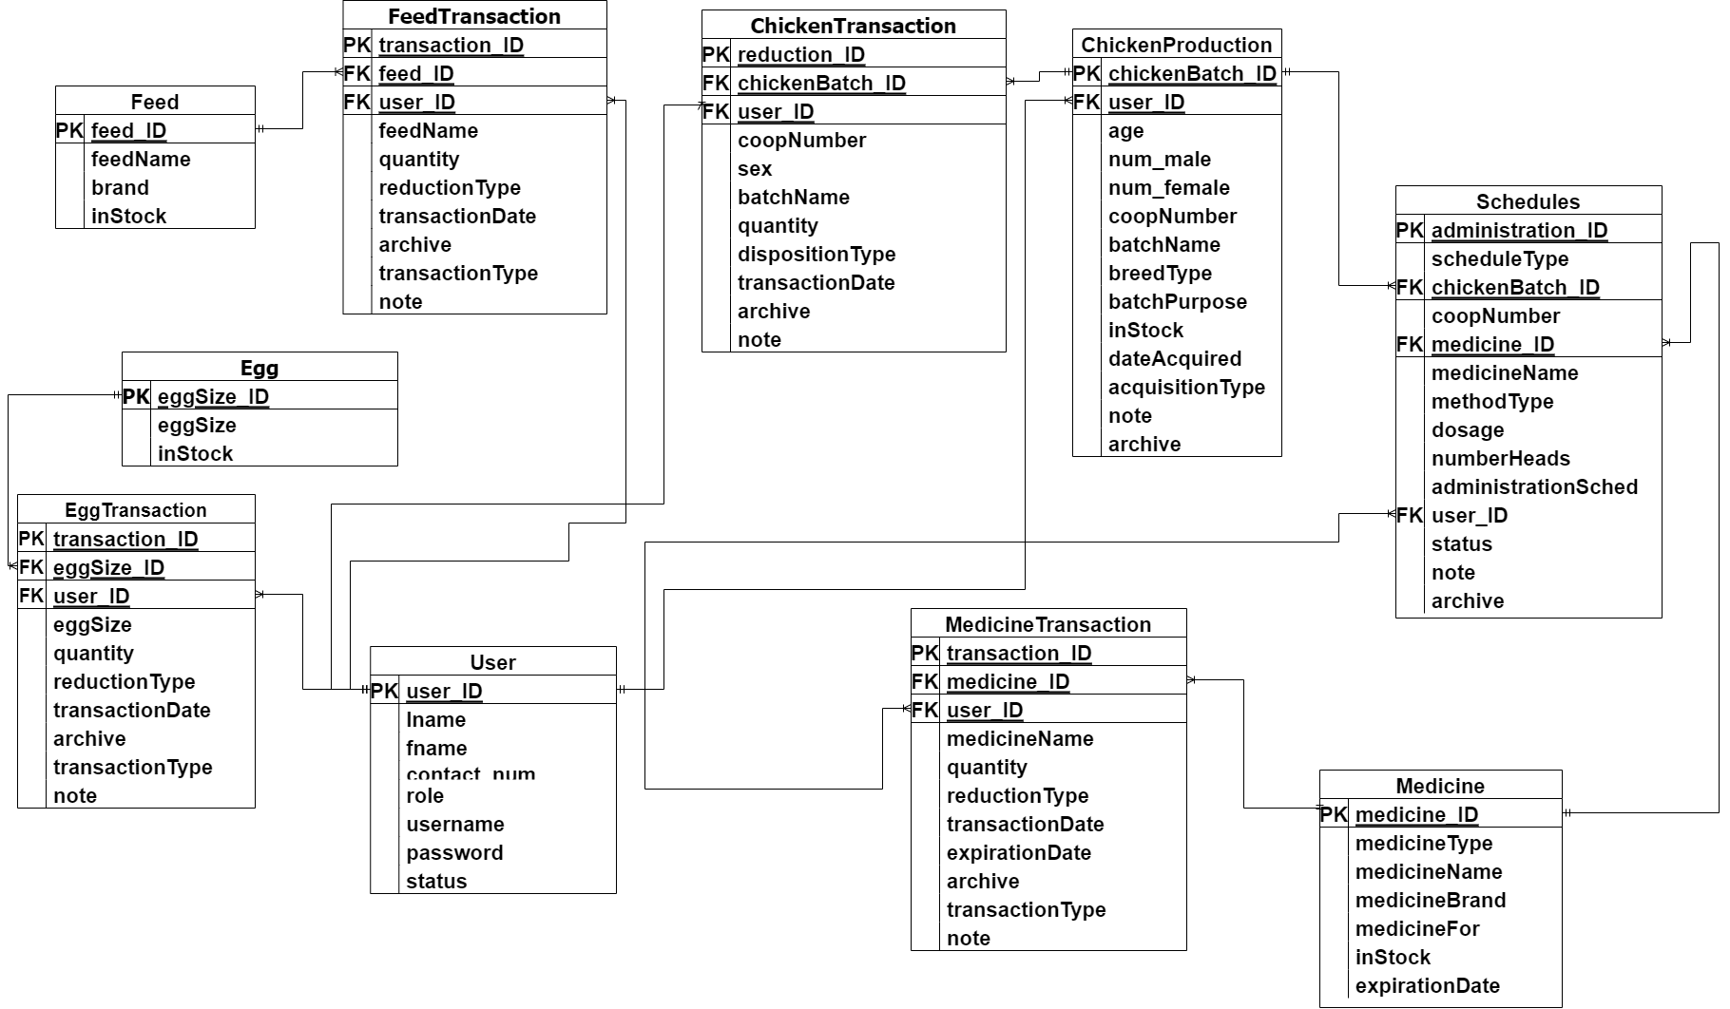

**3.2.2 File Structure**

**Table 1. User**

This table contains user information.

|  |  |  |
| --- | --- | --- |
| **Field Name** | **Data Type** | **Description** |
| **user_ID** | int(11) | An auto-incremented identification number that uniquely identifies a user. This is a primary key. |
| **role** | int(11) | The role type of the user. Identifies the user’s specific role such as being a system administrator, farm inventory manager or farm employee. |
| **username** | varchar(50) | The username of the user. |
| **password** | varchar(255) | The password created by the user to login to the system. |
| **fname** | varchar(50) | The first name of the user. |
| **lname** | varchar(50) | The last name of the user. |
| **contact_num** | varchar(13) | The contact number of the user. |
| **status** | Int(11) | The status where the user is an active member or not. |

**Table 2. Medicine**

This table contains information on the medicines that are currently in the farm’s inventory.

| **Field Name** | **Data Type** | **Description** |
| --- | --- | --- |
| **medicine_ID** | int(10) | An auto-incremented identification number of the medicine. This is a primary key. |
| **medicineType** | varchar(50) | The type of the medicine. |
| **medicineName** | varchar(50) | The name of the medicine. |
| **medicineBrand** | varchar(50) | The brand of the medicine. |
| **medicineFor** | varchar(50) | The purpose of the medicine which will be administrated to the chickens. |
| **startingQuantity** | int(10) | The total number of medicines at the time of addition remains constant. |
| **inStock** | int(10) | The number of available medicines remaining. |
| **dateAdded** | date | The date when the medicine was added to the inventory. |
| **expirationDate** | date | The expiration date of the medicine. |

**Table 3. MedicineTransaction**

This table contains information about medicine replenishment and reductions.

| **Field Name** | **Data Type** | **Description** |
| --- | --- | --- |
| **transaction_ID** | int(10) | An auto-incremented identification number that uniquely identifies a transaction. This is a primary key. |
| **medicine_ID** | varchar(15) | Identification number of a medicine. This is a foreign key. |
| **user_ID** | Int(11) | An identification number of the user. This is a foreign key. |
| **medicineName** | int(10) | The name of the medicine. |
| **quantity** | varchar(50) | The total quantity of a reduction. |
| **reductionType** | varchar(50) | The type of reduction for the medicine. |
| **transactionDate** | int(10) | The date of the transaciton. |
| **expirationDate** | date | The expiration date of the medicine. |
| **transactionType** | varchar(10) | The type of transaction. |
| **notes** | varchar(100) | Notes or remarks related to the schedule. |
| **archive** | varchar(20) | Indicates if the record is active or inactive. |

**Table 4. Schedule**

This table contains information on all the schedules for medication and vaccination.

| **Field Name** | **Data Type** | **Description** |
| --- | --- | --- |
| **administration_ID** | int(10) | An auto-incremented identification number that uniquely identifies a schedule. |
| **user_ID** | Int(11) | An identification number of the user. This is a foreign key. |
| **scheduleType** | varchar(15) | The type of schedule. |
| **chickenBatch_ID** | int(10) | An identification number of the chicken batch. This is a foreign key. |
| **coopNumber** | varchar(50) | The coop number/house number of where the chicken is located. |
| **medicine_ID** | varchar(50) | An identification number of a medicine. This is a foreign key. |
| **medicineName** | int(10) | The name of the medicine. |
| **methodType** | varchar(20) | The type of method to be used in administering the medicine. |
| **dosage** | int(10) | The dosage or amount of medicine to administer. |
| **numberHeads** | int(10) | The number of chickens requiring treatment. |
| **administrationSched** | date | An administration schedule specifies the date when medication should be administered. |
| **administeredBy** | int(11) | The employee responsible for administering the medicine. |
| **status** | varchar(20) | The status of the schedule, indicating whether it is completed or pending |
| **notes** | varchar(100) | Notes or remarks related to the schedule. |
| **archive** | varchar(20) | Indicates if the record is active or inactive. |

**Table 5. ChickenProduction**

This table contains information on chicken production.

| **Field Name** | **Data Type** | **Description** |
| --- | --- | --- |
| **chickenBatch_ID** | int(10) | An auto-incremented identification number that uniquely identifies a chicken batch. |
| **user_ID** | Int(11) | An identification number of the user. This is a foreign key. |
| **age** | int(5) | The age of the chicken. |
| **male** | int(10) | The number of males in the batch |
| **female** | int(10) | The number of females in the batch |
| **coopNumber** | int(5) | The coop number/house number of where the chicken is located. |
| **batchName** | varchar(50) | The name of the chicken batch. |
| **breedType** | varchar(50) | The breed type of the chicken. |
| **batchPurpose** | int(10) | The purpose of the chicken batch. |
| **inStock** | int(10) | The number of available chicken remaining. |
| **dateAcquired** | date | The date when the chicken was added to inventory. |
| **acquisitionType** | varchar(50) | The type of acquisition for the chicken batch. |
| **note** | varchar(100) | Notes or remarks related to the chicken batch. |
| **archive** | varchar(20) | Indicates if the record is active or inactive. |

**Table 6. ChickenTransaction**

This table contains information on chicken allocation, replenishments, and reductions.

| **Field Name** | **Data Type** | **Description** |
| --- | --- | --- |
| **transaction_ID** | int(10) | An auto-incremented identification number that uniquely identifies a chicken transaction. This is a primary key. |
| **chickenBatch_ID** | int(5) | An identification number of the chicken batch. This is a foreign key. |
| **user_ID** | Int(11) | An identification number of the user. This is a foreign key. |
| **coopNumber** | int(5) | The coop number/house number of where the chicken is located. |
| **sex** | enum | The sex of the chicken. |
| **batchName** | varchar(50) | The name of the chicken batch. |
| **quantity** | varchar(50) | The quantity for the transaction. |
| **dispositionType** | int(10) | The type of transaction for the chicken. |
| **transactionDate** | varchar(20) | The date of the transaction. |
| **archive** | varchar(20) | Indicates if the record is active or inactive. |
| **note** | varchar(100) | Notes or remarks related to egg production. |

**Table 7. EggProduction**

This table contains information on egg production.

| **Field Name** | **Data Type** | **Description** |
| --- | --- | --- |
| **eggSize_ID** | int(10) | An auto-incremented identification number that uniquely identifies the egg size. |
| **eggSize** | char(10) | The size of the egg. |
| **inStock** | int(10) | The total quantity of egg inventory. |

**Table 8. EggTransaction**

This table contains information on the egg collection and egg reduction.

| **Field Name** | **Data Type** | **Description** |
| --- | --- | --- |
| **transaction_ID** | int(10) | An auto-incremented identification number that uniquely identifies an egg reduction. This is a primary key. |
| **eggSize_ID** | int(10) | An identification number of the egg size. This is a foreign key. |
| **user_ID** | Int(11) | An identification number of the user. This is a foreign key. |
| **eggSize** | char(10) | The size of an egg. |
| **quantity** | int(10) | The total quantity of the transaction. |
| **reductionType** | varchar(30) | The type of reduction for the egg. |
| **transactionDate** | date | The date of the transaction. |
| **archive** | varchar(20) | Indicates if the record is active or inactive. |
| **transactionType** | varchar(10) | The type of transaction. |
| **note** | varchar(100) | Notes or remarks related to egg production. |

**Table 9. Feed**

This table contains information on the feeds that are currently in the farm’s inventory.

| **Field Name** | **Data Type** | **Description** |
| --- | --- | --- |
| **feed_ID** | int(10) | An auto-incremented identification number that uniquely identifies a feed. |
| **feedName** | varchar(50) | The name of the feed. |
| **brand** | varchar(50) | The brand of the feed. |
| **inStock** | int(10) | The number of available feeds. |

**Table 10. FeedTransaction**

This table contains information on feed replenishment and reductions.

| **Field Name** | **Data Type** | **Description** |
| --- | --- | --- |
| **Transaction_ID** | int(10) | An auto-incremented identification number that uniquely identifies a feed reduction. This is a primary key. |
| **feed_ID** | int(10) | An identification number of the feed. This is a foreign key. |
| **user_ID** | Int(11) | An identification number of the user. This is a foreign key. |
| **feedName** | varchar(50) | The feed name. |
| **quantity** | int(10) | The quantity for the transaction. |
| **reductionType** | varchar(50) | The type of reduction for the feeds. |
| **transactionDate** | date | The date of the transaction. |
| **transactionType** | varchar(10) | The type of transaction. |
| **note** | varchar(100) | Notes or remarks related to egg production. |
| **archive** | varchar(20) | Indicates if the record is active or inactive. |

**3.2.3 Program Hierarchy**

**3.2.3.1 Top Level**

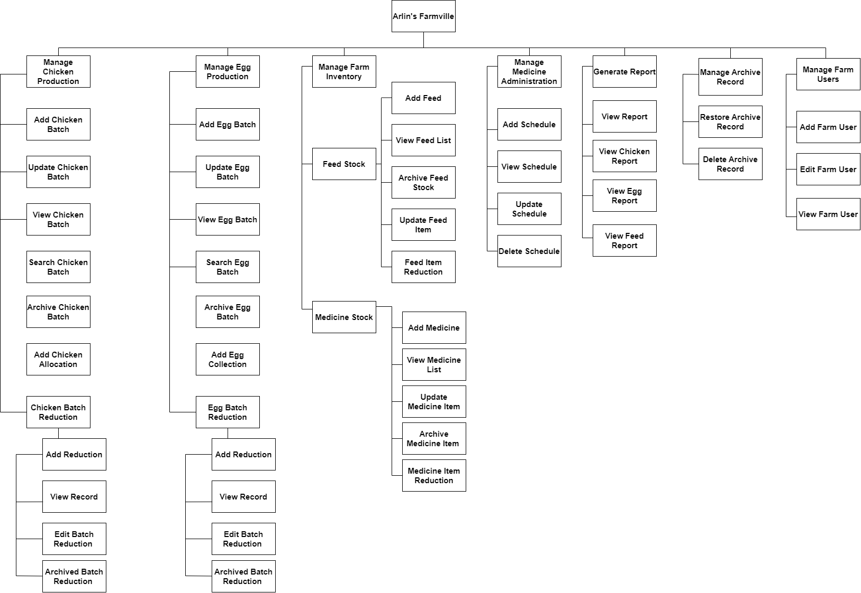

**3.2.3.2 Farm Inventory Manager**

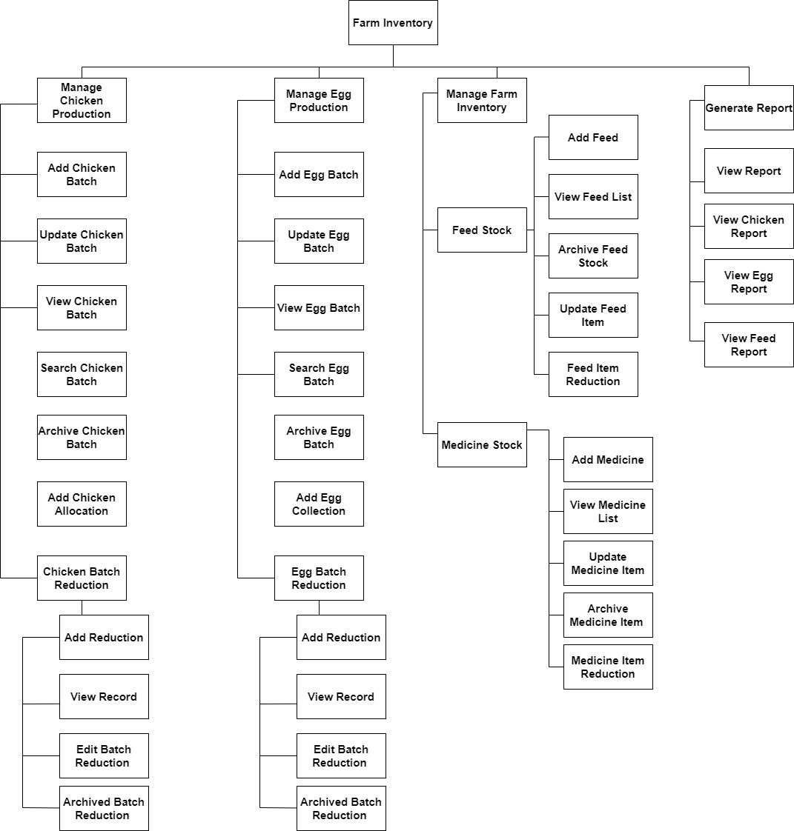

**3.2.3.3 Farm Employee**

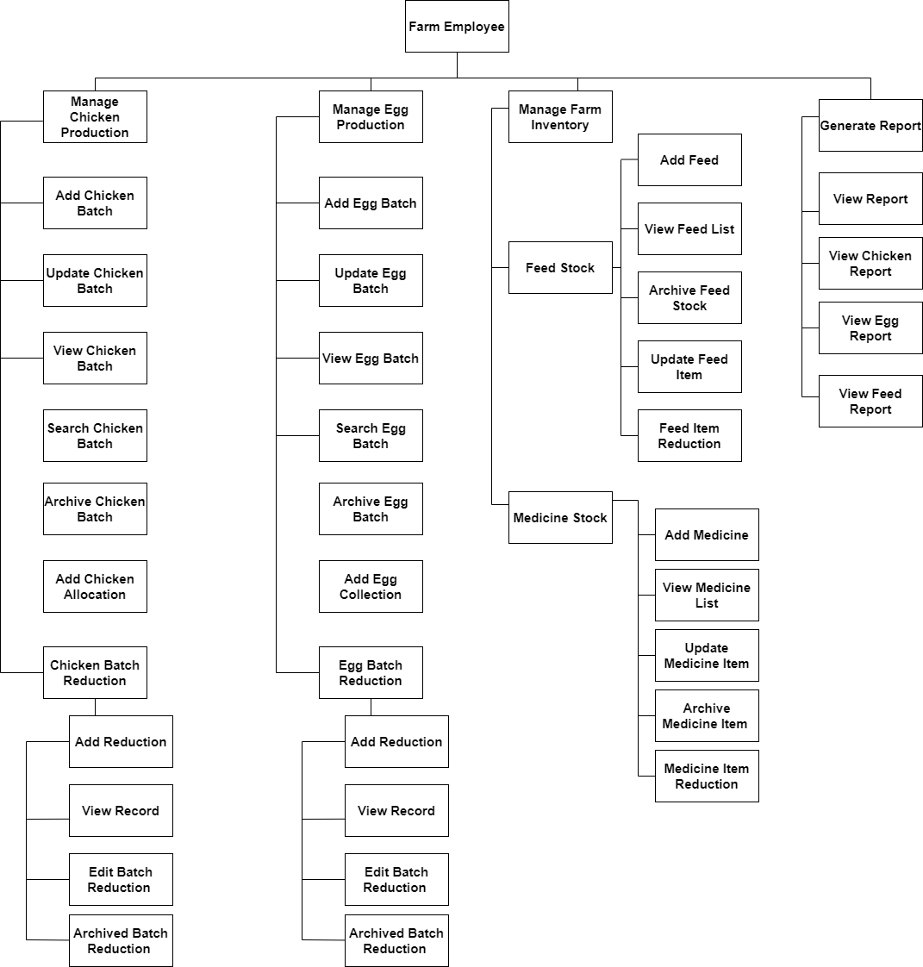

**3.2.3.4 System Administrator**

