**CHAPTER V**

**IMPLEMENTATION**

This section presents the implementation plan for Arlin’s Farmville. This includes the deployment process, the conversion plan, and the policies of the system. The minimum hardware requirements for the users to run the system is Intel core i3-4170 processor and a 4GB of RAM would be sufficient. The system also runs in any Operating System but Windows 10 Operating System is recommended. Since the system is a web system it requires an internet connection, so default internet browsers such as Google Chrome and Microsoft Edge can run the system with little to no issue.

Parallel implementation will be used in implementing the system. With this approach, Parallel implementation involves running both the old and new systems side-by-side for a period of time to ensure that the new system is functioning correctly before fully replacing the old one. This approach can be useful for Arlin’s Farmville that is transitioning to a new inventory system and want to minimize disruptions to their operations. During the parallel implementation phase, Arlin’s Farmville can continue to use the old system while testing and refining the new one. This approach can also help to identify any issues or challenges that arise during the transition and ensure that they are addressed before fully implementing the new system. While parallel implementation can be more time-consuming and require additional resources, it can provide a safety net and help to ensure a smoother transition to the new system.

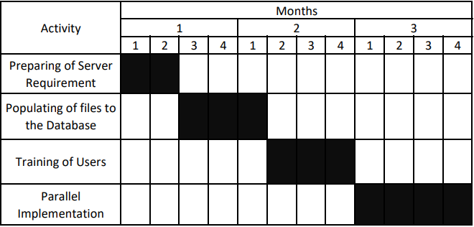

**Figure 1. System Conversion Plan**

**Preparing of Server Requirements**

This activity involves setting up the server requirements of the system.In this phase, registration of domain name is done, the website will be hosted using Epizy which is a free website hosting platform in order to be accessed on the internet. This activity will take (2) weeks.

**Populating of Files to the Database**

This activity involves the population of files in the database. The creation of manager account files will be done first as the manager account involves the inventory database. The manager account is needed for the training of users. The creation of system administrator account files comes second, which is needed for the training of farm employee users, and plays a secondary role in the inventory database. Other files come after the creation of these two accounts, such as new employee account files after training of users and populating the inventory database with production files. This activity can be completed in (3) weeks.

**Training of Users**

This activity involves training the users of the system, namely the Farm Inventory Manager, Farm Employee, and System Administrator. Instructions and policies will also be given governing the use of the system. This activity can be completed in (3) weeks.

**Parallel Implementation**

In this phase, the final implementation of the system will be carried out, which includes deploying the system to all users and replacing manual systems, after which the current manual system is discontinued entirely. This phase will take (4) weeks to complete, and by ensuring that all functionalities are in place, Arlin’s Farmville can confidently implement the system and maximize its benefits. Overall, the system implementation had a duration of 3 months for preparing the server, database population, training of users, running the demo and parallel implementation.

**POLICIES**

For a successful implementation and utilization of the system, the following should be followed:

1. Before user creation is accepted, rules and policies must be given such that he/she must also be part of the farm's organizational structure, identifying roles that will be given for each member of Arlin's Farmville.
2. The Farm Inventory Manager must perform a monthly regular back-up of the database. This is done for security and safety purposes. It is handled by the system administrator and the farm inventory manager using a password and data encryption in order to access the database. A Full back-up where data is cloned is a common practice, and issues of storage space can be remedied through cloud storage, but an incremental back-up, where new data is stored on top of old data, is also ideal.
3. All users must maintain accurate records of data, from recording egg and chicken production, feeds, and medicine, to scheduling of vaccination and medication. Data must be thoroughly reviewed before being input into the system to minimize the risk of mismanagement or misinformation. This must be put to practice in order to maintain system integrity. There are options put in place such as editing incorrect data or archiving data only when necessary.
4. Whenever data is removed from the system, they will still populate the database in an archived format, inaccessible to the manager and employees. This is put in place for data safety, so as to not lose potentially relevant or valuable data. In the event data is archived, it will continue to exist in the database, including during back-ups, and will affect unarchived records related to it. The System Administrator will have access to Archived Records, and will be given the privilege to restore or permanently remove data, which must be done with care and consideration.