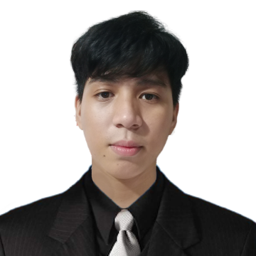
JAYSON V. BERNANTE
662GulayanCatmonMalabon City
09771301659
jaysonbernante@gmail.com

OBJECTIVES

To be associated with a progressive organization that will give me privilege to utilize and continuously develop my knowledge and skills.

WORK EXPERIENCE

Production Worker – Manly Plastic Inc. February 4, 2022 – July 1, 2022
Graphics Designer – Abcd Design Inc. April 25, 2027 – February 5, 2030

PERSONAL SKILL

Highly Organized And Efficient
Computer Troubleshooting
Photoshop Editing
Programaming ( C++ oop, Java, Visual Basic)
EDUCATIONAL BACKGROUND

College Bachelor of Science in formation and communications (2023) – (2027)
Datamex College Saint Adeline
10th Avenue,Caloocan City
Senior High Information Communication and Technology (2017) – (2020)
Tinajeros National High School
B. Rivera St, Tinajeros Malabon City

Junior High Tinajeros National High School (2013) – (2017)
B. Rivera St, Tinajeros Malabon City

Elementary Tunsuya Elementary School (2007) – (2013)
Sanciangco St, Malabon City

PERSONAL INFORMATION
Date of Birth: December 27, 2000
Age 23
Height: 5’9
Weight: 63kg
Religion: Roman Catholic
Marital Status: Single
Citizenship: Filipino

PERSONAL INFORMATION
NAME WORK/PLACE CONTACNUMBER

MEEKO I. TAN PRODUCTION ENGINEER 09155045921
MANLY PLASTIC INC.

RENEBOY V. VILLAJOS CALL CENTER 09887264335
PLDT INC.

ELJOHN C PALACAT COUNTER CLERK 09451643454
FISHER MALL
I hereby certify that all information given are true and correct to the best of my knowledge and beliefs.

_Jayson Bernante_
Applicant Signature

