CSUS
COLLEGE OF ENGINEERING AND COMPUTER SCIENCE
Department of Computer Science

CSc/CpE 138 Computer Networks and Internets
Fall 2013
Ghansah

Assignment Completed By: Jayson Francis and Pao Fang

Assignment #2 (Programming Assignment #1)
Due: November 12, 2013

Main assignment → webserver.py
Extra Credit Assignment → multi.py

Each code has all the steps written in the comment sections for the required steps. (1-7)
Screenshots of input/output results are listed below for both webserver and multi
threaded.

Python was used for both.
Main Program: webserver.py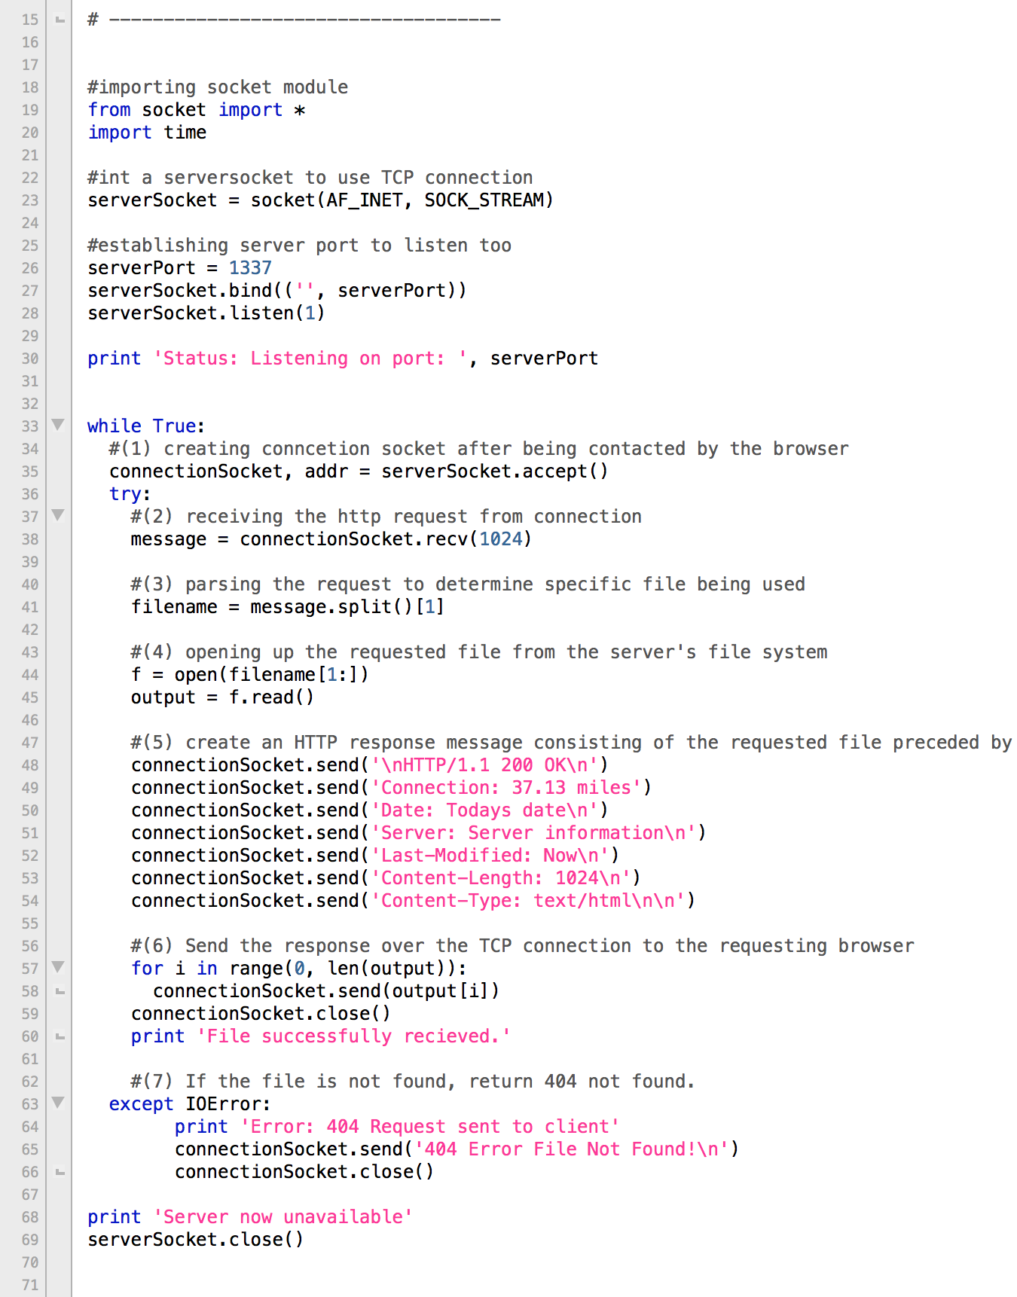

Starting the program (webserver.py)
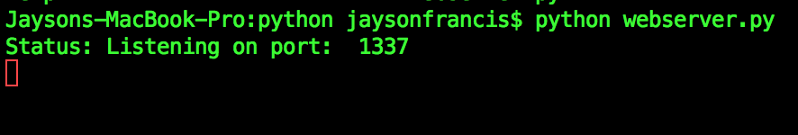

Browser view after file is requested (index.html)
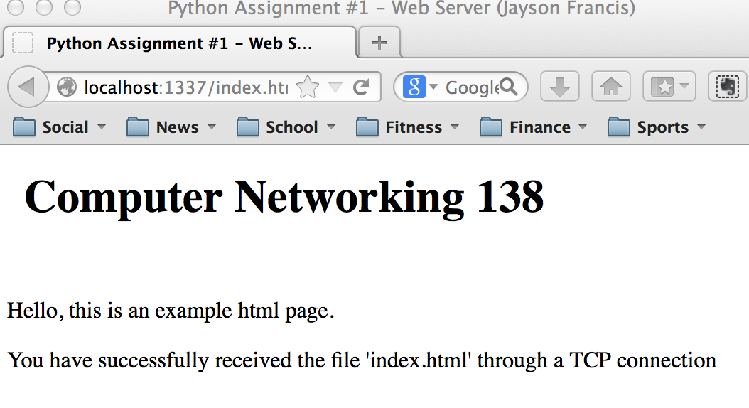
Browser view after invalid file is requested. (404 Error)
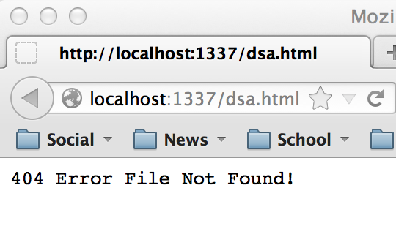
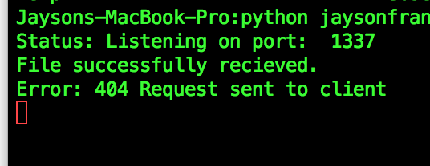

Extra Credit: multi.py
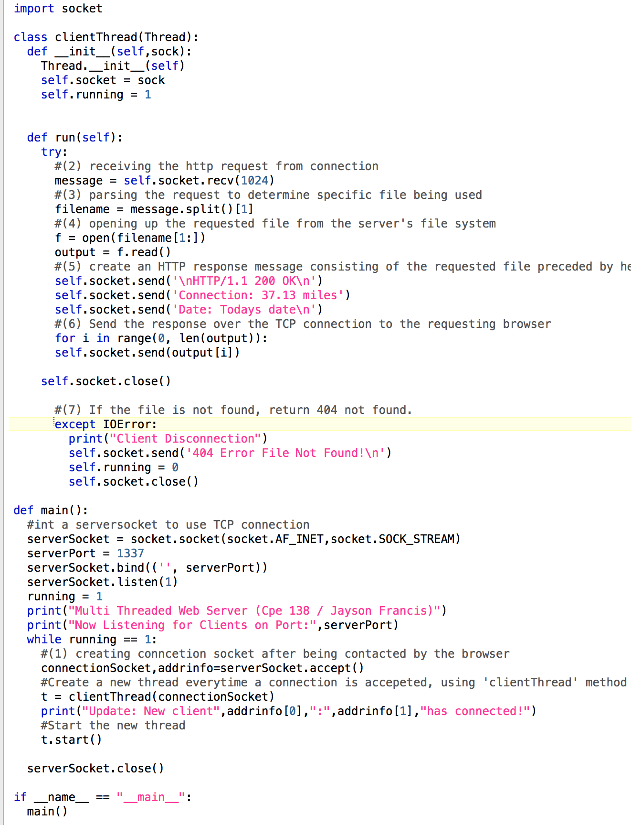
Starting The Program (multi.py)
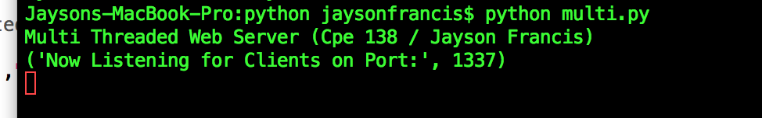

Browser view after initial request (index.html)
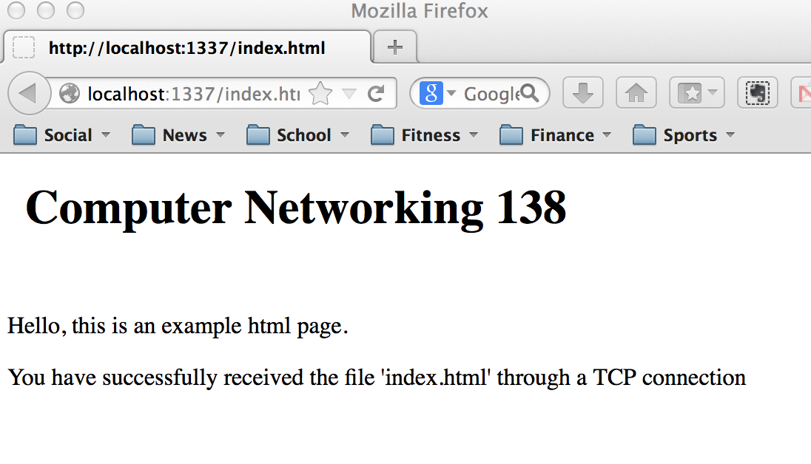

Server view after connection established, and data sent.
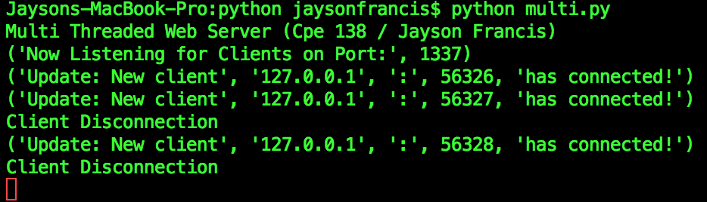

Browser view after invalid file request. (404 Error)
