**Practical File**

**Of**

**Fundamentals of C**

**Programming(23CS001)**

***Submitted***

***in partial fulfilment for the award of the degree***

***of***

**BACHELEOR OF ENGINEERING**

***in***

COMPUTER SCIENCE & ENGINEERING



**CHANDIGARH-PATIALA NATIONAL HIGHWAY RAJPURA**

**(PATIALA) PUNJAB-140401 (INDIA)**

**Submitted To: Submitted By:**

Faculty name: Dr Shanky Goyal Name: Jay Soni

Chitkara University, Punjab Roll No: 2310991943

Batch:G-22, Sem: 2

**INDEX**

|  |  |  |
| --- | --- | --- |
| **Sr.No.** | **Practical Name** | **Teacher Sign** |
| 1 | Write a Program to show the use to input (Scanf)/output (Printf) statements and block structure of C-program by highlighting the features of "stdio.h". |  |
| 2 | Write a program to add two numbers and display the sum. |  |
| 3 | Write a program to calculate the area and the circumference of a circle by using radius as the input provided by the user. |  |
| 4 | Write a Program to perform addition, subtraction, division and multiplication of two numbers given as input by the user. |  |
| 5 | Write a program to evaluate each of the following equations. (i) V = u + at. (ii) S = ut+1/2at 2 (iii) T=2*a+√b+9c (iv) H=√b 2+p |  |
| 6 | Write a program to swap two variable: a) By using temporary variable.  b) ) By using temporary variable. |  |
| 7 | Write a Program to find the greatest among three numbers using:   * Conditional Operator * If-Else statement |  |
| 8 | Write the following programs using switch case statement:   * To check that an input alphabet is vowel or consonant * To check whether a number is positive, negative or zero |  |

**Program 1: Write a Program to show the use to input (Scanf)/output (Printf) statements and block structure of C-program by highlighting the features of "stdio.h".**

**Solution:**

#include <stdio.h>

int main()

{

    printf("Name:Jay Soni\nRoll no.:2310991943\n");

    printf("Enter a number:");

    int num;

    scanf("%d",&num);

    return 0;

}

**Output:**

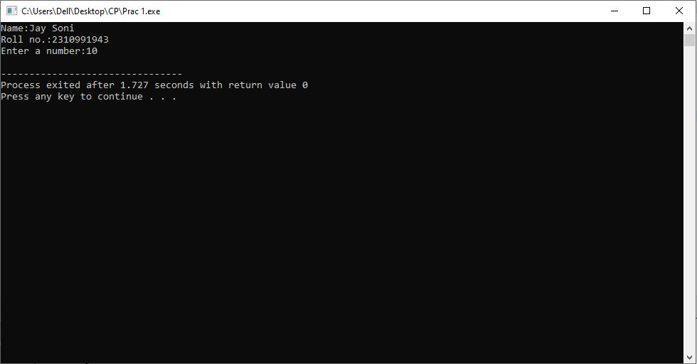

**Program 2: Write a program to add two numbers and display the sum.**

**Solution:**

#include <stdio.h>

int main()

{

    printf("Name:Jay Soni\nRoll no.:2310991943\n");

    int num1,num2,sum;

    printf("Enter number1:");

    scanf("%d",&num1);

    printf("Enter number2:");

    scanf("%d",&num2);

    sum=num1+num2;

    printf("The sum of two numbers is %d",sum);

    return 0;

}

**Output:**

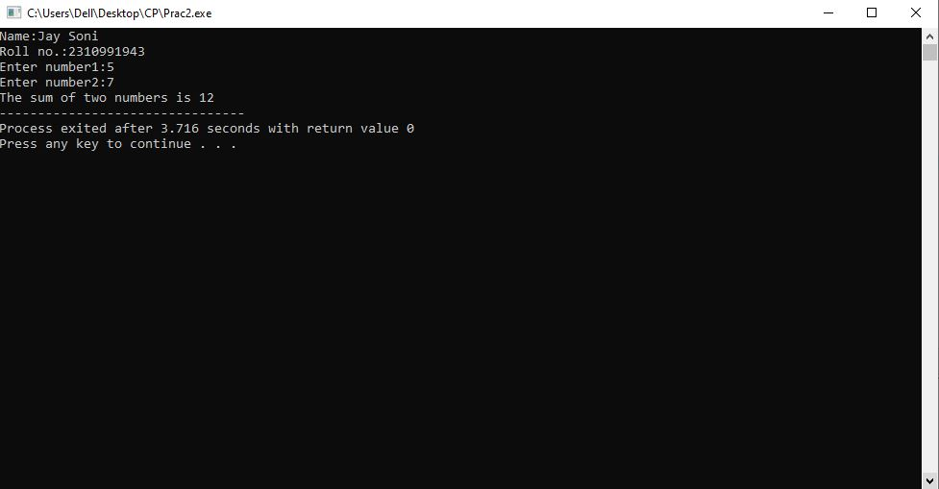

**Program 3: Write a program to calculate the area and the circumference of a circle by using radius as the input provided by the user.**

**Solution:**

#include <stdio.h>

int main()

{

    printf("Name:Jay Soni\nRoll no.:2310991943\n");

    float radius,area,circumference;

    printf("Enter radius:");

    scanf("%f",&radius);

    area=3.14*radius*radius;

    printf("Area of the circle is %f\n",area);

    circumference=2*3.14*radius;

    printf("Circumference of the circle is %f",circumference);

    return 0;

}

**Output:**

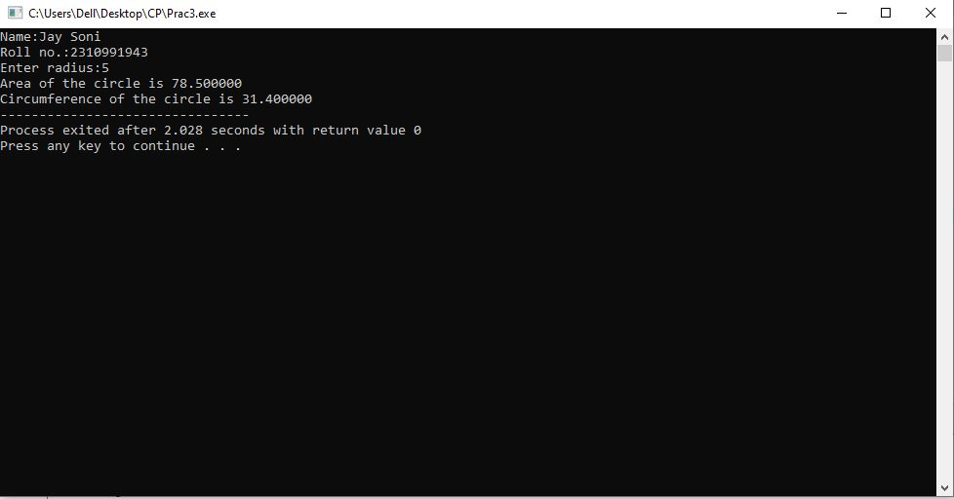

**Program 4: Write a Program to perform addition, subtraction, division and multiplication of two numbers given as input by the user.**

**Solution:**

#include <stdio.h>

int main()

{

    printf("Name:Jay Soni\nRoll no.:2310991943\n");

    float num1,num2,addition,subtraction,multiplication,division;

    printf("Enter num1:");

    scanf("%f",&num1);

    printf("Enter num2:");

    scanf("%f",&num2);

    addition=num1+num2;

    subtraction=num1-num2;

    multiplication=num1*num2;

    division=num1/num2;

    printf("Addition:%.2f\n",addition);

    printf("Subtraction:%.2f\n",subtraction);

    printf("Multiplication:%.2f\n",multiplication);

    printf("Division:%.2f\n",division);

    return 0;

}

**Output:**

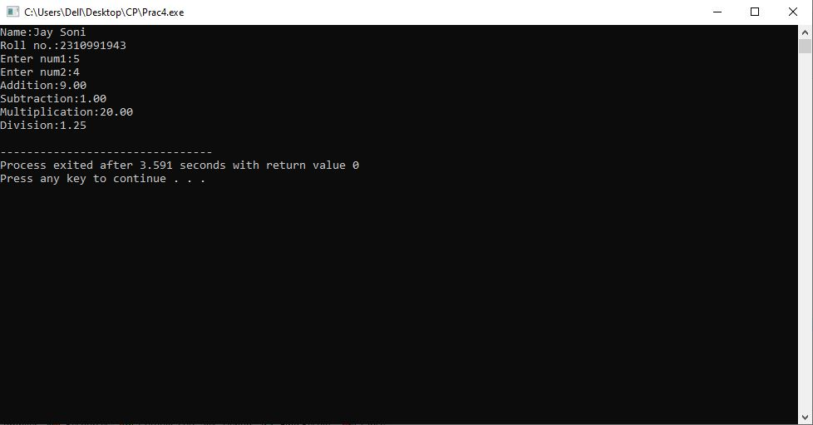

**Program 5: Write a program to evaluate each of the following equations. (i) V = u + at. (ii) S = ut+1/2at 2 (iii) T=2*a+√b+9c**

**(iv) H=√b 2+p**

**Solution:**

#include <stdio.h>

#include <math.h>

int main()

{

    printf("Name:Jay Soni\nRoll no.:2310991943\n");

    float u,a,t,b,c,p,V,S,T,H;

    printf("Enter u:");

    scanf("%f",&u);

    printf("Enter a:");

    scanf("%f",&a);

    printf("Enter t:");

    scanf("%f",&t);

    printf("Enter b:");

    scanf("%f",&b);

    printf("Enter c:");

    scanf("%f",&c);

    printf("Enter p:");

    scanf("%f",&p);

    V= u+a*t; S= u*t+0.5*a*t*t;

    T= 2*a+sqrt(b)+9*c; H= sqrt(b*b)+p*p;

    printf("V:%.2f\n",V);

    printf("S:%.2f\n",S);

    printf("T:%.2f\n",T);

    printf("H:%.2f\n",H);

    return 0;

}

**Output:**

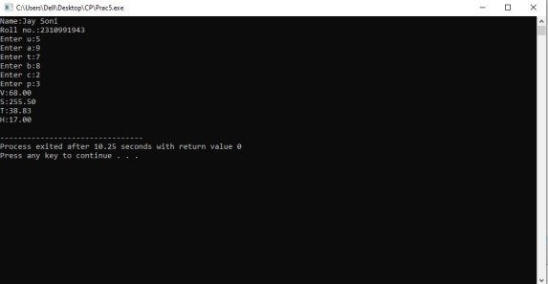

**Practical 6: Write a program to swap two variables.**

**a. By using temporary variable.**

**b. Without using temporary variable.**

**Solution:**

a. #include <stdio.h>

int main()

{

    printf("Name:Jay Soni\nRoll no.:2310991943\n");

    int x,y;

    printf("Enter x:");

    scanf("%d",&x);

    printf("Enter y:");

    scanf("%d",&y);

    if (y == 0){

        y = x;

        x = 0;}

    else if (x == 0){

        x = y;

        y = 0;}

    else{

        x = x * y;

        y = x / y;

        x = x / y;}

    printf("After Swapping: x = %d, y = %d", x, y);

    return 0;

}

**Output:**

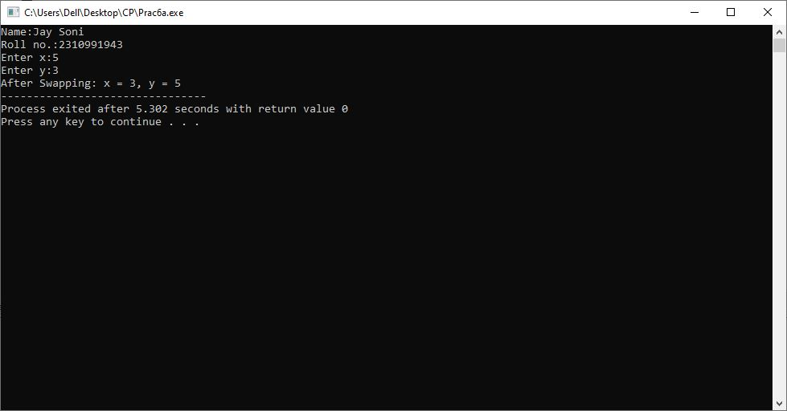

**Solution:**

b. #include <stdio.h>

int main()

{

    printf("Name:Jay Soni\nRoll no.:2310991943\n");

    int x,y,temp;

    printf("Enter x:");

    scanf("%d",&x);

    printf("Enter y:");

    scanf("%d",&y);

    temp = x;

    x = y;

    y = temp;

    printf("After Swapping: x = %d, y = %d", x, y);

    return 0;

}

**Output:**

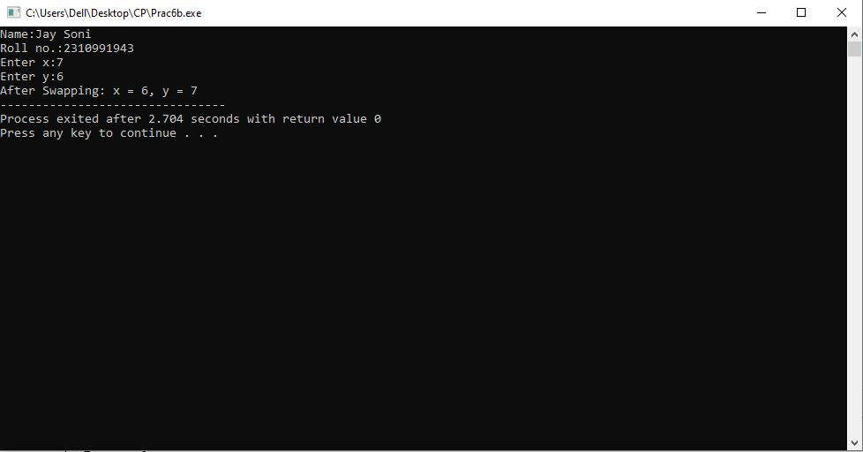

**Program 7: Write a Program to find the greatest among three numbers using:**

**a. Conditional Operator**

**b. If-Else statement**

**Solution:**

a. #include <stdio.h>

int main()

{

printf("Name:Jay Soni\nRoll no.:2310991943\n");

int num1, num2, big, num3;

printf("Enter 1st Number: ");

scanf("%d", &num1);

printf("Enter 2nd Number: ");

scanf("%d", &num2);

printf("Enter 3rd Number: ");

scanf("%d", &num3);

big = (num1 > num2 && num1 > num3 ? num1 : num2 > num3 ? num2: num3);

printf("The Greatest Number is: %d", big);

return 0;

}

**Output:**

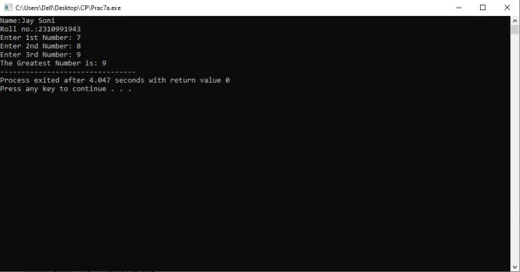

**Solution:**

b. #include <stdio.h>

int main()

{

printf("Name:Jay Soni\nRoll no.:2310991943\n");

int n1, n2, n3;

printf("Enter three different numbers: \n");

scanf("%d %d %d", &n1, &n2, &n3);

if (n1 >= n2 && n1 >= n3){

printf("%d is the largest number.", n1);}

else if (n2 >= n1 && n2 >= n3){

printf("%d is the largest number.", n2);}

else{

printf("%d is the largest number.", n3);}

return 0;

}

**Output:**

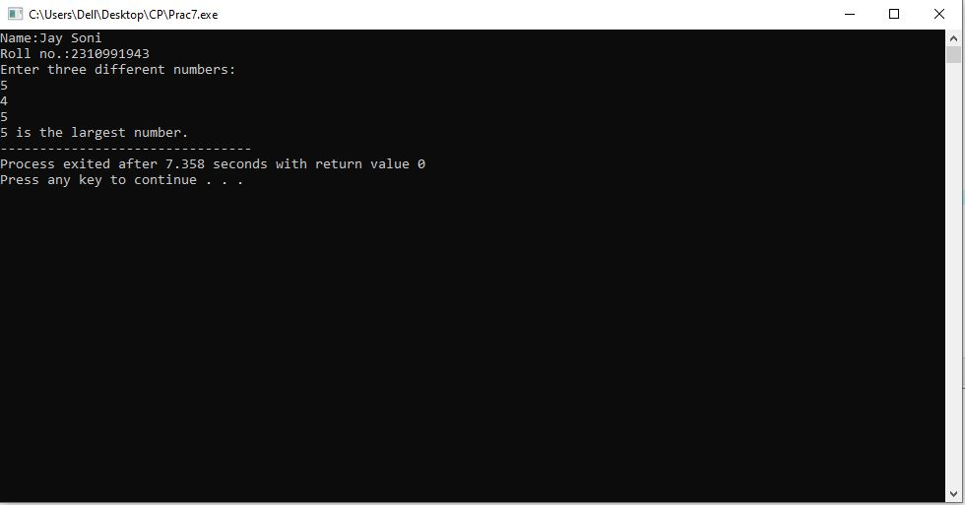

**Program 8. Write the following programs using switch case statement:**

**a. To check that an input alphabet is vowel or consonant**

**b. To check whether a number is positive, negative or zero**

**Solution:**

a) #include <stdio.h>

int main()

{

    printf("Name:Jay Soni\nRoll no.:2310991943\n");

    char x;

    printf("Enter any Alphabet:");

    scanf("%c", &x);

    switch (x{

    case 'a':

        printf("Vowel");

        break;

    case 'e':

        printf("Vowel");

        break;

    case 'i':

        printf("Vowel");

        break;

    case 'o':

        break;

    case 'u':

        printf("Vowel");

        printf("Vowel");

        break;

    default:

        printf("Consonant");

        break;}

    return 0;

}

**Output:**

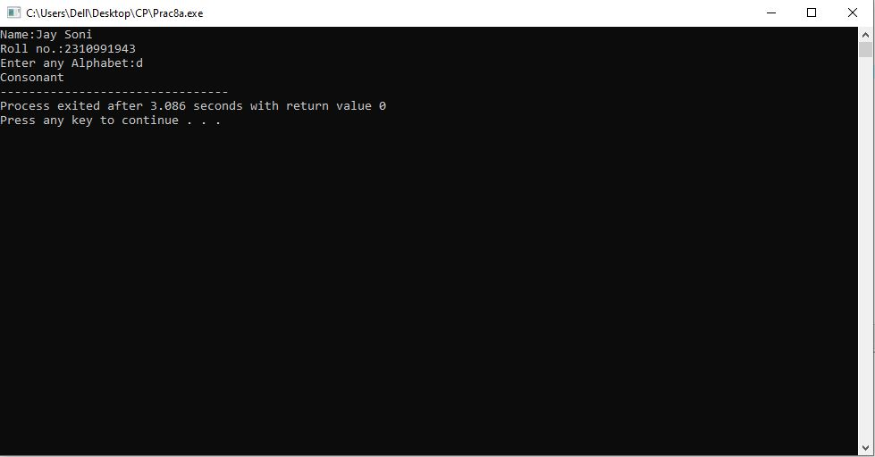

**Solution:**

b) #include <stdio.h>

int main()

{

    printf("Name:Jay Soni\nRoll no.:2310991943\n");

    int num;

    printf("Enter a number:");

    scanf("%d",&num);

    switch (num>0){

    case 1:

        printf("Positive number!");

        break;

    case 0:

        switch (num<0){

        case 1:

            printf("Negative number!");

            break;

        default:

            printf("Zero!");

            break;}

        }

    return 0;

}

**Output:**

