STUDENT INTERN’S PERSONAL INFORMATION |  |  |  | 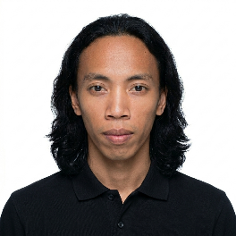  “1X1” ID Picture
Student Personal Information:
Last Name: Francisco | First Name: Jayson |  |  | Middle Name: Pacificador
Age: 21 | Sex: (✓) Male ( ) Female
Height: 156 | Weight: 46.8 |  |  | Complexion: Medium Brown
Disability (If any):
Birthdate: October 05, 2004 |  | Birth Place: Caloocan City, Metro Manila, Philippines
Citizenship: Filipino |  | Civil Status: Single
Present Address: Pob. Sta. Catalina, Negros Oriental |  | Telephone/Cellphone Number: 0953-455-9021
Permanent Address: Pob. Sta. Catalina, Negros Oriental |  | Telephone/Cellphone Number: 0953-455-9021
Family Background (if parents are deceased, provide data from the nearest relative and indicate relationship to applicant)
Father’s Name: Renante Francisco |  | Occupation: Foreman/Maintenance
Mother’s Name: Michelle Pacificador-Mag-aso |  | Occupation: Housewife
Parents’ Address: Pob. Sta. Catalina, Negros Oriental |  | Telephone/Cellphone Number: 09940396003
Guardian’s Name: Michelle Pacificador-Mag-aso |  | Telephone/Cellphone Number: 09940396003
SCHOOL INFORMATION
Program/Degree: Bachelor of Science in Information Technology |  |  | Year Level: Fourth Year
OJT Coordinator: JOVANY B. CASTILLO, LPT |  |  | Telephone/Cellphone Number: 09279792711
OJT Director: N/A |  |  | Telephone/Cellphone Number: N/A
College Dean: JEAN CARREM R. ESPARCIA, Ph.D. |  |  | Telephone/Cellphone Number: 09266722267
In case of an emergency, please notify:
Name: Michelle Pacificador-Mag-aso |  | Relationship: Mother
Address: Pob. Sta. Catalina, Negros Oriental |  | Telephone/Cellphone Number: 09940396003

I hereby certify that the foregoing pieces of information given are true and correct to the best of my knowledge, belief, and ability.

Signed at: _____________________ Date: ______________________

_____________________________________
Student Intern’s Signature Over Printed Name

