**MPE MDNA BA SCRIPTS**

# Introduction

This is a Tool which consolidate all the local scripts in a single Graphical User Interface. The tool can call different scripts such as:

1. Versatile Shmoo Analyzer
2. Fuse File Compare
3. Extract Test Program to Excel
4. Test Data Extract from Zipped ITUFF
5. Sort IDSK from AQUA Excel

# Main GUI

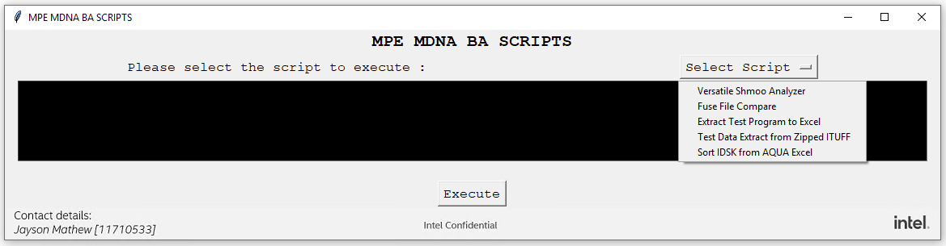

Main window is designed with

* **Select Script**: Drop-down button which help to select the required script need to run.
* **Text Box:** This will show a short description about the selected script from the drop-down button.
* **Execute:** Execute button for the selected script.

# Versatile Shmoo Analyzer

## Introduction

Shmoo is a tool used on ATE (Automated Test Equipment) which plots Frequency Vs Voltage or any parameters along XY axes used for Content bring up Validation, Test Program Stability and Quality improvement of Intel products. This **Versatile Shmoo Analyzer** is the tool which analyses any shmoo data and performs effective data analysis. Existing data analysis tools are not capable of analyzing shmoo datalog that are not uploaded to Test Data database (Midas) used by Test analysis tools like TRACE and AQUA. This Versatile Shmoo Analyzer tool can take shmoo datalog directly from the ATE, in any of the 3 formats such as ituff, ascii or xml and generates shmoo images in HTML. Product Development Engineers (PDE) on ATE would need only less than 30 minutes to analyze 100 shmoo data Vs atleast 1 day if in the traditional way of manually verifying the shmoos, hence this tool significantly improves the efficiency of Test Program development.

## GUI

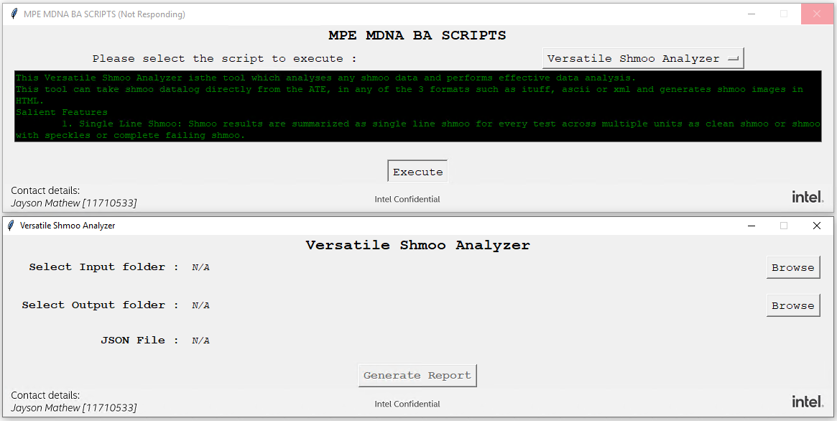

This script requires 2 input such as:

* **Input Folder**: The folder which contains shmoo ascii files (ituff, xml etc.). This tool can search for the file recursivefolders.
* **Output Folder**: Location where you need to store output files.

## Description

* Automatically identifying the shmoo datalog files.

This tool identifies the files consists of the valid shmoo data from a directory that has multiple files. Below are the formats which can support for the tool.

* + Multiline ituff shmoo format.​ This is the datalog generated by ATE after running test program with multiline shmoo settings.

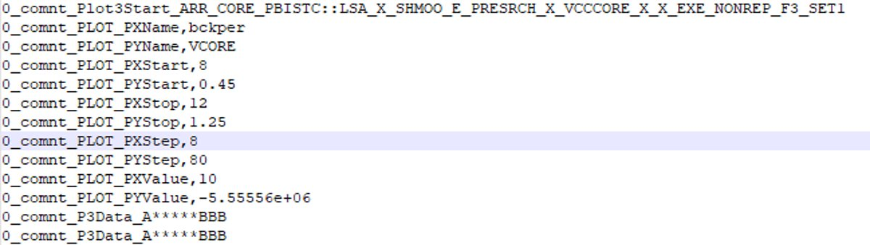

* + Single line ituff shmoo format.​ This is the datalog generated by ATE after running test program with single shmoo settings.



* + Beyond shmoo xml format.​ This is the output of Beyond shmoo tool while we save as the output in xml format.

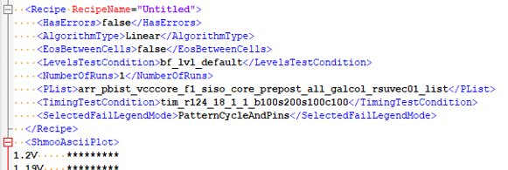

* + Blueline ascii format.​ This is the output of Beyond shmoo tool while we save as the output in ascii format.

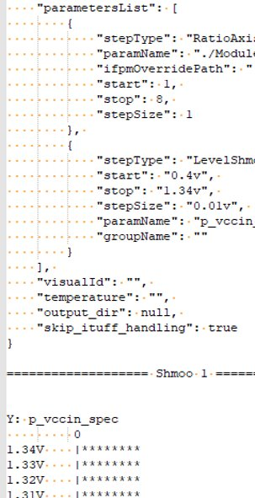

* Overlay shmoo: Overlay is a shmoo which will be created by overlapping all the available shmoos of the same test, which can show the overall Vmin and behavior of shmoo. This tool also generates overlay shmoo with same test for easy analysis.​

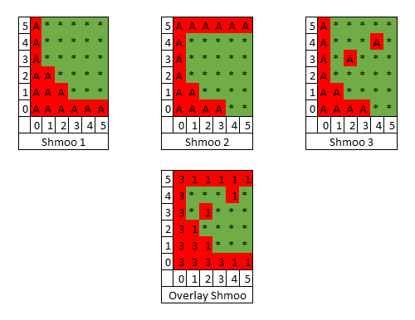

* Single Line Shmoo: Summary indicates whether the shmoo contains speckles (fail spots at the passing region), hard-fail (failing across voltages), ceiling (failing at higher voltages) or clean (clean fail to pass transaction when voltage increases). Shmoo results are summarized as single line shmoo for every test across multiple units as clean shmoo or shmoo with speckles or complete failing shmoo.

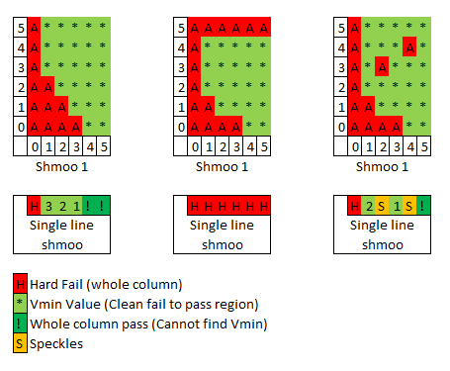

* Vmin: The tool will find the Vmin for target frequency, if target frequency available, else ​it will find the Vmin for all the frequencies. Determines Vmin for all tests that has clean shmoos and updated in the shmoo summary.
* Easy navigation: Output HTML contains multiple links and buttons, which will help the users to navigate across the summary table and respective shmoo plot.

## Results/ Output

Versatile Shmoo Analyzer Tool will generate a directory named ‘html_shmoo’ which consists of all the html output files. User can open the ‘Main_ShmooData.html’ in any browser from ‘html_shmoo’ directory. This will open the overlay page, which shows all the overlay shmoos.​ From there user can move across different pages, which consists of individual shmoo.

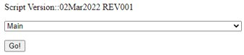

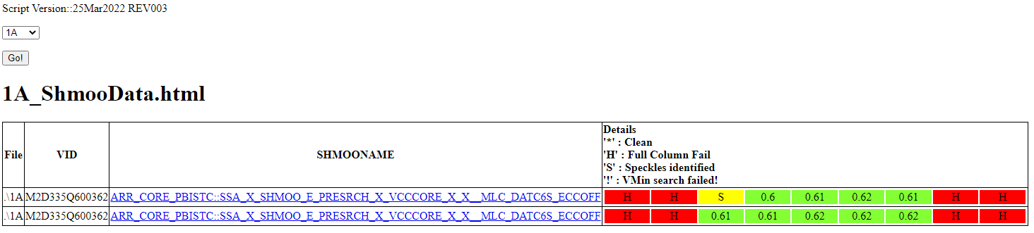

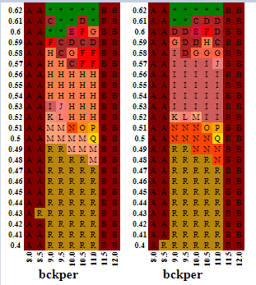

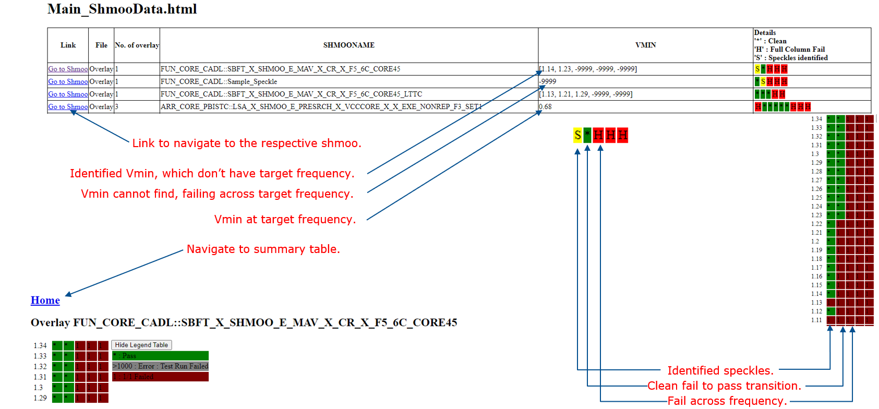

## Conclusion and Future Plans

Versatile Shmoo Analyzer has been in use since January 2022 by Product development Engineers for 2 products and received positive feedbacks. Moving forward this tool will need to be tested on different products and improvise further based on user inputs and also incorporate other datalog formats.

# Fuse File Compare

## Introduction

This tool can help to extract and summarize the not matches in fuse string group name, Address, Group Value for all the three registers (CPU0, CDF, NAC) of ICXD project. It reduces lots of manual data processing work.

Dependencies: Fuse_ProCheck.exe

## GUI

