Supplementary Material - Defining Schistosomiasis-Associated Colorectal Cancer: A Systematic Analysis and Meta-analysis
Supplementary Table S1. Complete search strategies

Table S1. Database search strategies (PRISMA-S)
Database | Platform | Exact query | Date range | Search date | Records | Limits
MEDLINE | PubMed | ("Schistosoma japonicum"[Mesh] OR "Schistosomiasis"[Mesh] OR "Schistosoma"[Mesh] OR "Schistosoma japonicum"[tiab] OR schistosomiasis[tiab] OR schistosomal[tiab] OR schistosoma*[tiab] OR bilharzia*[tiab]) AND ("Colorectal Neoplasms"[Mesh] OR ((colorectal[tiab] OR colon[tiab] OR colonic[tiab] OR rectal[tiab] OR rectum[tiab] OR "large bowel"[tiab] OR "large intestine"[tiab]) AND (cancer*[tiab] OR carcinoma*[tiab] OR neoplasm*[tiab] OR tumor*[tiab] OR tumour*[tiab] OR adenocarcinoma*[tiab] OR malignan*[tiab]))) | Inception to search date | 2026-10-05 | 337 | None
Europe PMC | europepmc.org REST API (MED, PMC, PPR, AGR, CBA) | (TITLE_ABS:schistosom* OR TITLE_ABS:bilharzi*) AND (TITLE_ABS:colorectal OR TITLE_ABS:colon OR TITLE_ABS:colonic OR TITLE_ABS:rectal OR TITLE_ABS:rectum OR TITLE_ABS:"large bowel" OR TITLE_ABS:"large intestine" OR TITLE_ABS:rectosigmoid) AND (TITLE_ABS:cancer* OR TITLE_ABS:carcinoma* OR TITLE_ABS:neoplas* OR TITLE_ABS:tumor* OR TITLE_ABS:tumour* OR TITLE_ABS:adenocarcinoma* OR TITLE_ABS:malignan*) | Inception to search date | 2026-10-05 | 297 (30 not in PubMed) | None
Crossref | api.crossref.org (query.bibliographic, top 200 per query) | schistosomal colorectal cancer; schistosomiasis colorectal cancer; schistosomiasis associated colorectal cancer; schistosomal rectal cancer; schistosomiasis colon carcinoma; 血吸虫 结直肠癌; 血吸虫病 大肠癌 (titles filtered for schistosomiasis + colorectal + cancer terms) | Inception to search date | 2026-10-05 | 15 (not in PubMed/Europe PMC) | None
Scopus | Elsevier Scopus | TITLE-ABS-KEY ( "Schistosoma japonicum" OR schistosomiasis OR schistosomal OR schistosoma* OR bilharzia* ) AND TITLE-ABS-KEY ( ( colorectal OR colon OR colonic OR rectal OR rectum OR "large bowel" OR "large intestine" ) W/3 ( cancer* OR carcinoma* OR neoplasm* OR tumor* OR tumour* OR adenocarcinoma* OR malignan* ) ) | - | Not searched (no subscription access) | - | -
Web of Science Core Collection | Clarivate | TS=("Schistosoma japonicum" OR schistosomiasis OR schistosomal OR schistosoma* OR bilharzia*) AND TS=((colorectal OR colon OR colonic OR rectal OR rectum OR "large bowel" OR "large intestine") NEAR/3 (cancer* OR carcinoma* OR neoplasm* OR tumor* OR tumour* OR adenocarcinoma* OR malignan*)) | - | Not searched (no subscription access) | - | -
Embase | Embase.com | ('schistosomiasis'/exp OR 'schistosoma japonicum'/exp OR schistosom*:ti,ab,kw OR bilharzia*:ti,ab,kw) AND ('colorectal tumor'/exp OR ((colorectal OR colon OR rectal OR rectum) NEAR/3 (cancer* OR carcinoma* OR neoplasm* OR tumor*)):ti,ab,kw) | - | Not searched (no subscription access) | - | -
CNKI / Wanfang / SinoMed | Chinese databases | SU=('血吸虫' + '血吸虫病' + '日本血吸虫') AND SU=('结直肠癌' + '大肠癌' + '结肠癌' + '直肠癌') | - | Not searched (no subscription access) | - | -
Deduplication by PubMed identifier and DOI (Python script, archived with the data). Searches were not peer reviewed with PRESS. Scopus, Web of Science, Embase, CNKI, Wanfang, and SinoMed require institutional subscriptions that were not available; their strategies are given so that the search can be extended.

Supplementary Table S2. Full texts excluded, with reasons
Table S2. Excluded full-text reports
Study | PMID / DOI | Principal reason for exclusion
Liu XF 2023¹ | 38125940 | Excluded at full text: no CRC-specific SACC-versus-NSACC data (cancer spectrum among S. japonicum patients)
Liu 2013² | 24083755 | Excluded at full text: SACC case series without a non-schistosomal comparator
Wang M 2016³ | 26922912 | Not retrieved (subscription); SACC-only cohort of 74
NCG 1986⁴ | 3021419 | Not retrieved (Chinese, print only)
Madbouly 2007⁵ | 16786317 | Not retrieved (subscription); S. mansoni
Zhang W 2012⁶ | 22658847 | Not retrieved; abstract shows SACC-only imaging study
Chen 2016⁷ | 26797844 | Not retrieved (Chinese); 80 vs 258, hMLH1/hMSH2
Yang DH 2014⁸ | 25434139 | Not retrieved (Chinese); 80 vs 80, p53/COX-2/Bax/c-myc
Ruan 2013⁹ | 24024441 | Not retrieved (Chinese); 30 vs 30, VEGF/PD-ECGF
Yang XG 2021¹⁰ | 34008361 | Not retrieved (Chinese); 30 vs 30, Bcl-2/Bax
Zhang R 1998¹¹ | 9851256 | Not retrieved (subscription); 22 vs 22, TP53 mutations
Zalata 2005¹² | 16308474 | Not retrieved (PMC and publisher access blocked); S. mansoni
Farid 2006¹³ | doi:10.21608/ejsur.2006.372983 | Not retrieved (journal site unreachable); S. mansoni setting
One principal reason per report, in the hierarchy: not CRC; not human; no schistosomiasis status; no comparator; no extractable outcome; duplicate cohort for the same outcome.
Supplementary Table S3. Complete extraction data
Duplicate extraction agreed exactly for 78 of 82 binary rows and for all survival, continuous, molecular, and within-SACC values; the four disagreements and their resolution are listed in data/ADJUDICATION_LOG.md. The data are provided as the Excel workbook SACC_master_extraction.xlsx (sheets: master_wide, binary_outcomes, continuous_outcomes, survival_outcomes, within_sacc_prognostic, molecular_evidence, evidence_direction, rob_nos, inventory, overlap). Every value records its origin (reported, calculated from raw data, Kaplan-Meier-reconstructed, converted from median/IQR) and its source location in the original report.
Supplementary Table S4. Risk-of-bias assessments
Table S4. Newcastle-Ottawa Scale assessments
Study | Selection (0-4) | Comparability (0-2) | Outcome/exposure (0-3) | Total (0-9) | Overall risk of bias
Zheng 2023¹⁴ | 4 | 2 | 1 | 7 | low
Wang Z 2020¹⁵ | 4 | 0 | 2 | 6 | moderate
Wang W 2020¹⁶ | 4 | 1 | 2 | 7 | low
Li 2024¹⁷ | 4 | 2 | 1 | 7 | low
Zhu 2024¹⁸ | 4 | 0 | 1 | 5 | moderate
Zhang 2023¹⁹ | 4 | 0 | 1 | 5 | moderate
Yang 2023²⁰ | 3 | 0 | 1 | 4 | high
Wu 2021²¹ | 4 | 0 | 1 | 5 | moderate
Feng 2015²² | 3 | 0 | 1 | 4 | high
Wang W 2021²³ | 4 | 0 | 2 | 6 | moderate
Wang W 2023²⁴ | 4 | 0 | 2 | 6 | moderate
Pan 2020²⁵ | 4 | 0 | 2 | 6 | moderate
Cheng 2023²⁶ | 4 | 0 | 2 | 6 | moderate
Chai 2026²⁷ | 4 | 0 | 2 | 6 | moderate
Ge 2023²⁸ | 4 | 2 | 1 | 7 | low
Wang M 2014²⁹ | 3 | 2 | 3 | 8 | low
Interim: one AI-assisted assessor; second independent assessment PENDING. Comparability awarded for analyses adjusted for stage plus age or sex. Low risk: 7-9 stars; moderate: 5-6; high: 0-4. Follow-up items are not met by cross-sectional comparisons.
Supplementary Table S4b. GRADE assessments

Table S4b. GRADE certainty of evidence for each pooled outcome
Outcome | Certainty | Risk of bias | Inconsistency | Indirectness | Imprecision | Publication bias | Rationale
OS - Adjusted | very low | not serious | serious | not serious | serious | undetected (k<10) | Start low (observational). Three small cohorts (197 SACC); I2 57% and leave-one-out estimates range 1.76-2.86; few events and wide CI. HR >2 not used to upgrade because of the downgrades.
OS - Unadjusted | very low | serious | very serious | not serious | serious | undetected (k<10) | Opposite directions across cohorts (I2 87%); one estimate derived from a log-rank P in a 100-patient subset; CI includes harm and benefit.
DFS - Adjusted | very low | not serious | serious | not serious | serious | undetected (k<10) | I2 67%; CI 0.93-3.07 includes no effect; three cohorts with different covariate sets.
DFS - Unadjusted | very low | serious | not serious | not serious | serious | undetected (k<10) | Two cohorts; unadjusted for stage; both attenuate after adjustment.
Stage III-IV | very low | not serious | serious | not serious | serious | undetected (k<10) | I2 61%; CI 0.56-1.07; significant without the preprint cohort (OR 0.84, 0.74-0.97) but not without the largest cohort (OR 0.68, 0.33-1.40).
Lymph-node metastasis | low | not serious | not serious | not serious | not serious | undetected (k<10) | Five cohorts; I2 49%; CI 0.76-1.23 excludes large differences in either direction.
Distant metastasis | very low | serious | not serious | not serious | serious | undetected (k<10) | Four cohorts (I2 12%) using stage IV as proxy; one report stated that metastatic disease was excluded; CI 0.58-1.13 includes appreciable benefit and no effect.
pT3-T4 | very low | not serious | serious | serious | not serious | undetected (k<10) | I2 69%; depth definitions differ (pathological vs infiltration-depth categories).
Male sex | low | not serious | not serious | not serious | not serious | undetected (k<10) | Seven cohorts, I2 0%, robust to every sensitivity analysis.
age | low | not serious | not serious | not serious | not serious | undetected (k<10) | Magnitude heterogeneous (I2 96%) but every cohort older or similar; not downgraded for inconsistency of direction.
Age > 60 years | low | not serious | not serious | not serious | not serious | undetected (k<10) | Five cohorts, all in the same direction; heterogeneity in magnitude only.
Rectal location | very low | not serious | not serious | not serious | serious | undetected (k<10) | Small effect (OR 1.17) that is lost without the largest cohort (OR 1.06, 0.88-1.26).
Sigmoid location | low | not serious | not serious | not serious | not serious | undetected (k<10) | Three cohorts, I2 0%, no difference.
Right-sided colon | very low | not serious | serious | not serious | serious | undetected (k<10) | I2 50%; CI includes no effect; side definitions differ.
Poor differentiation | very low | not serious | very serious | serious | serious | undetected (k<10) | I2 88%; definitions differ (one cohort includes mucinous/signet-ring); one implausible cohort.
Mucinous histology | very low | serious | serious | not serious | very serious | undetected (k<10) | Three small cohorts; wide CI 0.61-3.47.
Vascular invasion | low | not serious | not serious | not serious | not serious | undetected (k<10) | Five cohorts, I2 17%, no difference.
Perineural invasion | low | not serious | not serious | not serious | not serious | undetected (k<10) | Five cohorts, I2 6%, no difference.
Tumour budding | very low | not serious | very serious | serious | serious | undetected (k<10) | Two cohorts with different cut-offs; I2 90%.
Tumour size >= 5 cm | very low | not serious | not serious | not serious | very serious | undetected (k<10) | Two small cohorts.
KRAS mutation | very low | not serious | not serious | serious | serious | undetected (k<10) | Two cohorts with different assays; only the larger cohort significant; KRAS status unknown in 41-60% of the largest cohort.
Evidence from observational studies starts at low certainty. No outcome met criteria for rating up. Publication bias could not be assessed formally (fewer than 10 studies per outcome).

Supplementary Table S5. Sensitivity analyses
Table S5. Sensitivity analyses
Outcome | Analysis | Studies | Measure | Estimate (95% CI) | I²
Male sex | excluding largest cohort | 6 | OR | 1.43 (1.20-1.72) | 0%
Male sex | excluding high risk of bias | 6 | OR | 1.38 (1.23-1.55) | 0%
Male sex | excluding preprints | 6 | OR | 1.38 (1.22-1.55) | 0%
Male sex | leave-one-out: omit Zheng2023 | 6 | OR | 1.43 (1.20-1.72) | 0%
Male sex | leave-one-out: omit WangZ2020 | 6 | OR | 1.36 (1.20-1.54) | 0%
Male sex | leave-one-out: omit WangW2020 | 6 | OR | 1.40 (1.24-1.57) | 0%
Male sex | leave-one-out: omit Li2024 | 6 | OR | 1.38 (1.22-1.55) | 0%
Male sex | leave-one-out: omit Zhu2024 | 6 | OR | 1.37 (1.21-1.54) | 0%
Male sex | leave-one-out: omit Feng2015 | 6 | OR | 1.38 (1.23-1.55) | 0%
Male sex | leave-one-out: omit Ge2023 | 6 | OR | 1.38 (1.22-1.55) | 0%
Rectal location | excluding largest cohort | 5 | OR | 1.06 (0.88-1.26) | 0%
Rectal location | excluding preprints | 5 | OR | 1.19 (1.06-1.33) | 0%
Rectal location | leave-one-out: omit Zheng2023 | 5 | OR | 1.06 (0.88-1.26) | 0%
Rectal location | leave-one-out: omit WangZ2020 | 5 | OR | 1.15 (0.97-1.35) | 13%
Rectal location | leave-one-out: omit WangW2020 | 5 | OR | 1.18 (1.05-1.33) | 0%
Rectal location | leave-one-out: omit Li2024 | 5 | OR | 1.17 (1.04-1.32) | 3%
Rectal location | leave-one-out: omit Zhu2024 | 5 | OR | 1.19 (1.06-1.33) | 0%
Rectal location | leave-one-out: omit Ge2023 | 5 | OR | 1.19 (1.06-1.33) | 0%
Right-sided colon | excluding largest cohort | 5 | OR | 0.77 (0.60-0.98) | 29%
Right-sided colon | excluding preprints | 5 | OR | 0.79 (0.61-1.01) | 51%
Right-sided colon | leave-one-out: omit Zheng2023 | 5 | OR | 0.77 (0.60-0.98) | 29%
Right-sided colon | leave-one-out: omit WangZ2020 | 5 | OR | 0.86 (0.66-1.13) | 51%
Right-sided colon | leave-one-out: omit WangW2020 | 5 | OR | 0.85 (0.65-1.11) | 57%
Right-sided colon | leave-one-out: omit Li2024 | 5 | OR | 0.83 (0.64-1.06) | 59%
Right-sided colon | leave-one-out: omit Zhu2024 | 5 | OR | 0.90 (0.73-1.10) | 35%
Right-sided colon | leave-one-out: omit Ge2023 | 5 | OR | 0.79 (0.61-1.01) | 51%
Stage III-IV | excluding largest cohort | 4 | OR | 0.68 (0.33-1.40) | 82%
Stage III-IV | excluding high risk of bias | 4 | OR | 0.83 (0.73-0.95) | 0%
Stage III-IV | excluding preprints | 4 | OR | 0.84 (0.74-0.97) | 0%
Stage III-IV | leave-one-out: omit Zheng2023 | 4 | OR | 0.68 (0.33-1.40) | 82%
Stage III-IV | leave-one-out: omit WangW2020 | 4 | OR | 0.67 (0.35-1.29) | 86%
Stage III-IV | leave-one-out: omit Li2024 | 4 | OR | 0.71 (0.50-1.00) | 66%
Stage III-IV | leave-one-out: omit Feng2015 | 4 | OR | 0.83 (0.73-0.95) | 0%
Stage III-IV | leave-one-out: omit Ge2023 | 4 | OR | 0.84 (0.74-0.97) | 0%
pT3-T4 | excluding largest cohort | 4 | OR | 0.99 (0.63-1.56) | 67%
pT3-T4 | leave-one-out: omit Zheng2023 | 4 | OR | 0.99 (0.63-1.56) | 67%
pT3-T4 | leave-one-out: omit WangZ2020 | 4 | OR | 1.02 (0.84-1.25) | 12%
pT3-T4 | leave-one-out: omit WangW2020 | 4 | OR | 0.92 (0.63-1.34) | 75%
pT3-T4 | leave-one-out: omit Zhu2024 | 4 | OR | 0.92 (0.64-1.32) | 75%
pT3-T4 | leave-one-out: omit Wu2021 | 4 | OR | 0.89 (0.65-1.22) | 70%
Lymph-node metastasis | excluding largest cohort | 4 | OR | 1.06 (0.76-1.49) | 49%
Lymph-node metastasis | excluding high risk of bias | 4 | OR | 1.04 (0.77-1.41) | 60%
Lymph-node metastasis | leave-one-out: omit Zheng2023 | 4 | OR | 1.06 (0.76-1.49) | 49%
Lymph-node metastasis | leave-one-out: omit Yang2023 | 4 | OR | 1.04 (0.77-1.41) | 60%
Lymph-node metastasis | leave-one-out: omit WangW2020 | 4 | OR | 0.99 (0.71-1.39) | 66%
Lymph-node metastasis | leave-one-out: omit Zhang2023 | 4 | OR | 0.97 (0.71-1.34) | 65%
Lymph-node metastasis | leave-one-out: omit Wu2021 | 4 | OR | 0.85 (0.75-0.97) | 0%
Distant metastasis | excluding largest cohort | 3 | OR | 0.80 (0.26-2.45) | 52%
Distant metastasis | excluding high risk of bias | 3 | OR | 0.82 (0.52-1.30) | 35%
Distant metastasis | excluding preprints | 3 | OR | 0.94 (0.53-1.67) | 33%
Distant metastasis | leave-one-out: omit Zheng2023 | 3 | OR | 0.80 (0.26-2.45) | 52%
Distant metastasis | leave-one-out: omit Li2024 | 3 | OR | 0.72 (0.47-1.10) | 15%
Distant metastasis | leave-one-out: omit Ge2023 | 3 | OR | 0.94 (0.53-1.67) | 33%
Distant metastasis | leave-one-out: omit Feng2015 | 3 | OR | 0.82 (0.52-1.30) | 35%
Poor differentiation | excluding largest cohort | 6 | OR | 0.61 (0.27-1.37) | 82%
Poor differentiation | excluding high risk of bias | 6 | OR | 0.65 (0.30-1.40) | 90%
Poor differentiation | leave-one-out: omit Zheng2023 | 6 | OR | 0.61 (0.27-1.37) | 82%
Poor differentiation | leave-one-out: omit WangZ2020 | 6 | OR | 1.18 (0.99-1.40) | 0%
Poor differentiation | leave-one-out: omit WangW2020 | 6 | OR | 0.63 (0.28-1.42) | 87%
Poor differentiation | leave-one-out: omit Li2024 | 6 | OR | 0.68 (0.30-1.54) | 91%
Poor differentiation | leave-one-out: omit Zhu2024 | 6 | OR | 0.66 (0.29-1.49) | 90%
Poor differentiation | leave-one-out: omit Wu2021 | 6 | OR | 0.72 (0.32-1.63) | 90%
Poor differentiation | leave-one-out: omit Feng2015 | 6 | OR | 0.65 (0.30-1.40) | 90%
Vascular invasion | excluding largest cohort | 4 | OR | 1.00 (0.76-1.33) | 0%
Vascular invasion | excluding high risk of bias | 4 | OR | 0.89 (0.66-1.21) | 33%
Vascular invasion | leave-one-out: omit Zheng2023 | 4 | OR | 1.00 (0.76-1.33) | 0%
Vascular invasion | leave-one-out: omit Yang2023 | 4 | OR | 0.89 (0.66-1.21) | 33%
Vascular invasion | leave-one-out: omit Li2024 | 4 | OR | 0.86 (0.68-1.10) | 21%
Vascular invasion | leave-one-out: omit Zhu2024 | 4 | OR | 0.91 (0.66-1.25) | 35%
Vascular invasion | leave-one-out: omit Wu2021 | 4 | OR | 0.81 (0.66-1.00) | 0%
Perineural invasion | excluding largest cohort | 4 | OR | 1.07 (0.72-1.57) | 22%
Perineural invasion | leave-one-out: omit Zheng2023 | 4 | OR | 1.07 (0.72-1.57) | 22%
Perineural invasion | leave-one-out: omit WangW2020 | 4 | OR | 0.99 (0.74-1.32) | 29%
Perineural invasion | leave-one-out: omit Li2024 | 4 | OR | 0.91 (0.75-1.10) | 0%
Perineural invasion | leave-one-out: omit Zhang2023 | 4 | OR | 0.91 (0.74-1.11) | 0%
Perineural invasion | leave-one-out: omit Wu2021 | 4 | OR | 1.03 (0.78-1.34) | 22%
Tumour budding | leave-one-out: omit Zheng2023 | 1 | OR | 1.14 (0.73-1.77) | 0%
Tumour budding | leave-one-out: omit WangW2020 | 1 | OR | 0.52 (0.42-0.64) | 0%
KRAS mutation | leave-one-out: omit Zheng2023 | 1 | OR | 1.81 (0.84-3.89) | 0%
KRAS mutation | leave-one-out: omit Li2024 | 1 | OR | 1.39 (1.16-1.67) | 0%
Age > 60 years | excluding largest cohort | 4 | OR | 2.63 (0.88-7.89) | 94%
Age > 60 years | excluding preprints | 4 | OR | 2.63 (0.88-7.89) | 94%
Age > 60 years | leave-one-out: omit WangZ2020 | 4 | OR | 3.52 (1.14-10.88) | 92%
Age > 60 years | leave-one-out: omit WangW2020 | 4 | OR | 2.16 (1.11-4.20) | 87%
Age > 60 years | leave-one-out: omit Li2024 | 4 | OR | 3.96 (1.61-9.78) | 92%
Age > 60 years | leave-one-out: omit Zhu2024 | 4 | OR | 3.33 (1.05-10.59) | 94%
Age > 60 years | leave-one-out: omit Ge2023 | 4 | OR | 2.63 (0.88-7.89) | 94%
Sigmoid location | excluding largest cohort | 2 | OR | 0.92 (0.70-1.21) | 0%
Sigmoid location | excluding preprints | 2 | OR | 0.92 (0.70-1.21) | 0%
Sigmoid location | leave-one-out: omit WangZ2020 | 2 | OR | 1.01 (0.71-1.46) | 0%
Sigmoid location | leave-one-out: omit Zhu2024 | 2 | OR | 0.88 (0.66-1.16) | 0%
Sigmoid location | leave-one-out: omit Ge2023 | 2 | OR | 0.92 (0.70-1.21) | 0%
Tumour size >= 5 cm | leave-one-out: omit WangW2020 | 1 | OR | 1.03 (0.48-2.22) | 0%
Tumour size >= 5 cm | leave-one-out: omit Li2024 | 1 | OR | 1.00 (0.65-1.53) | 0%
Mucinous histology | excluding largest cohort | 2 | OR | 2.08 (0.55-7.91) | 71%
Mucinous histology | excluding high risk of bias | 2 | OR | 1.03 (0.60-1.77) | 0%
Mucinous histology | leave-one-out: omit WangW2020 | 2 | OR | 1.83 (0.33-10.10) | 78%
Mucinous histology | leave-one-out: omit Zhu2024 | 2 | OR | 2.08 (0.55-7.91) | 71%
Mucinous histology | leave-one-out: omit Feng2015 | 2 | OR | 1.03 (0.60-1.77) | 0%
OS - Adjusted | leave-one-out: omit WangW2020 | 2 | HR | 2.86 (1.66-4.94) | 0%
OS - Adjusted | leave-one-out: omit Li2024 | 2 | HR | 2.08 (0.86-5.01) | 71%
OS - Adjusted | leave-one-out: omit WangM2014 | 2 | HR | 1.76 (1.06-2.91) | 50%
OS - Unadjusted | leave-one-out: omit Zheng2023 | 4 | HR | 1.42 (0.70-2.88) | 87%
OS - Unadjusted | leave-one-out: omit WangW2020 | 4 | HR | 1.36 (0.67-2.77) | 89%
OS - Unadjusted | leave-one-out: omit Li2024 | 4 | HR | 1.19 (0.69-2.04) | 87%
OS - Unadjusted | leave-one-out: omit WangZ2020 | 4 | HR | 1.62 (1.15-2.28) | 67%
OS - Unadjusted | leave-one-out: omit Ge2023 | 4 | HR | 1.23 (0.66-2.28) | 90%
DFS - Adjusted | leave-one-out: omit Zheng2023 | 2 | HR | 2.26 (1.35-3.80) | 0%
DFS - Adjusted | leave-one-out: omit Li2024 | 2 | HR | 1.73 (0.62-4.81) | 81%
DFS - Adjusted | leave-one-out: omit WangM2014 | 2 | HR | 1.32 (0.81-2.15) | 47%
Male sex | fixed (common) effect | 7 | OR | 1.38 (1.23-1.55) | -
Rectal location | fixed (common) effect | 6 | OR | 1.17 (1.05-1.31) | -
Right-sided colon | fixed (common) effect | 6 | OR | 0.89 (0.78-1.02) | -
Stage III-IV | fixed (common) effect | 5 | OR | 0.82 (0.72-0.93) | -
pT3-T4 | fixed (common) effect | 5 | OR | 0.89 (0.77-1.01) | -
Lymph-node metastasis | fixed (common) effect | 5 | OR | 0.89 (0.78-1.01) | -
Distant metastasis | fixed (common) effect | 4 | OR | 0.80 (0.66-0.98) | -
Poor differentiation | fixed (common) effect | 7 | OR | 1.04 (0.88-1.24) | -
Vascular invasion | fixed (common) effect | 5 | OR | 0.85 (0.70-1.04) | -
Perineural invasion | fixed (common) effect | 5 | OR | 0.94 (0.78-1.14) | -
Tumour budding | fixed (common) effect | 2 | OR | 0.59 (0.49-0.72) | -
KRAS mutation | fixed (common) effect | 2 | OR | 1.41 (1.18-1.69) | -
Age > 60 years | fixed (common) effect | 5 | OR | 2.30 (1.87-2.83) | -
Sigmoid location | fixed (common) effect | 3 | OR | 0.92 (0.72-1.18) | -
Tumour size >= 5 cm | fixed (common) effect | 2 | OR | 1.00 (0.69-1.46) | -
Mucinous histology | fixed (common) effect | 3 | OR | 1.29 (0.78-2.11) | -
age | fixed (common) effect | 4 | MD | 6.49 (5.95-7.02) | -
OS - Adjusted | fixed (common) effect | 3 | HR | 1.75 (1.32-2.32) | -
OS - Unadjusted | fixed (common) effect | 5 | HR | 1.31 (1.11-1.54) | -
DFS - Adjusted | fixed (common) effect | 3 | HR | 1.38 (1.03-1.84) | -
DFS - Unadjusted | fixed (common) effect | 2 | HR | 1.62 (1.33-1.97) | -
From output/tables/TableS5_sensitivity.csv and Table 4 (fixed-effect columns). 'Excluding largest cohort' removes Zheng 2023. Analyses identical to the primary analysis (e.g. histology-confirmed only) are not repeated.
Supplementary Table S6. Potentially overlapping cohorts and decisions

Table S6. Overlap matrix
Study | Hospital | Recruitment dates | SACC n | NSACC n | Potential overlap | Decision
Zheng2023 | Changhai Hospital, Naval Medical University, Shanghai | 2001-01 to 2021-12 | 823 (808 database; 392 survival) | 30330 (16155 database; 6145 survival) | Genomic2023 (Changzheng Hospital; different hospital, 30 SACC, external comparator) | RESOLVED: G1 retained for all outcomes; Genomic2023 is never pooled (external comparator)
WangZ2020 | Yijishan Hospital of Wannan Medical College, Wuhu | 2012-01 to 2018-12 | 253 (43 survival) | 2885 (57 survival) | Yang2023 (same hospital; Yang adds Chizhou People's Hospital; 2015-2021) | RESOLVED: G2 index; WangZ2020 used for every outcome it reports
Yang2023 | Yijishan Hospital of Wannan Medical College + Chizhou People's Hospital | 2015-01 to 2021-12 | 298 CRC | 326 CRC (frequency-sampled) | WangZ2020 (overlap 2015-2018) | RESOLVED: used only for LN metastasis and vascular invasion (not reported by WangZ2020)
Wu2021 | Wuhu Second People's Hospital | 2015-06 to 2020-06 | 56 | 307 | Same city as G2 (different hospital) | RESOLVED: separate cohort G10; residual overlap judged unlikely (different institution)
WangW2020 | Qingpu Branch of Zhongshan Hospital, Fudan University, Shanghai | 2008-01 to 2016-08 | 137 | 214 | WangW2021, WangW2023, Pan2020, Cheng2023, Chai2026 (same hospital and period confirmed in full texts) | RESOLVED: G3 index for clinicopathological outcomes and OS
WangW2021 | Qingpu Branch of Zhongshan Hospital | 2008-01 to 2016-08 | 128 | 210 | WangW2020 (338 of 351) | RESOLVED: PD-L1 only; OS and clinicopathology never re-entered
WangW2023 | Qingpu Branch of Zhongshan Hospital | 2008-01 to 2016-08 | 137 (126 IHC) | 212 (188 IHC) | WangW2020 (349 of 351) | RESOLVED: TILs/CD3/CD20 only
Pan2020 | Qingpu Branch of Zhongshan Hospital | 2008-01 to 2016-08 | 138 | 216 | WangW2020 (354; superset by 3) | RESOLVED: c-MYC only (comparative and within-SACC)
Cheng2023 | Qingpu Branch of Zhongshan Hospital | 2008-01 to 2016-08 | 137 | 214 | WangW2020 (identical 351) | RESOLVED: CD4/CD8 only (comparative) and within-SACC HRs
Chai2026 | Qingpu Branch of Zhongshan Hospital | 2008-01 to 2016-08 | 112 | 174 | WangW2020 (286 of 351) | RESOLVED: CFIm25 only
Pan2023 | Zhongshan Hospital main campus, Fudan University, Shanghai | 2016-01 to 2018-12 | 172 | 0 | Formerly suspected G3; different campus and non-overlapping period | RESOLVED: separate SACC-only cohort G9 (within-SACC analysis only)
Li2024 | Union Hospital, Tongji Medical College, Wuhan | 2010-01 to 2019-06 | 30 | 459 | None identified | RESOLVED: G4 retained
Zhu2024 | Jingzhou Hospital Affiliated to Yangtze University (pathology) | 2020-01 to 2022-08 | 95 | 406 | Zhang2023 (same hospital, same years, shared author Zhu Y) | RESOLVED: G5 index for all shared outcomes (larger; pathological staging)
Zhang2023 | Jingzhou Hospital Affiliated to Yangtze University (radiology) | 2020-01 to 2022-12 | 101 | 240 | Zhu2024 | RESOLVED: used only for LN metastasis (Zhu2024 row internally inconsistent) and perineural invasion (not in Zhu2024)
Feng2015 | Ruijin Hospital, Shanghai Jiao Tong University | 2009-10 to 2013-11 | 26 | 34 | None identified | RESOLVED: separate cohort G11 (rectosigmoid only)
WangM2014 | West China Hospital, Chengdu | 2009 | 30 | 30 (matched) | WangM2016 (same department, 2009-07 to 2012-07, SACC only); Liu2013 (endoscopy series) | RESOLVED: survival only (adjusted HRs); WangM2016 not retrieved
WangM2016 | West China Hospital, Chengdu | 2009-07 to 2012-07 | 74 | 0 | WangM2014 | UNRESOLVED: full text not retrieved; not analysed
NCG1986 | Multicentre, China | NR | 430 | 2717 (secondary citations) | None identified (historical) | UNRESOLVED: Chinese full text not retrieved
Madbouly2007 | University of Alexandria, Egypt | NR | 40 | 20 | None | S. mansoni stratum; full text not retrieved (abstract data not analysed)
Genomic2023 | Changzheng Hospital, Naval Medical University, Shanghai | 2014-2020 | 30 | external (TCGA) | Zheng2023 (different hospital) | Molecular map only
Ge2023 | Xiangya Hospital, Changsha | 2014-01 to 2019-12 | 94 | 6025 (94 matched) | None identified | RESOLVED: separate cohort G14 (preprint)
Zhou2025 | Affiliated Hospital of Jiujiang University | 2013-07 to 2024-08 | NR (~95) | 1030 | None identified | Separate cohort G15; qualitative only (no denominators)
Pan2022 | Qingpu Branch of Zhongshan Hospital | 2008-01 to 2016-08 | 131 | 207 | WangW2020 (338 of 351) | RESOLVED: MET only
Groups: G1 Changhai (Shanghai); G2 Yijishan (Wuhu); G3 Qingpu Branch of Zhongshan Hospital (Shanghai); G4 Union Hospital (Wuhan); G5 Jingzhou (Hubei); G6 West China Hospital (Chengdu); G7 national cooperative group; G8 Alexandria. Institution and period for each report are to be confirmed from the full text.

PRISMA 2020 checklist
PRISMA 2020 checklist (location in manuscript)
Section/item | Location
1 Title | Title page
2 Abstract | Abstract
3 Rationale | Introduction, paragraphs 3-5
4 Objectives | Introduction, final paragraph
5 Eligibility criteria | Methods: Eligibility criteria
6 Information sources | Methods: Information sources; Table S1
7 Search strategy | Table S1
8 Selection process | Methods: Study selection
9 Data collection process | Methods: Data extraction
10a-b Data items | Methods: Outcome definitions; Table S3
11 Study risk of bias assessment | Methods: Risk of bias
12 Effect measures | Methods: Statistical analysis
13a-f Synthesis methods | Methods: Statistical, subgroup and sensitivity analyses
14 Reporting bias assessment | Methods: Small-study effects
15 Certainty assessment | Methods: Certainty of evidence
16a-b Study selection | Results: Search results; Figure 1; Table S2
17 Study characteristics | Table 1
18 Risk of bias in studies | Results: Risk of bias; Table S4
19 Results of individual studies | Figures 3-5; Table S3
20a-d Results of syntheses | Results; Table 4; Figures 3-7; Table S5
21 Reporting biases | Results: Sensitivity analyses
22 Certainty of evidence | Table 4
23a-d Discussion | Discussion
24a-c Registration and protocol | Methods: Protocol and registration
25 Support | Funding Source
26 Competing interests | Author Disclosure
27 Availability of data, code and other materials | Data Availability
Page numbers to be added after typesetting.
Supplementary figures
Study-level forest plots for every pooled outcome (random effects, REML). No outcome had 10 or more studies, so funnel plots were not drawn.
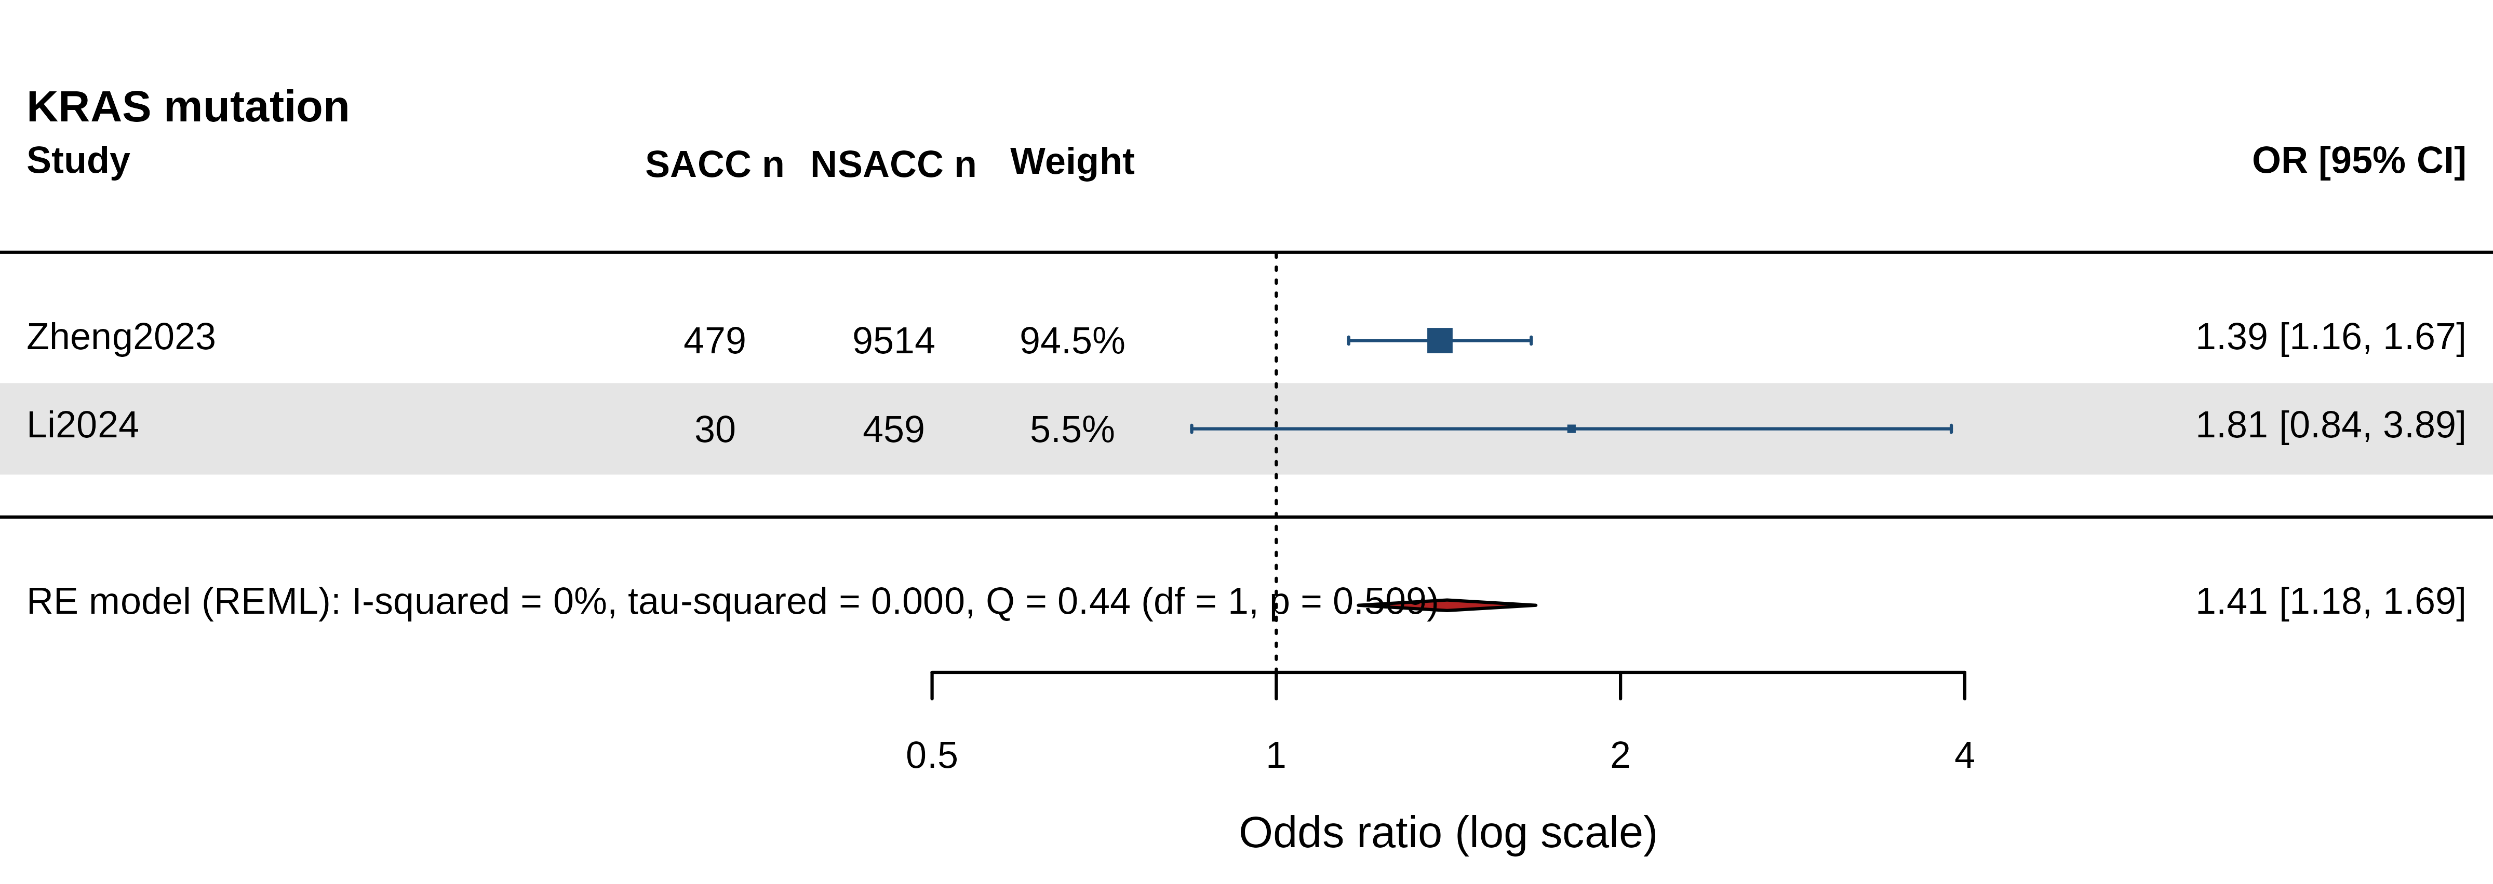
Figure S-KRAS_mut. Study-level forest plot: KRAS mut.
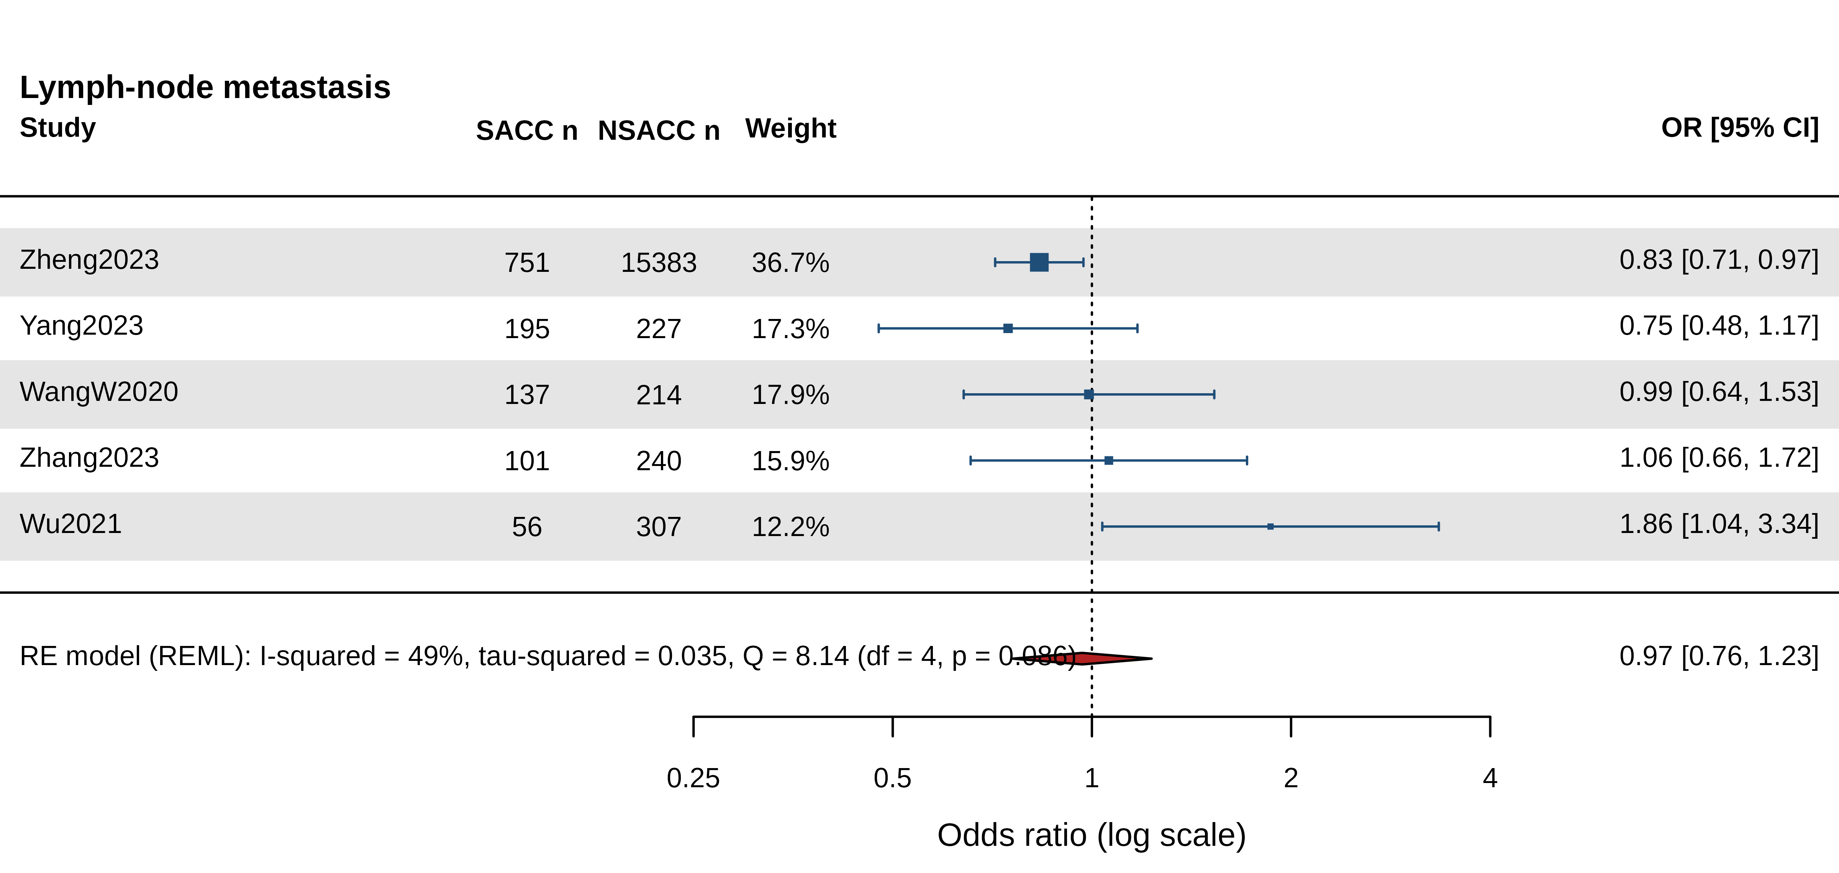
Figure S-LN_metastasis. Study-level forest plot: LN metastasis.
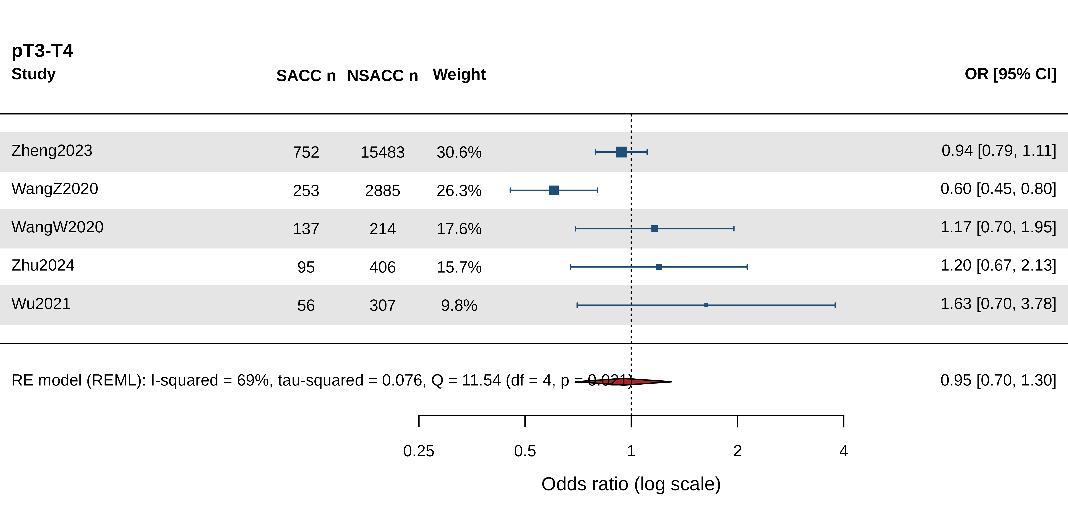
Figure S-T3_T4. Study-level forest plot: T3 T4.
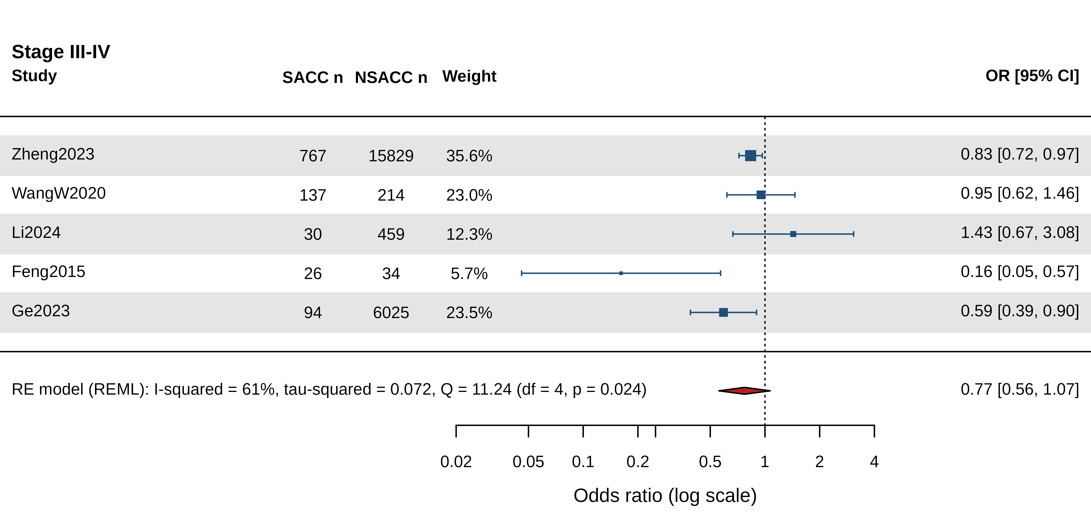
Figure S-advanced_stage_III_IV. Study-level forest plot: advanced stage III IV.
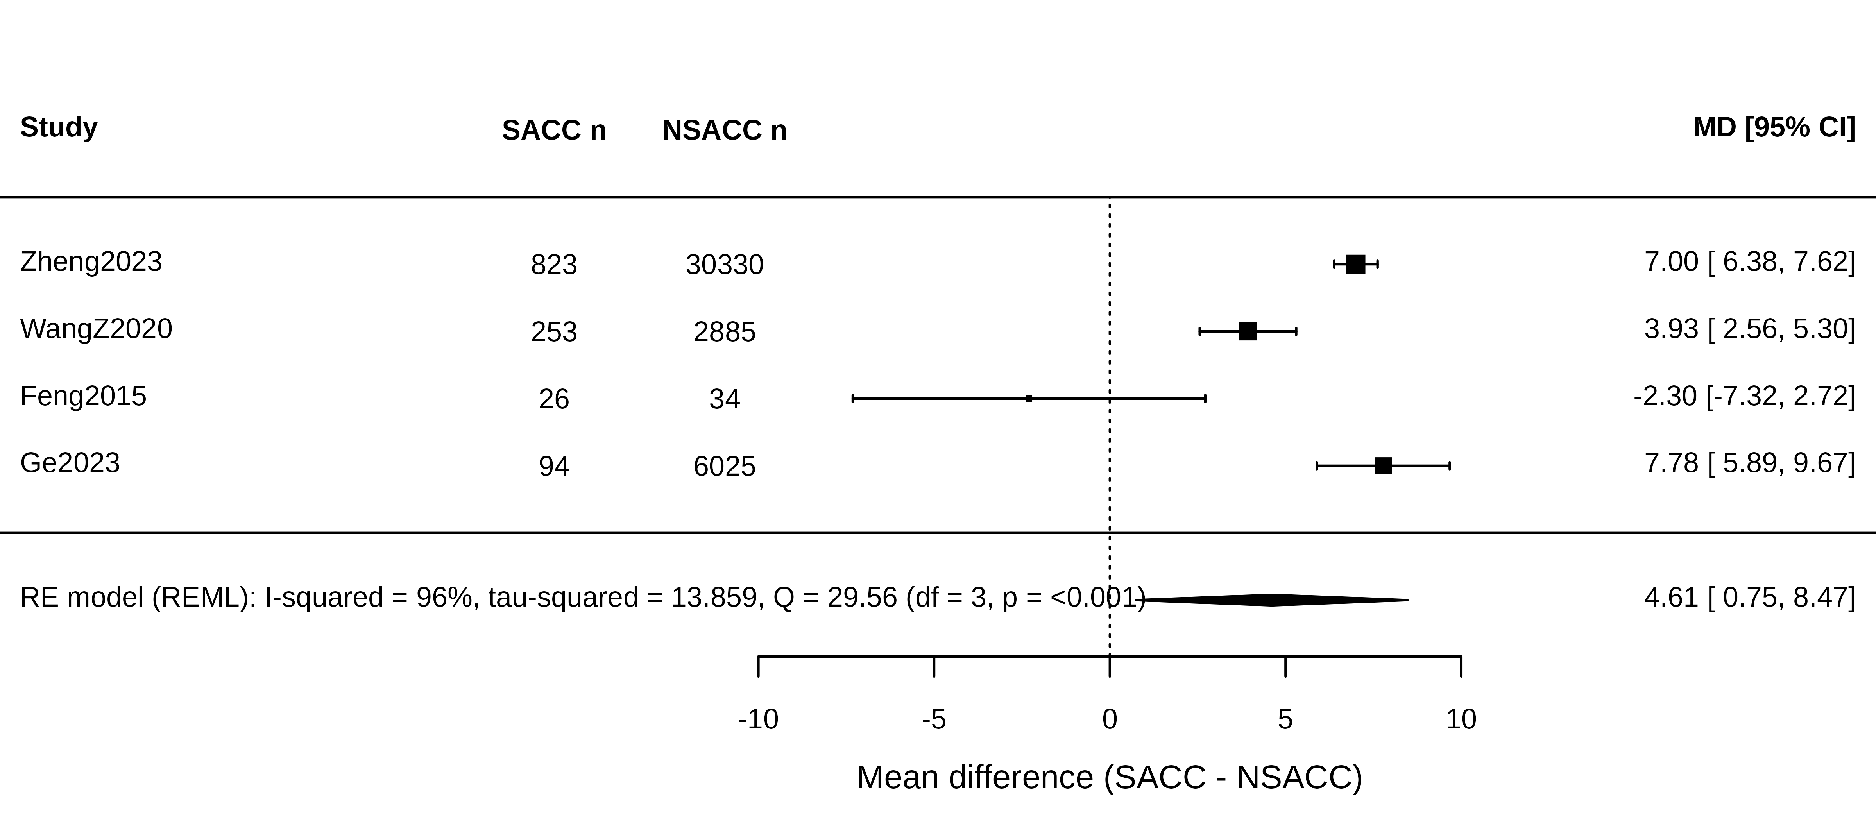
Figure S-age. Study-level forest plot: age.
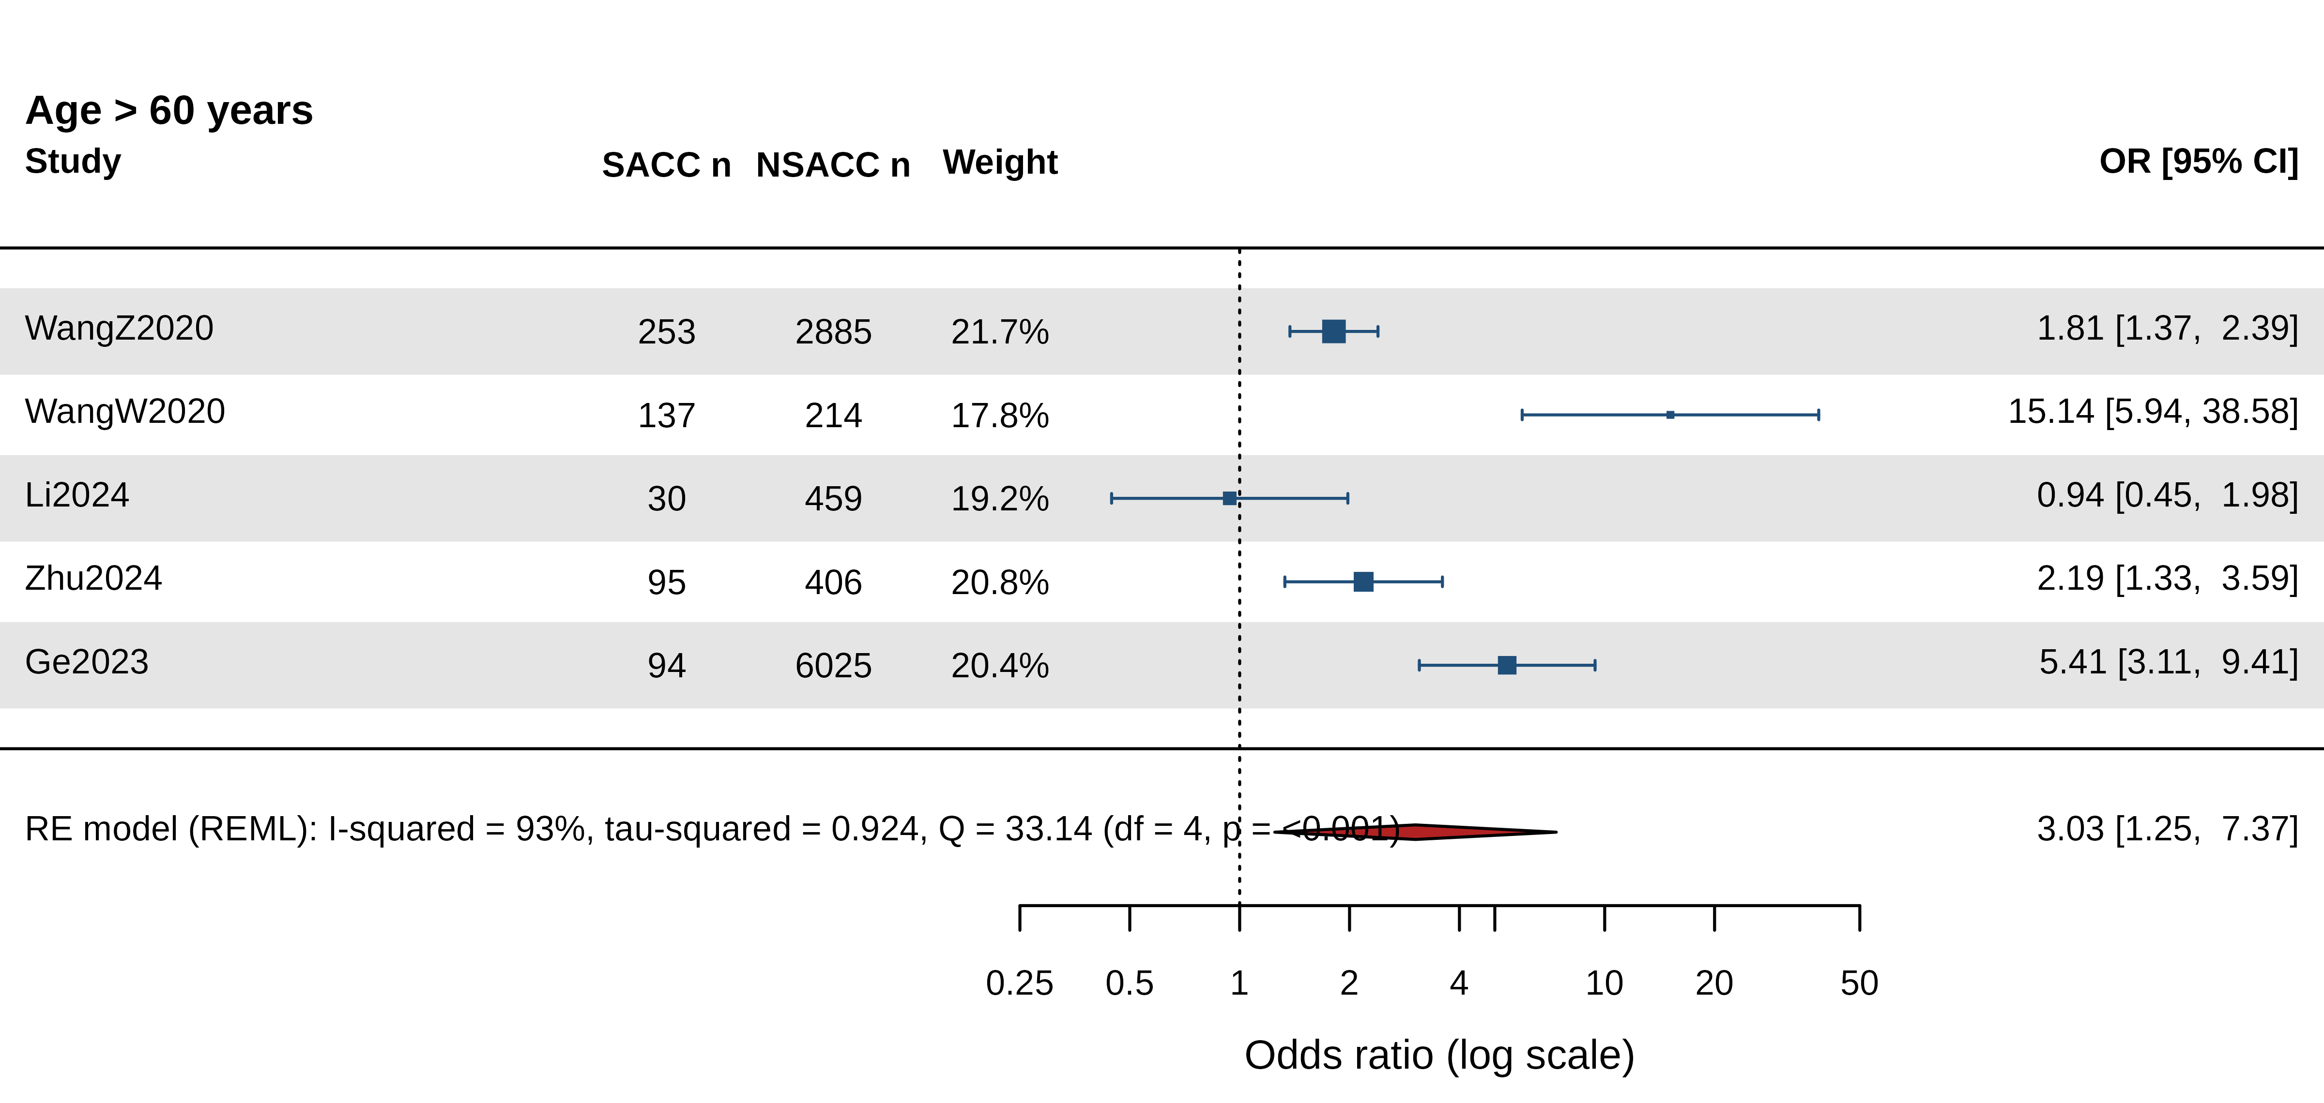
Figure S-age_over_60. Study-level forest plot: age over 60.
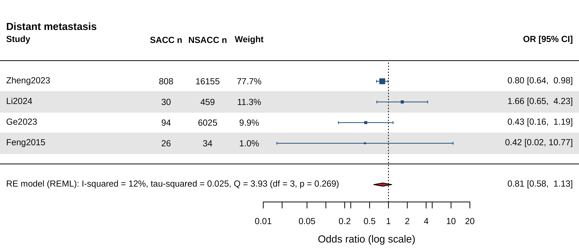
Figure S-distant_metastasis. Study-level forest plot: distant metastasis.
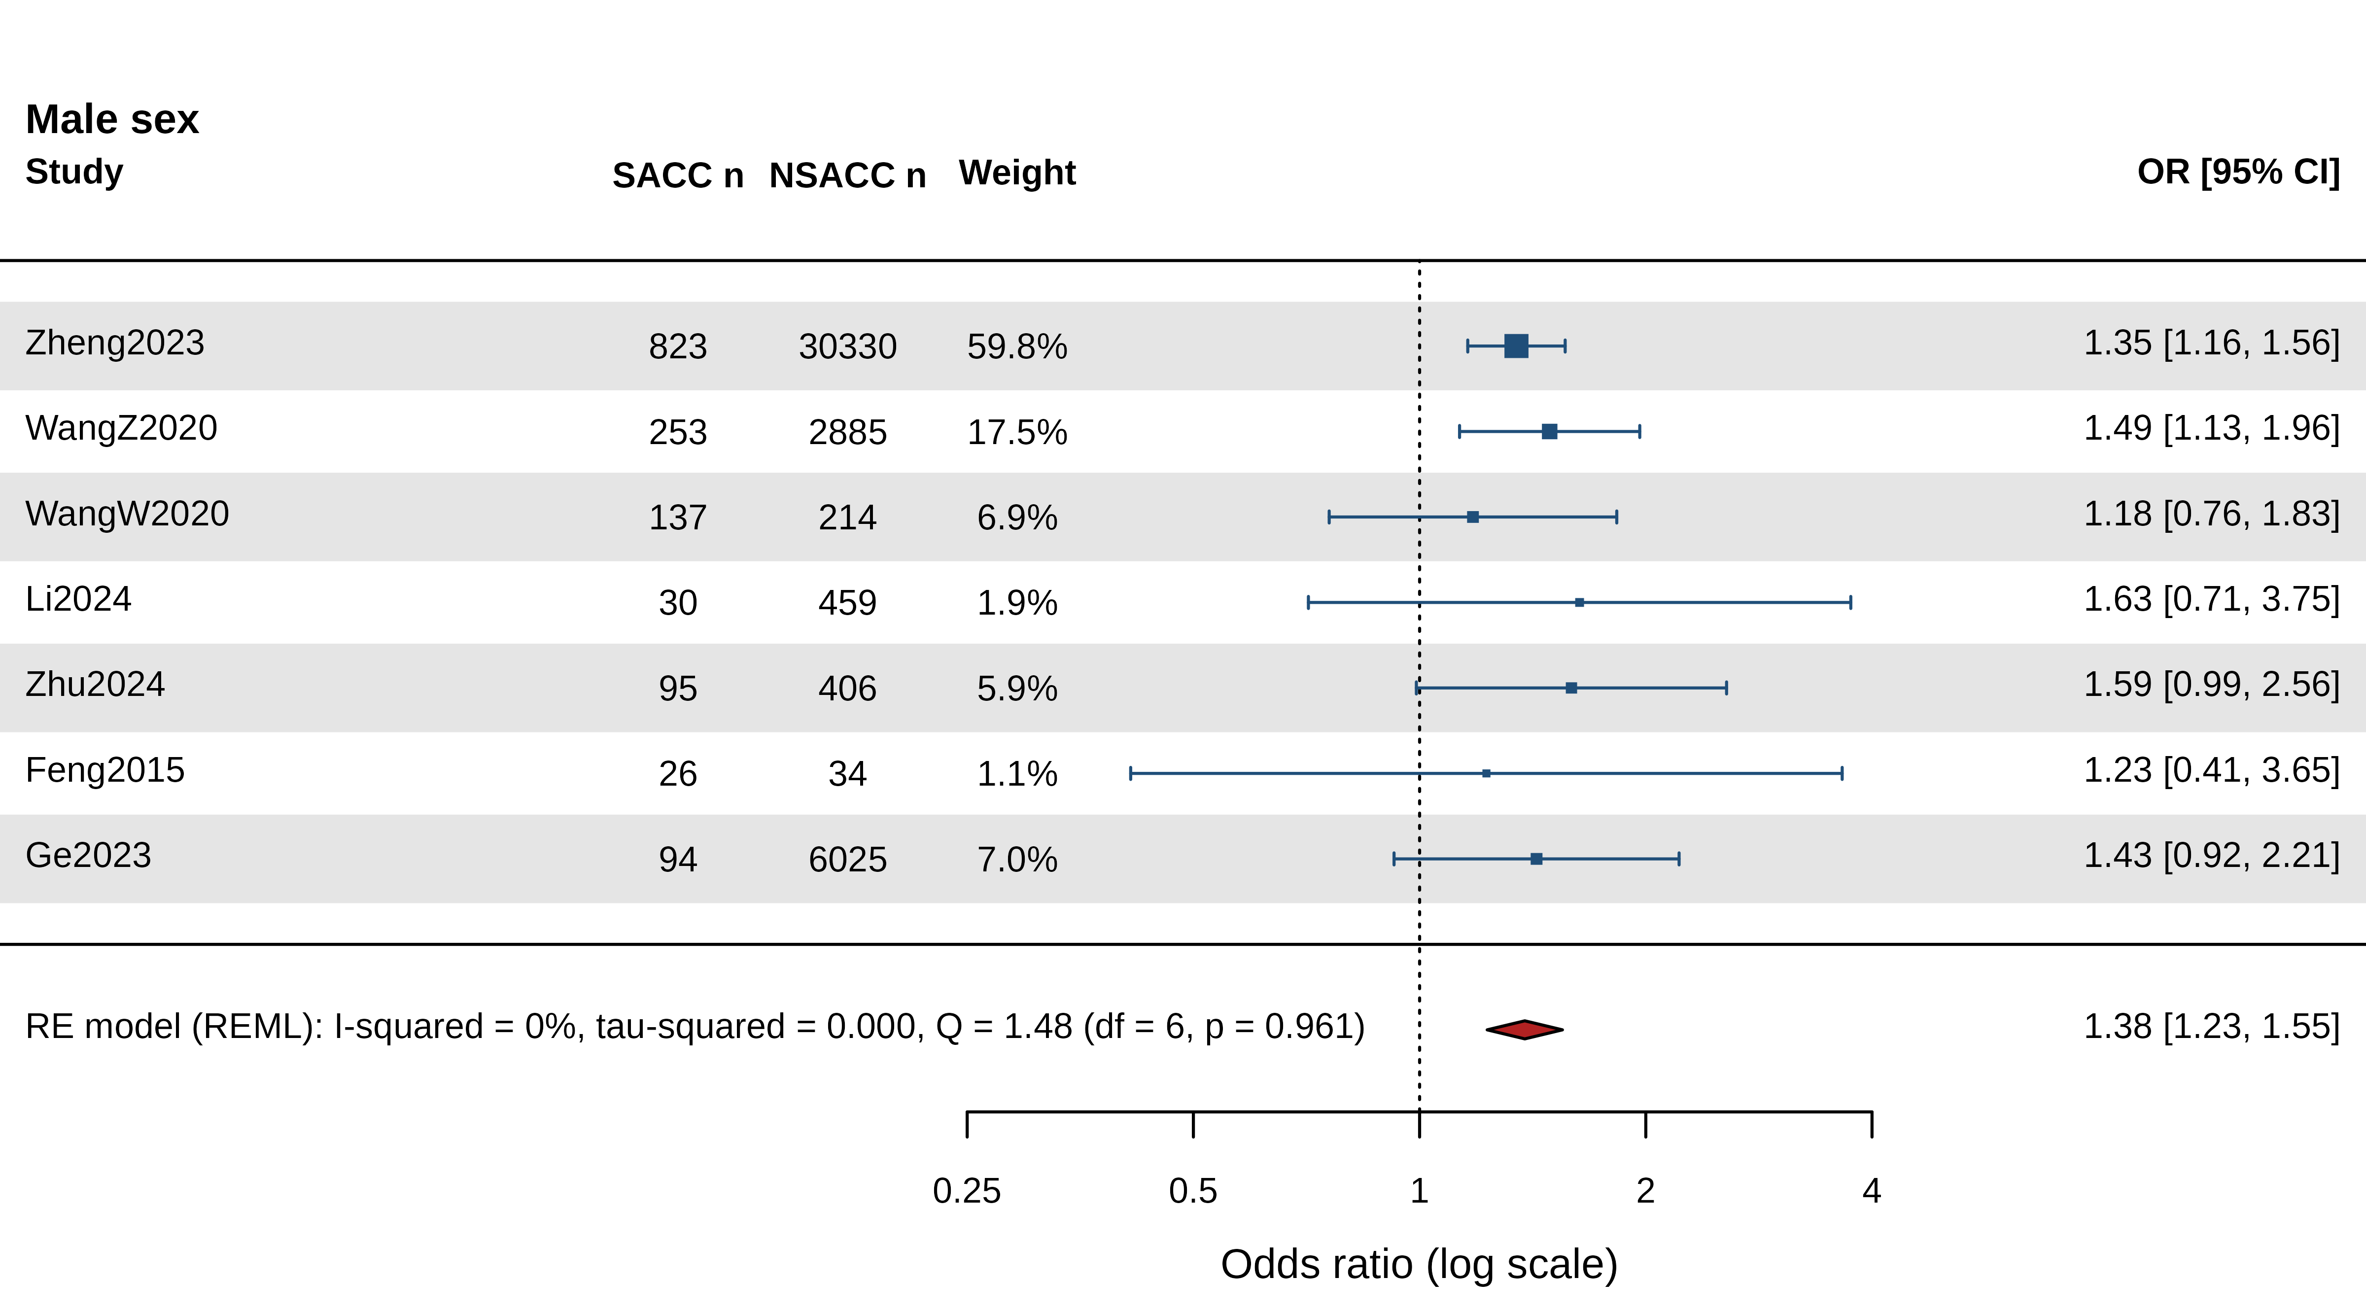
Figure S-male_sex. Study-level forest plot: male sex.
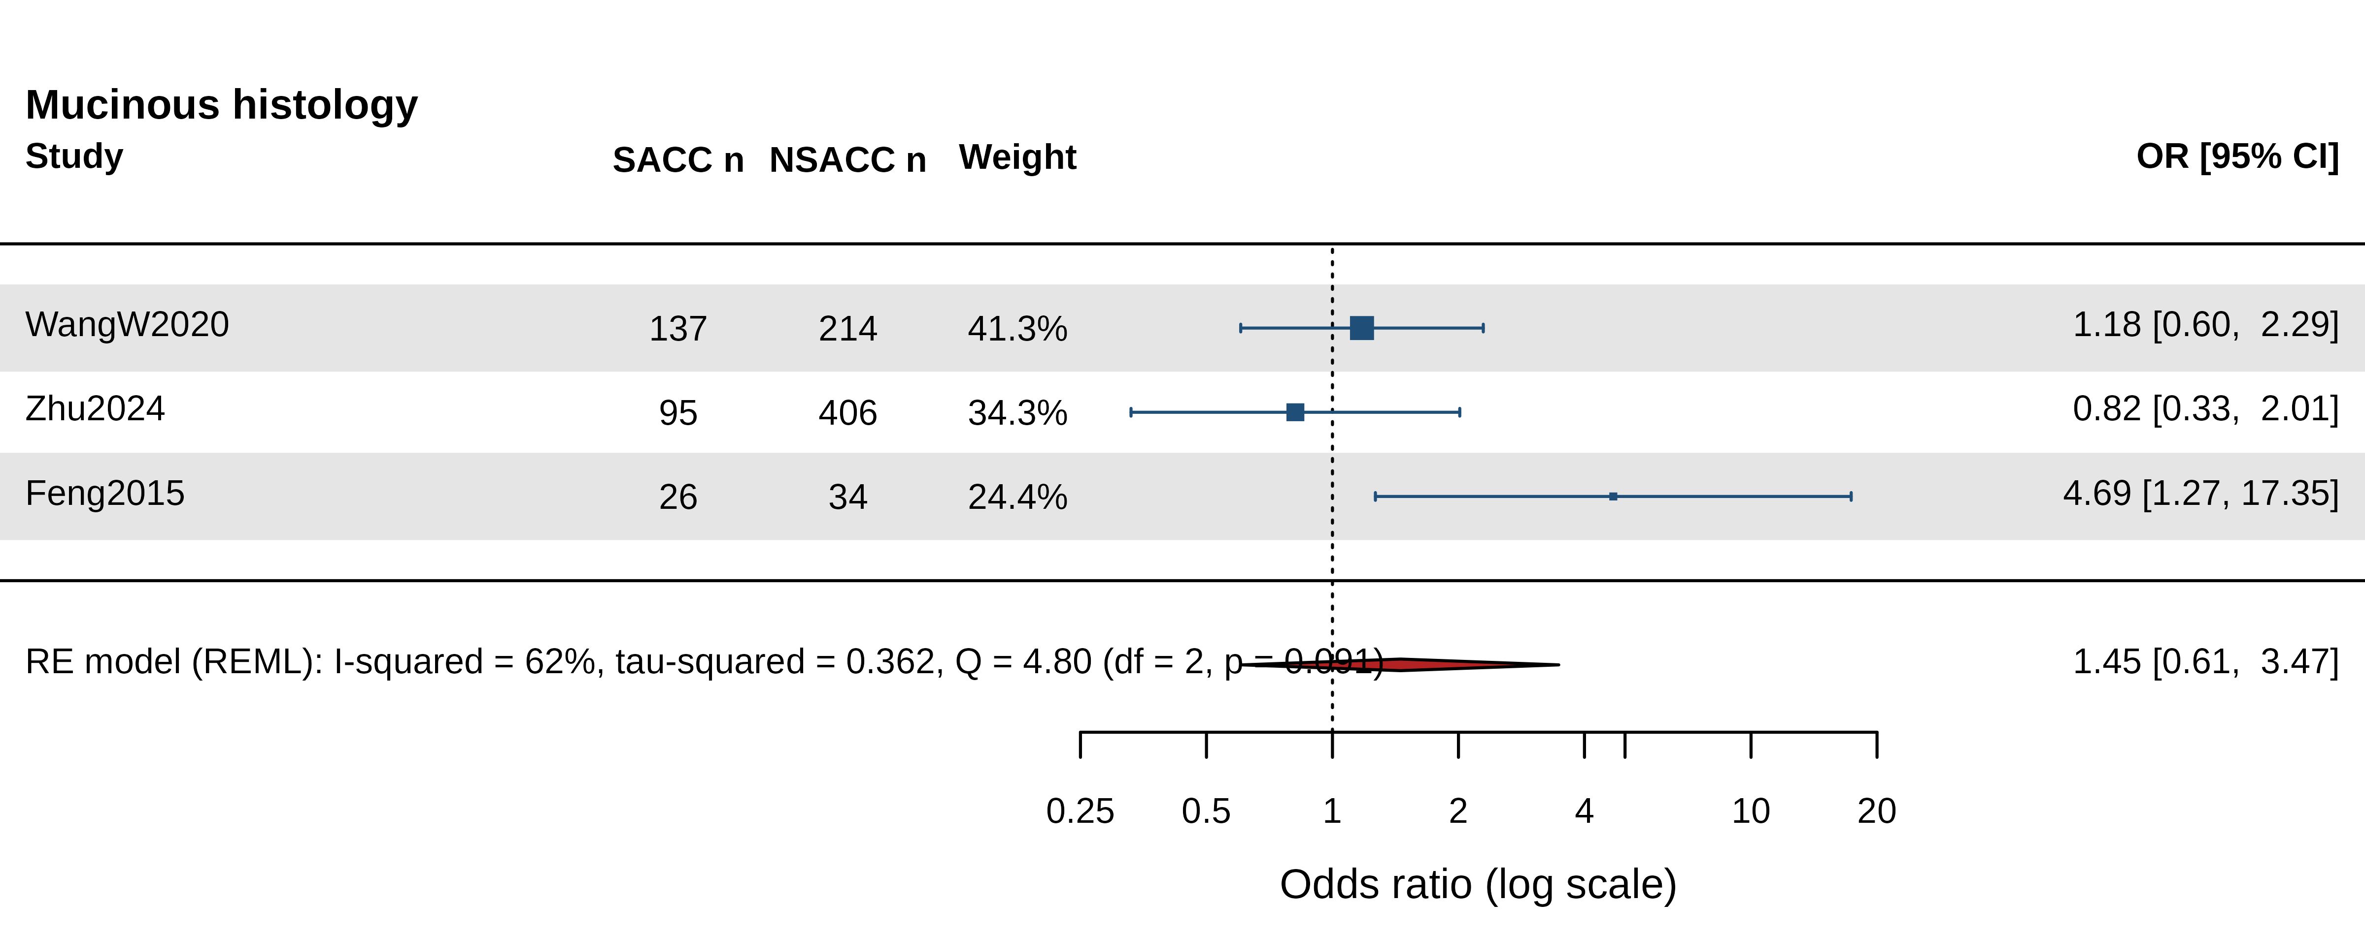
Figure S-mucinous. Study-level forest plot: mucinous.
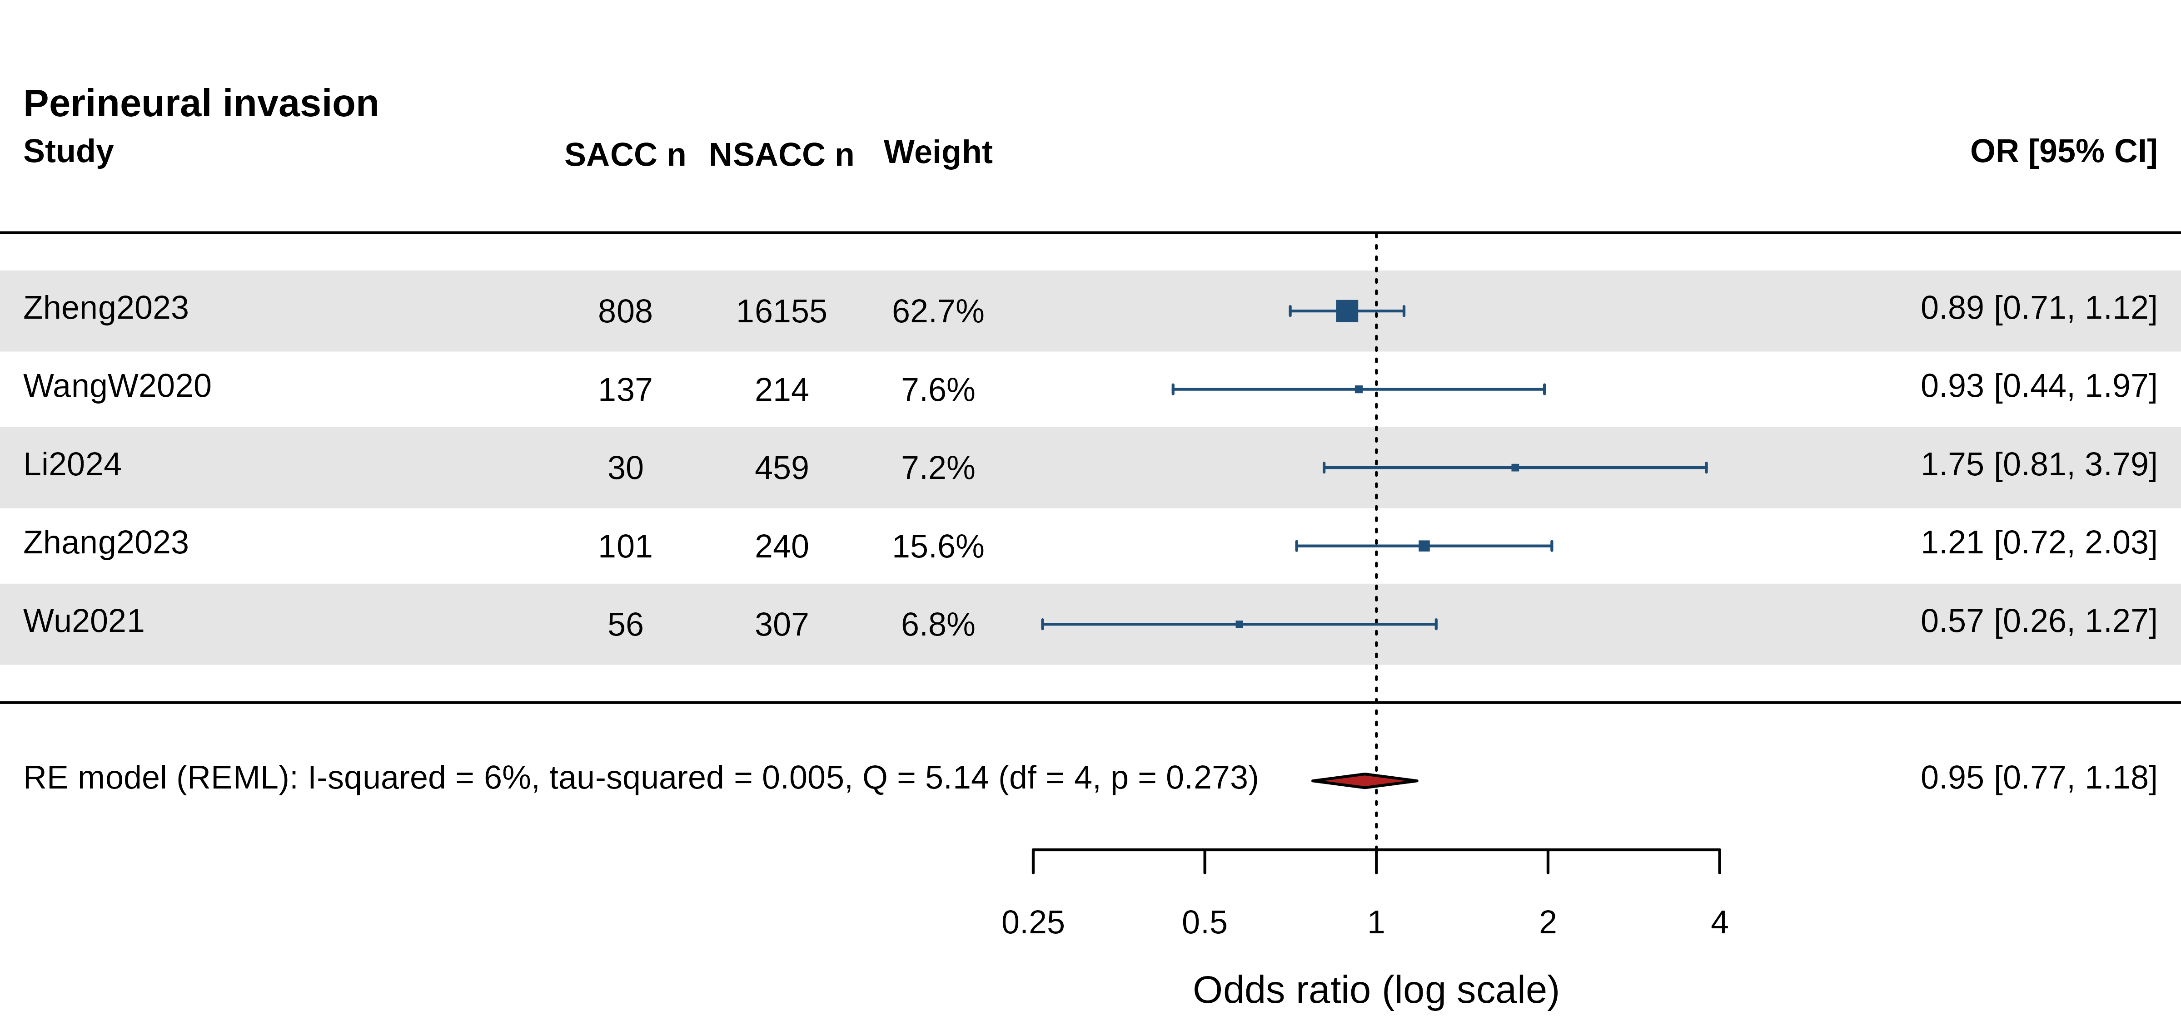
Figure S-perineural_invasion. Study-level forest plot: perineural invasion.
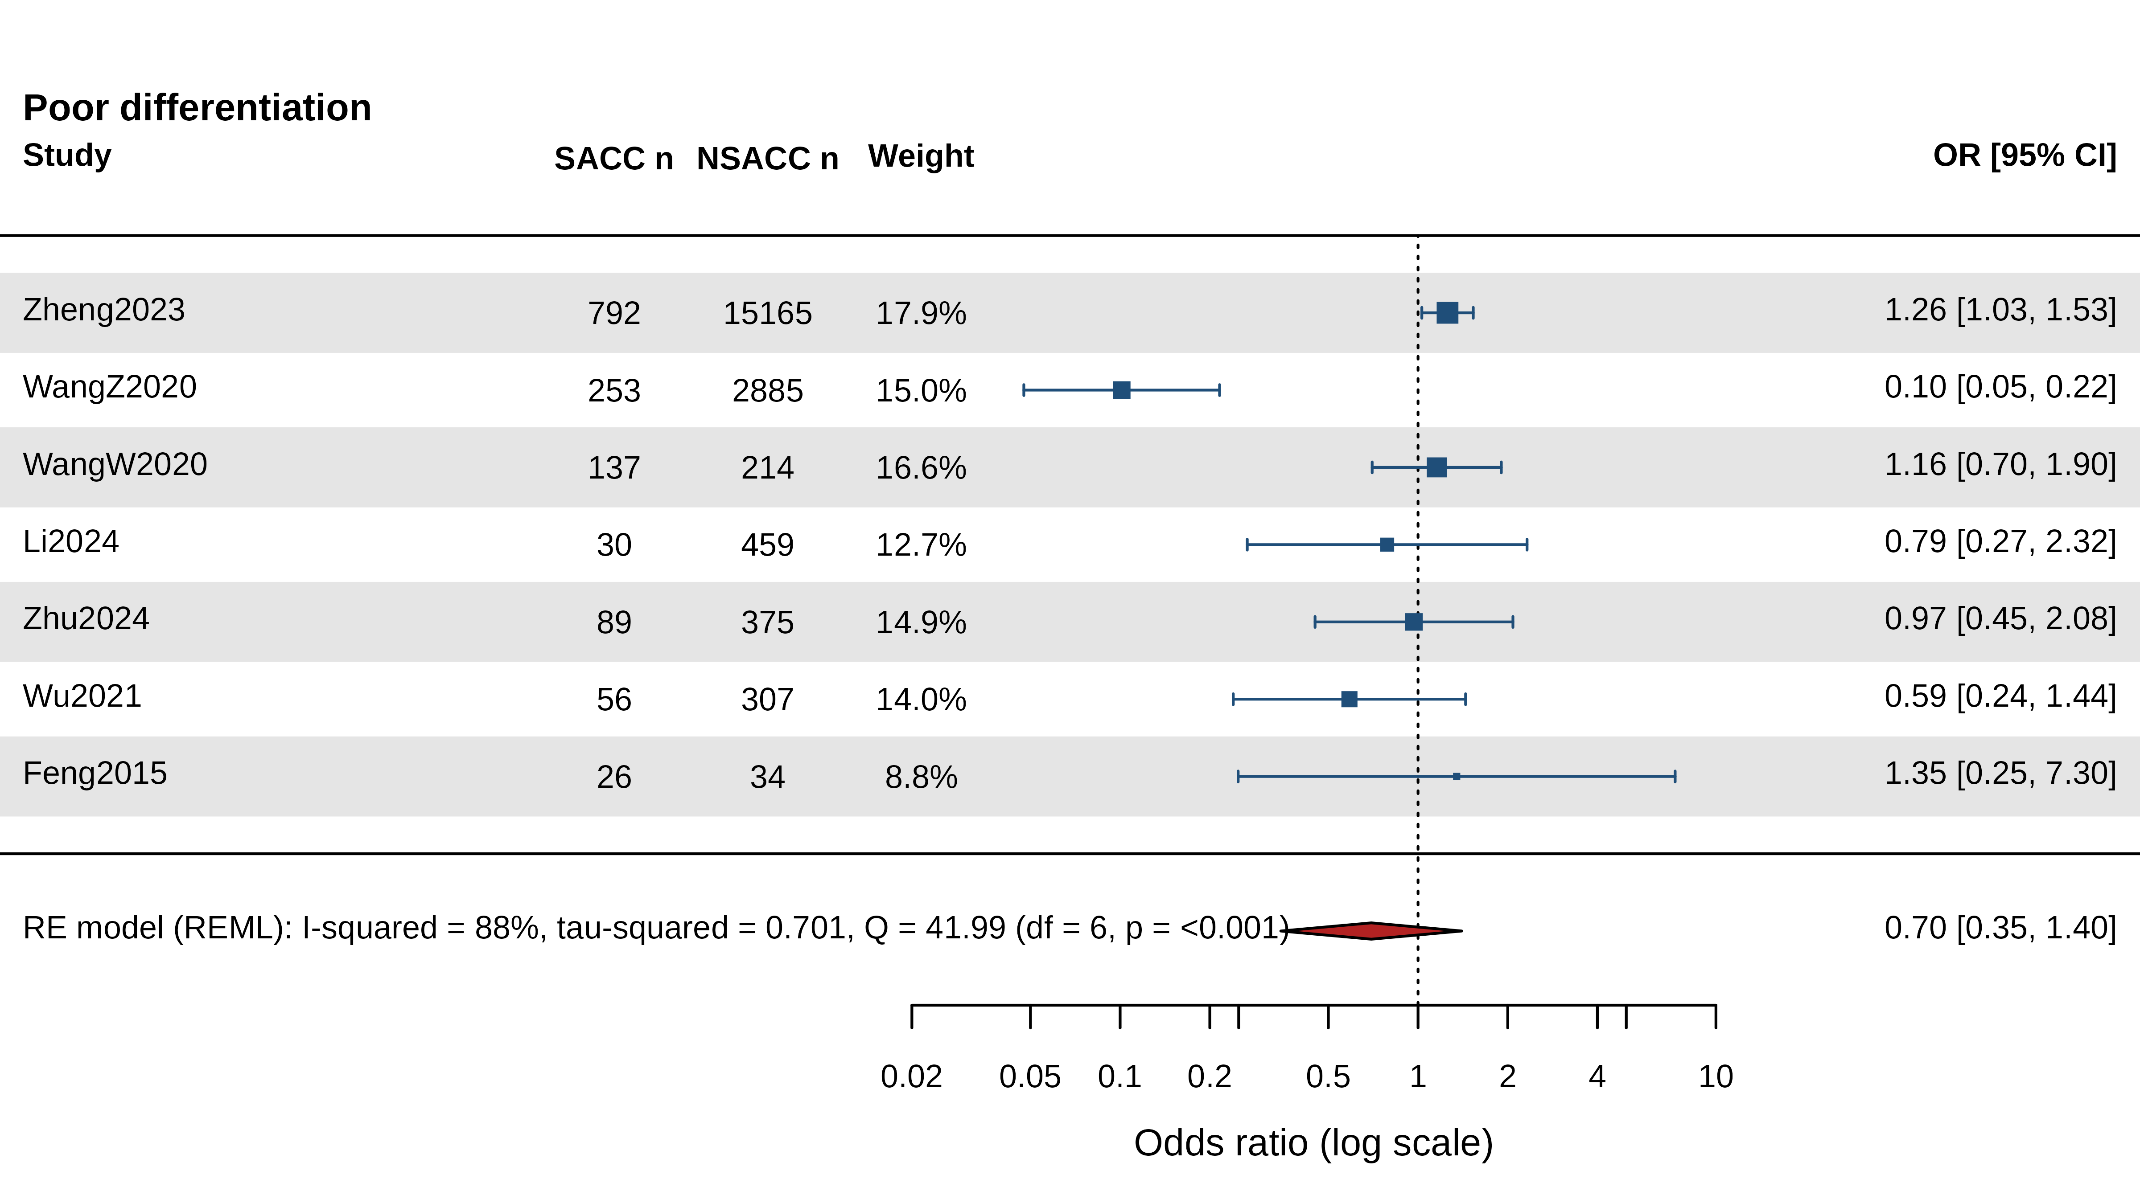
Figure S-poor_differentiation. Study-level forest plot: poor differentiation.
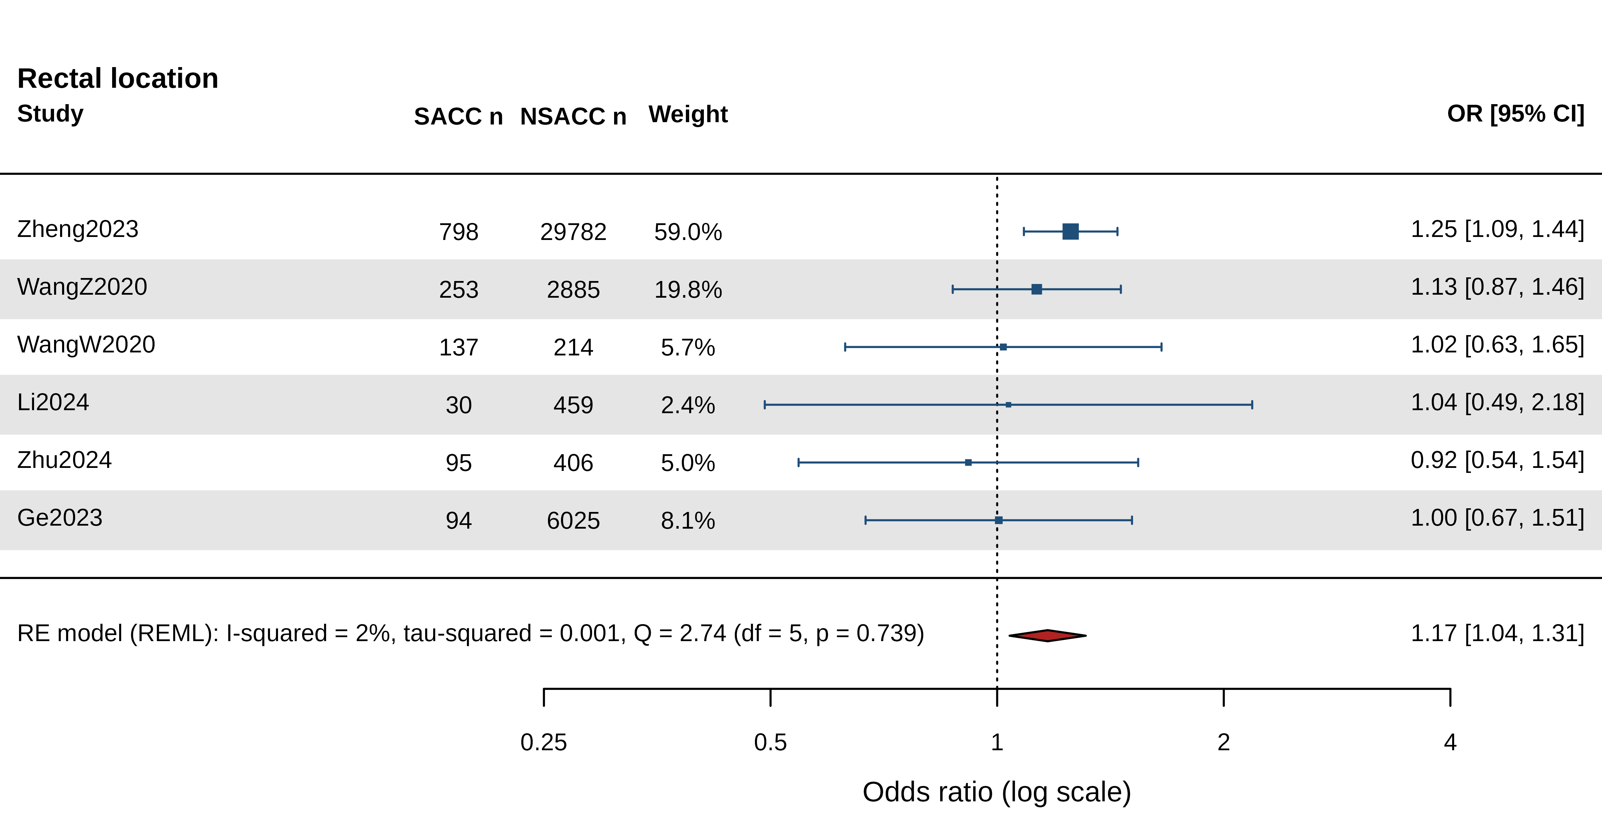
Figure S-rectal_location. Study-level forest plot: rectal location.
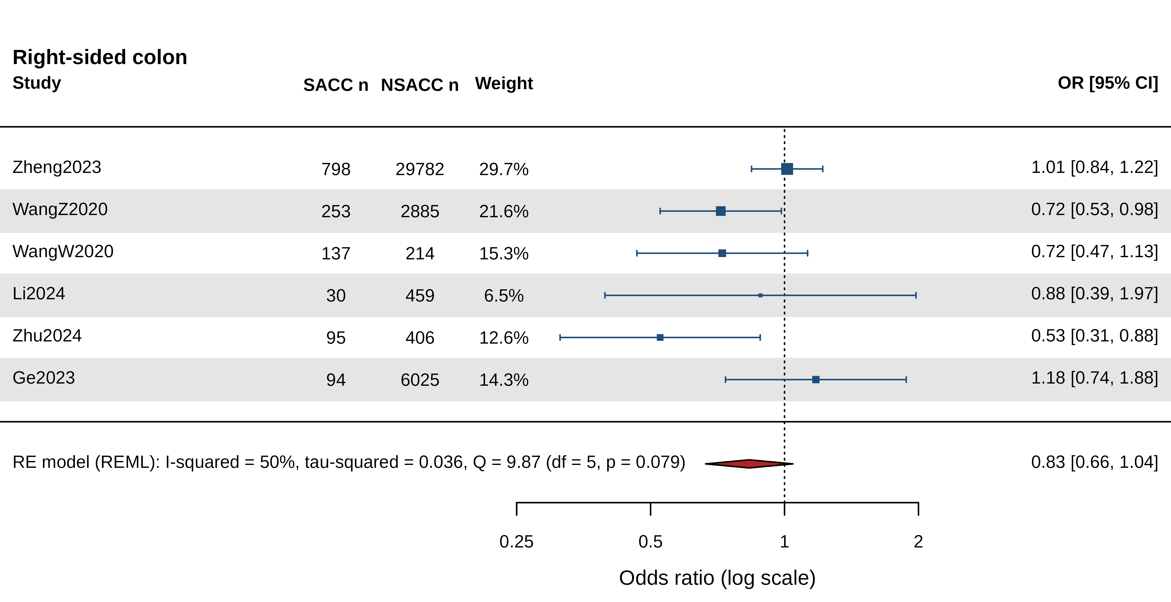
Figure S-right_sided. Study-level forest plot: right sided.
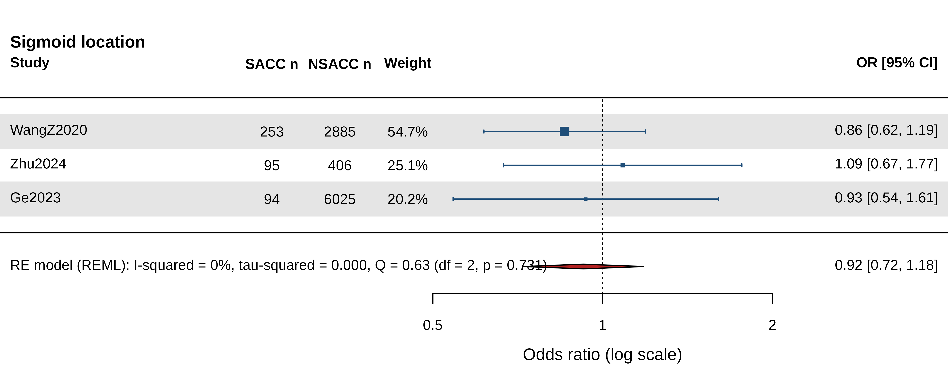
Figure S-sigmoid_location. Study-level forest plot: sigmoid location.
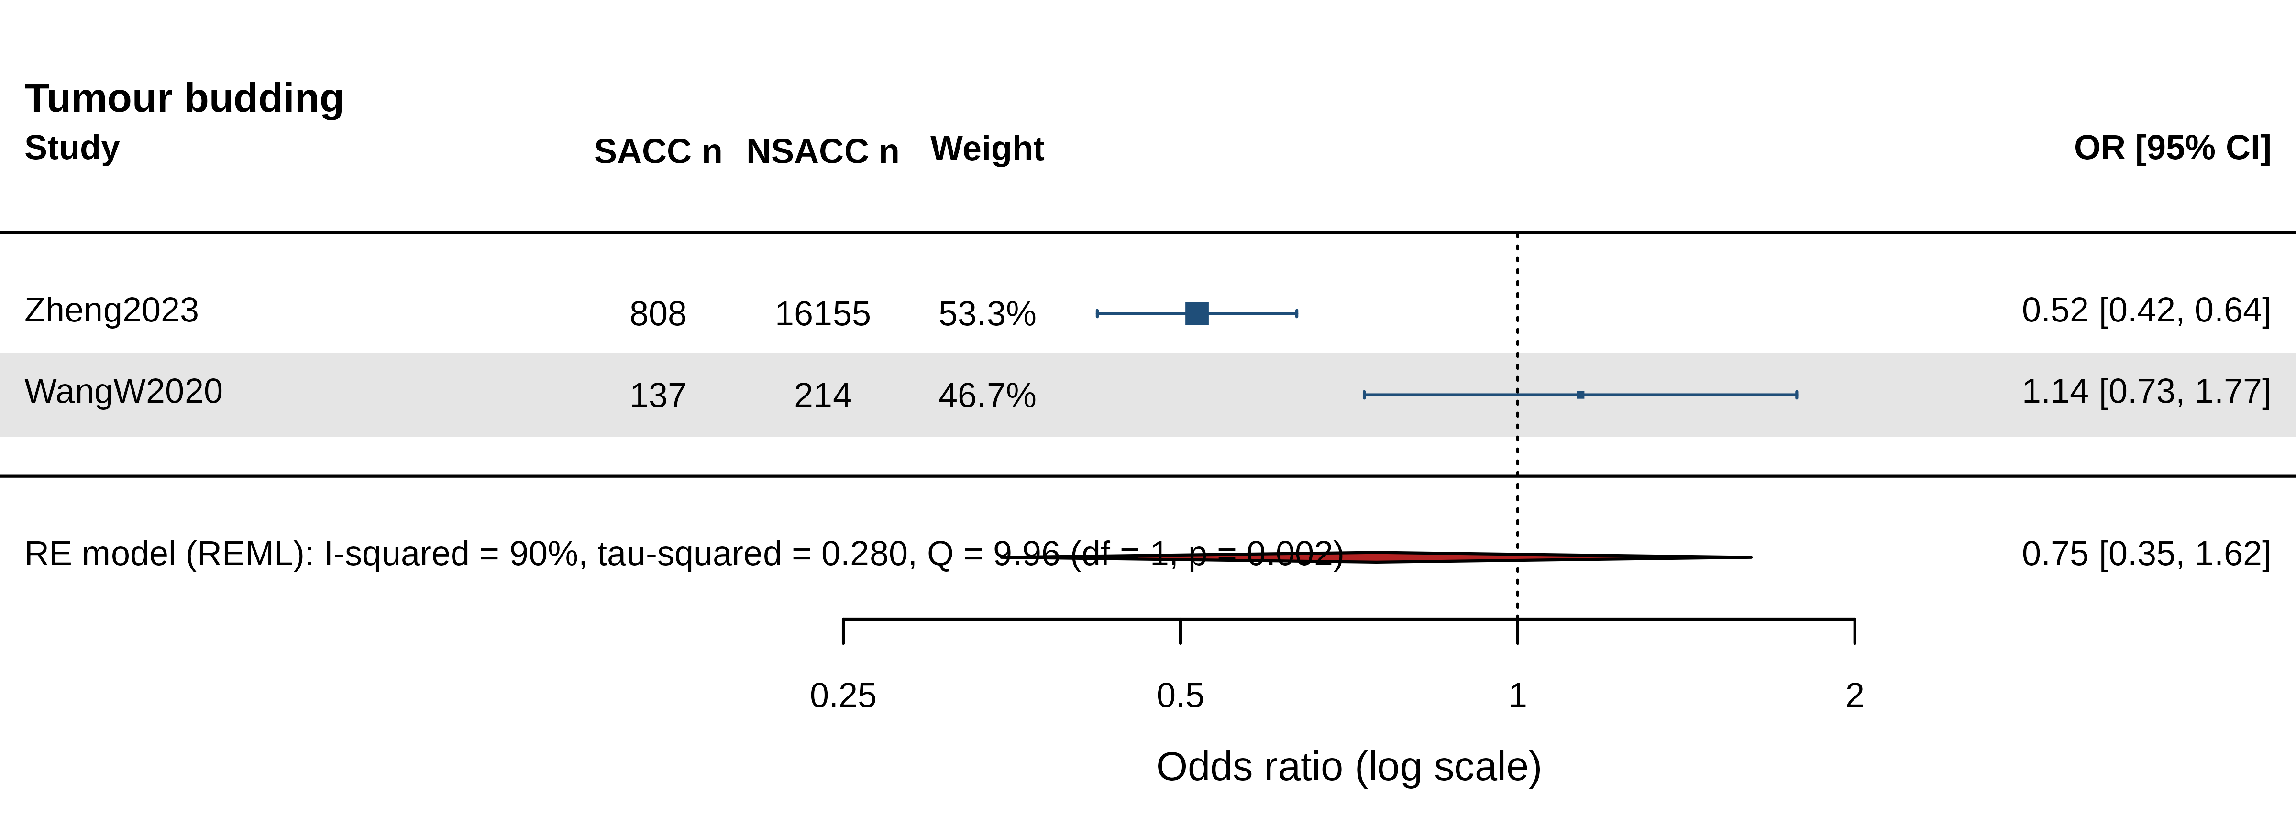
Figure S-tumor_budding. Study-level forest plot: tumor budding.
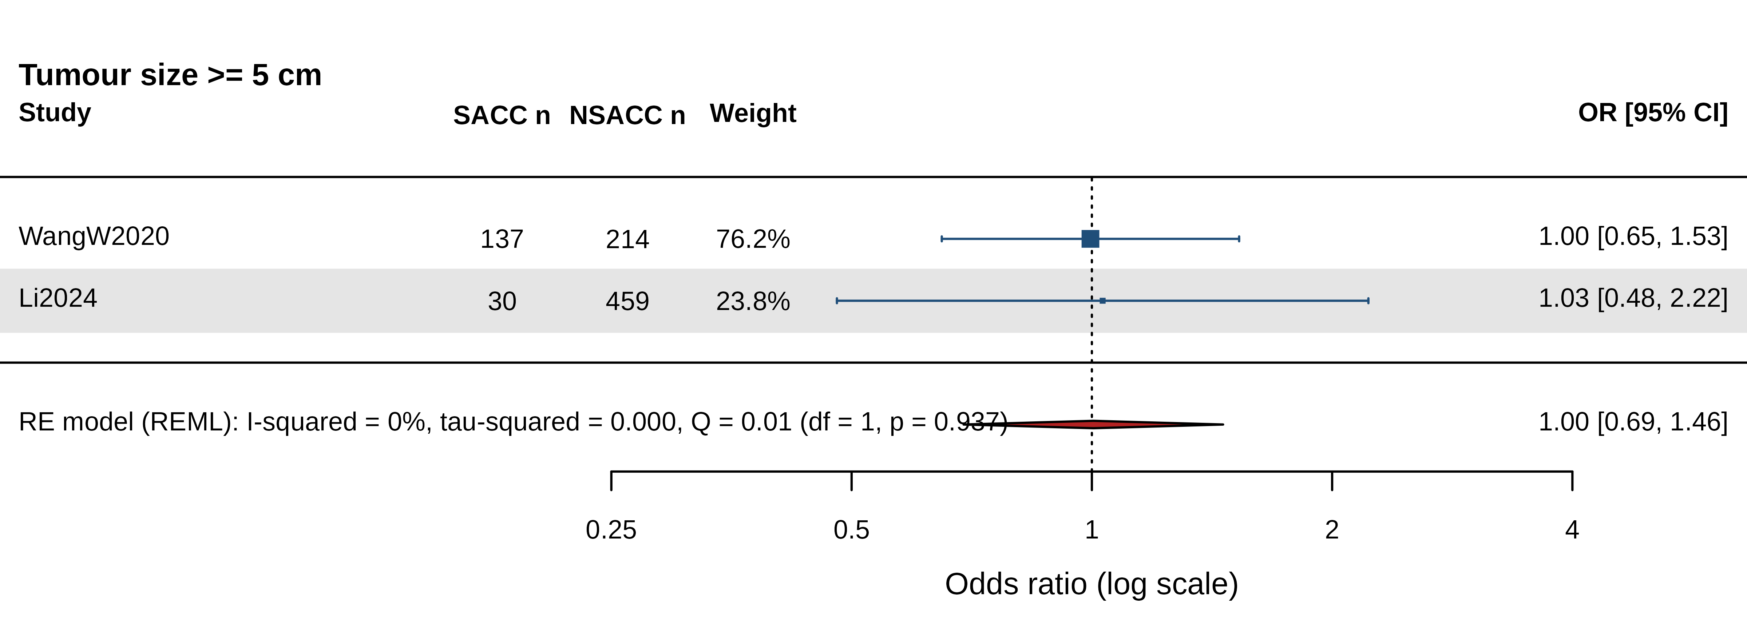
Figure S-tumor_size_5cm. Study-level forest plot: tumor size 5cm.
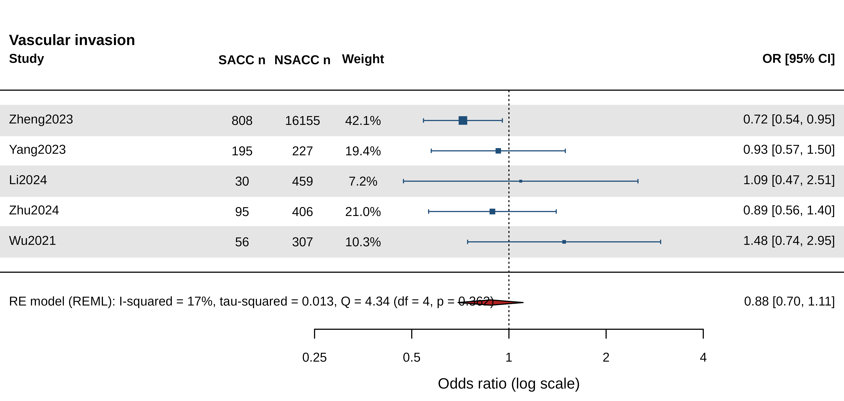
Figure S-vascular_invasion. Study-level forest plot: vascular invasion.
References cited in the Supplementary Material
1. Liu XF, Ju S, Wang KY, Li Y, Qiang JW. The prevalence rate, mortality, and 5-year overall survival of Schistosoma japonicum patients with human malignancy. Front Oncol. 2023;13:1288197. doi:10.3389/fonc.2023.1288197. PMID: 38125940
2. Liu W, Zeng HZ, Wang QM, Yi H, Mou Y, Wu CC, et al. Schistosomiasis combined with colorectal carcinoma diagnosed based on endoscopic findings and clinicopathological characteristics: a report on 32 cases. Asian Pac J Cancer Prev. 2013;14(8):4839-42. doi:10.7314/apjcp.2013.14.8.4839. PMID: 24083755
3. Wang M, Wu QB, He WB, Wang ZQ. Clinicopathological characteristics and prognosis of schistosomal colorectal cancer. Colorectal Dis. 2016;18(10):1005-1009. doi:10.1111/codi.13317. PMID: 26922912
4. National Cooperative Group on Pathology and Prognosis of Colorectal Cancer. [Schistosomiasis and its prognostic significance in patients with colorectal cancer]. Zhonghua Zhong Liu Za Zhi. 1986;8(2):149-51. Chinese. PMID: 3021419
5. Madbouly KM, Senagore AJ, Mukerjee A, Hussien AM, Shehata MA, Navine P, et al. Colorectal cancer in a population with endemic Schistosoma mansoni: is this an at-risk population?. Int J Colorectal Dis. 2007;22(2):175-81. doi:10.1007/s00384-006-0144-3. PMID: 16786317
6. Zhang W, Wang PJ, Shen X, Wang GL, Zhao XH, Seema SF, et al. CT presentations of colorectal cancer with chronic schistosomiasis: A comparative study with pathological findings. Eur J Radiol. 2012;81(8):e835-43. doi:10.1016/j.ejrad.2012.02.020. PMID: 22658847
7. Chen Y, Liu Z, Qian J, Feng H, Li D, Fan Y. [Expression difference of DNA mismatch repair gene hMLH1 and hMSH2 between schistosomiasis-associated colorectal cancer and sporadic colorectal cancer]. Zhonghua Wei Chang Wai Ke Za Zhi. 2016;19(1):75-9. Chinese. PMID: 26797844
8. Yang DH, Qiu CM, Sun WW, Gu MM, He PF, Xu YY. [Relationship between multi-gene proteins in colorectal carcinoma complicated with chronic schistosomiasis: an immunohistochemical study by using tissue microarray techniques]. Zhongguo Xue Xi Chong Bing Fang Zhi Za Zhi. 2014;26(4):405-9. Chinese. PMID: 25434139
9. Ruan SL, Wang B, Lu QM, Dong LR, Cao CX, Xu SL, et al. [Expression of vascular growth factors in intestinal tissues in colorectal carcinoma patients with schistosomiasis japonica]. Zhongguo Xue Xi Chong Bing Fang Zhi Za Zhi. 2013;25(3):250-4. Chinese. PMID: 24024441
10. Yang XG, Yang JW, Zhao PJ, Cheng W, Shi HB, Zhang B, et al. [Expression and clinicopathological significance of Bcl - 2 and Bax genes in colorectal cancer patients complicated with schistosomiasis]. Zhongguo Xue Xi Chong Bing Fang Zhi Za Zhi. 2021;33(2):148-153. Chinese. doi:10.16250/j.32.1374.2020320. PMID: 34008361
11. Zhang R, Takahashi S, Orita S, Yoshida A, Maruyama H, Shirai T, et al. p53 gene mutations in rectal cancer associated with schistosomiasis japonica in Chinese patients. Cancer Lett. 1998;131(2):215-21. doi:10.1016/s0304-3835(98)00154-2. PMID: 9851256
12. Zalata KR, Nasif WA, Ming SC, Lotfy M, Nada NA, El-Hak NG, et al. p53, Bcl-2 and C-Myc expressions in colorectal carcinoma associated with schistosomiasis in Egypt. Cell Oncol. 2005;27(4):245-53. doi:10.1155/2005/547010. PMID: 16308474
13. Farid M. Evolution of colorectal cancer in schistosomiasis. Egypt J Surg. 2006. doi:10.21608/ejsur.2006.372983
14. Zheng N, Wang H, Yu Q, Wang C, Bai CG, Pan AF, et al. Changing trends, clinicopathological characteristics, surgical treatment patterns, and prognosis of schistosomiasis-associated versus non-schistosomiasis-associated colorectal cancer: a large retrospective cohort study of 31 153 cases in Shanghai, China (2001-2021). Int J Surg. 2023;109(4):772-784. doi:10.1097/JS9.0000000000000293. PMID: 36999800
15. Wang Z, Du Z, Liu Y, Wang W, Liang M, Zhang A, et al. Comparison of the clinicopathological features and prognoses of patients with schistosomal and nonschistosomal colorectal cancer. Oncol Lett. 2020;19(3):2375-2383. doi:10.3892/ol.2020.11331. PMID: 32194737
16. Wang W, Lu K, Wang L, Jing H, Pan W, Huang S, et al. Comparison of non-schistosomal colorectal cancer and schistosomal colorectal cancer. World J Surg Oncol. 2020;18(1):149. doi:10.1186/s12957-020-01925-5. PMID: 32611359
17. Li X, Liu H, Huang B, Yang M, Fan J, Zhang J, et al. Schistosoma infection, KRAS mutation status, and prognosis of colorectal cancer. Chin Med J (Engl). 2024;137(2):235-237. doi:10.1097/CM9.0000000000002905. PMID: 37920960
18. Zhu Y, Wu X, Ran X, Rao C, Gong P. A retrospective cross-sectional study: comparison of the clinicopathological features of schistosomal and non-schistosomal colorectal cancer in Central China. BMC Infect Dis. 2024;24(1):732. doi:10.1186/s12879-024-09648-8. PMID: 39054428
19. Zhang F, Wang X, Zhu Y, Xia P. Conjoint analysis of clinical, imaging, and pathological features of schistosomiasis and colorectal cancer. Pathol Oncol Res. 2023;29:1611396. doi:10.3389/pore.2023.1611396. PMID: 38099242
20. Yang Y, Wang XY, Duan C, Wang ZJ, Sheng HY, Xu XL, et al. Clinicopathological characteristics and its association with digestive system tumors of 1111 patients with Schistosomiasis japonica. Sci Rep. 2023;13(1):15115. doi:10.1038/s41598-023-42456-9. PMID: 37704736
21. Wu C, Wang Y, Gao H, Zhang Y, Dai M, Li S. Relationship between salt-inducible kinase 2 (SIK2) and lymph node metastasis in colorectal cancer patients complicated with chronic schistosomiasis. Zhejiang Da Xue Xue Bao Yi Xue Ban. 2021;50(5):607-613. doi:10.3724/zdxbyxb-2021-0157. PMID: 34986532
22. Feng H, Lu AG, Zhao XW, Han DP, Zhao JK, Shi L, et al. Comparison of non-schistosomal rectosigmoid cancer and schistosomal rectosigmoid cancer. World J Gastroenterol. 2015;21(23):7225-32. doi:10.3748/wjg.v21.i23.7225. PMID: 26109809
23. Wang W, Jing H, Liu J, Bu D, Zhang Y, Zhu T, et al. Correlation between schistosomiasis and CD8+ T cell and stromal PD-L1 as well as the different prognostic role of CD8+ T cell and PD-L1 in schistosomal-associated colorectal cancer and non-schistosomal-associated colorectal cancer. World J Surg Oncol. 2021;19(1):321. doi:10.1186/s12957-021-02433-w. PMID: 34743724
24. Wang W, Zhang Y, Liu J, Jing H, Lu K, Wang L, et al. Comparison of the prognostic value of stromal tumor-infiltrating lymphocytes and CD3 + T cells between schistosomal and non-schistosomal colorectal cancer. World J Surg Oncol. 2023;21(1):31. doi:10.1186/s12957-023-02911-3. PMID: 36726115
25. Pan W, Wang W, Huang J, Lu K, Huang S, Jiang D, et al. The prognostic role of c-MYC amplification in schistosomiasis-associated colorectal cancer. Jpn J Clin Oncol. 2020;50(4):446-455. doi:10.1093/jjco/hyz210. PMID: 32297641
26. Cheng M, Jing H, Bu D, Liu J, Lu K, Liu J, et al. The predictive value of CD4, CD8, and C-reactive protein in the prognosis of schistosomal and non-schistosomal colorectal cancer. BMC Gastroenterol. 2023;23(1):194. doi:10.1186/s12876-023-02834-z. PMID: 37277702
27. Chai S, Zhang Y, Zhang X, Liu L, Jing H, Wang W, et al. The distinguished predictive value of CFIm25 in schistosomal and non-schistosomal colorectal cancer. Transl Cancer Res. 2026;15(8):638. doi:10.21037/tcr-2026-0893. PMID: 42724732
28. Ge H, Liu X, Zheng L, Tao Z, Li Y, Pei H. Clinicopathological features and prognosis of colorectal cancer patients with chronic schistosomiasis [preprint]. Research Square. 2023 Apr 20. doi:10.21203/rs.3.rs-2831569/v1
29. Wang M, Zhang YC, Yang XY, Wang ZQ. Prognostic analysis of schistosomal rectal cancer. Asian Pac J Cancer Prev. 2014;15(21):9271-5. doi:10.7314/apjcp.2014.15.21.9271. PMID: 25422211

