Defining Schistosomiasis-Associated Colorectal Cancer: A Systematic Analysis and Meta-analysis of Clinicopathological, Molecular, and Prognostic Features
Jayson Cagadas Pasaol, DVM, PhD,¹ [Co-author names and degrees TO BE ADDED]
¹[Department, Institution, City, Country TO BE ADDED]
Corresponding author: Jayson Cagadas Pasaol, DVM, PhD; [postal address TO BE ADDED]; email: jaysonpasaolrmt082@gmail.com; ORCID: [TO BE ADDED]
Running title: Schistosomiasis-associated colorectal cancer phenotype
Word count: abstract [TO BE CALCULATED]; main text [TO BE CALCULATED]. Tables: 5. Figures: 8. Supplementary tables: 6.
Keywords: Schistosoma japonicum; schistosomiasis; colorectal neoplasms; prognosis; neoplasm staging; meta-analysis

ABSTRACT
Background and Objective. Schistosoma japonicum infection has long been linked to colorectal cancer in endemic Asia, but whether schistosomiasis-associated colorectal cancer (SACC) is a reproducibly distinct clinical entity is unresolved. This study aimed to systematically quantify the clinicopathological, molecular, and prognostic differences between SACC and non-schistosomiasis-associated colorectal cancer (NSACC) and to determine whether the available evidence supports a distinct schistosomal colorectal cancer phenotype.
Methods. MEDLINE/PubMed, Scopus, Web of Science Core Collection, Embase, CNKI, Wanfang, and SinoMed were searched from inception to [SEARCH DATE TO BE ADDED], supplemented by citation searching, without language restriction. Observational studies comparing SACC with NSACC were eligible; SACC-only cohorts contributed to a separate within-SACC prognostic analysis. Two reviewers independently screened records, extracted data, and assessed study quality with the Newcastle-Ottawa Scale. Overlapping cohorts were identified and each patient was counted once per outcome. Odds ratios (OR), mean differences, and hazard ratios (HR) were pooled with random-effects models (restricted maximum likelihood). Species were analysed separately. Certainty of evidence was rated with GRADE.
Results. In this interim analysis (PubMed only), 337 records were screened and 16 reports from seven independent Chinese comparative cohorts, one SACC-only cohort, and one genomic study were included; 12 potentially relevant reports could not be retrieved. SACC patients were more often male (OR 1.38 (95% CI 1.22-1.55); 6 cohorts; I² 0%) and older. Adjusted overall survival was worse in SACC (HR 1.76 (95% CI 1.06-2.91); 2 cohorts), but unadjusted estimates were inconsistent (HR 1.23 (95% CI 0.66-2.28); I² 90%) and adjusted disease-free survival did not differ (HR 1.32 (95% CI 0.81-2.15)). Stage III-IV disease was less frequent (OR 0.84 (95% CI 0.74-0.97)), but not after exclusion of the largest cohort; lymph-node metastasis (OR 0.97 (95% CI 0.76-1.23)), distant metastasis (OR 0.99 (95% CI 0.51-1.93)), differentiation, and vascular and perineural invasion did not differ. KRAS mutation was more frequent in SACC (OR 1.41 (95% CI 1.18-1.69); 2 cohorts); other biomarkers came from single cohorts. Certainty of evidence [TO BE RATED with GRADE].
Conclusion. [TO BE WRITTEN after analysis, using restrained wording; see Conclusion template.] Prospective molecularly characterised cohorts from contemporary endemic settings are needed to determine whether these clinical differences reflect a biologically distinct form of colorectal carcinogenesis.
Registration. [PROSPERO/OSF registration number TO BE ADDED, or a statement that the protocol was not registered.]

INTRODUCTION
Colorectal cancer (CRC) is one of the most frequently diagnosed cancers and a leading cause of cancer death worldwide.¹ A substantial share of the global cancer burden is attributable to infectious agents,² and the International Agency for Research on Cancer (IARC) has classified infection with Schistosoma haematobium as carcinogenic to humans (Group 1) and infection with Schistosoma japonicum as possibly carcinogenic to humans (Group 2B).^{3,4} For CRC, the relevant paradigm is inflammation-associated carcinogenesis, in which long-standing tissue injury and repair precede neoplasia; schistosomiasis-associated CRC has been described as biologically analogous to colitis-associated CRC.⁵
Schistosoma japonicum is a zoonotic blood fluke whose adult worms live in the mesenteric venous system. A large proportion of eggs is not excreted but becomes trapped in the intestinal wall and liver, where it provokes granulomatous inflammation and, with time, fibrosis and calcification.^{3,5} The parasite remains endemic in parts of China, the Philippines, and Indonesia.⁶ In the Philippines, transmission is focal and persists despite long-standing control programmes,⁷ and in Indonesia it is confined to a small number of villages in Central Sulawesi that are approaching elimination.⁸ Populations with past or current exposure therefore remain at risk of the chronic intestinal sequelae of infection.
Evidence linking S. japonicum to colorectal neoplasia comes mainly from China. Epidemiological studies have produced inconsistent estimates: in an early study, the matched analysis reported in the abstract did not show a statistically significant increase in colon cancer risk,⁹ whereas a later matched case-control study in rural China reported an association between previous infection and colon cancer.¹⁰ Hospital-based series have also described a high frequency of digestive-tract malignancy among patients with schistosomiasis japonica.¹¹ On the basis of this limited evidence, IARC did not classify S. japonicum as a proven human carcinogen.³ These observational associations do not establish causation, and they address cancer risk rather than the features of the cancers that arise.
A separate clinical literature has compared patients with CRC with and without schistosomiasis. Several hospital cohorts have reported differences in age, sex, tumour site, T stage, or tumour markers,¹²⁻¹⁵ and some have reported less favourable survival among patients with schistosomiasis,^{13,16-18} whereas the largest cohort to date, 31,153 patients treated in Shanghai between 2001 and 2021, found that schistosomiasis was not an independent predictor of overall or disease-free survival after multivariable adjustment.¹⁹ Narrative reviews have described a characteristic phenotype that includes predilection for the sigmoid colon and rectum, multifocality, mucinous histology, and poor prognosis,^{5,20} but these descriptions have not been tested quantitatively. A recent meta-analysis addressed the prevalence of intestinal parasites among patients with CRC,²¹ which is a different question from whether schistosomiasis defines a distinct form of CRC.
Although schistosomiasis-associated colorectal cancer has been described for decades, whether it constitutes a reproducibly distinct clinicopathological and prognostic entity remains unresolved. Individual cohorts vary substantially in sample size, diagnostic criteria, patient characteristics, and reported outcomes, several reports appear to derive from the same institutions, and available molecular evidence has not been quantitatively synthesised. We therefore conducted a systematic analysis and meta-analysis to quantify the demographic, clinicopathological, molecular, and survival characteristics of schistosomiasis-associated colorectal cancer compared with non-schistosomal colorectal cancer.
METHODS
Study design and reporting framework
This systematic analysis and meta-analysis of observational studies is reported according to PRISMA 2020²² and, for the literature search, PRISMA-S.²³ The completed PRISMA 2020 checklist is provided in the Supplementary Material. The review question was framed as: among patients with colorectal cancer, does schistosomiasis define a distinct clinicopathological, molecular, and prognostic phenotype? It was not designed to estimate the prevalence of schistosomiasis among patients with CRC or the risk of CRC after infection.
Protocol and registration
The protocol, including eligibility criteria, outcomes, and analysis plan, was [registered in PROSPERO (CRDXXXXXXXXX) on DD Month YYYY / deposited on the Open Science Framework (doi:XXXX) on DD Month YYYY] before full-text data extraction. [Deviations from the protocol TO BE LISTED, or state 'There were no deviations from the protocol.']
Eligibility criteria
Eligibility followed a PECO framework. Population: adults with histologically or clinically confirmed colorectal adenocarcinoma or carcinoma. Exposure: current or previous intestinal schistosomiasis, ascertained by histological identification of schistosome eggs, pathology report, documented history, stool microscopy, serology, molecular testing, or a validated clinical diagnosis; the exact method used by each study was recorded. Comparator: patients with CRC without evidence, history, or pathological findings of schistosomiasis. Outcomes: clinicopathological, molecular, laboratory, and prognostic characteristics (see Outcome definitions).
We included retrospective or prospective cohorts, case-control studies, and comparative pathological series that reported extractable data for at least one outcome in patients with SACC and NSACC. Cohorts of SACC only were included solely in a separate within-SACC prognostic analysis and were never combined with the comparative analysis. We excluded case reports, case series without relevant comparative information, animal and in vitro studies, editorials, commentaries, narrative and systematic reviews (used only to identify primary studies), studies in which CRC could not be separated from other cancers or schistosomiasis status could not be determined, and duplicate reports of the same population for the same outcome. Population-based studies of CRC risk after schistosomiasis were catalogued separately and not combined with the phenotype analyses. No language restriction was applied; Chinese-language reports were assessed by a reviewer fluent in Chinese [NAME/INITIALS TO BE ADDED].
Information sources
We searched MEDLINE (PubMed), Scopus, Web of Science Core Collection, Embase [if accessible: TO BE CONFIRMED], and the Chinese databases CNKI, Wanfang Data, and SinoMed from inception to [SEARCH DATE TO BE ADDED]. Reference lists of included studies and of major reviews were screened, forward citation searching was performed for included studies, and Google Scholar was used only for citation chasing.
Search strategy
The search combined controlled vocabulary and free-text terms for schistosomiasis ("Schistosoma japonicum"[MeSH], schistosomiasis, schistosomal, schistosoma, bilharzia, bilharziasis) with terms for colorectal neoplasms ("Colorectal Neoplasms"[MeSH], colorectal, colon, colonic, and rectal cancer, carcinoma, or neoplasm). Outcome terms such as survival or prognosis were deliberately not required, to avoid missing comparative studies that report these outcomes only in the full text. Complete database-specific strategies, platforms, dates, and numbers retrieved are reported in Supplementary Table S1. Records were deduplicated in [EndNote/Zotero/Rayyan, version TO BE ADDED] and checked manually.
Study selection
Two reviewers ([INITIALS]) independently screened titles and abstracts and then full texts against the eligibility criteria. Disagreements were resolved by discussion or by a third reviewer ([INITIALS]). One principal reason was recorded for every excluded full text (Supplementary Table S2).
Data extraction
Two reviewers independently extracted data into a piloted spreadsheet (Supplementary Table S3) covering study identification (authors, year, PMID, DOI, institution, city, province, department), design and recruitment period, schistosomiasis ascertainment (species, diagnostic method, verbatim definition), patient numbers, demographics, tumour location, pathology, stage, metastasis, molecular and laboratory markers, and survival estimates. [Interim: for this draft, data were extracted from full texts by one AI-assisted extractor and checked programmatically against the source text; independent extraction by a second reviewer is PENDING.] Each value was labelled by origin: reported directly; calculated from reported raw data; estimated from Kaplan-Meier curves; or pooled. When studies reported medians with interquartile ranges, means and standard deviations were estimated with the method of Wan et al.²⁴ and the transformation was recorded. Study authors were contacted for missing data [TO BE CONFIRMED].
For survival, the extraction priority was: (1) multivariable-adjusted HR with 95% confidence interval (CI); (2) unadjusted HR; (3) HR derived from reported survival statistics with the methods of Tierney et al.;²⁵ and (4) HR reconstructed from Kaplan-Meier curves with the algorithm of Guyot et al.²⁶ All HRs were expressed as SACC versus NSACC. Adjusted and unadjusted estimates were analysed separately.
Outcome definitions
Primary outcomes were overall survival (HR), disease-free or recurrence-free survival (HR), advanced stage (stage III-IV versus I-II; OR), lymph-node metastasis (OR), and distant metastasis (OR). Secondary outcomes were age (mean difference in years) and age over 60 years; male sex; tumour location (rectum versus colon, sigmoid colon, right- versus left-sided); tumour size; differentiation; mucinous and signet-ring-cell histology; multiple primary or synchronous tumours; concomitant polyps; lymphovascular, vascular, and perineural invasion; tumour budding; positive margins; molecular alterations (KRAS, NRAS, BRAF, TP53, APC, PIK3CA, microsatellite instability, mismatch-repair proteins, beta-catenin, p53 immunohistochemistry, Ki-67, and any other reported marker); laboratory markers (CEA, CA19-9, haemoglobin, leukocyte and platelet counts, inflammatory indices); and recurrence. Laboratory outcomes were exploratory.
Assessment of study quality and risk of bias
Two reviewers independently assessed each comparative study with the Newcastle-Ottawa Scale (NOS) for cohort studies,²⁷ chosen before data extraction and applied unchanged to all studies. The comparability item was awarded when analyses accounted for stage and at least one of age or sex. Studies with 7-9 stars were rated as low, 5-6 as moderate, and 0-4 as high risk of bias. Results are summarised in Table S4 and in a risk-of-bias figure.
Management of overlapping cohorts
For every report we recorded hospital, city, province, department, recruitment period, authors, and patient numbers, and constructed an overlap matrix (Supplementary Table S6). Reports from the same institution with overlapping recruitment periods or shared author groups were treated as potentially overlapping. For each outcome, only the largest or most complete report from an overlap group was included; a second report from the same group contributed only to outcomes absent from the first. The analysis code rejects any outcome that contains two reports from the same overlap group.
Statistical analysis
ORs were computed from 2x2 tables, with 0.5 added to all cells of tables containing a zero cell. Log HRs and their standard errors were derived from the reported HR and 95% CI as SE = [ln(upper) - ln(lower)]/(2 x 1.96). Random-effects models with restricted maximum likelihood estimation of between-study variance (tau²) were used for all pooled analyses; fixed-effect (common-effect) estimates are reported only as a sensitivity analysis. For each outcome we report the pooled estimate, 95% CI, P value, tau², I², and Cochran's Q.²⁸ Heterogeneity was interpreted using all of these statistics and the clinical diversity of the studies, not I² alone. An outcome was pooled only when at least two independent cohorts reported sufficiently comparable data; otherwise, results were tabulated. The primary analysis was restricted to S. japonicum (confirmed, or presumed from cohorts in S. japonicum-endemic regions); studies of S. mansoni, S. haematobium, or unidentified species were analysed separately. Analyses were performed in R version 4.3.3²⁹ with metafor version 4.4.0.³⁰ The analysis code and the extraction dataset are available at [REPOSITORY URL/DOI TO BE ADDED].
Subgroup analyses
Where at least two studies were available per subgroup, we compared histologically confirmed versus other definitions of schistosomiasis, S. japonicum-confirmed versus presumed species, colon versus rectal cancer, earlier versus contemporary cohorts (recruitment ending before versus from 2010), lower versus higher risk of bias, geographic region, and adjusted versus unadjusted survival estimates.
Sensitivity analyses
Pre-specified sensitivity analyses were leave-one-out analysis; exclusion of studies at high risk of bias; exclusion of potentially overlapping cohorts; restriction to histology-confirmed SACC; restriction to S. japonicum-confirmed studies; fixed-effect models; and exclusion of the largest cohort, to determine whether a single study of more than 31,000 patients¹⁹ dominated any pooled estimate.
Assessment of small-study effects
Funnel plots and Egger's regression test³¹ were planned only for outcomes with at least 10 studies, in line with published recommendations.³²
Certainty of evidence
Two reviewers rated the certainty of evidence for overall survival, disease-free or recurrence-free survival, advanced stage, lymph-node metastasis, and distant metastasis using GRADE.³³ Evidence from observational studies started at low certainty and was rated down for risk of bias, inconsistency, indirectness, imprecision, and suspected publication bias, or up when criteria for a large effect or dose-response were met.
Ethics
This study used published, de-identified, aggregate data and did not require ethics review or informed consent.
RESULTS
Search results
This is an interim selection based on MEDLINE only. The PubMed strategy in Supplementary Table S1, run on 5 October 2026, returned 337 records, which contained all 22 reports of the earlier scoping inventory. Titles and abstracts of 337 records were screened and 308 were excluded. Of 29 reports sought, 12 could not be retrieved from open sources (mainly Chinese-language articles and subscription journals; Supplementary Table S2). 17 full texts were assessed and 1 was excluded, leaving 16 reports in the qualitative synthesis and 10 contributing to at least one meta-analysis (Figure 1). Scopus, Web of Science, Embase, CNKI, Wanfang, and SinoMed [ARE STILL TO BE SEARCHED; counts TO BE ADDED].
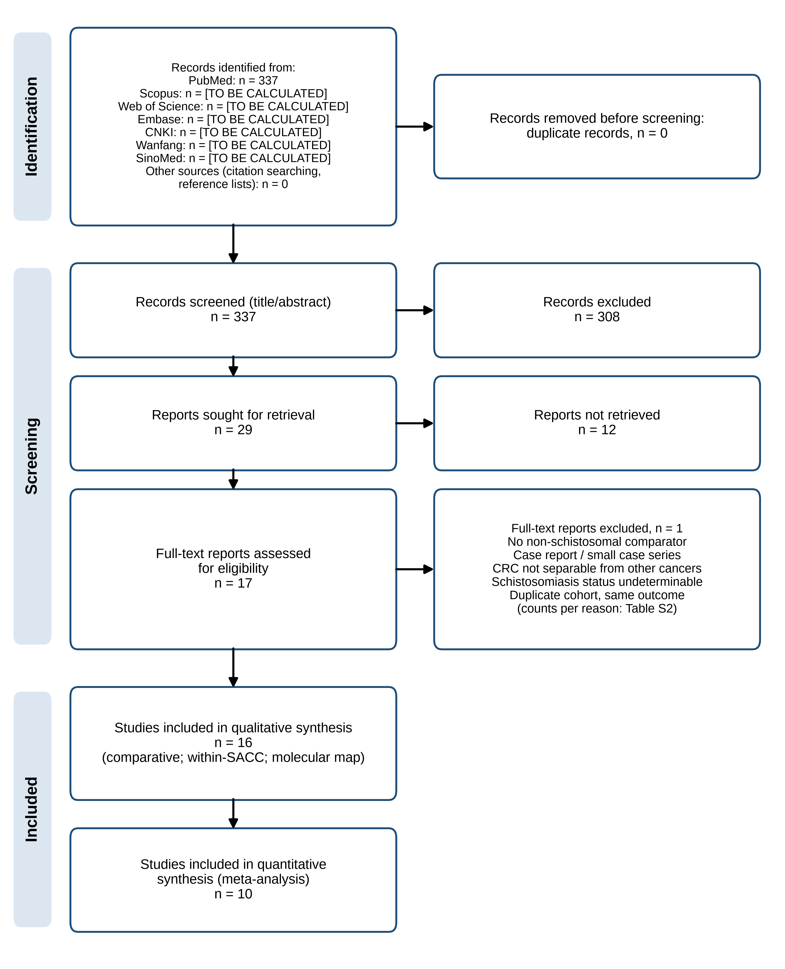
Figure 1. PRISMA 2020 flow diagram of study selection (interim: PubMed only; the remaining databases are still to be searched). Counts are read from data/analysis_ready/prisma_counts.csv.
Characteristics of included studies
The 16 included reports came from nine institutions or groups (Table 1). Seven independent comparative cohorts, all from China, compared SACC with NSACC: Changhai Hospital, Shanghai (823 SACC and 30,330 NSACC; 2001-2021);¹⁹ Yijishan Hospital, Wuhu (253 and 2,885; 2012-2018), with a second, partly overlapping report from the same hospital;^{12,34} the Qingpu Branch of Zhongshan Hospital, Shanghai (137 and 214; 2008-2016), from which five further reports provided biomarker data only;^{13,35-39} Union Hospital, Wuhan (30 and 459; 2010-2019);¹⁸ Jingzhou Hospital, Hubei (95 and 406; 2020-2022), with an overlapping radiology report;^{14,15} Wuhu Second People's Hospital (56 and 307; 2015-2020);⁴⁰ and Ruijin Hospital, Shanghai (26 and 34 rectosigmoid cancers; 2009-2013).⁴¹ Overlap was confirmed from the full texts: all six Qingpu reports described patients resected at the same hospital between January 2008 and August 2016, and the two Jingzhou reports shared the hospital, period, and an author (Supplementary Table S6). A previously suspected Qingpu report proved to be a separate SACC-only cohort from the main Zhongshan campus (2016-2018).⁴² One exome-sequencing study used an external sporadic-CRC comparator.⁴³ Allowing for overlap, individual meta-analyses included up to 1,383 SACC and 34,328 NSACC patients (Table 4). All cohorts were retrospective; survival data were available for four cohorts.

Table 1. Characteristics of identified studies
Study | Location | Institution | Study period | Design | SACC n | NSACC n | Species | Definition of schistosomiasis | Follow-up | Main outcomes | Overlap group | Analysis set
Zheng 2023¹⁹ | Shanghai | Dept of Colorectal Surgery | 2001-01 to 2021-12 | Retrospective single-centre cohort | 823 | 30330 | S. japonicum presumed | Calcified eggs in resected colorectal tissue | NR (survival in 6,537) | Trends; clinicopathological features; comorbidity; KRAS; multiple primary CRC; c | G1 | Primary comparative
Wang 2020¹² | Wuhu, Anhui | Dept of Infectious Diseases | 2012-01 to 2018-12 | Retrospective cohort | 253 | 2885 | S. japonicum presumed | Eggs on H&E in resected specimen | Median 78 mo (100 pts) | Age; sex; faecal occult blood; pT stage; CA19-9; WBC; RBC; PLT; 5-year survival | G2 | Primary comparative
Yang 2023³⁴ | Wuhu, Anhui | Yijishan Hospital of Wannan Medical College + Chizhou People's Hospital | 2015-01 to 2021-12 | Retrospective pathology series | 298 CRC (158 colon, 140 rectal) | 326 CRC (159 colon, 167 rectal) | S. japonicum | Eggs on H&E in resected specimen | None | Age, sex, differentiation in schistosomiasis-associated vs non-schistosomiasis t | G2 | Primary comparative
Wang 2020¹³ | Shanghai (Qingpu) | Qingpu Branch of Zhongshan Hospital | 2008-01 to 2016-08 | Retrospective cohort | 137 | 214 | S. japonicum presumed | Eggs on H&E in resected specimen | Median 62.4 mo | Age | G3 | Primary comparative
Wang 2021³⁵ | Shanghai (Qingpu) | Dept of Pathology | 2008-01 to 2016-08 | Retrospective cohort | 128 | 210 | S. japonicum | Eggs on H&E in resected specimen | NR (cohort as Wang 2020) | CD8+ TIL; tumoural/stromal PD-L1; OS | G3 | Primary comparative
Wang 2023³⁶ | Shanghai (Qingpu) | Dept of Pathology | 2008-01 to 2016-08 | Retrospective cohort | 137 (126 with IHC) | 212 (188 with IHC) | S. japonicum | Eggs on H&E in resected specimen | NR (cohort as Wang 2020) | sTILs; CD3; CD20; clinicopathological features | G3 | Primary comparative
Pan 2020³⁷ | Shanghai | Zhongshan Hospital | 2008-01 to 2016-08 | Retrospective cohort | 138 | 216 | S. japonicum | Eggs on H&E in resected specimen | Median 62.4 mo | c-MYC amplification | G3 | Molecular evidence table; within-SACC prognostic
Cheng 2023³⁸ | Shanghai (Qingpu) | Qingpu Branch of Zhongshan Hospital | 2008-01 to 2016-08 | Retrospective cohort | 137 | 214 | S. japonicum presumed | Eggs on H&E in resected specimen | Median 62.4 mo | Stromal/intratumoural CD4, CD8; CRP; OS | G3 | Primary comparative
Chai 2026³⁹ | Shanghai (Qingpu) | Qingpu Branch of Zhongshan Hospital | 2008-01 to 2016-08 | Retrospective cohort | 112 | 174 | S. japonicum presumed | Eggs on H&E in resected specimen | NR | CFIm25; OS | G3 | Molecular evidence table
Li 2024¹⁸ | Wuhan, Hubei | Dept of Pathology | 2010-01 to 2019-06 | Retrospective cohort | 30 | 459 | S. japonicum presumed | Intact/calcified eggs, granulomas, or worms in CRC tissue | NR | KRAS G12S/D | G4 | Primary comparative
Zhu 2024¹⁵ | Jingzhou, Hubei | Department of Pathology | 2020-01 to 2022-08 | Retrospective cross-sectional | 95 | 406 | S. japonicum presumed | Eggs on H&E in resected specimen | None | Age >60; site | G5 | Primary comparative
Zhang 2023¹⁴ | Jingzhou, Hubei | Dept of Radiology | 2020-01 to 2022-12 | Retrospective cohort | 101 | 240 | S. japonicum presumed | Eggs on H&E in resected specimen | None | Sex; TNM stage; LN metastasis; nerve invasion; vascular tumour thrombus; differe | G5 | Primary comparative
Wu 2021⁴⁰ | Wuhu, Anhui | Wuhu Second People's Hospital | 2015-06 to 2020-06 | Retrospective cohort | 56 | 307 | S. japonicum presumed | Eggs on H&E in resected specimen | None | LN metastasis; differentiation; vascular and perineural invasion; depth; SIK2 | G10 | Primary comparative
Feng 2015⁴¹ | Shanghai | Shanghai Minimally Invasive Surgical Center | 2009-10 to 2013-11 | Retrospective comparative series | 26 | 34 | S. japonicum presumed | Ova on microscopy (colon, rectum, or stool) | None | Sex, age, CEA, CA19-9, CA-125, stage, differentiation, histology | G11 | Primary comparative
Pan 2023⁴² | Shanghai | Department of Pathology | 2016-01 to 2018-12 | Retrospective SACC-only cohort | 172 | - | S. japonicum | Eggs on H&E in resected specimen | Median 50.1 mo | Eggs in lymph nodes | G9 | Within-SACC prognostic
Yu 2023⁴³ | Shanghai | Changzheng Hospital | 2014-2020 | Whole-exome sequencing, SACC tumours vs external sporadic-CRC data | 30 | NR | S. japonicum | History plus ova in specimen | NR | TMB | NR | Molecular evidence table
Wang 2014¹⁷ | Chengdu, Sichuan | Dept of Gastroenterological Surgery | NR | Retrospective matched | 30 | 30 | S. japonicum | NR (full text not retrieved) | NR | OS; DFS | G6 | Not analysed (no full text)
Wang 2016⁴⁴ | Chengdu, Sichuan | West China Hospital | 2009-07 to 2012-07 | Retrospective SACC-only cohort | 74 | - | S. japonicum | NR (full text not retrieved) | NR | Egg deposition site; CEA; pT; pN; resection margin eggs; OS | G6 | Not analysed (no full text)
NCG 1986¹⁶ | China (multi-province) | Multicentre | NR | Multicentre retrospective cohort | 430 | NR | S. japonicum | NR (full text not retrieved) | NR | 5-year survival lower in SACC; regional LN immune response; infiltrating growth | G7 | Not analysed (no full text)
Madbouly 2007⁴⁵ | Alexandria, Egypt | Dept of Surgery | NR | Comparative pathological series | 40 | 20 | S. mansoni | NR (full text not retrieved) | NR | p53 IHC; DCC; MLH1/MSH2 | G8 | Not analysed (no full text)
Extracted from full texts on 5 October 2026 except where marked 'no full text'. NR, not reported; mo, months; S. japonicum presumed = endemic-area cohort, species not confirmed. Overlap groups are defined in Supplementary Table S6. Six further comparative reports identified by the PubMed search could not be retrieved (Supplementary Table S2).

Figure 2. Chronological landscape of identified studies. Bars show recruitment periods where reported; diamonds show publication year. Right column: SACC/NSACC sample sizes (NR, not reported; dash, SACC-only cohort). Labels give city/province.
Schistosomiasis ascertainment
All analysed comparative cohorts defined schistosomiasis by histological identification of schistosome eggs (often calcified) in the resected colorectal specimen; one series also accepted ova in stool or biopsy.⁴¹ No study confirmed the species morphologically or molecularly; all were classified as S. japonicum presumed from endemic-area residence. Two pathologists blinded to clinical data reviewed slides in the Qingpu reports;^{13,36} Zheng et al. noted that egg reporting was not compulsory in routine pathology, so some SACC may have been misclassified as NSACC.¹⁹ The comparison was therefore strictly SACC with egg-proven intestinal involvement versus CRC without eggs in the specimen.
Demographic characteristics
For male sex, the pooled OR was 1.38 (95% CI 1.22-1.55; P < 0.001; 6 studies; I² = 0%; tau² = 0.000). For age (mean difference, years), the pooled MD was 3.39 (95% CI -1.52-8.31; P = 0.176; 3 studies; I² = 97%; tau² = 16.888). For age over 60 years, the pooled OR was 2.63 (95% CI 0.88-7.89; P = 0.084; 4 studies; I² = 94%; tau² = 1.145). Every cohort that reported age found SACC patients to be older or of similar age (Figure 7); the very high heterogeneity reflects the size, not the direction, of the difference.
Anatomical distribution
For rectal location, the pooled OR was 1.19 (95% CI 1.06-1.33; P = 0.004; 5 studies; I² = 0%; tau² = 0.000). After exclusion of the largest cohort,¹⁹ the OR was 1.07 (95% CI 0.87-1.31) (4 studies; I² = 0%). For right-sided colon location, the pooled OR was 0.79 (95% CI 0.61-1.01; P = 0.055; 5 studies; I² = 51%; tau² = 0.037). For sigmoid location, the pooled OR was 0.92 (95% CI 0.70-1.21; P = 0.562; 2 studies; I² = 0%; tau² = 0.000).
Pathological characteristics
For poor differentiation, the pooled OR was 0.70 (95% CI 0.35-1.40; P = 0.311; 7 studies; I² = 88%; tau² = 0.701). For mucinous or signet-ring histology, the pooled OR was 1.45 (95% CI 0.61-3.47; P = 0.399; 3 studies; I² = 62%; tau² = 0.362). For vascular invasion, the pooled OR was 0.88 (95% CI 0.70-1.11; P = 0.269; 5 studies; I² = 17%; tau² = 0.013). For perineural invasion, the pooled OR was 0.95 (95% CI 0.77-1.18; P = 0.664; 5 studies; I² = 6%; tau² = 0.005). For tumour budding, the pooled OR was 0.75 (95% CI 0.35-1.62; P = 0.460; 2 studies; I² = 90%; tau² = 0.280). For tumour size of 5 cm or more, the pooled OR was 1.00 (95% CI 0.69-1.46; P = 0.982; 2 studies; I² = 0%; tau² = 0.000). Heterogeneity for differentiation was driven by one cohort reporting 2.6% poorly differentiated SACC against 21.9% NSACC with a non-significant P value;¹² without it the OR was 1.18 (95% CI 0.99-1.40) (I² = 0%). Single cohorts reported more multiple primary CRC (4.3% vs 2.8%), more concomitant polyps (20.0% vs 13.6%), and more positive resection margins (3.6% vs 1.1%) in SACC, and lymphovascular invasion in 34% vs 36%;^{13,19} these were not pooled. Study-level counts are given in Table 2.

Table 2. Clinicopathological outcomes by study: events/total in SACC vs NSACC
Study | Male | Age >60 | Rectum | Stage III-IV | T3-T4 | LN+ | M1 | Poor diff. | Mucinous/SRC | Vascular inv. | PNI
Zheng 2023¹⁹ | 566/823 vs 18827/30330 | - | 474/798 vs 16047/29782 | 308/767 vs 7056/15829 | 563/752 vs 11779/15483 | 261/751 vs 6001/15383 | 103/808 vs 2504/16155 | 122/792 vs 1920/15165 | - | 54/808 vs 1461/16155 | 85/808 vs 1888/16155
Wang 2020¹² | 174/253 vs 1721/2885 | 176/253 vs 1609/2885 | 130/253 vs 1395/2885 | - | 178/253 vs 2300/2885 | - | - | 7/253 vs 633/2885 | - | - | -
Yang 2023³⁴ | - | - | - | - | - | 42/195 vs 61/227 | - | - | - | 38/195 vs 47/227 | -
Wang 2020¹³ | 86/137 vs 126/214 | 132/137 vs 136/214 | 37/137 vs 57/214 | 61/137 vs 98/214 | 108/137 vs 163/214 | 56/137 vs 88/214 | - | 35/137 vs 49/214 | 17/137 vs 23/214 | - | 12/137 vs 20/214
Li 2024¹⁸ | 22/30 vs 288/459 | 13/30 vs 206/459 | 13/30 vs 195/459 | 19/30 vs 251/459 | - | - | 6/30 vs 60/459 | 4/30 vs 75/459 | - | 8/30 vs 115/459 | 11/30 vs 114/459
Zhu 2024¹⁵ | 65/95 vs 234/406 | 70/95 vs 228/406 | 23/95 vs 105/406 | - | 78/95 vs 322/406 | - | - | 9/89 vs 39/375 | 6/95 vs 31/406 | 38/95 vs 174/406 | -
Zhang 2023¹⁴ | - | - | - | - | - | 38/101 vs 87/240 | - | - | - | - | 30/101 vs 62/240
Wu 2021⁴⁰ | - | - | - | - | 49/56 vs 249/307 | 35/56 vs 145/307 | - | 6/56 vs 52/307 | - | 13/56 vs 52/307 | 8/56 vs 69/307
Feng 2015⁴¹ | 18/26 vs 22/34 | - | - | 4/26 vs 18/34 | - | - | - | 3/26 vs 3/34 | 10/26 vs 4/34 | - | -
Only the report used for each outcome within an overlap group is shown (Supplementary Table S6). -, not reported or taken from another report of the same cohort. LN+, lymph-node metastasis; M1, distant metastasis (stage IV where M stage was not given separately); PNI, perineural invasion. Definitions differ between studies (see notes in the extraction file).

Tumour stage and metastatic behaviour
For stage III-IV disease, the pooled OR was 0.84 (95% CI 0.74-0.97; P = 0.015; 4 studies; I² = 0%; tau² = 0.000). After exclusion of the largest cohort,¹⁹ the OR was 0.67 (95% CI 0.21-2.18) (3 studies; I² = 86%). For pT3-T4 tumours, the pooled OR was 0.95 (95% CI 0.70-1.30; P = 0.755; 5 studies; I² = 69%; tau² = 0.076). For lymph-node metastasis, the pooled OR was 0.97 (95% CI 0.76-1.23; P = 0.783; 5 studies; I² = 49%; tau² = 0.035). For distant metastasis, the pooled OR was 0.99 (95% CI 0.51-1.93; P = 0.985; 2 studies; I² = 56%; tau² = 0.151). The largest cohort reported less nodal and distant metastasis in SACC,¹⁹ whereas the Wuhu Second People's Hospital cohort reported more nodal metastasis;⁴⁰ the pooled estimates show no consistent difference.
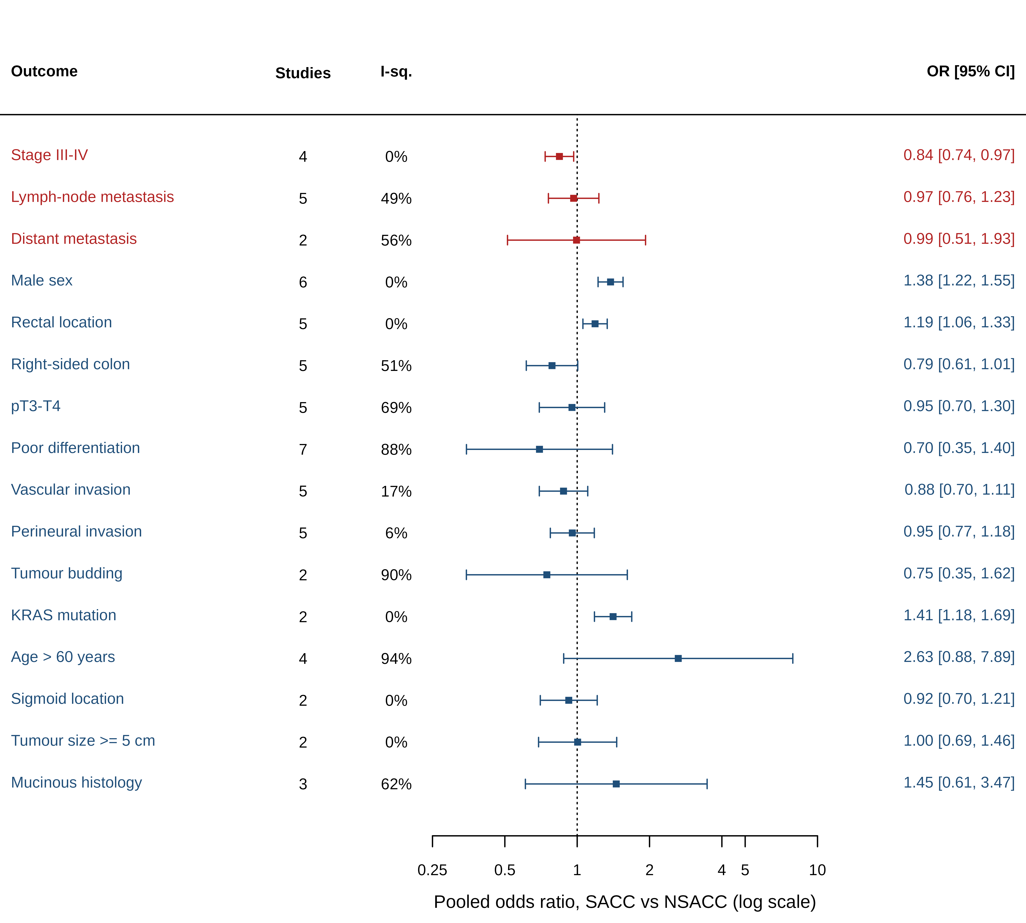
Figure 3. Clinicopathological phenotype of SACC versus NSACC: pooled odds ratios (random effects, REML) with 95% confidence intervals for each outcome with at least two independent cohorts. Red, primary outcomes; blue, secondary outcomes. Study-level forest plots are provided in the Supplementary Material.
Molecular characteristics
KRAS mutation was more frequent in SACC in the two cohorts with internal comparators (pooled OR 1.41 (95% CI 1.18-1.69); I² = 0%), although only the larger cohort was individually significant,¹⁹ and the smaller one found the excess confined to G12S/D mutations (43.3% vs 18.1%).¹⁸ In the largest cohort, NRAS, BRAF, and PIK3CA mutation and mismatch-repair deficiency did not differ.¹⁹ All other biomarkers came from single reports of the Qingpu cohort and showed no difference between groups: c-MYC amplification (13.8% vs 14.4%),³⁷ stromal and tumoural PD-L1,³⁵ stromal and intratumoural TILs, CD3 and CD20,³⁶ CD4 and CD8 densities,³⁸ and CFIm25.³⁹ Exome sequencing of 30 SACC tumours against an external sporadic-CRC reference found a lower median tumour mutational burden (1.61 vs 2.03 mutations/Mb), microsatellite stability or low instability in all cases, and less frequent RTK-RAS and Hippo pathway alteration.⁴³ Molecular data on S. mansoni (p53, mismatch repair, c-Myc) and several small Chinese-language comparisons (mismatch repair, p53, COX-2, Bax, Bcl-2, VEGF) were identified but their full texts could not be retrieved.⁴⁵⁻⁵¹

Table 3. Molecular evidence map for SACC versus NSACC
Biomarker | Study | Method | SACC positive/total | NSACC positive/total | Reported P | Pooled effect (random effects)
KRAS mutation | Zheng 2023¹⁹ | not stated | 249/479 (52.0%) | 4165/9514 (43.8%) | <0.001 | OR 1.41 (1.18-1.69); I2 0%
KRAS mutation | Li 2024¹⁸ | qPCR kit | 19/30 (63.3%) | 224/459 (48.8%) | 0.123 | OR 1.41 (1.18-1.69); I2 0%
KRAS G12S/D mutation | Li 2024¹⁸ | qPCR kit | 13/30 (43.3%) | 83/459 (18.1%) | 0.001 | Not pooled (k < 2)
NRAS mutation | Zheng 2023¹⁹ | not stated | 5/266 (1.9%) | 241/6341 (3.8%) | 0.105 | Not pooled (k < 2)
BRAF mutation | Zheng 2023¹⁹ | not stated | 17/478 (3.6%) | 297/9378 (3.2%) | 0.636 | Not pooled (k < 2)
PIK3CA mutation | Zheng 2023¹⁹ | not stated | 3/207 (1.4%) | 181/4511 (4.0%) | 0.063 | Not pooled (k < 2)
dMMR | Zheng 2023¹⁹ | not stated (MMR status) | 63/452 (13.9%) | 1157/7820 (14.8%) | 0.617 | Not pooled (k < 2)
c-MYC amplification | Pan 2020³⁷ | FISH on TMA | 19/138 (13.8%) | 31/216 (14.4%) | 0.878 | Not pooled (k < 2)
c-MYC protein overexpression | Pan 2020³⁷ | IHC (EP121) | 98/138 (71.0%) | 143/216 (66.2%) | 0.344 | Not pooled (k < 2)
Stromal PD-L1 positive | Wang 2021³⁵ | IHC (MXR003) on TMA | 56/128 (43.8%) | 86/210 (41.0%) | 0.650 | Not pooled (k < 2)
Tumoural PD-L1 positive | Wang 2021³⁵ | IHC (MXR003) on TMA | 58/128 (45.3%) | 80/210 (38.1%) | 0.210 | Not pooled (k < 2)
Stromal TILs rich | Wang 2023³⁶ | H&E | 73/126 (57.9%) | 121/188 (64.4%) | 0.287 | Not pooled (k < 2)
Intratumoral TILs rich | Wang 2023³⁶ | H&E | 6/126 (4.8%) | 3/188 (1.6%) | 0.164 | Not pooled (k < 2)
CD3 rich | Wang 2023³⁶ | IHC | 35/126 (27.8%) | 65/188 (34.6%) | 0.219 | Not pooled (k < 2)
CD20 rich | Wang 2023³⁶ | IHC | 53/126 (42.1%) | 84/188 (44.7%) | 0.728 | Not pooled (k < 2)
Intratumoral CD8 high | Cheng 2023³⁸ | IHC on TMA | 111/137 (81.0%) | 174/214 (81.3%) | 0.998 | Not pooled (k < 2)
Stromal CD8 high | Cheng 2023³⁸ | IHC on TMA | 41/137 (29.9%) | 67/214 (31.3%) | 0.813 | Not pooled (k < 2)
Intratumoral CD4 high | Cheng 2023³⁸ | IHC on TMA | 92/137 (67.2%) | 149/214 (69.6%) | 0.639 | Not pooled (k < 2)
Stromal CD4 high | Cheng 2023³⁸ | IHC on TMA | 78/137 (56.9%) | 139/214 (65.0%) | 0.144 | Not pooled (k < 2)
CFIm25 high | Chai 2026³⁹ | IHC on TMA | 70/112 (62.5%) | 120/174 (69.0%) | 0.25 | Not pooled (k < 2)
Tumour mutational burden | Yu 2023⁴³ | WES (FFPE, paired normal) | 30 | External (TCGA sporadic CRC) | NR | Not poolable (external comparator)
MSI-L/MSS | Yu 2023⁴³ | WES + IHC | 30/30 (100.0%) | External (TCGA sporadic CRC) | NR | Not poolable (external comparator)
APC, TP53 mutation, beta-catenin, Ki-67 | None with internal comparator | - | - | - | - | No evidence
All Qingpu reports (Wang 2021, Wang 2023, Pan 2020, Cheng 2023, Chai 2026) describe one cohort; each biomarker appears once. Biomarkers were pooled only with at least two independent internal-comparator cohorts. Abstract-only data on S. mansoni (Madbouly 2007: p53 32/40 vs 8/20; MSI 3/40 vs 1/20) are not shown in the analysis.

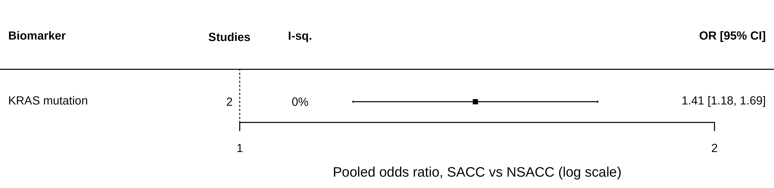
Figure 6. Molecular phenotype. Pooled odds ratios for biomarkers reported by at least two comparable studies, and evidence map for biomarkers that could not be pooled.
Overall survival
For overall survival (multivariable-adjusted HRs), the pooled HR was 1.76 (95% CI 1.06-2.91; P = 0.029; 2 studies; I² = 50%; tau² = 0.073). For overall survival (unadjusted or derived HRs), the pooled HR was 1.23 (95% CI 0.66-2.28; P = 0.519; 4 studies; I² = 90%; tau² = 0.342). The unadjusted pool combined three estimates above 1 with one HR below 1 derived from a log-rank P value in a 100-patient follow-up subset;^{12,25} the largest cohort reported no independent effect after adjustment but did not report the adjusted HR.¹⁹
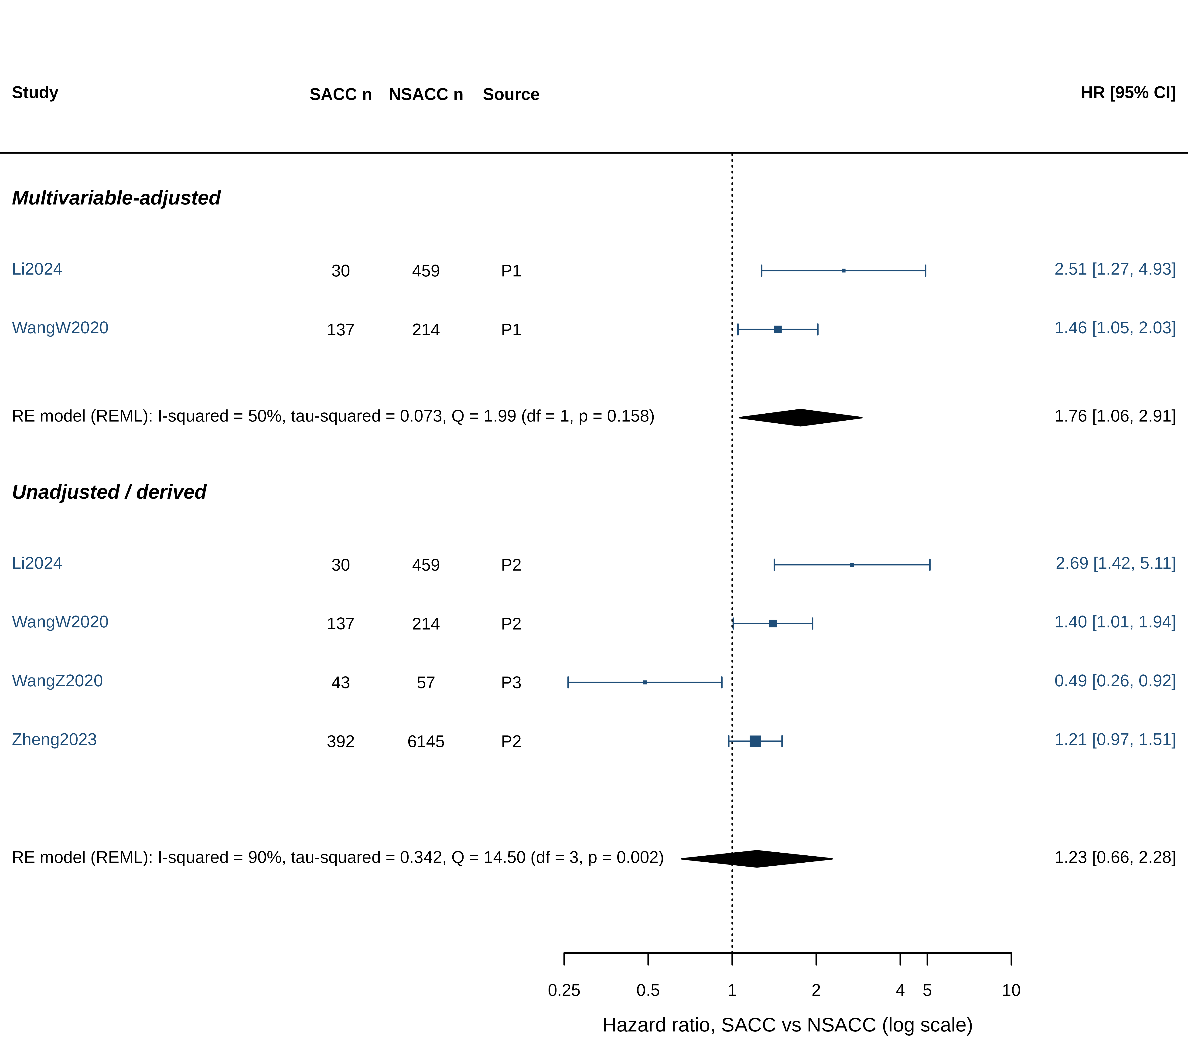
Figure 4. Overall survival in SACC versus NSACC. Hazard ratios with 95% CI; multivariable-adjusted and unadjusted/derived estimates are pooled separately. Source column: P1, adjusted HR reported; P2, unadjusted HR reported; P3, derived from survival statistics; P4, reconstructed from Kaplan-Meier curves.
Disease-free and recurrence-free survival
For disease-free survival (adjusted), the pooled HR was 1.32 (95% CI 0.81-2.15; P = 0.267; 2 studies; I² = 47%; tau² = 0.063). For disease-free survival (unadjusted), the pooled HR was 1.62 (95% CI 1.33-1.97; P < 0.001; 2 studies; I² = 0%; tau² = 0.000). Both cohorts showed shorter disease-free survival in SACC before adjustment and attenuated, non-significant HRs after adjustment.^{18,19}
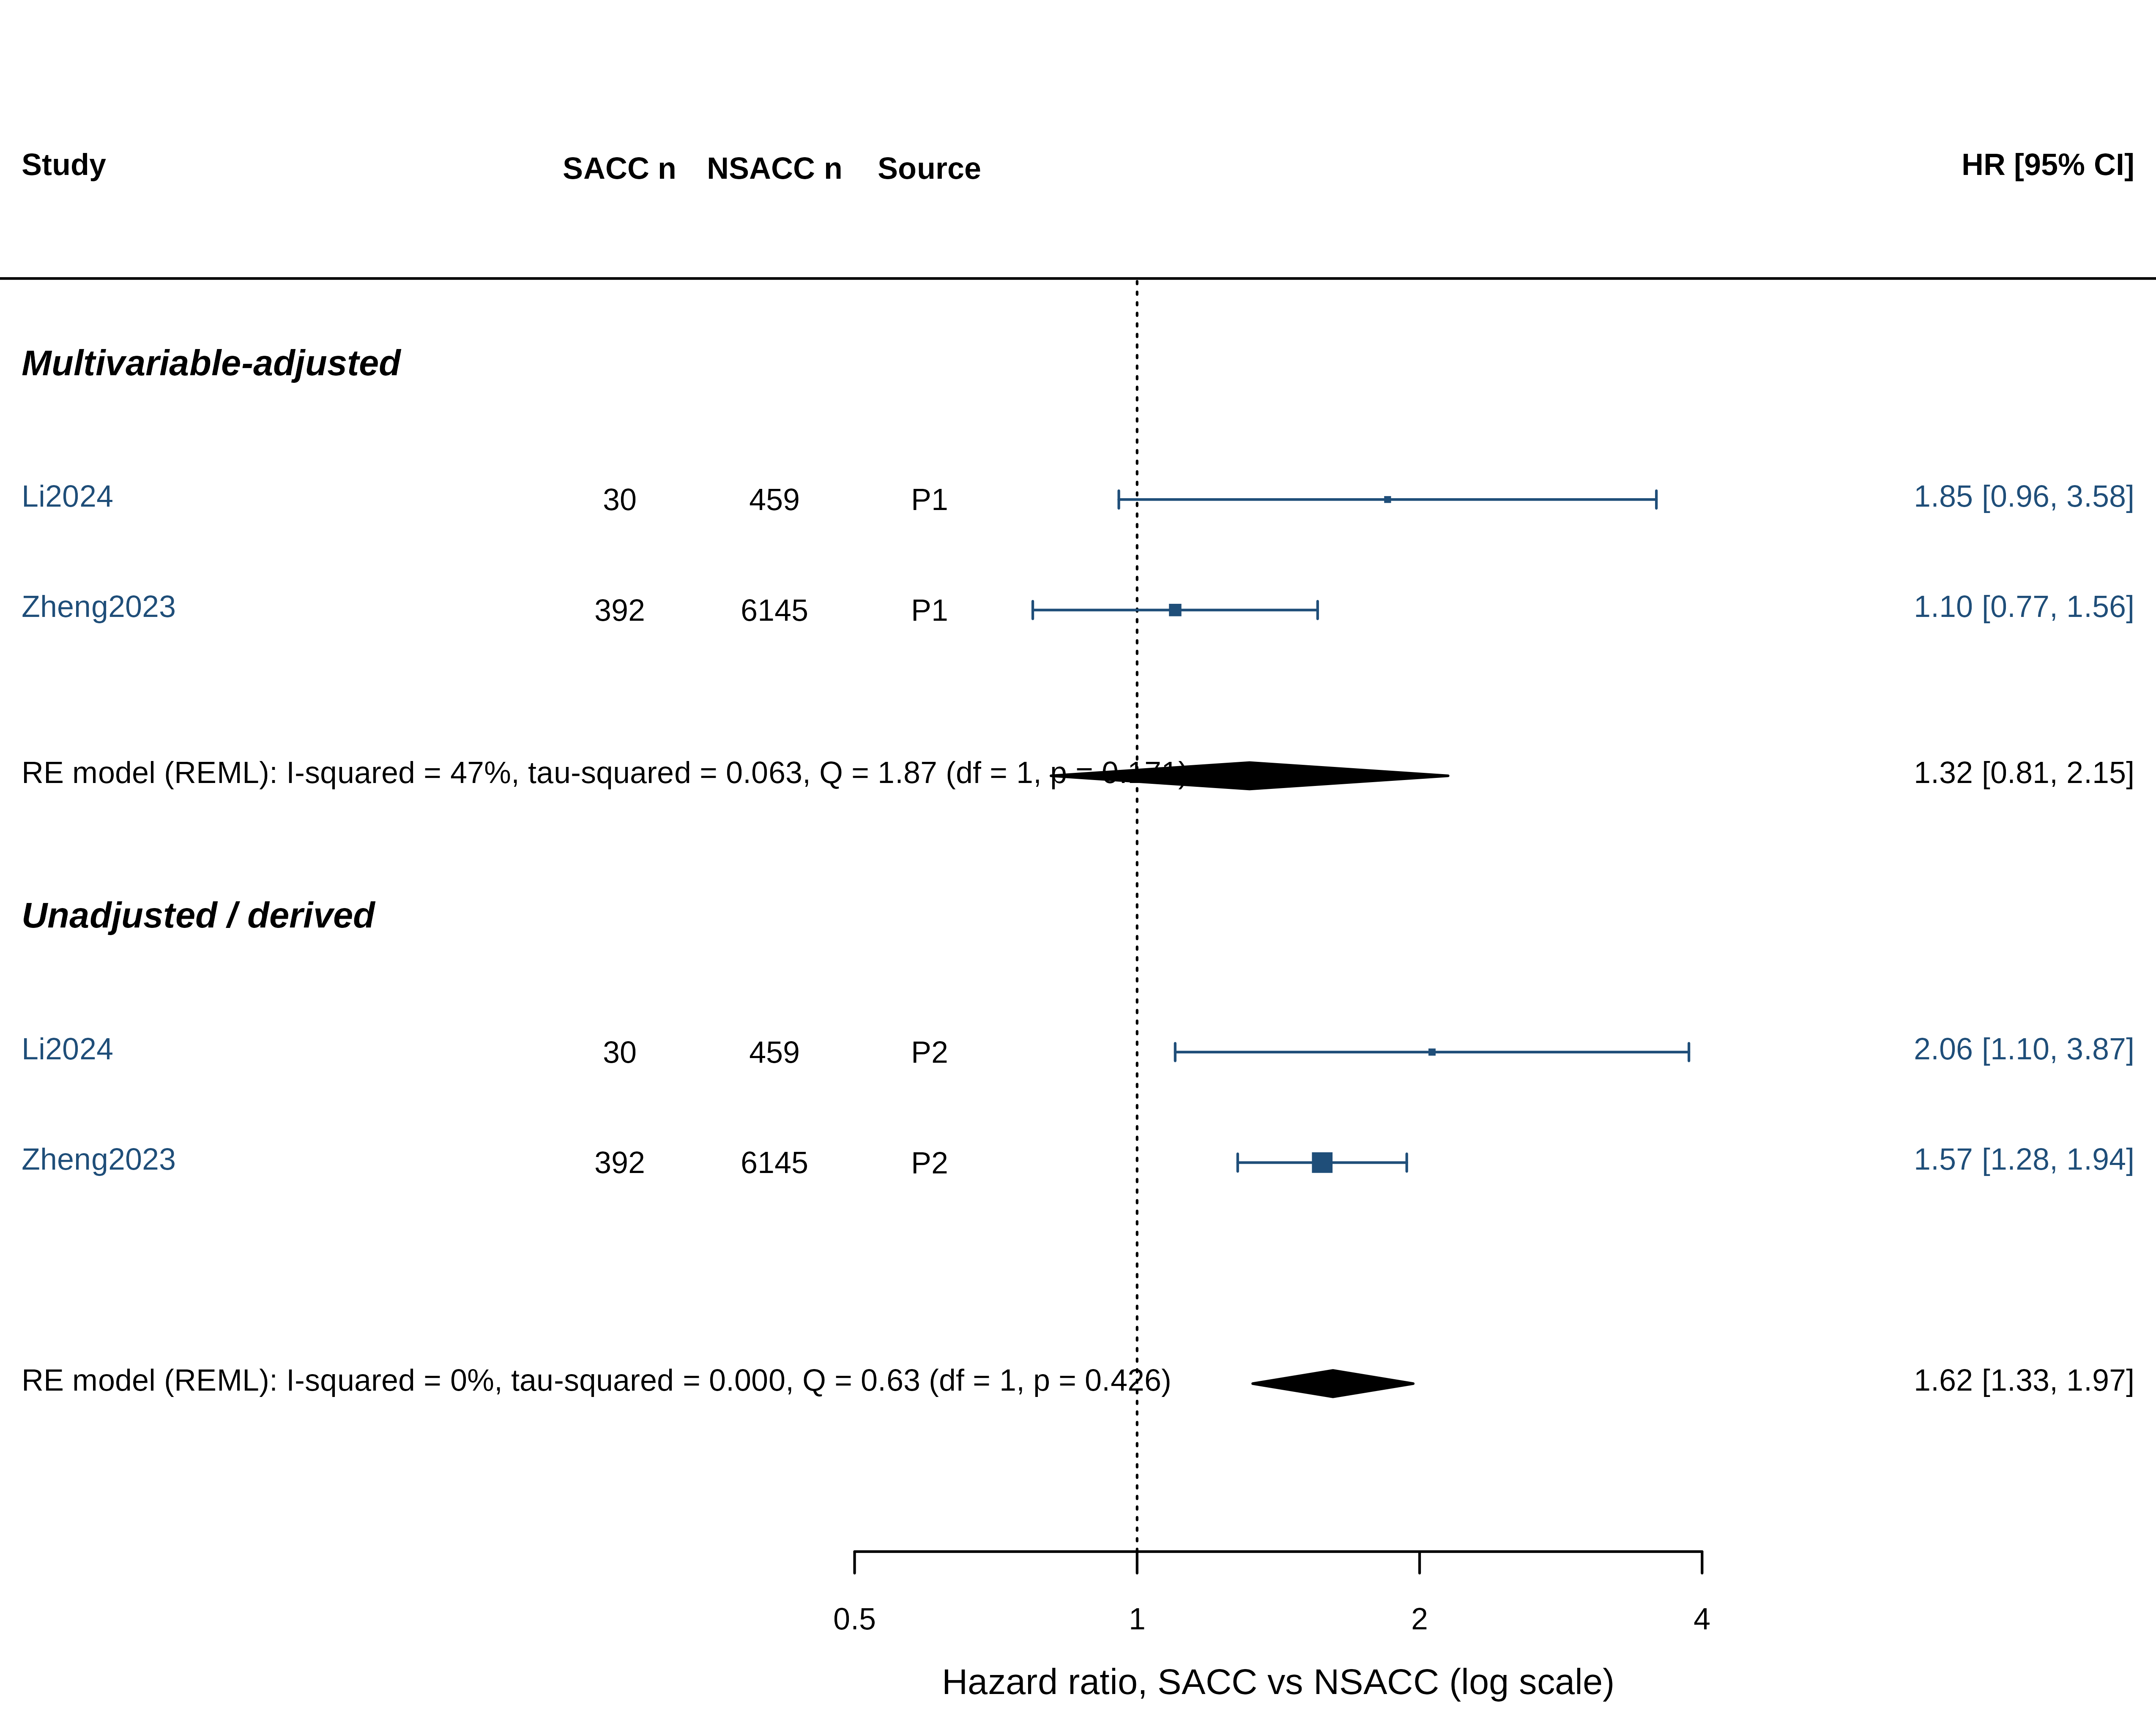
Figure 5. Disease-free/recurrence-free survival in SACC versus NSACC (hazard ratios, random effects).
Within-SACC prognostic factors
Within SACC, the conventional factors remained prognostic: nodal metastasis predicted overall survival in two cohorts (pooled adjusted HR 2.59 (95% CI 1.74-3.86); I² = 0%),^{19,38} as did distant metastasis, BRAF mutation, and tumour budding in the largest cohort.¹⁹ Schistosomiasis-specific features were examined only in the SACC-only cohort from the main Zhongshan campus (172 patients):⁴² in stage III disease, schistosome eggs in regional lymph nodes were associated with shorter disease-free survival (adjusted HR 3.00, 95% CI 1.37-6.59) and coexisting hepatic schistosomiasis with shorter disease-free (adjusted HR 3.95, 1.75-8.92) and overall survival (adjusted HR 4.97, 1.84-13.43); deep (muscularis or full-thickness) egg deposition was associated with disease-free survival in univariable analysis only. c-MYC amplification (adjusted HR 1.86, 1.01-3.42) and high intratumoural CD8 density (adjusted HR 0.52, 0.30-0.90) were prognostic in the Qingpu SACC subgroup.^{37,38} A West China cohort of 74 SACC on egg deposition site could not be retrieved.⁴⁴ With these exceptions, none of the within-SACC factors could be pooled (Table 5).

Table 5. Within-SACC prognostic factors
Factor | Study | Comparison | Outcome | HR (95% CI) | Model | Adjusted for | SACC n
eggs in lymph nodes stageIII | Pan 2023⁴² | eggs present vs absent in regional LNs (stage III) | DFS | 3.0 (1.365-6.592) | Adjusted | Perineural invasion, hepatic schistosomiasis | 62
eggs in lymph nodes stageIII | Pan 2023⁴² | eggs present vs absent in regional LNs (stage III) | OS | 2.396 (0.957-6.0) | Univariable | - | 62
eggs in lymph nodes | Pan 2023⁴² | eggs present vs absent in regional LNs (all stages) | DFS | 1.423 (0.814-2.49) | Univariable | - | 172
hepatic schistosomiasis stageIII | Pan 2023⁴² | present vs absent (imaging), stage III | DFS | 3.948 (1.748-8.917) | Adjusted | Perineural invasion | 62
hepatic schistosomiasis stageIII | Pan 2023⁴² | present vs absent (imaging), stage III | OS | 4.967 (1.836-13.432) | Adjusted | Perineural invasion | 62
egg deposition deep | Pan 2023⁴² | eggs in muscularis propria/full thickness (PS2) vs mucosa only (PS1) | DFS | 1.857 (1.048-3.289) | Univariable | - | 172
egg deposition deep | Pan 2023⁴² | PS2 vs PS1 | OS | 1.839 (0.899-3.762) | Univariable | - | 172
LN metastasis | Zheng 2023¹⁹ | pN1-2 vs pN0 | OS | 2.467 (1.383-4.401) | Adjusted | Multivariable Cox within SACC (stepwise) | 808
distant metastasis | Zheng 2023¹⁹ | yes vs no | OS | 4.248 (2.311-7.806) | Adjusted | Multivariable Cox within SACC (stepwise) | 808
BRAF mut | Zheng 2023¹⁹ | mutant vs wild type | OS | 4.033 (1.407-11.559) | Adjusted | Multivariable Cox within SACC (stepwise) | 808
BRAF mut | Zheng 2023¹⁹ | mutant vs wild type | DFS | 4.531 (1.608-12.762) | Adjusted | Multivariable Cox within SACC (stepwise) | 808
tumor budding | Zheng 2023¹⁹ | intermediate/high vs low | OS | 2.217 (1.06-4.635) | Adjusted | Multivariable Cox within SACC (stepwise) | 808
CEA elevated | Zheng 2023¹⁹ | >=5 vs <5 ng/mL | OS | 1.282 (0.646-2.541) | Adjusted | Multivariable Cox within SACC (stepwise) | 808
LN metastasis | Cheng 2023³⁸ | present vs absent | OS | 2.715 (1.57-4.696) | Adjusted | Multivariable Cox within SACC (backward stepwise; iCD8, tumour deposit, differentiation, sCD8, age) | 137
intratumoral CD8 high | Cheng 2023³⁸ | >=77 vs <77 cells/mm2 | OS | 0.518 (0.298-0.903) | Adjusted | LN metastasis, tumour deposit, differentiation, sCD8 | 137
CD8 TIL high | Wang 2021³⁵ | >=279 vs <279 cells/mm2 | OS | 0.592 (0.337-1.039) | Adjusted | TNM stage, tumour deposit | 128
CD3 rich | Wang 2023³⁶ | >=24% vs <24% | OS | 0.404 (0.16-1.021) | Adjusted | TNM stage | 126
cMYC amplification | Pan 2020³⁷ | c-MYC:CEP8 >=1.8 vs <1.8 (FISH) | OS | 1.861 (1.012-3.419) | Adjusted | Clinical stage | 138
LN metastasis OS (pooled) | 2 cohorts |  |  | 2.59 (1.74-3.86); I² 0% | Random effects |  | 945
SACC-only analyses; not combined with the SACC-versus-NSACC comparison. Wang 2021 and Wang 2023 report P = 0.045 for HRs whose 95% CI includes 1. Factors from the Qingpu cohort (Wang 2021, Wang 2023, Pan 2020, Cheng 2023) describe the same patients.

Risk of bias
Of the 9 comparative reports that contributed to meta-analyses, 3 were at low, 4 at moderate, and 2 at high risk of bias on the Newcastle-Ottawa Scale (Supplementary Table S4). The most frequent limitations were the absence of adjustment for confounders in cross-sectional comparisons, unreported or incomplete follow-up, and non-consecutive selection of the non-schistosomal group in two reports.^{34,41} Exposure ascertainment was secure (histology) in all, but may under-detect schistosomiasis, which would bias comparisons towards the null. Several reports contained internal numerical inconsistencies, which are documented in the extraction file. [Interim: risk of bias assessed by one AI-assisted reviewer; second independent assessment PENDING.]
Sensitivity and subgroup analyses
Excluding the Shanghai cohort of 31,153 patients¹⁹ gave ORs of male sex 1.43 (95% CI 1.17-1.75); stage III-IV disease 0.67 (95% CI 0.21-2.18); lymph-node metastasis 1.06 (95% CI 0.76-1.49). The male excess was therefore robust, whereas the lower odds of stage III-IV disease and the excess of rectal tumours depended on the largest cohort. For unadjusted overall survival, omitting the only cohort with a favourable (derived) HR¹² gave an HR of 1.50 (95% CI 1.03-2.18) (I² = 69%). Restricting to histology-confirmed SACC did not change any estimate because all analysed cohorts used histology; no cohort confirmed the species, so the S. japonicum-confirmed analysis could not be performed. Pre-specified subgroup analyses were not feasible with two to seven cohorts per outcome. With fewer than 10 studies for every outcome, small-study effects were not assessed. All sensitivity results are in Supplementary Table S5.
Certainty of evidence and overall phenotype
Table 4 summarises all pooled analyses with GRADE ratings. Figure 7 shows, study by study, the reported direction of each feature, including features that could not be pooled. Table 6 integrates these results into a phenotype matrix.

Table 4. Summary of meta-analyses: SACC versus NSACC
Outcome | Studies | SACC n | NSACC n | Measure | Pooled effect | 95% CI | I² | tau² | P value | GRADE certainty
Overall survival (adjusted) | 2 | 167 | 673 | HR | 1.76 | 1.06-2.91 | 50% | 0.073 | 0.029 | [TO BE ASSESSED]
Overall survival (unadjusted/derived) | 4 | 602 | 6875 | HR | 1.23 | 0.66-2.28 | 90% | 0.342 | 0.519 | [TO BE ASSESSED]
DFS/RFS (adjusted) | 2 | 422 | 6604 | HR | 1.32 | 0.81-2.15 | 47% | 0.063 | 0.267 | [TO BE ASSESSED]
DFS/RFS (unadjusted) | 2 | 422 | 6604 | HR | 1.62 | 1.33-1.97 | 0% | 0.000 | <0.001 | [TO BE ASSESSED]
Stage III-IV | 4 | 960 | 16536 | OR | 0.84 | 0.74-0.97 | 0% | 0.000 | 0.015 | [TO BE ASSESSED]
Lymph-node metastasis | 5 | 1240 | 16371 | OR | 0.97 | 0.76-1.23 | 49% | 0.035 | 0.783 | [TO BE ASSESSED]
Distant metastasis | 2 | 838 | 16614 | OR | 0.99 | 0.51-1.93 | 56% | 0.151 | 0.985 | [TO BE ASSESSED]
pT3-T4 | 5 | 1293 | 19295 | OR | 0.95 | 0.70-1.30 | 69% | 0.076 | 0.755 | [TO BE ASSESSED]
Male sex | 6 | 1364 | 34328 | OR | 1.38 | 1.22-1.55 | 0% | 0.000 | <0.001 | [TO BE ASSESSED]
Age, years | 3 | 1102 | 33249 | MD | 3.39 | -1.52-8.31 | 97% | 16.888 | 0.176 | [TO BE ASSESSED]
Age > 60 years | 4 | 515 | 3964 | OR | 2.63 | 0.88-7.89 | 94% | 1.145 | 0.084 | [TO BE ASSESSED]
Rectal location | 5 | 1313 | 33746 | OR | 1.19 | 1.06-1.33 | 0% | 0.000 | 0.004 | [TO BE ASSESSED]
Sigmoid location | 2 | 348 | 3291 | OR | 0.92 | 0.70-1.21 | 0% | 0.000 | 0.562 | [TO BE ASSESSED]
Right-sided colon | 5 | 1313 | 33746 | OR | 0.79 | 0.61-1.01 | 51% | 0.037 | 0.055 | [TO BE ASSESSED]
Poor differentiation | 7 | 1383 | 19439 | OR | 0.70 | 0.35-1.40 | 88% | 0.701 | 0.311 | [TO BE ASSESSED]
Mucinous/signet-ring histology | 3 | 258 | 654 | OR | 1.45 | 0.61-3.47 | 62% | 0.362 | 0.399 | [TO BE ASSESSED]
Vascular invasion | 5 | 1184 | 17554 | OR | 0.88 | 0.70-1.11 | 17% | 0.013 | 0.269 | [TO BE ASSESSED]
Perineural invasion | 5 | 1132 | 17375 | OR | 0.95 | 0.77-1.18 | 6% | 0.005 | 0.664 | [TO BE ASSESSED]
Tumour budding | 2 | 945 | 16369 | OR | 0.75 | 0.35-1.62 | 90% | 0.280 | 0.460 | [TO BE ASSESSED]
Tumour size >= 5 cm | 2 | 167 | 673 | OR | 1.00 | 0.69-1.46 | 0% | 0.000 | 0.982 | [TO BE ASSESSED]
KRAS mutation | 2 | 509 | 9973 | OR | 1.41 | 1.18-1.69 | 0% | 0.000 | <0.001 | [TO BE ASSESSED]
Random-effects models with REML estimation; S. japonicum (presumed) cohorts; one report per overlap group per outcome. HR > 1 and OR > 1 indicate higher hazard or higher odds in SACC; MD > 0, older SACC patients. Generated from output/tables/Table4_meta_analysis_summary.csv. GRADE ratings require two reviewers and are pending.

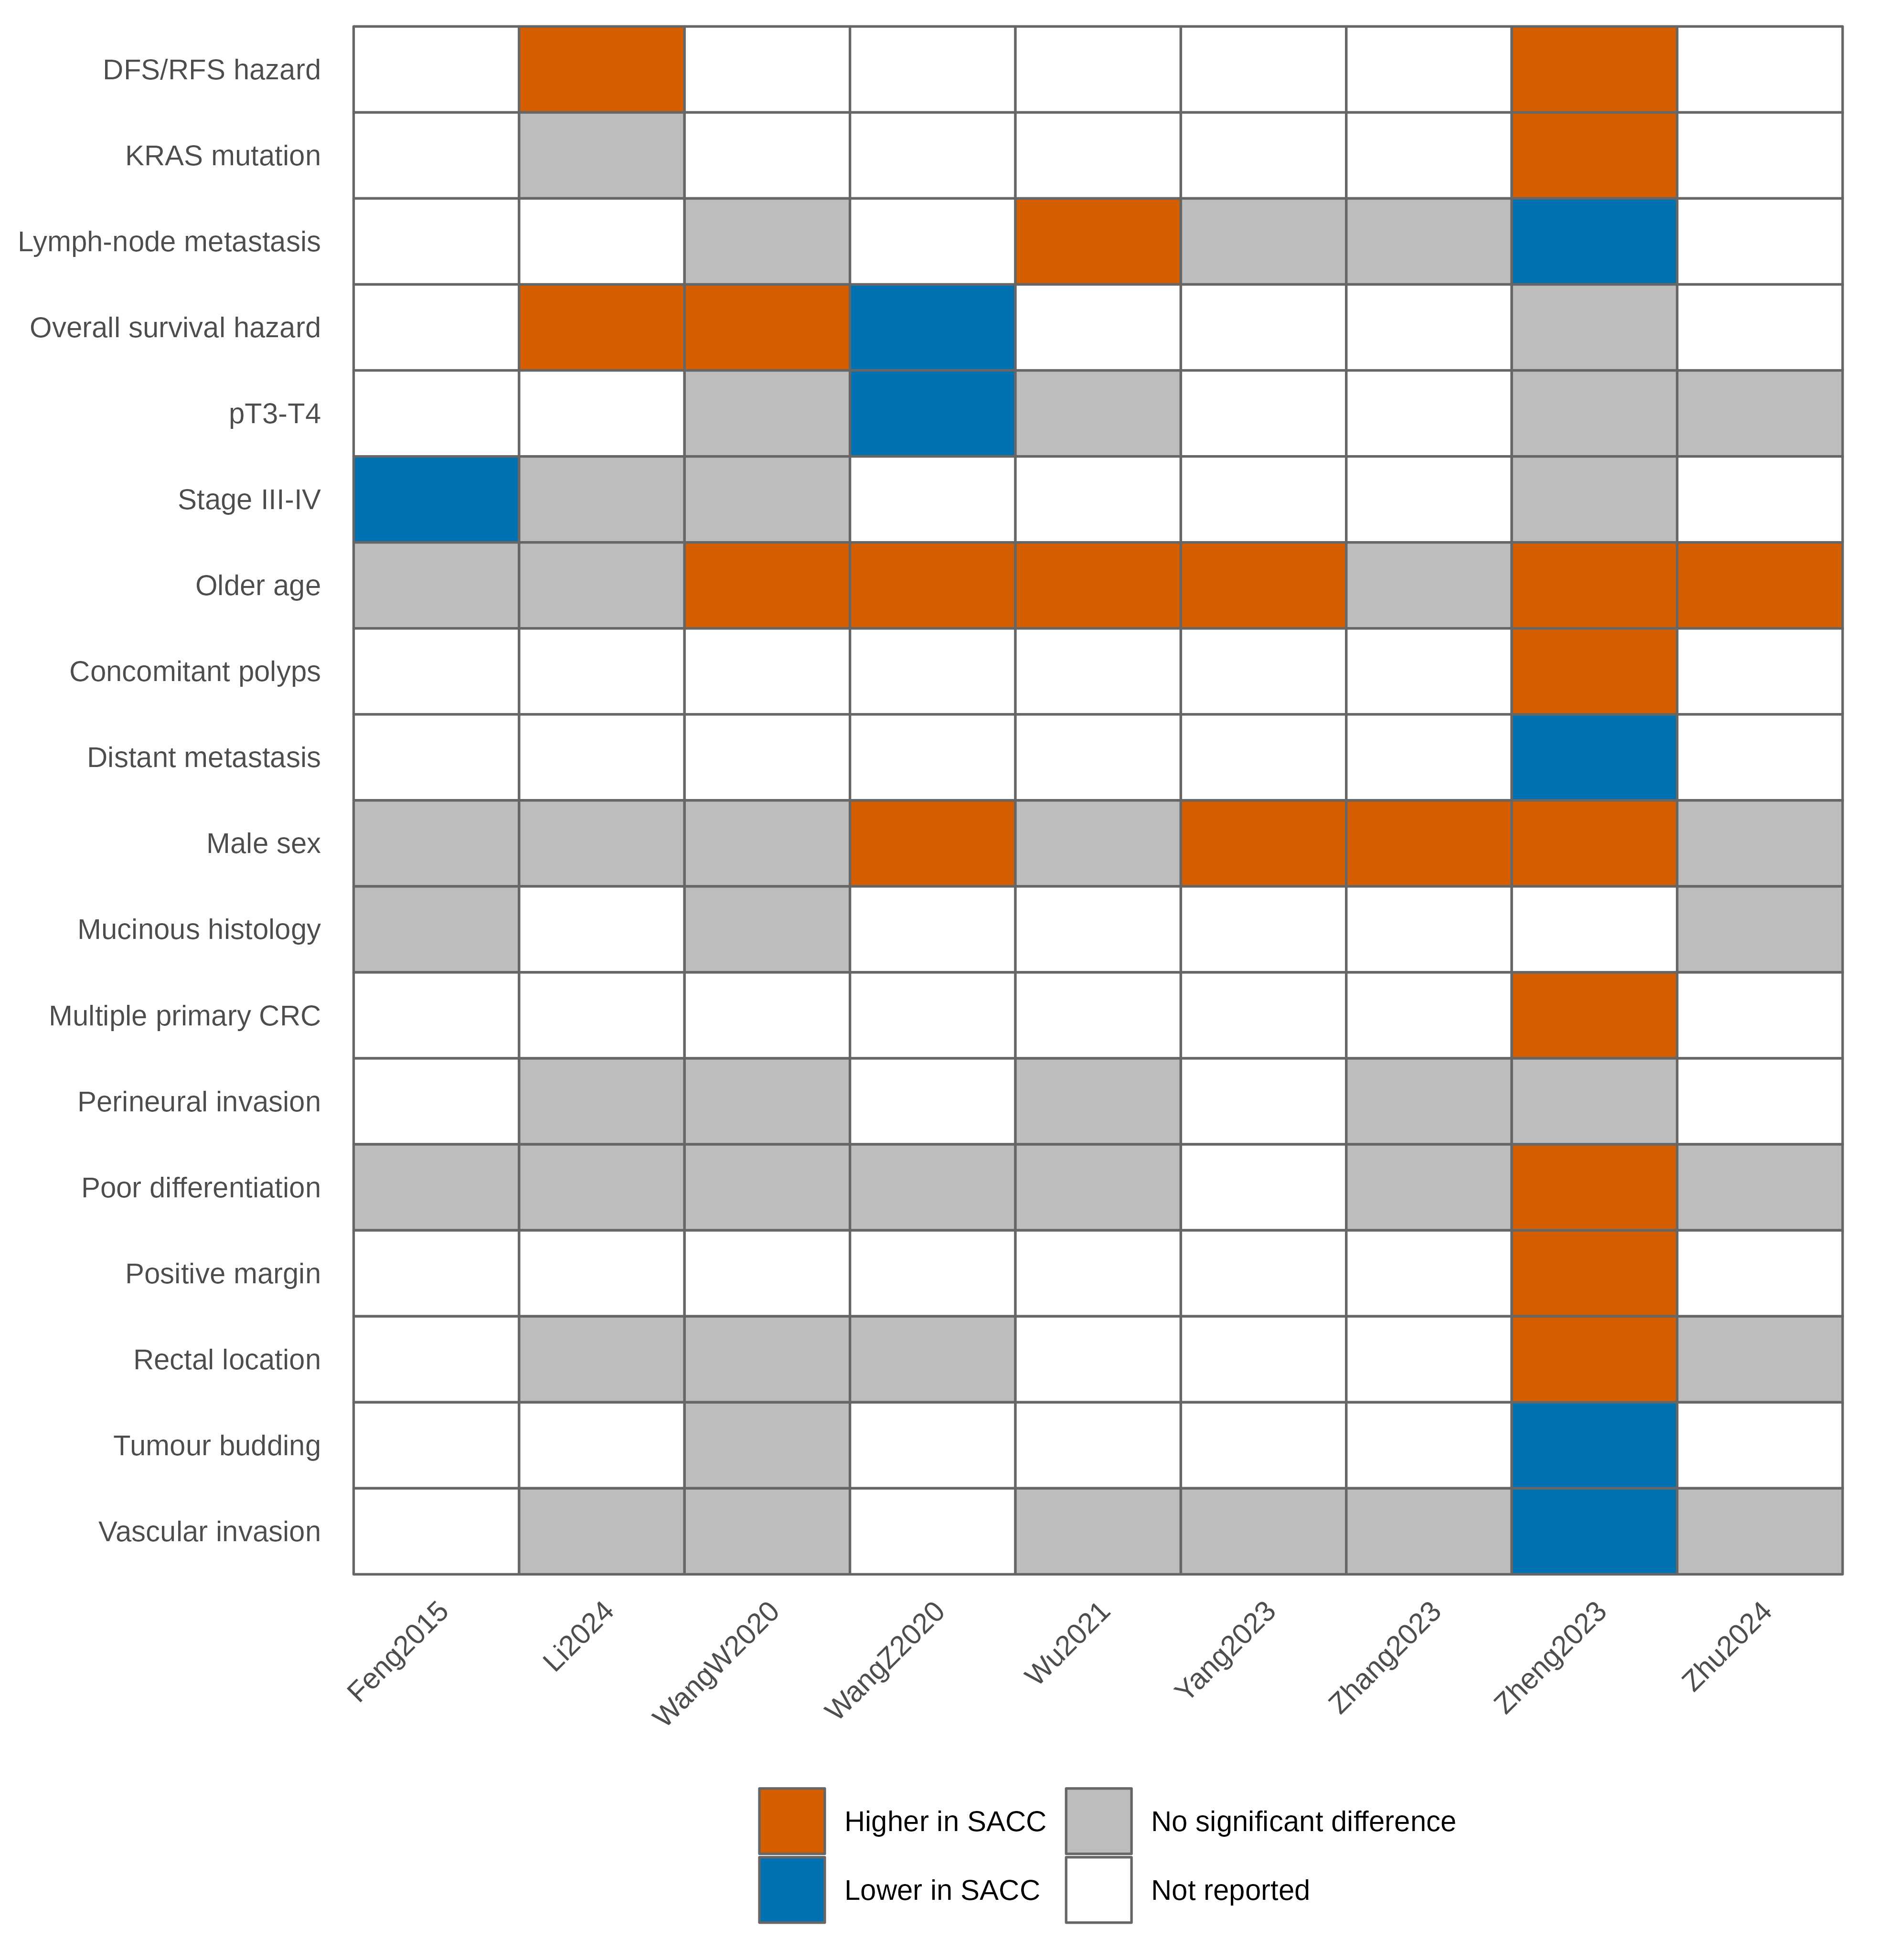
Figure 7. Evidence heat map. For each study (columns) and feature (rows), the reported direction in SACC relative to NSACC: higher, lower, no significant difference, or not reported.
Table 6. Phenotype matrix: is SACC distinct? (provisional)
Feature | Pooled direction | Strength of evidence
Older age | Up (all cohorts older or similar) | Moderate (direction consistent; magnitude heterogeneous)
Male sex | Up | Moderate
Rectal localisation | Up | Moderate - depends on largest cohort
Advanced stage | Down | Moderate - depends on largest cohort
Lymph-node metastasis | Neutral (CI includes no difference) | Limited
Distant metastasis | Neutral (CI includes no difference) | Limited
Vascular invasion | Neutral (CI includes no difference) | Limited
Mucinous histology | Neutral (CI includes no difference) | Limited
Multiple primary CRC | Higher in SACC (single cohort) | Limited
KRAS mutation | Up | Limited
Overall survival (adjusted) | Worse in SACC | Limited
DFS/RFS (adjusted) | Neutral (CI includes no difference) | Limited
Classified automatically from Table 4 before GRADE: Moderate, >= 3 cohorts, 95% CI excluding no difference, I² < 50%; Limited, fewer cohorts or imprecise; Inconsistent, I² >= 75%. 'Strong' is reserved for findings with moderate/high GRADE certainty and is not yet assigned.
DISCUSSION
Principal findings
[TO BE WRITTEN after analysis. Answer directly: does SACC appear phenotypically distinct, for which features, and with what certainty? Use 'associated with', 'more frequently observed', 'pooled evidence suggests'.]
Clinical interpretation
[TO BE WRITTEN: age, sex, tumour location, stage, metastasis, pathology, survival. Interpret survival in light of the separation of adjusted and unadjusted estimates and of the result excluding the largest cohort.]
Molecular interpretation
The molecular evidence base is narrow. At the screening stage, KRAS data came from two cohorts with different assays,^{18,19} exome data from 30 tumours compared with an external reference,⁴³ and p53 and mismatch-repair data from a single S. mansoni series that cannot be extrapolated to S. japonicum.⁴⁵ [TO BE WRITTEN with pooled results.] Unless consistent differences are found across several independent cohorts, these data do not support a defined molecular signature of SACC.
Biological plausibility
Several mechanisms could link chronic intestinal schistosomiasis to a distinct form of CRC, but they should be distinguished by the strength of evidence (Figure 8). Egg deposition in the colorectal wall and the resulting granulomatous inflammation and fibrosis are established histopathological features of infection.^{3,5} Experimental work suggests that S. japonicum soluble egg antigen activates MAPK and PI3K-AKT signalling and inhibits autophagy in CRC models,⁵² and that intestinal tumour-associated macrophage polarisation influences schistosomal CRC development.⁵³ Schistosoma mansoni eggs have been shown to activate Wnt/beta-catenin signalling and c-Jun in human and hamster colon,⁵⁴ but this concerns a different species. In patients, immune-cell infiltrates and PD-L1 expression appear to carry different prognostic value according to schistosomiasis status,^{35,36,38} and eggs in regional lymph nodes have been associated with poorer disease-free survival in stage III SACC.⁴² Other plausible pathways, including oxidative and nitrosative DNA damage, NF-kB and IL-6/STAT3 signalling, and microbiome change, have not, to our knowledge, been demonstrated specifically in human SACC and remain hypotheses. None of these observations establishes that S. japonicum causes CRC.
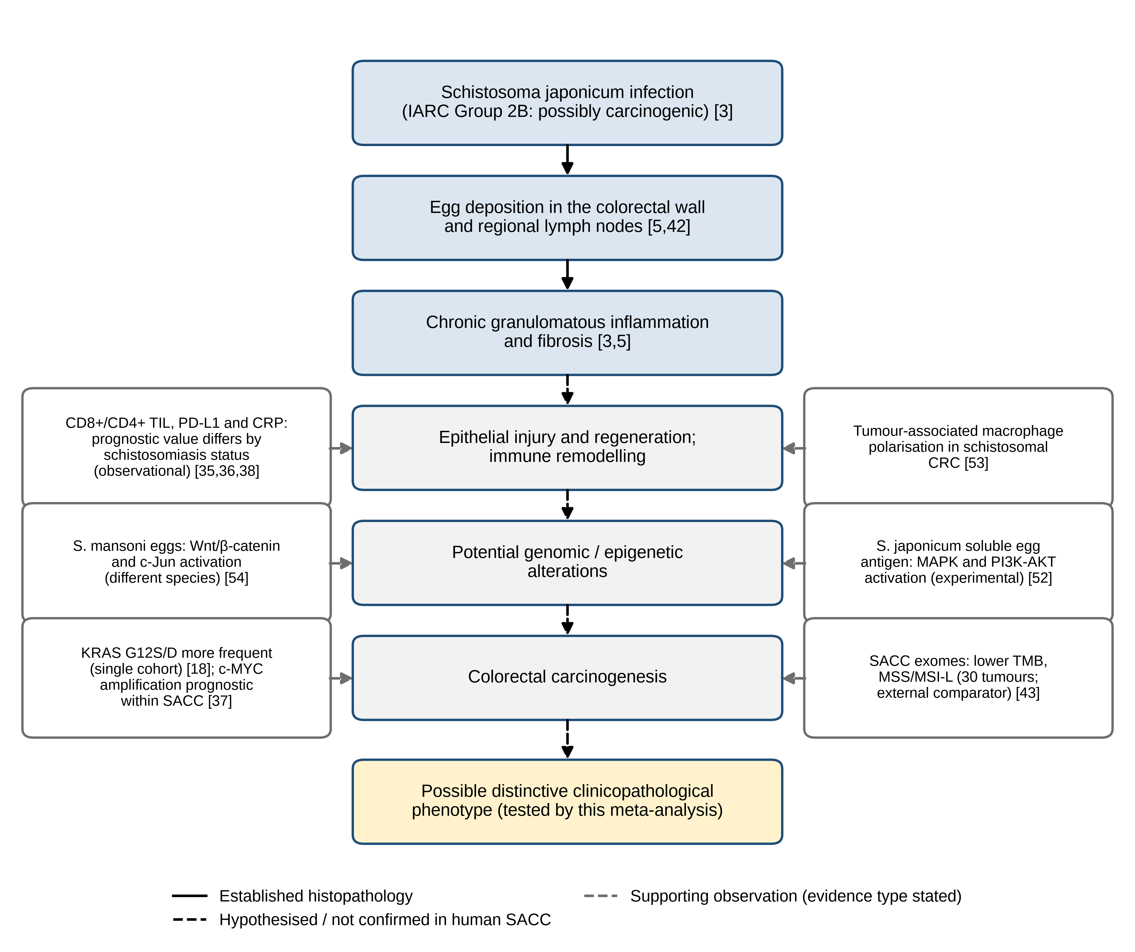
Figure 8. Conceptual model of how chronic S. japonicum infection might relate to colorectal carcinogenesis and a possible SACC phenotype. Solid arrows: established histopathology. Dashed black arrows: hypothesised steps not confirmed in human SACC. Grey boxes: supporting observations with the type of evidence stated; numbers are references. The figure does not imply that S. japonicum causes CRC.^{3,5,18,35-38,42,43,52-54}
Comparison with previous literature
Earlier descriptions of SACC as a distinct subtype were based on narrative reviews and single-centre series.^{5,20,55} A recent meta-analysis pooled the prevalence of intestinal parasitic infection among patients with CRC and its association with CRC,²¹ which addresses frequency and risk rather than the characteristics of cancers that have arisen. The present analysis differs in asking, among patients who already have CRC, whether schistosomiasis is associated with a different clinicopathological, molecular, and prognostic profile; in separating species, adjusted and unadjusted survival estimates, and SACC-only cohorts; and in explicitly managing overlap among reports from the same institutions. [TO BE COMPLETED: state whether any previous quantitative synthesis of this question was found by the final search; do not claim primacy unless confirmed.]
Implications for endemic countries
Most comparative cohorts came from China. No comparative cohort from the Philippines or Indonesia was identified at the screening stage [TO BE CONFIRMED by the final search], although both countries remain endemic.^{7,8} The findings therefore may not transfer directly to these settings. [TO BE WRITTEN after analysis: implications for pathological recognition of schistosome eggs in resection specimens and for recording schistosomiasis history in cancer registries.] These data do not, by themselves, justify changes to CRC screening policy.
Research implications
The evidence calls for prospective cohorts in which schistosomiasis is ascertained by standardised histological and serological criteria, tumours are profiled with contemporary genomic, transcriptomic, and immune assays against internal comparators, and outcomes are analysed with adjustment for stage and treatment. Patient-derived samples and experimental models are needed to test the hypothesised mechanisms. Studies from endemic settings outside China, particularly the Philippines and Indonesia, are a priority.
Limitations
This analysis has several limitations. The evidence is predominantly retrospective and geographically concentrated in China, and several reports appear to come from the same institutions and patient populations; although overlap was managed explicitly, undetected overlap cannot be excluded. Definitions of schistosomiasis ranged from histological identification of eggs to documented history, which may misclassify exposure. Cohorts span several decades with different staging systems and treatment eras. Survival estimates were adjusted for different covariates or not adjusted at all, and confounding by age, stage, and comorbidity is likely. Molecular data were limited, and few studies contributed to some endpoints, which limits precision and precluded formal assessment of small-study effects for most outcomes. Finally, as for any synthesis of observational data, the associations reported here cannot establish causality.
CONCLUSION
The available evidence indicates that schistosomiasis-associated colorectal cancer may exhibit a measurable clinicopathological phenotype distinct from non-schistosomal colorectal cancer; however, the magnitude and consistency of these differences vary across outcomes. [The most strongly supported pooled characteristics TO BE STATED from Table 4 and Table 6.] Prospective molecularly characterised cohorts from contemporary endemic settings are needed to determine whether these clinical differences reflect a biologically distinct form of colorectal carcinogenesis.
Acknowledgments
[TO BE ADDED]
Statement of Authorship
[TO BE ADDED, e.g., CRediT roles: conceptualisation, methodology, investigation (screening and extraction), formal analysis, writing - original draft, writing - review and editing; all authors approved the final version.]
Author Disclosure
[TO BE ADDED: conflicts of interest for each author.]
Funding Source
[TO BE ADDED, or 'This study received no specific funding.']
Use of AI-assisted Tools
[AUTHOR DECISION: describe any use of AI-assisted tools in search design, coding, or drafting, as required by the journal's current policy. The authors take full responsibility for the content.]
Data Availability
The extraction dataset, analysis code (R/metafor), and figure scripts are available at [REPOSITORY URL/DOI TO BE ADDED].
REFERENCES
1. Bray F, Laversanne M, Sung H, Ferlay J, Siegel RL, Soerjomataram I, et al. Global cancer statistics 2022: GLOBOCAN estimates of incidence and mortality worldwide for 36 cancers in 185 countries. CA Cancer J Clin. 2024;74(3):229-63. doi:10.3322/caac.21834
2. de Martel C, Georges D, Bray F, Ferlay J, Clifford GM. Global burden of cancer attributable to infections in 2018: a worldwide incidence analysis. Lancet Glob Health. 2020;8(2):e180-90. doi:10.1016/S2214-109X(19)30488-7
3. International Agency for Research on Cancer. Schistosomes, liver flukes and Helicobacter pylori. IARC Monographs on the Evaluation of Carcinogenic Risks to Humans, Vol. 61. Lyon: IARC; 1994.
4. International Agency for Research on Cancer. Biological agents. IARC Monographs on the Evaluation of Carcinogenic Risks to Humans, Vol. 100B. Lyon: IARC; 2012.
5. Hamid HKS. Schistosoma japonicum-associated colorectal cancer: a review. Am J Trop Med Hyg. 2019;100(3):501-5. doi:10.4269/ajtmh.18-0807
6. World Health Organization. Schistosomiasis [Internet]. Geneva: WHO; [cited YYYY Mon DD]. Available from: https://www.who.int/news-room/fact-sheets/detail/schistosomiasis [VERIFY: complete authors/year/pages from PubMed]
7. Gordon CA, Acosta LP, Gobert GN, Olveda RM, Ross AG, Williams GM, et al. Real-time PCR demonstrates high prevalence of Schistosoma japonicum in the Philippines: implications for surveillance and control. PLoS Negl Trop Dis. 2015;9(1):e0003483. doi:10.1371/journal.pntd.0003483 [VERIFY: complete authors/year/pages from PubMed]
8. [Authors to be verified]. Schistosomiasis japonicum in Indonesia: progress and surveillance needs in verge-of-elimination settings. Trop Med Infect Dis. 2026;11(4):86. doi:10.3390/tropicalmed11040086 [VERIFY: complete authors/year/pages from PubMed]
9. Xu Z, Su DL. Schistosoma japonicum and colorectal cancer: an epidemiological study in the People's Republic of China. Int J Cancer. 1984;34(3):315-8. doi:10.1002/ijc.2910340305. PMID: 6480152
10. Qiu DC, Hubbard AE, Zhong B, Zhang Y, Spear RC. A matched, case-control study of the association between Schistosoma japonicum and liver and colon cancers, in rural China. Ann Trop Med Parasitol. 2005;99(1):47-52. PMID: 15701255
11. Liu XF, Ju S, Wang KY, Li Y, Qiang JW. The prevalence rate, mortality, and 5-year overall survival of Schistosoma japonicum patients with human malignancy. Front Oncol. 2023;13:1288197. doi:10.3389/fonc.2023.1288197. PMID: 38125940
12. Wang Z, Du Z, Liu Y, Wang W, Liang M, Zhang A, et al. Comparison of the clinicopathological features and prognoses of patients with schistosomal and nonschistosomal colorectal cancer. Oncol Lett. 2020;19(3):2375-2383. doi:10.3892/ol.2020.11331. PMID: 32194737
13. Wang W, Lu K, Wang L, Jing H, Pan W, Huang S, et al. Comparison of non-schistosomal colorectal cancer and schistosomal colorectal cancer. World J Surg Oncol. 2020;18(1):149. doi:10.1186/s12957-020-01925-5. PMID: 32611359
14. Zhang F, Wang X, Zhu Y, Xia P. Conjoint analysis of clinical, imaging, and pathological features of schistosomiasis and colorectal cancer. Pathol Oncol Res. 2023;29:1611396. doi:10.3389/pore.2023.1611396. PMID: 38099242
15. Zhu Y, Wu X, Ran X, Rao C, Gong P. A retrospective cross-sectional study: comparison of the clinicopathological features of schistosomal and non-schistosomal colorectal cancer in Central China. BMC Infect Dis. 2024;24(1):732. doi:10.1186/s12879-024-09648-8. PMID: 39054428
16. National Cooperative Group on Pathology and Prognosis of Colorectal Cancer. [Schistosomiasis and its prognostic significance in patients with colorectal cancer]. Zhonghua Zhong Liu Za Zhi. 1986;8(2):149-51. Chinese. PMID: 3021419
17. Wang M, Zhang YC, Yang XY, Wang ZQ. Prognostic analysis of schistosomal rectal cancer. Asian Pac J Cancer Prev. 2014;15(21):9271-5. doi:10.7314/apjcp.2014.15.21.9271. PMID: 25422211
18. Li X, Liu H, Huang B, Yang M, Fan J, Zhang J, et al. Schistosoma infection, KRAS mutation status, and prognosis of colorectal cancer. Chin Med J (Engl). 2024;137(2):235-237. doi:10.1097/CM9.0000000000002905. PMID: 37920960
19. Zheng N, Wang H, Yu Q, Wang C, Bai CG, Pan AF, et al. Changing trends, clinicopathological characteristics, surgical treatment patterns, and prognosis of schistosomiasis-associated versus non-schistosomiasis-associated colorectal cancer: a large retrospective cohort study of 31 153 cases in Shanghai, China (2001-2021). Int J Surg. 2023;109(4):772-784. doi:10.1097/JS9.0000000000000293. PMID: 36999800
20. Hamid HKS, Mekki SO, Suleiman SH, Ibrahim SZ. Colorectal carcinoma associated with schistosomiasis: a possible causal relationship. World J Surg Oncol. 2010;8:68. doi:10.1186/1477-7819-8-68. PMID: 20704754
21. Hataminejad M, Basirpour B, Baharlou M, Gholami Koohestan M, Ziaei Hezarjaribi H, Rahimi Esboei B, et al. Global prevalence and correlation of intestinal parasitic infections in patients with colorectal cancer: a systematic review and meta-analysis. BMC Gastroenterol. 2025;25(1):584. doi:10.1186/s12876-025-04144-y. PMID: 40804378
22. Page MJ, McKenzie JE, Bossuyt PM, Boutron I, Hoffmann TC, Mulrow CD, et al. The PRISMA 2020 statement: an updated guideline for reporting systematic reviews. BMJ. 2021;372:n71. doi:10.1136/bmj.n71
23. Rethlefsen ML, Kirtley S, Waffenschmidt S, Ayala AP, Moher D, Page MJ, et al. PRISMA-S: an extension to the PRISMA statement for reporting literature searches in systematic reviews. Syst Rev. 2021;10:39. doi:10.1186/s13643-020-01542-z
24. Wan X, Wang W, Liu J, Tong T. Estimating the sample mean and standard deviation from the sample size, median, range and/or interquartile range. BMC Med Res Methodol. 2014;14:135. doi:10.1186/1471-2288-14-135
25. Tierney JF, Stewart LA, Ghersi D, Burdett S, Sydes MR. Practical methods for incorporating summary time-to-event data into meta-analysis. Trials. 2007;8:16. doi:10.1186/1745-6215-8-16
26. Guyot P, Ades AE, Ouwens MJ, Welton NJ. Enhanced secondary analysis of survival data: reconstructing the data from published Kaplan-Meier survival curves. BMC Med Res Methodol. 2012;12:9. doi:10.1186/1471-2288-12-9
27. Wells GA, Shea B, O'Connell D, Peterson J, Welch V, Losos M, et al. The Newcastle-Ottawa Scale (NOS) for assessing the quality of nonrandomised studies in meta-analyses [Internet]. Ottawa: Ottawa Hospital Research Institute; [cited YYYY Mon DD]. Available from: https://www.ohri.ca/programs/clinical_epidemiology/oxford.asp
28. Higgins JPT, Thompson SG. Quantifying heterogeneity in a meta-analysis. Stat Med. 2002;21(11):1539-58. doi:10.1002/sim.1186
29. R Core Team. R: a language and environment for statistical computing. Version 4.3.3. Vienna: R Foundation for Statistical Computing; 2024.
30. Viechtbauer W. Conducting meta-analyses in R with the metafor package. J Stat Softw. 2010;36(3):1-48. doi:10.18637/jss.v036.i03
31. Egger M, Davey Smith G, Schneider M, Minder C. Bias in meta-analysis detected by a simple, graphical test. BMJ. 1997;315(7109):629-34. doi:10.1136/bmj.315.7109.629
32. Sterne JAC, Sutton AJ, Ioannidis JPA, Terrin N, Jones DR, Lau J, et al. Recommendations for examining and interpreting funnel plot asymmetry in meta-analyses of randomised controlled trials. BMJ. 2011;343:d4002. doi:10.1136/bmj.d4002
33. Guyatt GH, Oxman AD, Vist GE, Kunz R, Falck-Ytter Y, Alonso-Coello P, et al. GRADE: an emerging consensus on rating quality of evidence and strength of recommendations. BMJ. 2008;336(7650):924-6. doi:10.1136/bmj.39489.470347.AD
34. Yang Y, Wang XY, Duan C, Wang ZJ, Sheng HY, Xu XL, et al. Clinicopathological characteristics and its association with digestive system tumors of 1111 patients with Schistosomiasis japonica. Sci Rep. 2023;13(1):15115. doi:10.1038/s41598-023-42456-9. PMID: 37704736
35. Wang W, Jing H, Liu J, Bu D, Zhang Y, Zhu T, et al. Correlation between schistosomiasis and CD8+ T cell and stromal PD-L1 as well as the different prognostic role of CD8+ T cell and PD-L1 in schistosomal-associated colorectal cancer and non-schistosomal-associated colorectal cancer. World J Surg Oncol. 2021;19(1):321. doi:10.1186/s12957-021-02433-w. PMID: 34743724
36. Wang W, Zhang Y, Liu J, Jing H, Lu K, Wang L, et al. Comparison of the prognostic value of stromal tumor-infiltrating lymphocytes and CD3 + T cells between schistosomal and non-schistosomal colorectal cancer. World J Surg Oncol. 2023;21(1):31. doi:10.1186/s12957-023-02911-3. PMID: 36726115
37. Pan W, Wang W, Huang J, Lu K, Huang S, Jiang D, et al. The prognostic role of c-MYC amplification in schistosomiasis-associated colorectal cancer. Jpn J Clin Oncol. 2020;50(4):446-455. doi:10.1093/jjco/hyz210. PMID: 32297641
38. Cheng M, Jing H, Bu D, Liu J, Lu K, Liu J, et al. The predictive value of CD4, CD8, and C-reactive protein in the prognosis of schistosomal and non-schistosomal colorectal cancer. BMC Gastroenterol. 2023;23(1):194. doi:10.1186/s12876-023-02834-z. PMID: 37277702
39. Chai S, Zhang Y, Zhang X, Liu L, Jing H, Wang W, et al. The distinguished predictive value of CFIm25 in schistosomal and non-schistosomal colorectal cancer. Transl Cancer Res. 2026;15(8):638. doi:10.21037/tcr-2026-0893. PMID: 42724732
40. Wu C, Wang Y, Gao H, Zhang Y, Dai M, Li S. Relationship between salt-inducible kinase 2 (SIK2) and lymph node metastasis in colorectal cancer patients complicated with chronic schistosomiasis. Zhejiang Da Xue Xue Bao Yi Xue Ban. 2021;50(5):607-613. doi:10.3724/zdxbyxb-2021-0157. PMID: 34986532
41. Feng H, Lu AG, Zhao XW, Han DP, Zhao JK, Shi L, et al. Comparison of non-schistosomal rectosigmoid cancer and schistosomal rectosigmoid cancer. World J Gastroenterol. 2015;21(23):7225-32. doi:10.3748/wjg.v21.i23.7225. PMID: 26109809
42. Pan W, Guo J, Li J, Su J, Zhang X, Liu J, et al. Presence of schistosome eggs in lymph node predict unfavorable prognosis in schistosomal colorectal cancer. Eur J Cancer Prev. 2023;32(6):566-574. doi:10.1097/CEJ.0000000000000811. PMID: 37200090
43. Yu D, Wang A, Zhang J, Li X, Jiang C, Zhou H. Genomic analysis of schistosomiasis-associated colorectal cancer reveals a unique mutational landscape and therapeutic implications. Genes Dis. 2023;10(3):657-659. doi:10.1016/j.gendis.2022.05.026. PMID: 37396536
44. Wang M, Wu QB, He WB, Wang ZQ. Clinicopathological characteristics and prognosis of schistosomal colorectal cancer. Colorectal Dis. 2016;18(10):1005-1009. doi:10.1111/codi.13317. PMID: 26922912
45. Madbouly KM, Senagore AJ, Mukerjee A, Hussien AM, Shehata MA, Navine P, et al. Colorectal cancer in a population with endemic Schistosoma mansoni: is this an at-risk population?. Int J Colorectal Dis. 2007;22(2):175-81. doi:10.1007/s00384-006-0144-3. PMID: 16786317
46. Zalata KR, Nasif WA, Ming SC, Lotfy M, Nada NA, El-Hak NG, et al. p53, Bcl-2 and C-Myc expressions in colorectal carcinoma associated with schistosomiasis in Egypt. Cell Oncol. 2005;27(4):245-53. doi:10.1155/2005/547010. PMID: 16308474
47. Chen Y, Liu Z, Qian J, Feng H, Li D, Fan Y. [Expression difference of DNA mismatch repair gene hMLH1 and hMSH2 between schistosomiasis-associated colorectal cancer and sporadic colorectal cancer]. Zhonghua Wei Chang Wai Ke Za Zhi. 2016;19(1):75-9. Chinese. PMID: 26797844
48. Yang DH, Qiu CM, Sun WW, Gu MM, He PF, Xu YY. [Relationship between multi-gene proteins in colorectal carcinoma complicated with chronic schistosomiasis: an immunohistochemical study by using tissue microarray techniques]. Zhongguo Xue Xi Chong Bing Fang Zhi Za Zhi. 2014;26(4):405-9. Chinese. PMID: 25434139
49. Ruan SL, Wang B, Lu QM, Dong LR, Cao CX, Xu SL, et al. [Expression of vascular growth factors in intestinal tissues in colorectal carcinoma patients with schistosomiasis japonica]. Zhongguo Xue Xi Chong Bing Fang Zhi Za Zhi. 2013;25(3):250-4. Chinese. PMID: 24024441
50. Yang XG, Yang JW, Zhao PJ, Cheng W, Shi HB, Zhang B, et al. [Expression and clinicopathological significance of Bcl - 2 and Bax genes in colorectal cancer patients complicated with schistosomiasis]. Zhongguo Xue Xi Chong Bing Fang Zhi Za Zhi. 2021;33(2):148-153. Chinese. doi:10.16250/j.32.1374.2020320. PMID: 34008361
51. Zhang R, Takahashi S, Orita S, Yoshida A, Maruyama H, Shirai T, et al. p53 gene mutations in rectal cancer associated with schistosomiasis japonica in Chinese patients. Cancer Lett. 1998;131(2):215-21. doi:10.1016/s0304-3835(98)00154-2. PMID: 9851256
52. Zhang J, Zheng W, Gong Y, Jia X, Liu H, Guan F, et al. A Hidden "Promoter": Schistosoma japonicum soluble egg antigen activates MAPK/PI3K-AKT pathways and inhibits autophagy to facilitate colorectal cancer. Infect Immun. 2026;94(4):e0069625. doi:10.1128/iai.00696-25. PMID: 41769997
53. Wang Z, Du Z, Sheng H, Xu X, Wang W, Yang J, et al. Polarization of intestinal tumour-associated macrophages regulates the development of schistosomal colorectal cancer. J Cancer. 2021;12(4):1033-1041. doi:10.7150/jca.48985. PMID: 33442402
54. Weglage J, Wolters F, Hehr L, Lichtenberger J, Wulz C, Hempel F, et al. Schistosoma mansoni eggs induce Wnt/β-catenin signaling and activate the protooncogene c-Jun in human and hamster colon. Sci Rep. 2020;10(1):22373. doi:10.1038/s41598-020-79450-4. PMID: 33361772
55. Jain S, Rana M, Choubey P, Kumar S. Schistosoma japonicum Associated Colorectal Cancer and Its Management. Acta Parasitol. 2023;68(4):723-734. doi:10.1007/s11686-023-00707-9. PMID: 37594685

