CUSTOMER ENGAGEMENT
ANALYSIS
Excel Statistics Portfolio Project
━━━━━━━━━━━━━━━━━━━━━━━━━━━━━━━━━━━━━━━━
Prepared by | Jayson P. Sugpatan
Tool | Microsoft Excel
Source workbook | Engagement Project.xlsx
Scope | Descriptive statistics, confidence intervals and hypothesis testing
Project purpose
Assess whether student engagement changed between Q4 2021 and Q4 2022, whether the change differs between free- and paid-plan students, and whether 2022 free-plan engagement differs between the US and India.

1. Executive Summary
This project uses Excel-based statistical analysis to support a customer engagement decision. The analysis compares minutes watched across subscription plans, time periods and regions, and then translates the results into practical business insights.
Comparison | Average 1 | Average 2 | Finding
Paid: 2021 vs 2022 | 332.50 | 368.35 | Engagement increased 10.8%; statistically significant
Free: 2021 vs 2022 | 133.93 | 69.15 | Engagement decreased 48.4%; opposite of the expected increase
Free 2022: US vs India | 73.07 | 78.42 | Difference not statistically significant at the 5% level
Main conclusion: The data does not support a blanket claim that the platform changes improved engagement for all students. Paid-plan students improved, while free-plan students declined sharply.
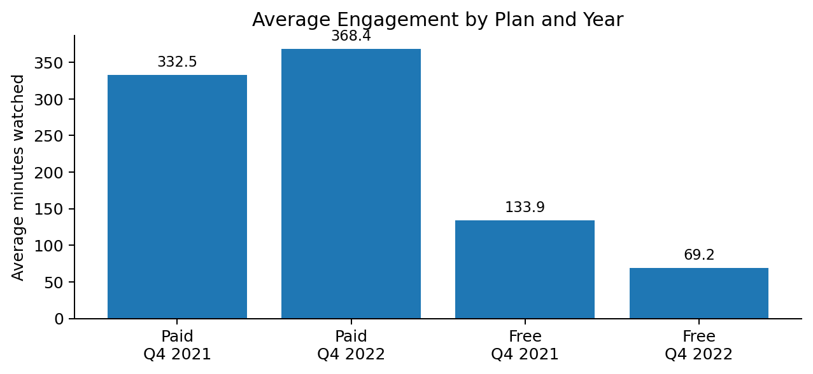
Figure 1. Average minutes watched by plan and year

2. Approach and Excel Methods
- Descriptive statistics: mean, median, standard deviation, skewness and kurtosis.
- 95% confidence intervals for mean engagement using z = 1.96.
- Two-sample F-tests to check whether variances differed between groups.
- Welch two-sample t-tests (unequal variances) for 2021 vs 2022 and US vs India comparisons.
- Business interpretation focused on whether the results justify product and engagement decisions.
Key Excel functions used: AVERAGE, MEDIAN, STDEV.S, SKEW, KURT, COUNT, SQRT, VAR.S, F.TEST and T.DIST.

3. Descriptive Statistics (Task 2)
Group | n | Mean | Median | Skewness | Kurtosis
Paid - Q4 2021 | 457 | 33.80 | 26.33 | 0.63 | -0.85
Paid - Q4 2022 | 457 | 273.02 | 40.28 | 7.07 | 58.48
Free - Q4 2021 | 2,065 | 25.39 | 14.17 | 1.17 | 0.36
Free - Q4 2022 | 2,065 | 117.64 | 11.83 | 15.06 | 315.76
Interpretation. The 2022 distributions are strongly right-skewed, especially for free-plan students. This means a relatively small number of very heavy viewers pull the mean upward. The paid-plan 2022 skewness (7.07) is lower than the free-plan 2022 skewness (15.06).

4. Confidence Intervals (Task 3)
A 95% confidence interval was calculated for the population mean using: mean ± 1.96 × (sample standard deviation / √n).
Group | n | Mean | Margin of Error | 95% CI
Paid - Q4 2021 | 3,433 | 332.50 | 16.25 | 316.25 - 348.76
Paid - Q4 2022 | 5,104 | 368.35 | 16.36 | 351.99 - 384.72
Free - Q4 2021 | 32,171 | 133.93 | 4.01 | 129.92 - 137.95
Free - Q4 2022 | 120,658 | 69.15 | 1.44 | 67.71 - 70.59
Interpretation. The free-plan 2022 interval lies entirely below the 2021 interval, indicating materially lower engagement. For paid-plan students, the 2022 interval lies above the 2021 interval, indicating higher average engagement.

5. Hypothesis Testing (Task 4)
Null hypothesis for each plan: Q4 2021 engagement is greater than or equal to Q4 2022 engagement. The alternative tests whether Q4 2022 engagement is higher. A 5% significance level was used.
Group | F-test result | t-statistic | df | Decision | Conclusion
Paid | Unequal variances (p < 0.001) | -3.05 | 8,229 | Reject H₀ | 2022 engagement is significantly higher
Free | Unequal variances (p < 0.001) | 29.78 | 40,836 | Fail to reject H₀ | No evidence of an increase; data shows a large decline
Business interpretation. The feature or platform changes are associated with improved engagement among paid students, but not among free students. The effect is therefore segment-specific rather than universal.

6. Type I and Type II Error
Error | Meaning in this study | Business impact
Type I | Conclude the new features increased engagement when they actually did not. | Potential direct cost from investing, scaling or marketing an ineffective feature.
Type II | Fail to detect a real engagement improvement. | Opportunity cost from underinvesting in a feature that actually works.
For this decision, Type I error can create the higher immediate financial risk if product development and rollout are expensive. However, the relative cost depends on the value of the opportunity that could be missed under a Type II error.

7. Geographic Comparison (Task 5)
The final test compares 2022 free-plan students in the US and India using a two-sample t-test assuming unequal variances.
Region | n | Mean | Std. Dev. | Variance
US | 6,459 | 73.07 | 308.56 | 95,208.64
India | 21,210 | 78.42 | 319.34 | 101,975.55
Test result: t = -1.21, df ≈ 11,001, one-sided p ≈ 0.113. At α = 0.05, the null hypothesis is not rejected.
Conclusion. India has a slightly higher sample average (78.42 vs 73.07 minutes), but the difference is not statistically significant. This analysis alone is not sufficient to justify different product decisions for the US and India.

8. Business Recommendations
- Investigate why paid-plan students improved while free-plan students declined.
- Measure feature adoption separately by subscription plan before attributing changes to the new features.
- Because 2022 engagement is highly skewed, include medians, percentiles and outlier analysis alongside averages.
- Segment future analysis by content type, acquisition channel, tenure and activity level to identify what drives engagement.
- Do not localize the product differently for the US and India based only on the Task 5 result; collect additional behavioral evidence first.

9. Skills Demonstrated
Excel | Statistics | Analysis | Communication | Business thinking
Functions & ToolPak | CI, F-test, Welch t-test | Segment comparison | Clear findings | Actionable recommendations

Portfolio Summary
Customer Engagement Analysis in Excel — Used descriptive statistics, confidence intervals, F-tests and Welch t-tests to compare engagement by plan, year and region. Found significant improvement for paid users, a sharp decline for free users, and no significant US–India difference in 2022 free-plan engagement.

