ECA5802 IOE and AI Driven Systems
Simulation and Comparative Performance Evaluation of Zigbee, 6LoWPAN and NB-IoT Communication Protocols for IoE Applications

Objective:
To simulate and compare the performance of Zigbee, 6LoWPAN, and NB-IoT communication protocols by analysing Bit Error Rate (BER) with respect to communication distance.

Procedure :
- Import NumPy, Matplotlib, and the erfc function from SciPy.
- Define the communication distance range from 10 m to 1000m.
- Set the transmission power, path loss, path loss exponent, and noise power for each protocol.
- Calculate path loss, received power, SNR, and BER using the given equations.
- Plot BER versus distance separately for Zigbee, 6LoWPAN, and NB-IoT.
- Compare the plots to evaluate the effect of distance on communication performance

Tabulation :
N (dBm) | Zigbee (10m) | 6LoWPAN (20m) | NB-IoT (400 m)
N = -100 | 0 | 1.29x10^-56 | 0.057
N = -95 | 7.30x10^-140 | 3.01x10^-19 | 0.188
N = -102 | 0 | 1.82x10^-88 | 0.0237

Output :
- N = -100
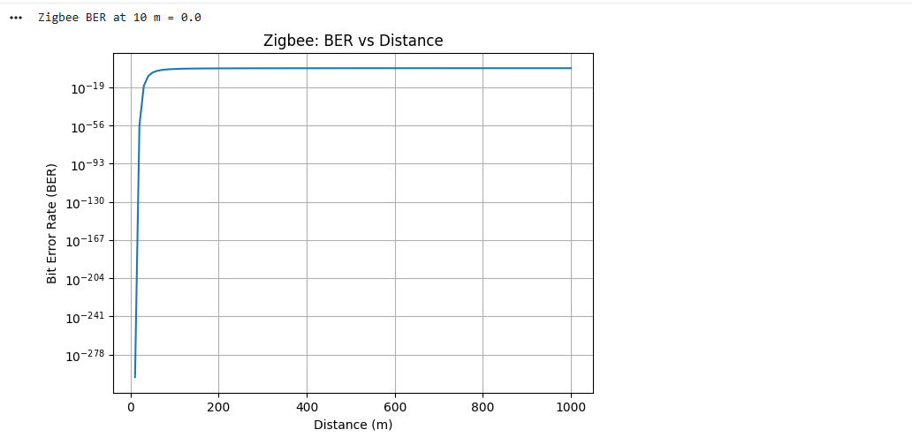

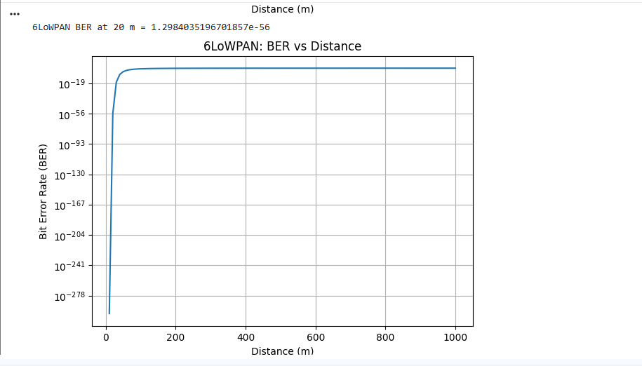

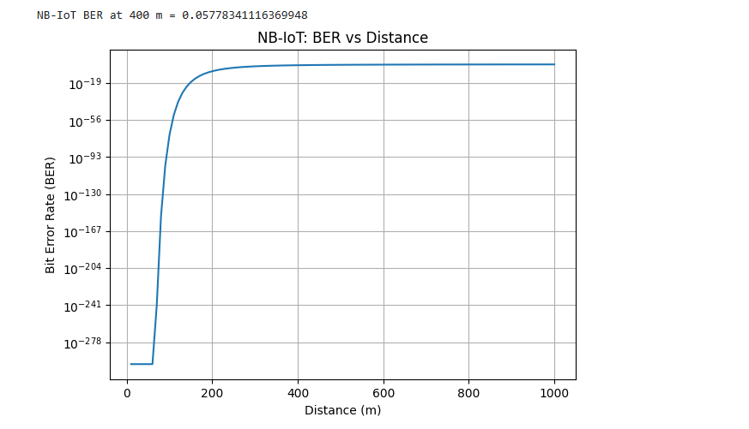

- N = -95
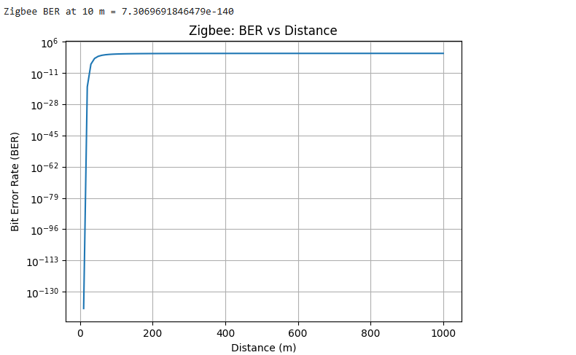
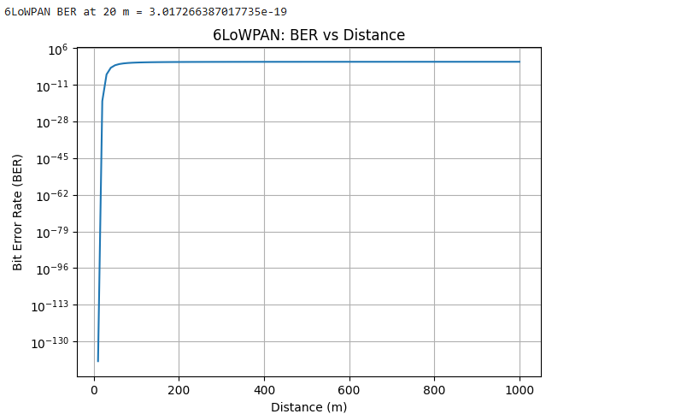

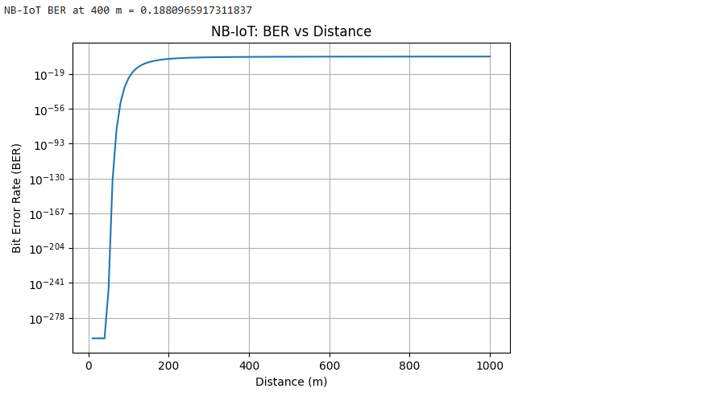

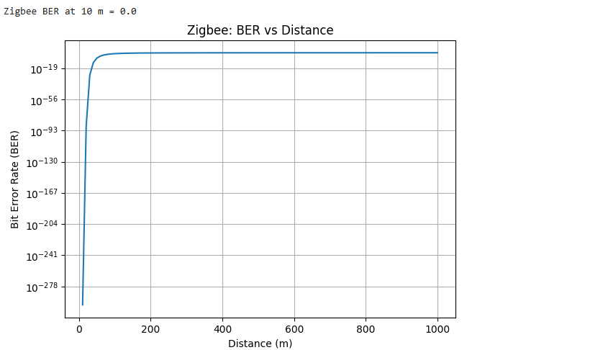
- N = - 102

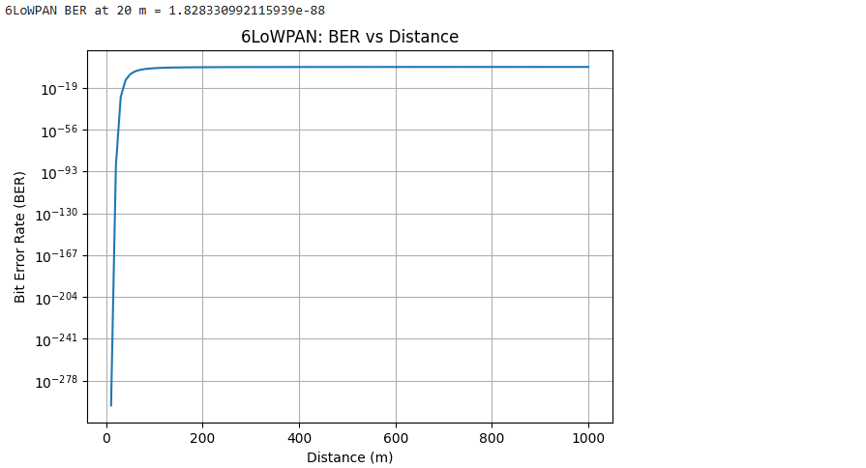

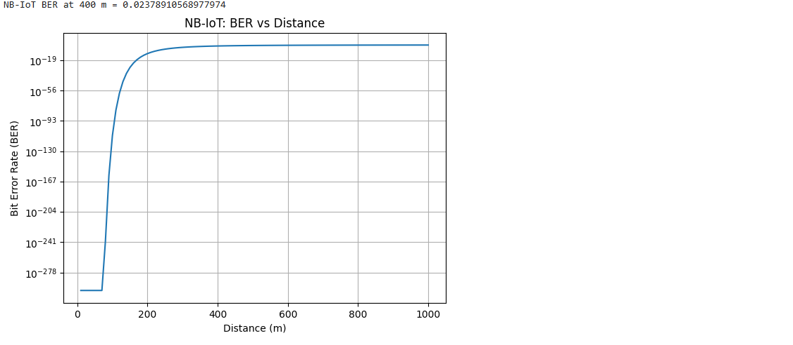
Result :
The BER-versus-distance graphs are generated for all three protocols. With increasing distance, received signal strength and SNR decrease, generally causing BER to increase. Under the given simulation parameters, NB-IoT is expected to provide better long-range communication performance than Zigbee and 6LoWPAN.

