ECA5802 IOE and AI Driven Systems
Evaluation of People–Process–Data–Things IoE Framework using Edge/Fog-to-Cloud Pipeline

Objective:
To evaluate and compare the end-to-end time delay of Edge, Fog, and Cloud computing in an IoE framework at different data rates using Python simulation.

Procedure:
- Import NumPy and Matplotlib libraries for calculations and plotting graphs.
- Define the packet size as 1500 bytes and generate data rates ranging from 0.5 Mbps to 20 Mbps.
- Calculate the transmission delay using the packet size and data rate.
- Define assumed propagation, processing, and queueing delays for Edge, Fog, and Cloud computing.
- Calculate the total end-to-end delay for each computing model.
- Plot a graph of data rate versus end-to-end time delay and compare the results.

Tabulation :

Delay Type | 1 Data Source | 10 Data Sources | 120 Data Sources | 400 Data Sources
Processing delay | 2 ms | 20 ms | 240 ms | 800 ms
Propagation delay | 1 ms | 10 ms | 120ms | 400 ms
Queing delay | 0.5 ms | 5 ms | 60ms | 200 ms
End-to-End delay | 4.65 ms | 36.15 | 421.5 | 1401.15
Processing delay | 4 ms | 40 ms | 480ms | 1600 ms
Propagation delay | 5 ms | 50 ms | 600ms | 2000 ms
Queing delay | 1.5 ms | 15 ms | 180ms | 600 ms
End-to-End delay | 11.65 ms | 101.15 | 1261.15 | 4201.15
Processing delay | 8ms | 80 ms | 960 ms | 3200 ms
Propagation delay | 20 ms | 200 ms | 2400 ms | 8000 ms
Queing delay | 3ms | 30 ms | 360 ms | 1200 ms
End-to-End delay | 32.15 ms | 311.15 | 3721.5 | 12401.15

Output :
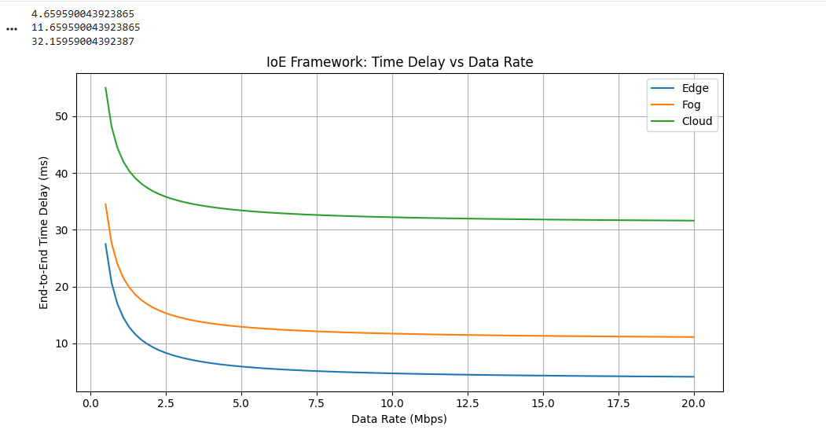
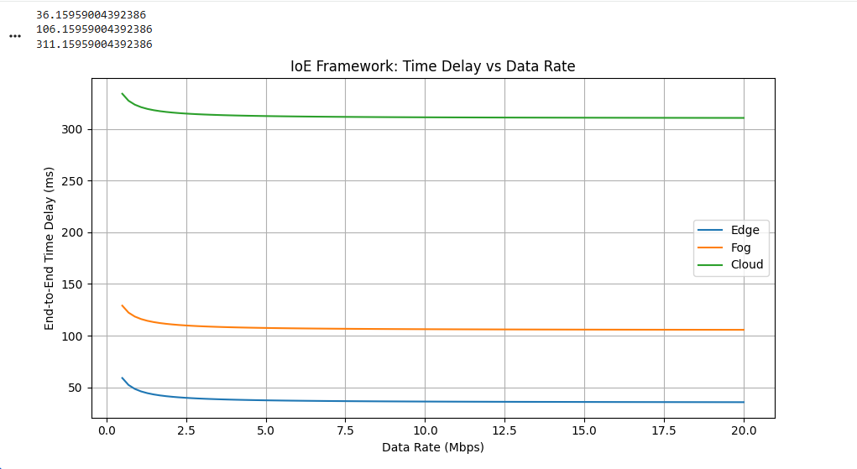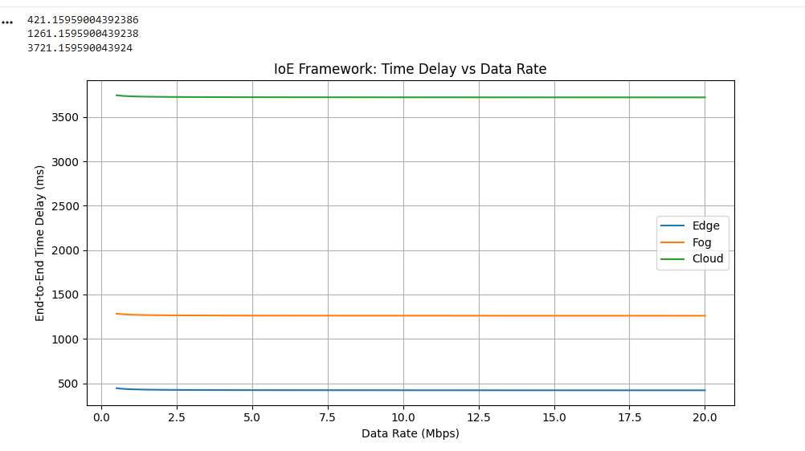
Result:
The simulation compares the end-to-end delay of Edge, Fog, and Cloud computing at different data rates. As the data rate increases, the total delay decreases. Based on the assumed parameters, Edge computing has the lowest delay, followed by Fog and Cloud computing, demonstrating the advantage of processing data closer to the source.

