ECA5802 IOE and AI Driven Systems
Modelling and simulation of a 4-Layer IoE Architecture (Perception–Network–Middleware–Application) using Node- RED, MQTT and a Cloud Dashboard

Objective
To model and simulate a four-layer IoE architecture (Perception, Network, Middleware, and Application) using Node-RED and MQTT for data collection, communication, processing, and visualization through a cloud dashboard
Procedure
- Install Node.js, Node-RED, and the Mosquitto MQTT broker.
- Configure the MQTT broker and connect the MQTT nodes in Node-RED using a common topic.
- Perception Layer: Generate simulated sensor data, such as temperature and humidity, using Inject nodes.
- Network Layer: Transmit sensor data through MQTT.
- Middleware Layer: Process the received data using Function and Switch nodes and check threshold conditions.
- Application Layer: Display the processed sensor readings and device status on a dashboard.
- Connect all four layers, deploy the flow, and verify the data transmission and dashboard output.
- Evaluate the system using communication latency, message delivery rate, and data processing results.

Output
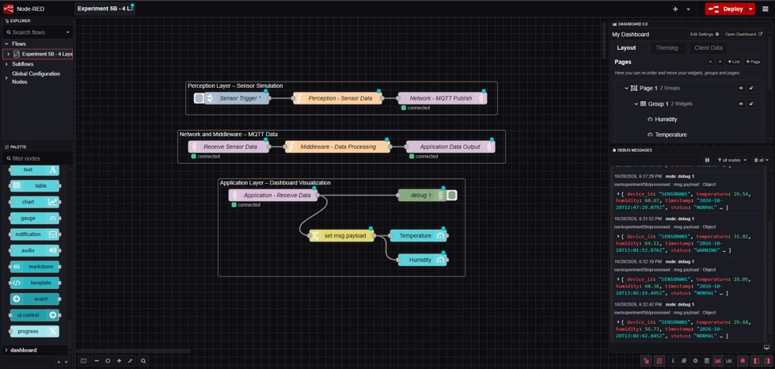
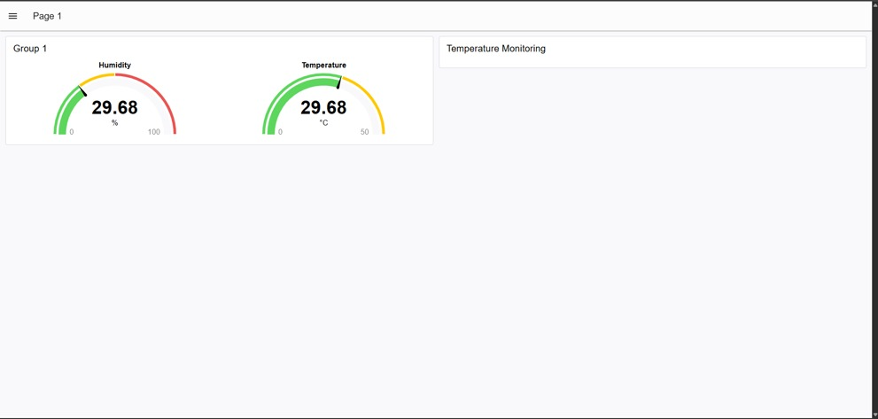

Result
The four-layer IoE architecture was successfully simulated using Node-RED and MQTT. Sensor data was transmitted, processed, and displayed on a dashboard, demonstrating communication between all four layers and enabling real-time monitoring.

