ECA5802 IOE and AI Driven Systems
Simulation and Performance Evaluation of RFID/NFC-Based Device Identification and loE Data Integration using Node-RED, MQTT

Objective
To simulate RFID/NFC-based device identification using Node-RED and MQTT, and evaluate system performance based on identification accuracy, message delivery, and communication latency

Procedure
- Create the flow: Open Node-RED and create separate publisher and receiver flows.
- Simulate RFID/NFC data: Use an Inject node to generate device ID, tag ID, temperature, and other sample data.
- Process the data: Use Function nodes to format the device information into a JavaScript object or JSON message.
- Publish using MQTT: Configure an MQTT Out node to publish the data to the topic ioe/device/scan.
- Receive the data: Configure an MQTT In node with the same topic to receive the published messages.
- Process and display: Use a Function node to process the received data and a Debug node to display the results.
- Evaluate performance: Record the transmitted and received messages, identification status, and message latency for multiple test cases.

Tabulation :

Node-RED MQTT Debug Results
S. No. | RFID/NFC Tag ID | Device ID | Identification Status | Temperature (°C) | Latency (ms)
1 | RFID0004 | DEV-RFID004 | True | 29.22 | 4
2 | RFID0002 | DEV-RFID002 | True | 31.8 | 2

Output :

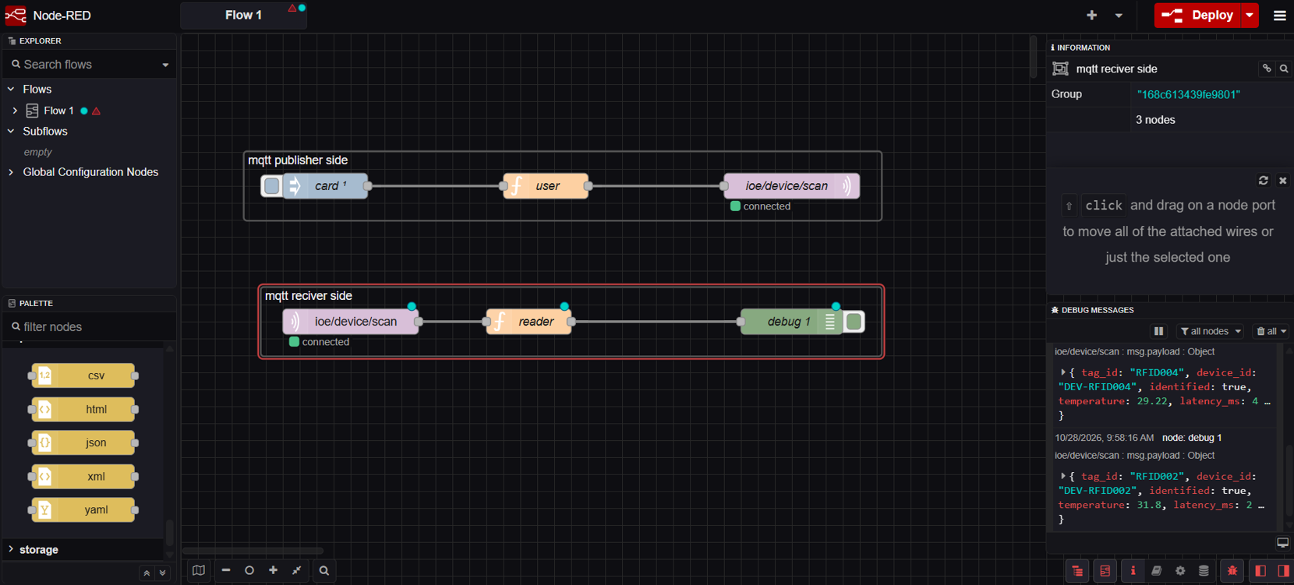

Result :
The RFID/NFC-based device identification system was successfully simulated using Node-RED and MQTT. Two devices were identified successfully, and their temperature data was received with communication latencies of 2 ms and 4 ms, demonstrating effective device identification and IoE data transmission

