ECA5802 IOE and AI Driven Systems
Simulation and Performance Evaluation of Cross-Platform Edge AI Model Deployment using ONNX and PyTorch Mobile

Objective
To simulate and evaluate the performance of Edge AI model deployment using PyTorch, ONNX Runtime and PyTorch Mobile. The performance is compared based on inference latency, throughput, speedup, model size, memory usage and accuracy to identify the most efficient framework for edge devices.

Program Code :

import numpy as np
import pandas as pd
import matplotlib.pyplot as plt

# 1. Simulation Parameters
N = 10000
A_fp32 = 96.0
M_fp32 = 12.0
RAM_fp32 = 24.0

# 2. Deployment Frameworks
models = [
"PyTorch CPU",
"ONNX Runtime CPU",
"PyTorch Mobile INT8"
]

compute_factor = np.array([1.0, 0.75, 0.55])
storage_factor = np.array([1.0, 0.90, 0.35])
accuracy_factor = np.array([1.0, 0.998, 0.990])
memory_factor = np.array([1.0, 0.85, 0.40])

# 3. Performance Calculations
T_pre = 0.3
T_post = 0.2
T_infer = 2.5 * compute_factor

latency = T_pre + T_infer + T_post
total_time = latency * N / 1000

throughput = N / total_time
speedup = latency[0] / latency

model_size = M_fp32 * storage_factor
memory = RAM_fp32 * memory_factor
accuracy = A_fp32 * accuracy_factor

storage_reduction = (
(M_fp32 - model_size) / M_fp32 * 100
)

memory_reduction = (
(RAM_fp32 - memory) / RAM_fp32 * 100
)

accuracy_retention = accuracy / A_fp32 * 100

# 4. Display Results
results = pd.DataFrame({
"Framework": models,
"Latency (ms)": latency,
"Throughput": throughput,
"Speedup": speedup,
"Model Size (MB)": model_size,
"Storage Reduction (%)": storage_reduction,
"Memory (MB)": memory,
"Memory Reduction (%)": memory_reduction,
"Accuracy (%)": accuracy,
"Accuracy Retention (%)": accuracy_retention
})

print("CROSS-PLATFORM EDGE AI PERFORMANCE")
print("-" * 90)
print(results.round(2).to_string(index=False))

# 5. Plot Performance Graphs
metrics = [
("Latency (ms)", "Inference Latency"),
("Throughput", "Throughput"),
("Speedup", "Speedup"),
("Model Size (MB)", "Model Size"),
("Memory (MB)", "Memory Usage"),
("Accuracy (%)", "Accuracy")
]

for col, title in metrics:
plt.figure(figsize=(7, 4))
plt.bar(models, results[col])
plt.title(title + " Comparison")
plt.ylabel(col)
plt.xticks(rotation=10)
plt.grid(axis="y", alpha=0.3)
plt.tight_layout()
plt.show()

# 6. Display Performance Improvements
print("\nIMPROVEMENT OVER PYTORCH CPU")

for i in range(1, len(models)):
print("\n", models[i])

print(
"Latency Improvement:",
round((latency[0] - latency[i]) /
latency[0] * 100, 2), "%"
)

print(
"Storage Reduction:",
round(storage_reduction[i], 2), "%"
)

print(
"Memory Reduction:",
round(memory_reduction[i], 2), "%"
)

print(
"Accuracy Retention:",
round(accuracy_retention[i], 2), "%"
)

Procedure
- Import the required Python libraries: NumPy, Pandas and Matplotlib.
- Initialize the simulation parameters and deployment frameworks.
- Assign computational, storage, memory and accuracy factors.
- Calculate latency, throughput and speedup.
- Calculate model size, memory usage and accuracy retention.
- Display the performance results in tabular form.
- Plot graphs to compare the performance of different frameworks.
- Analyze the results and identify the most efficient framework.

Tabulation

Performance Evaluation of Cross-Platform Edge AI Model Deployment
S.No | Performance Metrics | PyTorch CPU | ONNX Runtime CPU | PyTorch Mobile INT8
1 | Latency (ms) | 3.00 | 2.38 | 1.88
2 | Throughput (samples/sec) | 333.33 | 421.05 | 533.33
3 | Speedup (x) | 1.00 | 1.26 | 1.60
4 | Model Size (MB) | 12.00 | 10.80 | 4.20
5 | Storage Reduction (%) | 0.00 | 10.00 | 65.00
6 | Memory Usage (MB) | 24.00 | 20.40 | 9.60
7 | Memory Reduction (%) | 0.00 | 15.00 | 60.00
8 | Accuracy (%) | 96.00 | 95.81 | 95.04
9 | Accuracy Retention (%) | 100.00 | 99.80 | 99.00

Output :

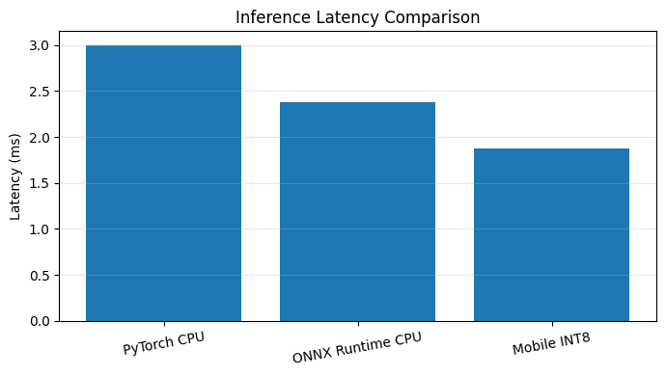

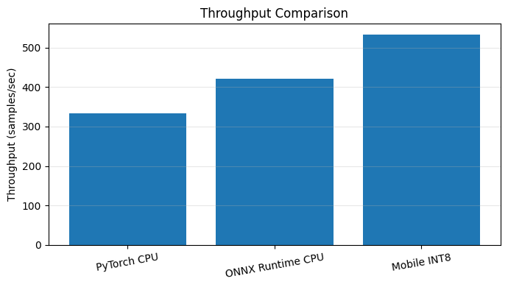

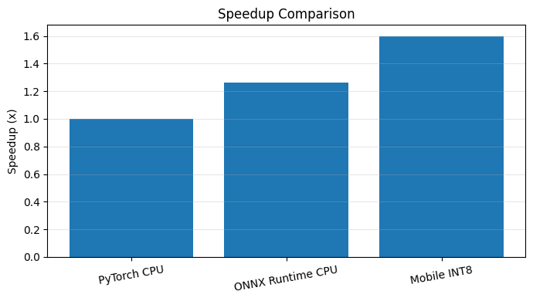

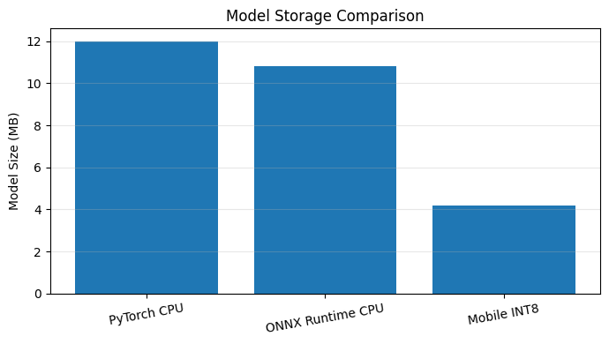

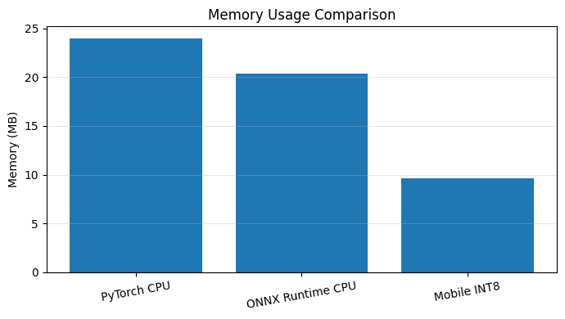

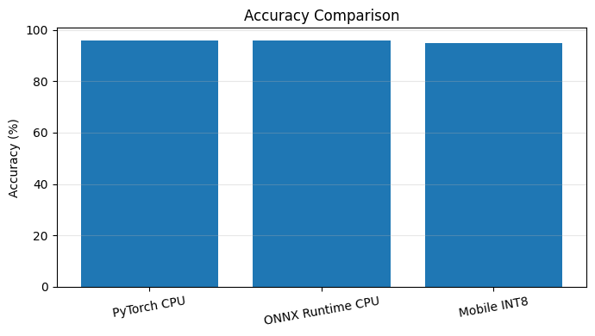

Result :
The simulation and performance evaluation of Edge AI model deployment using PyTorch, ONNX Runtime and PyTorch Mobile were successfully completed. PyTorch Mobile INT8 achieved lower latency, higher throughput and reduced memory usage compared to the other frameworks

