ECA5802 IOE and AI Driven Systems
Simulation and Performance Analysis of Big Data Processing for IoE Sensor Data using
Hadoop and Apache Spark

Objective
To compare the performance of Hadoop MapReduce and Apache Spark based on execution time, throughput, speedup and performance improvement for different IoE sensor data sizes

Procedure
- Import the required Python libraries.
- Initialize the IoE sensor record values and execution times for Hadoop and Apache Spark.
- Calculate the throughput, speedup and performance improvement.
- Display the calculated results in tabular form.
- Plot the execution time and throughput comparison graphs.
- Compare the performance of Hadoop MapReduce and Apache Spark.

Tabulation: Hadoop MapReduce vs Apache Spark
S.No | Number of IoE Sensor Records | Hadoop Execution Time (s) | Spark Execution Time (s) | Hadoop Throughput (Records/s) | Spark Throughput (Records/s)
1 | 1,00,000 | 8 | 5 | 12,500.00 | 20,000.00
2 | 5,00,000 | 25 | 14 | 20,000.00 | 35,714.29
3 | 10,00,000 | 45 | 25 | 22,222.22 | 40,000.00
4 | 50,00,000 | 180 | 90 | 27,777.78 | 55,555.56
5 | 1,00,00,000 | 350 | 170 | 28,571.43 | 58,823.53

Performance Analysis Table
S.No | Number of Records | Speedup | Improvement (%)
1 | 1,00,000 | 1.60 | 37.50
2 | 5,00,000 | 1.79 | 44.00
3 | 10,00,000 | 1.80 | 44.44
4 | 50,00,000 | 2.00 | 50.00
5 | 1,00,00,000 | 2.06 | 51.43

Output :

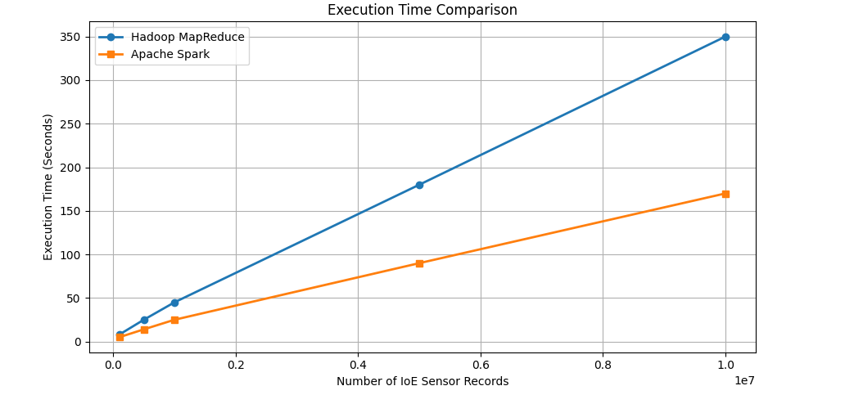

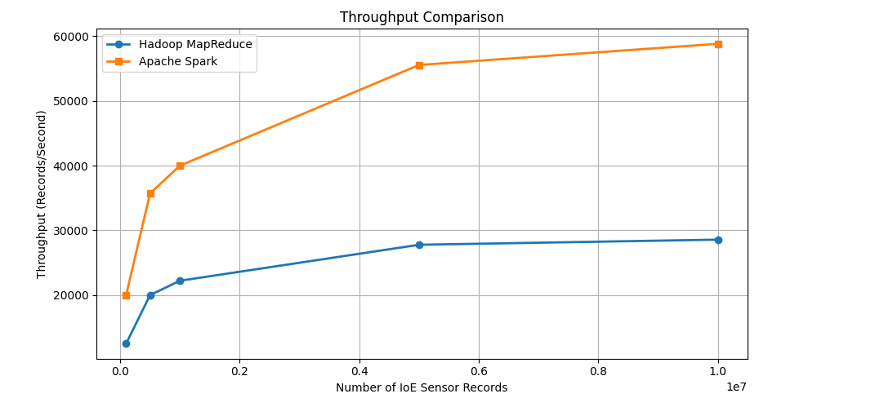

Result

The simulation and performance analysis of IoE sensor data using Hadoop MapReduce and Apache Spark were successfully performed. The results show that Apache Spark provides lower execution time and higher throughput than Hadoop MapReduce, making it more efficient for processing large-scale IoE sensor data.

