**COM162 Database Systems**

**Team Assignment**

**Team Member Details**

|  |  |
| --- | --- |
| **Team Member Name** | **Student Number** |
| Jay Steele | B00836003 |
| Justin Simpson | B00841817 |
| Matthew O’Hare | B00837153 |
| Sean Theseira | B00858013 |
| Conall Northrop | B00849276 |

Contents

Task 1. Entity-Relationship Modelling 3

Task 2. Database Schema Design 4

Task 3. Database Schema Implementation 5

Task 4. Populating the Database 9

Task 5. Querying the Database 14

Task 6. Peer Review of Team Collaboration 16

**Identifying entities, attributes and relationships:**

*Entities & Attributes:*

* **Student** (Student_ID{PK}, CourseNo{FK}, ComputerNetwork_ID {AK}, FName, SName, Address - Street, City, Postcode, DOB, Sex)

* **Module** (CourseNo {FK}, ModuleNo {PK}, moduleTitle {AK}, startDate, endDate, assessmentScheme, textbooks)

* **Course** (CourseNo {PK},  courseName {AK}, courseDuration, Department_Name{FK}, Staff_ID {FK})

* **Staff** (StaffID {PK}, AcademicStaff_ID {FK}, ComputerNetwork_ID {AK}, FName, SName, Address, NI_number {AK}, OfficeNo, Sex, Salary, Post, Email, Qualifications, Department_Name {FK}, Phone_Number, Fax_number, location, role)

* **Department** (DName {PK}, Phone_number, Fax_number, Location {AK})

*Relationships:*

Department *runs* Course

1..1                  1..*

Course *has* Module

1..1                  1..*

Module *studied by* Student **---** StudentPerformanceMark

1..*                      0..*

Course *coordinated by* Staff

1..1                        1..1

Student *enrols in* Course

0..*                      1..1

Department *employs* Staff

1..1                      1..*

[Two arrows between Staff and Department]

Staff *work for* Department

1..1                       1..1

[Unary for Staff] Academic Staff *mentor* New Staff

       0..1         0..*

Staff *teaches* Module **---** StaffTeachingHours

1..*        0..*

# Task 1. Entity-Relationship Modelling

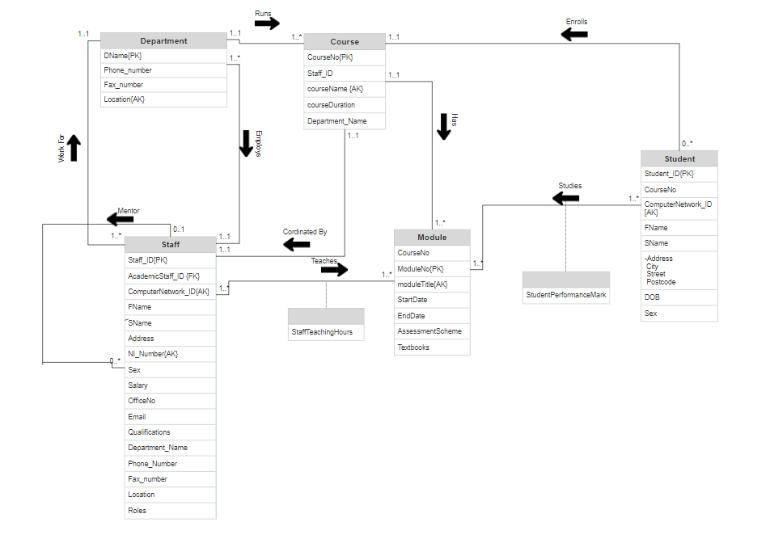

# Task 2. Database Schema Design

**Student**(Student_ID, CourseNo, ComputerNetwork_ID, FName, SName, Street, City, Postcode, DOB, Sex)

**PRIMARY KEY** Student_ID

**FOREIGN KEY** CourseNo **REFERENCES** Course (CourseNo)

**ALTERNATE KEY** ComputerNetwork_ID

**Department** (DName, Phone_number, Fax_number, location)

**PRIMARY KEY** DName

**ALTERNATE KEY** location, Phone_number, fax_number

**Staff** (Staff_ID, AcademicStaff_ID , ComputerNetwork_ID, FName, SName, Address, NI_number, OfficeNo, Sex, Salary, Post, Email, Qualifications, Department_Name, Phone_Number, Fax_Number, location, role)

**PRIMARY KEY** Staff_ID

**ALTERNATE KEY** ComputerNetwork_ID, NI_Number, Department_Name

**FOREGIN KEY** AcademicStaff_ID **REFERENCES** Staff (AcademicStaff_ID)

**FOREIGN KEY** Department_Name **REFERENCES** Department (DName)

**StaffModule** (Staff_ID, ModuleNo, StaffTeachingHours)

**PRIMARY KEY** Staff_ID, ModuleNo

**FOREIGN KEY** Staff_ID **REFERENCES** Staff (Staff_ID)

**FOREIGN KEY** ModuleNo **REFERENCES** Module (ModuleNo)

**Module** (ModuleNo, CourseNo, moduleTitle, startDate, endDate, textbook)

**PRIMARY KEY** ModuleNo

**ALTERNATE KEY** moduleTitle

**FOREIGN KEY** CourseNo **REFERENCES** Course (CourseNo)

**StudentModule** (Student_ID, ModuleNo, studentPerformanceMark)

**PRIMARY KEY** Student_ID, ModuleNo

**FOREIGN KEY** Student_ID **REFERENCES** Student (Student_ID)

**FOREIGN KEY** ModuleNo **REFERENCES** Module (ModuleNo)

**Course** (CourseNo, Staff_ID, CourseName, CourseDuration, Department_Name)

**PRIMARY KEY** CourseNo

**ALTERNATE KEY** CourseName

**FOREIGN KEY** Staff_ID **REFERENCE** Staff (Staff_ID)

**FOREIGN KEY** Department_Name **REFERENCES** Department (DName)

# Task 3. Database Schema Implementation

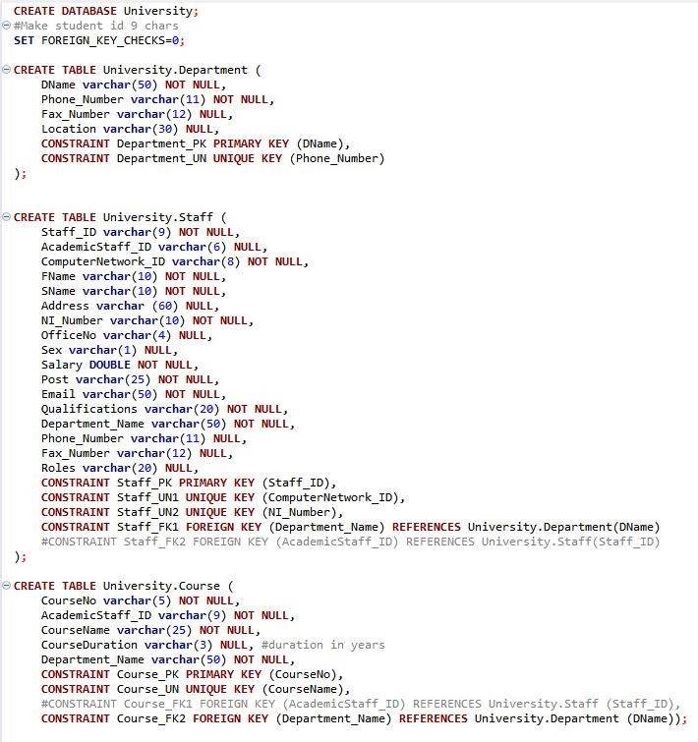

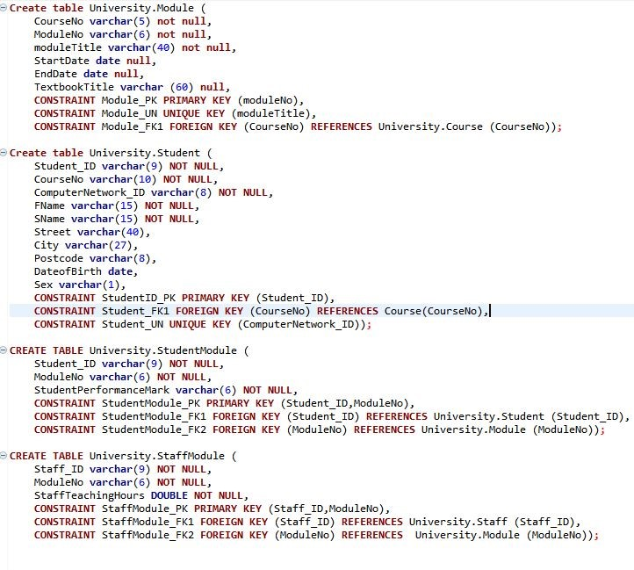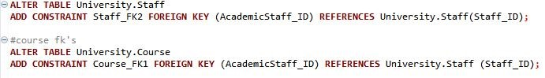

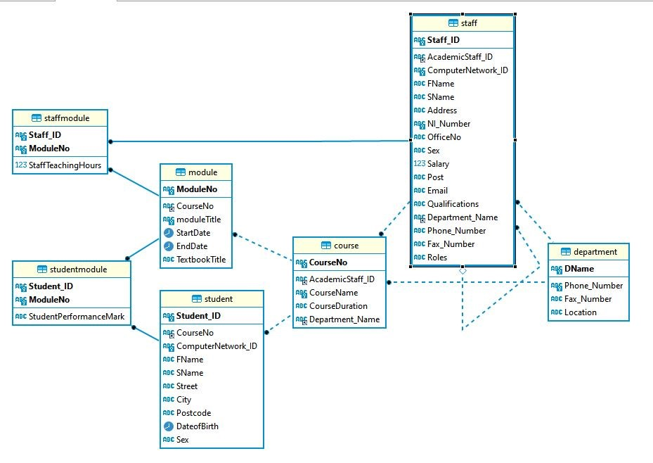

# Task 4. Populating the Database

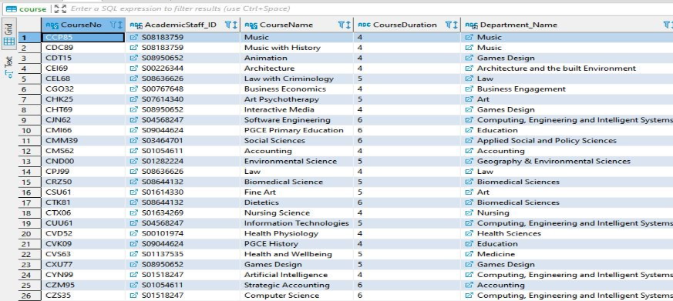***Course:***

***Department:***

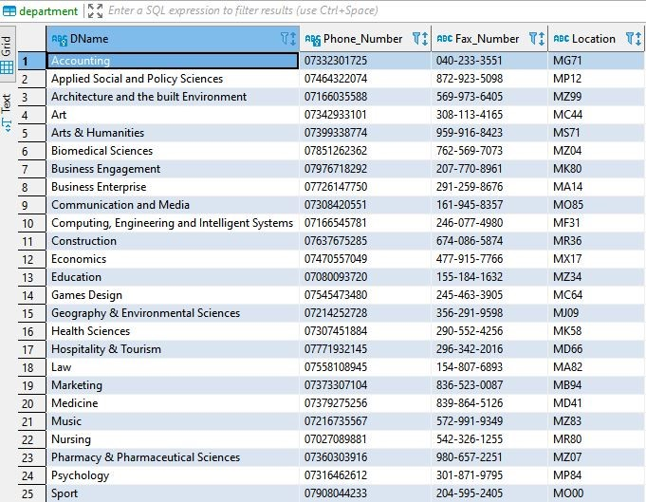

***Module:***

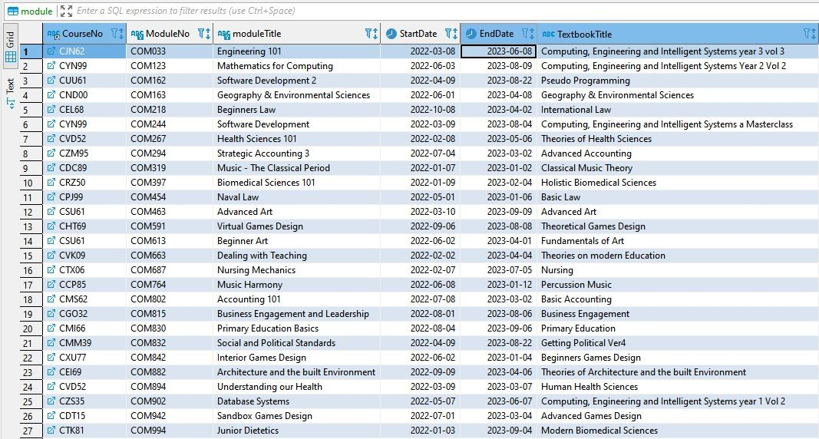

***Staff:***

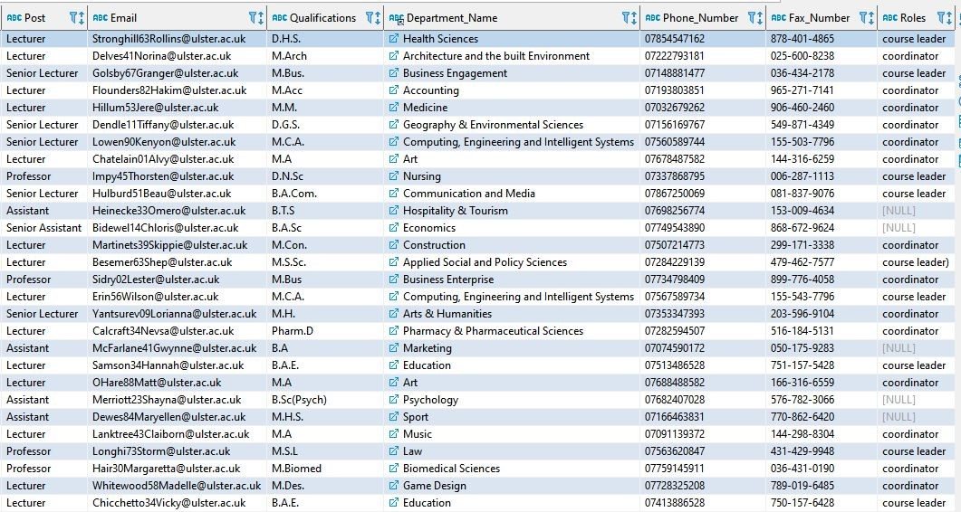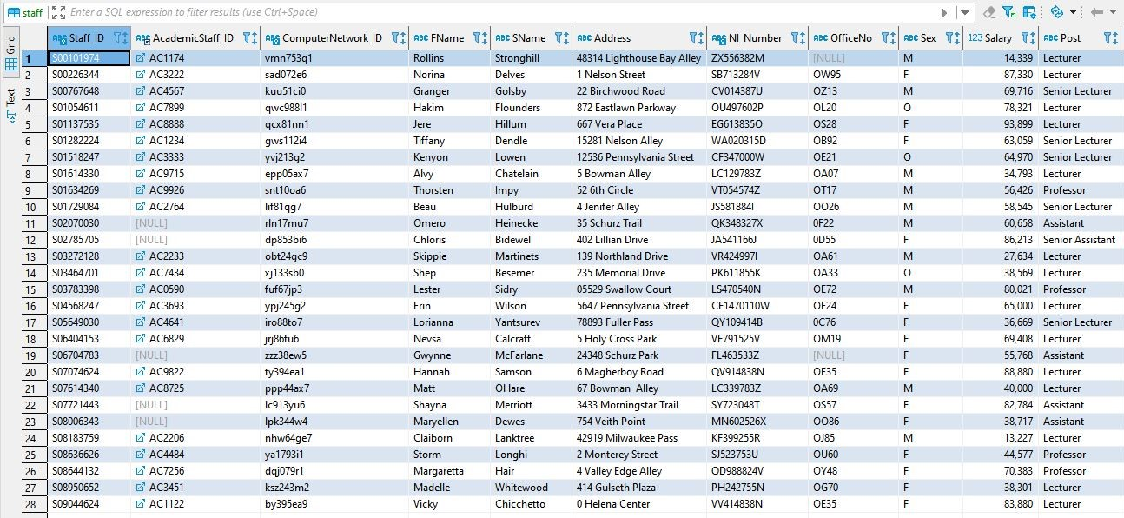

***StaffModule:***

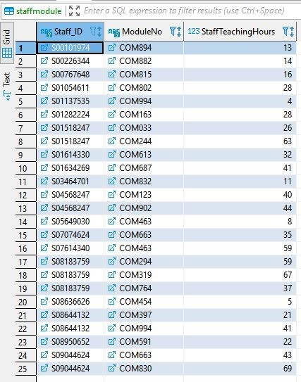

***Student:***

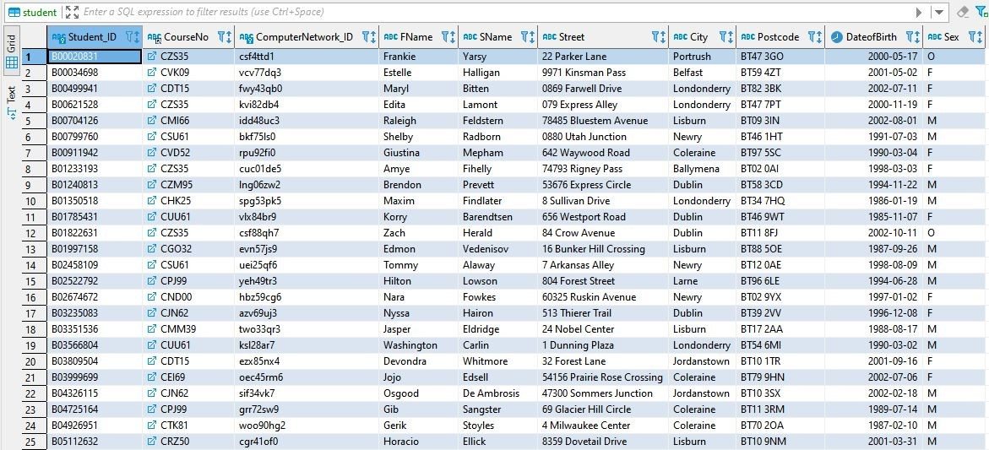

***StudentModule:***

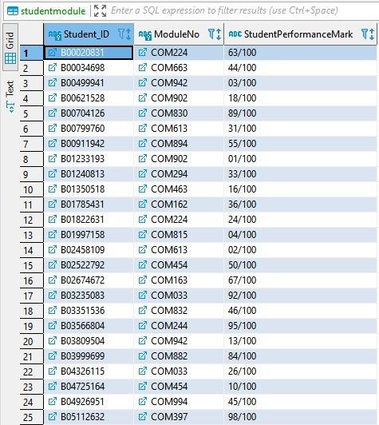

# Task 5. Querying the Database

|  |  |  |
| --- | --- | --- |
| *Query* | *SQL DML* | *Screenshot* |
| *a* | **SELECT** moduleTitle, StartDate, EndDate  **FROM** University.Module  **WHERE** Module.CourseNo = "CUU61"; | C:\Users\csf21stj\AppData\Local\Microsoft\Windows\INetCache\Content.MSO\28E36D1D.tmp |
| *b* | **SELECT** SName, Post, Qualifications  **FROM** University.Staff  **WHERE** Staff.Department_Name = 'Computing, Engineering and Intelligent Systems'  **AND** Staff.Roles **is** **not** **null**; |  |
| *c* | **SELECT** Student.Student_ID, SName, Sex  **FROM** University.Student, University.StudentModule  **WHERE** StudentModule.ModuleNo = "COM902" **AND** StudentModule.Student_ID = Student.Student_ID  **ORDER** **BY** SName **DESC**; |  |
| *d* | **SELECT** Staff_ID, SName, Sex, Post  **FROM** University.Staff  **WHERE** Salary = (**SELECT** **MAX**(Salary) **FROM** University.Staff); |  |
| *e* | **SELECT** Staff_ID, SName, Sex, Post, Salary  **FROM** University.Staff  **WHERE** Salary < (**SELECT** **MAX**(Salary) **FROM** University.Staff)  **GROUP** **BY** Salary  **ORDER** **BY** Salary **desc** **limit** 0,1; |  |
| *f* | **select** Staff_ID, SName, Sex, Post  **from** University.Staff  **where** salary >  (**SELECT** **AVG**(Salary) **from** University.Staff) **and** Staff.Roles **is** **not** **null**; |  |
| *g* | **SELECT** Course.CourseName,**count** (Student.Student_ID) **as** StudentCount  **FROM** University.Student  **inner** **join** University.Course **on** Student.CourseNo = Course.CourseNo  **group** **by** Student.CourseNo  **having** **count**(Student_ID) >= 6; |  |
| *h* | **select**  **count**(**case** **when** Sex = "F" **then** 1 **end**) **as** female_staff,  **count**(**case** **when** Sex = "M" **then** 1 **end**) **as** male_staff,  **count**(**case** **when** Sex = "O" **then** 1 **end**) **as** other_staff,  **count**(*) **as** total_staff  **from** University.Staff  **where** Staff.Department_Name = 'Computing, Engineering and Intelligent Systems'; |  |
| *i* | ​**Select** SName, moduleTitle, StaffTeachingHours  **From** University.StaffModule  **inner** **join** University.Staff **on** StaffModule.Staff_ID = Staff.Staff_ID  **inner** **join** University.Module **on** StaffModule.ModuleNo = Module.ModuleNo  **Where** StaffTeachingHours > 6; |  |
| *j* | **UPDATE** University.Staff  **SET** Salary = Salary * 1.025  **WHERE** Department_Name = 'Biomedical Sciences' **and** Staff.Roles **is** **not** **null**; |  |

# Task 6. Peer Review of Team Collaboration

**Please complete this section:**

**We as a team confirm that we have shared our Slack workspace with the lecturer via the following email account:** [**d.rankin1@ulster.ac.uk**](mailto:d.rankin1@ulster.ac.uk)**. Please tick the following checkbox to confirm this task is complete:**

**Please also ensure each individual has completed the WebPA peer assessment.**