LAB EXERCISE 11 AND 12

JAYSURYA BHUYAN
24BCE1864

STEPS:

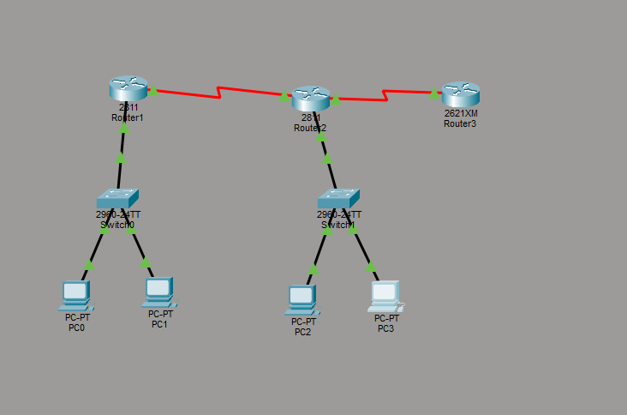

Create this network topology, connect the cables as shown in the image, connect router 1,2 and 3 with serial dce cables

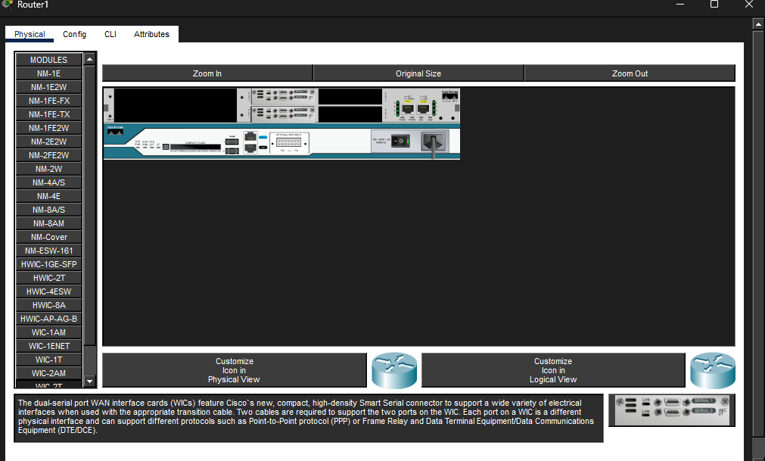

Serial ports should we installed in all routers as shown above
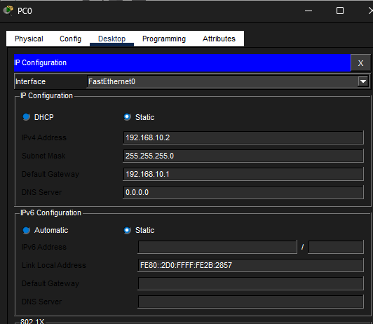

Now configure ip addresses and gateway for every PC node

In router 1:

enable
conf t

int fa0/0
ip address 192.168.10.1 255.255.255.0
no shutdown

int s0/1/0
ip address 10.1.1.1 255.255.255.252
clock rate 64000
no shutdown

Router 2:
enable
conf t

int fa0/0
ip address 192.168.20.1 255.255.255.0
no shutdown

int s0/0/0
ip address 10.1.1.2 255.255.255.252
no shutdown

int s0/1/1
ip address 10.2.2.1 255.255.255.252
clock rate 64000
no shutdown

Router 3:

enable
conf t

int fa0/0
ip address 192.168.20.1 255.255.255.0
no shutdown

int s0/0/0
ip address 10.1.1.2 255.255.255.252
no shutdown

int s0/1/1
ip address 10.2.2.1 255.255.255.252
clock rate 64000
no shutdown

OSPF CONFIGURATION

R1:

router ospf 1
network 192.168.10.0 0.0.0.255 area 0
network 10.1.1.0 0.0.0.3 area 0

R2:

router ospf 1
network 192.168.20.0 0.0.0.255 area 1
network 10.1.1.0 0.0.0.3 area 0
network 10.2.2.0 0.0.0.3 area 1

R3:

router ospf 1
network 10.2.2.0 0.0.0.3 area 1

After this, run these commands on all routers:
show ip interface brief
show ip ospf neighbor
show ip route

Router 1:

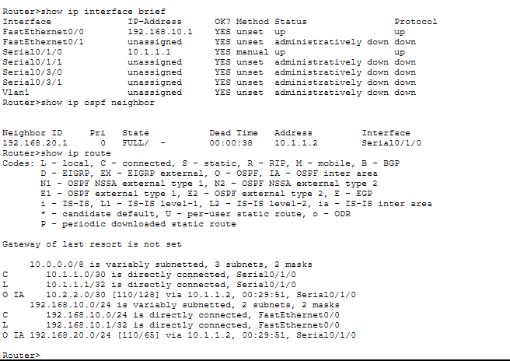

Router 2:
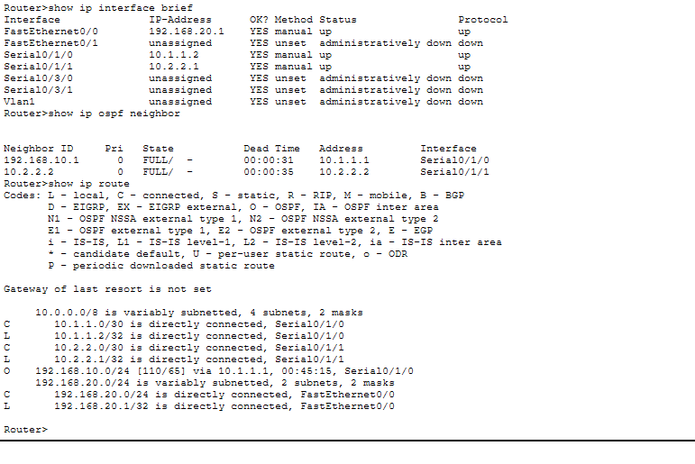

Router 3:

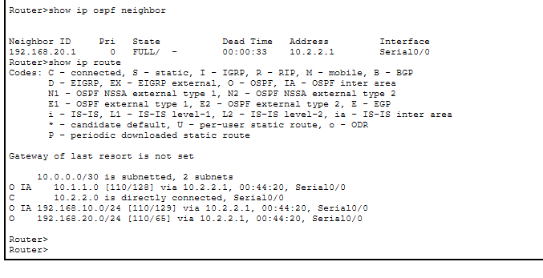

TESTING

Run this command on PC0 to test routing from PC2

ping 192.168.20.2

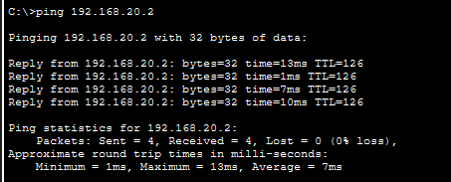

Testing PC0 from all routers and swtiches

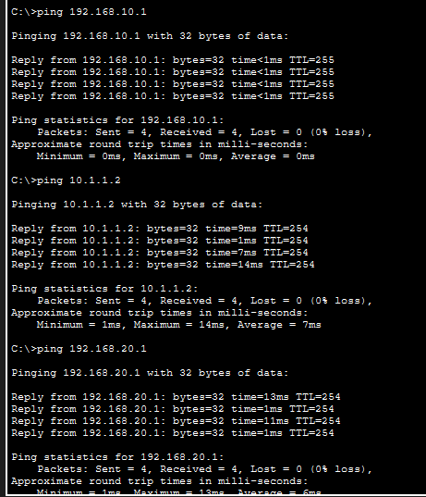

IP Routes of every Router:

With use of show ip route command
Router 1:
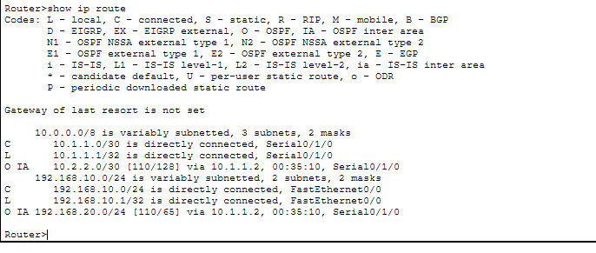
Router 2:

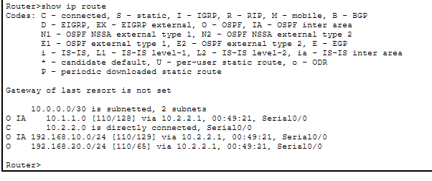
Router 3:

