ASSIGNMENT-2
JAYSURYA BHUYAN (24BCE1864)

GITHUB REPOSITORY LINK: https://github.com/jaysurya7/Computer-Networks-Hybrid-Topology
Question 1 (a)
Display the created topology

clc;clear;close;
scf(0);clf();
n = 25;
x = [ 7.00 6.12 4.00 1.88 1.00 1.88 4.00 6.12 7.50 9.00 8.56 7.50 6.44 6.00 6.44 7.50 8.56 1.00 2.29 3.57 4.86 6.14 7.43 8.71 10.00 ];
y = [ 6.00 8.12 9.00 8.12 6.00 3.88 3.00 3.88 4.50 4.50 5.56 6.00 5.56 4.50 3.44 3.00 3.44 1.00 1.00 1.00 1.00 1.00 1.00 1.00 1.00 ];
edges = [ ...
1 2; 2 3; 3 4; 4 5; 5 6; 6 7; 7 8; 8 1;
9 10; 9 11; 9 12; 9 13; 9 14; 9 15; 9 16; 9 17;
18 19; 19 20; 20 21; 21 22; 22 23; 23 24; 24 25;
4 9; 8 18; 17 22];
for i = 1:size(edges, 1)
plot([x(edges(i,1)) x(edges(i,2))], ...
[y(edges(i,1)) y(edges(i,2))], 'k-', 'LineWidth', 2);end
plot(x, y, 'ro', 'MarkerSize', 8, 'MarkerFaceColor', 'r');
for i = 1:n
xstring(x(i)+0.1, y(i)+0.1, string(i), fontsize=12);end
xtitle("Hybrid Network Topology (Ring + Star + Bus)", fontsize=16);xgrid(1);
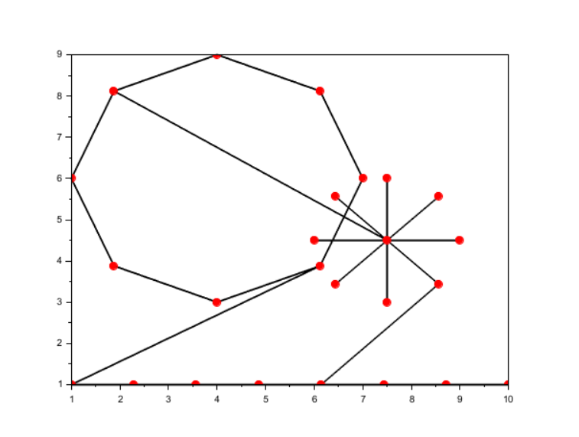

Question 1(b)
Display Nodes and Edges numbered in the graph

clc;clear;close;
scf(0);clf();
n = 25;
x = [7.00 6.12 4.00 1.88 1.00 1.88 4.00 6.12 7.50 9.00 8.56 7.50 6.44 6.00 6.44 7.50 8.56 1.00 2.29 3.57 4.86 6.14 7.43 8.71 10.00];y = [6.00 8.12 9.00 8.12 6.00 3.88 3.00 3.88 4.50 4.50 5.56 6.00 5.56 4.50 3.44 3.00 3.44 1.00 1.00 1.00 1.00 1.00 1.00 1.00 1.00];
edges = [
1 2; 2 3; 3 4; 4 5; 5 6; 6 7; 7 8; 8 1;
9 10; 9 11; 9 12; 9 13; 9 14; 9 15; 9 16; 9 17;
18 19; 19 20; 20 21; 21 22; 22 23; 23 24; 24 25;
4 9; 8 18; 17 22];
// draw edgesfor i = 1:size(edges, 1)
plot([x(edges(i,1)) x(edges(i,2))], ...
[y(edges(i,1)) y(edges(i,2))], "k-");end
plot(x, y, "ro");
for i = 1:n
xstring(x(i)+0.1, y(i)+0.1, string(i));end
for i = 1:size(edges, 1)
mid_x = (x(edges(i,1)) + x(edges(i,2)))/2;
mid_y = (y(edges(i,1)) + y(edges(i,2)))/2;
xstring(mid_x+0.05, mid_y+0.05, string(i));end
xtitle("Hybrid Network Topology (Ring + Star + Bus)");xgrid(1);

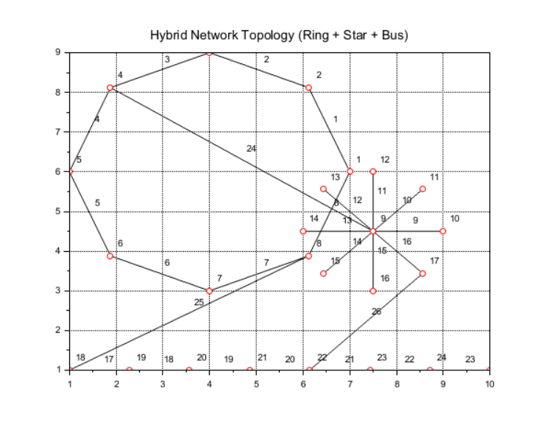

Question 1(c)

Colour the nodes and edges

clc;clear;close;
scf(0);clf();
n = 25;
x = [7.00 6.12 4.00 1.88 1.00 1.88 4.00 6.12 7.50 9.00 8.56 7.50 6.44 6.00 6.44 7.50 8.56 1.00 2.29 3.57 4.86 6.14 7.43 8.71 10.00];y = [6.00 8.12 9.00 8.12 6.00 3.88 3.00 3.88 4.50 4.50 5.56 6.00 5.56 4.50 3.44 3.00 3.44 1.00 1.00 1.00 1.00 1.00 1.00 1.00 1.00];
edges = [
1 2; 2 3; 3 4; 4 5; 5 6; 6 7; 7 8; 8 1;
9 10; 9 11; 9 12; 9 13; 9 14; 9 15; 9 16; 9 17;
18 19; 19 20; 20 21; 21 22; 22 23; 23 24; 24 25;
4 9; 8 18; 17 22];
ringColor = 1; starColor = 2;busColor = 3;hybColor = 4; nodeColor = 5;
for i = 1:8
plot([x(edges(i,1)) x(edges(i,2))], ...
[y(edges(i,1)) y(edges(i,2))], "LineColor", ringColor);end
for i = 9:16
plot([x(edges(i,1)) x(edges(i,2))], ...
[y(edges(i,1)) y(edges(i,2))], "LineColor", starColor);end
for i = 17:23
plot([x(edges(i,1)) x(edges(i,2))], ...
[y(edges(i,1)) y(edges(i,2))], "LineColor", busColor);end
for i = 24:26
plot([x(edges(i,1)) x(edges(i,2))], ...
[y(edges(i,1)) y(edges(i,2))], "LineColor", hybColor);end
plot(x, y, "o", "MarkerSize", 8, ...
"MarkerFaceColor", nodeColor, "MarkerEdgeColor", nodeColor);
xtitle("Hybrid Network Topology (Ring + Star + Bus)");xgrid(1);

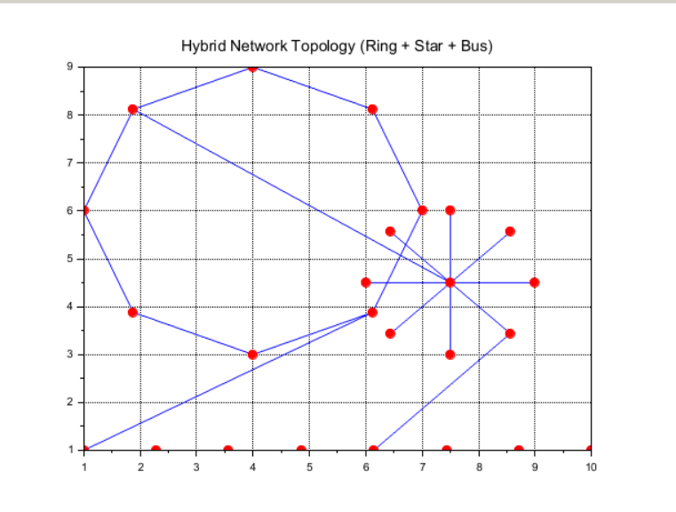

Question 1(d):
Print the number of edges every node has along with the node with
maximum edges.

Code:
clc;clear;close;
scf(0);clf();
n = 25;
x = [7.00 6.12 4.00 1.88 1.00 1.88 4.00 6.12 7.50 9.00 8.56 7.50 6.44 6.00 6.44 7.50 8.56 1.00 2.29 3.57 4.86 6.14 7.43 8.71 10.00];y = [6.00 8.12 9.00 8.12 6.00 3.88 3.00 3.88 4.50 4.50 5.56 6.00 5.56 4.50 3.44 3.00 3.44 1.00 1.00 1.00 1.00 1.00 1.00 1.00 1.00];
edges = [
1 2; 2 3; 3 4; 4 5; 5 6; 6 7; 7 8; 8 1;
9 10; 9 11; 9 12; 9 13; 9 14; 9 15; 9 16; 9 17;
18 19; 19 20; 20 21; 21 22; 22 23; 23 24; 24 25;
4 9; 8 18; 17 22];
// ---------- draw colored topology (same as before) ----------ringColor = 1;starColor = 2;busColor = 3;hybColor = 4;nodeColor = 5;
for i = 1:8
plot([x(edges(i,1)) x(edges(i,2))],[y(edges(i,1)) y(edges(i,2))],"LineColor",ringColor);endfor i = 9:16
plot([x(edges(i,1)) x(edges(i,2))],[y(edges(i,1)) y(edges(i,2))],"LineColor",starColor);endfor i = 17:23
plot([x(edges(i,1)) x(edges(i,2))],[y(edges(i,1)) y(edges(i,2))],"LineColor",busColor);endfor i = 24:26
plot([x(edges(i,1)) x(edges(i,2))],[y(edges(i,1)) y(edges(i,2))],"LineColor",hybColor);end
plot(x, y, "o", "MarkerSize", 8, "MarkerFaceColor", nodeColor, "MarkerEdgeColor", nodeColor);xtitle("Hybrid Network Topology (Ring + Star + Bus)");xgrid(1);
deg = zeros(n,1);for i = 1:size(edges,1)
a = edges(i,1);
b = edges(i,2);
deg(a) = deg(a) + 1;
deg(b) = deg(b) + 1;end
disp("Node : Degree");for i = 1:n
disp(string(i) + " : " + string(deg(i)));end
maxDeg = max(deg);maxNodes = find(deg == maxDeg);
disp("Maximum degree = " + string(maxDeg));disp("Node(s) with maximum degree: " + string(maxNodes));
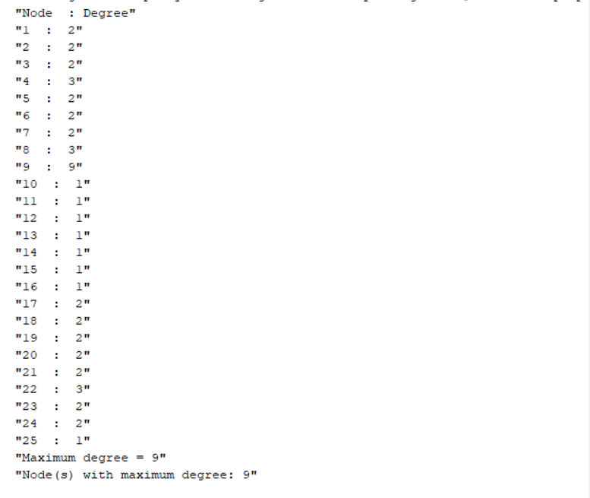

Question 4(e)
Print the total number of nodes and edges

clc;clear;close;
scf(0);clf();
n = 25;
x = [7.00 6.12 4.00 1.88 1.00 1.88 4.00 6.12 7.50 9.00 8.56 7.50 6.44 6.00 6.44 7.50 8.56 1.00 2.29 3.57 4.86 6.14 7.43 8.71 10.00];y = [6.00 8.12 9.00 8.12 6.00 3.88 3.00 3.88 4.50 4.50 5.56 6.00 5.56 4.50 3.44 3.00 3.44 1.00 1.00 1.00 1.00 1.00 1.00 1.00 1.00];
edges = [
1 2; 2 3; 3 4; 4 5; 5 6; 6 7; 7 8; 8 1;
9 10; 9 11; 9 12; 9 13; 9 14; 9 15; 9 16; 9 17;
18 19; 19 20; 20 21; 21 22; 22 23; 23 24; 24 25;
4 9; 8 18; 17 22];
// colorsringColor = 1;starColor = 2;busColor = 3;hybColor = 4;nodeColor = 5;
for i = 1:8
plot([x(edges(i,1)) x(edges(i,2))], ...
[y(edges(i,1)) y(edges(i,2))], "LineColor", ringColor);end
for i = 9:16
plot([x(edges(i,1)) x(edges(i,2))], ...
[y(edges(i,1)) y(edges(i,2))], "LineColor", starColor);end
for i = 17:23
plot([x(edges(i,1)) x(edges(i,2))], ...
[y(edges(i,1)) y(edges(i,2))], "LineColor", busColor);end
for i = 24:26
plot([x(edges(i,1)) x(edges(i,2))], ...
[y(edges(i,1)) y(edges(i,2))], "LineColor", hybColor);end
plot(x, y, "o", "MarkerSize", 8, ...
"MarkerFaceColor", nodeColor, "MarkerEdgeColor", nodeColor);
xtitle("Hybrid Network Topology (Ring + Star + Bus)");xgrid(1);
num_edges = size(edges, 1);disp("Total nodes : " + string(n));disp("Total edges : " + string(num_edges));

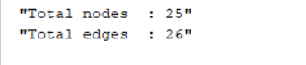

Question 2

This scenario describes your topology in simpler, shorter form.

Scenario
A college is setting up a network for its new Computer Science building. The building has three areas that must all be connected into one network:
An Analytics Lab with 8 powerful PCs that need high availability.
A Faculty Wing with 8 staff PCs connected to one central switch.
A Student Corridor with 8 self-service kiosks placed in a straight line.

Requirements
The 8 Analytics Lab PCs (nodes 1–8) must be connected in a ring, so every PC has two neighbors and the network still works if one link fails.
The Faculty Wing uses a star: one central switch (node 9) connected directly to 8 staff PCs (nodes 10–17).
The Student Corridor uses a bus: the 8 kiosks (nodes 18–25) are connected in a simple chain 18–19–…–25.
To make one hybrid network:
Connect one ring node to the central switch (ring ↔ star).
Connect a different ring node to the first kiosk (ring ↔ bus).
Connect one star PC to a kiosk in the middle of the bus (star ↔ bus).

Task
Write a program that:
Stores all 25 nodes and all links (edges).
Draws the ring, star, and bus in one figure.
Prints the total number of nodes and total number of edges in the network.

