Machine Learning-Based Electricity Demand Forecasting
Final Exploratory Data Analysis, Model Evaluation and Forecasting Results

1. Historical Electricity Demand
Figure 1. Historical Electricity Demand
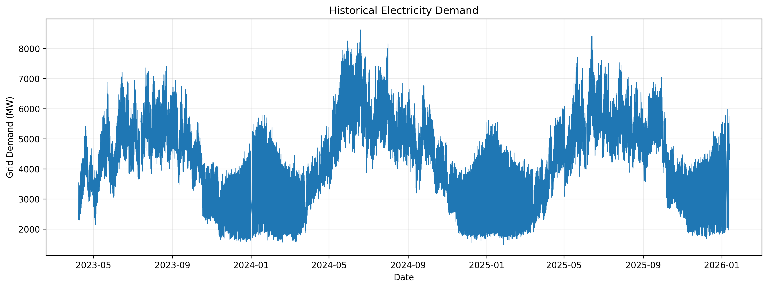
The historical demand series shows the variation in electricity demand over the observation period.

2. Demand Pattern by Hour
Figure 2. Electricity Demand by Hour of Day
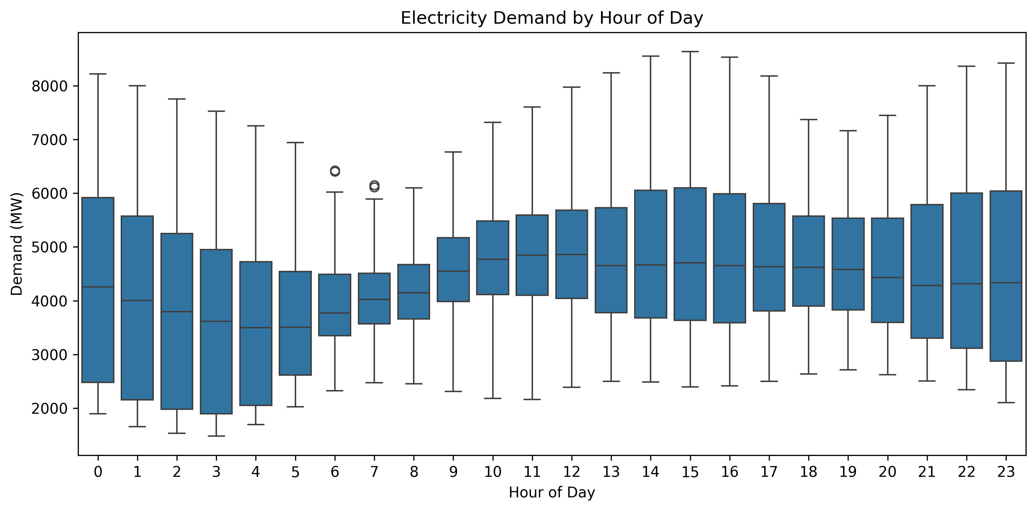
The hourly distribution illustrates the intraday variation in electricity demand.

3. Demand Pattern by Day of Week
Figure 3. Electricity Demand by Day of Week
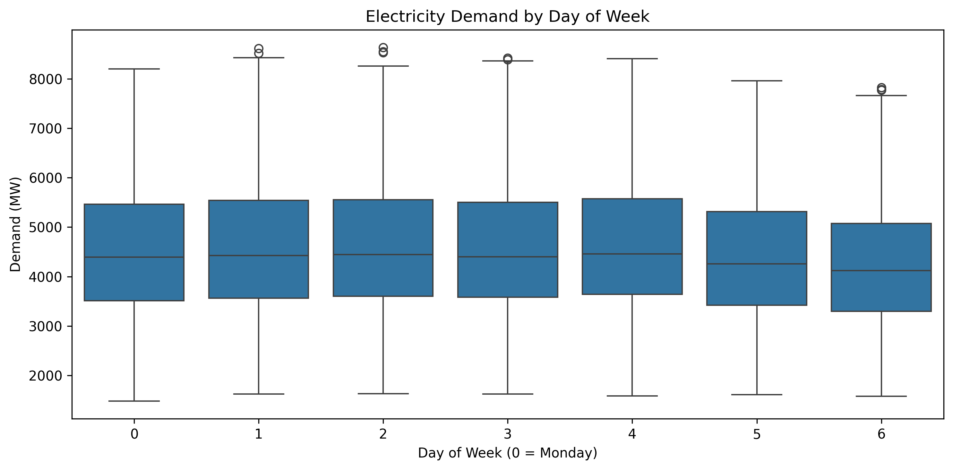
The distribution indicates differences in electricity demand between weekdays and weekends.

4. Seasonal Demand Pattern
Figure 4. Electricity Demand by Month
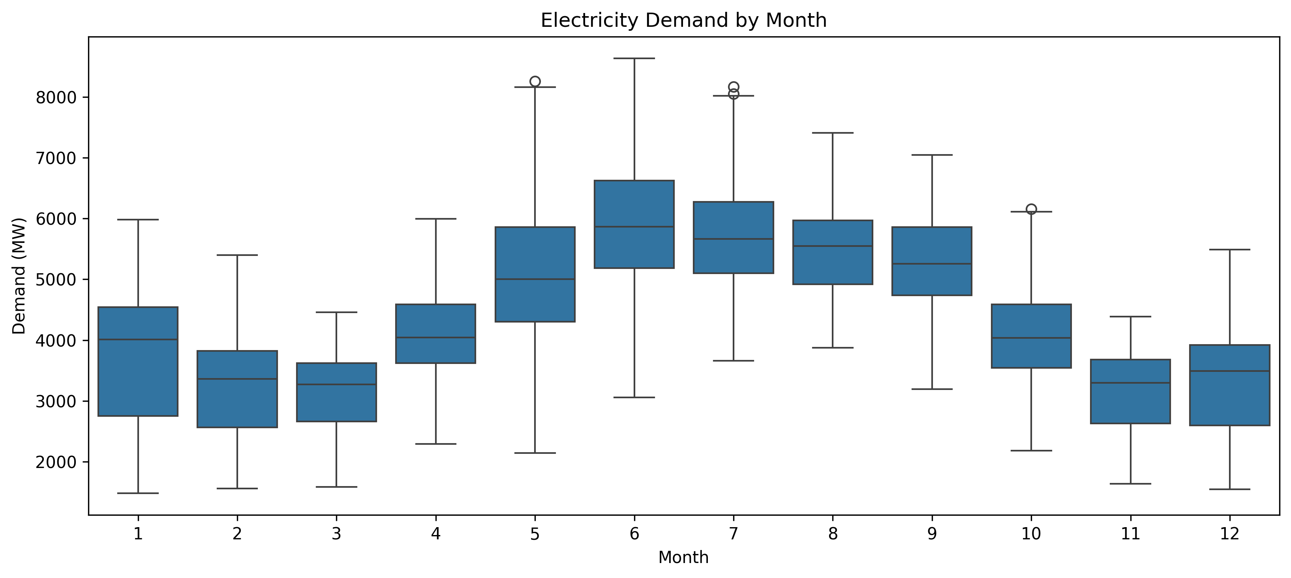
Monthly demand distributions show seasonal variation in grid electricity demand.

5. Temperature and Electricity Demand
Figure 5. Temperature vs Electricity Demand
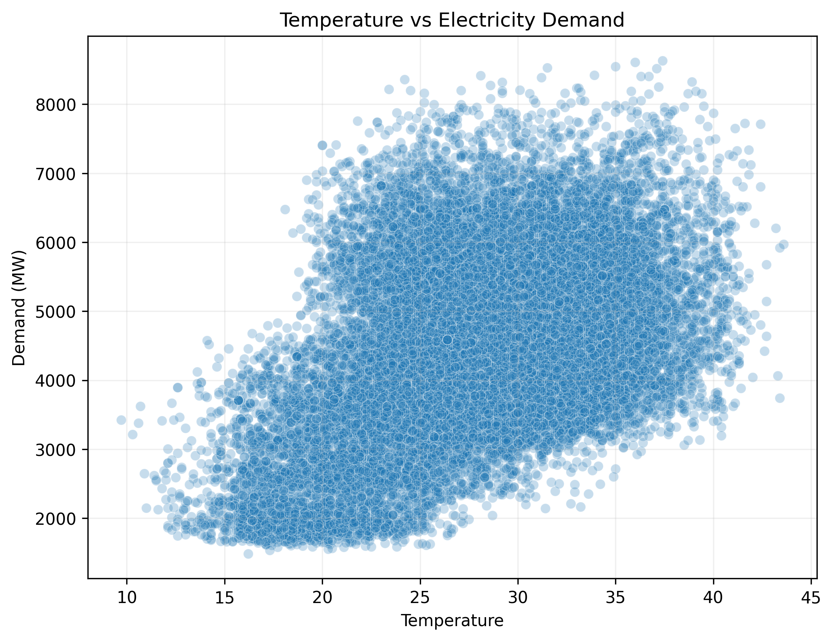
The scatter distribution can be used together with the correlation analysis to assess the relationship between temperature and electricity demand.

6. Humidity and Electricity Demand
Figure 6. Humidity vs Electricity Demand
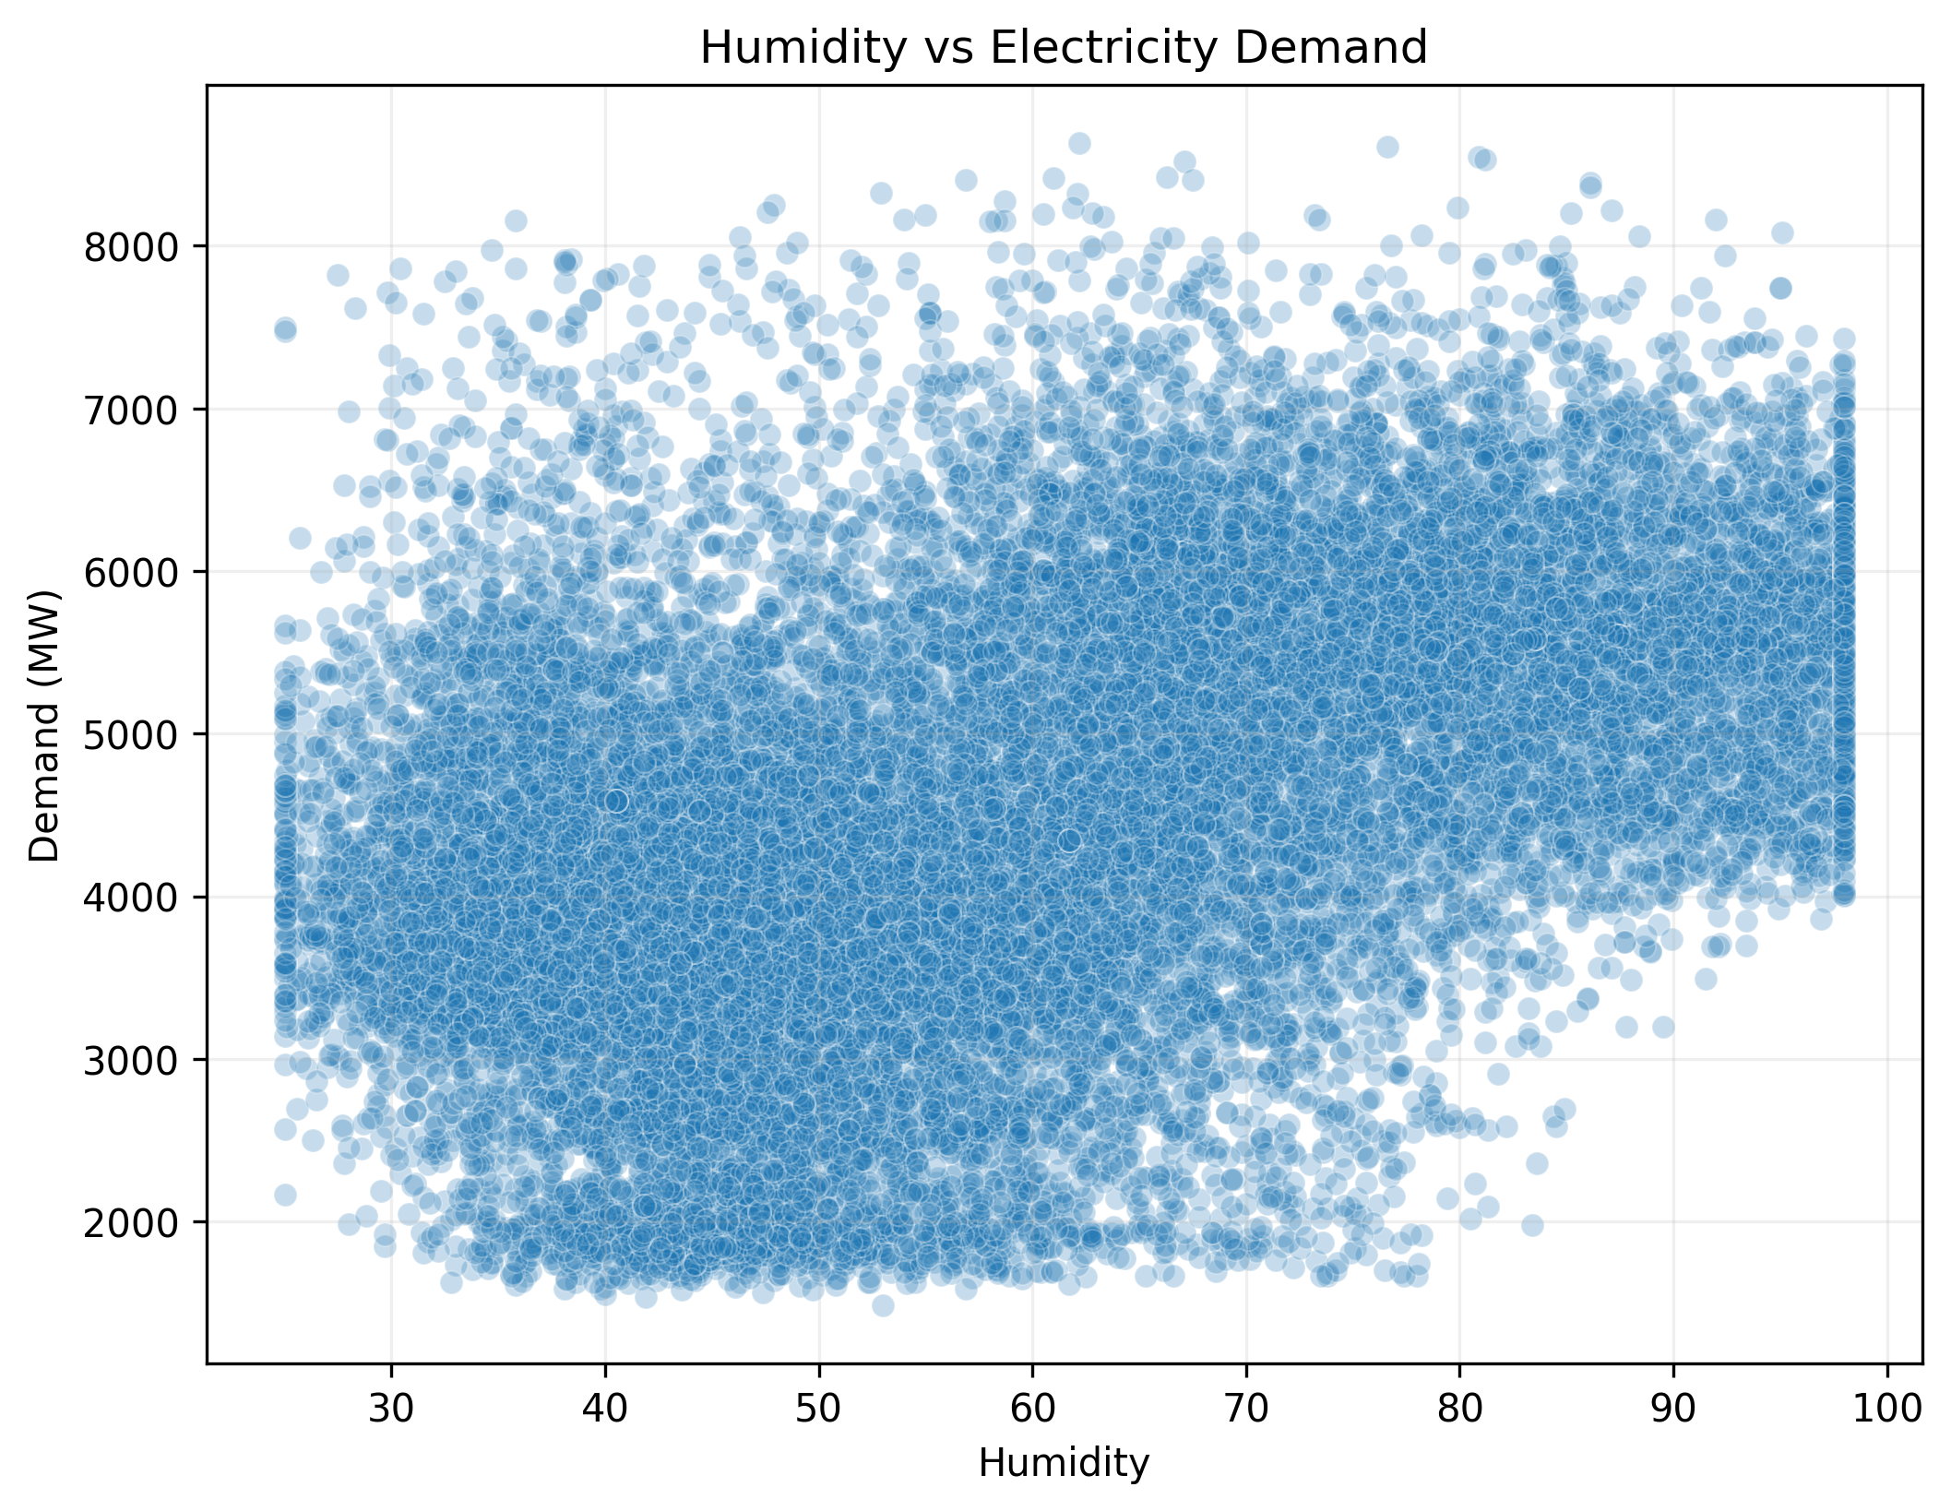
The scatter distribution shows the dispersion of electricity demand across different humidity levels.

7. Correlation Analysis
Figure 7. Correlation Matrix
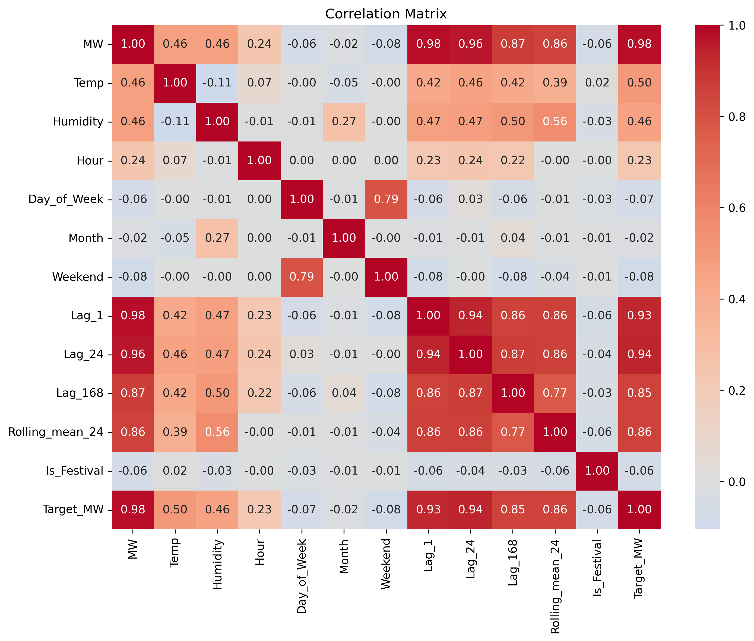
The correlation matrix summarizes the pairwise linear relationships among numerical variables.

8. Electricity Demand by Holiday Type
Figure 8. Electricity Demand by Holiday Type
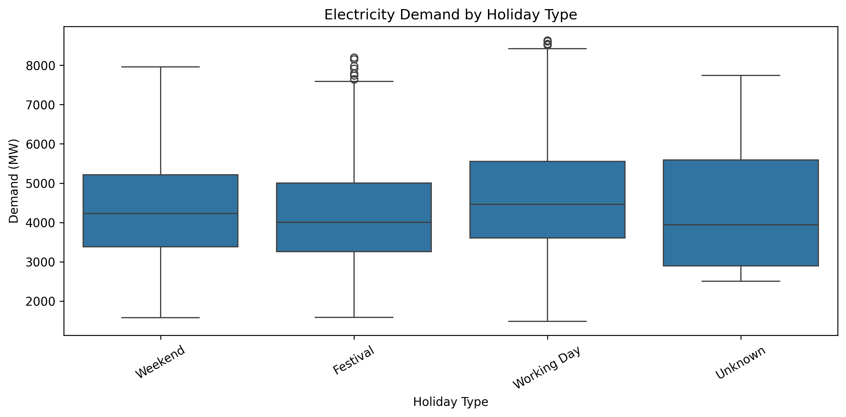
The distribution provides an exploratory view of demand variation across holiday categories.

10. Model Performance Comparison
Figure 10. Model Comparison Using MAE
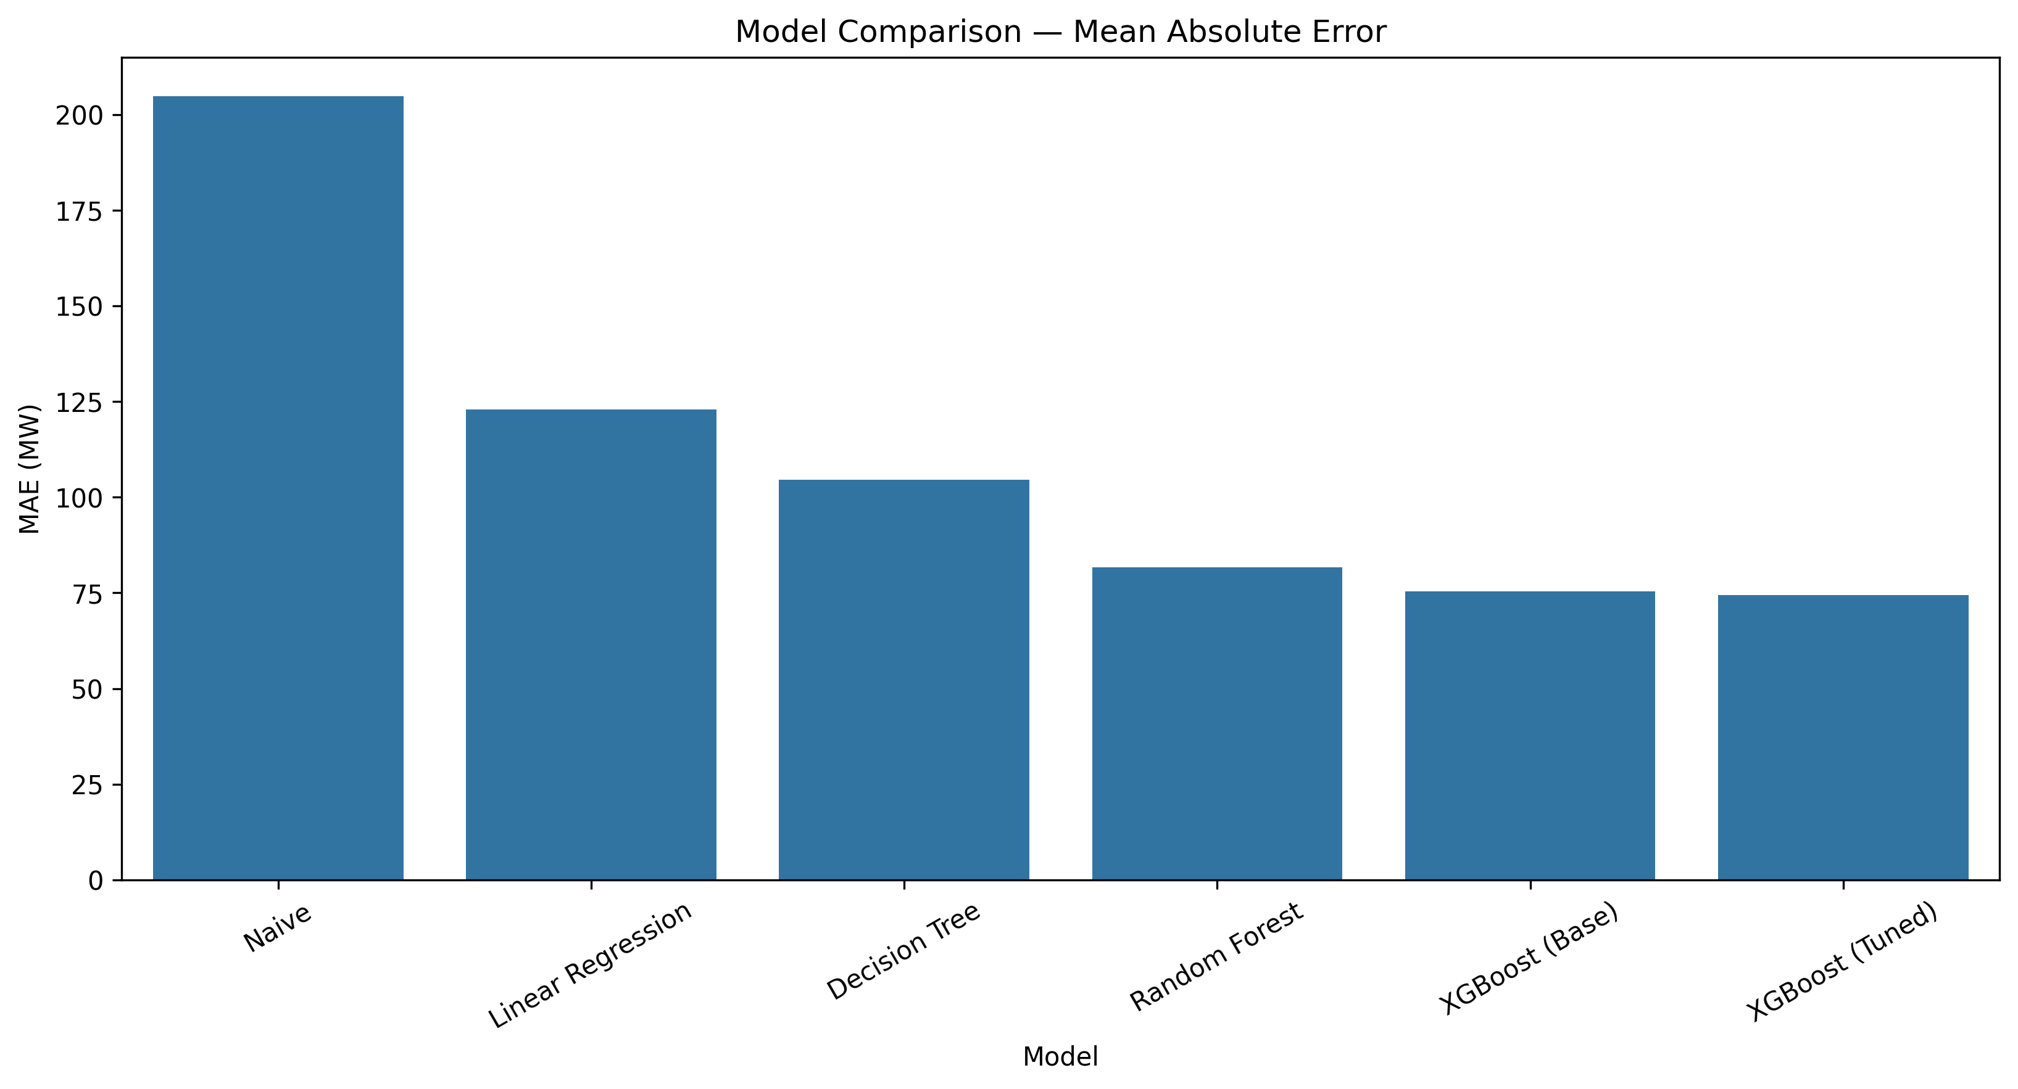
Lower MAE indicates lower average absolute forecasting error.

Figure 11. Model Comparison Using RMSE
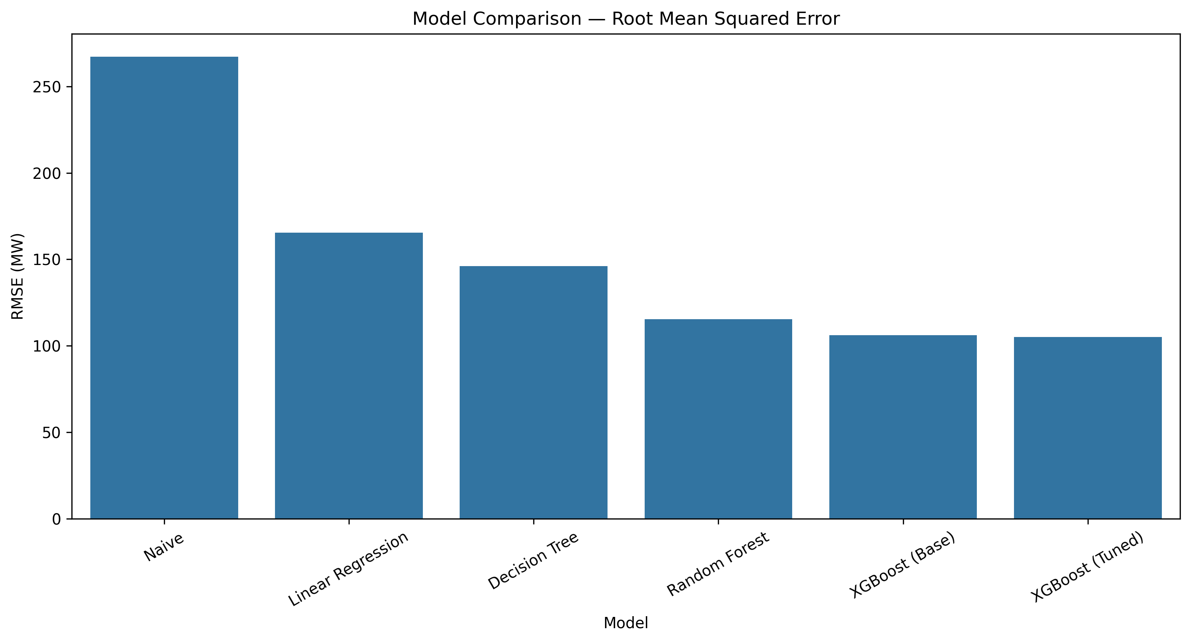
RMSE gives greater weight to larger forecasting errors.

Figure 12. Model Comparison Using MAPE
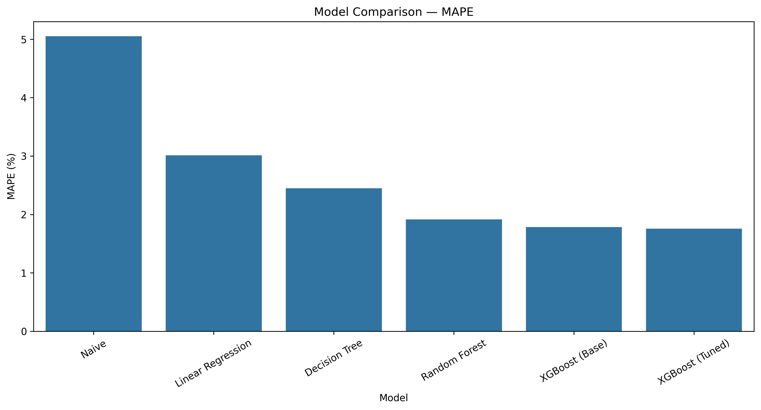
MAPE expresses the average absolute forecasting error as a percentage of actual demand.

11. Feature Group Experiment
Figure 13. Feature Group Experiment
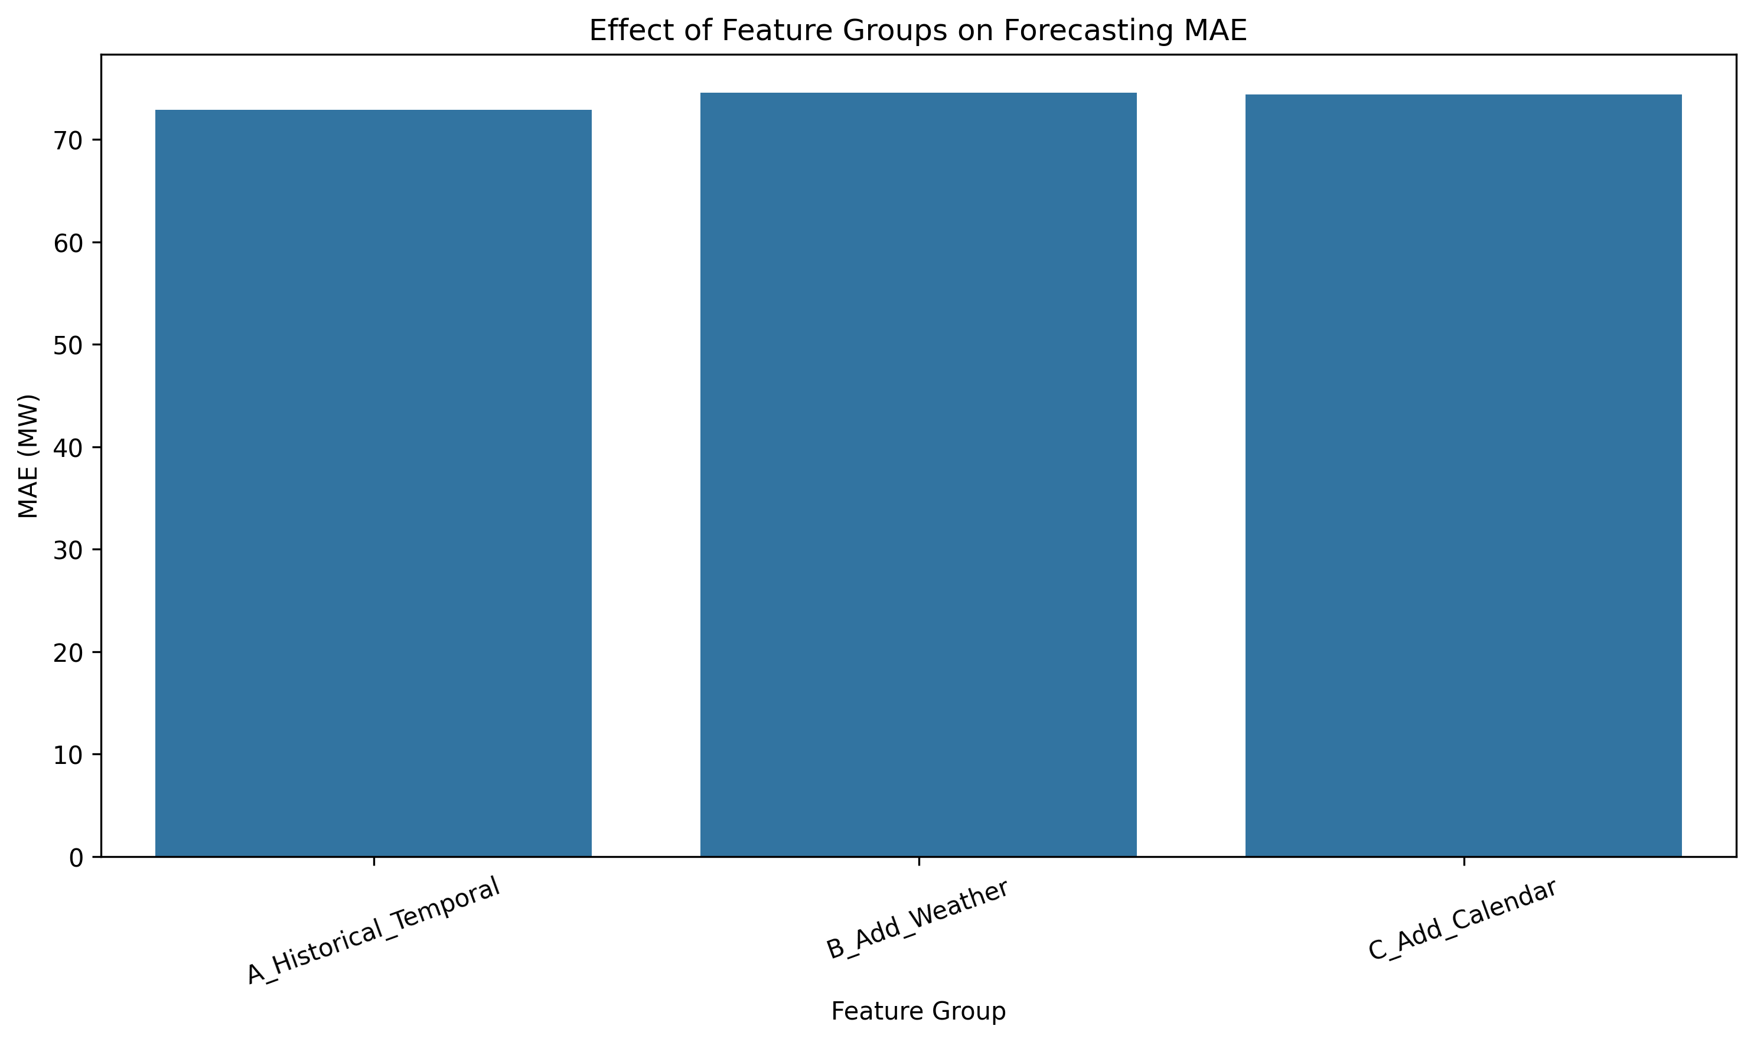
The experiment compares historical-temporal features with the addition of weather and calendar/festival information.

12. Naive Baseline Comparison

13. Actual vs Predicted Demand
Figure 15. Actual vs Predicted Demand
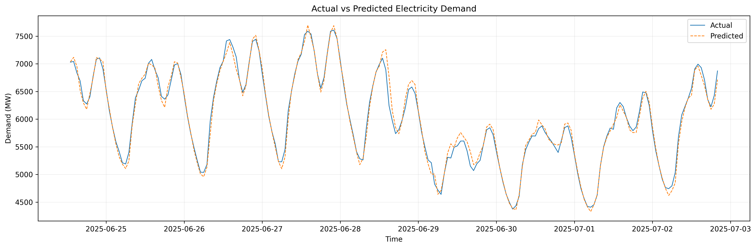
The plot compares actual electricity demand with the tuned XGBoost predictions for the test period.

Figure 16. Actual vs Predicted Demand Scatter
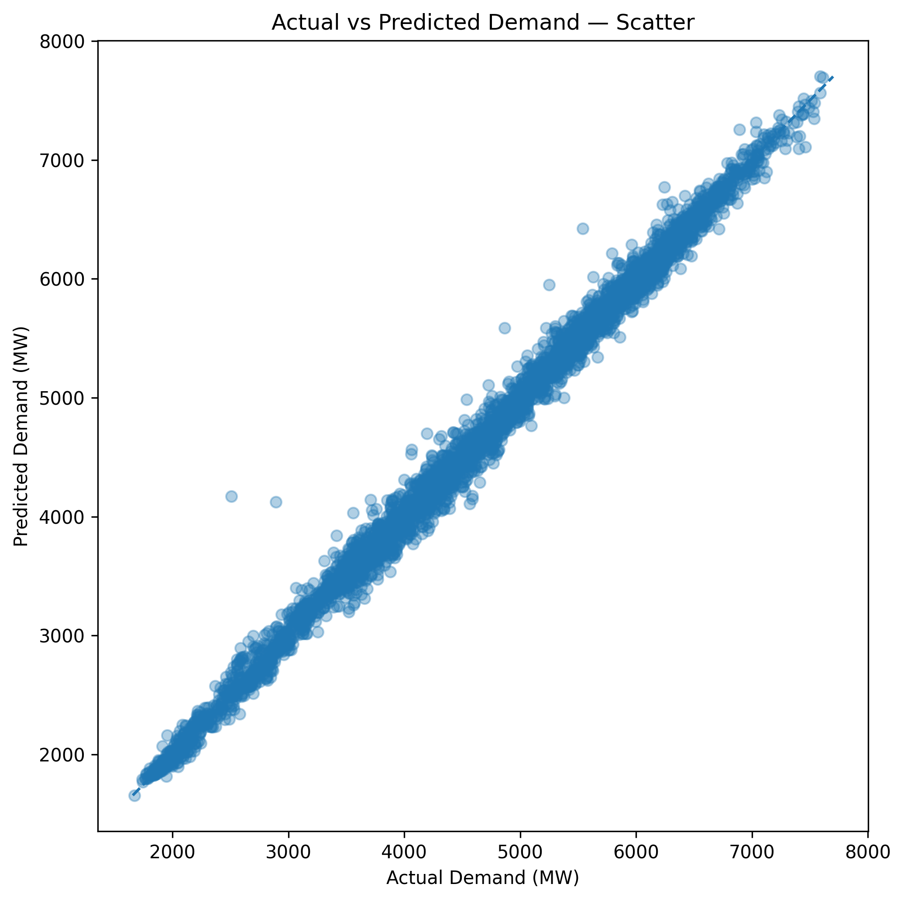
Points closer to the diagonal line indicate closer agreement between actual and predicted demand.

14. Forecast Error Analysis
Figure 17. Forecast Error Distribution
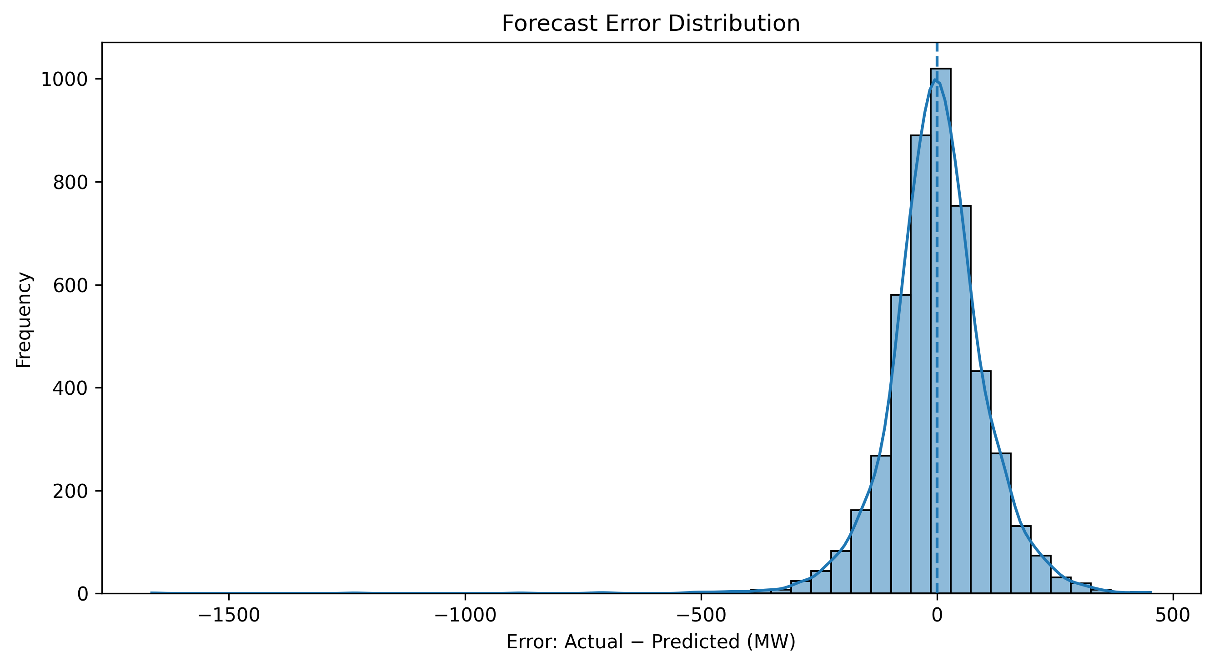
The distribution of forecast errors shows the spread and central tendency of prediction errors.

15. Forecast Accuracy by Hour
Figure 18. Forecast MAE by Hour
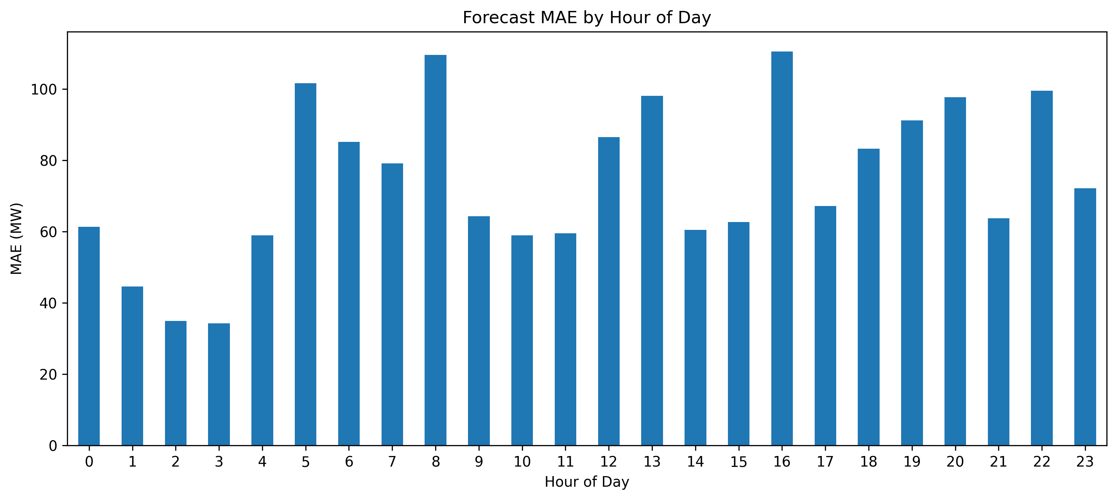
Forecasting error varies across hours of the day, indicating that some periods are more difficult to predict than others.

16. Weekday vs Weekend Forecast Accuracy
Figure 19. Weekday vs Weekend Forecast MAE
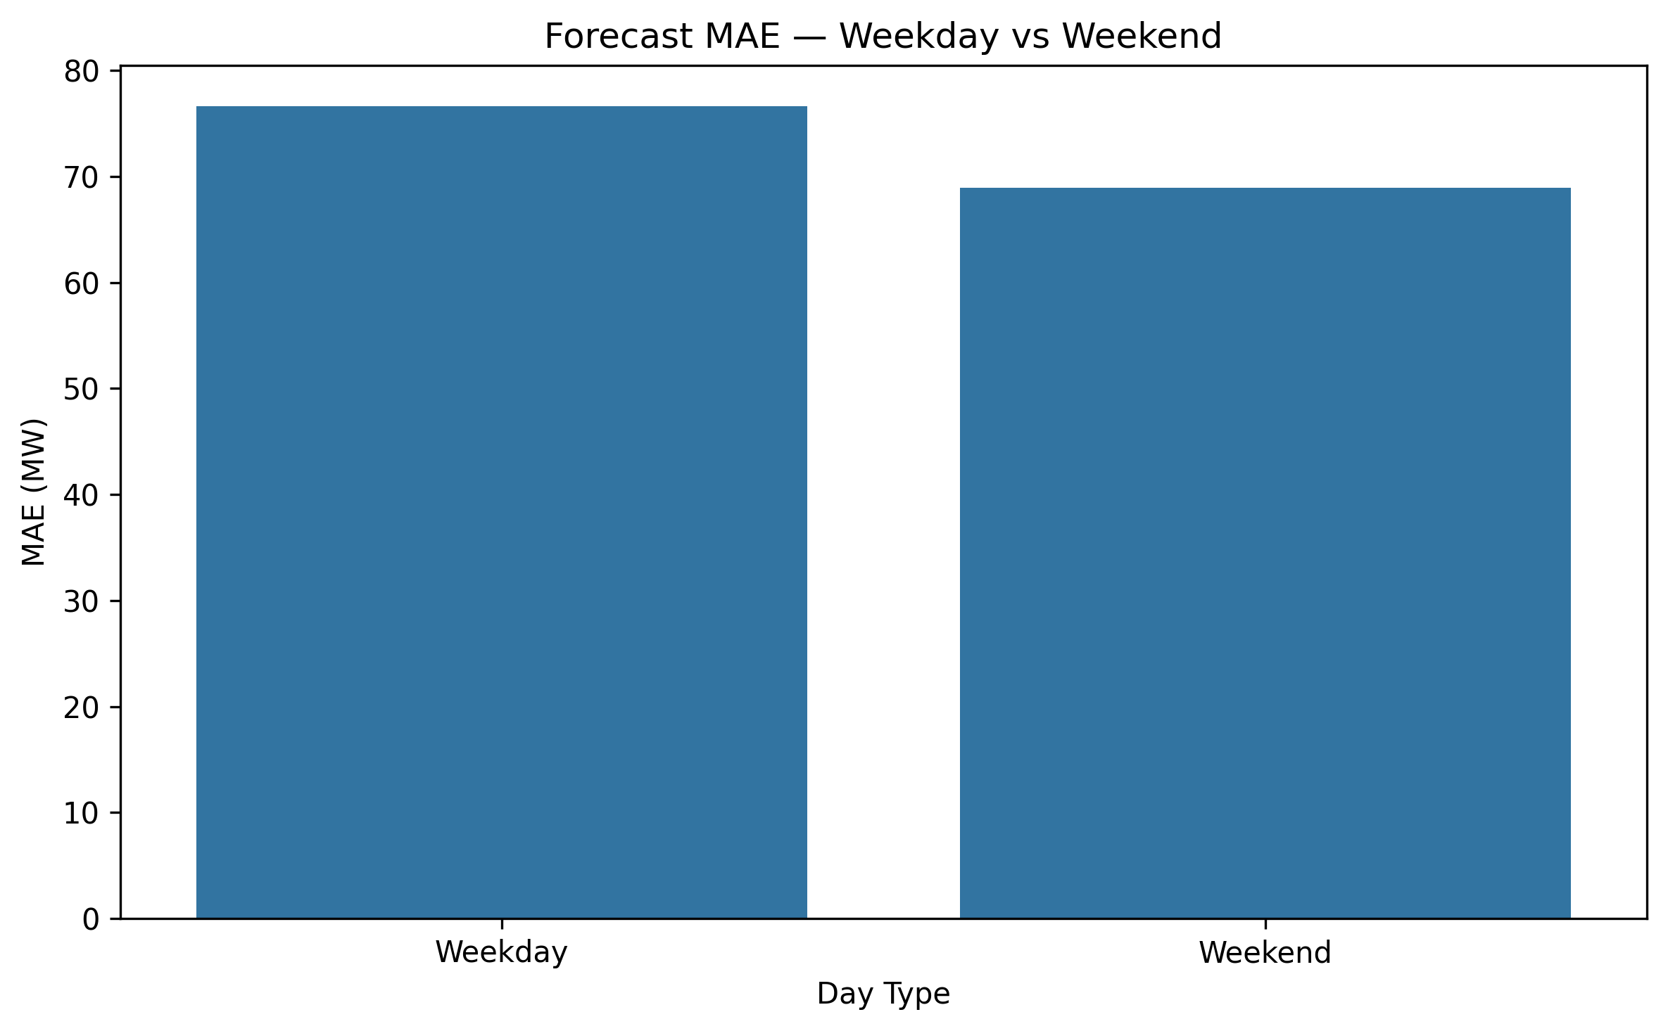
Forecast accuracy is compared between weekday and weekend observations.

17. Forecast Accuracy by Demand Level
Figure 20. Forecast MAE by Demand Level
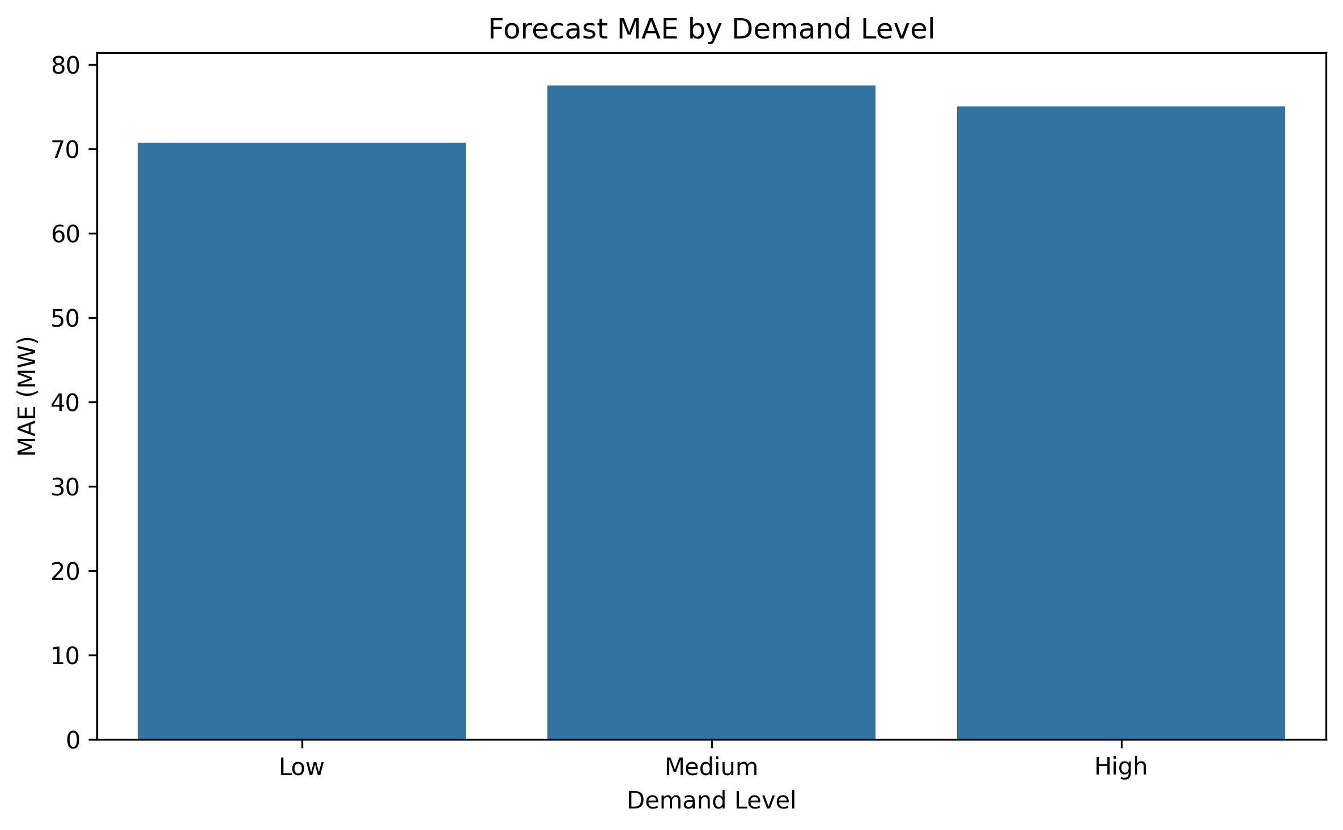
Forecast error is evaluated separately for low, medium and high demand observations.

18. Peak Demand Analysis
Figure 21. Peak Demand Forecast
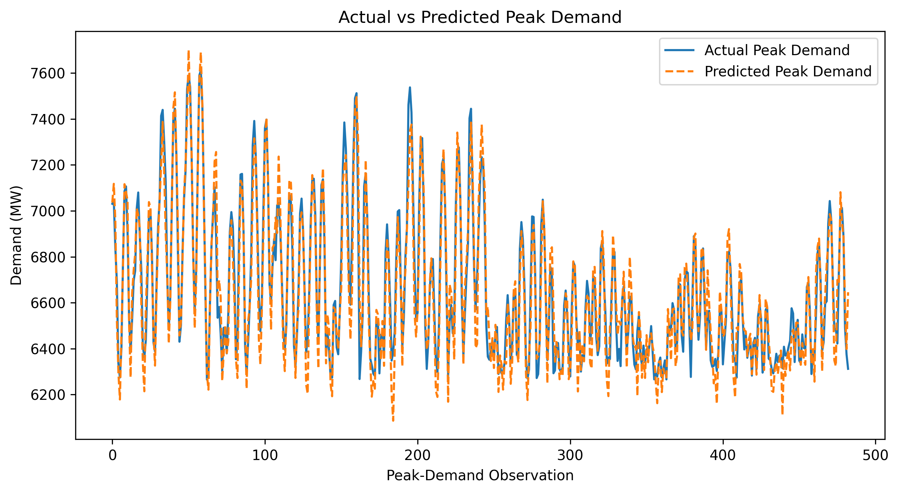
The tuned XGBoost model is evaluated specifically on the highest-demand observations.

19. XGBoost Feature Importance
Figure 22. Top XGBoost Feature Importances
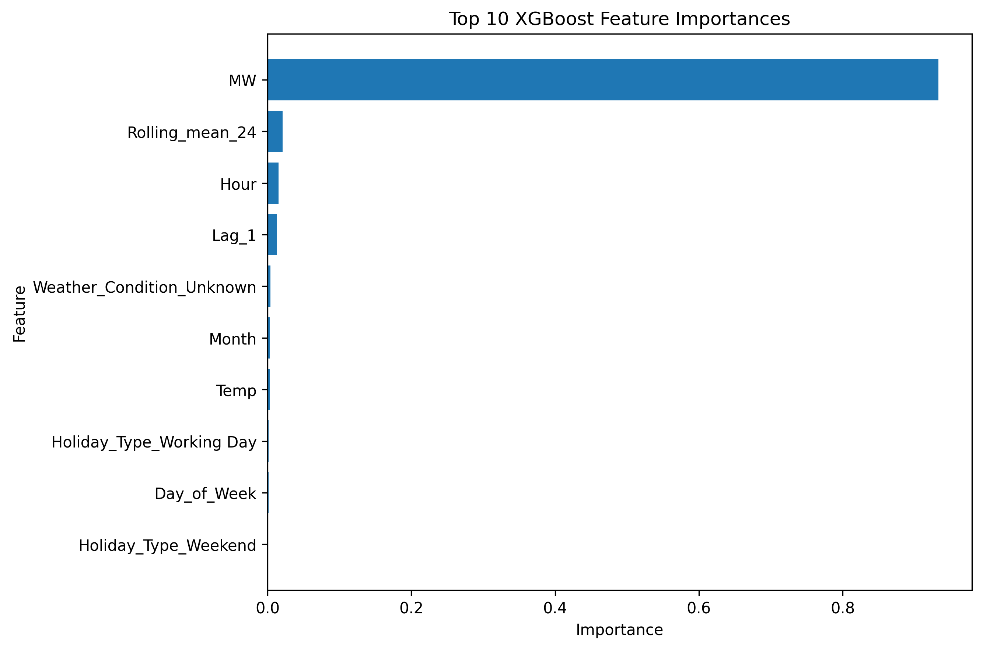
The plot shows the ten features with the highest built-in importance values in the tuned XGBoost model.

20. Cyclic Time Feature Experiment
Figure 23. Cyclic Time Feature Experiment
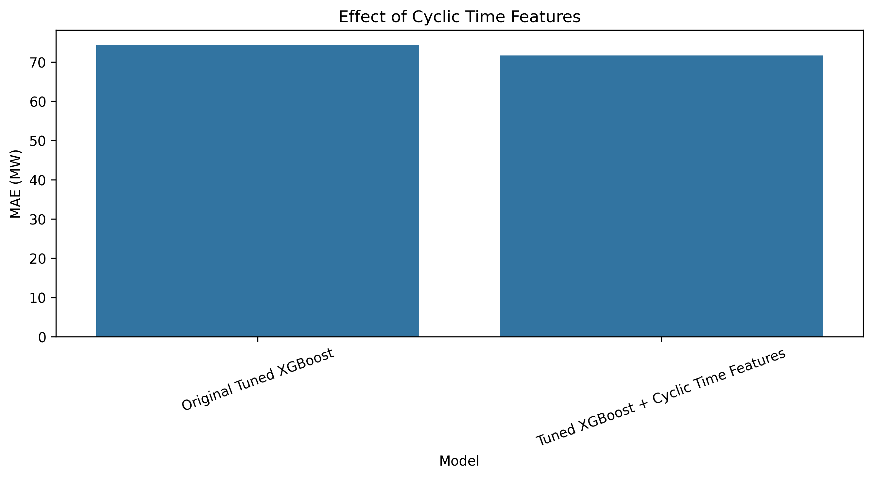
The experiment compares the original tuned XGBoost model with the version incorporating cyclic time representations.

21. Walk-Forward Validation
Figure 24. Walk-Forward Validation
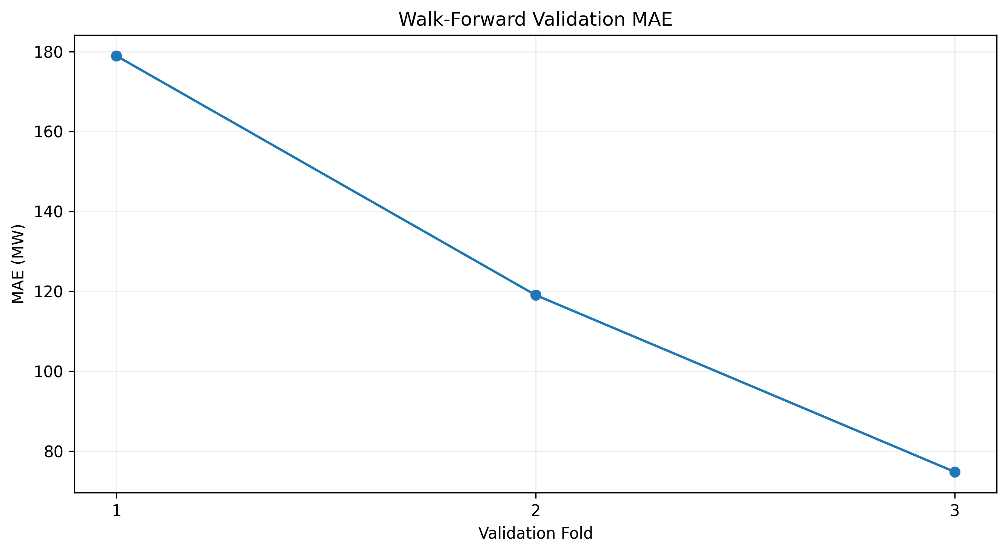
The fold-wise MAE illustrates forecasting performance across sequential validation periods.

22. Peak Demand Classification
Figure 25. Peak Demand Classification
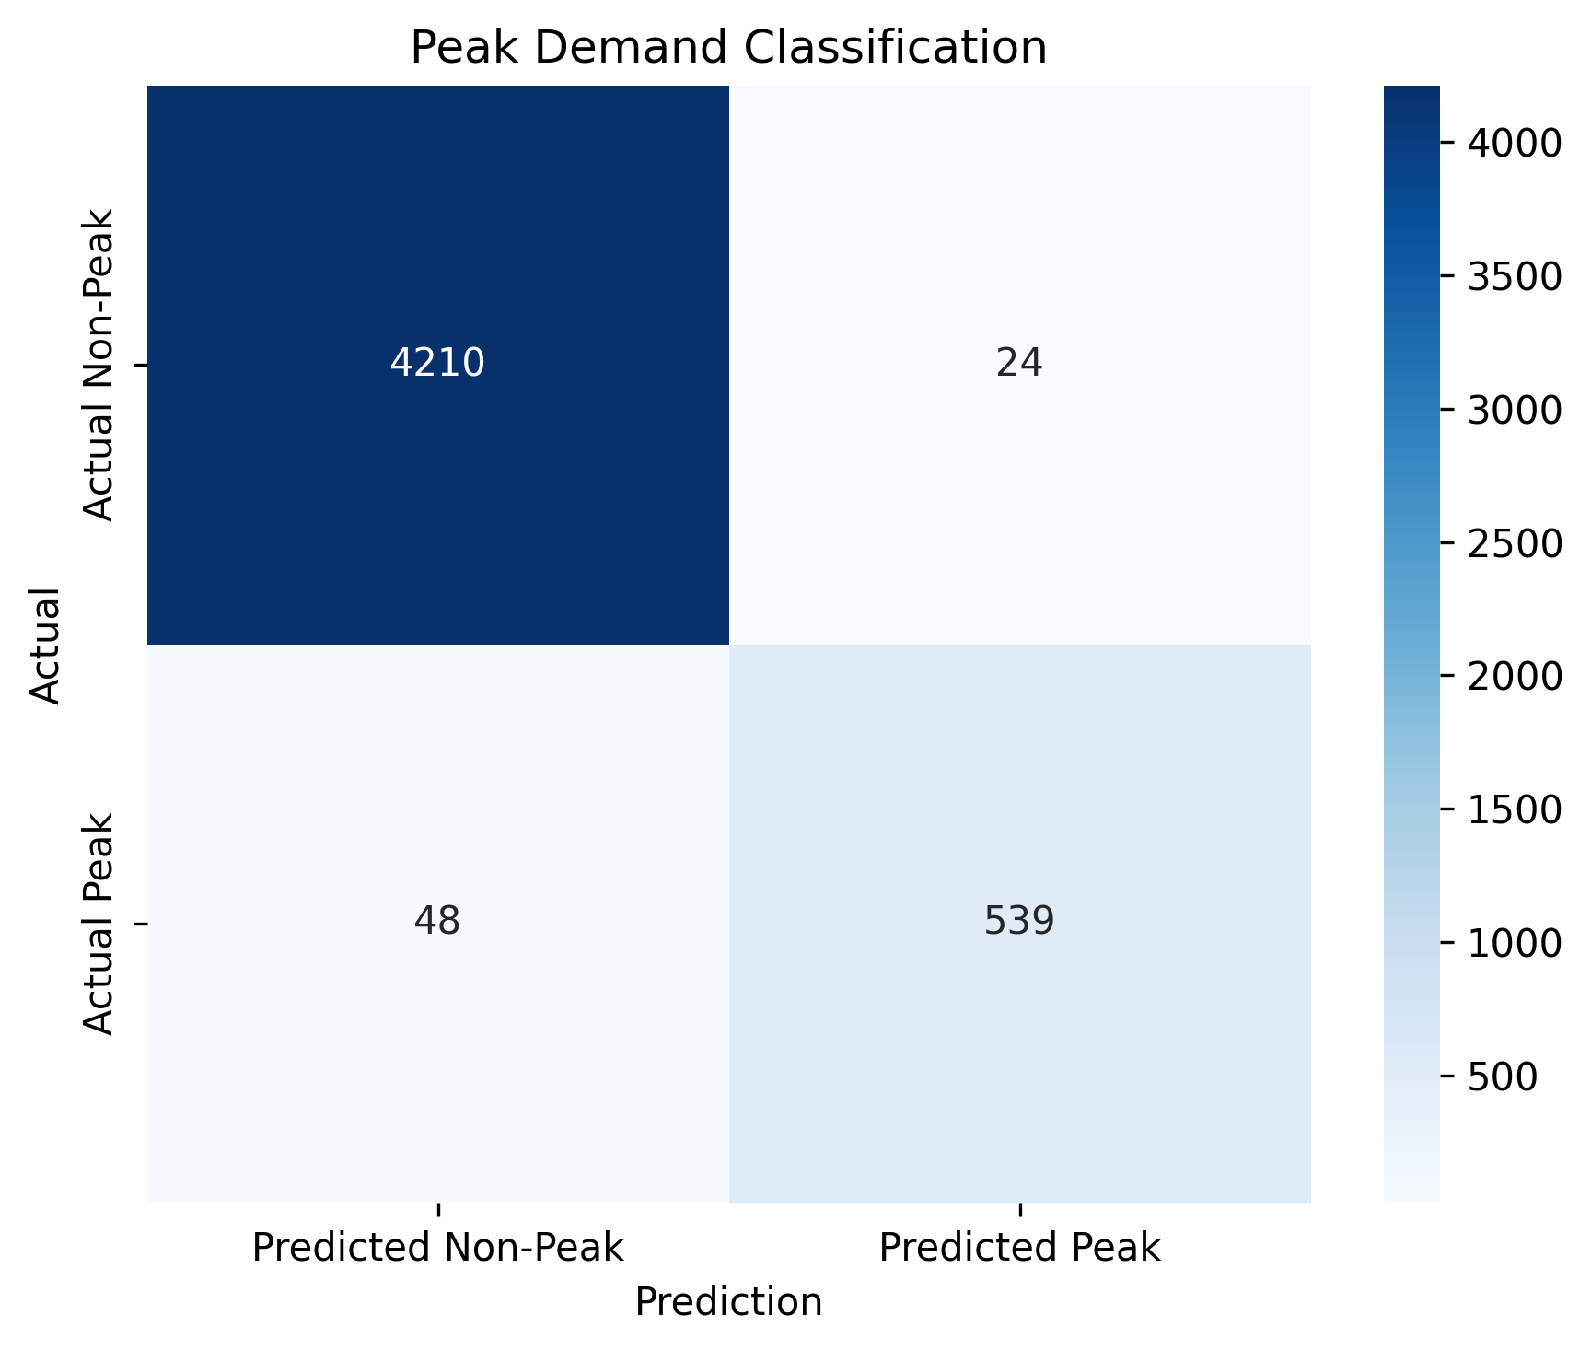
The confusion matrix summarizes the classification of peak and non-peak demand observations using a threshold derived from the training data.

23. Final Model Results
Model | MAE | RMSE | MAPE | R2
Naive | 204.8204 | 267.1255 | 5.0496 | 0.9583
Linear Regression | 122.9608 | 165.3285 | 3.0135 | 0.9840
Decision Tree | 104.5829 | 146.0715 | 2.4484 | 0.9875
Random Forest | 81.6385 | 115.4449 | 1.9157 | 0.9922
XGBoost (Base) | 75.3792 | 106.1009 | 1.7823 | 0.9934
XGBoost (Tuned) | 74.3984 | 105.1687 | 1.7546 | 0.9935

24. Automatically Generated Key Results
Model with lowest test MAE: XGBoost (Tuned)
Lowest test MAE: 74.40 MW
Weather feature MAE change: -2.34%
Calendar/festival feature MAE change: 0.25%
Tuned XGBoost improvement over previous-hour naive baseline: 63.68%

