Software Requirements Specification

for

Movie Streaming website

**Prepared by 21CE143, 21CE148, 21CE150**

**CSPIT-CE**

**02-09-22**

**Table of Contents**

**Table of Contents ii**

**Revision History ii**

**1.** **Introduction 1**

1.1 Objective 1

1.2 Document Conventions 1

1.3 Intended Audience and Reading Suggestions 1

1.4 Project Scope 1

1.5 References 2

**2.** **Overall Description 2**

2.1 Product Perspective 2

2.2 Product Features 2

2.3 User Classes and Characteristics 2

2.4 Operating Environment 2

2.5 Design and Implementation Constraints 3

2.6 User Documentation 3

2.7 Assumptions and Dependencies 3

**3.** **System Features 3**

3.1 System Feature 1 3

**4.** **External Interface Requirements 4**

4.1 User Interfaces 4

4.2 Hardware Interfaces 5

4.3 Software Interfaces 5

4.4 Communications Interfaces 5

**5.** **Other Nonfunctional Requirements 5**

5.1 Performance Requirements 5

5.2 Safety Requirements 6

5.3 Security Requirements 6

5.4 Software Quality Attributes 6

**6.** **Other Requirements 6**

**Appendix A: Glossary 6**

**Appendix B: Analysis Models 7**

**Appendix C: Issues List 7**

**Revision History**

|  |  |  |  |
| --- | --- | --- | --- |
| **Name** | **Date** | **Reason For Changes** | **Version** |
|  |  |  |  |
|  |  |  |  |

# 1) Introduction

## 1.1 Introduction

We are designing a streaming website that deals with renting and buying movies and series . The basic motto of this project is to give the facility to user to either download or rent any movie and series and also provide the rating and all other details of it. This website helps the user to surf for the movies according to it’s rating .

**1.2 Document Conventions**

We have chosen fonts and highlighted certain information which will be reader friendly.

## 1.3 Intended Audience and Reading Suggestions

The people who have interested to watch movie after the reviews and rating , then this website should be a good option for them.

1.4 **Project Scope**

The basic motto of this project is to give the facility to user to either download or rent any movie and series and also provide the rating and all other details of it. This website helps the user to surf for the movies according to it’s rating .

The purpose of this website is to provide a single platform where user can get all the information related to films, television series and streaming content  and based on that information, user can download or can get rented streaming content.

**1.5 References**

Reference has been taken from the official website of the IMDb, flixter, Netflix, Amazon Prime Video

Reference has also been taken from web designing and development tutorials from Youtube.

# 2 Overall Description

## 2.1 Product Perspective

A movie streaming website contains the following information

* **Product details:**It displays various movies’ ratings and provides the option to download it and at a cheaper cost. There are various options to select from many regional languages, save the collection and make playlist. User will have the ability to purchase and download a higher quality movie with respect to the plan purchased.

**2.2 Product features**

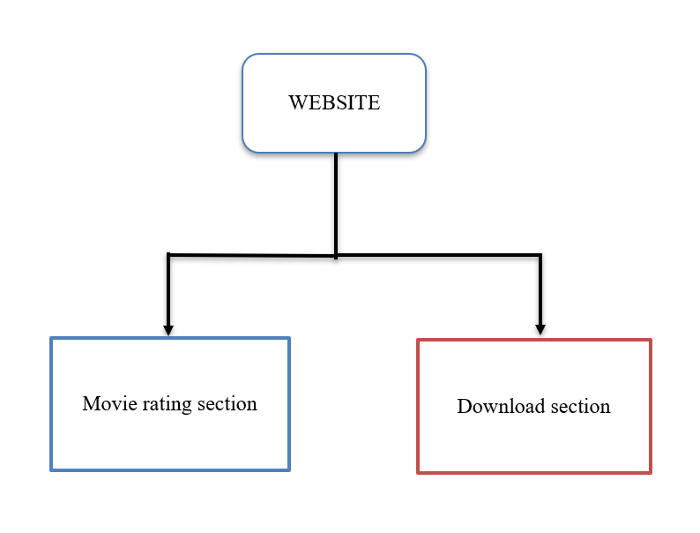

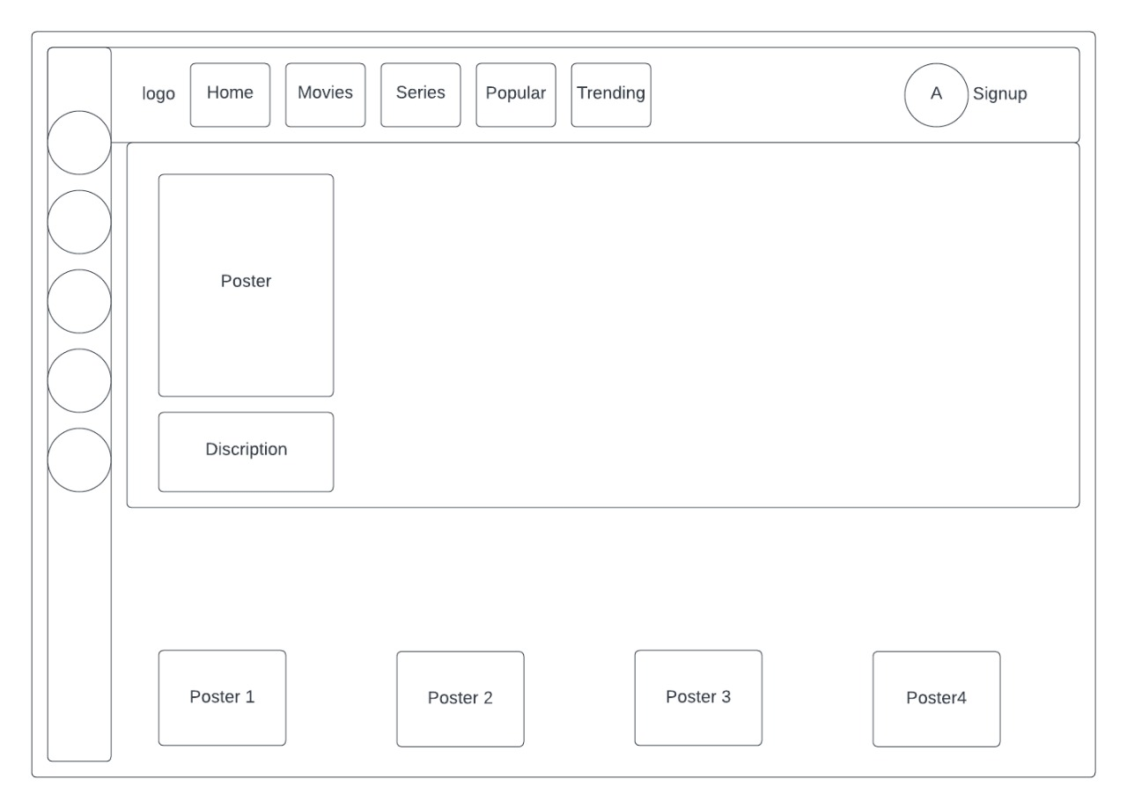

2.3 User Classes and Characteristics

2.4 Operating Environment

Operating environment for our retailed website is as listed below.

client/server system

Operating system: Windows, MacOs.

platform: HTML/Javascript/CSS

2.5 Design and Implementation Constraints

<Describe any items or issues that will limit the options available to the developers. These might include: corporate or regulatory policies; hardware limitations (timing requirements, memory requirements); interfaces to other applications; specific technologies, tools, and databases to be used; parallel operations; language requirements; communications protocols; security considerations; design conventions or programming standards (for example, if the customer’s organization will be responsible for maintaining the delivered software).>

|  |  |  |  |  |
| --- | --- | --- | --- | --- |
| **3rd Sem** | **4th Sem** | **5th Sem** | **6th Sem** | **7th Sem** |
| Not required | Not Required | Not Required | Mandatory | Mandatory |

## 2.6 User Documentation

In the About Us section of the project there will be a brief description of the Website and the list of features we are dealing with. The section will also consist of the showroom directions and a few glimpses of our showroom.

## 2.7 Assumptions and Dependencies

The main assumption of this project is that the user will get the quality of experience with user friendly interface. There will be various chargable plans that be available for the user. Based on that they can access different quality of content. In the home page there are various options to categorize these content.

# 3 System Features

## 3.1 System Feature 1

3.1.1 Description and Priority

3.1.2 Stimulus/Response Sequences

3.1.3 Functional Requirements

* The user will be able to get the various chargable plan and based on that they can get different quality of content.
* User can get movie rating and all the details of the movies and also get an option to download it.
* The user can get the content based on regional languages also.

# 4 External Interface Requirements

## 4.1 User Interfaces

Front-end Software: Visual studio code, Bootstrap.

4.2 Hardware Interfaces

Windows

Browser which supports CSS, HTML, Javascript

## 4.3 Software Interfaces

Following are the software used for the our website.

|  |  |
| --- | --- |
| ***Software used*** | ***Description*** |
| *Operating system* | *We have chosen Windows operating system for its best support and user-friendliness.* |
| *Database* | *To save the user’s information , we have chosen languages like SQL or PHP. And MongoDb for streaming* |
| *Visual studio code* | *To implement the project we have chosen HTML,CSS,j avascript language for its more interactive support.* |

## 4.4 Communications Interfaces

This project supports all types of web browsers.

5 Other Nonfunctional Requirements

## 5.1 Performance Requirements

As the project is web based so there are no specifications for performance but in further updates of the project the user will be able to select the products they wish to buy and will also be able to generate a rough expenditure(Quotation) for the products.

## 5.2 Safety Requirements

<Specify those requirements that are concerned with possible loss, damage, or harm that could result from the use of the product. Define any safeguards or actions that must be taken, as well as actions that must be prevented. Refer to any external policies or regulations that state safety issues that affect the product’s design or use. Define any safety certifications that must be satisfied.>

|  |  |  |  |  |
| --- | --- | --- | --- | --- |
| **3rd Sem** | **4th Sem** | **5th Sem** | **6th Sem** | **7th Sem** |
| Not Required | Not Required | Required, if requirement needs | Required, if requirement needs | Required, if requirement needs |

## 5.3 Security Requirements

<Specify any requirements regarding security or privacy issues surrounding use of the product or protection of the data used or created by the product. Define any user identity authentication requirements. Refer to any external policies or regulations containing security issues that affect the product. Define any security or privacy certifications that must be satisfied.>

|  |  |  |  |  |
| --- | --- | --- | --- | --- |
| **3rd Sem** | **4th Sem** | **5th Sem** | **6th Sem** | **7th Sem** |
| Not Required | Not Required | Required, if requirement needs | Required, if requirement needs | Required, if requirement needs |

## 5.4 Software Quality Attributes

* AVAILABILITY: Our retailed website is available 24*7.
* CORRECTNESS: The flight should reach start from correct start terminal and should reach the correct destination.
* MAINTAINABILITY: To maintain the data of the user in which it can
* The administrators and flight in chargers should maintain correct schedules of flights.
* USABILITY: The database can store maximum number of content what needs.

# Other Requirements

<Define any other requirements not covered elsewhere in the SRS. This might include database requirements, internationalization requirements, legal requirements, reuse objectives for the project, and so on. Add any new sections that are pertinent to the project.>

**Appendix A: Glossary**

*<Define all the terms necessary to properly interpret the SRS, including acronyms and abbreviations. You may wish to build a separate glossary that spans multiple projects or the entire organization, and just include terms specific to a single project in each SRS.>*

|  |  |  |  |  |
| --- | --- | --- | --- | --- |
| **3rd Sem** | **4th Sem** | **5th Sem** | **6th Sem** | **7th Sem** |
| If applicable | If applicable | If applicable | If applicable | If applicable |

**Appendix B: Analysis Models**

*<Optionally, include any pertinent analysis models, such as data flow diagrams, class diagrams, state-transition diagrams, or entity-relationship diagrams*.>

|  |  |  |  |  |
| --- | --- | --- | --- | --- |
| **3rd Sem** | **4th Sem** | **5th Sem** | **6th Sem** | **7th Sem** |
| If applicable | If applicable | If applicable | If applicable | If applicable |

**Appendix C: Issues List**

*< This is a dynamic list of the open requirements issues that remain to be resolved, including TBDs, pending decisions, information that is needed, conflicts awaiting resolution, and the like.>*

|  |  |  |  |  |
| --- | --- | --- | --- | --- |
| **3rd Sem** | **4th Sem** | **5th Sem** | **6th Sem** | **7th Sem** |
| If applicable | If applicable | If applicable | If applicable | If applicable |

*References*

[*https://krazytech.com/projects/sample-software-requirements-specificationsrs-report-airline-database*](https://krazytech.com/projects/sample-software-requirements-specificationsrs-report-airline-database)