**Jenkins Integration.**

This is a very naïve version of Jenkins implementation, which utterly focusses on building the pipeline rather than worrying about the actual outcome of it.

As I am setting up Jenkins locally, I will attach screenshots for the same.

I have created a new item on my local **Jenkins named Leads as freestyle**.

I have used source code management as Git **with no build triggers.**

We can build manually when needed.

Next, I have used build step as windows batch execution.

These will run a version_shift.bat file, which on successful build will allow user to push their build to release else rollbacking the operation to previous version.

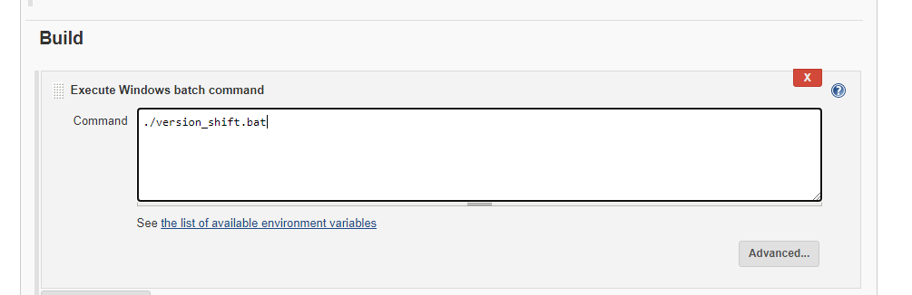

I build the application and ran it, here is the screenshot.

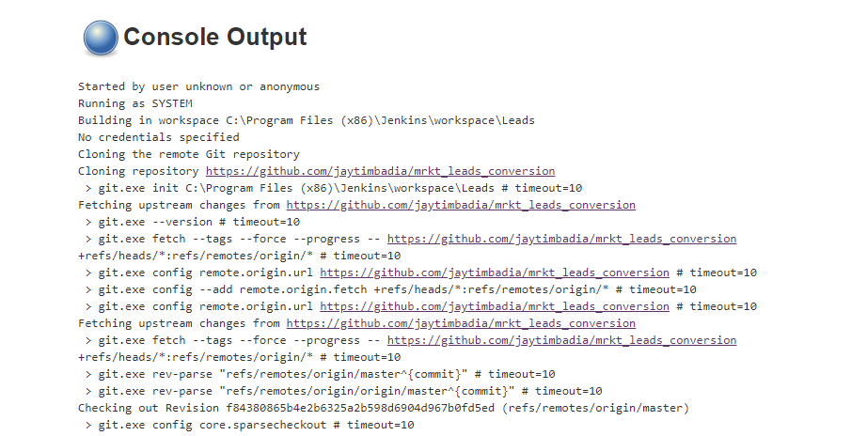

It ran successfully.

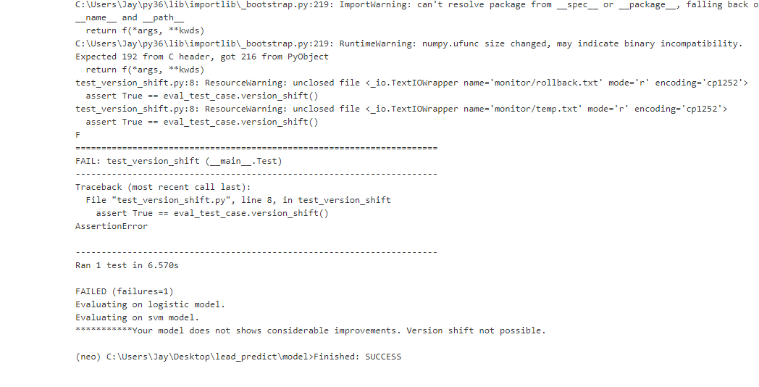

As we can see, test case got failed, which indicates that, new model developed by a developer doesn’t performs well as compared to existing one and thus not allowing to move its codebase to integrate with master.