## Mini Project Report

On

## OlX Portal

Submitted To

## Prof. Sachin Bhandari Sir

**NMIMS**

**Mukesh Patel School of Technology Management & Engineering, Shirpur**

**.**

Submitted By

1. Harshal Patil 70022300440 (B305)

2. Bhargav Patil 70022300441 (B306)

Under The Guidance of

## Prof. Sachin Bhandari Sir

**Department of Computer Engineering** **YEAR 2024-25**

**Project Title:SkillShareOnlineLearning**

Creation & Insertion Queries:-

CREATE DATABASE OnlineLearning;

USE OnlineLearning;

CREATE TABLE Users (

UserID INT IDENTITY(1,1) PRIMARY KEY,

Name NVARCHAR(100) NOT NULL,

Email NVARCHAR(100) UNIQUE NOT NULL,

Password NVARCHAR(255) NOT NULL,

Role NVARCHAR(50) CHECK (Role IN ('Student', 'Instructor', 'Admin')),

JoinDate DATETIME DEFAULT GETDATE()

);

CREATE TABLE Courses (

CourseID INT IDENTITY(1,1) PRIMARY KEY,

Title NVARCHAR(255) NOT NULL,

Description TEXT,

InstructorID INT,

Price DECIMAL(10,2) DEFAULT 0,

FOREIGN KEY (InstructorID) REFERENCES Users(UserID) ON DELETE SET NULL

);

CREATE TABLE Enrollments (

EnrollID INT IDENTITY(1,1) PRIMARY KEY,

UserID INT,

CourseID INT,

EnrollDate DATETIME DEFAULT GETDATE(),

FOREIGN KEY (UserID) REFERENCES Users(UserID) ON DELETE CASCADE,

FOREIGN KEY (CourseID) REFERENCES Courses(CourseID) ON DELETE CASCADE

);

CREATE TABLE Lectures (

LectureID INT IDENTITY(1,1) PRIMARY KEY,

CourseID INT,

Title NVARCHAR(255) NOT NULL,

VideoURL NVARCHAR(500),

UploadDate DATETIME DEFAULT GETDATE(),

FOREIGN KEY (CourseID) REFERENCES Courses(CourseID) ON DELETE CASCADE

);

CREATE TABLE Quizzes (

QuizID INT IDENTITY(1,1) PRIMARY KEY,

CourseID INT,

Title NVARCHAR(255),

TotalMarks INT,

FOREIGN KEY (CourseID) REFERENCES Courses(CourseID) ON DELETE CASCADE

);

CREATE TABLE QuizAttempts (

AttemptID INT IDENTITY(1,1) PRIMARY KEY,

UserID INT,

QuizID INT,

Score INT,

AttemptDate DATETIME DEFAULT GETDATE(),

FOREIGN KEY (UserID) REFERENCES Users(UserID) ON DELETE CASCADE,

FOREIGN KEY (QuizID) REFERENCES Quizzes(QuizID) ON DELETE CASCADE

);

CREATE TABLE Assignments (

AssignmentID INT IDENTITY(1,1) PRIMARY KEY,

CourseID INT,

Title NVARCHAR(255) NOT NULL,

Deadline DATETIME,

MaxMarks INT,

FOREIGN KEY (CourseID) REFERENCES Courses(CourseID) ON DELETE CASCADE

);

CREATE TABLE Payments (

PaymentID INT IDENTITY(1,1) PRIMARY KEY,

UserID INT,

CourseID INT,

Amount DECIMAL(10,2),

Status NVARCHAR(50) CHECK (Status IN ('Pending', 'Completed', 'Failed')),

FOREIGN KEY (UserID) REFERENCES Users(UserID) ON DELETE CASCADE,

FOREIGN KEY (CourseID) REFERENCES Courses(CourseID) ON DELETE CASCADE

);

CREATE TABLE Discussions (

PostID INT IDENTITY(1,1) PRIMARY KEY,

UserID INT,

CourseID INT,

Message TEXT,

PostDate DATETIME DEFAULT GETDATE(),

FOREIGN KEY (UserID) REFERENCES Users(UserID) ON DELETE CASCADE,

FOREIGN KEY (CourseID) REFERENCES Courses(CourseID) ON DELETE CASCADE

);

select * from users;

# ABSTRACT:-

**TABLES:-**

**NO OF TABLES :9**

1. **Users**
   * Stores user data (Student, Instructor, Admin).
   * UserID is the primary key.
   * Role-based functionality is handled via the Role field.
2. **Courses**
   * Each course has an instructor.
   * InstructorID is a foreign key from Users(UserID).
3. **Enrollments**
   * Tracks which student is enrolled in which course.
   * Links UserID and CourseID.
4. **Lectures**
   * Linked to specific courses.
   * Stores video URL and lecture titles.
5. **Quizzes**
   * Created by instructors and tied to courses.
6. **QuizAttempts**
   * Tracks quiz scores for students.
7. **Assignments**
   * Created by instructors for students.
   * Includes title, deadline, and max marks.
8. **Payments**
   * Tracks course payments with status (Pending, Completed, Failed).
9. **Discussions**
   * Stores user posts per course for community interaction.

**Application Features**

**User Authentication:**

* **Register:** New users can register by entering name, email, password, and role.

**GUI Images :-**

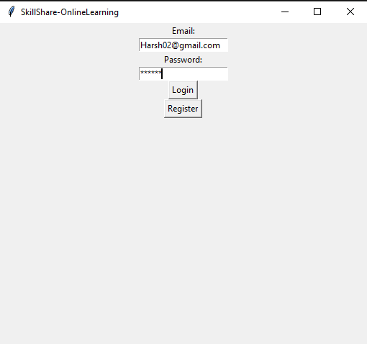

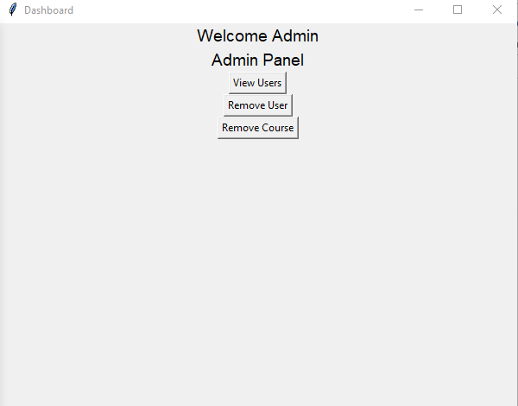 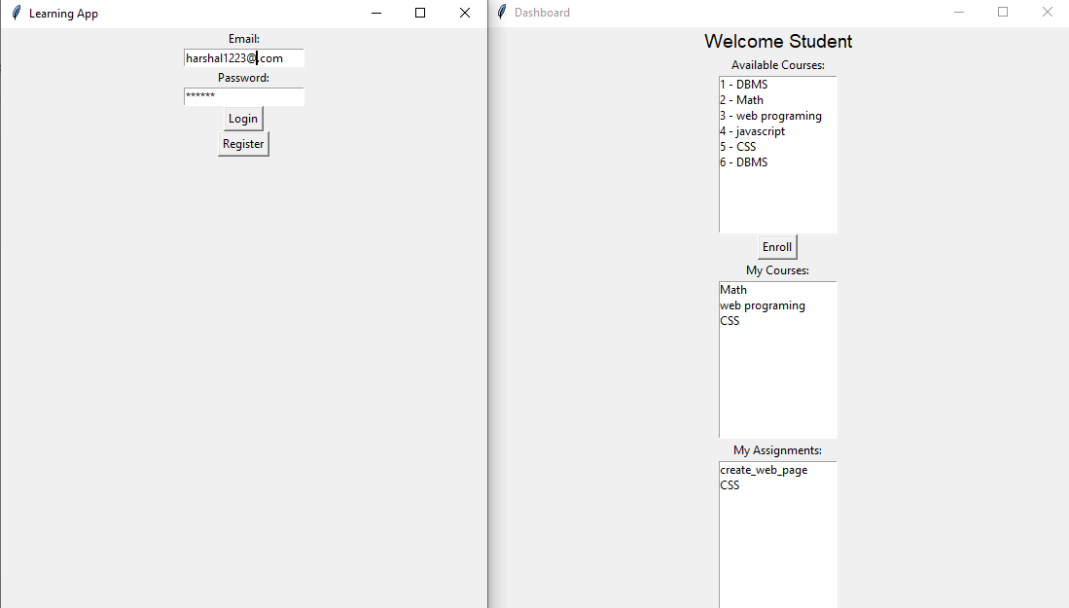

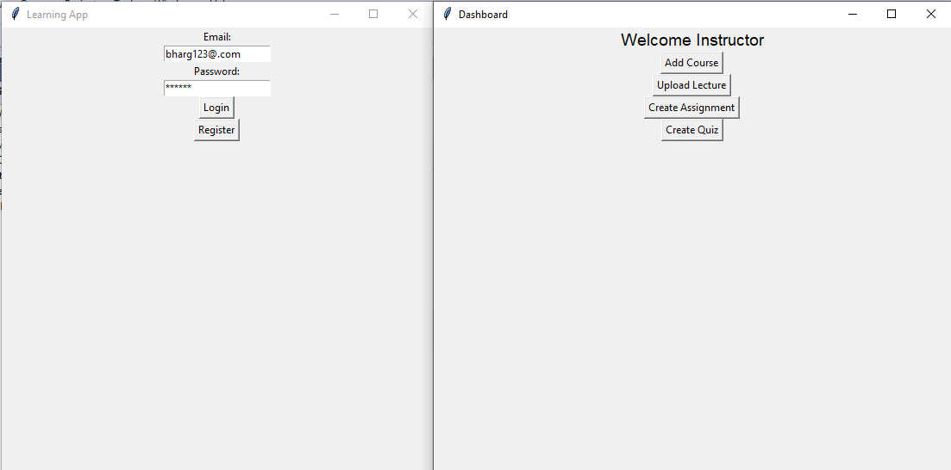 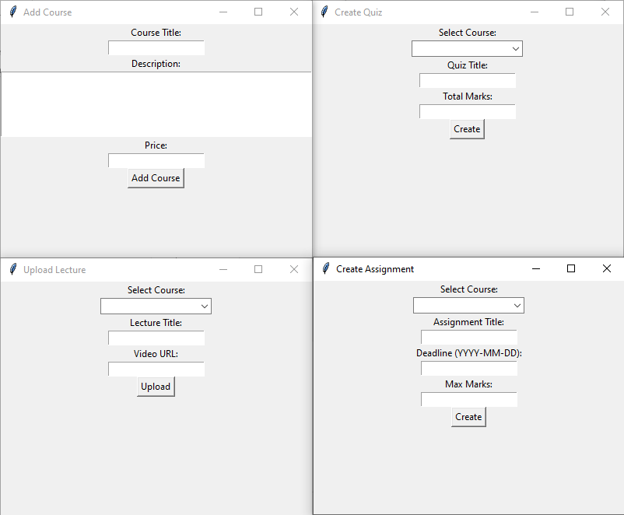

# Conclusion:

This project successfully implements a basic yet functional SkillShare OnlineLewith distinct user roles and core learning features. The combination of a Tkinter GUI and SQL Server provides a strong foundation for managing courses, users, and content digitally.