Style Guidelines for Final Year Project ReportsLEMONS

(Local Energy Monitoring System)

Final Year Project

Session 2012-2016

A 4th Year Student

A project submitted in partial fulfilment of the

COMSATS-Lancaster Dual Degree

of

BSc. (Hons.)BS in Computer Science / Software Engineering (CIIT)

BS in Computing / Software Engineering (LU)

**C:\Documents and Settings\drzhabib\Desktop\lancaster-university-logo.png**

Department of Computer Science

COMSATS Institute of Information Technology, Lahore

30 May 2016

# Project Detail

|  |  |  |  |  |  |
| --- | --- | --- | --- | --- | --- |
| Type (Nature of project) | | | [ ] **D**evelopment [ ] **R**esearch [ ] **R**&**D** | | |
| Area of specialization | | |  | | |
| **Project Group Members** | | | | | |
| Sr.# | Reg. # | Student Name | | Email ID | *Signature |
| (i) |  | Ahmad Bashir | | [achillesion@gmail.com](mailto:achillesion@gmail.com) |  |
| (ii) |  | Umer Fayyaz | | umerfayyaz786@gmail.com |  |
| (iii) |  | Zeeshan Arshad | | zeearshad@gmail.com |  |

*The candidates confirm that the work submitted is their own and appropriate credit has been given where reference has been made to work of others

# Plagiarism Free Certificate

This is to certify that, I am ________________________ S/D/o _______________________, group leader of FYP under registration no CIIT/_________________/LHR at Computer Science Department, COMSATS Institute of Information Technology, Lahore. I declare that my FYP proposal is checked by my supervisor and the similarity index is ________% that is less than 20%, an acceptable limit by HEC. Report is attached herewith as Appendix A.

Date: ____________ Name of Group Leader: ________________________ Signature: _____________

Name of Supervisor: _____________________ Co-Supervisor (if any):____________________

Designation: _____________________ Designation: _____________________

Signature: _____________________ Signature: _____________________

HoD: _____________________

Signature: _____________________

**Acknowledgement**

Table of Contents

1 Introduction 8

2 Problems Defiantions 16

3 Requirement Analysis 22

4 Design & Architecture 26**Error! Bookmark not defined.**

5 Implementation 36**Error! Bookmark not defined.**

6 Learning 29

7 Achievements 42

8 Indivisual Contribution 46

9 Conclusion and Future Work **Error! Bookmark not defined.**

10 Bibliography 49

List of abbrieveiations

|  |  |
| --- | --- |
| ADC | Analouge to Digital Converter |
| HTML | HyperText Markup Language |
| CSS | Cascading Style Sheets |
| AB | Ahmad Bashir |
| UF | Umer Fayyaz |
| ZA | Zeeshan Arshad |
|  |  |
|  |  |

List of Figures

|  |  |
| --- | --- |
| Figure 1.3 | Tools and Techniques |
| Figure 1.5.3 | Microcontrollers |
| Figure 1.5.4 | Analouge to digital converter |
| Figure( 1.9.1-1.9.3) | Examples of Current Systems |
| Figure 4.1 | System Architecture |
| Figure 4.2 | Main login Screen |
| Figure 4.3 | Main Screen |
| Figure 4.4 | Sign-Up Page |
| Figure 7.1 | Gantt Chart |

List of Tables

|  |  |
| --- | --- |
| Table 4.1 | User Login |
| Table 4.2 | Forgot Password |
| Table 4.3 | User Logout |
| Table 4.4 | Edit Profile |
| Table 4.5 | Monitoring and Switching |
| Table 4.6 | Performance |
| Table 4.7 | Security |
| Table 4.8 | Defects Maintenance |
| Table 4.9 | Documentation. |
| Table 4.10 | Disaster Recovery |
| Table 5.1.3.1 | Administrator Login |
| Table 5.1.3.2 | Activity |
| Table 5.1.3.3 | Monitoring Activity |
| Figure 7.1 | Gantt Chart |

# Chapter 1 Introduction

## Abstract

The world is moving on clean and green energy systems. Due to the shortage and depletion of fossil fuels at this exponential pace. Scientists and engineers are trying to solve the energy crisis our planet is facing from last 20 years. As due to the growth of the Internet and Industrial revolution. The are electrical and mechanical systems replacing man-labour in industries which is the most major leap mankind has taken after centuries. There are around twenty billion devices to be expected launched from 2016-2020. There are machines for everything, coffee makers, weight machines and many more gadgets that today have come a very obvious part of our daily life’s.  
Our product LEMONS has the ability to help humans to conserve and monitor there electricity consumption at a very feasible and cheap cost. The product has a web interface which is very easy to use and manageable. The interaction with the users of the product is focused to provide a very user friendly experience but at the same time the empowerment of the user to access energy consumption of there environment at many cutting edge levels. This project implements the remote control operation of the product with the website being able to access from different devices and part of the area. So basically this project implements the remote controlled operation of online automation and energy monitoring system for electronics &amp; electric appliances of now and the future .We discuss the solution to our environmental security and Surveillance system by building a web-based application through which we can control and monitor different appliances in local systems of homes, offices, schools, hospital and sky is the limit

## Outcomes

The fully implemented project will provide the user

* Controlling
* Scheduling
* Monitoring

The controlling feature will allow the user to switch on and off electronic devices in real-time. The devices can be accessed from anyplace inside the home where there is the range of the same network on which all of the devices are connected.

The scheduling will allow the user to switch on and off on the basis of checks and timers. The conditions will be hard coded into the code of the microcontroller controlling the devices.

The monitoring of the electrical appliances will be in

* Current
* Voltage
* Power
* kWh Units price.

## Tools & Techniques

The tools and techniques used are :

SQL (Database Management).

* + Visual Studio (Tool)
  + Arduino and Rasberry Pie (Microcontroller)
  + Arduino Wifi Sheild.
  + Open-Source Arduino Software (IDE).
  + Arduino Relay Shield.
  + Temperature, Voltage, Current Sensor’s etc.
  + 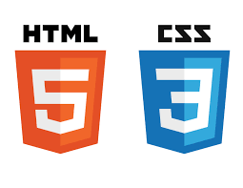 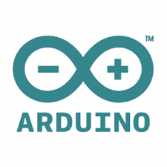

## Highlights of Chapters

**Chapter 1: Introduction**

* Abstract
* Outcomes
* Tools and Techniques
* Highlights of Chapter
* Modules
  + Graphical user Interface
  + Database
  + Microcontroller
  + ADC
* Goals And Objectives

**Chapter 2: Problem Definition**

* Problem Statement
* Feasibilty of new systems
* Management Issues
* Current Systemu

**Chapter 3: Requirement analysis**

* Functional Requirements
* Non-functional requirements

**Chapter 4: Design & Architecture**

* System Architecture
* Use case diagrams
* System Design
* Main Login Screen
* Main Screen
* Signup page
* Usability testing

**Chapter 5: Implementation**

* Software
* Hardware
* Arduino
* Raspberry pie

**Chapter 6: Learning**

* Learning of C programming Language
* Learning of Python Programming Language
* Hyper Text Mark-up Language
* Learning of cascading Style Sheets (CSS) Language
* Learning of PHP

**Chapter 7: Achievements**

* Gantt Chart
* Achievements and work

**Chapter 8: Individual Contribution**

**Chapter 9: Conclusion & Future Work**

* Conclusion
* Future work

**Chapter 10: Bibliography**

## Modules

### Graphical User Interface

The Web application would be the Graphical user interface of the system. Web application is built on HTML and CSS with back-end controlled by PHP. The value is the database will be reflected onto the website using text fields using server side scripting language. The buttons will be created to witch on and off electrical appliances with values of ON and OFF. The Web application would be the Graphical user interface of the project ,which means you can control, monitor, and schedule your devices and appliances using a Web application.Following image shows the basic idea of the graphic user interface that we will try to achieve in this project.

### Database (MySQL)

In localhost, Server software like Xamp a database will be created on the PhpMyAdmin. Thw mysql database will be given the name of Lemons with username and password. Then a python script will be used to POST and GET data onto the database at realtime.

### Microcontroller

A Microcontroller or MCU, short for microcontroller unit is a small computer (SoC) on a single integrated circuit containing a processor core, memory, and programmable input/output peripherals.The microcontrollers today are so powerful and compact that they can be operated as a complete computer having the same capabilities that a Pentium 3 had. Microcontrollers like Arduino and Rasberry pie are open-source and ready to implement.Following figure shows the outlook of a microcontroller

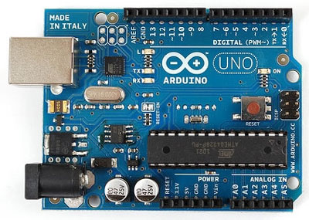 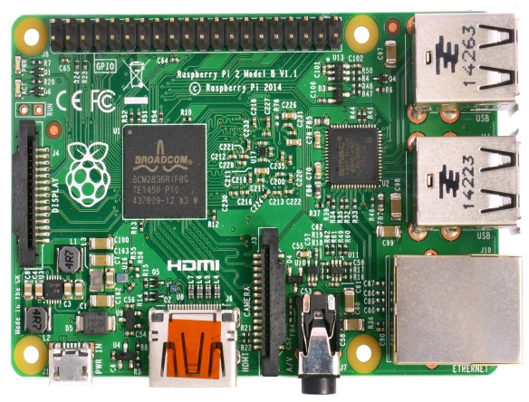

### ADC (Analogue to Digital Converter)

Analogue to digital converters are used to convert the Analogue Values of currents into Digital vales so they can further processed into the micro controllers. The micro controllers work on DC currents and the data processed by them should be in DC form. These converters are used to distribute 0 ~ 1023 values (1024 in total) into 0~5 volts.

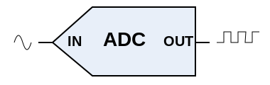

## Goals And Objectives

# Automated controlling of multiple electric appliances

# To manage, analyze and monitor bifurcated current,voltage and power values.

# Web development and designing.

# Micro-controllers and hardware integration with a online Application.

# 24 hours energy monitoring with built in energy back up.

# Remote access from web application.

# Application will be user-friendly, cost-effective, efficient and reliable.

# Chapter 2

Problem Defination

## 2.1 Problem Statement

As you know in the recent past years the energy crisis in our our country are raised to a great extent and the security threats are also increasing day by day one of which is house robbery so to overcome such problems wo are making this product. Another problem which pushed us for making this product is billing problems i.e in many hostels there are sub-meters which shows the units of an AC which means if there are 23 rooms in a hostel then you’ll need 23 sub-meters to measure the electric bill ,so in order to overcome this problem this product will give the value of electricity cost per month.

Another problem people face is the scheduling of their home appliances ,like if a person is out of station and he/she wants the electric appliances to automatically switched off and on at or after a particular time then using this product the scheduling of the product can be done very easily. Security and robbery threats can also be overcome using this product as you can monitor security cameras using a web video of your home, office etc security cameras can be watched any time using this product.

Now a days as we all know due to energy crisis every person and industry is using generators and measuring the amount of electricity any generator is consuming.

It is hard to find and there has to be a way to calculate that so in our product the total amount of electricity consumed by the generator of a particular electric appliance can also be calculated.which means in a house how much electricity is generated by an AC that is consumed by generator which will avoid overloading the generator.

## 2.2 Feasibility of new systems

The main problem now a days is overpricing of electricity and security threats to our home and offices etc. The project presented here is made to provide a one low cost and an easy technology solution.

The implication of this project is not so complicated and severe and the usage of the product is also very simple and is not so complicated. Therefore the product is quite easy and simple to implement in the houses, offices, banks, shopping malls or shops. It is a cheap solution for controlling the electricity cost and keep safe from any kind of security.

A web based integrated automation application by which we can control, observe and monitor our electrical systems, from any location. The system will enable the user to :

* Savings

We can manage the electricity usage by controlling all appliances like thermostat to smart sprinklers, staircase lights to garage. Almost 99% of all electrical appliances can be monitored and controlled efficiently. Cutting down line losses and resource wastage including water and energy.

* Control

Home automation helps people to get things done conveniently. For example, it helps to turn on the electronic appliances from the office laptop, remotely.Controlling is the basic function of this app, A Lighting control system can be used to switch lights based on a time cycle,. Lighting can be controlled remotely by a wireless control or over the Internet. Maintain the system smart enough to have an entire database of your facilities electricity bills and even the record of the life span of the appliance or product.

* Security

With home automation the lights of the room can be turned on and off, in case of threat or a emergency we can also watch video streaming of CCTV camera’s at home and most importantly making devices smart enough to email the owner and related authorities in case of any threat.

**During the recent years technology has jumped it’s curves with a rapidly. Computers are getting cheaper and advanced.The advancement in technology helping improve human’s lifestyle. The automation systems still today have an huge amount of potential to get technically more intelligent and smarter.**

Using the product on the web is very simple which does not require any special skills. The controlling of the product via web is very simple, user will login to main page of our web application and options will be given on the screen i.e scheduling monitoring surveillance bill management and user can click on any desired option which can be switching of any electric appliance off or on , scheduling of a particular electric device , watching the video of the security placed in home or office ,or it can include calculating the electricity bills.

## 2.3 Management Issues

The limitations or management issues in our product is that electricity should be available so that microcontroller can work properly , security camera should be of a good quality and should be water proof or placed at a location where it can’t get wet or damage.The wiring must be good shouldnot be cheap to avoid any short circuit or burning of the wire which can damage the product.

## 2.4 Current System

Currently there are many systems available in the market that provide real time power usage and monitoring. There are many different applications for home automation and surveillance systems in the United States of America, France , Germany and China. Already in different areas of world work is been by different students of science and technology. But after a very thorough research on we came to find no product which integrates all important aspects such as automation, surveillance and monitoring facilities which a modern homes, offices or any area requires and binds it all into a single, complete cutting edge product.

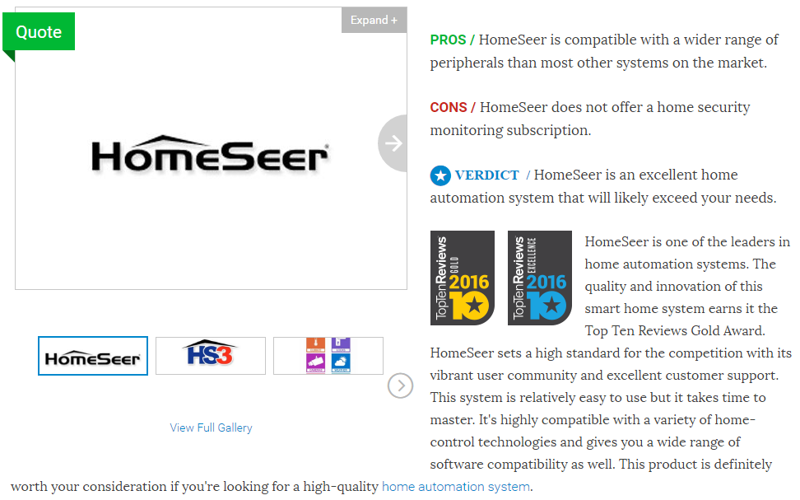

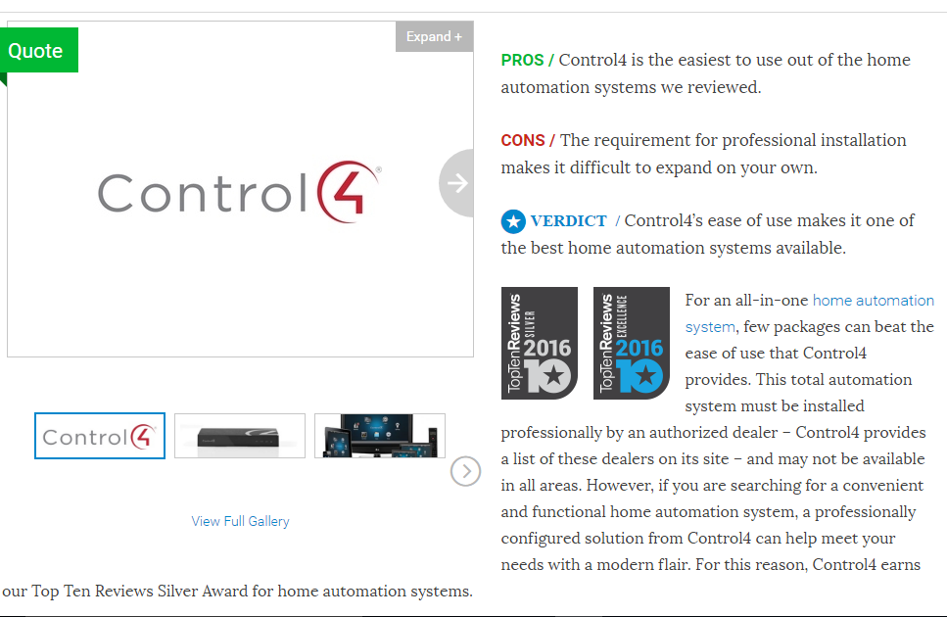

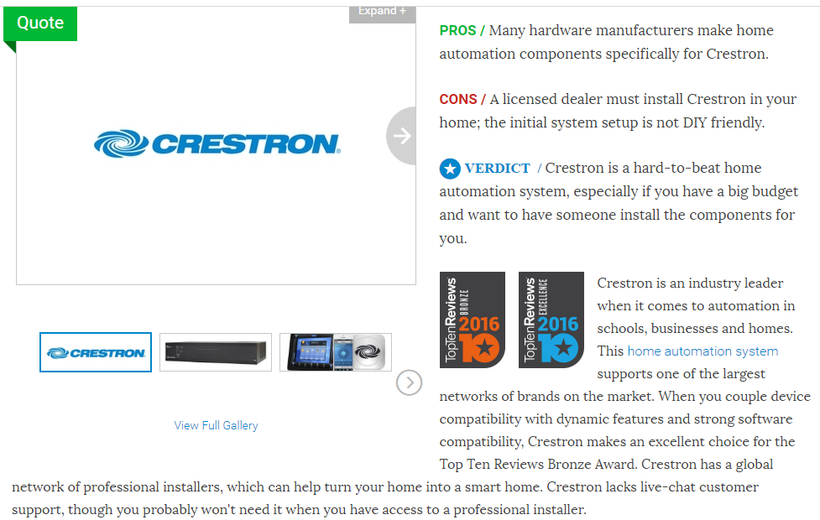

# Chapter 3 Requiremental Analysis

## 3.1 Functional Requiremnets

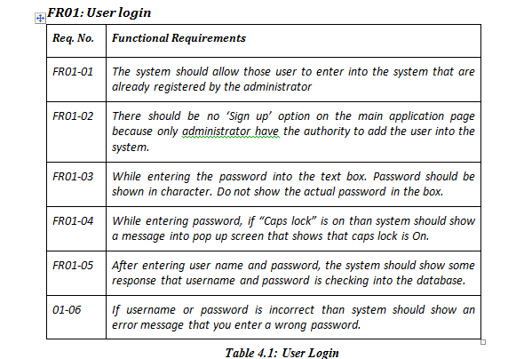

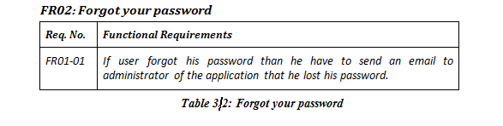

## 

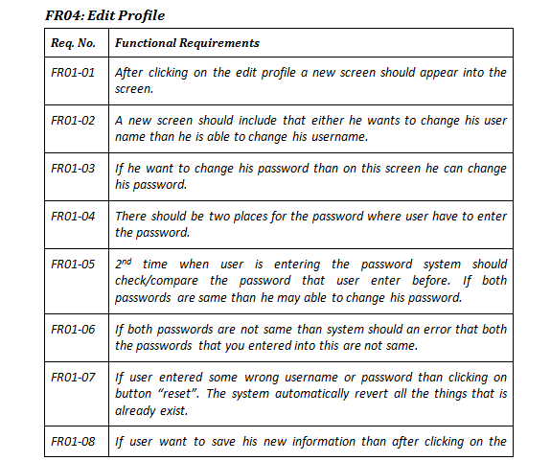

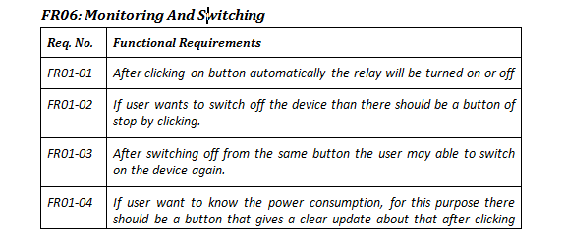

## 3.2 Non-Functional Requirements

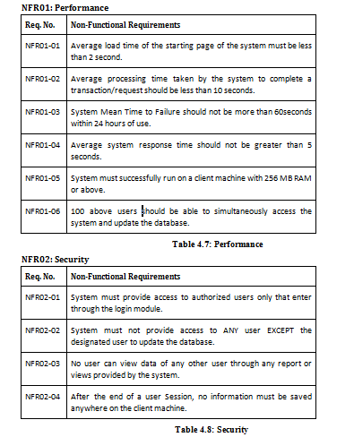

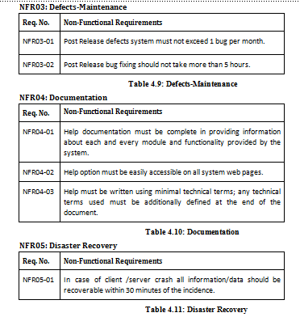

# Chapter 4 Design & Architecture

## 4.1 System Architecture

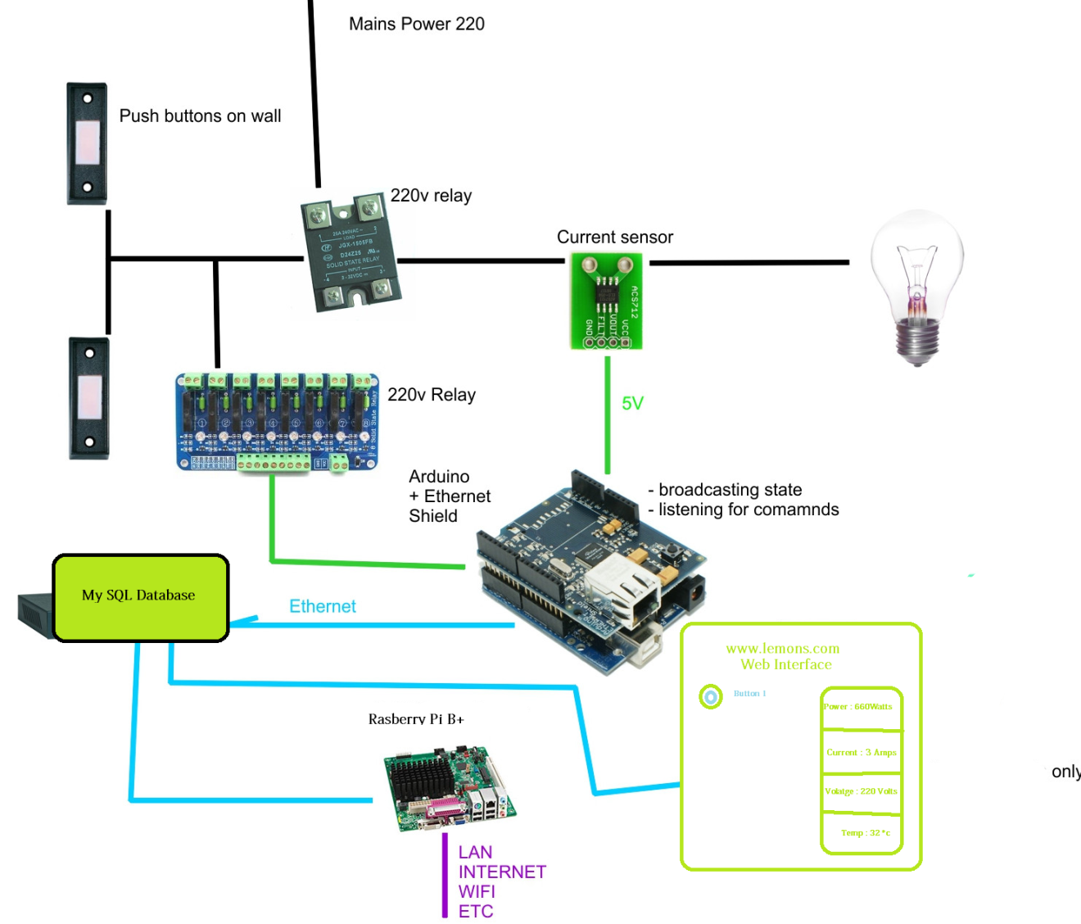

### Use Case Diagram’s

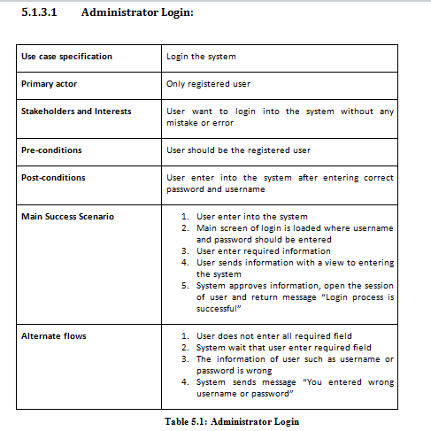

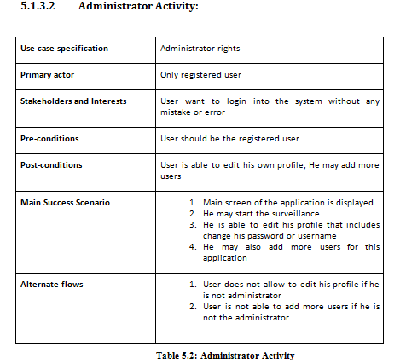

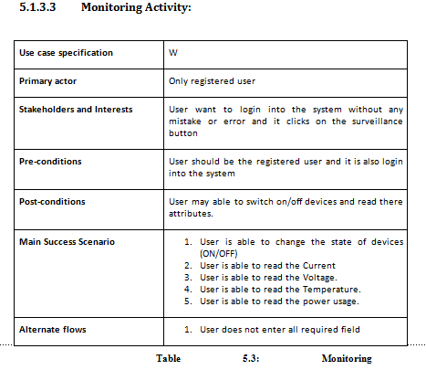

## System Design

The web interface has been created using HTML and CSS. The server side scripting language used is PHP.

### Main Login Screen

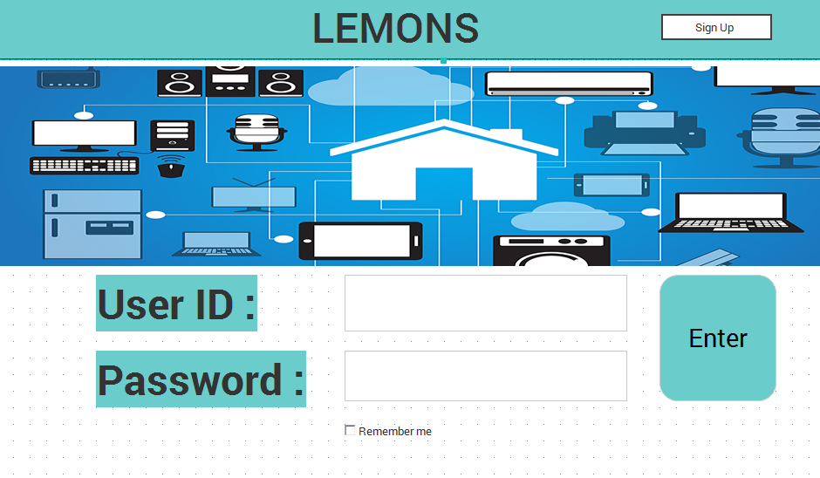

### Main Screen

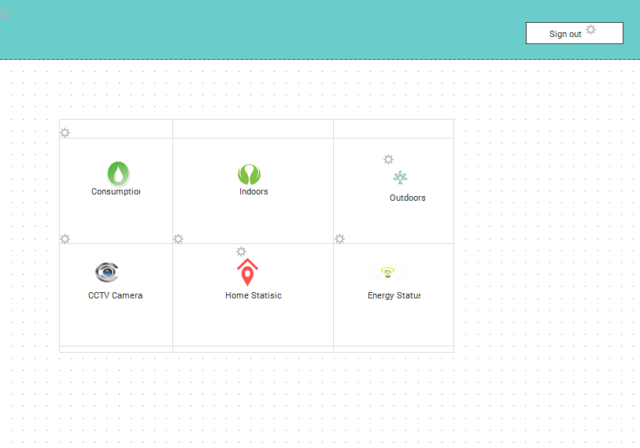

### Sign up Page

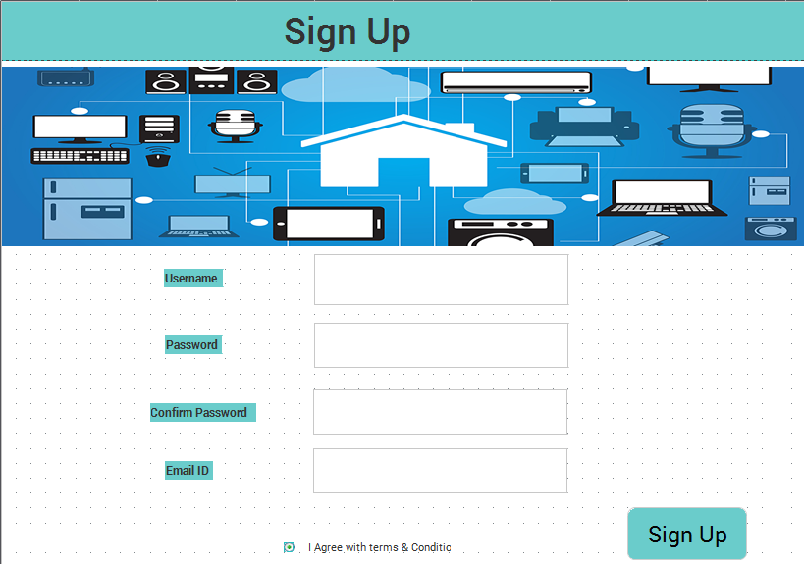

## Usability Testing

### 

### After conducting the usability testing there were some problems which were diagnosed as the values of current were not coming out as absolute values. The absolute function values will make all values positive.

# Chapter 5 Implementation

Brief Summary:

The Implementation of the projects starts with the Arduino C-programming language and and other analogue sensors which process the analogue values in digital values,

Two main functions read the values and parse it to the serial port

void loop();

void begin();

Baud rate is to be selected which is in this case 9600. The speed at which the devices will talk to each other.

Then through serial communication the data is sent to Rasberry Pi, Which has a built in operating system installed called Rasbian. The Rasbian supports the MySQl database connector. The data will be sent to the MYSQL database.

And then the values will be reflected by the website using php and html.

## 5.1 Software

### C Programing Language, Python Programing Language,

### Sequectional Query Language,

### Electronics, Digital Logic Design, Proteus

### HTML 5 CSS PHP.

**High Fidelity:**

Just-in-mind Prototyper

**Adobe Dreamweaver:**

For the development of website.

## 5.2 Hardware

### 5.2.1 Arduino

**Arduino** is a software company, project, and user community that designs and manufactures computer [open-source hardware](https://en.wikipedia.org/wiki/Open-source_hardware), [open-source software](https://en.wikipedia.org/wiki/Open-source_software), and [microcontroller](https://en.wikipedia.org/wiki/Microcontroller)-based kits for building digital devices and interactive objects that can sense and control physical devices.

### 5.2.2 Raspberry pie

The **Raspberry Pi** is just a [credit card](https://en.wikipedia.org/wiki/Credit_card)-sized [single-board computers](https://en.wikipedia.org/wiki/Single-board_computer) developed in the [United Kingdom](https://en.wikipedia.org/wiki/United_Kingdom) by the [Raspberry Pi Foundation](https://en.wikipedia.org/wiki/Raspberry_Pi_Foundation) with the intent to promote the teaching of basic [computer science](https://en.wikipedia.org/wiki/Computer_science) in schools and [developing countries](https://en.wikipedia.org/wiki/Developing_countries).[[8]](https://en.wikipedia.org/wiki/Raspberry_Pi#cite_note-8)[[9]](https://en.wikipedia.org/wiki/Raspberry_Pi#cite_note-9)[[10]](https://en.wikipedia.org/wiki/Raspberry_Pi#cite_note-10) The original Raspberry Pi and Raspberry Pi 2 are manufactured in several board configurations through licensed manufacturing agreements with [Newark element14](https://en.wikipedia.org/wiki/Newark_element14) ([Premier Farnell](https://en.wikipedia.org/wiki/Premier_Farnell)), [RS Components](https://en.wikipedia.org/wiki/RS_Components) and Egoman.[[11]](https://en.wikipedia.org/wiki/Raspberry_Pi#cite_note-11) The hardware is the same across all manufacturers. The firmware is [closed-source](https://en.wikipedia.org/wiki/Closed-source). ([www.wikipedia.com](http://www.wikipedia.com))

# Chapter 6 Learning

Final year project is the most important thing in the four years of a student bachelor life so one should do it by all his will and devotion.Final year project is one of the ways to learn new things and ideas and also it is a best chance to revise all the things quickly that are learned in the four years,

In this project we also learned some new languages and had a chance to revise previously studied things.Some main and basic languages learned during this project are given below.

## 6.1Learning of C Programming language

As you know Arduino is one the basic components of our project and C language is implemented on it, so for this reason we use C programming language.We haven’t faced any difficulty in this language because we have studied this language and have some great and basic concepts about it.

## 6.2 Learning of Python Programming Language

Raspberry Pi one of the main thing that is used in our project is used by Python programming Language.In our degree we haven’t studied this language so we took tutorials and took some help from our supervisor for learning the concept of this language.

## 6.3 Hyper Text Mark-up Language

Our product is controlled via web application so in order to make a web application we need Hyper Text Mark-up Language (HTML).This is an easy language so we just took basic lectures from youtube about the working and implementation of this language as we aren’t offered this languagee in our degree.

## 6.4 Learning of Cascading Style Sheets (CSS) Language

As described earlier our project uses web application to control the product for which HTML is used for making a web application whereas Cascading Style Sheets (CSS) is used for the styling of HTML.This language is more simple and easy to understand .

## 6.6 Learning of PHP

As we know PHP works at the backend so this language is used in server site scripting ,which means all the work done at the backend of the web application is controlled by PHP.We aren’t offered this Language in our degree so we took some coaching classes for learning this language as it is one of the most important language now a days.

# Chapter 7 Achievements

## 7.1 Gantt Chart

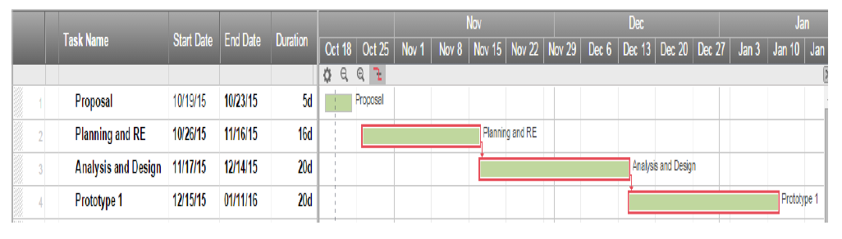

## 7.2 Achievements and Work

By the grace of Allah and help of our supervisor we have accomplished an idea that at one stage seemed very difficult and complicated to manage but now we have made the this product that isn’t introduced in Pakistan yet with such components , attributes and working. This project can be further implemented in countries where electric cars and clean energy is supported. Energy is one of the greatest gifts of mother nature. In coming years as fossil fuels are running out and environmental issues, it would be mandatory for every country to have a clean energy policy. This system can be further improvised and improved for the coming challenges of energy crisis on planet earth.

# Chapter 8 Individual Contribution

**Dr. Muhammad Husnain Chaudary (**Supervisor**)**

* Project supervision.
* Modules configuration.
* Networking tools
* Serial Communication

**Ahmad Bashir(**Group Leader**)**

* Micro-controller and hardware controlling through Window’s.
* Prototype Development
* Research and Development
* Project Documentation.

**Umer Fayyaz**

* Andriod Application development
* Andriod UI Design (GUI Desiging).
* Project Documentation
* Research and Development

**Zeeshan Arshad**

* Project Management.
* Hardware and Software Resource Planning.
* Research and Development of product.
* Product Design.

# Chapter 9 Conclusion & Future Work

## 9.1 Conclusion

In conclusion we all participants in the development of this product and our supervisor, we strongly believe that the final product is a cutting edge, revolutionary idea to make future smart houses, schools and industries. We firmly believe that our product has a great maket vaue.There are a few advantage we would like to share in conclusion, as far as our research results tell that to this date there are no as such products available in the market, which include all the features our product is offering. In some cases the products which are already available do have some of the functionalities we are offering but as a whole package, we were unable to find any competitor to our product in the market .Our product has some key features

* Scalable
* Maintainable
* Simple and sleek.
* Cheap
* Open-Source
* Energy efficient system. (Microcontroller power consumption 1.21 Watts)

The source code will shortly will updated on *Github:* an online repository as soon as our Final year project is presented and completed.

*https://github.com/jaytronlabs/Lemons*

for source codes of open source projects.and we are providing installations instructions on setting up home automation and monitoring system. And we know we are unable to complete video survillance module. But we hope that on presentation day we will manage to give away the idea to the audience about our module. We have the system almost complete and ready to go within a week. Hence we feel that there is no beeter product available in the market offering as many functionalities we are offering with such compact and user-friendly technologies.

## 9.2 Future Work

In future,

* There can be more sensors and control devices attached to this system very easily.
* The billing system module can be further attached with the devices so that we can have our data and bills reflected on the database. A pdf bill can be generated as well by that module to use in hostels and to sell electricity in villages and industries.
* Mobile application can be further launched to control, monitor and schedule the tasks. Mobile applications can further developed in the furute projects. As due to a recent study 60% of the internet users are accessing the internet from mobiles phones. This tells how much important it is to launch an mobile application as a client side application for the monitoring of LEMONS.

Our product is sound and complete. However in the world of technologies and engineering nothing is perfect and there is plenty of room for future work and integration of modern technologies. We hope that our product can play a vital part in the conservation of energy which is one of the top issues of or planet and provide a user friendly experience to users who can control and monitor the energy of there enviroments in smart and efficient ways.

# Chapter 10 Bibliography

References to any book, journal paper or website should properly be acknowledged, For example.

1. <http://users.ece.gatech.edu/owen/Academic/ECE4006/ECE4006_Fall2000/Example_Projects/home_automation/Home_Automation_Final_Report.pdf>
2. <https://www.python.org/doc/>
3. <https://github.com/geerlingguy/raspberry-pi-dramble/wiki/Power-Consumption>
4. <https://pypi.python.org/pypi?%3Aaction=index>
5. http://www.youtube.com/pythonprog
6. <http://www.stackoverflow.com>
7. <http://www.quora.com>
8. <http://www.pythonprogramming.com>
9. <http://www.w3schools.com>

<http://www.tutorialspoint.com>

<http://www.oracle.com>

<http://www.htmllearning.com>

<http://www.instructables.com>

<http://www.cascadinghacker.com>

<http://www.diyhacker.com>

http://www.diyhacker.blogspot.com

http://www.mysqlware.blogspot.com

<http://www.sackoverflow.com>/pythonscripting

<http://www.picworld.com>

<http://www.proteus.com>

<http://www.kickstarter.com>/homeautomation

<http://www.homeautomaton.com>

<http://users.ece.gatech.edu/owen/Academic/ECE4006/ECE4006_Fall2000/Example_Projects/home_automation/Home_Automation_Final_Report.pdf>

<https://www.python.org/doc/>

<https://github.com/geerlingguy/raspberry-pi-dramble/wiki/Power-Consumption>

<https://pypi.python.org/pypi?%3Aaction=index>

http://www.youtube.com/pythonprog

<http://www.stackoverflow.com>

<http://www.quora.com>

<http://www.pythonprogramming.com>

www.diyhacker.blogspot.com

http://www.mysqlware.blogspot.com

<http://www.sackoverflow.com>/pythonscripting

<http://www.picworld.com>

<http://www.proteus.com>

<http://www.kickstarter.com>/homeautomation

<http://www.homeautomaton.com>

<http://users.ece.gatech.edu/owen/Academic/ECE4006/ECE4006_Fall2000/Example_Projects/home_automation/Home_Automation_Final_Report.pdf>

1. <http://users.ece.gatech.edu/owen/Academic/ECE4006/ECE4006_Fall2000/Example_Projects/home_automation/Home_Automation_Final_Report.pdf>
2. <https://www.python.org/doc/>
3. <https://github.com/geerlingguy/raspberry-pi-dramble/wiki/Power-Consumption>
4. <https://pypi.python.org/pypi?%3Aaction=index>
5. http://www.youtube.com/pythonprog
6. <http://www.stackoverflow.com>
7. <http://www.quora.com>
8. <http://www.pythonprogramming.com>
9. <http://www.w3schools.com>

APPENDICES

1. ANY OTHER SUPPORTING SCHEDULES or DOCUMENTS

Appendix A

*Include here the 1st page of Turnitin Report*

Every supervisor has his/her own Turnitin account. If not then the supervisors are requested to get the account from Library as soon as possible.