**Design Document for Tetris Game**

Group 2_SC_3

Jay Tiwari

Zach Morris

Jesse Slater

John Mindrup

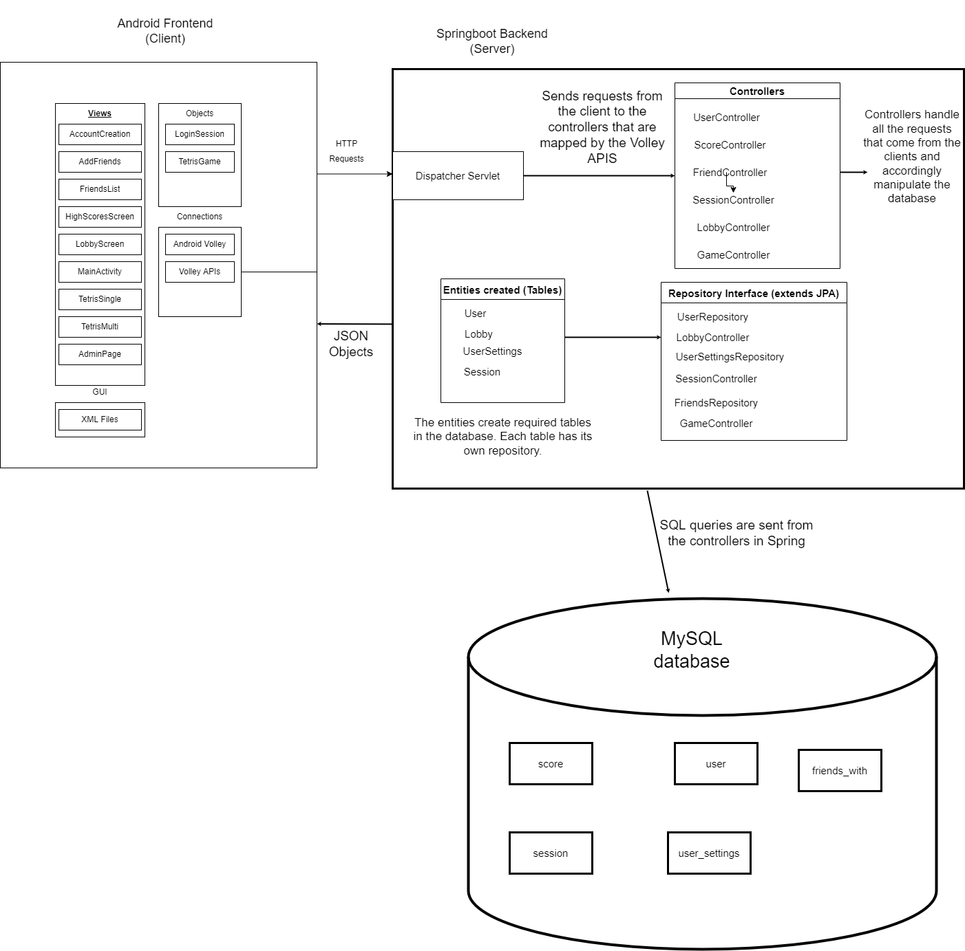

**Design Description**

Overall description:

Our application allows users to play a game of Tetris by themselves or against an opponent. The user can create an account which saves their high score and other accounts who they are friends with. The user can challenge their friends to a game of Tetris or see their friends’ highscores. There are also administrative users who can delete other users' accounts and alter a variety of things about other users.

Frontend-Backend communication:

The frontend Android application communicates with the Springboot server by utilizing the Android Volley library to send GET/POST requests to the server. The application sends information to specific URLs and the server either stores the information or sends back the requested JSON objects to the application. Players must login or create an account in order to play multiplayer games. When logged in the player receives a login token which uniquely identifies the user's login session.

Tetris Game:

The game of Tetris works by giving the player a randomly generated 4 part piece which they have to carefully place on the game board. They can move and rotate the piece as it falls to the bottom. The player is awarded points by filling a full row of tiles, said row will then be cleared. Multiplayer works by having the two players play the tetris game at the same time while being able to see the other player’s board as well as their own. Players will compete for the highest score.

