Spring MVC framework

Introduction
1. Spring MVC is sub framework of Spring Framework, used to build web applications.
2. *** Built on top of SERVLET API. ***
3. Unlike normal servlet JSP web apps this follows MVC pattern as default.
4. Implements all basic features of a core spring framework like Inversion of control, Dependency Injection.

Why ?
1. Separation of concerns (MVC).
2. Powerful configuration
3. Core spring features (IOC, DI) which results into loosely coupled code
4. Spring mvc is flexible, easy to test

MVC pattern
Controller (servlet)
View (jsp)
Model (data)

Working of Spring MVC
Client – Server
Client ------request------> Front Controller/ Dispatcher Servlet (only accepts request) ------delegate request (using handler mapping)------> Controller (actually handles the request using DAO and Service layer) ------model and name of view------> Front Controller ------model (mapping using view resolver)------> View template ------response------> Front Controller ------response------> Client

Mandatory dependencies
<dependency>
<groupId>org.springframework</groupId>
<artifactId>spring-webmvc</artifactId>
<version>5.2.4.RELEASE</version>
</dependency>

<dependency>
<groupId>javax.servlet</groupId>
<artifactId>javax.servlet-api</artifactId>
<version>3.0.1</version>
<scope>provided</scope>
</dependency>

Crucial Steps
1. configure front controller / dispatcher servlet in web.xml
2. create spring config file (declare beans)
3. configure view resolver
4. create controller
5. create view
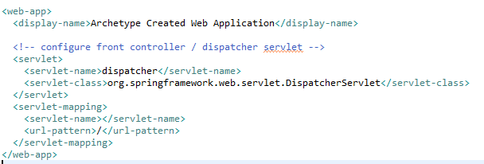
1.

2. spring config file in WEB-INF with name as: (front controller or dispatcher servlet’s name)-servlet.xml and boiler configuration will be picked from these resources:
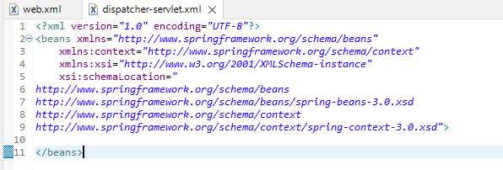

3. configure view resolver by adding bean of class org.springframework.web.servlet.view.InternalResourceViewResolver

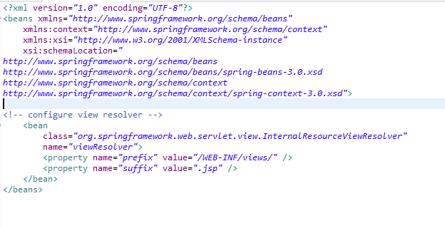
4. creating controllers (controller should return viewname)

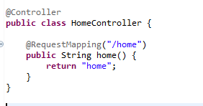

5. create view (/src/main/webapp/WEB-INF/views)
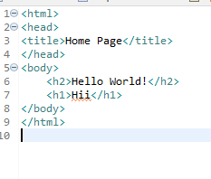

**** DO NOT FORGET ****

in dispatcher-servlet.xml

Transfer data from Controller to JSP:
1. Model
1. controller method return type: string (name of jsp)
2. model object is declared in method declaration as a parameter and is injected by spring at runtime
3. model.addAttribute(key, object)
4. getting attributes in jsp requires typecasting
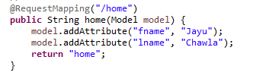

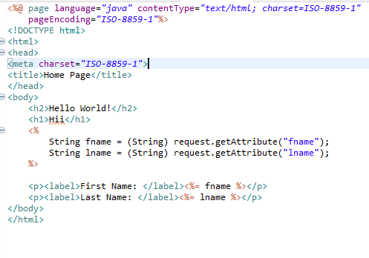

2. ModelAndView
1. controller method return type: ModelAndView (pass view to setViewName method)
2. model.addObject(key, object)
3. getting attribute is same as in model
