CS4881 Artificial Intelligence Jay Urbain

Problem Set 3-5 – Designing Logical Agents for Acting Under Uncertainty

Naive Bayes is a simple technique for constructing classifiers: models that assign class labels to problem instances, represented as vectors of feature values, where the class labels are drawn from some finite set. It is not a single algorithm for training such classifiers, but a family of algorithms based on a common principle: all naive Bayes classifiers assume that the value of a particular feature is independent of the value of any other feature, given the class variable. For example, a fruit may be considered to be an apple if it is red, round, and about 10 cm in diameter. A naive Bayes classifier considers each of these features to contribute independently to the probability that this fruit is an apple, regardless of any possible correlations between the color, roundness, and diameter features.

Abstractly, naive Bayes is a conditional probability model: given a problem instance to be classified, represented by a vector representing some n features (independent variables):
It assigns to this instance probabilities.
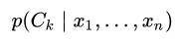
for each of K possible outcomes or classes: C_{k}.

The problem with the above formulation is that if the number of features n is large or if a feature can take on a large number of values, then basing such a model on probability tables is infeasible. We therefore reformulate the model to make it more tractable. Using Bayes' theorem, the conditional probability can be decomposed as

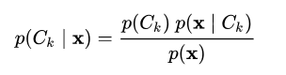

In plain English, using Bayesian probability terminology, the above equation can be written as:
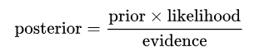

Assignment

- Extend your knowledge-based Wumpus Agent, from Problem Set 3 to use Naive Bayes (NB) uncertainty reasoning when selecting next moves.
Notes:
- Prior: prior probability should be distributed evenly among all possible moves. For example, if there are three available moves, the prior is ~0.33.
- Likelihood: is the probability of move k given your accumulated knowledge.
- Evidence: sum of all possible likelihood for all values of k (moves).
- Posterior: normalized probability of move k.
Submission:
Quality of reports and analysis will be rewarded. Submit report, results, and analysis as a PDF file with your name, class, and problem set number along with your project archive to Blackboard. A demo is required!

