
CONTAINERIZED APPLICATION DEPLOYMENT ON AWS USING DOCKER, JENKINS, GITHUB, AND DEVOPS PRACTICES

A Project Report
Submitted in partial fulfillment of the requirements for the award of the degree of
Bachelor of Technology
in
Computer Science and Engineering



Submitted By: Jay Uttam
Registration Number: 12300557

CERTIFICATE
This is to certify that the project report entitled “Containerized Application Deployment on AWS Using Docker, Jenkins, GitHub, and DevOps Practices” submitted by Jay Uttam in partial fulfillment for the award of the degree of Bachelor of Technology in Computer Science and Engineering is a record of genuine work carried out under our supervision and guidance.
The work presented in this report has not been submitted elsewhere for the award of any degree or diploma.

Project Guide Signature: ____________________
Head of Department Signature: ____________________
Date: ____________________

DECLARATION
I hereby declare that the project report entitled “Containerized Application Deployment on AWS Using Docker, Jenkins, GitHub, and DevOps Practices” submitted in partial fulfillment for the award of the degree of Bachelor of Technology in Computer Science and Engineering is my original work.
The information submitted in this report is true to the best of my knowledge and belief.

Signature of Student: ____________________
Name: Jay Uttam
Date: ____________________

ACKNOWLEDGEMENT
I would like to express my sincere gratitude to my project guide and the faculty members of the Department of Computer Science and Engineering for their valuable guidance, continuous support, and encouragement throughout the development of this project.
I am thankful to the department for providing the necessary resources and opportunities required for the successful completion of this work.
I also extend my appreciation to all those who directly or indirectly contributed to this project through their suggestions, technical assistance, and constructive feedback.
This project has provided me with practical exposure to modern DevOps tools and cloud deployment technologies, and I am grateful for the learning experience gained during its implementation.

ABSTRACT
The rapid growth of cloud computing and DevOps practices has transformed the software deployment lifecycle. Traditional deployment methods are often time-consuming, error-prone, and difficult to scale. This project focuses on automating the deployment process of a machine learning web application using Docker, Jenkins, GitHub, and Amazon Web Services (AWS).
The application used in this project is a Retail Sales Forecasting application developed using Python and Streamlit. The project integrates GitHub for source code management, Docker for containerization, Jenkins for CI/CD automation, and AWS EC2 for cloud deployment.
The implementation demonstrates how Continuous Integration and Continuous Deployment (CI/CD) pipelines can automate application deployment processes efficiently. Docker ensures consistent application environments, while Jenkins automates build and deployment workflows. AWS EC2 provides scalable cloud infrastructure for hosting the application.
The project also addresses challenges faced during deployment, including memory limitations on AWS free-tier infrastructure and optimization of Dockerized machine learning deployments.
This project provides practical exposure to DevOps tools and demonstrates the importance of automation in modern software engineering.

TABLE OF CONTENTS

- Introduction
- Background of DevOps
- Literature Review
- Problem Statement
- Objectives
- Scope of the Project
- Proposed System
- System Architecture
- Technologies Used
- Docker Implementation
- Jenkins CI/CD Pipeline
- AWS EC2 Deployment
- Prometheus & Grafana Monitioring
- GitHub Integration
- Application Implementation
- Challenges Faced
- Results and Outcomes
- Advantages of the System
- Future Scope
- Conclusion
- References

CHAPTER 1: INTRODUCTION
1.1 Introduction to DevOps
DevOps is a modern software development methodology that combines software development (Dev) and IT operations (Ops) to improve collaboration, automation, and software delivery speed. It focuses on reducing the gap between development and deployment teams by automating workflows and infrastructure management.
In traditional software deployment models, developers manually transfer application code to production environments. This process is often slow, inconsistent, and prone to errors. DevOps solves these issues by introducing Continuous Integration (CI) and Continuous Deployment (CD) practices.
Continuous Integration refers to the process of automatically integrating code changes into a shared repository, while Continuous Deployment automates the process of deploying applications to production environments.
This project demonstrates the implementation of DevOps practices using Docker, Jenkins, GitHub, and AWS EC2 for deploying a machine learning application.

1.2 Need for Automation
Modern software applications require rapid development and deployment cycles. Manual deployment processes introduce delays, inconsistencies, and operational risks.
Automation provides several advantages:
- Faster deployment cycles
- Reduced manual effort
- Consistent environments
- Improved reliability
- Better scalability
- Reduced deployment errors
Automation is especially important for machine learning applications that depend on multiple libraries and frameworks.

1.3 Overview of the Project
This project focuses on containerizing a Retail Sales Forecasting application and deploying it using a Jenkins CI/CD pipeline on AWS cloud infrastructure.
The workflow implemented in this project is:
Developer → GitHub → Jenkins → Docker → AWS EC2 → Live Application
The application is developed using Python and Streamlit. Docker is used to package the application and dependencies into a container. Jenkins automates deployment tasks, while AWS EC2 hosts the application.

CHAPTER 2: BACKGROUND OF DEVOPS
2.1 Evolution of Software Deployment
Software deployment has evolved significantly over the years. Initially, software applications were deployed manually on physical servers. Manual deployment required developers to configure environments individually, which often caused compatibility issues.
With the rise of cloud computing and distributed systems, organizations required faster and more reliable deployment methods. This led to the adoption of DevOps practices.

2.2 Continuous Integration and Continuous Deployment
Continuous Integration (CI) allows developers to frequently merge code into a shared repository. Automated tools then build and test the application.
Continuous Deployment (CD) automates the release process by deploying applications automatically after successful builds.
Benefits of CI/CD include:
- Faster delivery
- Improved collaboration
- Automated testing
- Reduced downtime
- Increased productivity

2.3 Importance of Containerization
Containerization allows applications to run consistently across different systems by packaging the application with all required dependencies.
Docker is one of the most widely used containerization platforms.
Advantages of Docker include:
- Portability
- Lightweight deployment
- Isolation
- Faster scaling
- Simplified dependency management

CHAPTER 3: LITERATURE REVIEW
Several organizations and researchers have explored DevOps and cloud deployment technologies to improve software delivery efficiency.
Research studies indicate that CI/CD pipelines significantly reduce deployment time and increase deployment reliability. Jenkins has become one of the most widely adopted automation servers due to its flexibility and plugin ecosystem.
Docker containerization has transformed software deployment by eliminating compatibility issues and enabling lightweight virtualization.
Cloud platforms such as AWS provide scalable infrastructure that supports modern DevOps workflows.
The integration of Docker, Jenkins, GitHub, and AWS has become a standard approach for implementing modern deployment pipelines.
Machine learning applications particularly benefit from containerization because they depend on multiple heavy libraries such as NumPy, Pandas, Scikit-learn, and XGBoost.

CHAPTER 4: PROBLEM STATEMENT
Traditional software deployment methods are inefficient and difficult to maintain.
The major problems associated with manual deployment are:
- Time-consuming deployment process
- Environment inconsistency
- Dependency conflicts
- Human errors during deployment
- Difficult rollback procedures
- Lack of automation
- Slow software delivery cycles
Machine learning applications face additional challenges due to large dependencies and complex environments.
This project aims to solve these problems by implementing an automated DevOps pipeline using Docker, Jenkins, GitHub, and AWS.

CHAPTER 5: OBJECTIVES
The primary objectives of this project are:
- To automate application deployment using DevOps practices.
- To containerize the machine learning application using Docker.
- To implement a Jenkins CI/CD pipeline.
- To integrate GitHub with Jenkins.
- To deploy the application on AWS EC2.
- To reduce manual deployment effort.
- To improve deployment consistency and reliability.
- To provide practical exposure to cloud and DevOps technologies.

CHAPTER 6: SCOPE OF THE PROJECT
The project demonstrates the implementation of DevOps concepts in a cloud environment.
The scope includes:
- Source code management using GitHub
- Containerization using Docker
- Deployment automation using Jenkins
- Cloud deployment using AWS EC2
- Hosting a machine learning web application
The project can be extended further using:
- Kubernetes
- Terraform
- AWS ECS/EKS
- Auto-scaling infrastructure
- Monitoring and logging systems

CHAPTER 7: PROPOSED SYSTEM
The proposed system automates the deployment lifecycle of a machine learning application.
The system architecture consists of the following components:
- GitHub Repository
- Jenkins CI/CD Pipeline
- Docker Container
- AWS EC2 Instance
- Streamlit Application
The deployment workflow is:
- Developer pushes code to GitHub.
- Jenkins pulls the latest code.
- Docker container is created or updated.
- Application is deployed on AWS EC2.
- Users access the application through a public IP address.
This approach minimizes manual effort and ensures deployment consistency.

CHAPTER 8: SYSTEM ARCHITECTURE
8.1 Architecture Overview
The architecture of the project integrates multiple DevOps tools into a unified deployment pipeline.
The workflow can be represented as:
Developer → GitHub → Jenkins → Docker → AWS EC2 → Live Application
8.2 Components of the Architecture
GitHub
Used for version control and source code management.
Jenkins
Used for automating build and deployment processes.
Docker
Used for containerizing the application and dependencies.
AWS EC2
Provides cloud infrastructure for hosting the application.
Streamlit Application
Acts as the frontend interface for the machine learning application.

CHAPTER 9: TECHNOLOGIES USED
9.1 Python
Python is used as the primary programming language due to its simplicity and rich machine learning ecosystem.
9.2 Streamlit
Streamlit is used to create the frontend interface for the Retail Sales Forecasting application.
9.3 Docker
Docker is used to containerize the application and dependencies.
9.4 Jenkins
Jenkins automates the CI/CD pipeline.
9.5 GitHub
GitHub is used for version control and collaboration.
9.6 AWS EC2
AWS EC2 provides cloud-based virtual machines for hosting the application.

CHAPTER 10: DOCKER IMPLEMENTATION
10.1 Introduction to Docker
Docker is a containerization platform that packages applications with all required dependencies.
10.2 Dockerfile
The Dockerfile defines instructions for creating the Docker image.
Key Dockerfile instructions used in the project:
- FROM
- WORKDIR
- COPY
- RUN
- EXPOSE
- CMD
10.3 Benefits of Docker in the Project
- Consistent environments
- Simplified deployment
- Portability
- Dependency management
- Faster deployment process
10.4 Docker Image Creation
The Docker image was built using the following command:
sudo docker build -t retail-forecast .
10.5 Running Docker Container
The application container was executed using:
sudo docker run -d -p 8501:8501 retail-forecast

CHAPTER 11: JENKINS CI/CD PIPELINE
11.1 Introduction to Jenkins
Jenkins is an open-source automation server used for implementing Continuous Integration and Continuous Deployment pipelines.
11.2 Jenkins Pipeline Workflow
The Jenkins pipeline performs the following tasks:
- Clone repository from GitHub
- Stop old Docker container
- Deploy updated container
11.3 Jenkinsfile
The Jenkins pipeline configuration was stored inside a Jenkinsfile.
11.4 Benefits of Jenkins
- Automated deployment
- Reduced manual effort
- Faster software delivery
- Improved reliability
11.5 Jenkins Deployment Challenges
The project encountered memory-related challenges due to AWS free-tier limitations.
These issues were resolved by:
- Optimizing the Jenkins pipeline
- Using prebuilt Docker images
- Reducing repeated dependency installation
CHAPTER 12: AWS EC2 DEPLOYMENT
12.1 Introduction to AWS EC2
Amazon Elastic Compute Cloud (EC2) provides scalable cloud-based virtual machines.

12.2 EC2 Instance Configuration
The project used a t3.micro AWS EC2 instance.
Security group ports enabled:
- Port 22 (SSH)
- Port 8080 (Jenkins)
- Port 8501 (Streamlit Application)
12.3 Deployment Process
The deployment process involved:
- Launching AWS EC2 instance
- Connecting using SSH
- Installing Docker
- Configuring Jenkins
- Deploying Docker container
12.4 Public Application Access
The deployed application was accessed through the public IP address of the EC2 instance.

CHAPTER 13: GITHUB INTEGRATION
13.1 Version Control
GitHub was used as the central repository for storing project code.
13.2 Benefits of GitHub Integration
- Version tracking
- Collaboration
- Centralized code storage
- Easy rollback
- CI/CD integration
13.3 Git Workflow
The workflow followed in the project:
- Modify code locally
- Commit changes
- Push code to GitHub
- Jenkins pulls updated code
- Deployment pipeline executes automatically

Chapter 14: Prometheus Monitoring
14.1 Introduction to Prometheus
Prometheus is an open-source monitoring and alerting tool used to collect system metrics.
14.2 Role in the Project
Prometheus was used to monitor:
- CPU usage
- RAM usage
- Disk utilization
- Container performance
14.3 Integration Process
- Installed Prometheus on EC2
- Configured target endpoints
- Connected metrics with Grafana dashboard
Chapter 15: Grafana Dashboard Visualization
15.1 Introduction to Grafana
Grafana is an open-source visualization platform used for displaying monitoring metrics.
15.2 Role in the Project
Grafana was used to visualize:
- Server health metrics
- CPU monitoring
- Memory usage
- Real-time performance analytics
15.3 Dashboard Features
- Live monitoring graphs
- Interactive visualization
- Better infrastructure monitoring

CHAPTER 16: APPLICATION IMPLEMENTATION
16.1 Retail Sales Forecasting Application
The machine learning application predicts retail sales based on input features.
16.2 Frontend Interface
The frontend interface was developed using Streamlit.
16.3 Machine Learning Workflow
The application processes user inputs and generates predictions using trained machine learning models.
16.4 Deployment Integration
The application was integrated into Docker and deployed using Jenkins on AWS EC2.

CHAPTER 17: CHALLENGES FACED
Several challenges were encountered during project implementation.
17.1 Memory Limitations
AWS free-tier infrastructure had limited RAM, causing Docker builds to slow down.
17.2 Jenkins Configuration Issues
Jenkins required Docker socket integration to execute Docker commands.
17.3 Large Machine Learning Dependencies
Libraries such as Pandas, NumPy, Scikit-learn, and XGBoost increased Docker build complexity.
17.4 CI/CD Pipeline Optimization
The pipeline was optimized to use prebuilt Docker images to reduce resource consumption.

CHAPTER 18: RESULTS AND OUTCOMES
The project successfully implemented a working DevOps deployment pipeline.
Key outcomes achieved:
- Successful Docker containerization
- Jenkins CI/CD automation
- GitHub integration
- AWS cloud deployment
- Automated application deployment
- Live web application hosting
The project demonstrated the practical implementation of modern DevOps practices.

CHAPTER 19: ADVANTAGES OF THE SYSTEM
The implemented system offers several advantages:
- Automated deployment
- Faster delivery cycles
- Reduced manual errors
- Improved scalability
- Better maintainability
- Consistent deployment environments
- Simplified dependency management

CHAPTER 20: FUTURE SCOPE
The project can be enhanced using advanced cloud and DevOps technologies.
Future improvements include:
- Kubernetes orchestration
- Terraform infrastructure automation
- AWS ECS/EKS deployment
- Monitoring and logging systems
- Auto-scaling infrastructure
- GitHub Webhooks integration
- Security enhancements

CONCLUSION

This project successfully implemented a DevOps-based deployment pipeline for a machine learning web application using Docker, Jenkins, GitHub, and AWS EC2.
The project demonstrated the importance of automation, containerization, and cloud deployment in modern software engineering.
Docker ensured consistent deployment environments, Jenkins automated deployment workflows, GitHub managed source code, and AWS EC2 hosted the application in the cloud.
The project provided practical experience with real-world DevOps tools and deployment strategies.
Despite challenges related to AWS free-tier limitations and heavy machine learning dependencies, the deployment pipeline was successfully implemented and optimized.
The project highlights how DevOps practices improve software delivery speed, reliability, and scalability.

REFERENCES

- Docker Documentation – https://docs.docker.com
- Jenkins Documentation – https://www.jenkins.io/doc/
- AWS EC2 Documentation – https://docs.aws.amazon.com/ec2/
- GitHub Documentation – https://docs.github.com
- Streamlit Documentation – https://docs.streamlit.io
- Python Documentation – https://docs.python.org
- DevOps Concepts and Practices – Research Articles and Online Resources

APPENDIX

Appendix A: Docker Commands
sudo docker build -t retail-forecast .
sudo docker run -d -p 8501:8501 retail-forecast
sudo docker ps

Appendix B: Jenkins Commands
sudo docker start jenkins
sudo docker logs Jenkins

Appendix C: AWS Commands
ssh -i aws-key.pem ubuntu@public-ip

SCREENSHOT PLACEHOLDERS
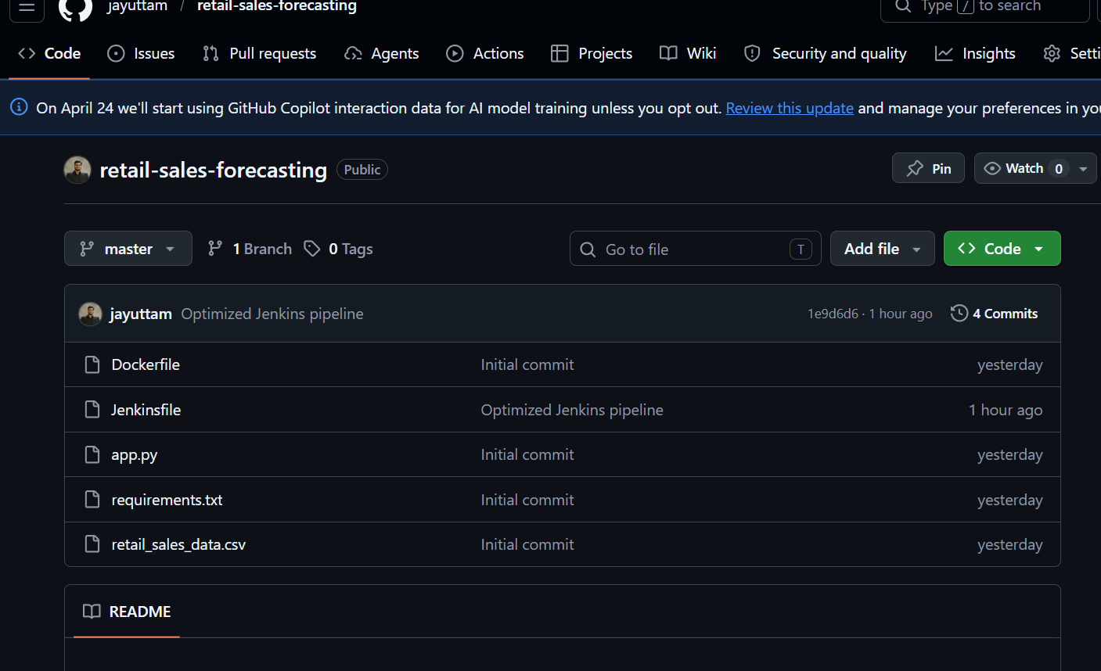
- GitHub Repository Screenshot

- Jenkins Pipeline Success Screenshot

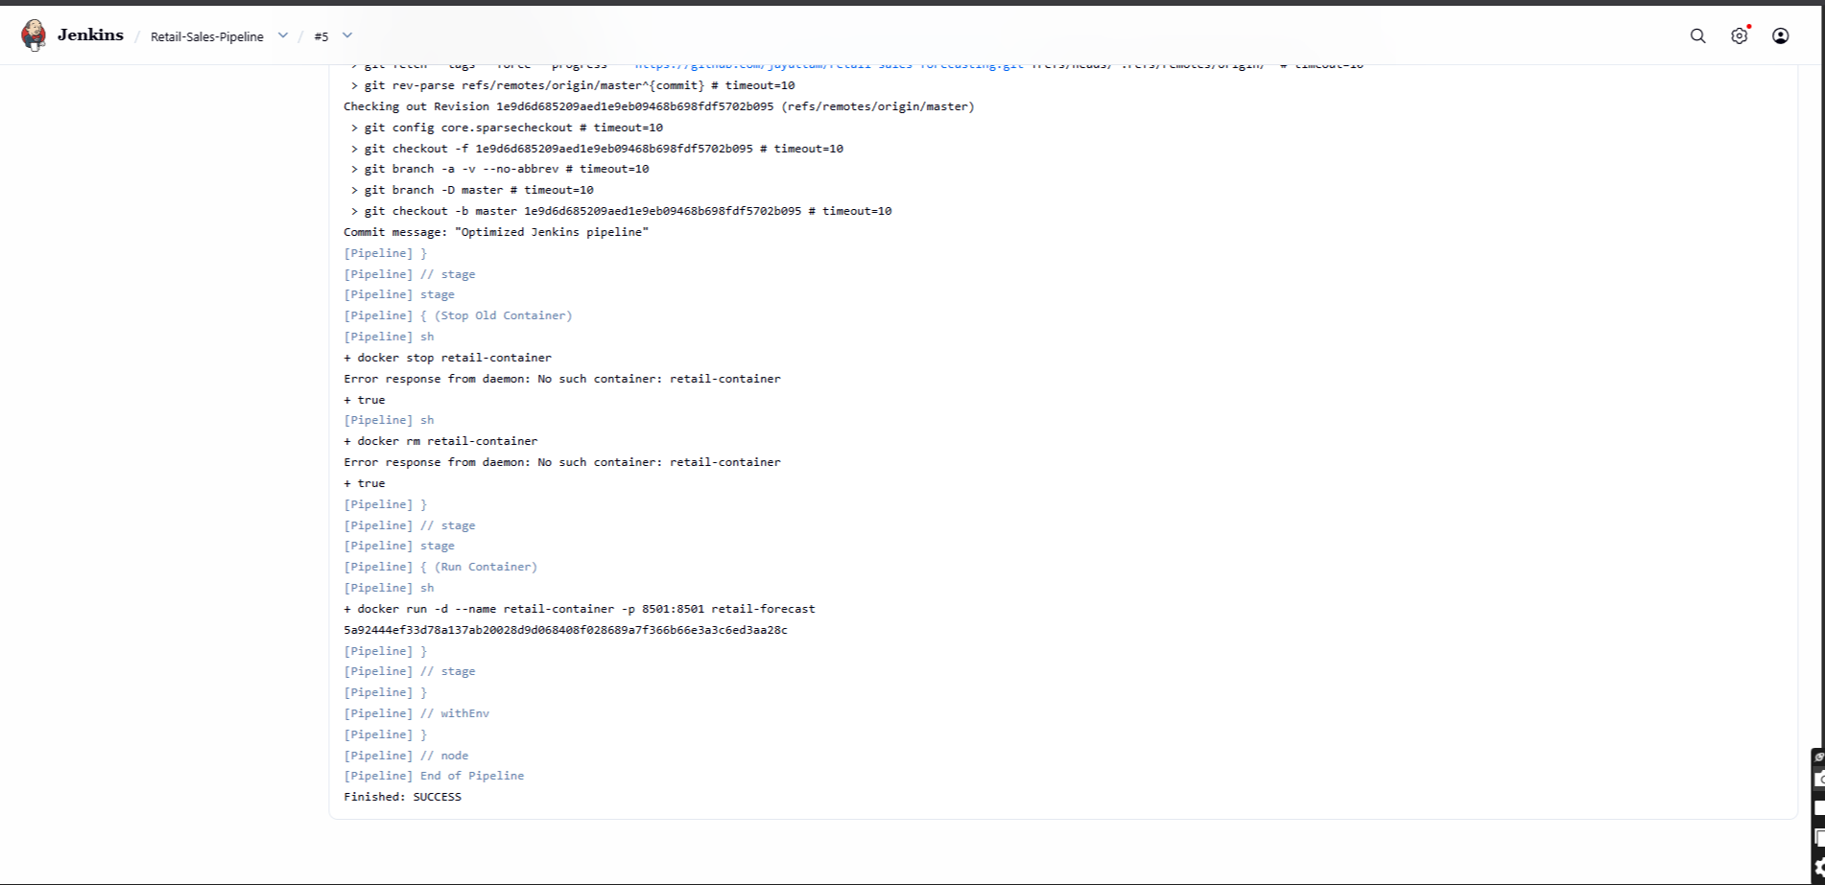
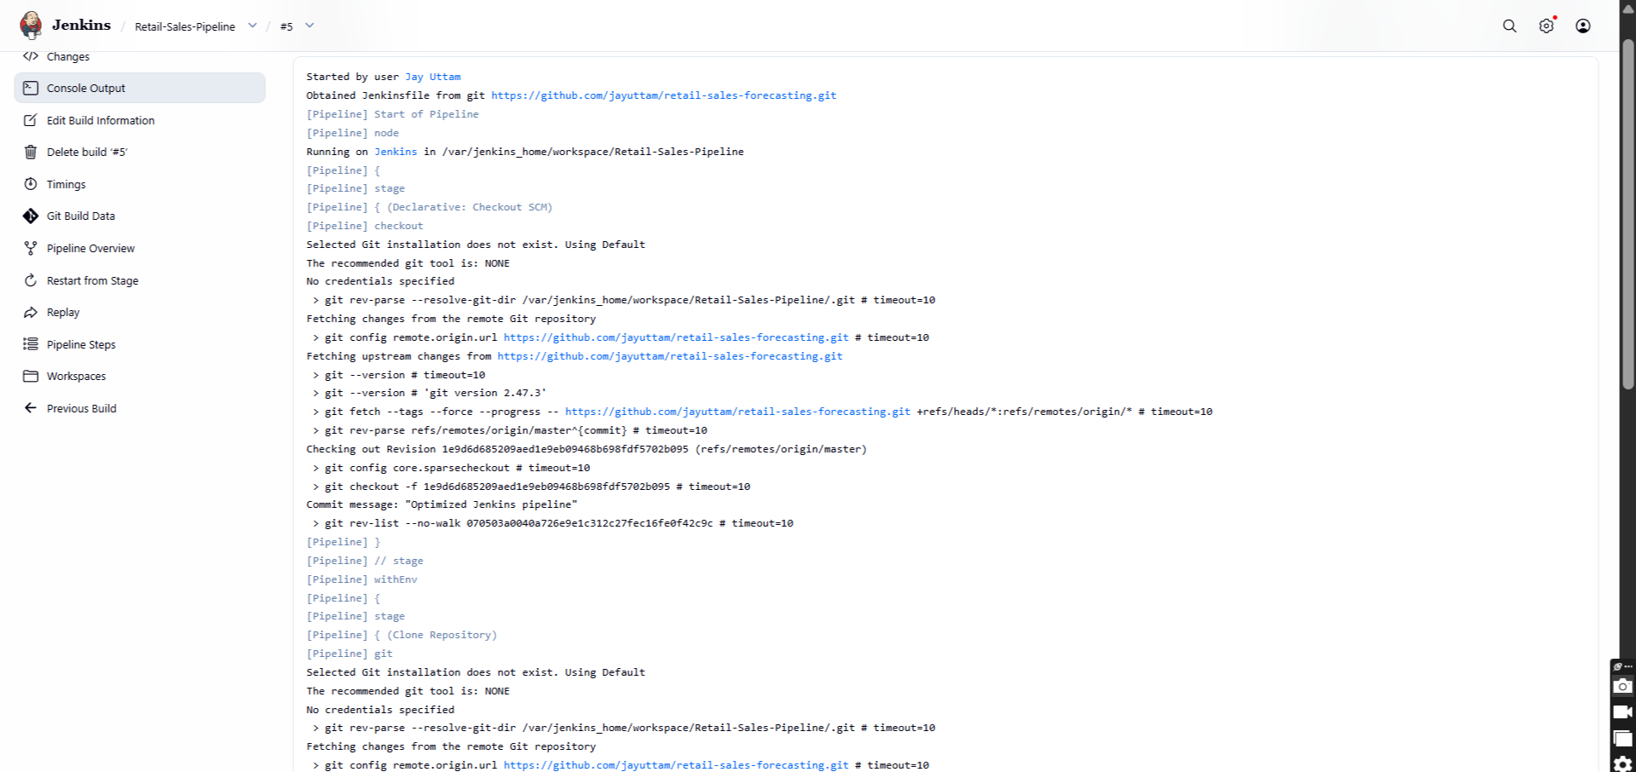

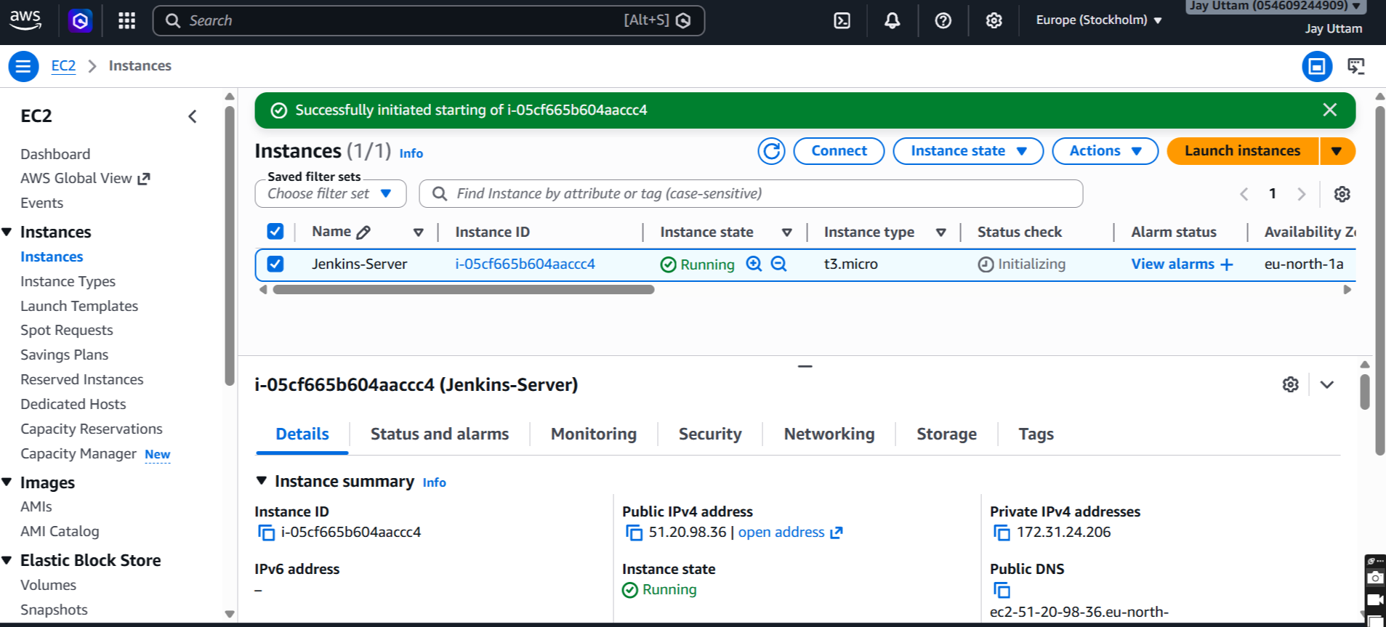
- AWS EC2 Dashboard Screenshot
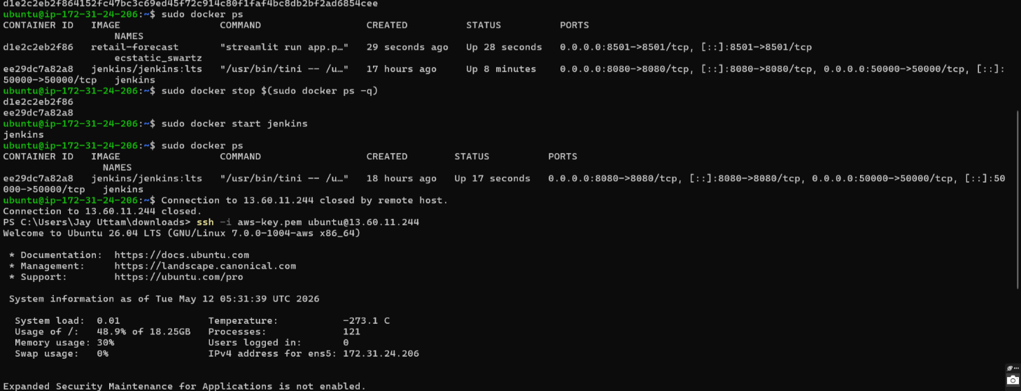
- Docker Container Screenshot

- Streamlit Application Screenshot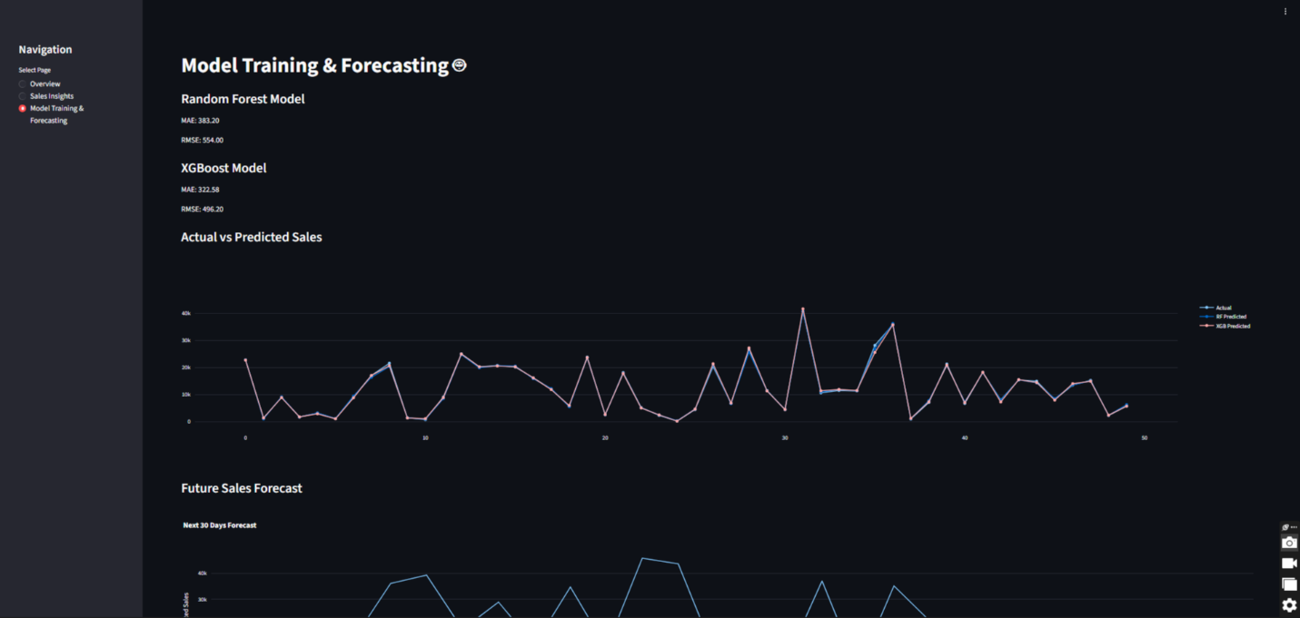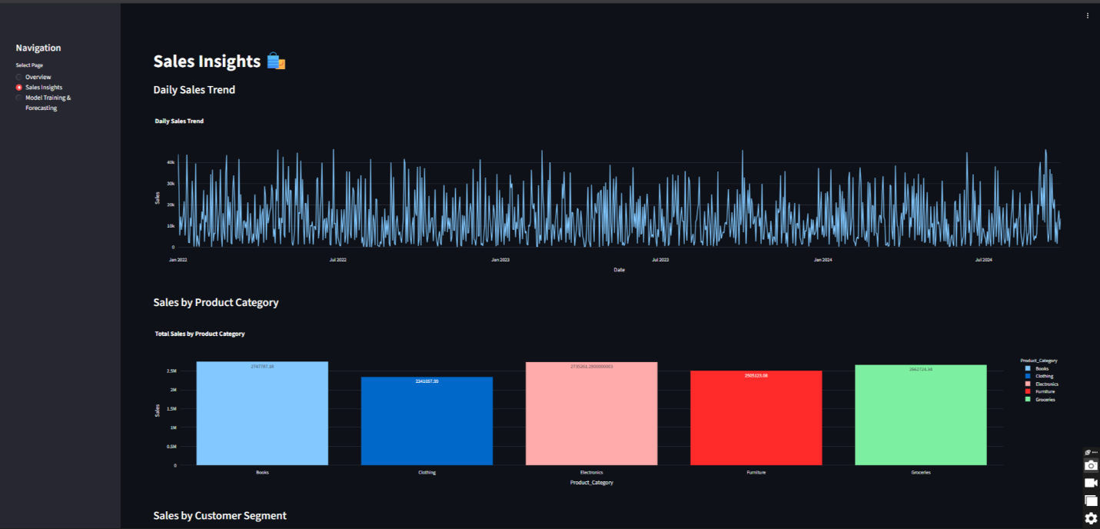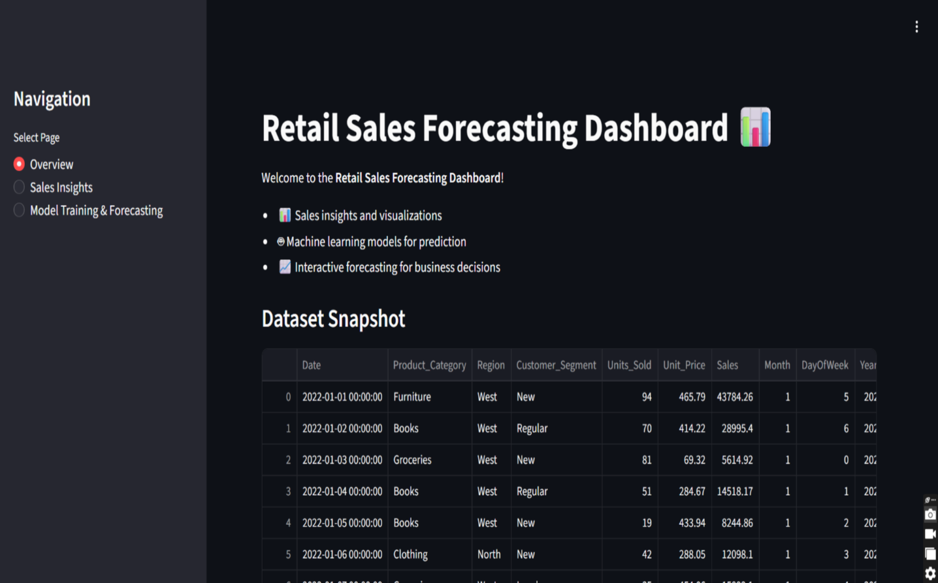
- System Architecture Diagram
