**To create docker file and docker image and docker container**

1. To create docker image

* A computer screen with blue text

  AI-generated content may be incorrect.Docker build -t fenrir .

1. To create docker containder

* 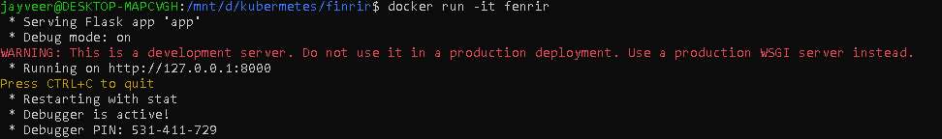Docker run -it Fenrir

1. Output of a container app

<http://127.0.0.1:8000>

my container is properly working

1. To push this container to docker hub

To create a new Create repository in docker hub

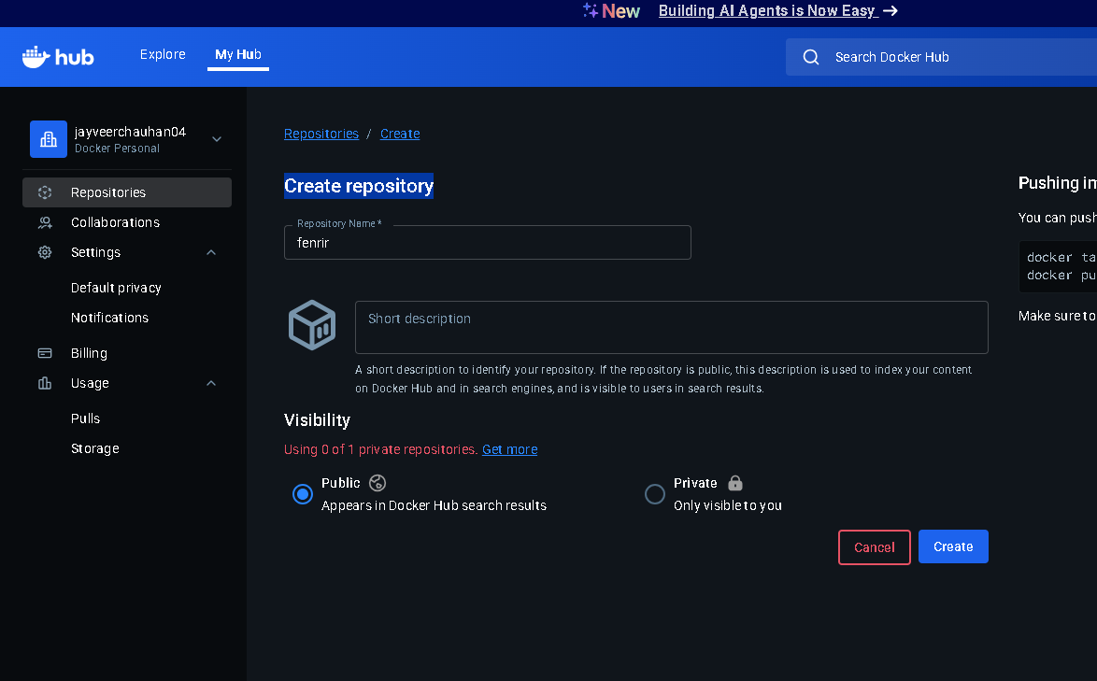

1. Login docker using this command

* Docker login

1. Then we use this command to push our container in docker hub

🡪 docker push jayveerchauhan04/Fenrir

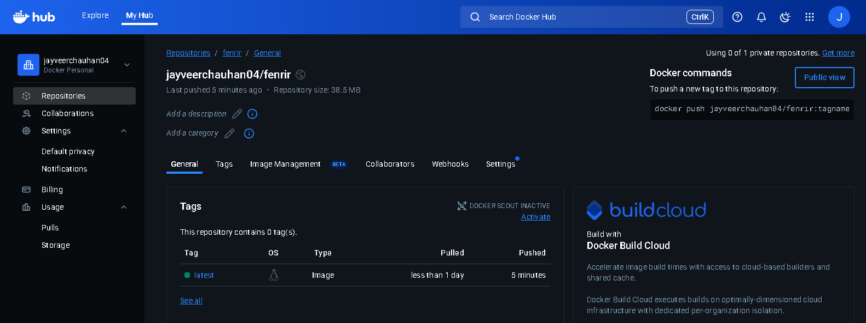Our container successfully push in docker hub

# Now push this image in Kubernetes

* kubectl apply -f deployment.yaml

The container successfully deployed in Kubernetes

To create pods we need to modify deployment.yaml file and add ( replicas:3)

And the pad is added in our container

# How to access a deployment

We need to create a service,yaml file

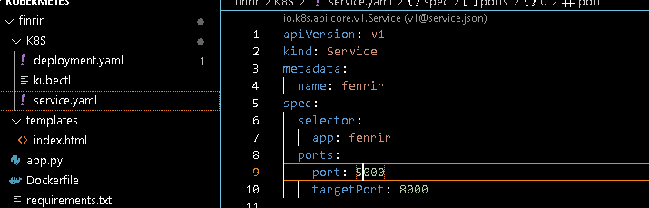

And the command to activate this service in our container is

🡪 kubectl apply -f service.yaml

Finally my application is successful hosted:

This is a flask application to show environment variables and this is hosted using Kubernetes and docker hub

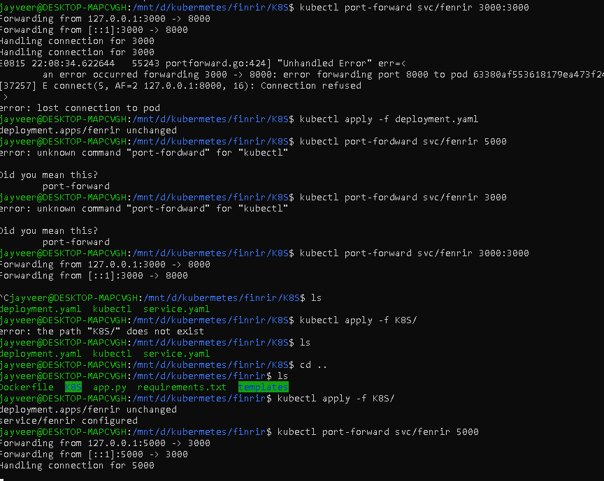This is for port fordwarding

# All commands

* Kubectl get nodes

This command is use to show all nodes

* Kubectl get pods

This command is used to show all running pods

* Kubectl get all

This command is used to show everything like, services, deployments, pods, and namespaces

* Kubectl delete pod/<pod name>

This command is used to delete pods

But it can be backup automatically because in configuration we provide 3 pods so that why it can restore with another name.

We can not delete a pod so we delete deployments using this command

🡪 kubectl delete deployment/<deployments name>

We we want to restore our deployment

🡪kubectl apply -f k8s/

Day 4

To download mongo in docker local machine in ubuntu

* Docker run mongo