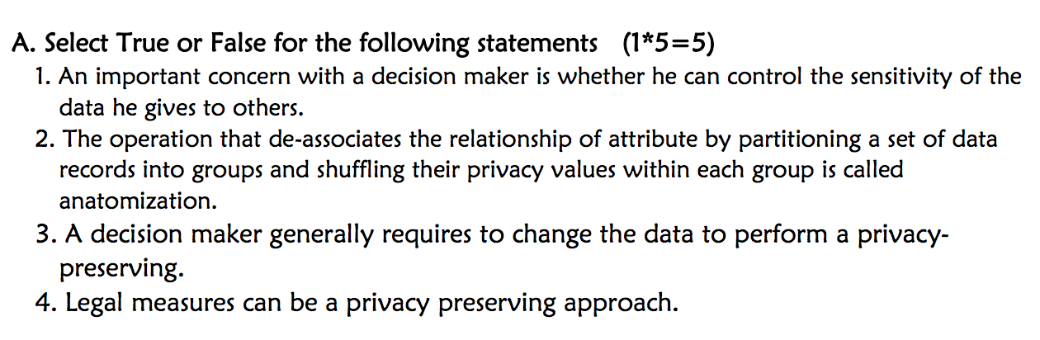

1. True
2. False
3. False
4. True

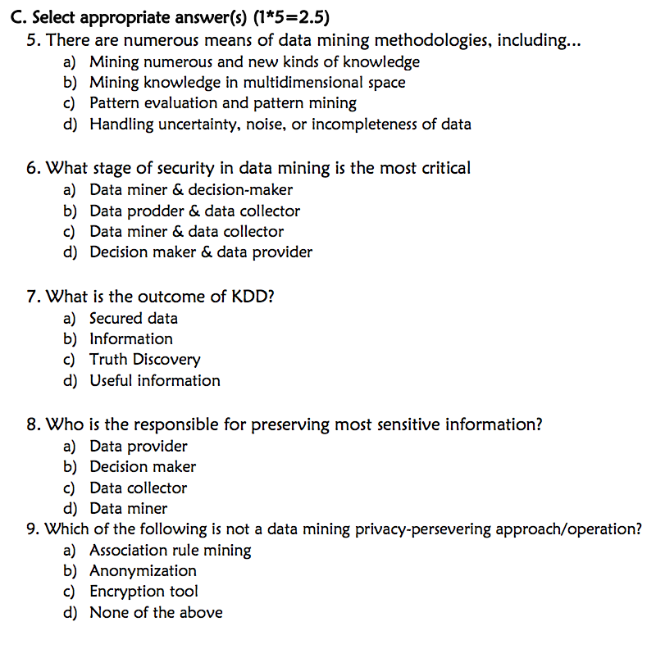

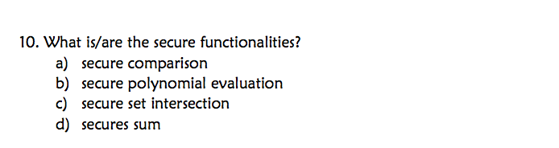

1. C
2. D
3. C
4. A
5. D
6. A, B, C, D

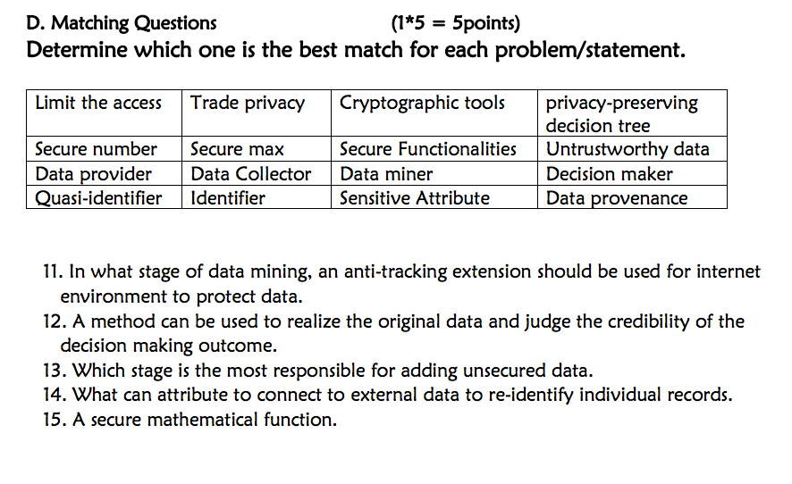

1. Data provider
2. Decision maker
3. Data Collector
4. Quasi-identifier
5. Secure Functionality